Change Memory

15_04_2010

Inexistent foreign keys
The first difficulty we have found in the process is that the current db has not any relationship created between tables, our Framework manage the relations on the model it self at the application layer so the database is not aware of any of these relationships. Although we could change the database script generators in order to create the relationships also in the form of foreign keys, as a starting point we have decided to created them manually. This is an extract of the Contactable table after adding the relationships as in the domain model. Another difficulty with this task is that our framework codes the “one to many” and “many to many” relationships in the same way witch is the creation of an intermediary table. One example of this in the picture is the table “com_fpdsavills_pr_Contactable$To$ContactEvent”. (See annexes for more information about this issue)

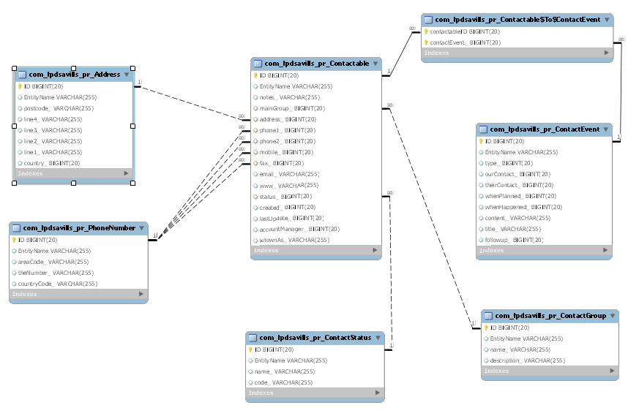

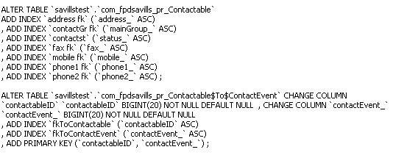

16_04_2010
The database engine issue
Currently, our framework is coupled to mysql, generates the tables with an old db engine that does not allow foreign keys, the engine name is “MyISAM”. Another problem with that engine is that it does not allows transactions, In order to allow the code generation tools to work correctly we need to change that engine to “InnoDb”.
The ID issue

Another problem is that in our framework all the entities has got and id that is an object of class ID although in the database it is save a primitive BIGINT. We needed to use something called composite-id in hibernate mapping files so hibernate will create this kind of objects on the spot when getting the entities from the database, also it allows searches on this composite-id.

Contactable instance = (Contactable) getSession()
.get(Contactable.class, new ID(“123123123”));

<composite-id name="ID" class="domain.ID">
<key-property name="identifier" column="ID" type="java.lang.Long"/>
</composite-id>

<property generated="never" lazy="false" name="identifier" type="java.lang.Long" insert="false" update="false" >
<column name="ID" />
</property>

The restriction is that if we want to map the column ID to a non-object attribute like for example “Contactable.indentifier” (which is of type Long) we need to declare the second mapping of the property as a read only.

17_04_2010
One-to-One Relationships
In hibernate, there are two types of one-to-one associations: “by primary key” and “by unique foreign key”. The first one only can be use when the two entities share the same Identifier (ID) .For example if Employee has a Person and then if the ID are the same on both tables i.e. “employee_table” and “person_table” then you can use the hibernate mapping “one-to-one”.
In our case the IDs do not have to be equal, in fact, they will not be equal on any one to one association. They will only be equal in the case inheritance relation, i.e. Person extends Contactable.
Because of that we need to represent this kind of relationships like many-to-one relationships witch actually works perfectly fine in both cases :many-to-one and one-to-one.

Creating generic Data Access Objects
Most of the data persistence technologies follow the same patter, there is a set of domain objects that represent entities or tables in a database and there is another kind of classes which only job is to give utility methods to interact with the domain object classes. This second type of classes is called “Data Access Objects” and do not represent any business data and are not persistent. The patters establish that for each domain object class should be a Data Access Object to handler the interaction with that specific domain object. Since there are many methods that will be share between the DAO classes i.e. findbyId() , save() or delete() and others, there is a need to avoid code repletion. But the challenge comes because although the methods are similar , they returns different types.
In order to address this issue the best option is using a genericDAO class coded using java generics and create concrete DAO classes for each domain object but every one of them extends the genericDAO class , this will simplify greatly the code, will reduce duplication and at the same time will bring type safety to the common operations. In addition, this will save memory because a generic class is only one class in memory, not matter who many different classes instantiate them with using different types.

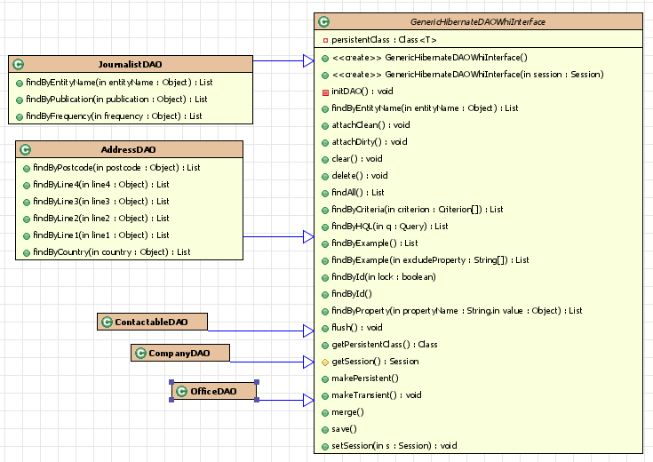
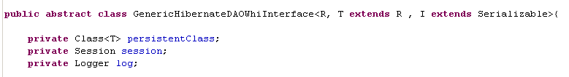

20_4_2010
The problem with inheritance
Our framework is totally able to model and implements inheritance in the domain model it does it creating tables which share the same ID number in addition to the use of a database field named “Entity Name”. Although that field is added by the framework in all the tables of the model, it has got especial relevance in the case of inheritance. In order to explain better the issue I will present a real example in the application we are currently migrating to hibernate.

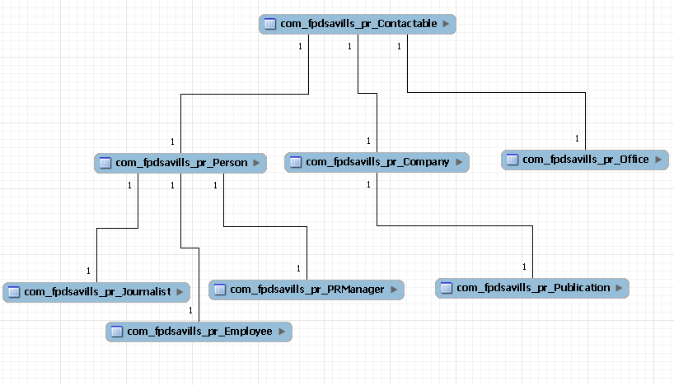

As it can be seen on the diagram there is a Super class with is Contactable and it has three direct subclasses witch are Person, Company and Office. The way our framework would model this in the database is :
- When ever a Person is created two rows are added, one in the Contactable table and another one in the person table, and both of them will have the same ID.
- In addition in both rows the field “entityName_” will be populated with the name of the class prefixed by the name of the domain model , in this case “com_fpdsavills_pr_Person”.
- In the source code that the application generates the relationship is actually of implementation of an interface. But the framework handles the creation of the instance of that entity using all the tables of the superclasses.
- Another thing to remark is that our framework would also handle the deletion of a Person deleting the both rows in the Person table and in the Contactable table.

This is how inheritance can be implemented using hibernate :

-Table per class – All the entities involved in the inheritance relationship are hold in the same table, each time a new subclass is added to the hierarchy, the new attributes of that subclass are added to the table. The main problem with this is that the new fields representing the new attributes of subclasses cannot have not null constrains. The main advantage its is performance since no join is needed ether in generting the instances of the entities nor in polychromic queries (Queries to the super class that implicitly refers to elements of all subclasses).
-Table per subclass – There are different tables for each subclass, each shares the same ID with the subclass.
-Table per subclass with discriminator – like the second class but with the use of a discriminator.

22_04_2010
Although we have discriminators in our database, the implementation of the discriminators in hibernated is more complex and does not bring any extra benefit, so we decided to go for we first second option.

The problem aroused, when we found some inconsistency on our database. The inconsistency was that there were different subclasses with the same ID. In example: being Office and Company both subclasses of Contactable there was a Company with ID 128 and a Office with ID 128 and a company with ID 128. This is illegal because the system would not know what object to return in the case of ‘getContactableByID (128)’ because both Company and Office are Contactable with ID 128. At first we thought that we could try to use the discriminators for this reason (using the option 3 suggested by hibernate) but then we discovers two things. The first this is that the way our DB implements the discriminator is not compatible with the way Hibernate understand them. The second thing is that we had also inconsistency with the discriminators; using the same example of above we found that in the table Contactable, in the row ID 128 the discriminator was set to “Contactable” instead of “Office” or “Company”. The source of this inconsistency was the import process followed at the setup the application in which we imported data from an existing MSAccess database.
The consequence is that using the current framework if you want to modify any of the
Attributes of the superclasse (Contactable) through any affected instance of Office or Company then the result is unpredictable sometimes overriding the values of the other instance with the same id and other times just not saving the results. Fortunately in this small application such changes are very unlikely and that is way we did not find the problem before. Instead, Hibernate found this problem and force us to fix the integrity of the database, mainly through SQL command like the following (see the annexes to find the complete list):

ADD AN OFFSET TO THE ID ON OFFICES SO IT DO COLISSION WITH THE IDs of the COmpanies
------------------------------------------------------------------------------------
UPDATE `savillstest`.`com_fpdsavills_pr_contactable`
SET
`ID` = ID+1999999
WHERE `EntityName` like 'com.fpdsavills.pr.Office';

SELECT * FROM `savillstest`.`com_fpdsavills_pr_contactable`
WHERE `EntityName` like 'com.fpdsavills.pr.Office';

UPDATE `savillstest`.`com_fpdsavills_pr_office`
SET
`ID` = ID+1999999;

UPDATE `savillstest`.`com_fpdsavills_pr_coverage`
SET
`office_` = office_+1999999;

UPDATE `savillstest`.`com_fpdsavills_pr_office$to$allmanager`
SET
`officeID` = officeID+1999999;

Once we fixed that inconsistency problem we carried out the steps needed to configure and implement inheritance with Hibernate. Which in our case were :
- Create foreign keys from the subclasses to the super classes. To allow integrity constrains when deleting subclasses.
- Create the POJO classes to hold the new entities specifying the inheritance hierarchy.
- Make the needed changes in the Hibernate mapping files.
- Coding the test cases to test the inheritance.

23_04_2010

Adding to the implantation of the BusinessObject
In our current framework, all the domain objects implement on interfaces called “BussinesObject” this interfaces forces the implementation of two methods getID() and getEnitityType() on all the domain objects.
Based on that, there are many Data access methods on our framework that return and receive objects of type “BussinesObject” and then methods based on reflexion to interact with this unknown type objects. This is basically an alternative to the use of “generics” and it was the only alternative when the framework was build 10 years ago sine “generics” is part of java only since java 1.5.
In order to keep compatibility we need to make all the domain objects generated with Hibernate implement BussinesObject interface. Other option is to create a supper class BussinesObject and them make all the domain object inherited from it, directly or indirectly (through the super classes). Being this only an application requirement, and with no need to store any particular information to the BussinesObject, the inheritance is not the best option because it will override one the main advantages of using hibernate that is that our domain object model represent purely the business domain through POJO objects and in this way free from any implementation details in this way supporting separation of concerns (SoC) programming paradigm.

24_4_2010-04-24

Date Problem and custom Types
In our current framework, dates are stored in the database as Big Integer type instead data type, in fact the framework saves in the database the epoch value (number of millisecond since midnight 1-1-1970). The number that we store is in milliseconds and hibernate default data mapping types only convert if the number is in seconds. Fortunately hibernate allows the creation of custom types to be use in the mapping between the domain object and the database. Basically it provides an interface “UserType” that needs to be implemented and then specified in the configuration files.
The main methods of that interface are “nullSafeGet” “nullSafeSet” that are called when hibernate reads the data from the database and when it saves it to the database respectively.
In our case we coded a class called DataLong where we implement those two methods and others.
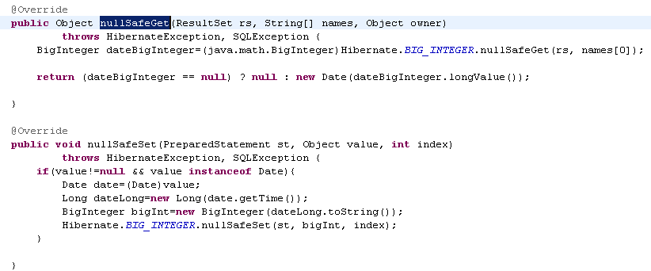

This feature allows also creating composite attributes that are represented by one or more columns on the database but they are represented only by one field in the domain object. For example an address that is represented by a string and when ever it is saved it will find the postcode and saved it in another column.

Implementation of the Domain Objects Interfaces in hibernate
The framework we use currently, relays heavily in inheritance in order to implement persistence this means that there is not real inheritance in the domain model (because all the classes needs to inherit from a supper class that handle the persistence). The immediate consequence is that the relations on the domain model and the domain object inheritance is implemented through interfaces instead. In example there is an entity called “Person” and another entity called “Journalist” that should inherited from “Person”. In this case our current framework will create two interfaces “Person” and “Journalist” and make the classes PersonH and JournalistH implement those interfaces.
This has two problems , the first one is that there is not separation of concerns , our domain model is coupled to the persistent implementation. And the second problem is that although using interfaces you use some kind of inheritance, we cannot benefit of some of the main advantages of inheritance like avoiding code repetition and encapsulation. In this case all the person attributes and methods need to be re-implemented in Journalist domain object.

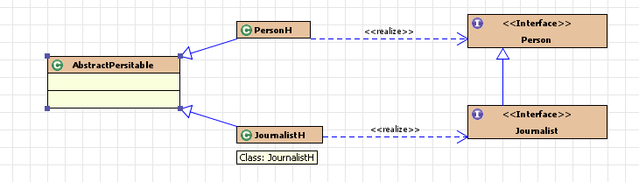

Using hibernate all this is not needed because hibernate uses “non intrusive programming” in order to implement persistence and we can use pure inheritance between the domain objects.

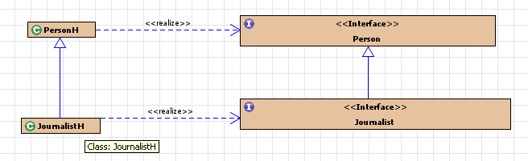

Although the use of interfaces is not longer required we will implement the existent interfaces during the development process in order to help us in creating tests that integrate both frameworks to compare the behaviour and performance. After that we should refactor the application in order to remove the interfaces.

interceptors and IDS.
sandbox and xmls importing.

