Testing Strategy

Written test is considered a good practice in software development but becomes even more relevant when the development involves the migration from an ORM(our current framework) to a new ORM(Hibernate) in an existing application. Tests should ensure that the behaviour of the old ORM has been replicated by the new one, and this is very important to corroborate because a hidden defect or misbehaviour on the implementation could easily lead to irreversible data corruption in the client application that has been migrated to hibernate. This risk makes the creation and implementation of a proper test strategy a crucial requirement of the migration project.

The test strategy aims to define the kind of test to be created and what they are supposed to assert. At the end the complete set of tests should cover all the function points (that are the public interfaces) between the different layers (application layers, data access layers and persistence layer).In addition of the benefits of Test Driven Development TDD, having a test suit that cover all the function points of the application bring many benefits to the process of software development some of them are:

- Increase quality of the code, because all the code is been tested before deployment.
- It facilitates posterior refactoring, the test suit can ensure that the refactor has not change the public behaviour of the refactored classes and also that there is not hidden side effects. This is known as “Regression Tests”.
- The test suit can be use as a real-time updated documentation of the software features. Test can be seen as detailed specification of features since they should cover all the functionality of the feature including exceptions. This is better achieved if using domain specific language inside the test (naming the methods and variables in a way that domain experts can understand the test)

For each layers we should have unit tests and integration tests to cover all the function points. The unit test should run quickly in a mocked environment they only should test one isolated program unit that can be compose by one or more function points. We better achieve this using a “Dependency Injection Pattern” (see the patter) to extract the environment instantiation (the dependencies of the object to be test) outside the tested class. And then instantiate a mock environment or a real environment depending if it is a unit test or integration test. For example, in the case of unit test involves the use of a external resources (database, web service, external API) the external resources should be mocked (see mock object testing pattern) following the principle of “Only Mock Types That You Own”, witch means that in the case of external resources (like external services of API) we should not try to mock the external resource it self. Instead we should create a wrapping class using the decorator pattern (see decorator pattern). This wrapping class should only expose the methods that we use in our domain model and hide the rest of the API. Then create test for that wrapping class and finally mock the wrapping class in other unit test.

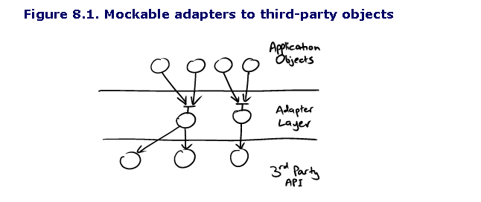

Then the integration test should run a similar test against a real environment (not mocked environment).

Best practices in testing with databases:

As a best practice, when instantiating the entities we should use the build pattern (see the build pattern) this will separate the logic of the construction of the classes from the logic of the test. And will make the code easy to write and to read.

Another best practice is setup a fix dataset before the test so the test starts with a known state. It is important not to delete the database at the end of the test because it can be use to find out problems if the test failed.

Another best practice is to define clearly the boundaries of transactions, this means that we clearly specify when the transaction starts and when it finish and make sure that we complete the transaction inside the test because only if the transaction is committed then queries will be sent to the database to persist the new entities. Also is better if all the data interaction (searches, savings, retrieving) live inside their own transaction boundary to avoid residual states (this is really relevant in the case of saving and retrieving objects because the session cache inside the same unit of work)

Persistence Layer Testing
The aim of testing this layer is to ensure that the ORM has been setup correctly, this involves all the mapping files, POJO definitions, hibernate and database configuration. The way we achieved this certainty is to ensure that we can persist all the different entities, and that when we retrieved the same entity from the database it is exactly the same entity as we inserted, this is kind of test is call round-trip testing.

As a best practice, when instantiating the entities we should use the build pattern (see the build pattern) this will separate the logic of the construction of the classes from the logic of the test.

In this kind of the test the fix dataset is preferable and empty version version o the database so we ensure that the retrieved object and only the ones saved before by the test itself.

Regarding to the boundaries of transitions, in this case we should ensure that the action of persisting the object and the action of retrieving the object are carried by different transactions.

Basically it consist of a generic builder that build all the objects

