Numerical differentiation formulae (the proof of these formulae is based on taylor series)
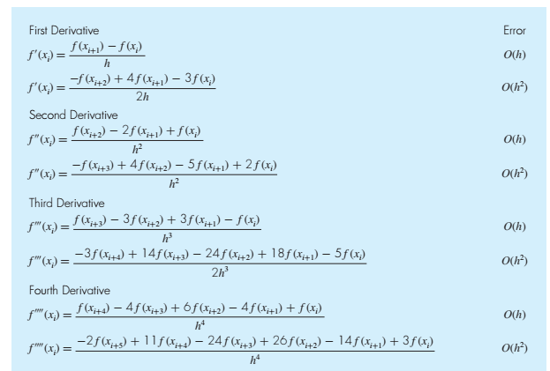

For a function y, generate data of y and x vectors. Use the “diff” built in function to calculate derivative as below.

For a function y, generate data of y and x vectors. Use the “gradient” built in function to calculate derivative as below.

Problem#1
- Calculate the exact first four derivatives expressions.
- Plot the function and its first four exact derivatives from -1 to 2

- Use appropriate step size and calculate first four derivatives using the numerical formulae given above and plot. Plot 4 graphs (for four derivatives). In each graph represent exact curve, curve with error O(h) and curve with error O(h^2).

- Use “diff” and “gradient” built in MATLAB functions to calculate first four derivatives and plot. Plot 4 graphs (for four derivatives). In each graph represent exact curve, curve obtained with “diff” and curve obtained with “gradient”.

Comment and compare all versions.

Problem#2

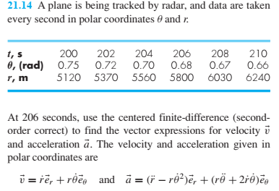
- Plot the path in rectangular coordinates.
- Plot velocity vectors on the plane path in a separate graph
- Plot the acceleration vectors on the plane path in a separate graph

