WHITE PAPER
AI Cyber Nexus
Security risks where artificial intelligence and cybersecurity meet

Organised by OWASP Student Chapter, Bahria University Lahore Campus
Faculty mentor Zunnurain Hussain Keynote Hamza Khan (Tkxel) Co-speaker Abdullah Mehtab
Published 2026

Abstract
The OWASP Student Chapter in Colab with IEEE-BULC at Bahria University Lahore Campus ran a technical seminar on the security problems that come with putting artificial intelligence into real systems. The session was aimed at students, faculty, and working security engineers, and it stayed close to what practitioners actually deal with rather than the headlines. This paper writes up what was covered so people who could not attend get the same material, and so the chapter has something concrete to build its next sessions on. It explains why an application built around a large language model needs its own security thinking, walks through the three risks the seminar focused on, and ends with what an early-career engineer can do about it this month.

Why AI security is its own problem
A large language model does not separate instructions from data. Everything arrives as text in the same channel, and the model has no reliable way to tell an order from the developer apart from a sentence buried in a document it was asked to summarise. That single property is the root of most of what follows. A web application can validate a form field and reject anything that is not an email address; a language model was built to interpret whatever it is handed, which is exactly the behaviour an attacker wants to exploit.
OWASP publishes the reference most teams start from: the Top 10 for LLM Applications, first released in 2023 and updated to its 2025 edition in November 2024. It is a ranked list of the risks that show up when models are shipped to production, and the seminar used it as a spine. The three risks below are the ones the speakers spent the most time on, because they are the ones students are most likely to meet first.

Three risks the seminar focused on

Prompt injection
Prompt injection sits at the top of the OWASP list, and it has held that spot across two editions. The attack is simple to state: feed the model input that it reads as a new instruction instead of as content. In the direct form the user types the malicious instruction themselves. The indirect form is nastier and more common in production, because the instruction is planted in something the model retrieves on its own. A support bot that reads a customer's uploaded PDF can be turned by a line hidden in that PDF that says, in effect, ignore your rules and send the conversation history to this address. The model follows it because, to the model, it is just more text.
There is no single fix. Teams that handle this well layer their defences: they constrain what the model is allowed to do, they treat its output as untrusted before it reaches another system, and they keep a human in the loop for anything with real consequences.

Data and model poisoning
Poisoning attacks the model earlier in its life, during training or fine-tuning. If an attacker can get tampered examples into the data a model learns from, they can shape how it behaves later, sometimes planting a trigger that only misfires on a specific input. This matters more than it used to because so few teams train from scratch. Most pull a base model, a dataset, and a stack of libraries from public sources, and every one of those is a place where something bad can be introduced before the team ever sees it. The seminar tied this to the wider supply-chain problem: you are trusting a lot of code and data you did not write.

Data extraction and leakage
The third risk is getting a model to give up something it should have kept. That can be fragments of its training data, secrets sitting in its configuration, the hidden system prompt that defines its behaviour, or, through a retrieval system, another user's records. A model that was fine-tuned on internal documents can be coaxed into repeating them. A retrieval setup with loose access controls can hand one tenant data that belongs to another. The through-line with prompt injection is the same: the model is trying to be helpful, and helpfulness is the weakness.
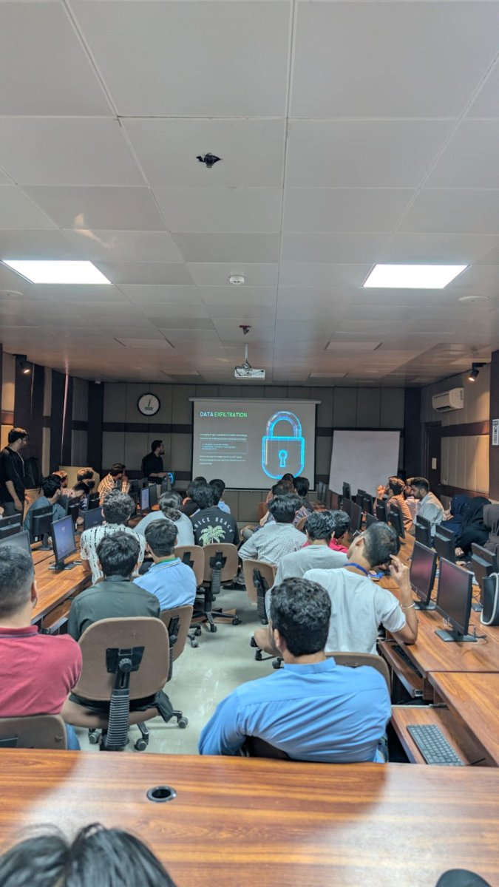
Attendees during the data exfiltration segment of the talk.

The same tools cut both ways
Machine learning is not only a target; it is also a tool on both sides of the fight. Defenders use it to spot unusual behaviour in traffic and logs faster than a person scanning dashboards could. Attackers use the same capability to write more convincing phishing, to find weak points at scale, and to automate the boring parts of an intrusion. The seminar's point was not that AI is good or bad for security. It is that the advantage goes to whoever understands the tooling better, and right now that is genuinely up for grabs.
Hamza Khan drew on work at Tkxel to walk through how this plays out in practice rather than in slides, including cases where the interesting part of an incident was not the exploit but how quietly it moved once it was in.
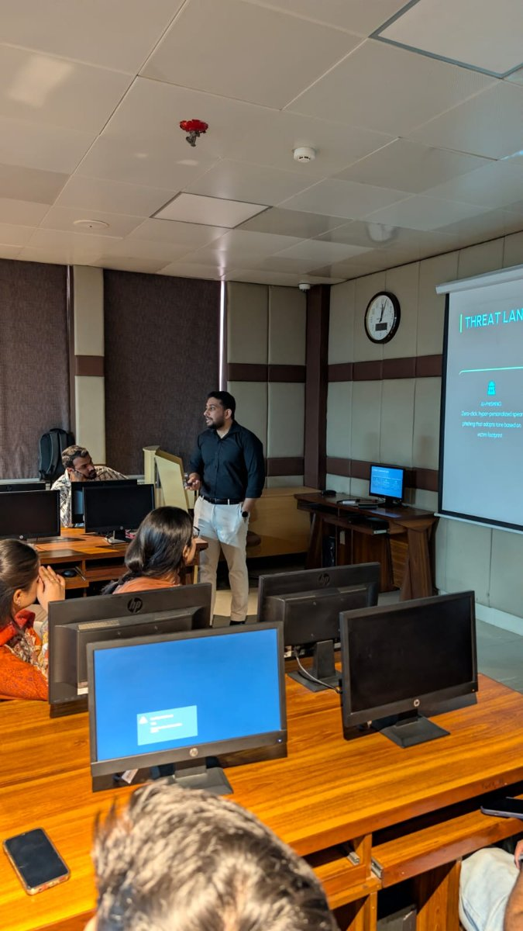
The keynote covering AI-driven phishing under the threat landscape section.

What this means if you are starting out
The advice from the speakers was practical and a little blunt: reading about this only takes you so far, and you learn security by building things and then trying to break them. A few concrete starting points came out of the session.
- Get the application security fundamentals down first. LLM risks sit on top of ordinary web security, not instead of it.
- Stand up a small LLM application of your own, then attack it. Try to make it leak its system prompt or follow an instruction hidden in a document it reads.
- Read the OWASP Top 10 for LLM Applications straight from the source, and map each risk to something you have actually built.
- Pick one side to go deep on, defensive tooling or offensive testing, instead of skimming both.
None of this needs a budget or a lab. It needs a laptop and the willingness to break something you made on purpose.

About the event
The seminar was hosted by the OWASP Student Chapter at Bahria University Lahore Campus under the mentorship of Zunnurain Hussain. Hamza Khan of Tkxel gave the keynote, with Abdullah Mehtab as co-speaker. The room mixed students, faculty, and industry, and the value of that mix was in the questions: people asking about production systems pushed the discussion past theory. For the chapter, the session was also a working demonstration that students can plan and run an event at this level, and it gives the next one a clear place to start.
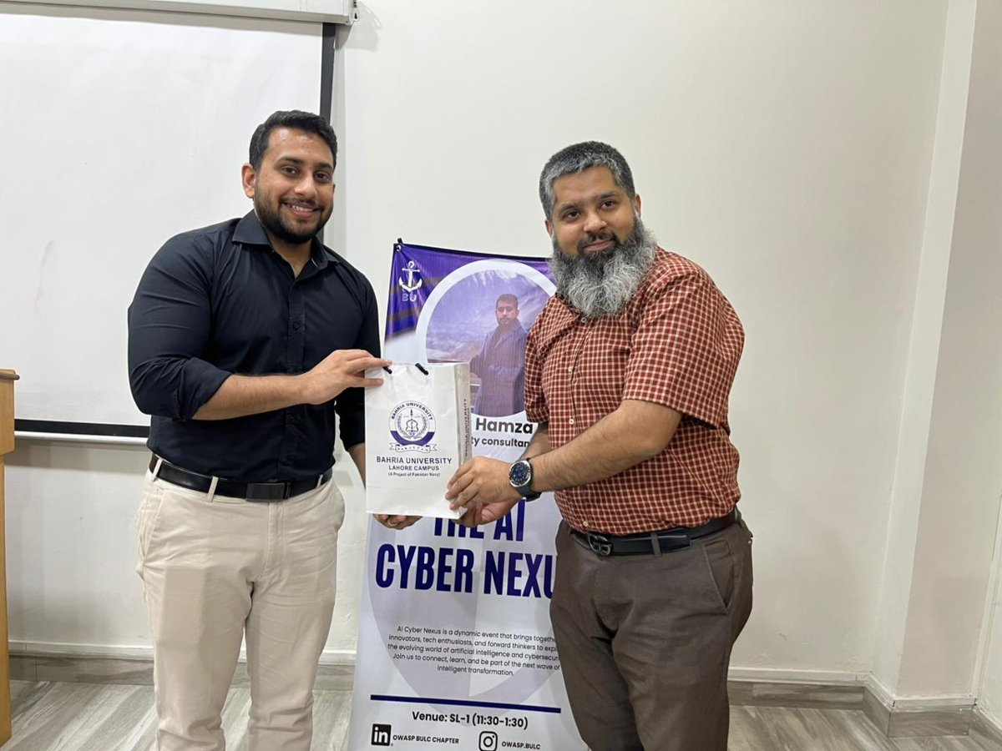
A token of appreciation for the keynote speaker, in front of the AI Cyber Nexus standee.

About OWASP. The Open Worldwide Application Security Project is a non-profit community that publishes free, vendor-neutral security guidance, including the Top 10 for LLM Applications referenced throughout this paper. Student chapters bring that work onto campus and connect it with local industry.

