Supplementary material
Scale Trade-offs in Within-Sample Self-Normalization for Cross-Study Generalization in Public cfDNA Cohorts
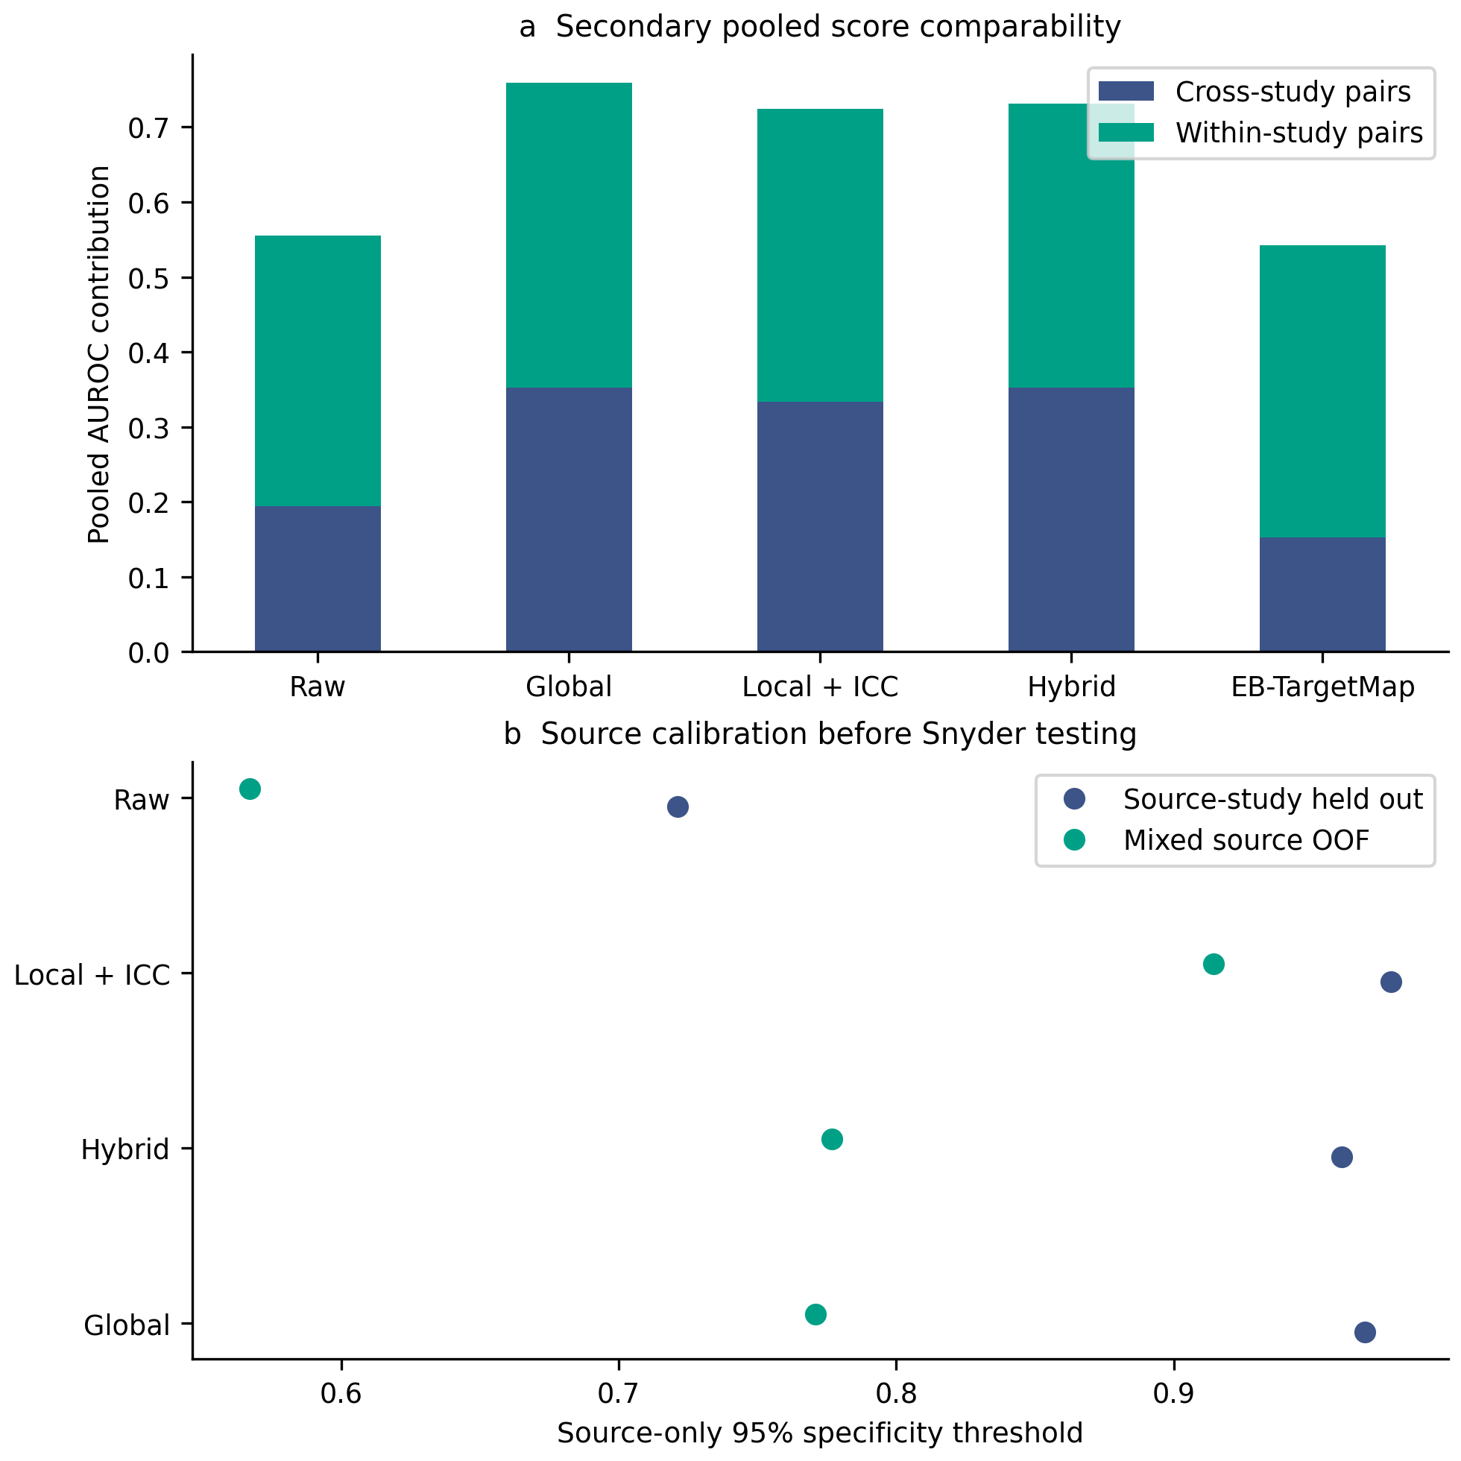
Supplementary Figure S5. Secondary score comparability and source calibration. (a) Within-study and cross-study pair contributions to pooled Combined LOCO AUROC. (b) Mixed-source OOF versus source-study-held-out thresholds fitted before testing Snyder. Pooled discrimination is a cross-model score diagnostic; the primary performance evidence is direction-specific.
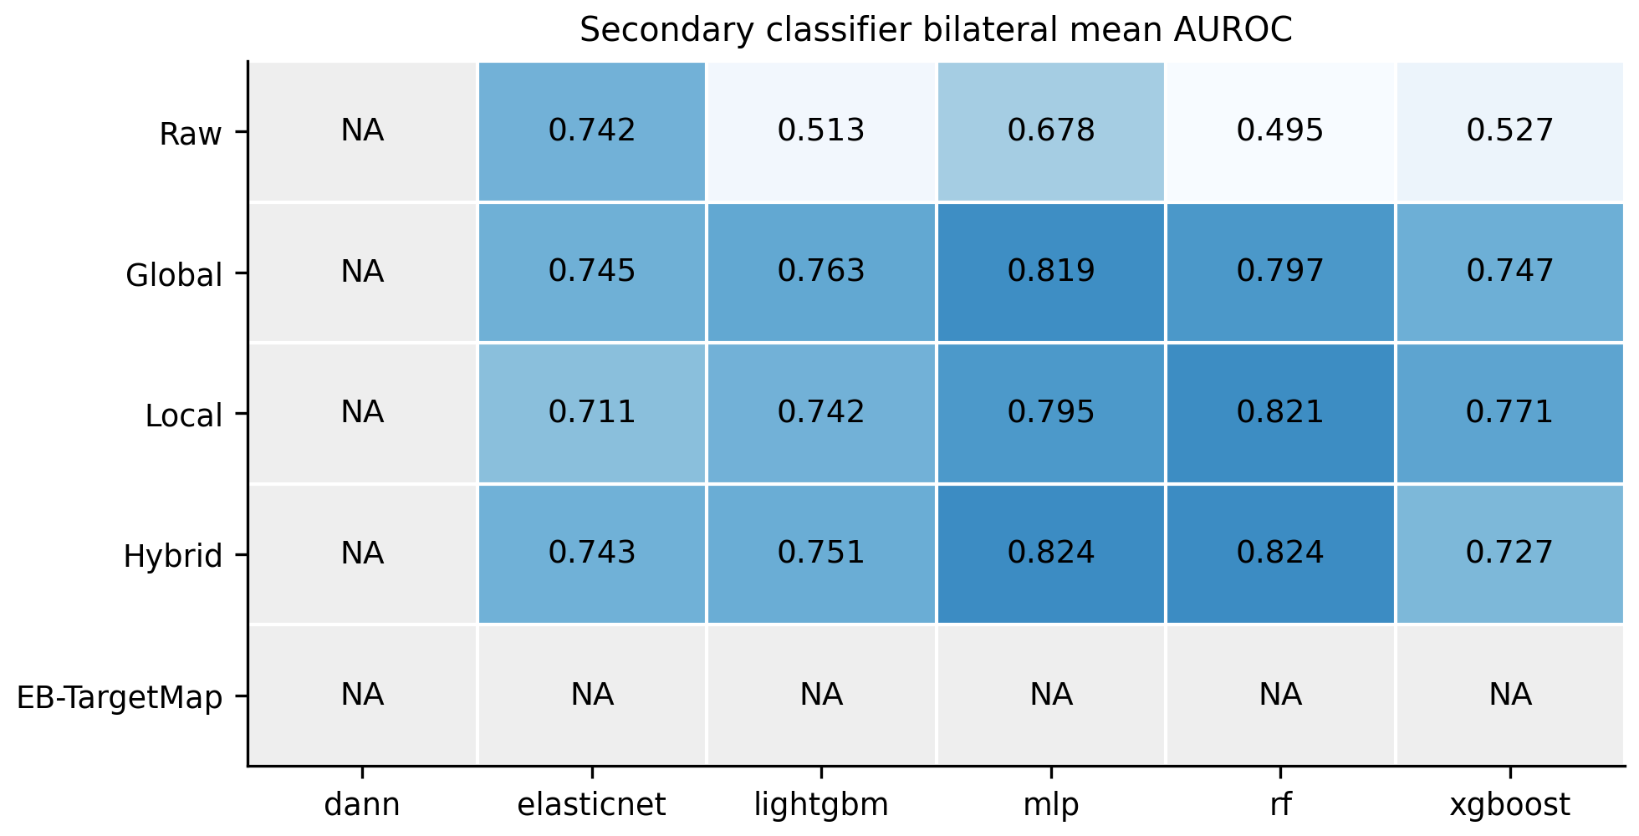
Supplementary Figure S6. Secondary classifier comparisons. Bilateral mean target AUROC by representation and fixed classifier. Gray cells denote unidentifiable EB-TargetMap/DANN configurations. Local uses its Local_LSN branch in the primary one-source design. Full random and study-held-out metrics are in Supplementary Table S6.

Statistical table guide
Supplementary Table S1: Primary_BH_Hypothesis_Family.csv. All 38 primary hypotheses, models, target studies, DeLong p and BH q values. The complete family remains the historical prespecified family.
Supplementary Table S9: Threshold_Calibration_Comparison.csv. Mixed-source OOF and source-study-held-out calibration, source threshold intervals and propagated operating points. Missing one-source EB-TargetMap cells are explicit.
Supplementary Table S3: Primary_Hybrid_Global_Delta.csv. Paired Hybrid−Global ΔAUROC and 1000 diagnosis-stratified patient-bootstrap intervals.
Supplementary Table S4: Depth_CancerType_Sensitivity.csv. Post-hoc exploratory sensitivity analyses of the shared-depth interval and GI-versus-HCC restriction, using the same public cohorts with altered target size/composition; not independent external validation or confirmatory evidence.
Supplementary Table S5: Chromosome_Block_Associations.csv. Nine genomic block tests with full block bootstrap intervals and block-wild BH correction. PERMDISP_Dispersion.csv gives the four separate dispersion tests.
Supplementary Table S6: Table3_Benchmark_Metrics_Full_Revision.csv. Complete fixed-classifier random and study-held-out metrics, with current method names and explicit unidentifiable cells.
Supplementary Table S7: Anchor_Distribution_Summary.csv. Median, Q1, Q3, IQR, full range and threshold-crossing rates. Anchor_All_Predictions.csv gives all repeated observations and Anchor_Real_Batch_Members.csv supplies patient identities for reproducibility.
Supplementary Table S8: Table2_Study_Depth_Fragments_Composition.csv. Exact depth/fragment ranges and cancer/stage categories for all sources. Source stage codes 0 and X remain as supplied.
Supplementary Table S2. Software versions.
package | version
numpy | 2.2.6
pandas | 2.3.3
pyarrow | 24.0.0
scipy | 1.15.3
scikit-learn | 1.7.2
statsmodels | 0.15.0
torch | 2.5.1+cu121
xgboost | 2.1.4
lightgbm | 4.6.0
umap-learn | 0.5.12
matplotlib | 3.10.9
seaborn | 0.13.2
requests | 2.34.2
Python | 3.10.10
Supplementary Table S9. Source threshold calibration (primary).
Target | Method | Source threshold [95% CI] | Target specificity | Propagated specificity [95% CI]
Cristiano | Global | 0.629 [0.407, 0.744] | 0.660 | [0.512, 0.737]
Cristiano | Hybrid | 0.559 [0.334, 0.617] | 0.632 | [0.517, 0.675]
Cristiano | Local LSN | 0.671 [0.517, 0.805] | 0.512 | [0.445, 0.632]
Cristiano | Raw | 0.695 [0.679, 0.709] | 0.450 | [0.105, 0.770]
Jiang | Global | 0.729 [0.576, 0.881] | 0.406 | [0.281, 0.594]
Jiang | Hybrid | 0.764 [0.624, 0.883] | 0.531 | [0.406, 0.719]
Jiang | Local LSN | 0.866 [0.820, 0.915] | 0.812 | [0.750, 0.812]
Jiang | Raw | 0.537 [0.506, 0.570] | 1.000 | [1.000, 1.000]

