**1.) TO RETAIN TARGETS:**

* All users in Dashboard and Navbar.

**2.) SUPER ADMIN / CAMPUS ADMIN IN PLAN > TARGETS:**

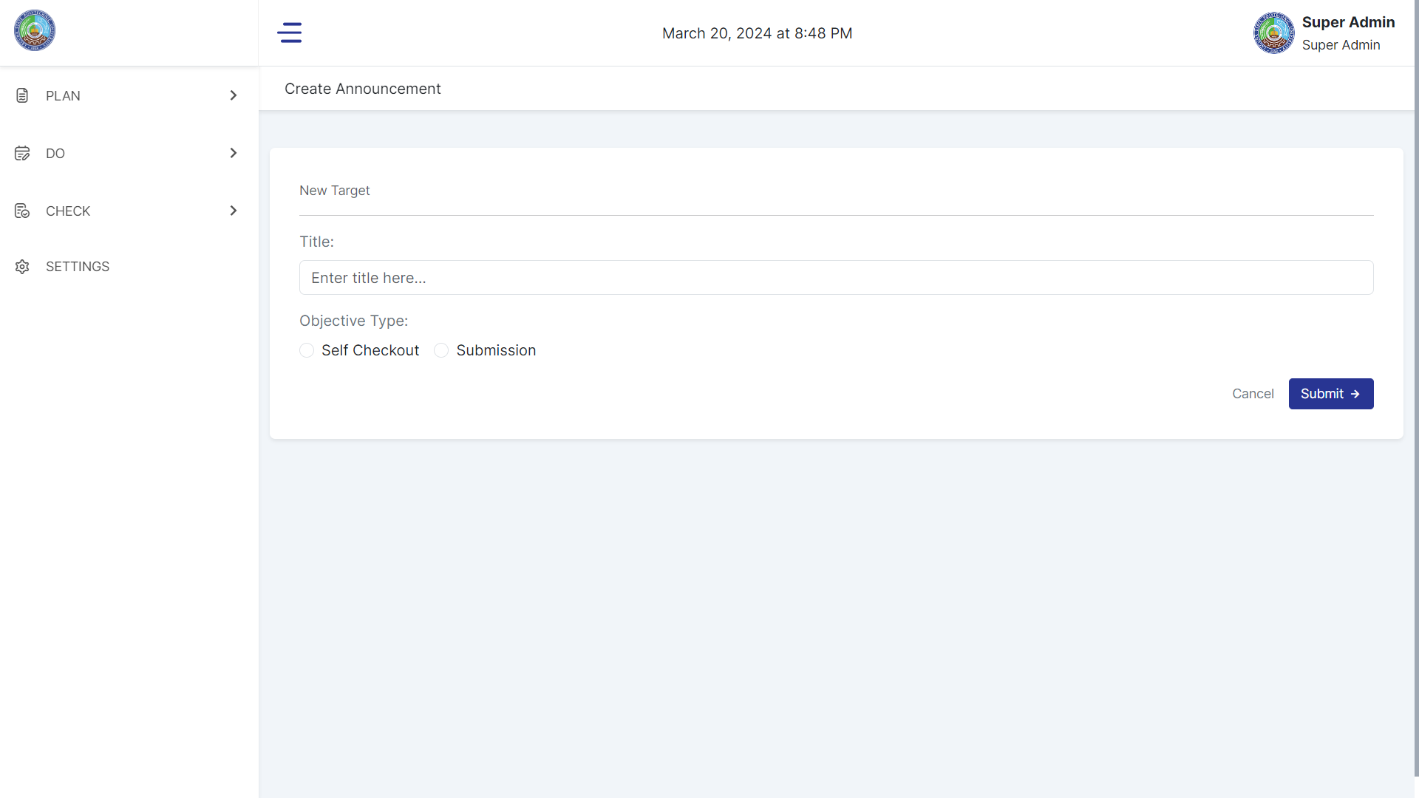

* The Super admin/Campus Admin will select office as dropdown to customized the specific “targets” per office.

|  |  |  |  |  |  |  |  |  |  |  |
| --- | --- | --- | --- | --- | --- | --- | --- | --- | --- | --- |
| **Targets** (Title) **Select Office** (Dropdown)  **Able to add the entry as button** (like submission bin page) * Manually enter the description per row as the “requirement” of Super Admin / Admin Campus para ideliver kay Unit Heads Dashboard itong mga dapat nilang checkan.   |  | | --- | | ☑ Provided the text target by super admin / campus admin, item number 1 | | ☑ Provided the text target by super admin / campus admin, item number 2 | | ☑ Provided the text target by super admin / campus admin, item number 3 | | ☑ Provided the text target by super admin / campus admin, item number 4 | | ☑ Provided the text target by super admin / campus admin, item number 5 | | ☑ Provided the text target by super admin / campus admin, item number 6 | | ☑ Provided the text target by super admin / campus admin, item number 7 | | ☑ Provided the text target by super admin / campus admin, item number 8 | | ☑ Provided the text target by super admin / campus admin, item number 9 | | ☑ Provided the text target by super admin / campus admin, item number 10 | |

**3.) SUPER ADMIN / CAMPUS ADMIN IN CHECK:  
  
CHECK**

* **Tracking**
* **For Reviewal**
* **For Targets**

|  |  |  |  |  |  |
| --- | --- | --- | --- | --- | --- |
| **ACTIVITIES / PROGRAMS** | **TARGETS** | **STATUS** | **OFFICES** | **CAMPUS** (will show the CAMPUS DESIGNATED if Campus Admin is logged-in) | **ACTION (Approve or Reject)** |
| Item 1: The office should attend 50% in that event Item 2: The office should attend 50% in that event Item 3: The office should attend 50% in that event | ☑ Entry 1  ☑ Entry 2  ☐ Entry 3  Progress: 66.67% | Not completed | GUIDANCE | SINILOAN |  |
| Item 1: Lorem Ipsum | ☑ Entry 1  Progress: 100% | Completed | SCHOLARSHIP | SINILOAN |  |
|  |  |  |  |  |  |
| End of row, the total offices approved reports will be counted as 11/22.  **Total Offices**: 22 **Approved Reports**: 10/22 with Progress bar  **Targets Completion Status Reports**: 50% with Progress bar | | | | |  |

**Unit Heads will receive the Targets via Dashboard as Shorcut (also will have the page in the Targets Page):**

* 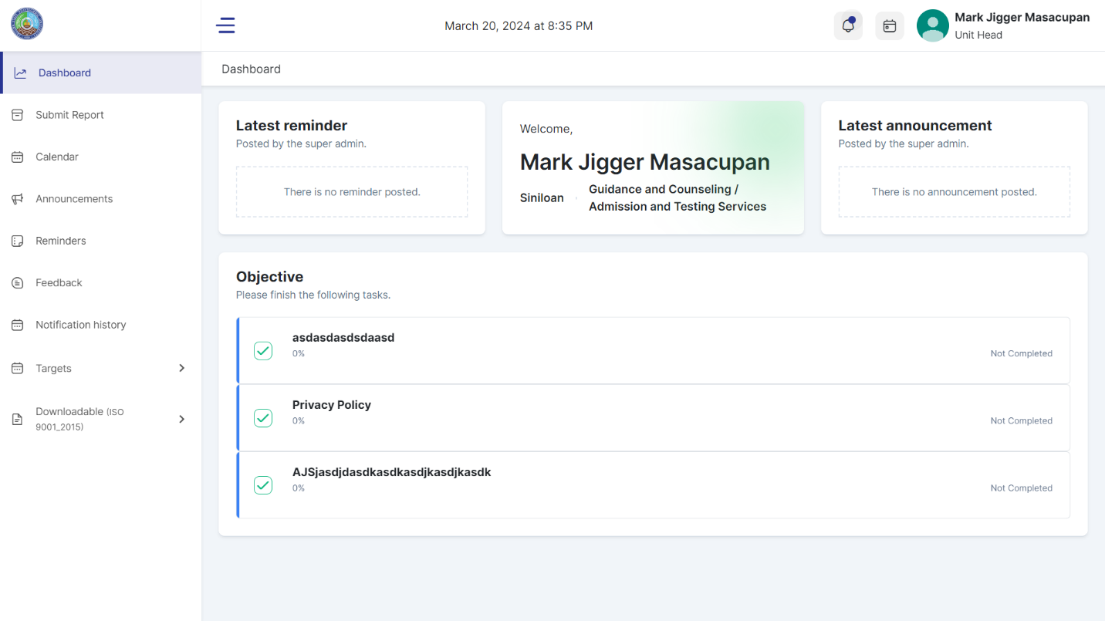Objective will be renamed as “To accomplish”, and the Unit Heads may able to manually clicked the checkbox as live and “Not Completed” will changed into “Completed” but with button (blue), + to remove the 0%.

**Example in the Office received the targets to accomplish:**

Title of Activities: Lorem Ipsum (Manually enter by Unit Heads)   
 ☑ Description item no. 1 [Completed]  
 ☑ Description item no. 1 [Completed]

**Notable:**

* If Campus Admin, will only display its designated Campus Admin.
* Campus Admin, will only count its Total Offices, Status, and Approved Reports.
* Legend status for the Progress counting:  
  * Guidance, ☑ Entry 1, ☑ Entry 2, ☑ Entry 3, Progress 100%  
  * Scholarship, ☑ Entry 1, ☑ Entry 2, ☑ Entry 3, Progress 60%  
  * Sports, ☑ Entry 1, ☑ Entry 2, ☑ Entry 3, Progress 40%  
    
  For visualization how the progress percentage works:

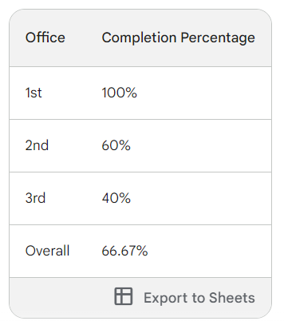

* If Super Admin, it will compute all offices in all campuses, while in Campus Admin, it will only compute its campuses.

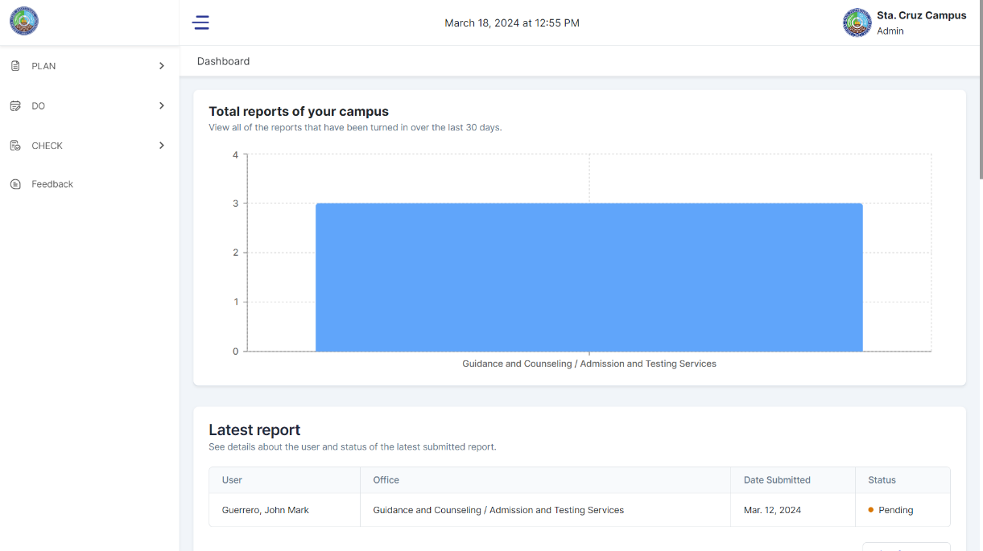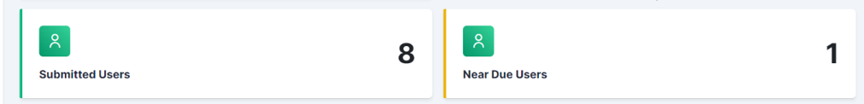* The computation will be featured in the Dashboard per box (Super Admin and Campus Admin according to its campus): - Box 1: Approved Reports: 10/22  
 - Box 2: Targets Completion Status Reports: 50%  
 - Position for both boxes: Above “Total Reports for your campus”.

4. **To modify the layout in Admin Campus Dashboard.**

* New Users will adjust the card to right until it aligns in Total Users
* 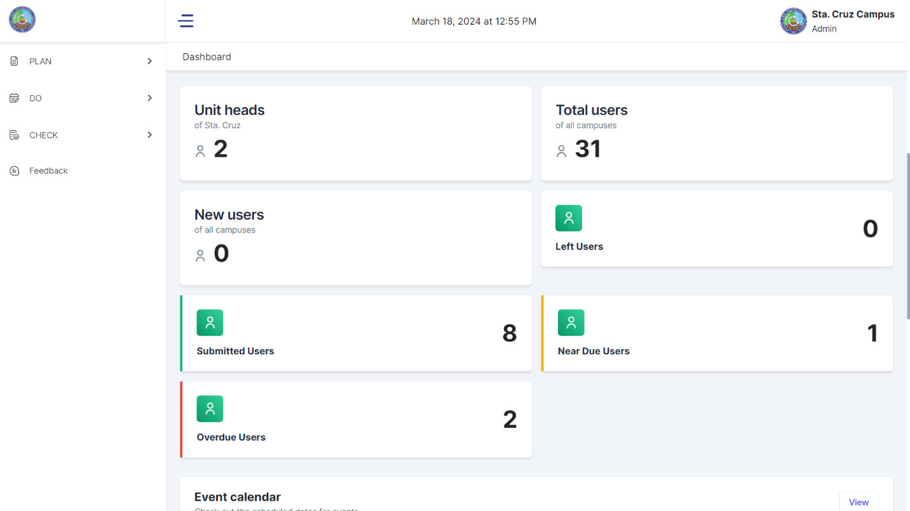Left Users Card will be positioned below and aligned as:  
   *Left Users, Submitted Users, Near Due Users and Overdue users*

**5.) Floating Rectangular box for everywhere:**

It is based on the “For Targets” tabular:  
* Total Offices: 22  
* Approved Reports: 10/22 with Progress bar  
* Targets Completion Status Reports: 50% with Progress bar

**Notable:**

*\* If Super Admin: it will compute all offices in all campuses, while in Campus Admin, it will only compute its campuses.*