## **Chapter Overview**

This chapter introduces our project, including a definition to the problem which we have identified in modern day recruitment, through our study of the domain and background to the problem, which has been elaborated on in Section 1.2.2. Afterwards, the chapter defines the aim of our project, features and scope of our system scope of our system. We also define the Research Gap which includes data science component in detail of our project.

## **1.2 Project Background**

### **1.2.1. Background to the problem**

Diabetes, which was once considered a disease of the developed world, has become a worldwide pandemic, with two thirds of the global diabetic population living in the developing countries. Sri Lanka is among the countries with the highest diabetes prevalence rates in the world. This chart represents the number of patients that has increased since 2000-2016 in Sri Lanka.

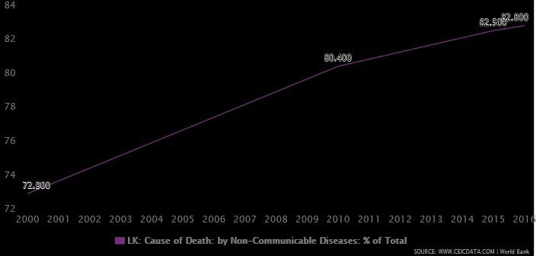

Figure1:Couse of death because of diabetes

There are different types of diabetes, mainly Type 1 Diabetes, Type 2 Diabetes, Gestational Diabetes. Diabetes is a group of diseases in which the body does not produce enough or any insulin, does not properly use the insulin that is produced or exhibits a combination of both.

When any of these things happens, the body is unable to get sugar from the blood into the cells. That leads to high blood sugar levels. According to what we have planned is basically there will be an application to make it more useful for people, through the application we will be creating an own account for the beginners, and after having an own personal account we will be checking through specific data set which we will be including to the application.

Mainly except type 1 diabetes we get all these several data fact to use in our own data base to have an accurate result for the user. It is no use for checking type 1 diabetes because it always happens because of genetics. Here what we are highly considering is type 2 diabetes and gestational diabetes. The main goal is to keep blood glucose levels within your target range. our application will let you know the level of our diabetes, by following the exact details you may control your blood glucose levels.

And mainly in our application we show the result to the users after they enter their correct details. likewise, we will display the result as,

* If the user is currently suffering from diabetes, the application finally shows how much is the percentage the user is having diabetes and what time the user will have a critical situation if he/she will not change his/her current habits or lifestyle.
* If not, if the user doesn’t currently suffer from diabetes or didn't have diabetes in the past according to his/her current details we will ensure that whether he/she will have or not have a percentage of diabetes in present and future.
* Or according to the user's details if he/she is fully cured we will show that status as well.

By building up this main problem like daily businessmen’s they do not even have time to care about their health by spending in hospitals, through an app like this they could easily answer the questions through the application and get their diabetes level.

By getting the information through the app they can schedule a doctor visit if not they might waste their time. In the meanwhile people thinks this won’t be worthy because people can check their own diabetes level at home with a glucometer ,but the truth is every person doesn’tcarry a glucometer at all the time , because of that the app will be more useful for every person instantly .And another solution for money is, we do not cost from anyone by getting information and by providing the result through the application and, we fully ensure to keep users details privacy. And anytime you can recheck your status to see whether it has improved or not.