**Practical 3**

**Question1**

1. Create a new Android Application Project and giving a name called Practical3A.

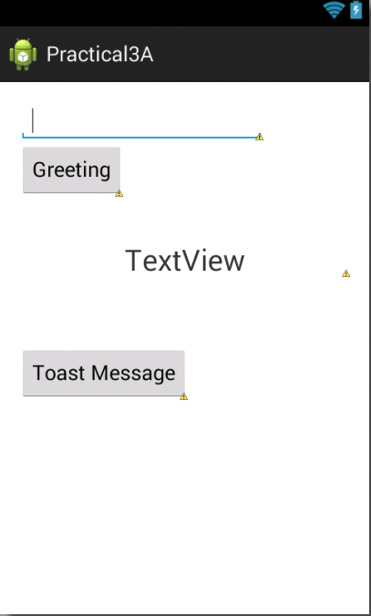

1. In the /layout directory, open the activity_main.xml and design the interface as above using graphical layout or edit the xml file. If you choose to edit the xml file, you may refer to the following code. You should make sure that the proper function onClick(), and onClick1() assigned to the related button.

<RelativeLayout xmlns:android=*"http://schemas.android.com/apk/res/android"*

xmlns:tools=*"http://schemas.android.com/tools"*

android:layout_width=*"match_parent"*

android:layout_height=*"match_parent"*

android:paddingBottom=*"@dimen/activity_vertical_margin"*

android:paddingLeft=*"@dimen/activity_horizontal_margin"*

android:paddingRight=*"@dimen/activity_horizontal_margin"*

android:paddingTop=*"@dimen/activity_vertical_margin"*

tools:context=*"com.example.practical3a.MainActivity"* >

<EditText

android:id=*"@+id/main_input"*

android:layout_width=*"wrap_content"*

android:layout_height=*"wrap_content"*

android:layout_alignParentLeft=*"true"*

android:layout_alignParentTop=*"true"*

android:ems=*"10"* >

<requestFocus />

</EditText>

<Button

android:id=*"@+id/start_button"*

android:layout_width=*"wrap_content"*

android:layout_height=*"wrap_content"*

android:layout_alignParentLeft=*"true"*

android:layout_below=*"@+id/main_input"*

android:onClick=*"onClick"*

android:text=*"Greeting"* />

<Button

android:id=*"@+id/button1"*

android:layout_width=*"wrap_content"*

android:layout_height=*"wrap_content"*

android:layout_above=*"@+id/textView1"*

android:layout_marginLeft=*"22dp"*

android:layout_toRightOf=*"@+id/start_button"*

android:onClick=*"onClick1"*

android:text=*"Toast Message"* />

<TextView

android:id=*"@+id/textView1"*

android:layout_width=*"fill_parent"*

android:layout_height=*"wrap_content"*

android:layout_alignRight=*"@+id/button1"*

android:layout_below=*"@+id/start_button"*

android:layout_marginTop=*"62dp"*

android:gravity=*"center"*

android:text=*"TextView"*

android:textSize=*"25sp"* />

</RelativeLayout>

1. In the **MainActivity.java**, you should perform the following coding in order to apply the function of onClick().

package com.example.practical3a;

import android.support.v7.app.ActionBarActivity;

import android.os.Bundle;

import android.view.Menu;

import android.view.MenuItem;

import android.view.View;

import android.widget.Button;

import android.widget.EditText;

import android.widget.TextView;

import android.widget.Toast;

public class MainActivity extends ActionBarActivity {

Button mButton;

EditText mEdit;

TextView mText;

@Override

protected void onCreate(Bundle savedInstanceState) {

super.onCreate(savedInstanceState);

setContentView(R.layout.activity_main);

mButton = (Button)findViewById(R.id.start_button);

mButton.setOnClickListener(new View.OnClickListener() {

public void onClick(View view) {

mEdit = (EditText)findViewById(R.id.main_input);

mText = (TextView)findViewById(R.id.textView1);

mText.setText("Welcome to Android, "+mEdit.getText().toString()+"!");

}

});

}

@Override

public boolean onCreateOptionsMenu(Menu menu) {

// Inflate the menu; this adds items to the action bar if it is present.

getMenuInflater().inflate(R.menu.main, menu);

return true;

}

@Override

public boolean onOptionsItemSelected(MenuItem item) {

// Handle action bar item clicks here. The action bar will

// automatically handle clicks on the Home/Up button, so long

// as you specify a parent activity in AndroidManifest.xml.

int id = item.getItemId();

if (id == R.id.action_settings) {

return true;

}

return super.onOptionsItemSelected(item);

}

public void onClick1(View view)

{

String s2=getResources().getString(R.string.app_name);

Toast.makeText(this,mEdit.getText().toString(), Toast.LENGTH_LONG).show();

}

}

1. After make sure all the coding appropriate done, you may compile and run your coding .

**Question 2(Change Text Color using radio button)**

1. Create a new Android Application Project and giving a name called Practical3B.
2. By using the **GraphicalbLayout** editor or **xml file**, create the similar designed interface as shown in the following diagram.

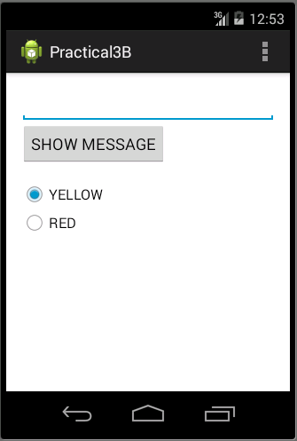

1. In this question, you should create a EditText, a button and also TWO radio button. You should provide the suitable name for all the components created.
2. Below show the activity_main.xml file.

<RelativeLayout xmlns:android=*"http://schemas.android.com/apk/res/android"*

xmlns:tools=*"http://schemas.android.com/tools"*

android:layout_width=*"match_parent"*

android:layout_height=*"match_parent"*

android:paddingBottom=*"@dimen/activity_vertical_margin"*

android:paddingLeft=*"@dimen/activity_horizontal_margin"*

android:paddingRight=*"@dimen/activity_horizontal_margin"*

android:paddingTop=*"@dimen/activity_vertical_margin"*

tools:context=*"com.example.practical3b.MainActivity"* >

<EditText

android:id=*"@+id/input1"*

android:layout_width=*"fill_parent"*

android:layout_height=*"wrap_content"*

android:layout_alignParentLeft=*"true"*

android:layout_alignParentTop=*"true"*

android:ems=*"10"* >

<requestFocus />

</EditText>

<Button

android:id=*"@+id/show_button"*

android:layout_width=*"wrap_content"*

android:layout_height=*"wrap_content"*

android:layout_alignLeft=*"@+id/input1"*

android:layout_below=*"@+id/input1"*

android:text=*"SHOW MESSAGE"* />

<RadioGroup

android:id=*"@+id/orientation"*

android:layout_width=*"wrap_content"*

android:layout_height=*"wrap_content"*

android:layout_alignLeft=*"@+id/show_button"*

android:layout_below=*"@+id/show_button"*

android:layout_marginTop=*"17dp"* >

<RadioButton

android:id=*"@+id/yellow"*

android:layout_width=*"wrap_content"*

android:layout_height=*"wrap_content"*

android:checked=*"true"*

android:text=*"YELLOW"* />

<RadioButton

android:id=*"@+id/red"*

android:layout_width=*"wrap_content"*

android:layout_height=*"wrap_content"*

android:text=*"RED"* />

</RadioGroup>

<TextView

android:id=*"@+id/textView1"*

android:layout_width=*"fill_parent"*

android:layout_height=*"wrap_content"*

android:layout_alignLeft=*"@+id/orientation"*

android:layout_below=*"@+id/orientation"*

android:layout_marginLeft=*"20dp"*

android:layout_marginTop=*"86dp"*

android:text=*"TextView"*

android:textSize=*"20sp"* />

</RelativeLayout>

1. Now, you should then modify your MainActivity.java.

**package** com.example.practical3b;

**import** com.example.practical3b.R;

**import** android.support.v7.app.ActionBarActivity;

**import** android.graphics.Color;

**import** android.os.Bundle;

**import** android.view.Menu;

**import** android.view.MenuItem;

**import** android.view.View;

**import** android.view.animation.AnimationUtils;

**import** android.view.animation.RotateAnimation;

**import** android.widget.Button;

**import** android.widget.EditText;

**import** android.widget.LinearLayout;

**import** android.widget.RadioGroup;

**import** android.widget.RelativeLayout;

**import** android.widget.TextView;

**public** **class** MainActivity **extends** ActionBarActivity {

EditText mEdit;

TextView mText;

Button mButton;

@Override

**protected** **void** onCreate(Bundle savedInstanceState) {

**super**.onCreate(savedInstanceState);

setContentView(R.layout.***activity_main***);

RadioGroup group1 = (RadioGroup) findViewById(R.id.***orientation***);

mButton = (Button)findViewById(R.id.***show_button***);

mButton.setOnClickListener(**new** View.OnClickListener() {

**public** **void** onClick(View view) {

mEdit = (EditText)findViewById(R.id.***input1***);

mText = (TextView)findViewById(R.id.***textView1***);

mText.setText(mEdit.getText().toString());

}

});

group1.setOnCheckedChangeListener(**new** RadioGroup.OnCheckedChangeListener() {

@Override

**public** **void** onCheckedChanged(RadioGroup group, **int** checkedId) {

**switch** (checkedId) {

**case** R.id.***yellow***:

mText.setTextColor(Color.***YELLOW***);

**break**;

**case** R.id.***red***:

mText.setTextColor(Color.***RED***);

**break**;

}

}

});

}

@Override

**public** **boolean** onCreateOptionsMenu(Menu menu) {

// Inflate the menu; this adds items to the action bar if it is present.

getMenuInflater().inflate(R.menu.***main***, menu);

**return** **true**;

}

@Override

**public** **boolean** onOptionsItemSelected(MenuItem item) {

// Handle action bar item clicks here. The action bar will

// automatically handle clicks on the Home/Up button, so long

// as you specify a parent activity in AndroidManifest.xml.

**int** id = item.getItemId();

**if** (id == R.id.***action_settings***) {

**return** **true**;

}

**return** **super**.onOptionsItemSelected(item);

}

}

1. After make sure all the coding appropriate done, you may compile and run your coding .

**Exercise**

**Question3**

Base on the understanding from question 1 and 2, create the following apps.

1. Create an app to perform the temperature conversion. User will enter the reading in EditText and by using radio buttons, user can convert between Celsius and Fahrenheit. Following is the functions which might be used to calculate the conversion.

**public** **static** **float** convertFahrenheitToCelsius(**float** fahrenheit) {

**return** ((fahrenheit - 32) * 5 / 9);

}

**public** **static** **float** convertCelsiusToFahrenheit(**float** celsius) {

**return** ((celsius * 9) / 5) + 32;

}

1. Create your icon instead of using ic_launcher.
2. Sample interface as below:

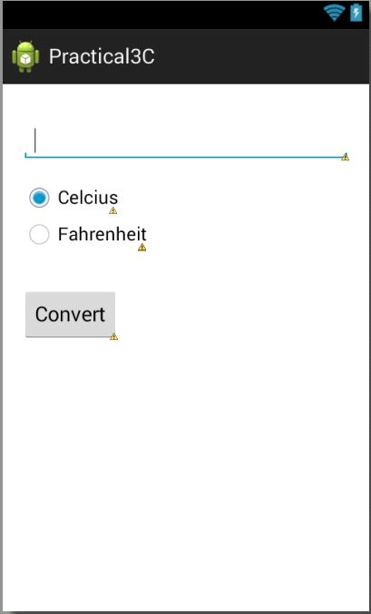

**Question 4**

1. Create an app to perform result checking. User will enter the reading (Only number) in EditText and by clicking on the CHECK button, result of the score will be shown. If the reading is MORE than 50, the “Pass” should be displayed, else “Fail” displayed. You should also set the text color to RED and size to 25sp.
2. Create your icon instead of using ic_launcher.
3. Sample interface shown as below:

