Practical 8

- Create the following GUI. You do not have to provide any functionality. You should consider using different types of Layout Manager and JPanel.
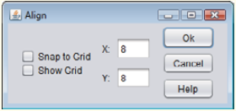

- Create the following GUI. You do not have to provide any functionality. You should consider using different types of Layout Manager and JPanel.
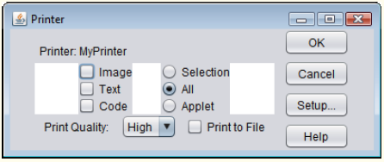

- Create a GUI application to do greeting to the user. This application should allow user to enter their name and then the name should be displayed in the GUI application with greeting. Hints: use setFont()
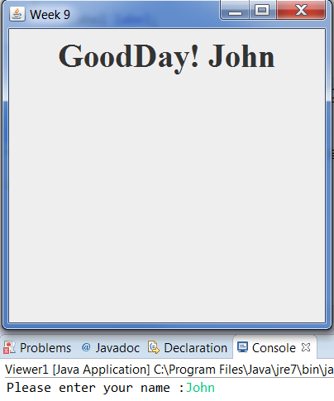

- Write a GUI application that converts Celsius temperature to Fahrenheit temperatures. The user should be able to enter a Celsius temperature, click a button and then see the equivalent Fahrenheit temperature. Use the following formula to make the conversion:
F=9/5C+32
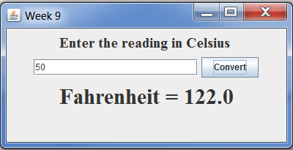

- Write a GUI application that calculates a car’s gas mileage. The application should let the user enter the number of gallons of gas the car holds and the number of miles it can be driven on a full tank. When a Calculate MPG button is clicked, the application should display the number of miles that the car may be driven per gallon of gas. Use the following formula to calculate MPG.

Miles
MPG= Gallons

- Create a GUI application where the user enters the wholesale cost of an item and its markup percentage into text fields. (For example, if an item’s wholesale cost is $5 and its markup percentage is 100 percent, then its retail price is $10.) The application should have a button that displays the item’s retail price when clicked.

- Write a program that prompts the user for an integer, using JOptionPane, and then draws as many rectangles at random positions, random color and random dimension as the user requested.

- Create an application to change the color of the rectangle shape. In this application, you should provide 3 radio buttons which represents RED,GREEN,BLUE. When user click the radio button and click on the change button, the color of the rectangle should be changed.

