Practical 7
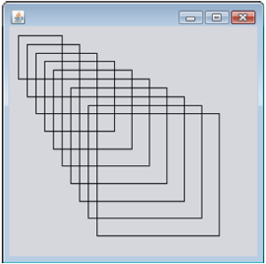

Question 1
Write an application that uses Rectangle object to draw a series of rectangle as above.

Question 2
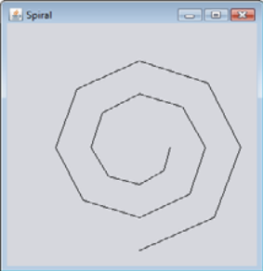

Write an application that uses Graphics method drawPolyline to draw a spiral similar to the one shown above.

Question 3
Write an application to draw random lines, in random colors and random line thicknesses. Use Line2D.Double and method draw of class Graphics2D to draw lines.
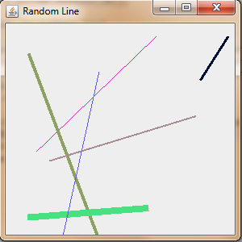

Question 4
Write an application to draw rectangle, in random size, random thickness, random location and random colors. Use Rectangle class to create rectangle object and method draw of class Graphics2D to draw rectangle.
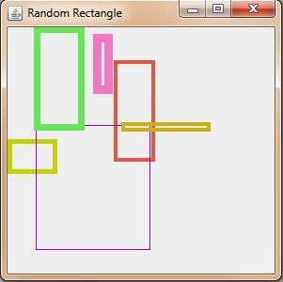

Question 5
Write an application that asks the user to input the radius of a circle as a floating point number and draws the circle, as well as the values of the circle’s diameter, circumference and area. Use the value Math.PI for π. Use the following formulas:
Diameter= 2r
Circumference = 2πr
Area=πr
The user should also be prompted for a set of coordinates in addition to radius. Then draw the circle, and display its diameter, circumference and area, using an Ellipse2D.Double object to represent the circle and method draw of class Graphics2D to display it. Use drawString() method to display the diameter, circumference and area of the circle.
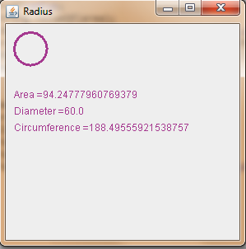

Question 6
Write an application that allows the user to select a shape from a JComboBox and draws it 20 times with random locations and dimensions in method paintComponent. The first item in the JComboBox should be the default shape that is displayed the first time paintComponent is called.
Question 7
Modify the solution from Question 4 to draw each of the 20 randomly sized shapes in a randomly selected color.
Question 8
Write an application to simulate a screen saver. The application should randomly draw lines using method drawLine of class Graphics. After drawing 100 lines, the application should clear itself and start drawing lines again. To allow the program to draw continuously, place a call to repaint as the last line in method paintComponent.

