**Object-oriented Programming using Java 2015**

**Homework 1**

**Title :** **Knight’s Tour**

**Due Date:** **Week 9** (during practical class)

**Description :**

Mathematician Euler proposed a solution for **Knight’s Tour** problem in 1759. Knight’s Tour problem is a chess exercise where a player attempt to make move for Knight piece around the chess board and visit each of the square on the chess board without repetition. The knight makes only “L”-shaped moves (two spaces in one direction and one space in a perpendicular direction).

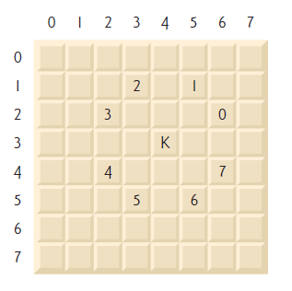

**Figure 1: Knight’s Tour game**

As shown in Figure 1, from a square near the middle of an empty chessboard, the knight (labeled K) can make eight different moves (numbered 0 through 7).

By referring to the example of Knight’s Tour of 3X3 as shown below, the upper left corner used as starting point for the tour. The numbers displayed in the table representing the order of the visit. The center square is impossible for a Knight to reach for board size of 3X3.

|  |  |  |
| --- | --- | --- |
| 1 | 6 | 3 |
| 4 |  | 8 |
| 7 | 2 | 5 |

One of the popular algorithms used to solve the Knight’s Tour is **Warnsdorff’s algorithm**. **Pseudocode** of Warnsdorff’s algorithm as below:

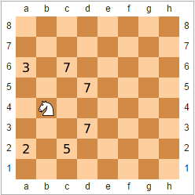

**Pseudocode**

1. Set P to be a random initial position on the board
2. Mark the board at P with the move number "1"
3. For each move number from 2 to the number of squares on the board,
   1. let S be the set of positions accessible from the input position
   2. set P to be the position in S with minimum accessibility
   3. mark the board at P with the current move number
4. Return the marked board -- each square will be marked with the move number on which it is visited.

**Requirements :**

In this homework, you are required to create an application that can play the Knight’s Tour automatically or allow the user to play the game. You should fulfill the following requirements:

1. Create an application using Java.
2. Create a Knight’s Tour board in the following size. User should have the option to choose the size of the board.
   1. 3 X 3
   2. 5 X 5
   3. 8 X 8
3. Starting point of the game should be random.
4. Your program should provide **TWO** mode:
   1. **Computer**

In the computer mode, you should implement the **Warnsdorff’s algorithm** and shows one of the possible solutions of the Knight’s Tour.

* 1. **User**

In the user mode, you should allow user to play the Knight’s Tour and tell user if any of the movement is invalid (repeated). If there is no more available move, you should return the number of successful movement from user.

1. You should use **ONLY String toString()** method to represent the board.