**Q1:**

Users are required to enter two float variables a and b using the key board (STDIN).

Please check the following conditions.

* If a is greater than b then print: float a > b
* If a is less than or equal to b then print: float a <= b

Below is an example of how the program will run:

Enter the value 5.0 for ‘a’ and the value 4.0 for ‘b’

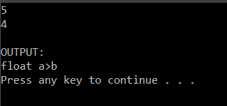

**Q2:**

Users are required to enter non-negative integer variables n using the keyboard (STDIN).

The system displays the product of all even numnbers that are greater than or equal to 2 and smaller than or equal to half of n.

Below is an example of how the program will run when entering the value of 9 for ‘n’:

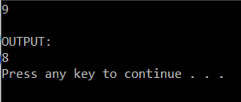

**Q3:**

Your program allows users to enter 5 float numbers.

The system displays the entered numbers in descending order.

Below is an example of how the program will run:

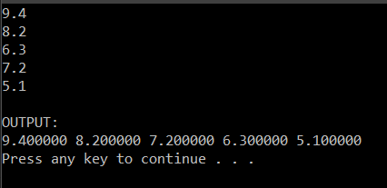

**Q4:**

Your program allows users to enter an integer number n.

The system displays an inverted right triangle with the height = n.

Below is an example of how the program will run:

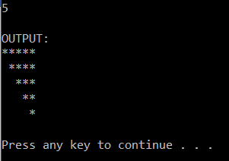

**Q5:**

Your program allows users to enter array of n integers, where n is entered by the user (n should be kept as a small value, in this case, n <= 10). Your program should then print the sum of squared of each even integer.

Hint: It is possible to use int* array = (int*)malloc(sizeof(int)*n) to create a dynamic array

Below is an example:

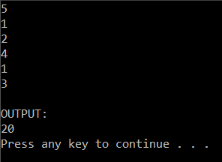

**Q6:**

Yours progarm allows users enter a long string ‘o’ and a short string ‘p’. The system finds the occurrences of ‘p’ in ‘o’ and replaces them by the reversed of ‘p’. It then prints out the modified string ‘o’.

Below is an example:

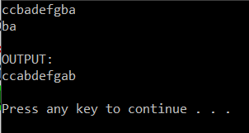

**Q7:**

Your program should allow users to find the two-digit number(s) that appear(s) the most in the array of 7 integers. Then your program should print out the found two-digit numbers.

Below are some examples to show how the program works:

|  |  |  |
| --- | --- | --- |
| There is only one most appearing two-digit number | There is no two-digit number | There are more than one most appearing two-digit numbers |

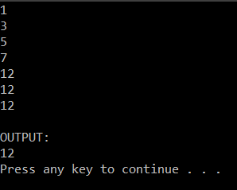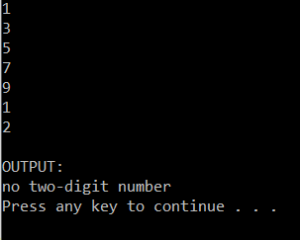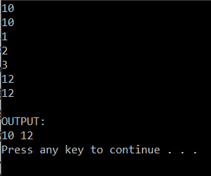

**Q8:**

Your program should allow users to enter a character, then it should display the location of that character in the ASCII table and its octal format.

Example:

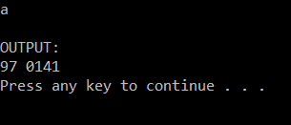

**Q9:**

Your program should allow users to enter an integer numnber ‘n’, then it should display the sum of all the digits forming ‘n’.

Example:

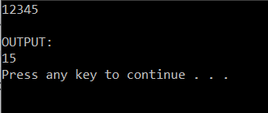

**Q10:**

Your program should allow users to enter an integer number ‘n’, then it should display as follows.

If ‘n’ is prime number, displays: Not Prime

If ‘n’ is not prime number, displays: Prime

