The Value of location: What Matters Most for Older Adults Considering Relocation in Sweden?
Nick Christieª, Björn Slaugª, Magnus Zingmark^{abc}, Jonas Björk^{de}, and Susanne Iwarssonª

ªDepartment of Health Sciences, Faculty of Medicine, Lund University, Lund, Sweden; ^{b}Health and Social Care Administration, Municipality of Östersund, Östersund, ^{c}Community Medicine and Rehabilitation, Umeå University, Umeå, Sweden;
^{d}Clinical Studies Sweden, Forum South, Skåne University Hospital, Lund, Sweden;
^{e}Division of Occupational and Environmental Medicine, Lund University, Lund, Sweden

For correspondence, please contact Nick Christie, nick.christie@med.lu.se

Nick Christie, PhD, is a postdoctoral researcher and research engineer at Lund University. His research bridges health sciences and economics, focusing on housing, urban planning, and ageing, with particular attention to relocation patterns among older adults.
Björn Slaug, PhD, is an Associate Professor of Health Sciences at Lund University and a member of the at the Centre for Ageing and Supportive Environments (CASE) and the profile area Proactive Ageing. His research focuses on the built environment and how it can be adapted to support active and healthy ageing.
Magnus Zingmark, PhD, is an Associate Professor in Occupational Therapy and affiliated researcher at Epidemiology and Global Health, Umeå University. His work focuses on health promotion, falls prevention, and re-ablement for older adults, and he leads R&D for active and healthy ageing in the Municipality of Östersund.
Jonas Björk, PhD, is a Professor of Epidemiology at Lund University. His research focuses on sociodemographic differences in health and wellbeing, using population-based data, and he contributes to developing infrastructure for population research and public health surveillance.
Susanne Iwarsson, PhD, is Professor of Gerontology and Care for Older Adults at Lund University and Doctor Honoris Causa at Riga Stradins University, Latvia. Her research in environmental gerontology focuses on ageing, health, housing, and participation. She was the founding Coordinator of the Centre for Ageing and Supportive Environments (CASE) and the profile area Proactive Ageing, and is Coordinator of the Swedish National Graduate School on Ageing and Health (SWEAH).

Research Aim (variations on a theme) | - To explore willingness-to-pay estimates of preferred locational attributes for older individuals in Sweden considering relocation.  - Explore heterogeneity in locational preferences for older individuals in Sweden considering relocation.  - To identify differences in willingness to pay estimates among older individuals considering relocation in Sweden.
Journals | - Housing studies – Have published a handful of studies using a DCE. Good candidate  - Journal of housing and the built environment. (latex) Good candidate https://link.springer.com/journal/10901  - Nature Ageing – appears to be rooted in medical science (DNA sequences, biological indicators, etc). No DCE studies identified. Low candidate  - Lancet – No DCE studies found – low candidate  - Others?
Methodological approach | - Estimate mixed logit models on Renters and Owners to identify MWTP estimates  - Extend these models to include interaction terms which facilitate identifying differences across age, gender, and health.
Methodological considerations | - Our primary focus is on tenure groups. We could shift this to another group – age groups perhaps – to move the focus of the paper.  - The heterogenous tests identify some significant differences, but they are not very strong (if not relying on delta method significance). Exploring alternative groups could produce stronger results. (retired, civil status, city center vs urban environment, etc)  - Alternatively, estimation of latent class models would be feasible, although we would have to alter the text and aim as we sought to uncover sources of heterogeneity.
Other considerations | - Convert SEK to Euro for international audience?  - Tables - We decided that separate tables for MWTP values would be desirable, yet for the interaction models this would result in sparse coefficient tables – only showing the coefficients. The interaction tables include coefficients, MRS, and MWTP for renters and owners at this point, but this can be changed if we find a better way to present them.  - Add full sample test results in addition to renters/owners?  - In conducting the DCE, we programmed the experiment to be adaptive, utilizing each respondent’s “Planned future housing cost” value to calculate the relative prices in addition to the presented percentage change. For example, if a respondent stated 10,000 in planned costs, a price option would display: “Option #2 10% more than planned costs (11000 SEK/month total )” It is unclear if this would be advantageous to incorporate into the methodology.

The Value of location: What Matters Most for Older Adults Considering Relocation in Sweden?
We examined heterogeneity in housing preferences among older adults in Sweden using discrete choice experiment data (n = 957; mean age = 72; 55.3% women). Respondents assessed trade-offs between key residential attributes, including proximity to shops and services, green spaces, access to public transportation, dedicated parking, and planned monthly expenses. We estimate mixed logit models to recover marginal willingness to pay estimates for each attribute, including interactions with age, gender, and health to capture systematic variation in preferences. We identified meaningful differences between homeowners and renters with homeowners generally willing to pay up to two times more for housing attributes. Differences between gender and tenure status were also identified, reflecting underlying patterns of social inequality in later life. These findings contribute policy-relevant evidence to support the development of age-inclusive housing strategies that address both diverse preferences and structural disparities in residential choice.
Keywords: stated choice; discrete choice; ageing in place; housing; housing preferences

Introduction
Population ageing is reshaping housing markets and welfare systems across much of the developed world. By 2050, the number of people aged 65 years or older is projected to more than double from 2021 levels, rising to 1.6 billion individuals globally (United Nations Department of Economic and Social Affairs, 2023). As the proportion of older adults continues to rise, policymakers face growing challenges in ensuring that housing and neighborhoods support autonomy, accessibility, and wellbeing in later life. Although most older adults prefer to age in place, remaining in familiar environments rather than relocating to institutional care (Wiles et al., 2012; Abramsson & Andersson, 2015), life-course events and declining physical capacity often necessitate or motivate residential change. Understanding how older individuals evaluate potential relocation alternatives is therefore essential for developing effective, age-inclusive housing strategies.
Population ageing is also shaping the future demand for housing in terms of both quantity and suitability. Older adults spend a greater share of their time at home and rely heavily on their residential environment for daily functioning, social contact, and wellbeing (De Jong et al., 2022). The concept of ageing in place has become central to housing policy in many places across the world, emphasising the desire of older adults to remain in familiar surroundings for as long as possible (Grimmer et al., 2015). However, a key pillar of ageing in place depends on the suitability of existing housing and the availability of accessible alternatives when relocation becomes necessary.
Relocation decisions in later life are shaped by a complex interplay of personal, social, and environmental factors (Roy et al., 2018). At older ages, maintaining a dwelling may become burdensome, while multi-level homes or inaccessible layouts may no longer fit changing functional abilities (Ewen et al., 2014). The departure of children or the loss of a partner can alter household needs and attachment to place (Abramsson & Andersson, 2012) while reduced mobility and increased social integration alter expectations of relocation (Robison & Moen, 2000). As the dwelling is typically the greatest source of household’s net worth, financial considerations, including the desire to release housing equity or lower housing costs after retirement, may also encourage relocation (Clark et al., 2006). Psychological factors such as loss aversion may further reinforce reluctance to move, as individuals weigh potential losses in comfort, familiarity, or community more heavily than prospective gains (Ossokina & Arentze, 2022). Nevertheless, relocation rates among older adults remain low, reflecting strong place attachment, social ties, and perceived risks associated with moving (Abramsson & Andersson, 2015).
When relocations do occur, they inevitably involve evaluating a range of neighbourhood and accessibility attributes that influence daily life. The residential environment affects not only physical mobility and independence but also opportunities for social contact and recreation. Older adults considering relocation must therefore weigh multiple trade-offs among desirable housing attributes. For instance, some may prioritise proximity to green areas, while others place greater value on access to public transport or nearby shops and services. However, little is known about what and how people prioritise among such attributes, and these preferences, along with their implicit trade-offs, are likely to vary systematically across socio-demographic groups. Despite growing recognition of these issues, empirical evidence on how older adults value specific residential attributes remains limited. Much of the literature has focused on life course transitions, housing tenure, and affordability (e.g. Damhuis & Van Gent, 2024; Lu & Kong, 2024) ,but relatively few studies quantify trade-offs among housing and locational characteristics.
One approach to quantify these preferences, a Discrete Choice Experiment (DCE), represents a specific and widely used form of stated choice methodology, enabling the assessment of important trade-offs individuals make. Respondents are presented with choice sets containing two or more alternatives that vary systematically across predefined attributes, and they select their preferred option in each set. The approach is rooted in random utility theory which assumes that individuals choose the alternative that maximizes their utility based on observable attributes and unobserved factors (McFadden, 1974). By observing patterns of choice across multiple scenarios, researchers can infer the relative importance of different attributes and estimate willingness to pay (WTP) values when a cost attribute is included. This capacity to quantify trade-offs makes DCEs particularly valuable in housing research, where individuals must balance multiple, often competing, considerations such as price, location, accessibility, and amenities.
Discrete choice experiments have been used in a variety of housing and ageing studies. Ossokina et al. (2020) estimate a stated choice experiment to study the residential preferences of older homeowners in the Netherlands, reporting that residential attributes connecting to safety and social cohesion play an important role for older adults. Ossokina and Arentze (2022) examine reference-dependent housing choice behavior among older adults, finding that proximity to public transport and shops significantly influences residential decisions. Applications of DCEs to housing have expanded considerably in recent decades. Early studies focused primarily on environmental amenities and locational factors, such as proximity to green spaces, transit, and urban services (Earnhart, 2002; Cho et al., 2005; Liao et al., 2015). More recent work has integrated socio-demographic and behavioral factors to explore heterogeneity in preferences across population subgroups. For example, Caplan et al. (2021) examined residential preferences along Utah's Wasatch Front and found substantial variation in willingness to pay for amenities such as green space and access to transit. Ossokina and Arentze (2022) demonstrated that housing decisions among older homeowners are reference-dependent, showing how individuals in the Netherlands value safety, accessibility, and social cohesion relative to their current housing situation. Similarly, Lee et al. (2025) analyzed willingness to pay for circular and affordable housing among younger adults in South Korea, while Ardeshiri et al. (2024) used a dual DCE to distinguish between preferences for owner-occupied and investment properties in Sydney.
Housing preferences are rarely uniform across individuals. Economic capacity, household composition, tenure status, and health conditions can all shape how people evaluate residential alternatives. Studies have shown that income influences willingness to pay for proximity and comfort amenities, while tenure reflects differences in security, attachment, and investment orientation (SOURCES). Ageing itself introduces new dimensions of heterogeneity, as physical ability, mobility, and social networks evolve over time (Lofqvist et al., 2013). To capture this systematic variation, recent housing studies have incorporated interaction terms and advanced econometric specifications (Caplan et al., 2021; Aitken et al., 2024; Schulz et al., 2025). Such methods are particularly suitable for studying diverse populations like older adults, whose housing preferences may differ systematically by age, health status, income, or tenure arrangement.
Despite these advances, the evidence base for older populations remains limited, and most findings are context specific, reflecting local housing systems and welfare regimes. Few studies have explicitly focused on older populations or systematically examined heterogeneity within this demographic, and applications in Scandinavian contexts remain rare. This gap is particularly consequential given the rapid ageing of populations across developed countries and the distinct housing systems that shape housing opportunities and constraints. Thus, there is a need to better understand how older people reason regarding housing and relocation and in this process, how different attributes are valued.
The aim of this study was to explore these residential trade-offs by examining willingness to pay values of key locational and amenity attributes of older adults in Sweden considering relocation, for both renters and homeowners. Using data on individuals aged 55 and older, a robust experimental design, and mixed logit modelling, we identify key determinants of housing preferences and quantify their associated willingness to pay values across diverse subgroups. Specifically, we examine how preferences for proximity to green areas, shops, public transport, and parking amenities vary systematically by age, gender, and tenure status among individuals actively considering relocation. In doing so, the study provides policy relevant insights into the housing needs of an ageing population and supports the planning of inclusive, adaptable living environments that promote independence and quality of life in later life.

Using data from a large-scale discrete choice experiment embedded in the Prospective RELOC-AGE project, we estimate mixed logit models to derive marginal willingness to pay (MWTP) measures for proximity to green space, shops, and public transport, as well as for access to dedicated parking. We further examine heterogeneity in preferences by age, gender, and health status to identify systematic variation in the valuation of these attributes. The study builds on recent stated choice housing studies (Ossokina et al., 2020; Caplan et al., 2021; Ossokina & Arentze, 2022; Aitken et al., 2024; Lee et al., 2025), extending discrete choice methods to a Scandinavian context where ageing-in-place policies are well established but evidence on relocation preferences remains limited. By linking relocation motivations to the economic valuation of locational factors, the study offers policy-relevant insights into the housing needs of an ageing population and contributes empirical evidence to guide the planning of inclusive, adaptable living environments that support independence and quality of life in later life.

Materials and Methods

Participants and data collection
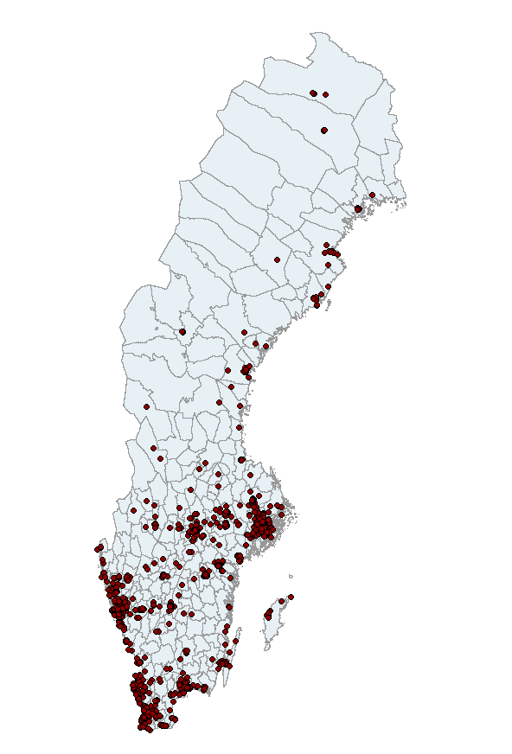
The primary objective of the ongoing Prospective RELOC-AGE project, a longitudinal two-tiered mixed-method cohort investigation conducted in Sweden, was to explore the long-term dynamics associated with housing choices, relocation, and active and healthy ageing, focusing on individuals across the ageing process. The project was registered under the identifier NCT04765696 on ClinicalTrials.gov (U.S. National Library of Medicine, 2021). At baseline (2021) eligible participants were individuals aged 55 or older, residing in Sweden, and actively registered with an interest in relocation with one of three housing companies: two local public housing providers and a national provider of tenant-owned dwellings. With over 200 questions in each survey setting, the Prospective RELOC-AGE provides a rich source of information, including a wide set of socio-demographic information.
Figure 1
Location of DCE participants (N = 957)
The DCE was administered in conjunction with the second follow-up survey administered during May to October 2024, where 1,247 respondents agreed to participate in the survey via a web-based platform. After the main survey was completed, respondents were asked to continue and take part in the optional DCE. Following the initial DCE administration, two reminder emails were sent out to encourage participation in the experiment. The first in September 2024, to the entire respondent group, and another reminder in October 2024, targeting only those who had not taken the experiment portion of the survey. The final sample size consisted of 957 individuals, representing a 73% response rate of follow-up respondents and representing a geographically diverse sample of individuals aged 55 and above across Sweden (see Figure 1).

Prior to administering the DCE, we conducted an internal review (n =20) and a pilot study to review the experiment (n = 56). The internal review involved researchers and staff within the research team’s network. The pilot study was administered to participants in the Stakeholder Pool, a network of individuals collaborating with academia and society in the areas of ageing and health, which has been established at the Centre for Ageing and Supportive Environments (CASE) at Lund University. In both phases, respondents completed the experiment and a structured feedback form assessing the relevance of attributes, clarity of wording and levels, and overall task comprehension and burden. Feedback was instrumental in refining the experiment and clarifying the descriptions and wording of the instructions. We made several informed revisions: clarifying attribute descriptions and levels; removing redundant instructional text; fine-tuning attribute levels; and reducing the number of choice sets to manage respondent burden.
The final DCE questionnaire included three parts: an introduction to the experiment while defining the attributes and levels, a short questionnaire on household income, costs, and planned future housing costs, and the actual experiment with nine choice sets.

Experiment design
Stated choice experiments encompass a range of techniques in which respondents indicate their preferences by explicitly stating their choices. In contrast to revealed choice experiments, where preferences are inferred from past behavior, stated choice methods allow for the evaluation of decisions in a controlled setting (Lancsar & Louviere, 2008) This controlled environment enables researchers to systematically manipulate attributes and isolate the impact of specific factors on decision-making (Hensher et al., 2015). A DCE is a type of stated choice model that presents individuals with hypothetical scenarios, allowing researchers to quantify how much value respondents place on different attributes of a product, service, or in our case, a housing option.
In our experiment, respondents were asked to choose the most desirable housing option from a set of alternatives containing varying levels of attributes. The choice of attributes and associated levels was guided by a combination of factors identified from the Prospective RELOC-AGE follow-up study and attributes identified in the housing literature. Green space proximity has been examined in numerous contexts including improved cardiometabolic and general health (Maas, 2006; Paquet et al., 2013), lower stress (Nielsen & Hansen, 2007), and improved mental health (Sturm & Cohen, 2014; Cohen-Cline et al., 2015). The attribute greenspace is defined as the distance in kilometers to green areas including parks, forests, hiking areas, and open spaces. Proximity to shops and services represents not only distance to frequent amenities which may become more burdensome to traverse with age but also constitutes an integral social experience to participate in the social life of communities (Lucas et al. 2016). The attribute shops represented the distance to shopping amenities such as grocery stores, malls, boutiques, and shopping centers. Access to public transportation has been shown to affect accessibility levels of populations, with significant differences identified in older cohorts (Alsnih & Hensher, 2003; Hildebrand, 2003; Ricciardi et al., 2015). The attribute transport was defined as the distance to public transportation, such as a bus stop, metro station, or train station. Parking availability may also affect acceptability, particularly for the Prospective RELOC-AGE sample where over 90% of respondents indicated access to an automobile. Table 1 presents the attributes with their corresponding levels.

Table 1
Attributes and their corresponding levels used in the experiment
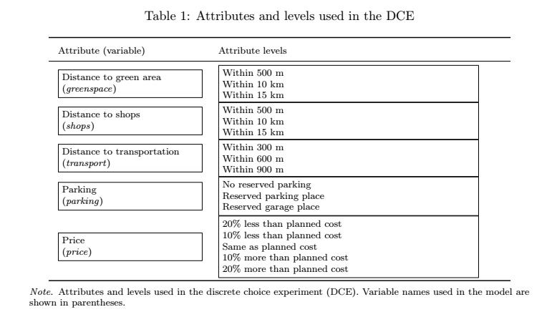

Before commencing the experiment, respondents were given a definition of each attribute, as well as an example to minimize any ambiguity in interpretation. Respondents were also instructed to base each choice on the assumption that the alternative housing options were identical in every way aside from the attributes presented. When designing the experiment, including every combination of attribute levels in the construction of the choice sets, a full factorial design, is often too large to be used in practice. To reduce the dimensionality of a full factorial design, a D-optimal subset was generated that reduces dimensionality while maintaining statistical power and balanced attribute representation (Lancsar & Louviere, 2008). Furthermore, the number of choice sets was limited to nine in order to minimize the cognitive burden of the DCE while maximizing the statistical power of our tests (DeShazo & Fermo, 2002; Mangham et al., 2009; Himmler et al., 2021). Figure 2 depicts a typical choice set presented to the respondents.
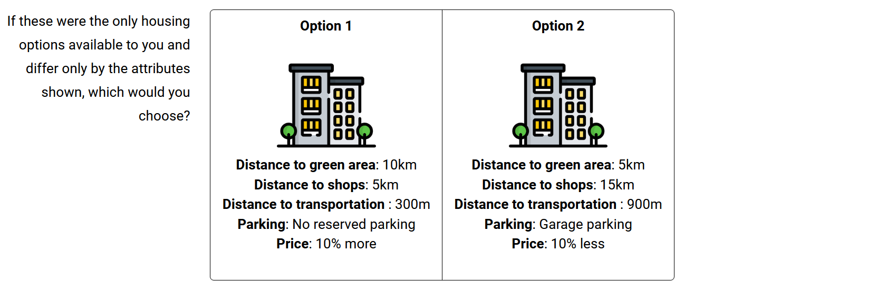
Figure 2
Example of choice set

Statistical analysis
Respondent’s choices were modelled within the random utility theory framework, which assumes individuals choose options which maximize their utility based upon available options (Lancsar & Louviere, 2008). An underlying utility model can then be estimated where the utility that individual i derives from alternative j in a choice set t is given by:

$$\begin{aligned}U_{itj}= V_{itj}+ ε_{itj} \#(1)\end{aligned}$$

where $V_{itj}$ is the systematic component of utility, modelled as a function of the attributes of the alternative, and $ε_{itj}$is an unobserved random error term. The systematic utility is specified as:

$$\begin{aligned}V_{itj}= β1X_{itj}+ β2X_{itj}+ … + βkX_{itjk}\#(2)\end{aligned}$$

where $X_{itjk}$represents the level of attribute k for alternative j in task t, and $βk$ are the corresponding utility coefficients to be estimated.
Under the multinomial logit (MNL) model, preferences are assumed to be homogeneous across respondents and the error terms $ε_{itj}$ are independently and identically distributed (i.i.d.). The probability that individual $i$ chooses alternative $j$ in task $t$ is then:

$$\begin{aligned}P_{itj}=\operatorname{Pr}\left(y_{it}=j\right)= \frac{\exp\left(V_{itj}\right)}{Σ_{l}\exp\left(V_{itj}\right)}\#(3)\end{aligned}$$

While MNL models are commonly used in choice modelling, they are not well suited to uncover heterogeneity in preferences, which is a central aim of our study. Recent housing studies address this limitation by allowing utility coefficients to vary across individuals or groups in their tests (Caplan et al., 2021; Zhao et al., 2023; Ardeshiri et al., 2024; Aitken et al., 2024; Lee et al., 2025). We followed this line of research and estimate mixed logit (ML) models, in which the utility coefficients βi are allowed to vary randomly across individuals to account for unobserved heterogeneity in preferences (McFadden & Train, 2000). Instead of assuming that all individuals share the same preference parameters, the mixed logit model allows each respondent to have their own vector of utility coefficients. These individual‐specific coefficients are treated as random draws from a population distribution with a mean vector $β$and a covariance matrix $Σ$. The mean vector represents the average preferences in the sample, while the covariance matrix captures the extent to which preferences vary across individuals and the degree to which these random parameters may be correlated with one another.
The mixed logit model captures heterogeneity by integrating over the distribution of random coefficients using simulated maximum likelihood

 | $$P_{itj}= \int{\frac{\exp\left(V_{itj}\left(β_{i}\right)\right)}{Σ_{l}\exp\left(V_{itj}\left(β_{i}\right)\right)}} f\left(β_{i }\right| β,Σ) dβ_{i}$$ | (4)

Because this integral has no closed-form solution, it was approximated using simulation. The simulated choice probability for an alternative is then obtained by averaging these draw-specific probabilities across all simulation draws. The log-likelihood function is constructed from these simulated probabilities by matching them to the alternatives actually chosen by each respondent across all choice tasks. This simulated log-likelihood is then maximized to recover the mean coefficients and covariance parameters of the mixed logit model. In our application, all non-monetary attributes were specified as random with normal distributions, while the price coefficient was fixed to ensure consistent derivation of willingness to pay measures. We also allowed the random parameters to be fully correlated, enabling the model to capture systematic relationships in preferences across attributes. Models were estimated in R using the logitr package (Helveston, 2023) using 1000 Sobol draws and multiple random starting values to ensure convergence to the global maximum (Train, 2003).
We then use our price coefficient to compute monetary trade-offs for non-cost attributes. First, we estimated marginal rate of substitution (MRS) for each attribute, where the MRS for attribute k was calculated as:
$$\begin{aligned}{MRS}_{k}= - \frac{{\hat{β}}_{k}}{{\hat{β}}_{price}}\#(5)\end{aligned}$$

Where $\hat{β}$ price is the estimated coefficient on the price attribute. To account for interaction terms with socio-demographic variables, the MRS for attribute k and individual characteristic z was calculated as:
$$\begin{aligned}{MRS}_{kz}= - \frac{{\hat{β}}_{k }+ {\hat{β}}_{k,z }}{{\hat{β}}_{price}+ {\hat{β}}_{price,z }}\#(6)\end{aligned}$$

We followed Caplan et al. (2021) in methodology when estimating willingness to pay values. As the cost attribute was specified as a percentage change from the respondent’s expected housing cost in 10 percent intervals, we converted marginal rates of substitution (MRS) into marginal willingness to pay (MWTP) in monetary terms by scaling with 10 percent of the mean reported monthly housing cost:
$$\begin{aligned}{MWTP}_{k} = {MRS }_{k}× 0.10 × Planned Cost\#(7)\end{aligned}$$

where Planned Cost denotes the mean of respondents’ stated planned monthly housing cost, captured in the DCE questionnaire. These MWTP estimates represent the amount, in SEK per month, that respondents are willing to pay for improvements in each housing attribute, relative to their planned future housing costs.
We first estimated mixed logit models separately for homeowners and renters to identify preference patterns across housing tenure. Positive (negative) coefficients indicate increases (decreases) in average utility relative to the reference level of each attribute. Reference levels were defined as the least preferred option, such that estimated coefficients are expected to be positive where improvements are valued.
Next, we estimated interaction models to examine whether preferences vary systematically across key socio-demographic characteristics: gender, age, and self-reported health. For each characteristic, a separate mixed logit model was estimated in which all attribute levels were interacted with an indicator variable for the relevant group. For example, in the gender model, a dummy variable equal to one for men was interacted with each attribute. In this specification, the main effects represent preferences for the reference group (women), while the interaction terms indicate how the preferences of the comparison group (men) deviate from those of the reference group. Analogous models were estimated for age, using a dummy equal to one for respondents above the sample median age, and for health, using a dummy equal to one for respondents reporting “good” or better health.
To aid interpretation, we converted the estimated coefficients into MWTP values using the approach described above. MWTP expresses the monetary value respondents place on marginal improvements in each attribute, relative to its reference level. For models including interactions, MWTP values were computed separately for each subgroup using the appropriate combination of main and interaction coefficients. These estimates provide an interpretable monetary metric for comparing preferences across socio-demographic groups.
To assess significance, we computed MRS confidence intervals using the delta method, allowing formal tests of whether MRS, and subsequent MWTP estimates, differ from zero (Wooldridge, 2010). As the MRS is based on a non-linear function of multiple estimated coefficients, the delta method is necessary as variance cannot be obtained directly from the model output. However, even when delta-method significance is reported, a conservative interpretation is warranted: if the coefficient (or combination of coefficients) generating an MWTP estimate is not statistically significant, then the corresponding MWTP should be viewed as an estimated trade-off rather than strict evidence of a robust preference. The delta method thus provides a consistent, statistically grounded basis for inference while maintaining the intuitive interpretability of MWTP values.

Ethics
The Prospective RELOC-AGE study was approved by the Swedish Ethical Review Authority (Dnr 2020–03457), in alignment with the Declaration of Helsinki and current national ethical regulations for research involving human participants. Potential participants received written information highlighting that participation was voluntary and that declining would not affect their access to housing options or public services. Informed consent was considered given upon the completion and return of the survey.

Results

Sample characteristics
Table 2 provides descriptive statistics for the study sample, disaggregated by housing tenure. Of the 957 respondents, 790 were homeowners and 167 were renters. The sample was slightly majority female (55.3%), with most participants aged 65–74 years (43.5%) followed by those aged 75+ (36.5%). Most respondents were partnered (60.6%), retired (77.1%), and lived in apartment or condominium housing (63.0%). Most had attained at least three years of university education (47.6%) and lived in city or town locations (62.2%). Most respondents described their health as “Good” or better (82%). Households predominantly consisted of one or two members (95.2%), with 3.8% reporting three or more. The mean monthly household income was 46,700 SEK, and the average planned monthly housing cost was 10,500 SEK.

Table 2 –Sample characteristics by tenure type (N = 790 for homeowners, N = 167 for renters)

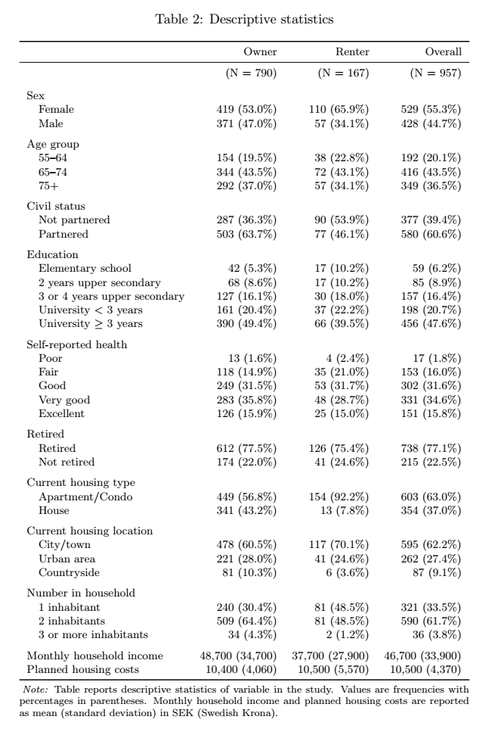

Standard model results
Table 3 presents the results from the standard mixed logit models estimated separately for renters and homeowners. Across both tenure groups, the estimated coefficients display the expected signs and are generally highly statistically significant. For all non-price attributes, the mean coefficients are positive, indicating that respondents systematically prefer locations with closer proximity to green areas, shops, and public transportation, as well as access to reserved parking, relative to their respective reference levels. The negative and significant price coefficient aligns with theoretical expectations, confirming that higher monthly housing costs reduce utility. The standard deviation estimates for many random parameters are statistically significant, which provides strong evidence of unobserved preference heterogeneity in the sample.
Table 3 – Mixed logit results: Renters and Owners
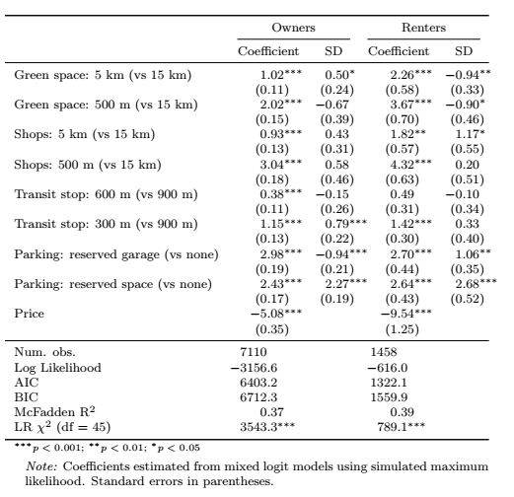
Monetary valuations derived from these coefficients are reported in Table 4. MRS are first computed as the ratio of each attribute coefficient to the price coefficient, which are then translated into MWTP estimates by scaling with 10 percent of each tenure group’s average planned housing cost per Equation 7. This yields interpretable monthly SEK values that quantify preference across the sample.

Table 4 – MWTP Estimates: Renters and Owners
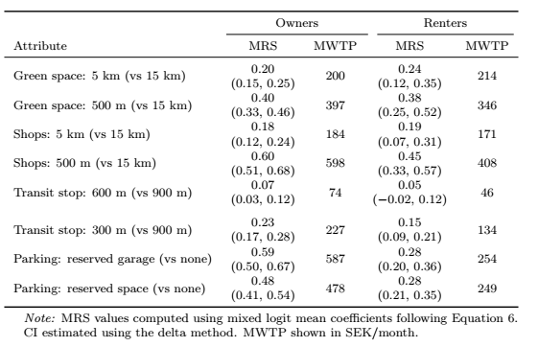
Among homeowners, the MWTP values indicate substantial willingness to pay for improved accessibility and amenities. For example, homeowners are willing to pay 397 SEK per month to avoid living 15 km from the nearest green area and 598 SEK per month to live within 500 meters of shops. Parking amenities are highly valued, with MWTP estimates of 587 SEK for a reserved parking space and 478 SEK for a reserved garage compared to no reserved parking.
Turning to renters, Table 4 reveals similar preference patterns but with generally lower MWTP magnitudes. Renters are willing to pay 346 SEK per month to reside within 500 m of green space and 408 SEK for proximity to shops within 500 meters. These values remain economically meaningful yet modestly below those of owners. Renters also show strong preferences for parking access, although their MWTP for a reserved garage (254 SEK) or space (249 SEK) is roughly half that of homeowners.

Heterogeneity model results

Age Models
Table 5 tabulates the mixed logit results which include age interactions with the attributes. Among homeowners below the median age of 72, proximity to amenities generates strong and statistically significant utility gains. The baseline MWTPs for younger respondents are 347 SEK a month for green space within 500 m (vs 15 km), 479 SEK for shops within 500 m, and 463 SEK for a reserved garage.
For homeowners aged 72 and older, we see a positive and significant Price x Age interaction term (1.51, p < 0.01) suggesting the older adults are less price sensitive when it comes to valuing attributes. Older homeowners demonstrate MWTP values for green space within 500 m of 350 SEK a month, lower than the younger baseline group.
In contrast, the coefficient Transit stop × Age+ is positive (0.50, p < 0.01), suggesting that the oldest homeowners place greater value on transit accessibility. Their MWTP for a 600 m transit stop is approximately 122 SEK a month, compared with 13 SEK for younger respondents. These results imply that while overall preference patterns are stable across age groups, the relative importance of green space and public transport accessibility shifts modestly among homeowners above median age.
Among renters under 72, MWTPs mirror those of homeowners in relative terms: 475 SEK for green space within 500 m, 475 SEK for shops within 500 m, and 243–263 SEK for parking amenities. We observe that older renters aged proximity to shops to a lesser extent than their younger counterpart with a MWTP of 381 SEK compared to 475 SEK. Other interactions, including those for green space, transit, and parking, are statistically insignificant, although delta method confidence intervals MWTP values remain positive, suggesting continued but more modest preferences for these amenities.
Both specifications demonstrate good fit. The homeowner model yields a log-likelihood of −3143.01 (McFadden R² = 0.36), and the renter model −623.13 (R² = 0.38). Likelihood-ratio tests reject the null of no interaction effects (p < 0.001 for both models), confirming that age heterogeneity contributes significantly to explaining observed choice behavior.

Table 5- Interaction Regression - Age
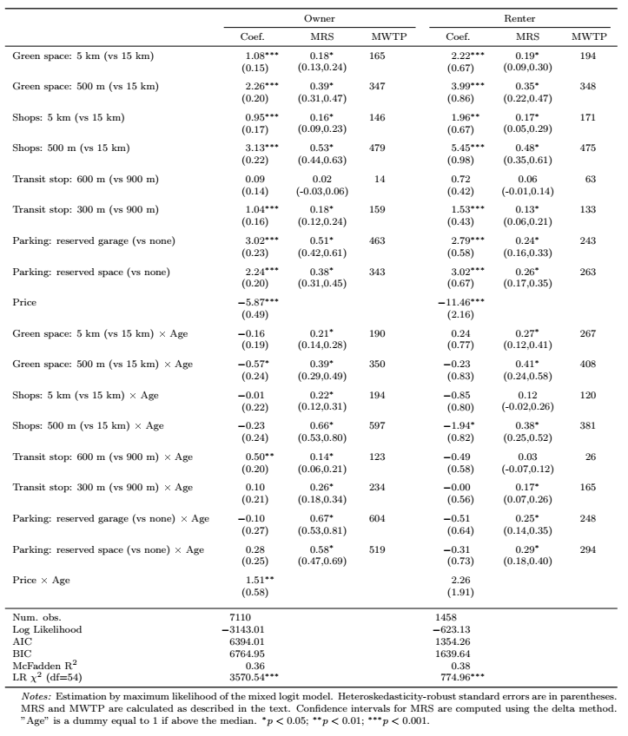

Gender models
As shown in Table 6, female homeowners show strong and statistically significant preferences for proximity-based amenities. The corresponding MWTPs are 478 SEK a month for green space within 500 m, 618 SEK for shops within 500 m, and 430–550 SEK for parking amenities. Male homeowners prioritize proximity to shops, with MWTP values 75 SEK greater than female homeowners. Parking availability is also prioritized by male homeowners, who demonstrate much stronger preferences for reserved parking facilities than women (518-624 SEK vs 430-550 SEK). Compared to female homeowners, males value proximity to green spaces to a lesser extent with a MWTP value of 313 SEK a month.
Among renters, coefficient estimates reveal no statistically significant gender interactions. The main effects for female renters indicate positive and significant preferences for proximity to green space and shops, with corresponding MWTPs of 324 and 366 SEK a month, respectively. Male renters’ coefficients are directionally similar, though MWP magnitudes are modestly higher (381 SEK for green space and 510 SEK for shops), indicating consistent but not statistically distinct preferences.
The results suggest that gender differences in housing preferences are limited in statistical terms, though systematic patterns are evident. Among homeowners, men show weaker preferences for green space but stronger preferences for shop proximity relative to women. Parking MWTPs are demonstratively higher for men while transit accessibility appears gender neutral. The consistency of results across tenure groups indicates that gendered patterns in housing choice are modest in magnitude, with significant variation only for specific amenity types.

Table 6 - Interaction Regression - Sex
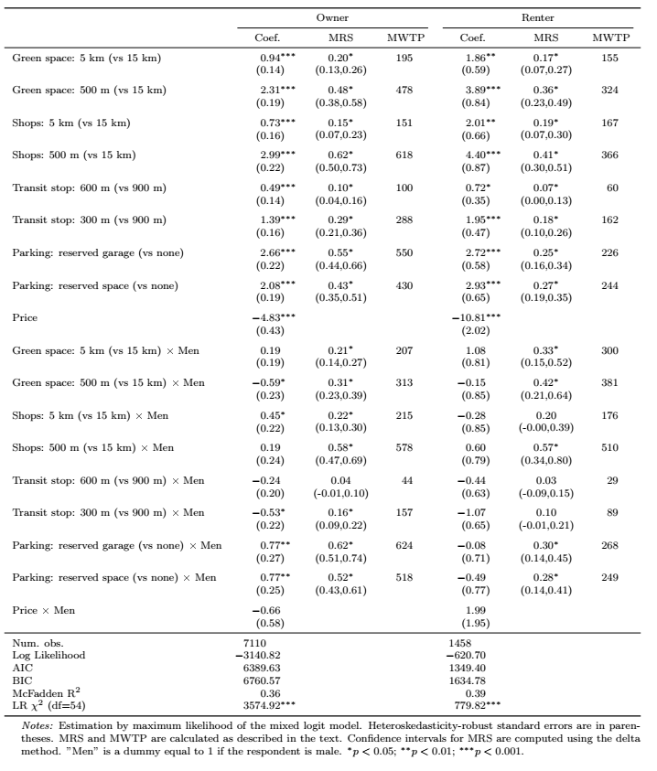

Health models
In Table 7, we present the results for tests including interactions terms of attributes and health (coded as 1 for "good" or better health; reference = fair/poor). For homeowners, those reporting good or better health place less importance on distance to transportation, expressing MWTP values that are about one third of those with fair/poor health (47 SEK vs 164 SEK). However, those reporting better health value proximity to green space to a greater extent, with MWTP values of 416 SEK a month compared to 293 SEK a month.
Among renters, lesser value is placed on proximity to transportation, with those in better health demonstrating MWTP values of 93 SEK compared to 252 SEK a month. Other interaction terms do not meet conventional measures of significance. Nonetheless, MWTPs suggest similar patterns: renters in good health exhibit somewhat higher valuations for green space, whereas those in poorer health show suppressed MWTP for transit stop proximity.

Table 7 - Interaction Regression - Health

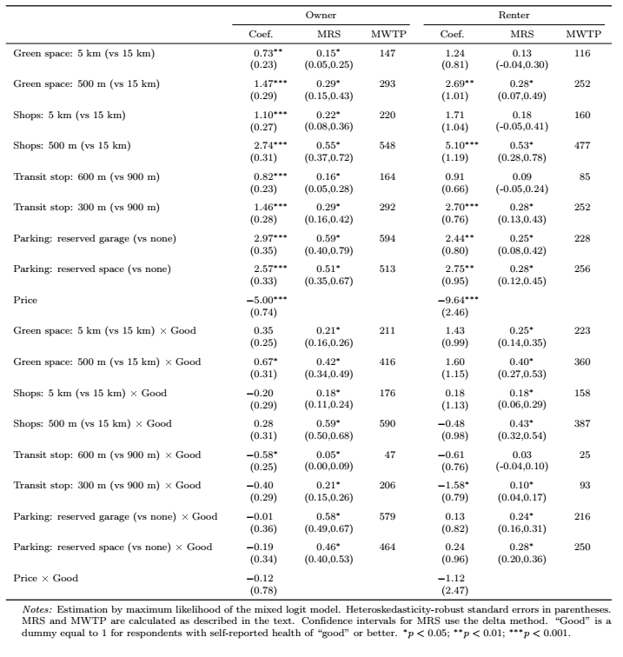

Discussion
This study provides new evidence on how older adults in Sweden value housing and neighbourhood attributes when considering relocation. Using a discrete choice experiment embedded in the RELOC-AGE project, we identify strong preferences for neighbourhood accessibility and reveal meaningful heterogeneity across tenure, age, gender, and health. The findings extend prior behavioural housing research by quantifying trade-offs older adults are willing to make, rather than relying on descriptive or revealed-preference approaches.
Across all subgroups, proximity to daily amenities, particularly shops, services, and green areas, is highly valued. Willingness to pay estimates for these attributes are substantial, confirming that neighbourhood accessibility is central to residential utility in later life. These results align with findings from the United States and the Netherlands (Caplan et al., 2021; Ossokina & Arentze, 2022), while contributing new evidence from a Scandinavian context where empirical valuation studies remain limited. Access to services and green space appears to function as essential infrastructure supporting independence, physical activity, and social participation rather than as optional amenities. Age-related differences in preferences are present but modest in magnitude. Among homeowners, older respondents place relatively greater value on proximity to public transport and slightly higher value on proximity to green space compared to younger counterparts. This shift is consistent with increasing reliance on public transport as driving ability declines, while the increased valuation of green space may reflect greater appreciation. Among renters, age-related interactions are weaker, with statistically significant differences observed primarily for proximity to shops. Overall, these findings suggest that ageing influences the relative importance of attributes rather than reversing underlying preference patterns.
Gender differences in housing preferences are limited and concentrated among homeowners. Male homeowners exhibit stronger preferences for parking amenities and proximity to shops, while female homeowners place relatively greater value on green space. Among renters, gender interactions are not statistically significant, and MWTP estimates are directionally similar across men and women. These results indicate that gendered patterns in housing preferences exist but are modest and attribute-specific, rather than systematic across all dimensions of residential choice.
Health status also shapes housing preferences in intuitive ways, though most interaction effects are not statistically strong. Respondents reporting fair or poor health place greater value on proximity to public transport, while those in better health exhibit higher valuations for green space. These patterns are consistent with differing mobility needs and opportunities for outdoor engagement. However, given the limited statistical significance of many interaction terms, these findings should be interpreted as indicative tendencies rather than definitive subgroup differences.
From a policy perspective, the results highlight the centrality of mobility and accessibility in later-life housing decisions. Both public and private transport access play a critical role in sustaining autonomy and independence, regardless of age, gender, or health. The slightly higher MWTP for green space among the oldest respondents suggests that access to nearby green areas remains valued in advanced old age, reinforcing the importance of maintaining such amenities within close reach of housing. Improving the accessibility and usability of green environments, through level pathways, seating, lighting, and safe crossings, may help ensure that the health and wellbeing benefits of green space remain available across the ageing spectrum.
In comparison with previous studies, our findings align closely with evidence from the Netherlands showing strong preferences for proximity to shops and public transport among older adults (Ossokina & Arentze, 2022). The present study extends this literature by incorporating both renters and homeowners within a Scandinavian welfare context and by focusing on individuals actively considering relocation. This strengthens the behavioral relevance of the results and addresses an important gap in the existing evidence base.

Limitations
Several limitations warrant consideration. First, the study sample comprises individuals already registered for relocation services. Although this can be viewed as a strength, since these individuals are actively considering relocation and may therefore give more thoughtful responses to hypothetical housing choices, they may differ from the broader older population in terms of motivation or socioeconomic characteristics. In addition, the sample is skewed toward higher levels of educational attainment, which limits the generalizability of the findings. The attribute set focuses primarily on locational factors and does not capture dwelling-level characteristics such as size, accessibility, or interior adaptability. Moreover, the monetary estimates are context-specific and may vary across housing markets. Finally, the cross-sectional design precludes an assessment of how preferences evolve over time. Future research would benefit from longitudinal and mixed-method approaches to better capture how changes in health, financial, and social circumstances shape residential choices.

Conclusion
This study demonstrates that neighborhood accessibility is a central determinant of housing choice among older adults in Sweden. Proximity to shops, services, green space, public transport, and parking consistently increases residential utility, though the relative importance of these attributes varies systematically by age, gender, health, and tenure. Older adults are far from a homogeneous group: while younger cohorts prioritize amenity-rich environments, the oldest respondents place greater emphasis on mobility autonomy and comfort-related features such as parking access.
The persistence of strong preferences for both public and private mobility challenges simplified assumptions about transport needs in later life. Rather than substituting one mode for another, older adults appear to maintain mixed mobility strategies that evolve with health, geography, and personal circumstances. At the same time, income gradients in willingness to pay highlight the risk that market mechanisms may exacerbate spatial inequality, limiting access to supportive neighborhoods for lower-income older adults.
For policymakers and planners, the findings reinforce the importance of integrating housing, transport, and land-use planning. Age-friendly housing strategies should prioritize neighborhood context alongside dwelling design, ensuring that accessible housing is located within reasonable distances of essential services and green spaces. At the same time, policies must preserve affordability and tenure diversity in high-amenity locations to avoid reinforcing socioeconomic segregation in later life.
Beyond its substantive findings, the study illustrates the value of discrete choice methods for analyzing housing decisions among ageing populations. By quantifying trade-offs and heterogeneity, the approach provides actionable evidence to support more inclusive, flexible, and equitable housing strategies. As Sweden’s population continues to age, recognizing and planning for the diversity of later-life housing preferences will be essential for promoting independence, wellbeing, and social inclusion.

References
Abramsson, M., & Andersson, E. K. (2012). Residential Mobility Patterns of Elderly—Leaving the House for an Apartment. Housing Studies, 27(5), 582–604. https://doi.org/10.1080/02673037.2012.697553
Abramsson, M., & Andersson, E. K. (2015). Changing locations: Central or peripheral moves of seniors? Journal of Housing and the Built Environment, 30(4), 535–551. https://doi.org/10.1007/s10901-014-9427-0
Aitken, D., Willis, K., & Gilroy, R. (2024). Do older homebuyers prefer dwellings with accessibility and adaptability features? Findings from an exploratory study. Housing Studies, 39(3), 608–630. https://doi.org/10.1080/02673037.2022.2060944
Alsnih, R., & Hensher, D. A. (2003). The mobility and accessibility expectations of seniors in an aging population. Transportation Research Part A: Policy and Practice, 37(10), 903–916. https://doi.org/10.1016/S0965-8564(03)00073-9
Ardeshiri, A., Washington, L., Vij, A., Leishman, C., & Beer, A. (2024). Housing preferences for owner-occupied versus investment properties in Sydney, Australia. Housing Studies, 0(0), 1–23. https://doi.org/10.1080/02673037.2024.2428749
Caplan, A. J., Akhundjanov, S. B., & Toll, K. (2021). Measuring heterogeneous preferences for residential amenities. Regional Science and Urban Economics, 87, 103646. https://doi.org/10.1016/j.regsciurbeco.2021.103646
Clark, W., Deurloo, M., & Dieleman, F. (2006). Residential Mobility and Neighbourhood Outcomes. Housing Studies, 21(3), 323–342. https://doi.org/10.1080/02673030600585946
Cohen-Cline, H., Turkheimer, E., & Duncan, G. E. (2015). Access to green space, physical activity and mental health: A twin study. Journal of Epidemiology and Community Health, 69(6), 523–529. https://doi.org/10.1136/jech-2014-204667
Damhuis, R., & Van Gent, W. (2024). The period effects of crisis and recovery on life course and residential mobility of owner-occupants. Housing Studies, 39(4), 1066–1086. https://doi.org/10.1080/02673037.2022.2101626
De Jong, P., Rouwendal, J., & Brouwer, A. (2022). Staying put out of choice or constraint? The residential choice behaviour of Dutch older adults. Population, Space and Place, 28(4), e2553. https://doi.org/10.1002/psp.2553
DeShazo, J. R., & Fermo, G. (2002). Designing Choice Sets for Stated Preference Methods: The Effects of Complexity on Choice Consistency. Journal of Environmental Economics and Management, 44(1), 123–143. https://doi.org/10.1006/jeem.2001.1199
Ewen, H. H., Hahn, S. J., Erickson, M. A., & Krout, J. A. (2014). Aging in Place or Relocation? Plans of Community-Dwelling Older Adults. Journal of Housing for the Elderly, 28(3), 288–309. sih. https://doi.org/10.1080/02763893.2014.930366
Grimmer, K., Foot, J., Pastakia, K., & Kay, D. (2015). Consumer views about aging-in-place. Clinical Interventions in Aging, 1803. https://doi.org/10.2147/CIA.S90672
Helveston, J. P. (2023). logitr: Fast Estimation of Multinomial and Mixed Logit Models with Preference Space and Willingness-to-Pay Space Utility Parameterizations. Journal of Statistical Software, 105(10). https://doi.org/10.18637/jss.v105.i10
Hensher, D. A., Rose, J. M., & Greene, W. H. (2015). Applied Choice Analysis (2nd ed.). Cambridge University Press. https://doi.org/10.1017/CBO9781316136232
Hildebrand, E. D. (2003). Dimensions in elderly travel behaviour: A simplified activity-based model using lifestyle clusters.
Himmler, S., Soekhai, V., van Exel, J., & Brouwer, W. (2021). What works better for preference elicitation among older people? Cognitive burden of discrete choice experiment and case 2 best-worst scaling in an online setting. Journal of Choice Modelling, 38, 100265. https://doi.org/10.1016/j.jocm.2020.100265
Lancsar, E., & Louviere, J. (2008). Conducting Discrete Choice Experiments to Inform Healthcare Decision Making: A User??s Guide. PharmacoEconomics, 26(8), 661–677. https://doi.org/10.2165/00019053-200826080-00004
Lee, P.-H., Han, Q., de Vries, B., & Juan, Y.-K. (2025). Heterogeneities in willingness to pay for circular affordable housing: Insight from young users. Housing Studies, 40(11), 2450–2480. https://doi.org/10.1080/02673037.2024.2404063
Lofqvist, C., Granbom, M., Himmelsbach, I., Iwarsson, S., Oswald, F., & Haak, M. (2013). Voices on Relocation and Aging in Place in Very Old Age—A Complex and Ambivalent Matter. The Gerontologist, 53(6), 919–927. https://doi.org/10.1093/geront/gnt034
Lu, P., & Kong, D. (2024). Community-Based Residential Relocation in Middle and Older Age: A United States–China Comparison Study on Its Predictors and Associated Mortality Risk. Journal of Aging and Health, 08982643241276270. https://doi.org/10.1177/08982643241276270
Maas, J. (2006). Green space, urbanity, and health: How strong is the relation? Journal of Epidemiology & Community Health, 60(7), 587–592. https://doi.org/10.1136/jech.2005.043125
Mangham, L. J., Hanson, K., & McPake, B. (2009). How to do (or not to do) … Designing a discrete choice experiment for application in a low-income country. Health Policy and Planning, 24(2), 151–158. https://doi.org/10.1093/heapol/czn047
McFadden, D. (1974). The measurement of urban travel demand. Journal of Public Economics, 3(4), 303–328. https://doi.org/10.1016/0047-2727(74)90003-6
McFadden, D., & Train, K. (2000). Mixed MNL models for discrete response. Journal of Applied Econometrics, 15(5), 447–470. https://doi.org/10.1002/1099-1255(200009/10)15:5<447::AID-JAE570>3.0.CO;2-1
Nielsen, T. S., & Hansen, K. B. (2007). Do green areas affect health? Results from a Danish survey on the use of green areas and health indicators. Health & Place, 13(4), 839–850. https://doi.org/10.1016/j.healthplace.2007.02.001
Ossokina, I. V., & Arentze, T. A. (2022). Reference-dependent housing choice behaviour: Why are older people reluctant to move? Housing Studies, 1–19. https://doi.org/10.1080/02673037.2022.2151984
Ossokina, I. V., Arentze, T. A., Van Gameren, D., & Van Den Heuvel, D. (2020). Best living concepts for elderly homeowners: Combining a stated choice experiment with architectural design. Journal of Housing and the Built Environment, 35(3), 847–865. https://doi.org/10.1007/s10901-019-09716-5
Paquet, C., Orschulok, T. P., Coffee, N. T., Howard, N. J., Hugo, G., Taylor, A. W., Adams, R. J., & Daniel, M. (2013). Are accessibility and characteristics of public open spaces associated with a better cardiometabolic health? Landscape and Urban Planning, 118, 70–78. https://doi.org/10.1016/j.landurbplan.2012.11.011
Ricciardi, A. M., Xia, J., & Currie, G. (2015). Exploring public transport equity between separate disadvantaged cohorts: A case study in Perth, Australia. Journal of Transport Geography, 43, 111–122. https://doi.org/10.1016/j.jtrangeo.2015.01.011
Robison, J. T., & Moen, P. (2000). A Life-Course Perspective on Housing Expectations and Shifts in Late Midlife. Research on Aging, 22(5), 499–532. https://doi.org/10.1177/0164027500225003
Roy, N., Dubé, R., Després, C., Freitas, A., & Légaré, F. (2018). Choosing between staying at home or moving: A systematic review of factors influencing housing decisions among frail older adults. PLOS ONE, 13(1), e0189266. https://doi.org/10.1371/journal.pone.0189266
Schulz, M., Gross, C., & Teti, A. (2025). Owning, Renting and Environmental Proactivity: The Role of Housing Tenure in Hypothetical Housing Decisions.
Sturm, R., & Cohen, D. (2014). Proximity to Urban Parks and Mental Health.
Train, K. (Ed.). (2003). Discrete choice methods with simulation. Cambridge University Press.
United Nations Department of Economic and Social Affairs. (2023). World Social Report 2023: Leaving No One Behind in an Ageing World. United Nations. https://doi.org/10.18356/9789210019682
Wiles, J. L., Leibing, A., Guberman, N., Reeve, J., & Allen, R. E. S. (2012). The Meaning of “Aging in Place” to Older People. The Gerontologist, 52(3), 357–366. https://doi.org/10.1093/geront/gnr098
Wooldridge, J. M. (2010). Econometric Analysis of Cross Section and Panel Data, second edition. MIT Press.
Zhao, L., Szajnfarber, Z., Broniatowski, D., & Helveston, J. P. (2023). Using conjoint analysis to incorporate heterogeneous preferences into multimodal transit trip simulations. Systems Engineering, 26(4), 438–448. https://doi.org/10.1002/sys.21670

