# Abstract

This study examines heterogenous preferences for housing attributes among older individuals who have registered for housing relocation agencies across Sweden. We conduct a discrete choice experiment leveraging socio-demographic data to control for a diverse set of factors, which in turn allows the identification of characteristics contributing to heterogeneity in housing preferences. Implementing a percentage-based housing attribute in our choice experiment, we obtain measures of marginal willingness to pay estimates for the various attributes in our study. We find that preferences for housing preferences vary across [men and women, renters and homeowners, age…], with older individuals generally willing to pay more for these amenities. Our results provide urban planners and discison makers monetary measures for a diverse sample of the nations older residents.

# Introduction

# Ageing in place

# Methodology

The DCE we report is part of a larger longitudinal survey from the RELOC-AGE project on relocation preferences. The survey has provided us with large samples of responses and a rich source of socio-demographic variables that can be used as controls enabling us to account for a variety of factors contributing to differences in locational preferences among our sample.

Rational in choosing the DCE as a methodology

Utility theory

## Experiment design sample and data

Prospective RELOC-AGE presentation

The finalized experiment was conducted in conjunction with the Prospective RELOC-AGE follow up survey where 957 out of 1295 respondents participated in the experiment.

## [Insert map of respondents]

Development of the experiment was conducted in three steps. First, A prototype DCE was developed which incorporated key attributes from the Prospective RELOC-AGE project. This prototype was trialed among 50 researchers and aids asking for specific feedback on the number of attributes, the complexity of the design, and the relevancy of attributes when choosing a home. After reviewing the feedback, two attributes were removed and the number of choice sets was increased from six to nine. Second, the revised experiment was piloted among participants of Lund University’s Intresspoolen (present what the intresspoolen is). The experiment was conducted utilizing the Formr framework with the majority of indivuals utilizing their mobile phones to take the survey. After taking the experiment, individuals where asked to answer a series of questions relating to the experiment.

Discuss changes made. Fatigue bias – answering too many questions.

Respondednts were first asked to report their household income, current housing costs, and planed housing costs in a monthly basis.

Respondents were presented with descriptions of the attributes and levels to minimize any misinterpretation of the attributes. For example, distance to transportation was described as “Transportation refers to the nearest bus stop, metro station, railway station. The distance is expressed in meters and estimated time to walk there.”

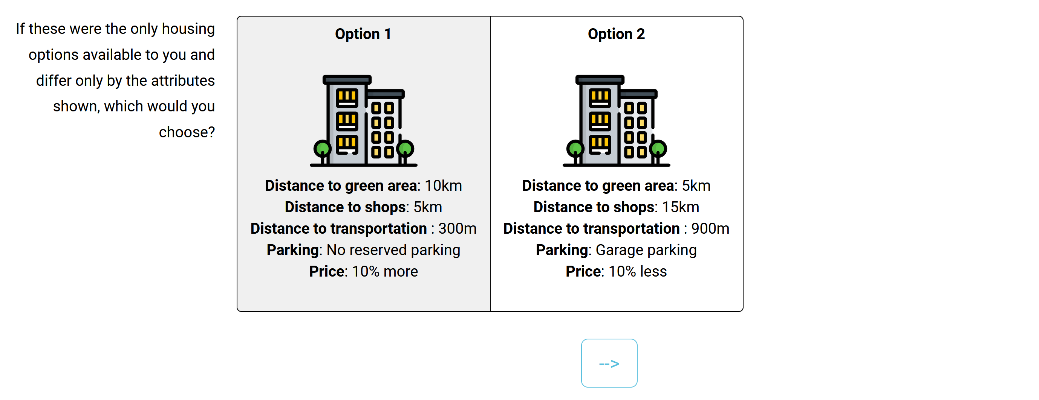

Figure 1 - Example choice set

# Results

Our discussion begins with results from our baseline model where no interaction terms with socio-demographic variables are included in the model. This baseline model provides estimates which are refined in subsequent test to account for heterogeneity among various household types.

Table X presents the results from the baseline model. Here a positive(negative) sign for a particular attribute indicates a increase(decrease) in the average utility lever for that attribute compared to its reference level. We present coefficient estimates for the multinomial model in column one, and estimates from the MXL model in column two. Results from both models are presented for comparison purposes

## Sample

## [Insert Descriptive Data Table]

Willingness to pay

Discussion

This study investigated preferences of older individuals wishing to relocate in Sweden. To our knowledge, it is the first study to explore locational housing preferences using a discrete choice experiment in Sweden. T

The study makes a number of contributions. First, the results highlight the importance of locataional attributes among

Our experiment was designed to elictit residential preferences for housing characteristics, in particular for: distance to green areas, distance to shops and ammenitieas, distance to transportation, and parking availability. Characterisics were chosen based on answers from the larger Perspective RELOC_AGE and fine tuned after feedback from two pilot studies. Monthly cost was incorporated into the experiment by first asking resondents to state their planned monthly expenditure, then incorporating percenagtage changes based on this amount into the experimetn.