DATABASE DESIGN DOCUMENT
The GRID — MoMo SMS Analytics System

momo_sms Schema — v1.0
May 2025

1. Entity Relationship Diagram

The diagram below uses Crow's Foot Notation, which expresses cardinality visually without supplemental explanation. A single vertical bar means "exactly one"; a double bar means "one and only one"; the crow's-foot symbol means "many". Mandatory participation is shown by the bar closest to the entity; optional participation by a small circle.

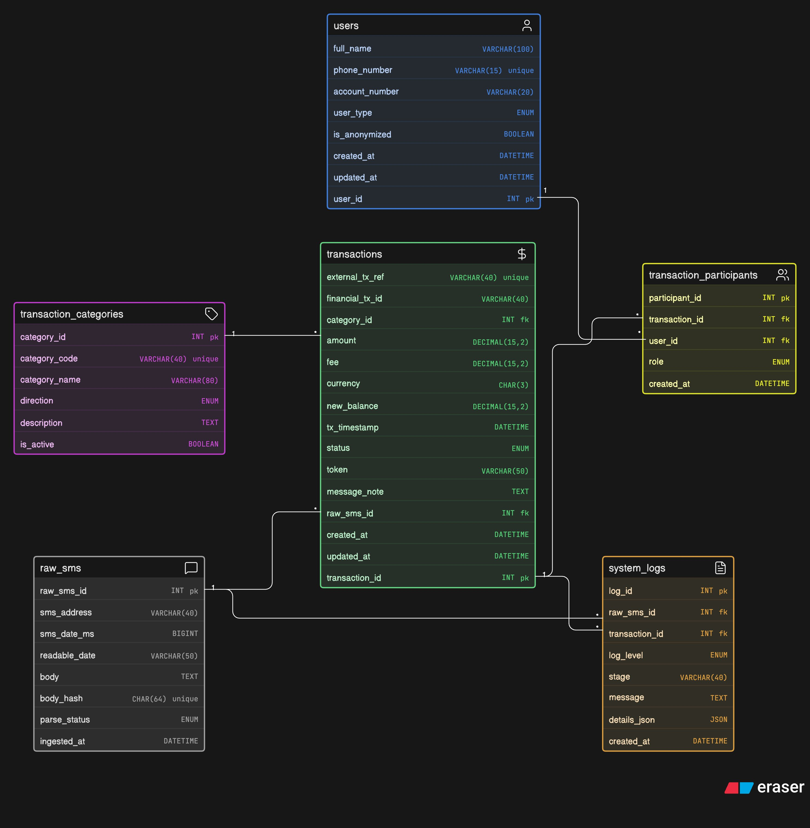
Figure 1 — momo_sms Entity Relationship Diagram

1.1 Notation Key
The following table summarises every relationship symbol used in the ERD:

Symbol | Meaning | Example in This Schema
|| | Exactly one | One transaction_category → many transactions
O| | Zero or one (optional one) | raw_sms_id on transactions (nullable FK)
>< (crow's foot) | Many | transaction_participants — many per transaction
PK | Primary key | user_id, transaction_id, …
FK | Foreign key | category_id references transaction_categories

2. Design Rationale and Justification

2.1 Immutable Audit Trail (raw_sms)
Every design decision starts from a single constraint: the original SMS must never be modified. The raw_sms table stores each message verbatim with a SHA-256 body_hash that acts as a deduplication key. All parsed data is built on top of — and always traceable back to — the original message. If a parsing bug is discovered, the raw record provides a perfect baseline for re-processing without data loss.

2.2 DECIMAL for Money Columns
All monetary fields (amount, fee, new_balance) use DECIMAL(15,2) rather than FLOAT or DOUBLE. Floating-point arithmetic introduces binary rounding errors that compound unpredictably in financial aggregations. DECIMAL stores exact decimal values and is mandated for any system dealing with real currency amounts.

2.3 Junction Table for Participants
A single transaction can involve multiple parties: a sender, a receiver, an agent facilitating a cash-out, or a merchant. Encoding sender_id and receiver_id directly on the transactions table would collapse under real-world complexity (e.g., three-party withdrawals) and would require schema changes for every new role type. The transaction_participants junction table solves this cleanly:
- Each row represents one person's involvement in one transaction
- The role ENUM (sender/receiver/agent/merchant) captures the nature of that involvement
- The composite unique constraint on (transaction_id, user_id, role) prevents accidental duplicate participation records

2.4 Unified users Table
Rather than maintaining separate tables for customers, agents, and businesses, all counterparties are stored in a single users table with a user_type ENUM discriminator. This simplifies JOIN paths across the schema, avoids redundant phone-number and name columns, and handles anonymised counterparties (is_anonymized flag) uniformly regardless of user type.

2.5 ENUM for Controlled Vocabularies
Status, direction, role, log level, parse status, and similar columns use MySQL ENUM types. ENUMs are enforced at the storage engine level — no application-layer validation is required — and they prevent unexpected free-text values from entering the database. Each ENUM is deliberately narrow to reflect the bounded domain of MoMo transaction data.

2.6 Category Catalogue (transaction_categories)
Transaction types are stored in a dedicated lookup table rather than hard-coded into application logic. This means new SMS patterns (e.g., new service fees or product types) can be added without schema migration — only a new row in transaction_categories is needed. The direction column (credit/debit/info) enables financial reporting without requiring callers to infer direction from the category name.

2.7 Pipeline Observability (system_logs)
The system_logs table records every significant event in the ingest-parse-categorise-persist pipeline. It supports both raw_sms_id and transaction_id foreign keys (both nullable), so a log entry can reference: a raw SMS that failed to parse, a transaction that was successfully persisted, or a pipeline warning unrelated to any specific record. The details_json column stores structured context (e.g., the regex that matched, the fields extracted) without polluting the main schema with rarely-queried columns.

3. Data Dictionary

All tables reside in the momo_sms database (CHARACTER SET utf8mb4, COLLATE utf8mb4_unicode_ci). Every table includes created_at DATETIME DEFAULT CURRENT_TIMESTAMP; tables that hold mutable records also include updated_at with ON UPDATE CURRENT_TIMESTAMP.

Table: users
Distinct parties involved in MoMo transactions — customers, agents, businesses, and the account holder (user_type = 'self').

Column | Data Type | Constraints | Default | Description
user_id | INT | PK, NOT NULL, AUTO_INCREMENT | — | Surrogate primary key
full_name | VARCHAR(100) | NOT NULL | — | Person or business name parsed from SMS body
phone_number | VARCHAR(15) | UNIQUE, NULL | NULL | MSISDN in international format (e.g. 250788…); NULL for anonymised contacts
account_number | VARCHAR(20) | NULL | NULL | MoMo wallet account number when present in the SMS
user_type | ENUM | NOT NULL | customer | customer | agent | business | self (self = account owner)
is_anonymized | BOOLEAN | NOT NULL | FALSE | TRUE when the phone number is masked (e.g. *********013)
created_at | DATETIME | NOT NULL | NOW() | Row creation timestamp
updated_at | DATETIME | NOT NULL | NOW() | Auto-updated on any row change

Table: transaction_categories
Reference catalogue of MoMo transaction types. New SMS patterns are handled by inserting a row here — no schema migration required.

Column | Data Type | Constraints | Default | Description
category_id | INT | PK, NOT NULL, AUTO_INCREMENT | — | Surrogate primary key
category_code | VARCHAR(40) | UNIQUE, NOT NULL | — | Machine-readable code, e.g. PAYMENT_CODE, CASH_POWER
category_name | VARCHAR(80) | NOT NULL | — | Human-readable label
direction | ENUM | NOT NULL | — | credit (money in) | debit (money out) | info (non-financial, e.g. OTP)
description | TEXT | NULL | NULL | Optional long-form explanation of this category
is_active | BOOLEAN | NOT NULL | TRUE | FALSE to retire a category without deleting historical records

Table: raw_sms
Verbatim SMS records. This is the immutable audit trail; all parsed data is derived from these rows.

Column | Data Type | Constraints | Default | Description
raw_sms_id | INT | PK, NOT NULL, AUTO_INCREMENT | — | Surrogate primary key
sms_address | VARCHAR(40) | NULL | NULL | Sender address from XML attribute, typically 'M-Money'
sms_date_ms | BIGINT | NOT NULL, CHECK > 0 | — | Epoch milliseconds from the XML date attribute
readable_date | VARCHAR(50) | NULL | NULL | Human-readable date string extracted from the XML
body | TEXT | NOT NULL | — | Full SMS body verbatim — the source of all parsed fields
body_hash | CHAR(64) | UNIQUE, NOT NULL | — | SHA-256 of body; serves as the deduplication key
parse_status | ENUM | NOT NULL | pending | pending | parsed | failed | ignored
ingested_at | DATETIME | NOT NULL | NOW() | Timestamp when this row was written to the database

Table: transactions
Parsed MoMo transactions — the central fact table. Each row represents one financial or informational event extracted from a raw SMS.

Column | Data Type | Constraints | Default | Description
transaction_id | INT | PK, NOT NULL, AUTO_INCREMENT | — | Surrogate primary key
external_tx_ref | VARCHAR(40) | UNIQUE, NULL | NULL | TxId from the SMS body (idempotency key)
financial_tx_id | VARCHAR(40) | NULL | NULL | Financial Transaction Id when present in the SMS
category_id | INT | FK → transaction_categories, NOT NULL | — | Transaction type
amount | DECIMAL(15,2) | NOT NULL, CHECK ≥ 0 | — | Transaction amount in RWF
fee | DECIMAL(15,2) | NOT NULL, CHECK ≥ 0 | 0.00 | Fee charged for this transaction
currency | CHAR(3) | NOT NULL, CHECK LEN=3 | RWF | ISO 4217 currency code
new_balance | DECIMAL(15,2) | NULL | NULL | Account balance reported after the transaction
tx_timestamp | DATETIME | NOT NULL | — | When the transaction occurred per the SMS
status | ENUM | NOT NULL | completed | completed | failed | reversed
token | VARCHAR(50) | NULL | NULL | Vendor token (Cash Power electricity token, airtime PIN)
message_note | TEXT | NULL | NULL | Free-text message from sender or agent
raw_sms_id | INT | FK → raw_sms (SET NULL), NULL | NULL | Source SMS; SET NULL on delete to preserve transaction record
created_at | DATETIME | NOT NULL | NOW() | Row creation timestamp
updated_at | DATETIME | NOT NULL | NOW() | Auto-updated on any row change

Table: transaction_participants
M:N junction table — records every party involved in a transaction and their role. Replaces a fixed sender_id / receiver_id column approach.

Column | Data Type | Constraints | Default | Description
participant_id | INT | PK, NOT NULL, AUTO_INCREMENT | — | Surrogate primary key
transaction_id | INT | FK → transactions (CASCADE), NOT NULL | — | Transaction this participant belongs to
user_id | INT | FK → users (RESTRICT), NOT NULL | — | The participating user
role | ENUM | NOT NULL | — | sender | receiver | agent | merchant
created_at | DATETIME | NOT NULL | NOW() | Row creation timestamp

Table: system_logs
Pipeline event log for ingest, parse, categorise, and persist stages. Provides full observability without polluting transactional tables.

Column | Data Type | Constraints | Default | Description
log_id | INT | PK, NOT NULL, AUTO_INCREMENT | — | Surrogate primary key
raw_sms_id | INT | FK → raw_sms (SET NULL), NULL | NULL | Source SMS that triggered this log entry
transaction_id | INT | FK → transactions (SET NULL), NULL | NULL | Transaction this log entry relates to
log_level | ENUM | NOT NULL | — | INFO | WARN | ERROR | DEBUG
stage | VARCHAR(40) | NOT NULL | — | Pipeline stage: ingest | parse | categorize | persist
message | TEXT | NOT NULL | — | Short human-readable description of the event
details_json | JSON | NULL | NULL | Structured context — regex used, fields extracted, etc.
created_at | DATETIME | NOT NULL | NOW() | Timestamp when this log entry was written

4. Index Inventory

Indexes are designed to support the most common query patterns: time-range scans on transactions, status filtering for triage, user lookups by type and name, and foreign-key traversal in JOIN-heavy reporting queries.

Table | Index Name | Column(s) | Purpose
users | idx_users_type | user_type | Filter users by role (customer / agent / business)
users | idx_users_name | full_name | Name search when parsing counterparty from SMS
raw_sms | idx_raw_status | parse_status | Pipeline worker query: fetch all pending rows
raw_sms | idx_raw_date | sms_date_ms | Time-range scans on ingestion window
transactions | idx_tx_timestamp | tx_timestamp | Date-range reporting — statements, dashboards
transactions | idx_tx_category | category_id | Category-mix aggregations (GROUP BY category)
transactions | idx_tx_status | status | Triage query: fetch all failed / reversed rows
transactions | idx_tx_finid | financial_tx_id | Lookup by MNO Financial Transaction Id
transaction_participants | idx_tp_tx | transaction_id | Join from transactions → participants
transaction_participants | idx_tp_user | user_id | Join from users → all transactions for a user
system_logs | idx_log_level | log_level | Filter logs by severity (ERROR / WARN)
system_logs | idx_log_stage | stage | Filter logs by pipeline stage
system_logs | idx_log_time | created_at | Time-ordered log retrieval

5. Constraint Inventory

The schema enforces data integrity at the database layer through four constraint categories. Each constraint is named explicitly so that application error handlers can parse MySQL error messages and map them to user-facing diagnostics.

5.1 UNIQUE Constraints
Table | Constraint Name | Column(s) | Business Rule
users | uq_users_phone | phone_number | One MSISDN per user — prevents duplicate account registration
transaction_categories | uq_cat_code | category_code | Machine codes are unique — prevents catalogue duplication
raw_sms | uq_raw_hash | body_hash | SHA-256 hash ensures exact-duplicate SMS bodies are rejected
transactions | uq_tx_external | external_tx_ref | MNO TxId is an idempotency key — one financial event, one row
transaction_participants | uq_tp_combo | (tx_id, user_id, role) | Same user cannot hold the same role twice in one transaction

5.2 CHECK Constraints
Table | Constraint Name | Expression | Business Rule
users | chk_users_name_len | CHAR_LENGTH ≥ 1 | Name must be non-empty; catches whitespace-only strings
raw_sms | chk_raw_date | sms_date_ms > 0 | Epoch timestamp must be positive — rejects Unix epoch zero
transactions | chk_tx_amount | amount ≥ 0 | Amounts cannot be negative; zero is permitted for informational records
transactions | chk_tx_fee | fee ≥ 0 | Fees cannot be negative
transactions | chk_tx_currency | CHAR_LENGTH = 3 | Enforces ISO 4217 format (e.g. RWF, USD)

5.3 Foreign Key Constraints
Table | Constraint Name | References | On Delete / Update
transactions | fk_tx_category | transaction_categories | RESTRICT / CASCADE — category must exist; code changes propagate
transactions | fk_tx_rawsms | raw_sms | SET NULL / CASCADE — transaction preserved if raw SMS is deleted
transaction_participants | fk_tp_tx | transactions | CASCADE / CASCADE — participants deleted with their transaction
transaction_participants | fk_tp_user | users | RESTRICT / CASCADE — cannot delete a user with participation records
system_logs | fk_log_rawsms | raw_sms | SET NULL / CASCADE — log preserved if raw SMS is deleted
system_logs | fk_log_tx | transactions | SET NULL / CASCADE — log preserved if transaction is deleted

6. Sample Data Overview

The following seed data was loaded to validate schema correctness, foreign-key resolution, and constraint enforcement. All sample rows are illustrative; the DML section of the schema file contains the full INSERT statements.

6.1 Transaction Categories (9 rows)
Code | Name | Direction | Description
INCOMING_RECEIVE | Incoming money received | credit | Received from another MoMo customer
PAYMENT_CODE | Payment to merchant code | debit | Payment to a numeric merchant code
TRANSFER_PHONE | Transfer to phone | debit | Funds to another MoMo number
BANK_DEPOSIT | Bank deposit | credit | Cash/bank deposit to MoMo account
WITHDRAWAL_AGENT | Agent withdrawal | debit | Cash withdrawn via MoMo agent
AIRTIME | Airtime purchase | debit | MTN airtime top-up
CASH_POWER | MTN Cash Power | debit | Electricity token purchase
DIRECT_PAYMENT | Direct payment (external) | debit | External vendor charge
OTP | One-time password | info | Non-financial OTP delivery

6.2 Seed Transactions (6 rows)
Ref / Fin ID | Category | Amount (RWF) | Fee | Status | Timestamp
76662021700 | INCOMING_RECEIVE | 2,000.00 | 0.00 | completed | 2024-05-10 16:30:51
73214484437 | PAYMENT_CODE | 1,000.00 | 0.00 | completed | 2024-05-10 16:31:39
— | BANK_DEPOSIT | 40,000.00 | 0.00 | completed | 2024-05-11 18:43:49
— | TRANSFER_PHONE | 10,000.00 | 100.00 | completed | 2024-05-11 20:34:47
14098463509 | WITHDRAWAL_AGENT | 20,000.00 | 350.00 | completed | 2024-05-26 02:10:27
14103506143 | CASH_POWER | 4,000.00 | 0.00 | completed | 2024-05-26 13:31:00

7. Sample Queries

The following queries were validated against the populated momo_sms database to confirm that schema relationships, indexes, and constraints support all required read and write patterns.

Q001: Customer Statement — 4-table JOIN
Purpose: Retrieves every transaction for a single user, joining through the participant junction table, with category context. This is the core account-statement query.

SELECT t.transaction_id, t.external_tx_ref,
u.full_name, tc.category_name,
t.amount, t.fee, t.status, t.tx_timestamp
FROM transactions t
JOIN transaction_participants tp ON tp.transaction_id = t.transaction_id
JOIN users u ON u.user_id = tp.user_id
JOIN transaction_categories tc ON tc.category_id = t.category_id
WHERE u.user_id = 1
ORDER BY t.tx_timestamp;

Q002: Category Mix Dashboard — GROUP BY Aggregation
Purpose: Counts and sums transactions per category. The LEFT JOIN ensures categories with zero transactions appear with 0 totals — critical for dashboard completeness.

SELECT tc.category_name, tc.direction,
COUNT(t.transaction_id) AS tx_count,
COALESCE(SUM(t.amount), 0) AS total_amount_rwf,
COALESCE(SUM(t.fee), 0) AS total_fees_rwf
FROM transaction_categories tc
LEFT JOIN transactions t ON t.category_id = tc.category_id
GROUP BY tc.category_id, tc.category_name, tc.direction
ORDER BY tx_count DESC, total_amount_rwf DESC;

Q003: Failed-Transaction Triage
Purpose: Retrieves every failed transaction with owner details and the original SMS body. This is the operations-team runbook query for investigating payment failures.

SELECT t.transaction_id, t.external_tx_ref,
u.full_name, tc.category_name,
t.amount, t.tx_timestamp, r.body AS source_sms
FROM transactions t
JOIN transaction_participants tp ON tp.transaction_id = t.transaction_id
JOIN users u ON u.user_id = tp.user_id
JOIN transaction_categories tc ON tc.category_id = t.category_id
LEFT JOIN raw_sms r ON r.raw_sms_id = t.raw_sms_id
WHERE t.status = 'failed'
ORDER BY t.tx_timestamp DESC;

Q004: Top 5 Users by Transaction Volume
Purpose: Ranks users by total RWF volume of completed transactions. Confirms that aggregation across the participant→transaction chain resolves correctly.

SELECT u.user_id, u.full_name,
COUNT(t.transaction_id) AS completed_tx_count,
SUM(t.amount) AS total_volume_rwf,
SUM(t.fee) AS total_fees_paid_rwf
FROM users u
JOIN transaction_participants tp ON tp.user_id = u.user_id
JOIN transactions t ON t.transaction_id = tp.transaction_id
WHERE t.status = 'completed'
GROUP BY u.user_id, u.full_name
ORDER BY total_volume_rwf DESC
LIMIT 5;

8. Constraint Enforcement Tests

Eight deliberately invalid INSERT statements were submitted to confirm that constraints actively reject bad data at the database layer, independent of application-level validation. Each test records the MySQL error code returned.

Test | Constraint | Table | Error | Result
SEC-01 | UNIQUE uq_tx_external | transactions | #1062 | Duplicate external_tx_ref rejected — idempotency key protects financial records from double-processing.
SEC-02 | UNIQUE uq_users_phone | users | #1062 | Duplicate phone_number rejected — one MSISDN per registered party across the system.
SEC-03 | UNIQUE uq_raw_hash | raw_sms | #1062 | Duplicate body_hash rejected — SHA-256 prevents the same SMS from being ingested twice.
SEC-04 | CHECK chk_tx_amount | transactions | #4025 | Negative amount rejected — database layer blocks invalid monetary values before any application logic runs.
SEC-05 | CHECK chk_tx_fee | transactions | #4025 | Negative fee rejected — mirrors the amount constraint for fee columns.
SEC-06 | ENUM status | transactions | #1265 | Invalid status string ('completedZZZ') truncated and rejected — ENUM guards against free-text pollution.
SEC-07 | FK fk_tx_category | transactions | #1452 | Non-existent category_id rejected — referential integrity enforced at storage engine level.
SEC-08 | UNIQUE uq_tp_combo | transaction_participants | #1062 | Duplicate (transaction_id, user_id, role) triplet rejected — prevents accidental double-participation records.

