Transparent Movie Recommendation System
Weekly Report
8 September 2015
Neil Getty
Mustafa Bilgic

Code changes this week:

Average rating is now scaled using sklearn.preprocessing.

Below are charts and tables depicting data features:
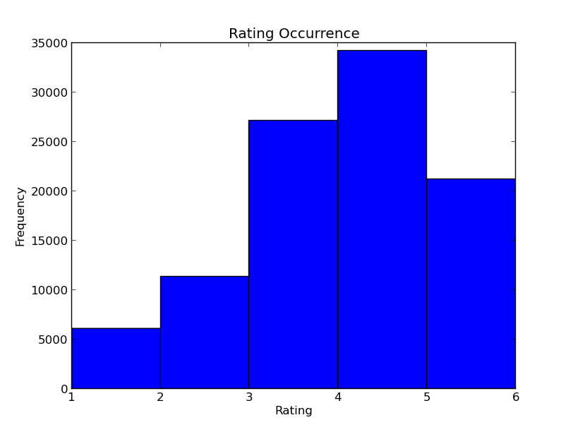

This chart depicts the ratings of 943 users.
The rating frequency distribution is left-skewed.
It is likely people tend to review movies they enjoy.

Drama and comedy are by far the most frequent genres of the 19.

Top 10 least/most frequent keywords of 370

Below are charts and tables depicting model results:

Models were trained with cross-validation using 5 folds

MAE given alphas in range(1,20).
Alphas that minimize MAE: 15 for Ridge regression and 0.1 for Lasso

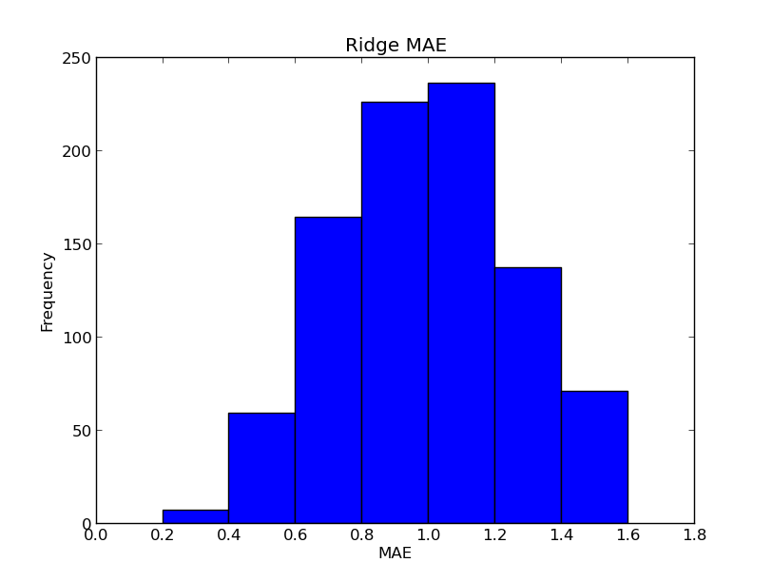

MAE frequency for Ridge and Lasso regression.
Average MAE approximately 0.80 for Ridge and 0.78 for Lasso

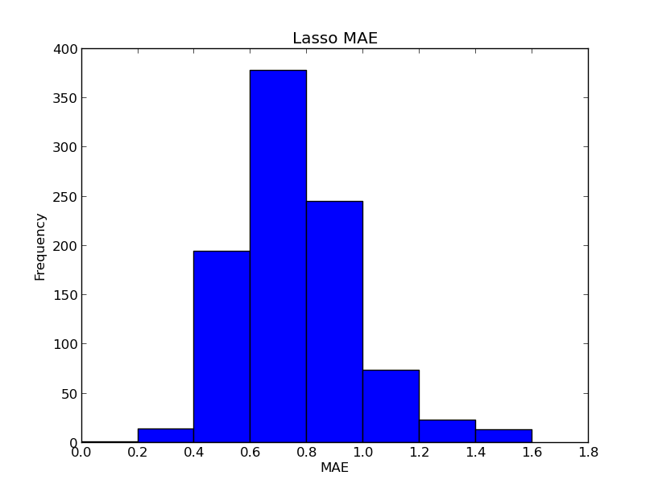

The top ten lowest/highest MAE for LassoCV with alpha = .01 and cv = 5.

