Transparent Movie Recommendation System
Weekly Report
8 September 2015
Neil Getty
Mustafa Bilgic

Code changes this week:

Data Preprocessing
- Improved grouplens/imdb movie matches from 60% to 80%.
- Minimum keyword occurrence is now dynamic with best results ~45
- Average movie rating now included in training set (resulting in 0.08 decrease in MAE)

Predictive Models
- Added method for computing MAE with Lasso Regression model
- alpha values now passed in dynamically

Descriptive Statistics
- Added methods for plotting MAE/keyword/genre/rating frequency

General
- Further organized methods into more specific classes
- Decreased time complexity

Below are charts and tables depicting data features:
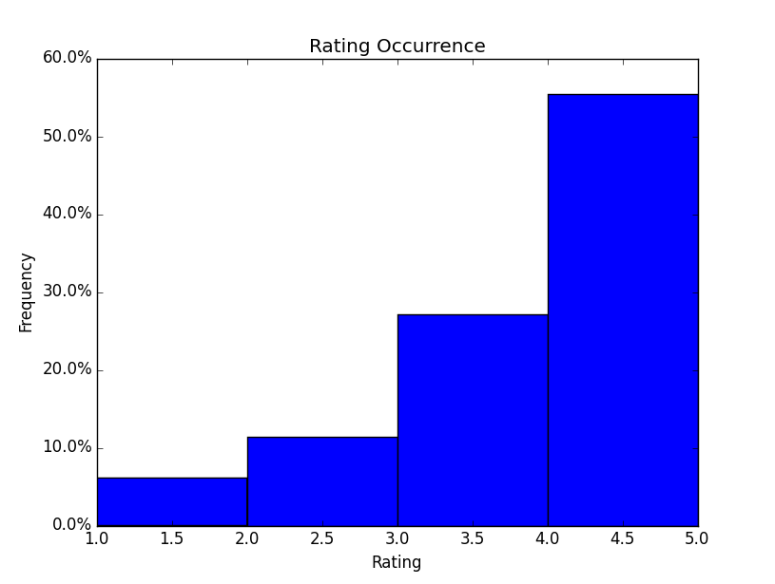

This chart depicts the ratings of 943 users.
The rating frequency distribution is left-skewed.
It is likely people tend to review movies they enjoy.
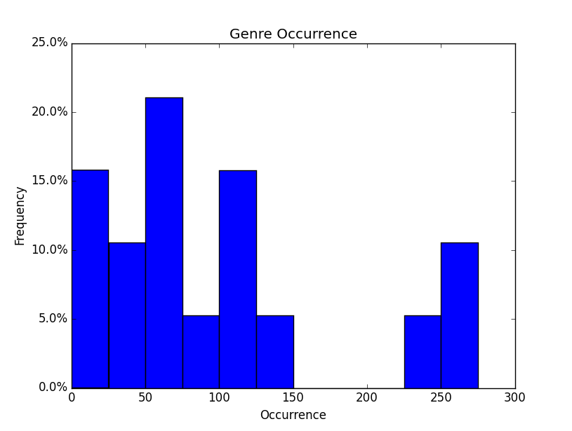

Drama and comedy are by far the most frequent genres of the 19.

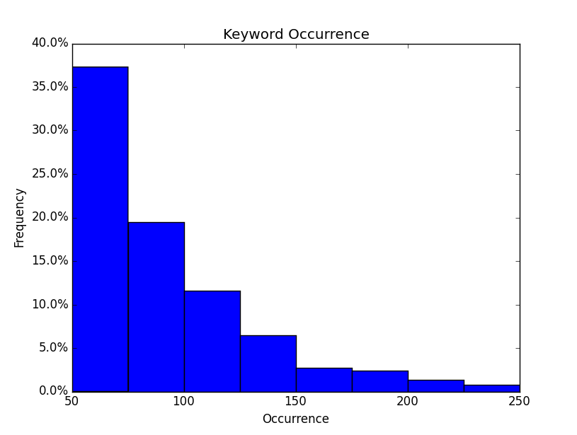
Right skewed keyword frequency distribution
Top 10 least/most frequent keywords of 370
Below are charts and tables depicting model results:

MAE given alphas in range(1,20). Not plotted is alpha=.1 which is off scale and yielded poor results.
Alphas that minimize MAE: 15 for Ridge regression and 0.1 for Lasso

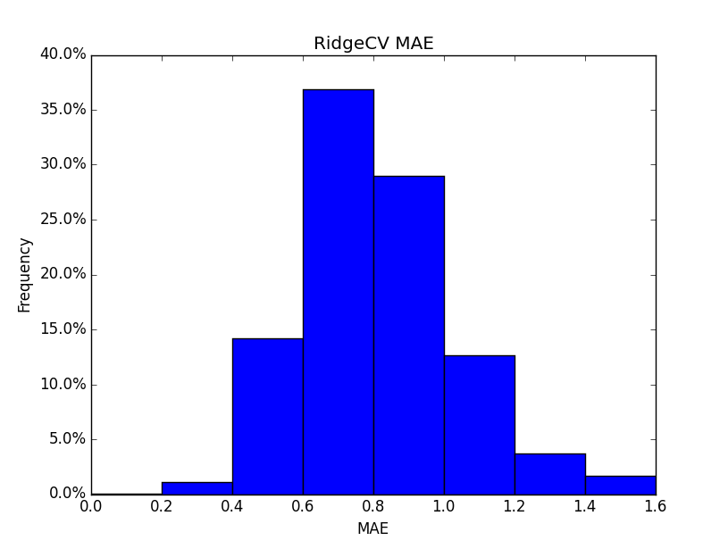

MAE frequency for Ridge and Lasso regression.
Average MAE approximately 0.80 for Ridge and 0.78 for Lasso

