Prerequisites
- Install Python 3.14.3
  - Jupiter notebook extension in VS code.
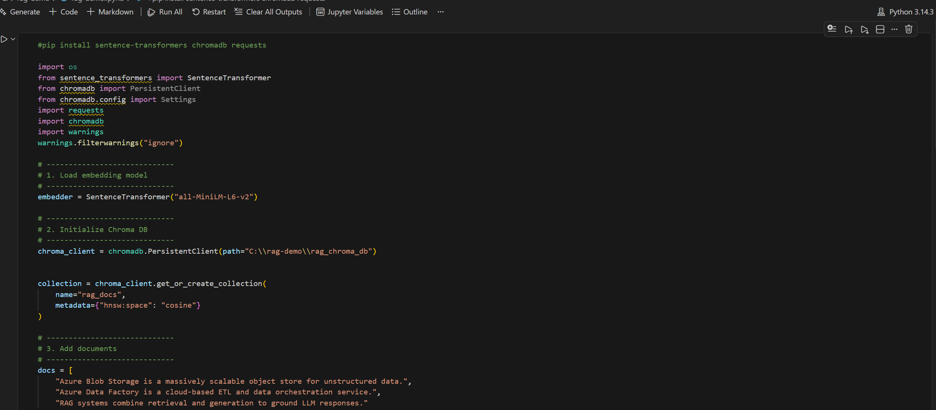
- Install packages
  - pip install sentence-transformers chromadb requests

- Install Ollama Server . Download Ollama Server from Ollama
  - Before running sample, Install the model needed.
  - Start the Ollama server
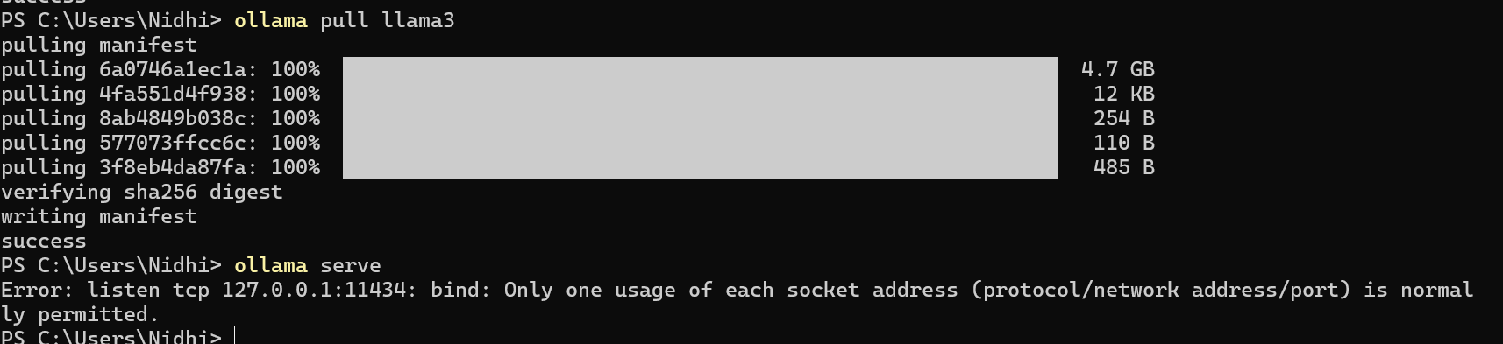

References
- Vector DB Chroma Clients - Chroma Docs
- For running Open source model such as (llma3 gemma4) without cloud api key in your local machine Ollama
- Microsoft Co-Pilot- Code references are researched there.

