15 Westerns
2026
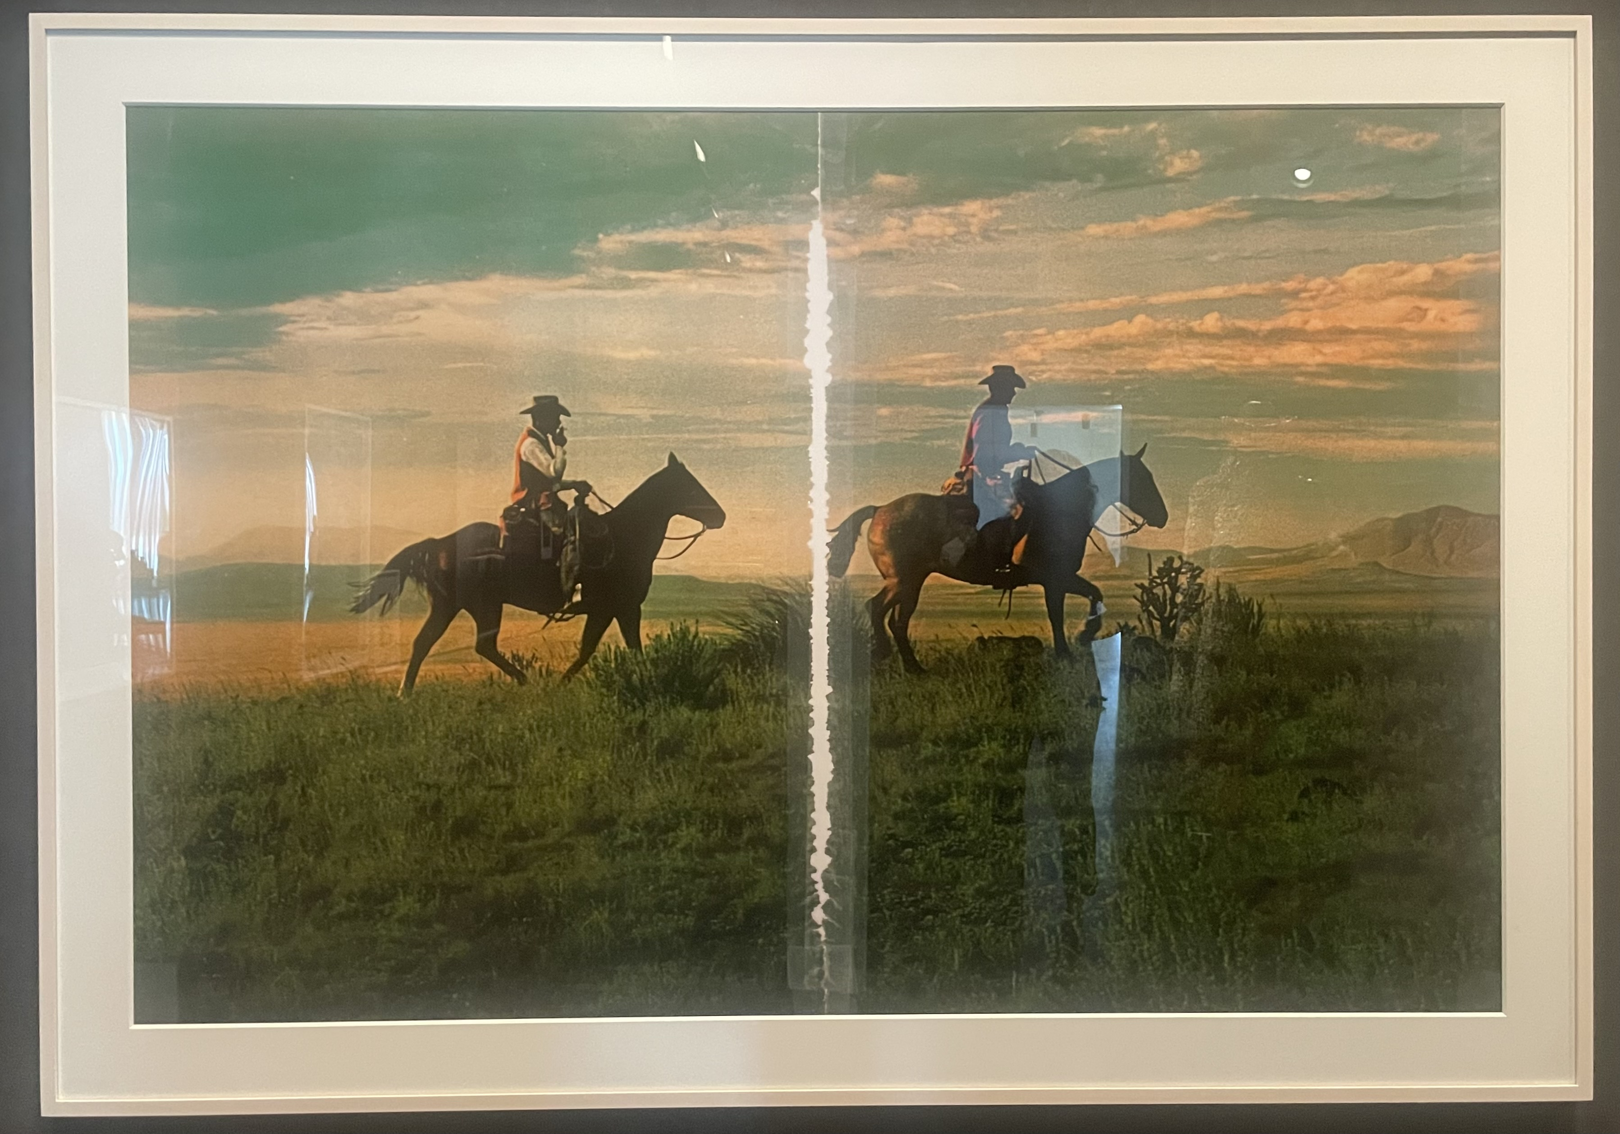
Richard Prince, Untitled (Cowboy) 2016
As usually happens when we go out for pizza the kids called. Walking into the pink and golden summer evening and away from our table to give their conversation some privacy. She listened. Giving each of them the time to express themselves and, from what I could see (but not hear), responding to what they said seriously. It seemed stressful, to raise three teens as a single mom. After the phone call, Ann was quiet for the rest of the meal. She didn’t share the specifics of their conversations with us but as we drove back from dinner her kids were stitched into our conversation. They say I don’t share my favorite movies with them. And so we talked about movies, some favorites and what might appeal to them and the possibility of putting together a list of movies for her kids to watch. It’s a kind of educational project. What are the movies that everyone should see in the process of becoming an adult? What about keeping the list to just Westerns? Gore Vidal liked to say that the Western was America’s only cultural gift to the world. It seems like a quip he made in 1948 while drinking and then repeated without reflection for the rest of his life. But there’s some truth there—the Western could only be invented in America. It is a reflection and a direction, a promise (or betrayal) and a myth, a landscape and a mood all as genre.
If we want to understand our country’s self-understanding, mythology and reevaluation of that myth, look at the stories it tells most frequently. Western movies fit the bill and they can provide a secret, sneaky education in American Studies. After all, a cardinal aspect of the 20th Century is that the people got their philosophical instruction through popular media like the movies than through books. Movies deserve and benefit from serious reflection. That said, I’m not going to articulate my theory of the Western except as it may be apprehended through my list. Scholarly theories and popular visions abound. The first major academic study of Western movies, Horizons West, was published in 1969. That Westerns matter is actually a bit of a dead letter now, the juice seems to be in the Horror genre which is more personal and less historical, moralistic, and racist (see Men, Women and Chain Saws: Gender in the Modern Horror Film).
Not all Westerns are very good. Most aren’t very good at all. And yet they were very popular and produced in terrific volume. Resolving that paradox may be education enough to thrive as an adult. Pulp novels. Serialized radio dramas. Hollywood used to release a new Western every other week. Long before cop shows and reality TV took over, Westerns dominated prime time TV. Think about the sprawling Yellowstone TV franchise and multiply it by the three broadcast networks and spread it across the whole week. There exists today, the way there used to be am radio stations dedicated to big band music for nursing home residents, several cable TV stations that only play Westerns. WEST (Western Entertainment Series Television), The Cowboy Channel, INSP, Grit. The list is much longer if we add stations that regularly but not exclusively broadcast Westerns. All day and all night, from TV and the movies, there is plenty of content if volume of content is what you are after.
There are many, many lists of the best and greatest Westerns of all time. I read lists like that but I don’t like to make them. Rankings of that sort create a hierarchy among movies that doesn’t exist. Implied therein is an arbitrary separation of the included from the rest. A top ten list depends on all the movies that didn’t make the list. If you only watch the greats don’t you lose the context required to understand what makes them great? If we only understand history through highlights we misunderstand what the experience of living through history. It is a tough argument, bad movies make good movies better, but it’s true.
And yet I made a list. Short descriptions of 15 Westerns focused some icons of the genre, certain actors and directors that I like. Following a person’s career can lead to a deep understanding, what changes and what is constant. Naturally there is a lot missing from my list. Nothing from the 1940’s. No Shane, Fort Apache, hardly anything international and nothing low budget and only one revisionist Western from the 1970’s. No Lee Van Cleef, no Michael Curtiz, nor the contemporary exemplars Dead Man, Brokeback Mountain, The Proposition, No Country for Old Men, The Way of the Dog. Watch all those too. My list was not intended to be exhaustive or exclusive. There is always something more worth seeing.
Before talking about individual Westerns, consider Tom Mix. The original man in the white hat. Mix is “important” to the degree silent film actors can still be important. His ghost shows up in Mulholland Drive (2001) to instruct the surly young director on what must be done to make a movie in Hollywood. I can’t recommend any of his movies, but you can watch clips on YouTube and his Wikipedia page. The acting is weird and storytelling strange, the pacing and the camera angles unfamiliar. Most silent films come across as anachronistic and disconnected from modern entertainment. All that said, Mix was a major star back when motion pictures were new and Los Angeles county was still America’s most productive agricultural county. Time was, to make a name in pictures it was enough to just look good on a horse.
Stagecoach (1939) John Ford
It’s a social movie, but also an action movie. It’s about class but is never didactic. There is so much here in prototype; the chase scene contains the seeds of all movie chase scenes to come. A hope for America as an egalitarian nation and a good demonstration of what can be done with a genre picture.
High Noon (1952) Fred Zinnemenn
A simple story: the sheriff stands up for what’s right while the townspeople he has sworn to protect, for their own selfish reasons, all stand aside. Westerns typically embody the nation’s self-confidence which generally makes the resolution of the drama a foregone conclusion. Of course the forces of right will prevail, but here the town folk are in doubt. The movie unfolds in real time and that creates a cinematic tension while Gary Cooper’s moral clarity in the face of cowardice provides the drama. This is the sort of film that could be shown in civics class to educate the youth about right and wrong, but it’s also a good film.
Johnny Guitar (1954) Nicolas Ray
A picture where Joan Crawford dominates and traditional gender roles are reversed. Filmed using TruColor, a color process that adds to the unreality of what we see on screen. Sterling Hayden’s larger than life man-child plays on the fact that Westerns are about masculinity and Andy Warhol’s aside “Haven’t cowboys have always been gay?” It’s the sort of film that has to be seen to believed.
The Searchers (1956) John Ford
By turns beautiful, hokey, odious, and loving. A true epic, shot in technicolor in Monument Valley with a particular reverence for the masculinity of John Wayne. The last time I watched this I saw it as riding on the subtext of race and identity in America, but upon reflection calling it subtext isn’t right. This is explicitly about white manifest destiny, and it has been called the greatest movie ever made. I’ve always found thinking about a movie in those terms confuses my ability to see the movie for what it is. Johnathan Lethem wrote an essay about his relationship with this movie and it’s legendary status, how he comes back to it again and again, the movie refusing each time an easy understanding. And then he wrote another essay about the film. The cinematography, the cinematography.
The Man who Shot Liberty Valance (1962) John Ford
A movie about myth making, violence and the role of newspapers—today we would say the media—in creating the idea of American West. It’s also about the coming of the law, learning and gentility, and what was required for such things to flourish. It’s interesting to think about this movie in connection with revisionist Westerns. This manages to be an entertaining movie in the form of a classical Western. It also says, quite explicitly, there is a more historically accurate way to tell these stories, and suggests that the only thing preventing these stories from being told a different way is the inclination of those who know the truth.
Ride the High Country (1962) Sam Peckinpah
The least essential movie on my list. It’s an example of what films in the genre were doing in general if not so explicitly. I think of this as an existential Western, an education into how a person should be. I love Peckinpah. Compare this with his other film on my list made just seven years later. He wanted to be a “serious director” but was pigeonholed into genre pictures. A big personality and a headstrong character, his biography is full of astounding stories. Eventually his alcoholism made him more or less unemployable and he ended his career directing music videos, a serious step down for a serious man. Though I remember the Julian Lennon video he directed being a hit on MTV.
Once Upon a Time in the West (1968) Sergio Leoni
Style as substance. Forget about all that moralizing, the subject matter is the look of the genre. A man with no name in a rural setting. You can watch Westerns from all over the world, from Italy but also from Argentina, Australia. A lot of the Japanese samurai movies can be thought of as sort of Western, famously The Magnificent Seven is a reworking of The Seven Samurai. If you are interested in the aesthetic of the Western genre you will recognize Sergio Leoni’s movies as a high water mark. The atmosphere, the opening scene, the Ennio Morricone score, the pacing, Henry Fonda playing against type. All perfect.
The Wild Bunch (1969) Sam Peckinpah
I used to say this is my favorite movie. It’s weird to have said that because I don’t like to pick singular favorites just like I object make top 10 lists and that sort of thing. This was one of the Westerns (like Once Upon a Time in the West, The Searchers, Pale Rider, Silverado, Unforgiven) that I watched with my dad. Released in 1969, people sometimes talk about this as an allegory for the war in Vietnam. Upon release it was considered profoundly bloody, that’s part of the allusion to Vietnam. The thing that really strikes me about the film now is how it celebrates relationships between men. Riding shoulder to shoulder across the open range. The sense that in the end you are fighting for your buddies, that heroic bond of fatalism and togetherness. The Townes Van Zant song Pancho and Lefty derives some of its tragedy from the betrayal of that bond. This is the movie where Peckinpah was able to work out his themes (pessimism about children-as-the-future), interests (shoot out as ballet), and biases (a disdain for women) in ways that presage the director-focused turn that Hollywood would take for much of the 1970’s. Part of what makes this movie great for me is that it is not a revisionist Western, it’s not showing us the awful truth we weren’t allowed to know. The simple truth of filial love unfolding the way it always has.
Blazing Saddles (1972) Mel Brooks
Some people don’t believe in genre. There aren’t Westerns they say. Only Nicolas Ray movies, John Ford movies, Sam Peckinpah movies. The vision of the director is the through-line that matters, genre is a marketing term that degrades the art form. Blazing Saddles makes both sides of the argument. It’s a Mel Brooks movie, and a satire. If you only watch one film on the list it should be this one. Partly because it’s a satire, and for satire to work it has to pick up on what we expect the Western to be and what is going on in the society at large. Co-written by Richard Pryor, this movie manages to tell fart jokes and be incredibly smart.
McCabe & Mrs Miller (1972) Robert Altman
There have always been revisionist Westerns and the early 1970’s brought a bumper crop. The mood in America in the 1970’s was one of disillusionment and the movies of that decade reflect that. 5 Easy Pieces, Coming Home, The Conversation, Nashville, and many others justify that impression. If we accept one function of the Western genre is to produce a national myth, incorporation of the national mood into the genre creates a different sort of myth, one that foregrounds aspects of the myth that were previously suppressed. The ending here is particularly devastating. After the early 70’s, most of the Westerns made were revisionist Westerns. Altman was on a run of great pictures when he made this but it was not a hit. A splendid film.
Heaven’s Gate (1980) Michael Cimino
The 70’s were a pivotal decade for American film. For a few years directors and blockbusters coexisted in Hollywood’s business model. The industry had been sold on a director with artistic vision delivering box office results (Francis Ford Coppola, Peter Bogdonovich, Stanley Kubrick, Robert Altman, Michael Friedkin, Ingmar Bergman, etc.) meanwhile the blockbuster economics of movies like Jaws and Star Wars promised a path to profit via mass-market thrills. Heaven’s Gate played a role in resetting the balance away from the director— a polite way saying this movie lost a lot of money. Some claim it killed the Western as a genre and ended Hollywood’s permissive attitude towards visionary directors. The first may be true, but the second is unfair. Heaven’s Gate is long, beautiful, heavy-handed, pretentious, occasionally incoherent, turgid, gorgeous, and joyous. See the 219 minute version if you can, and read the book Final Cut: Art, Money, and Ego in the Making of Heaven’s Gate, the Film That Sank United Artists, by Steven Bach as part of the experience. One way to think about this movie in a larger context is as being about the business of the film industry, “The business of America is business” and so forth. Within the film the plot is about a class war between ranchers and immigrants. Outside of the world of the film Heaven’s Gate is emblematic of changes in Hollywood’s distribution system that allowed for the “rediscovery” of movies through home video, cable (and eventually streaming); profound changes in the way movies are seen and generate revenue. The world we live in today. Focusing on the financial dynamics of the film and the industry may be unfair to the Cimino’s intentions. Movies like this are supposed to be watched in a dark theater with other people and in that experience they create meaning in a unique manner. But there are many ways to be meaningful.
Pale Rider (1985) Clint Eastwood
I like that it’s set in the mountains, it reminds me of early childhood summers in Colorado. My dad dubbed this from HBO onto VHS, so I watched it a bunch as a teen. Typecasting is part of what appearing in movies does, thus certain actors are associated with the Western genre. John Wayne, Tom Mix, and Clint Eastwood are classic examples. They made other kinds of movies, but you get the idea. Here, Eastwood directs himself and uses the audience’s expectations of him to help reestablish the Western genre five years on from the negative phenomena of Heaven’s Gate. It’s not quite a revisionist Western, but in its pessimistic-realism you can see it as indebted to the themes of 1970’s America.
Unforgiven (1992) Clint Eastwood
Sort of a revisionist take on the myth of the West, it’s also about aging and friendship and what a life of violence does to its practitioners. Originally, I saw this in the theater with my dad. After the movie he repeated a line from the movie, But I have a house, with approval. He wasn’t one to talk much about movies and art, so I spent a lot of time as a kid trying to understand what it was about that particular line that appealed to him. It could be that we are confused about what actually has power in the world. It’s easy to imagine the details of a story have a power they do not. The thought “this can’t be happening to me” expressed as “this doesn’t happen to people with a house.” Unforgiven isn’t really about the idea that the world is indifferent to the narrative structuring of our lives (Terrance Malick’s The Thin Red Line (1998) is a movie about that idea) but the thought lives in that one line. Unforgiven won the Oscar for Best Picture of 1992.
Drive (2011) Nicolas Refn
The Western genre as instrument of the national mythos requires a self-confidence that our country probably no longer possesses. Nevertheless the components of the genre remain; the existential landscape, a distinction between the law and morality, horses, and the man with a code but no name. Here is a film with all those elements fit for a nation without self-confidence. The car as the horse, Los Angeles standing in for Monument Valley, Ryan Gosling as the man with no name, and we have a contemporary Western.
Hell or High Water (2016) David Mackenzie
Anything can be a Western so long as it is located in the right landscape. This movie (part of a group of movies I call the great financial crisis film festival) fits the bill. Banks are still the baddies but now we have oil or gas instead of gold. If we take the Western seriously as the barometer of the legend America tells about itself, we should be clambering for more contemporary (or neo-) Westerns to understand ourselves better. What does the closing of the frontier mean today? Don’t they call cutting-edge AI companies “frontier labs” where the contemporary western about that? What are the good and bad archetypes of masculinity? What are the possibilities for existential freedom in this country?

