|  |  |  |  |  |  |  |  |
| --- | --- | --- | --- | --- | --- | --- | --- |
| **Functional Design Header** | | | | | | | |
| **Tech Goods** | **BC.R.000P – Transport Request ( TR ) Release Utility Tool** | | | | | **Version** | 1.00 |
| **Description** | Tool for consistency check, owner change and releasing TR’s in bulk number from single screen. | | | | | | |
| **Category** | Tool | **Target Region** | Global | **Industry** | Generic | | |
| **Contributor** | Neeraj Katiyar | | | **Reviewer** | Shridhar Patil | | |

|  |  |  |  |  |  |  |  |  |  |  |  |
| --- | --- | --- | --- | --- | --- | --- | --- | --- | --- | --- | --- |
| **Industrialization Factors** | | | | | | | | | | | |
| **RICEFW** | | | Report | | | **Complexity** | | | Medium | | |
| **Reduction Factor** | | **Analyze** | | 3h | **Design** | 10h | **Build** | 80h | | **Test** | 30h |
| **Credential** | N/A | | | | | | | | | | |

|  |  |  |  |
| --- | --- | --- | --- |
| **Obligatory Requirements** | | | |
| **SAP Version** | ERP 4.7 – 6.0 | **Support Package** | N/A |
| **Dependent Tech Goods** | These other technical goods are used by this one and must be installed before it | | |
| Tables – E070, E07T, V_USR_NAME,DD07T.  Message Class – Z_TR_MESSAGE | | |

|  |  |  |  |
| --- | --- | --- | --- |
| **Last Change Description** | | | |
| **Version** | **Modified in** | **Responsible** | **Modification** |
| **1.00** | 30 June 2015 | Neeraj Katiyar | Initial creation |

Implementation Guide v1.00 1

Copyright © 2008 Accenture – All rights reserved. Accenture – Proprietary and Confidential.

This component, containing its documentation and code, is proprietary of Accenture and its use and distribution is restrict. For further information or new technical

goods, access https://rtl.accenture.com

**Table of Contents**

1. Objective 3

1.1 Reason and Business Purposes 3

1.2 Product Objective 3

1.3 Assumptions 3

2. Solution 4

2.1 Process Flow 4

2.2 Process Inputs 4

2.2.1 Selection Screen 4

2.2.2 Input File Layout 4

2.2.3 External System Integration 4

2.3 Solution Detail 5

2.3.1 SHDB or BAPI Description 5

2.3.2 Screen Layout 5

2.3.3 Processing Type 5

2.4 Process Output 5

2.4.1 Report or Form Layout 5

2.4.2 Output File Layout 5

2.5 Error Handling 5

3. Appendix 7

4.1 Translation 7

4.2 Reference Documents 7

4. Version Change Log 8

**1. Objective**

## Reason and Business Purposes

We normally face challenges while releasing huge number of TRs.

Before releasing a single TR, we had to go through a time consuming process that takes around one minute to 2 minute for every TR.

Assuming around 300 to 500 TRs need to be released , it will take around 300 to 500 minutes (3 Hours to 8 hours) to release all subtasks for given number of TRs.

## Product Objective

The same job can be performed using TR Utility tool, which enables us to check, simulate, changing ownership of tasks/TRs and release bulk number of TRs in 2 minutes to 5 minutes with single screen navigation.

## Assumptions

N/A

# Solution

## Process Flow

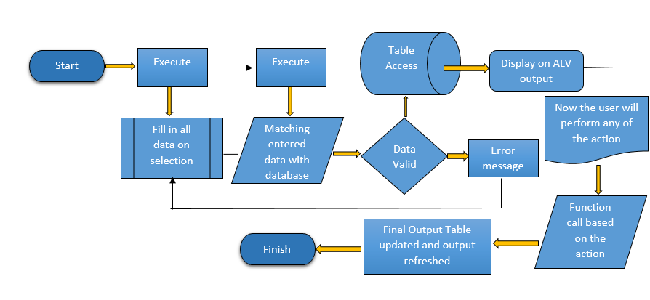

## Process Inputs

Selection Parameters:

Radio Buttons – There will be three options based on the option input parameter.

Input Parameter - User ID’s or TR (Single/list of TR’s)

### Selection Screen

|  |  |  |  |  |  |  |
| --- | --- | --- | --- | --- | --- | --- |
| **Type** | **Field Name** | **Reference** | **OBLIG** | **Default** | **Title** | **Search Help** |
| SEL_OPT | TR | E070-TRKORR | Yes | Blank | Subtask | NA |
| SEL_OPT | User ID | E070-AS4USER | Yes | SY-USER | Owner of the TR | NA |

### Input File Layout

NA

## Solution Detail

All the steps that are shown in the process flow is explained below.

**Step1** – Start the program either by entering TCODE or manually in SE38.

**Step 2** – Select any 1 option and provide the appropriate values (USER ID’s / TR Lists).

**Step 3 –** Now the entered data will be matched with the database whether the data is valid or not this step is the selection screen validation step.

**Step 4 –** If the entered data is valid then further data will be fetched from the base tables e070, e07t, dd07t, V_USR_NAME in to temporary internal tables and then in to final output display table. Else if the data is invalid then control will go back to selection screen with proper error message.

**Step 5 –** The Result will be displayed on the ALV. Now User will perform action as appropriate (Simulate, Change Owner, Release).

**Step 6 –** As per the action standard functions will be called and final output display table will be update with the appropriate results.

**Step 7 –** Now the final result will be refresh on the output table.

### SHDB or BAPI Description

N/A

### Screen Layout

Selection Screen

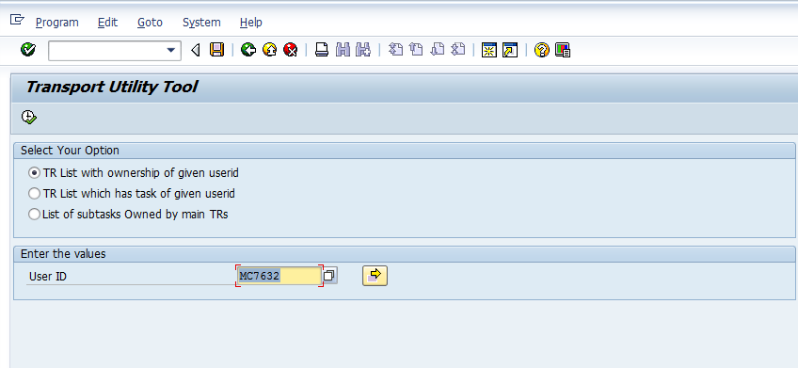

Output Layout

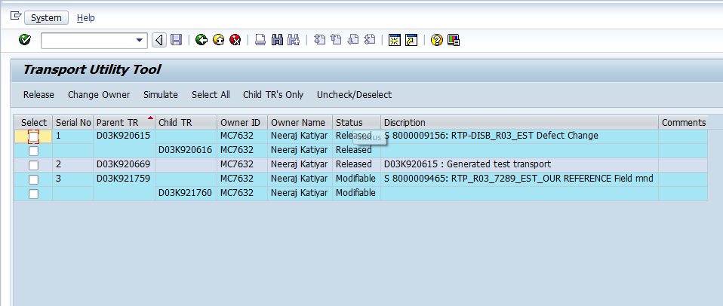

### Processing Type

N/A

# Appendix

## Translation

Not Applicable.

## Reference Documents

Not applicable.

# Version Change Log

|  |  |  |  |
| --- | --- | --- | --- |
| **Version** | **Modified in** | **Responsible** | **Modification** |
| **1.00** | 30-June-2015 | Neeraj Katiyar | Initial creation |