**15.1 Introduction**

**Learning Objectives**

1. Understand the extent of Google’s rapid rise and its size and influence when compared with others in the media industry.
2. Recognize the shift away from traditional advertising media to Internet advertising.
3. Gain insight into the uniqueness and appeal of Google’s corporate culture.

Google has been called a one-trick pony,[[1]](http://catalog.flatworldknowledge.com/bookhub/reader/12375?cid=1681397" \l "ftn.fn-1) but as tricks go, it’s got an exquisite one. Google’s “trick” is matchmaking—pairing Internet surfers with advertisers and taking a cut along the way. This cut is substantial—more than $50 billion in 2012. In fact, as *Wired*’s Steve Levy puts it, Google’s matchmaking capabilities may represent “the most successful business idea in history.”[[2]](http://catalog.flatworldknowledge.com/bookhub/reader/12375?cid=1681397" \l "ftn.fn-2) Google had already grown to earn more annual advertising dollars than *any* U.S. media company. No television network, no magazine group, no newspaper chain brings in more ad bucks than Google. And none is more profitable. While Google’s stated mission is “to organize the world’s information and make it universally accessible and useful,” advertising drives profits and lets the firm offer most of its services for free.

As more people spend more time online, advertisers are shifting spending away from old channels to the Internet; and Google is swallowing the lion’s share of this funds transfer.[[3]](http://catalog.flatworldknowledge.com/bookhub/reader/12375?cid=1681397" \l "ftn.fn-3) By some estimates Google has 76 percent of the search advertising business.[[4]](http://catalog.flatworldknowledge.com/bookhub/reader/12375?cid=1681397" \l "ftn.fn-4) Add to that Google’s lucrative ad network that serves ads to apps and Web sites ranging from small-time bloggers to the *New York Times*, plus Google ad-serving properties like YouTube, Gmail, Google Finance, and Google Maps, and the firm controls nearly half of *all* online advertising dollars.[[5]](http://catalog.flatworldknowledge.com/bookhub/reader/12375?cid=1681397" \l "ftn.fn-5) Facebook, Bing, Yahoo!, AOL, all the ads sold directly by media sites—add up *all* their advertising and together they’re *still* less than Google’s take. Google has one of the world’s strongest brands[[6]](http://catalog.flatworldknowledge.com/bookhub/reader/12375?cid=1681397" \l "ftn.fn-6) (its name is a verb—*just Google it*). It is regularly voted among the best firms to work for in America (topping *Fortune*’s list four times). While rivals continue to innovate (see the box “Search: Google Rules, but It Ain’t Over” in Section 10), Google continues to dominate the search market.

Figure 15.1 U.S. Advertising Spending (by selected media)

[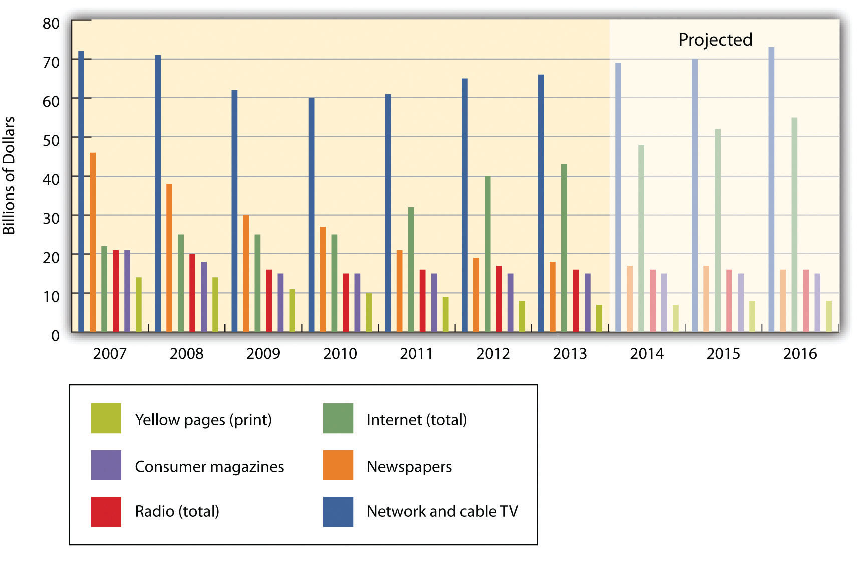](http://images.flatworldknowledge.com/gallaugher_2_0/gallaugher_2_0-fig08_001.jpg)

Over the past several years, online advertising represents the only advertising category that is consistently trending with positive growth.

Source: Data retrieved via eMarketer.com.

Figure 15.2 U.S. Online Ad Spending (by format)

[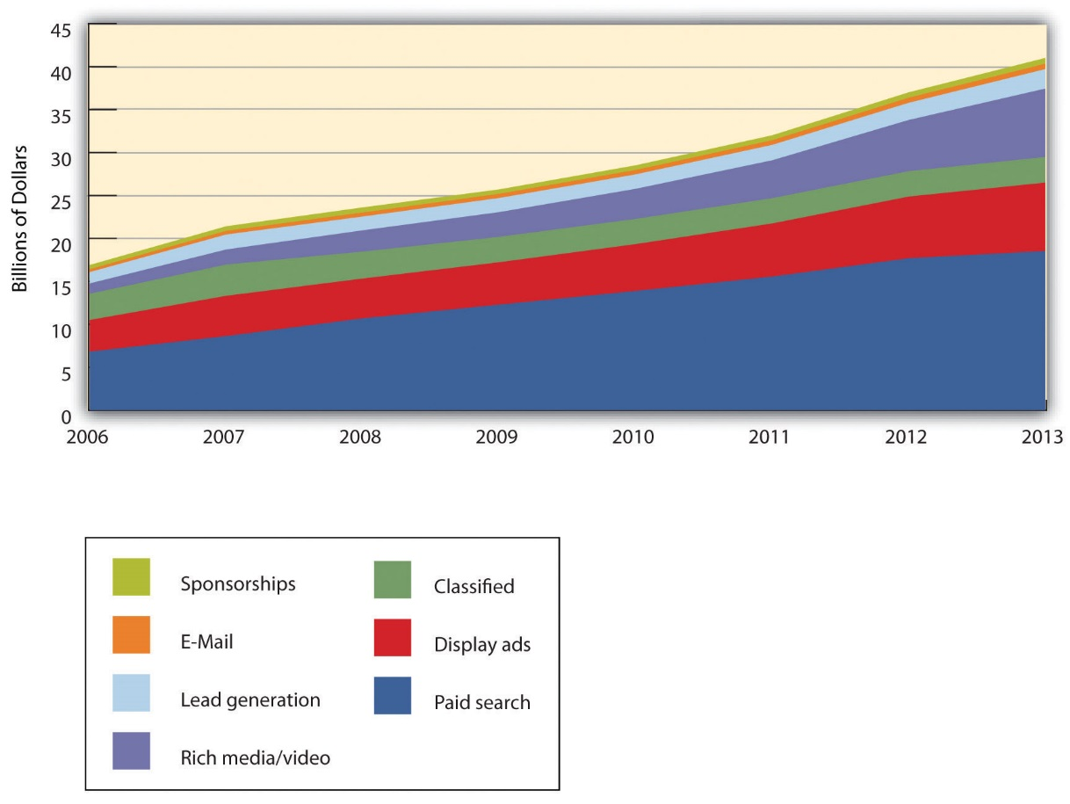](http://images.flatworldknowledge.com/gallaugher_2_0/gallaugher_2_0-fig08_002.jpg)

Search captures the most online ad dollars, and Google dominates search advertising.

Source: Data retrieved via eMarketer.com.

Wall Street has rewarded this success. The firm’s market capitalization (market cap), the value of the firm calculated by multiplying its share price by the number of shares, makes Google the most valuable media company on the planet. The firm’s founding duo, Sergey Brin and Larry Page, are billionaires, regularly appearing near the top of the *Forbes* 400 list of wealthiest Americans. Within five years of going public, Google’s market cap was greater than that of News Corp (which includes all of the Fox Networks, and the *Wall Street Journal*), Disney (including ABC, ESPN, theme parks, and Pixar), Time Warner (*Fortune*, *Time*, *Sports Illustrated*, CNN, and Warner Bros.), Viacom (MTV, VH1, and Nickelodeon), CBS, and the *New York Times*—combined! Just six years after its IPO, Google had become one of the twenty most profitable firms in the United States and was the youngest firm on the list—by far. Not bad for a business started by two twenty-something computer science graduate students.

Figure 15.3 U.S. Search Market Share (Volume of Searches, June 2013)[[7]](http://catalog.flatworldknowledge.com/bookhub/reader/12375?cid=1681397" \l "ftn.fn-7)

[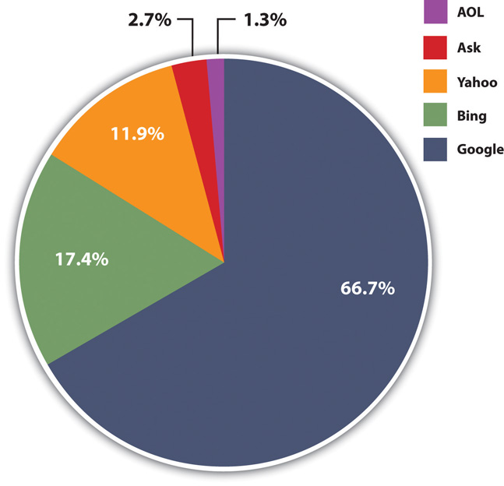](http://images.flatworldknowledge.com/gallaugher_2_0/gallaugher_2_0-fig08_003.jpg)

While the bulk of the firm’s revenues come from advertising, it may no longer be fair to say Google has just “one trick.” The firm is now clearly engaged in a wide-ranging multi-front war that includes mobile, browsers, cloud infrastructure, email, office apps, social media, maps, e-commerce, payments, tablets, television, video, wearable technology, and more. And while the firm’s performance in each space varies, the success of its existing businesses provides a massive cash hoard that allows the firm to fuel experimentation, constantly innovate, tolerate failure, acquire aggressively, and patiently build new markets.

**Genius Geeks and Plum Perks**

Brin and Page have built a talent magnet. At the Googleplex, the firm’s Mountain View, California, headquarters, geeks are lavished with perks that include on-site laundry, massage, carwash, bicycle repair, free haircuts, state of the art gyms, and Wi-Fi equipped shuttles that ferry employees around Silicon Valley and the San Francisco Bay area. The Googleplex is also pretty green. The facility gets 30 percent of its energy from solar cells, representing the largest corporate installation of its kind.[[8]](http://catalog.flatworldknowledge.com/bookhub/reader/12375?cid=1681397" \l "ftn.fn-8)

The firm’s quirky tech-centric culture is evident everywhere. A T-Rex skeleton looms near the volleyball court. Hanging from the lobby ceiling is a replica of SpaceShipOne, the first commercial space vehicle. And visitors to the bathroom will find “testing on the toilet,” coding problems or other brainteasers to keep gray matter humming while seated on one of the firm’s $800 remote-controlled Japanese commodes. Staff also enjoy an A-list lecture series attracting luminaries ranging from celebrities to heads of state.

And of course there’s the food—all of it free. The firm’s founders felt that no employee should be more than 100 feet away from nourishment, and a tour around Google offices will find espresso bars, snack nooks, and fully stocked beverage refrigerators galore. There are eleven gourmet cafeterias on-site, the most famous being “Charlie’s Place,” first run by the former executive chef for the Grateful Dead.

Chairman and former CEO Eric Schmidt said the goal of all this is “to strip away everything that gets in our employees’ way.”[[9]](http://catalog.flatworldknowledge.com/bookhub/reader/12375?cid=1681397" \l "ftn.fn-9) And the perks, culture, and sense of mission have allowed the firm to assemble one of the most impressive rosters of technical talent anywhere. The Googleplex is like a well-fed Manhattan project, and employee ranks have included a gaggle of geniuses that helped invent critical technologies such as the Macintosh user interface, the python programming language, the XML standard, and even the protocols that underlie the Internet itself.

Engineers find Google a particularly attractive place to work, in part due to a corporate policy of offering “20 percent time,” the ability to work the equivalent of one day a week on new projects that interest them. It’s a policy that has fueled innovation. Roughly half of Google products got their start in 20 percent time.[[10]](http://catalog.flatworldknowledge.com/bookhub/reader/12375?cid=1681397" \l "ftn.fn-10)

Studying Google gives us an idea of how quickly technology-fueled market disruptions can happen, and how deeply these disruptions penetrate various industries. You can consider this chapter as consisting of three extended sections. The first part ([Chapter 15, Section 2 "Understanding Search"](http://catalog.flatworldknowledge.com/bookhub/reader/12375?e=fwk-38086-ch08_s02)) covers Google Search, the firm’s core product. The second part ([Chapter 15, Section 3 "Understanding the Increase in Online Ad Spending"](http://catalog.flatworldknowledge.com/bookhub/reader/12375?e=fwk-38086-ch08_s03) through [Chapter 15, Section 9 "Search Engines, Ad Networks, and Fraud"](http://catalog.flatworldknowledge.com/bookhub/reader/12375?e=fwk-38086-ch08_s09)) covers how the firm makes most of its money—advertising. By reading this section you’ll get a solid introduction to various types of online advertising, how customer profiling works, and issues of online privacy and fraud. The last section ([Chapter 15, Section 10 "The Battle Unfolds"](http://catalog.flatworldknowledge.com/bookhub/reader/12375?e=fwk-38086-ch08_s10)) covers the firm’s evolving strategy, its competition with disparate rivals, and the opportunities and challenges the firm faces going forward.

**Key Takeaways**

* Online advertising represents the only advertising category that, over the last several years, has been consistently trending with positive growth.
* Google dominates Internet search volume and controls the lion’s share of the Internet search advertising business and online advertising dollars. The firm also earns more total advertising revenue than any other firm, online or off.
* Google’s market cap makes it the most valuable media company in the world; it has been rated as having one of the world’s strongest brands, and it ranks among the most profitable firms in the United States.

**15.2 Understanding Search**

**Learning Objectives**

1. Understand the mechanics of search, including how Google indexes the Web and ranks its organic search results.
2. Examine the infrastructure that powers Google and how its scale and complexity offer key competitive advantages.

Before diving into how the firm makes money, let’s first understand how Google’s core service, search, works.

Perform a search (or query) on Google or another search engine, and the results you’ll see are referred to by industry professionals as organic or natural search. Search engines use different algorithms for determining the order of organic search results, but at Google the method is called PageRank (a bit of a play on words, it ranks Web pages, and was initially developed by Google cofounder Larry Page). Google does not accept money for placement of links in organic search results. Instead, PageRank results are a kind of popularity contest. Web pages that have more pages *linking to them* are ranked higher (while organic search results can’t be bought, firms do pay for preferred placement in some Google products, including Google Shopping, Hotels, and Flight Search, and in financial products listed in Google Advisor). [[1]](http://catalog.flatworldknowledge.com/bookhub/reader/12375?cid=1681397#ftn.fn-1)

Figure 15.4

[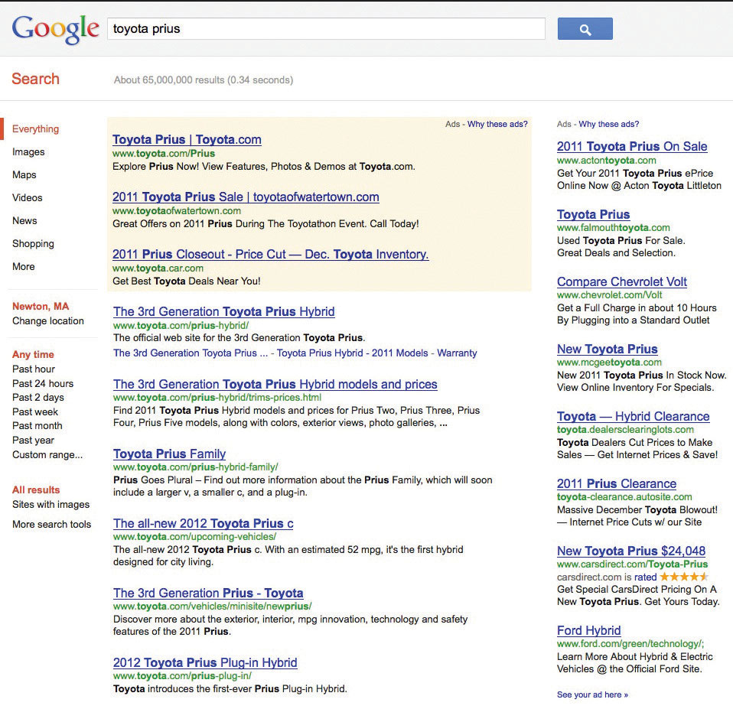](http://images.flatworldknowledge.com/gallaugher_1.4/gallaugher_1.4-fig08_005.jpg)

The query for “Toyota Prius” triggers organic search results, flanked top and right by advertisements.

The process of improving a page’s organic search results is often referred to as search engine optimization (SEO). SEO has become a critical function for many marketing organizations since if a firm’s pages aren’t near the top of search results, customers may never discover its site.

Google is a bit vague about the specifics of precisely how PageRank has been refined, in part because many have tried to game the system. In addition to in-bound links, Google’s organic search results also consider some two hundred other signals, and the firm’s search quality team is relentlessly analyzing user behavior for clues on how to tweak the system to improve accuracy. [[2]](http://catalog.flatworldknowledge.com/bookhub/reader/12375?cid=1681397#ftn.fn-2) The less scrupulous have tried creating a series of bogus Web sites, all linking back to the pages they’re trying to promote (this is called link fraud, and Google actively works to uncover and shut down such efforts—see the “Link Fraudsters” sidebar).

**Link Fraudsters, Be Prepared to Experience Google’s “Death Penalty”**

JCPenney is a big retailer, for sure, but not necessarily the first firm to come to mind when you think of most retail categories. So the *New York Times* suspected that something fishy was up when the retailer’s site came out tops for dozens of Google searches, including the phrases “skinny jeans,” “dresses,” “bedding,” “area rugs,” “home decor,” “comforter sets,” “furniture,” and “table cloths”. The phrase “Samsonite carry-on luggage” even placed Penney ahead of Samsonite’s own site!

The *Times* reported that “someone paid to have thousands of links placed on hundreds of sites scattered around the Web, all of which lead directly to JCPenney.com.” And there was little question it was blatant link fraud. Phrases related to dresses and linking back to the retailer were coming from such nondress sites as nuclear.engineeringaddict.com, casino-focus.com, and bulgariapropertyportal.com. One SEO expert called the effort the most ambitious link farming attempt he’d ever seen.

Link fraud undercuts the credibility of Google’s core search product, so when the search giant discovers a firm engaged in link farming they drop the hammer. In this case Google both manually demoted Penney rankings and launched tweaks to its ranking algorithm. Within two hours JCPenney organic results plummeted, in some cases from first to seventy-first (the *Times* calls this the organic search equivalent of the “death penalty”). Getting a top spot in Google search results is a big deal. On average, 34 percent of clicks go to the top result, about twice the percentage that goes to number two. Google’s punishment was administered despite the fact that Penney was also a large online ad customer, at times paying Google some $2.5 million a month for ads. [[3]](http://catalog.flatworldknowledge.com/bookhub/reader/12375?cid=1681397#ftn.fn-3)

Google is constantly playing defense against firms gaming organic search results. In another example a Brooklyn-based eyewear firm allegedly mistreated customers in order to get more ranking-influencing links (albeit from negative mentions) from service review sites. For a time these associated with bad ratings actually pushed the eyewear firm’s search results *ahead* of rivals, and since users typically focus on the top ranking, many customers went to the firm without seeing the bad reviews (Google has since changed search results to make it difficult to benefit from cultivating negative reviews). The owner of the busted eyewear retailer has also pled guilty to multiple counts, including sending threatening communications, one count of mail fraud, and one count of wire fraud. [[4]](http://catalog.flatworldknowledge.com/bookhub/reader/12375?cid=1681397#ftn.fn-4)

JCPenney isn’t the first firm busted. When Google discovered so-called black hat SEO was being used to push BMW up in organic search rankings, Google made certain BMW sites virtually unfindable in its organic search results. JCPenney claims that they were the victim of rogue behavior by an SEO consultant (who was promptly fired) and that the retailer was otherwise unaware of the unethical behavior. But it is surprising that the retailer’s internal team didn’t see their unbelievably successful organic search results as a red flag that something was amiss, and this case highlights the types of things managers need to watch for in the digital age. Penney outsourced SEO, and the fraud uncovered in this story underscores the critical importance of vetting and regularly auditing the performance of partners throughout a firm’s supply chain. [[5]](http://catalog.flatworldknowledge.com/bookhub/reader/12375?cid=1681397#ftn.fn-5)

While Google doesn’t divulge specifics on the weighting of inbound links from a given Web site, we do know that links from some Web sites carry more weight than others. For example, links from Web sites that Google deems “influential” have greater weight in PageRank calculations than links from run-of-the-mill sites. Additionally, different users might not see identical results in organic search. Google defaults to a mix of rankings that includes individual user behavior and, for those users searching while logged into Google accounts, social connections (although displaying generic results remains an option). [[6]](http://catalog.flatworldknowledge.com/bookhub/reader/12375?cid=1681397#ftn.fn-6)

**Spiders and Bots and Crawlers—Oh My!**

When performing a search via Google or another search engine, you’re not actually searching the Web. What really happens is that you’re searching something that amounts to a *copy* of the Web that major search engines make by storing and indexing the text of online documents on their own computers. Google’s index considers over one trillion URLs. [[7]](http://catalog.flatworldknowledge.com/bookhub/reader/12375?cid=1681397#ftn.fn-7) Google starts to retrieve results as soon as you begin to type, and the upper right-hand corner of a Google query shows you just how fast a search can take place.

To create these massive indexes, search firms use software to crawl the Web and uncover as much information as they can find. This software is referred to by several different names—spiders, Web crawlers, software robots—but they all pretty much work the same way. The spiders ask each public computer network for a list of its public Web sites (for more on this see DNS in [Chapter 13 "A Manager’s Guide to the Internet and Telecommunications"](http://catalog.flatworldknowledge.com/bookhub/reader/12375?e=fwk-38086-ch14)). Then the spiders go through this list (“crawling” a site), following every available link until all pages are uncovered.

Google will crawl frequently updated sites, like those run by news organizations, as often as several times an hour. Rarely updated, less popular sites might only be reindexed every few days. The method used to crawl the Web also means that if a Web site isn’t the first page on a public server, or isn’t linked to from another public page, then it’ll never be found. [[8]](http://catalog.flatworldknowledge.com/bookhub/reader/12375?cid=1681397#ftn.fn-8) Also note that each search engine also offers a page where you can submit your Web site for indexing.

While search engines show you what they’ve found on their *copy* of the Web’s contents; clicking a search result will direct you to the actual Web site, not the copy. But sometimes you’ll click a result only to find that the Web site doesn’t match what the search engine found. This happens if a Web site was updated before your search engine had a chance to reindex the changes. In most cases you can still pull up the search engine’s copy of the page. Just click the “Cached” link below the result (the term cache, which is pronounced “cash,” refers to a temporary storage space used to speed computing tasks).

But what if you want the content on your Web site to remain off limits to search engine indexing and caching? Organizations have created a set of standards to stop the spider crawl, and all commercial search engines have agreed to respect these standards. One way is to put a line of *HTML code* invisibly embedded in a Web page that tells all software robots to stop indexing a page, stop following links on the page, or stop offering old page archives in a cache. Users don’t see this code, but commercial Web crawlers do. For those familiar with HTML code (the language used to describe a Web site), the command to stop Web crawlers from indexing a page, following links, and listing archives of cached pages looks like this:

〈META NAME=“ROBOTS” CONTENT=“NOINDEX, NOFOLLOW, NOARCHIVE”〉

There are other techniques to keep the spiders out, too. Web site administrators can add a special file (called robots.txt) that provides similar instructions on how indexing software should treat the Web site. And a lot of content lies inside the “dark Web,” either behind corporate firewalls or inaccessible to those without a user account—think of private Facebook updates no one can see unless they’re your friend—all of that is out of Google’s reach.

**What’s It Take to Run This Thing?**

Sergey Brin and Larry Page started Google with just four scavenged computers. [[9]](http://catalog.flatworldknowledge.com/bookhub/reader/12375?cid=1681397#ftn.fn-9) But in a decade, the infrastructure used to power the search sovereign has ballooned to the point where it is now the largest of its kind in the world. [[10]](http://catalog.flatworldknowledge.com/bookhub/reader/12375?cid=1681397#ftn.fn-10) Google doesn’t disclose the number of servers it uses, but by some estimates, it runs over 1.4 million servers in over a dozen so-called server farms worldwide.[[11]](http://catalog.flatworldknowledge.com/bookhub/reader/12375?cid=1681397" \l "ftn.fn-11) Google has been known to spend as much as a billion dollars a quarter on data centers.[[12]](http://catalog.flatworldknowledge.com/bookhub/reader/12375?cid=1681397" \l "ftn.fn-12) Building massive server farms to index the ever-growing Web is now the cost of admission for any firm wanting to compete in the search market. This is clearly no longer a game for two graduate students working out of a garage.

Tour a Google Data Center

At the video link that follows, watch a tour of a Google data center. Or visit <http://www.google.com/about/datacenters/inside/streetview> if you’d like to explore one of Google’s data centers using the firm’s Street View technology.

The size of this investment not only creates a barrier to entry, it influences industry profitability, with market-leader Google enjoying huge economies of scale. Firms may spend the same amount to build server farms, but if Google has roughly two-thirds of this market while Microsoft’s search draws just a fraction of this traffic, which do you think enjoys the better return on investment?

The hardware components that power Google aren’t particularly special, but they are custom built to contain just what Google needs and eliminate everything it doesn’t (e.g., no graphic cards, since servers aren’t attached to monitors, or enclosures, since all servers are rack-mounted). In most cases the firm uses the kind of Intel or AMD processors, low-end hard drives, and RAM chips that you’d find in a desktop PC. These components are housed in racks, slotted like very tight shelving. Each server is about 3.5 inches thick yet contains processors, RAM memory, and hard drives.[[13]](http://catalog.flatworldknowledge.com/bookhub/reader/12375?cid=1681397" \l "ftn.fn-13)Google buys so many components for its custom-built servers that it, not a PC manufacturer, is Intel’s fifth largest customer.[[14]](http://catalog.flatworldknowledge.com/bookhub/reader/12375?cid=1681397" \l "ftn.fn-14)

In some cases, Google mounts racks of these servers inside standard-sized shipping containers, each with as many as 1,160 servers per box.[[15]](http://catalog.flatworldknowledge.com/bookhub/reader/12375?cid=1681397" \l "ftn.fn-15) A given data center may have dozens of these server-filled containers all linked together. Redundancy is the name of the game. Google assumes individual components will regularly fail, but no single failure should interrupt the firm’s operations (making the setup what geeks call fault-tolerant). If something breaks, a technician can easily swap it out with a replacement.

Each server farm layout has also been carefully designed with an emphasis on lowering power consumption and cooling requirements. Instead of using big uninterrupted power supply (UPS) systems common in most data centers, Google put smaller battery backups next to each server. These cost less; are more efficient, because they leak about 15 percent less energy than big units; and don’t have heavy cooling costs. Employees usually wear shorts inside the data center since the “cool isle” in the front of machines is around 80° F. The hot aisles venting out the back and cooled via constantly circulating, heat-absorbing water coils can get up to 120°. That’s hotter than most corporate data centers, but Google learned that its systems could take the heat. These practices allow Google to set the bar high for energy efficiency. The standard used to measure data center efficiency is PUE—power usage effectiveness. 1.0 is a perfect score—it means all the power a facility draws is put to use. Everyone loses power. 2.0 (meaning half the power drawn is wasted) is considered a “reasonable number.” Google’s PUE is 1.2—astonishingly high. Saving energy helps the firm meet its green goals—the firm is formally committed to being carbon neutral and offsetting its fossil fuel energy needs—but the data centers also help meet other “green” goals: massive cash savings. The firm’s infrastructure chief claims that the savings through the firm’s ultraefficient data center designs are vital to keeping costs low enough to keep services like Gmail free.[[16]](http://catalog.flatworldknowledge.com/bookhub/reader/12375?cid=1681397" \l "ftn.fn-16)

The firm’s custom software (much of it built upon open source products) allows all this equipment to operate as the world’s largest grid computer. Web search is a task particularly well suited for the massively parallel architecture used by Google and its rivals. For an analogy of how this works, imagine that working alone (the human equivalent of a single-server effort), you need to try to find a particular phrase in a hundred-page document. That’d take a while. Next, imagine that you can distribute the task across five thousand people, giving each of them a separate sentence to scan (that’s the human equivalent of a multi-server grid). The speed difference between a single searching entity and a search involving many entities simultaneously focused on a subset of the same task gives you a sense of how search firms use massive numbers of servers and the divide-and-conquer approach of grid computing to quickly find the needles you’re searching for within the Web’s haystack. (For more on grid computing, see [Chapter 5 "Moore’s Law and More: Fast, Cheap Computing, Disruptive Innovation, and What This Means for the Manager"](http://catalog.flatworldknowledge.com/bookhub/reader/12375?e=fwk-38086-ch04), and for more on the server farms employed by cloud computing providers, see [Chapter 11 "Software in Flux: Partly Cloudy and Sometimes Free"](http://catalog.flatworldknowledge.com/bookhub/reader/12375?e=fwk-38086-ch10).)

All this server farm tech helps Google index over 20 billion Web pages a day and serve up results from over 3 billion daily search queries, in most cases with answers coming before you’re even done typing.[[17]](http://catalog.flatworldknowledge.com/bookhub/reader/12375?cid=1681397" \l "ftn.fn-17) But not all Google-served data comes to you straight from Google’s own server farms. The firm also scatters racks of servers in scores of spots all over the world so that it can quickly get you copies of high-value rich media content, like trending YouTube videos. These mini racks of Google content are tucked away, sometimes within data centers run by big telecom firms like Comcast or AT&T, or kept inside colos (colocation facilities), big warehouse-like facilities where several telecom companies come together to exchange traffic.[[18]](http://catalog.flatworldknowledge.com/bookhub/reader/12375?cid=1681397" \l "ftn.fn-18)

Figure 15.5

[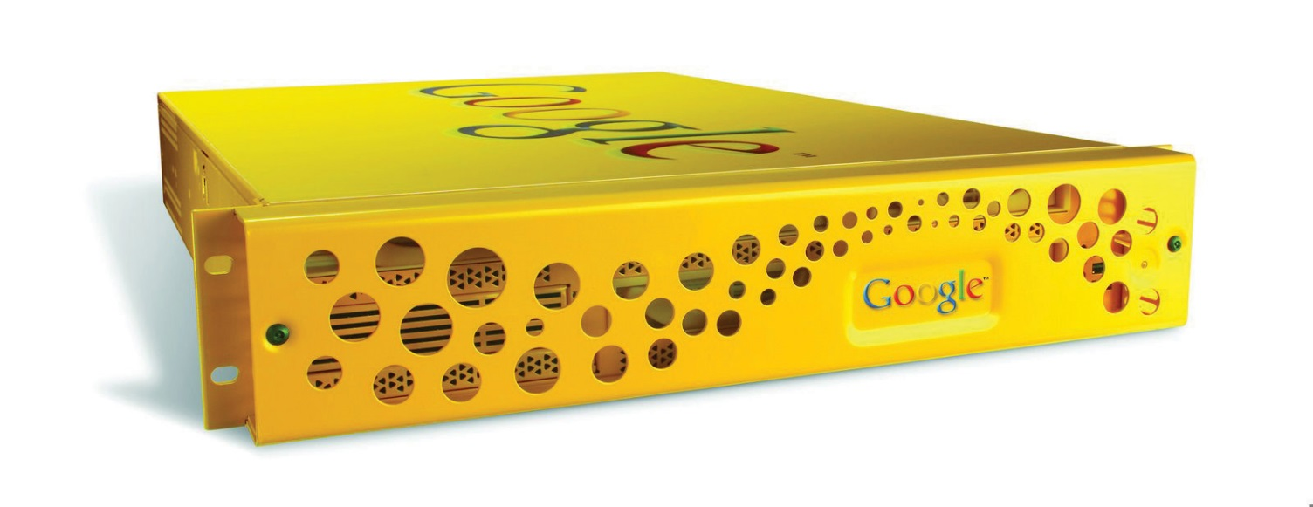](http://images.flatworldknowledge.com/gallaugher_1.3/gallaugher_1.3-fig08_008.jpg)

The Google Search Appliance is a hardware product that firms can purchase in order to run Google search technology within the privacy and security of an organization’s firewall.

Google will even sell you a bit of its technology so that you can run your own little Google in-house without sharing documents with the rest of the world. Google’s line of search appliances are rack-mounted servers that can index documents within the servers on a corporation’s own network, even managing user password and security access on a per-document basis. Selling hardware isn’t a large business for Google, and other vendors offer similar solutions, but search appliances can be vital tools for law firms, investment banks, and other document-rich organizations.

**Trendspotting with Google**

Google not only gives you search results, it lets you see aggregate trends in what its users are searching for, and this can yield powerful insights. For example, by tracking search trends for flu symptoms, Google’s Flu Trends Web site can pinpoint outbreaks one to two weeks faster than the Centers for Disease Control and Prevention.[[19]](http://catalog.flatworldknowledge.com/bookhub/reader/12375?cid=1681397" \l "ftn.fn-19) Want to go beyond the flu? Google’s Trends service allows anyone to explore search trends, breaking out the analysis by region, category (image, news, product), date, and other criteria. Savvy managers can leverage these and similar tools for competitive analysis, comparing a firm, its brands, and its rivals.

Figure 15.6

[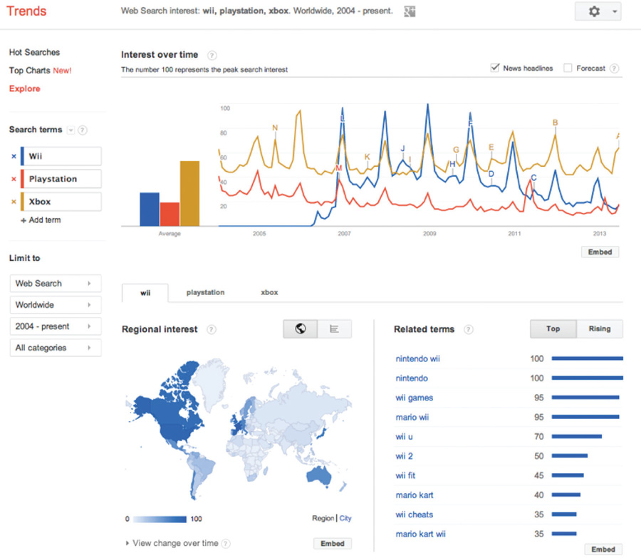](http://images.flatworldknowledge.com/gallaugher_2_0/gallaugher_2_0-fig08_010.jpg)

Google Trends can be a useful tool for competitive analysis and trend discovery. This chart shows a comparison (over a twelve-month period, and geographically) of search interest in the terms Wii, Playstation, and Xbox.

**Key Takeaways**

* Ranked search results are often referred to as organic or natural search. PageRank is Google’s algorithm for ranking search results. PageRank orders organic search results based largely on the number of Web sites linking to them, and the “weight” of each page as measured by its “influence.”
* Search engine optimization (SEO) is the process of using natural or organic search to increase a Web site’s traffic volume and visitor quality. The scope and influence of search has made SEO an increasingly vital marketing function.
* Users don’t really search the Web; they search an archived copy stored on a search firm’s computers. A firm creates such a copy by crawling and indexing discoverable documents.
* Google operates from a massive network of server farms containing hundreds of thousands of servers built from standard, off-the-shelf parts. The cost of the operation is a significant barrier to entry for competitors. Google’s share of search suggests the firm can realize economies of scales over rivals required to make similar investments while delivering fewer results (and hence ads).
* Web site owners can hide pages from popular search engine Web crawlers using a number of methods, including HTML tags, a no-index file, or ensuring that Web sites aren’t linked to other pages and haven’t been submitted to Web sites for indexing.

**15.3 Understanding the Increase in Online Ad Spending**

**Learning Objectives**

1. Understand how media consumption habits are shifting.
2. Be able to explain the factors behind the growth and appeal of online advertising.

For several years, Internet advertising has been the only major media ad category to show significant growth. There are three factors driving online ad growth trends: (1) increased user time online, (2) improved measurement and accountability, and (3) targeting.

American teenagers (as well as the average British, Australian, and New Zealander Web surfer) now spend more time on the Internet than watching television. [[1]](http://catalog.flatworldknowledge.com/bookhub/reader/12375?cid=1681397#ftn.fn-1) They’re reading fewer print publications, and radio listening among the iPod and Spotify generation is down 30 percent. [[2]](http://catalog.flatworldknowledge.com/bookhub/reader/12375?cid=1681397#ftn.fn-2) So advertisers are simply following the market. Online channels also provide advertisers with a way to reach consumers at work—something that was previously much more difficult to do.

Many advertisers have also been frustrated by how difficult it’s been to gauge the effectiveness of traditional ad channels such as TV, print, and radio. This frustration is reflected in the old industry saying, “I know that half of my advertising is working—I just don’t know which half.” Well, with the Internet, now you know. While measurement technologies aren’t perfect, advertisers can now count ad impressions (the number of times an ad is shown on a Web site), whether a user clicks on an ad, and the product purchases or other Web site activity that comes from those clicks. [[3]](http://catalog.flatworldknowledge.com/bookhub/reader/12375?cid=1681397#ftn.fn-3) And as we’ll see, many online ad payment schemes are directly linked to ad performance.

Various technologies and techniques also make it easier for firms to target users based on how likely a person is to respond to an ad. In theory a firm can use targeting to spend marketing dollars only on those users deemed to be its best prospects. Let’s look at a few of these approaches in action.

**Key Takeaways**

* There are three reasons driving online ad growth trends: (1) increasing user time online, (2) improved measurement and accountability, and (3) targeting.
* Digital media is decreasing time spent through traditional media consumption channels (e.g., radio, TV, newspapers), potentially lowering the audience reach of these old channels and making them less attractive for advertisers.
* Measurement techniques allow advertisers to track the performance of their ads—indicating things such as how often an ad is displayed, how often an ad is clicked, where an ad was displayed when it was clicked, and more. Measurement metrics can be linked to payment schemes, improving return on investment (ROI) and accountability compared to many types of conventional advertising.
* Advertising ROI can be improved through targeting. Targeting allows a firm to serve ads to specific categories of users, so firms can send ads to groups it is most interested in reaching, and those that are most likely to respond to an effort.

**15.4 Search Advertising**

**Learning Objectives**

1. Understand Google’s search advertising revenue model.
2. Know the factors that determine the display and ranking of advertisements appearing on Google’s search results pages.
3. Be able to describe the uses and technologies behind geotargeting.

The practice of running and optimizing search engine ad campaigns is referred to as search engine marketing (SEM). [[1]](http://catalog.flatworldknowledge.com/bookhub/reader/12375?cid=1681397#ftn.fn-1) SEM is a hot topic in an increasingly influential field, so it’s worth spending some time learning how search advertising works on the Internet’s largest search engine.

Over two-thirds of Google’s revenues come from ads served on its own sites, and the vast majority of this revenue comes from search engine ads. [[2]](http://catalog.flatworldknowledge.com/bookhub/reader/12375?cid=1681397#ftn.fn-2)  During Google’s early years, the firm actually resisted making money through ads. In fact, while at Stanford, Brin and Page even coauthored a paper titled “The Evils of Advertising.” [[3]](http://catalog.flatworldknowledge.com/bookhub/reader/12375?cid=1681397#ftn.fn-3)  But when Yahoo! and others balked at buying Google’s search technology (offered for as little as $500,000), Google needed to explore additional revenue streams. It wasn’t until two years after incorporation that Google ran ads alongside organic search results. That first ad, one for “Live Mail Order Lobsters,” appeared just minutes after the firm posted a link reading “See Your Ad Here”. [[4]](http://catalog.flatworldknowledge.com/bookhub/reader/12375?cid=1681397#ftn.fn-4)

Google has only recently experimented with incorporating video and image ads into search, but for the most part, the ads you’ll see to the right (and sometimes top) of Google’s organic search results are text ads. These ads are keyword advertising, meaning they’re targeted based on the words in a user’s search query. Advertisers bid on the keywords and phrases that they’d like to use to trigger the display of their ad. Linking ads to search was a brilliant move, since the user’s search term indicates an overt interest in a given topic. Want to sell hotel stays in Tahiti? Link your ads to the search term “Tahiti Vacation.” Google ads show up when many users have some sort of *purchasing intent*. This makes Google search ads far more effective than standard display ads like those on Facebook (see [Chapter 9 "Facebook: Building a Business from the Social Graph"](http://catalog.flatworldknowledge.com/bookhub/reader/12375?e=fwk-38086-ch07) for a more detailed comparison of the two firms). Google’s ability to tie advertising to purchasing intent (or to some other action that advertisers are willing to pay for) is the main reason the firm’s ads are so valuable.

Not only are search ads highly targeted, advertisers only pay for results. Text ads appearing on Google search pages are billed on a pay-per-click (PPC) basis, meaning that advertisers don’t spend a penny unless someone actually clicks on their ad. Note that the term pay-per-click is sometimes used interchangeably with the term cost-per-click (CPC).

**Not Entirely Google’s Idea**

Google didn’t invent pay-for-performance search advertising. A firm named GoTo.com (later renamed Overture) pioneered pay-per-click ads and bidding systems and held several key patents governing the technology. Overture provided pay-per-click ad services to both Yahoo! and Microsoft, but it failed to refine and match the killer combination of ad auctions and search technology that made Google a star. Yahoo! eventually bought Overture and sued Google for patent infringement. The two firms settled, with Google giving Yahoo! 2.7 million shares in exchange for a “fully paid, perpetual license” to over sixty Overture patents. [[5]](http://catalog.flatworldknowledge.com/bookhub/reader/12375?cid=1681397#ftn.fn-5)

If an advertiser wants to display an ad on Google search, they can set up a Google AdWords advertising account in minutes, specifying just a single ad, or multiple ad campaigns that trigger different ads for different keywords. Advertisers also specify what they’re willing to pay each time an ad is clicked, how much their overall ad budget is, and they can control additional parameters, such as the timing and duration of an ad campaign.

If no one clicks on an ad, Google doesn’t make money, advertisers don’t attract customers, and searchers aren’t seeing ads they’re interested in. So in order to create a winning scenario for everyone, Google has developed a precise ad ranking formula that rewards top performing ads by considering two metrics: the maximum CPC that an advertiser is willing to pay, and the advertisement’s quality score—a broad measure of ad performance. Create high quality ads and your advertisements might appear ahead of competition, even if your competitors bid more than you. But if ads perform poorly they’ll fall in rankings or even drop from display consideration.

Below is the formula used by Google to determine the rank order of sponsored links appearing on search results pages.

Ad Rank = Maximum CPC × Quality Score

Google is deliberately vague about precisely how quality score is calculated, and the firm’s metrics are regularly tweaked, but factors that determine an ad’s quality score have included an ad’s click-through rate (CTR), or the number of users who clicked an ad divided by the number of times the ad was delivered (the impressions). The CTR measures the percentage of people who clicked on an ad to arrive at a destination-site. Also included in a quality score are the overall history of click performance for the keywords linked to the ad, the relevance of an ad’s text to the user’s query, and Google’s automated assessment of the user experience on the landing page—the Web page displayed when a user clicks on the ad. Ads that don’t get many clicks, ad descriptions that have nothing to do with query terms, and ads that direct users to generic pages that load slowly or aren’t strongly related to the keywords and descriptions used in an ad will all lower an ad’s chance of being displayed. [[6]](http://catalog.flatworldknowledge.com/bookhub/reader/12375?cid=1681397#ftn.fn-6)

Google provides tools that firms can use to identify popular words and phrases for selecting keywords to associate with an ad. And Google also offers dynamic search ads, where the firm will automatically generate ads based on your Web site. This is useful if you have a constantly changing and updating inventory or are having difficulty tracking the ever-evolving search terms that may be relevant to users looking for products and services that your site offers.

When an ad is clicked, advertisers don’t actually pay their maximum CPC; Google discounts ads to just one cent more than the minimum necessary to maintain an ad’s position on the page. So if you bid one dollar per click, but the ad ranked below you bids ninety cents, you’ll pay just ninety-one cents if the ad is clicked. Discounting was a brilliant move. No one wants to get caught excessively overbidding rivals, so discounting helps reduce the possibility of this so-called bidder’s remorse. And with this risk minimized, the system actually encouraged higher bids! [[7]](http://catalog.flatworldknowledge.com/bookhub/reader/12375?cid=1681397#ftn.fn-7)

Ad ranking and cost-per-click calculations take place as part of an automated auction that occurs *every time* a user conducts a search. Advertisers get a running total of ad performance statistics so that they can monitor the return on their investment and tweak promotional efforts for better results. And this whole system is automated for self-service—all it takes is a credit card, an ad idea, and you’re ready to go.

**How Much Do Advertisers Pay per Click?**

Google rakes in billions on what amounts to pocket change earned one click at a time. Most clicks bring in between thirty cents and one dollar. However, costs can vary widely depending on industry and current competition. [Table 15.1 "Most Expensive Industries for Keyword Ads"](http://catalog.flatworldknowledge.com/bookhub/reader/12375?cid=1681397#fwk-38086-ch08_s04_s01_t01) shows some of the highest reported CPC rates across several. Since rates are based on auctions, top rates reflect what the market is willing to bear. As an example, law firms, which bring in big bucks from legal fees, decisions, and settlement payments, often justify higher customer acquisition costs. As of May 2013, the top twelve most expensive keywords were all associated with mesothelioma, a type of cancer-associated asbestos and the subject of several big money lawsuits. Single CPC ranged from an astonishing $246.60 to $370.53. [[8]](http://catalog.flatworldknowledge.com/bookhub/reader/12375?cid=1681397#ftn.fn-8) And firms that see results will keep spending. Los Angeles–based Chase Law Group has said that it brings in roughly 60 percent of its clients through Internet advertising. [[9]](http://catalog.flatworldknowledge.com/bookhub/reader/12375?cid=1681397#ftn.fn-9)

Table 15.1 Most Expensive Industries for Keyword Ads

| **Business/Industry** | **Keywords in the Top 100** | **Average CPC** |
| --- | --- | --- |
| Asbestos Lawyers | 12 | $68.03 |
| Mesothelioma Lawyers | 65 | $67.18 |
| Structured Settlements | 8 | $63.48 |
| DUI Lawyers | 14 | $62.64 |
| Criminal Defense Lawyers | 1 | $59.69 |

Source: Consolidated from SpyFu.com, June 2011.

[Table 15.2 "Big Spenders: Top AdWords Spenders Ranked by Daily Budget"](http://catalog.flatworldknowledge.com/bookhub/reader/12375?cid=1681397#fwk-38086-ch08_s04_s01_t02) shows a snapshot of the amount of money shelled out in the daily campaigns run by some of Google’s biggest customers. CPC rates here are much lower, but these firms run many more ads in total. Remember—any rankings fluctuate in real time based on auction participants, but you can see that at the time this data was gathered, for-profit education, e-commerce, and finance firms were among the biggest Google spenders.

Table 15.2 Big Spenders: Top AdWords Spenders Ranked by Daily Budget

| **Rank** | **Domain** | **Daily Budget** |
| --- | --- | --- |
| 1 | phoenix.edu | $519,446.94 |
| 2 | geico.com | $493,062.77 |
| 3 | progressive.com | $259,062.19 |
| 4 | amazon.com | $229,668.88 |
| 5 | ask.com | $205,592.18 |
| 6 | classesusa.com | $204,731.03 |
| 7 | google.com | $174,070.39 |
| 8 | quickenloans.com | $169,657.71 |
| 9 | att.com | $160,201.82 |
| 10 | waldenu.edu | $156,784.95 |
| 11 | devry.edu | $151,346.75 |
| 12 | expedia.com | $139,912.63 |
| 13 | homedepot.com | $131,065.42 |
| 14 | itt-tech.edu | $127,047.58 |
| 15 | americanexpress.com | $119,471.74 |

Source: SpyFu.com, May 2013.

**IP Addresses and Geotargeting**

Geotargeting occurs when computer systems identify a user’s physical location (sometimes called the *geolocation*) for the purpose of delivering tailored ads or other content. On Google AdWords, for example, advertisers can specify that their ads only appear for Web surfers located in a particular country, state, metropolitan region, or a given distance around a precise locale. They can even draw a custom ad-targeting region on a map and tell Google to only show ads to users detected inside that space.

Ads in Google Search (as well as in Maps and many other offerings) can be geotargeted based on IP address. Every device connected to the Internet has a unique IP address assigned by the organization connecting the device to the network. Normally you don’t see your IP address. It’s likely a set of four numbers, from 0 to 255, separated by periods (e.g., 136.167.2.220), but this standard (known as IPv4) is gradually being replaced by the IPv6 standard, which offers far more potential addresses. IP addresses are used in targeting because the range of IP addresses “owned” by major organizations and Internet service providers (ISPs) is public knowledge. In many cases it’s possible to make an accurate guess as to where a computer, laptop, or mobile phone is located simply by cross-referencing a device’s current IP address with this public list.

For example, it’s known that all devices connected to the Boston College network contain IP addresses starting with the numbers 136.167. If a search engine detects a query coming from an IP address that begins with those two numbers, it can be fairly certain that the person using that device is in the greater Boston area.

Figure 15.7

[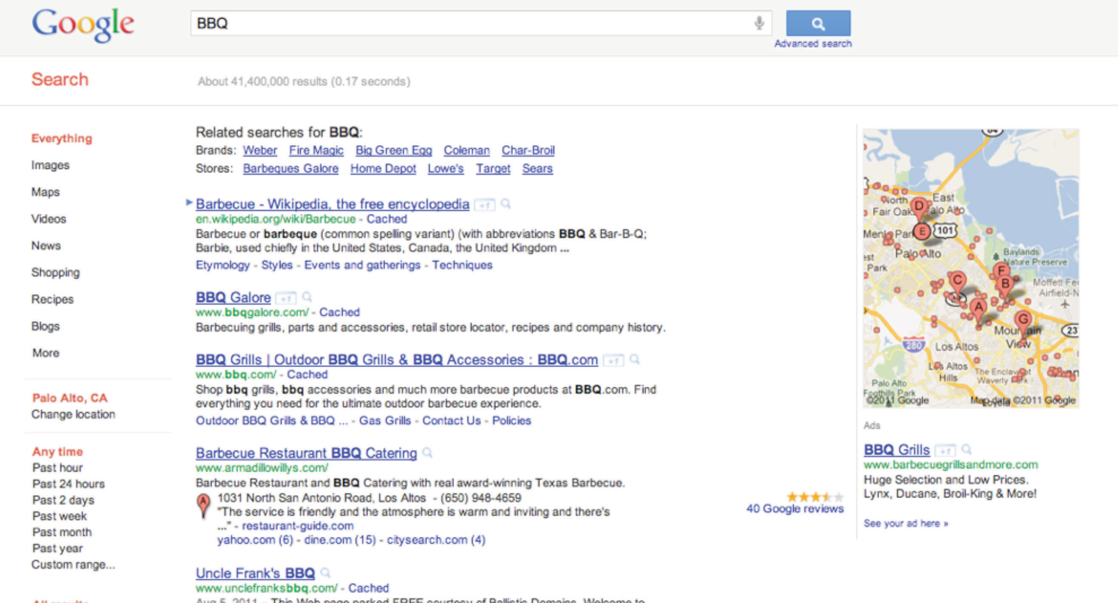](http://images.flatworldknowledge.com/gallaugher_1.4/gallaugher_1.4-fig08_011.jpg)

Figure 15.8

[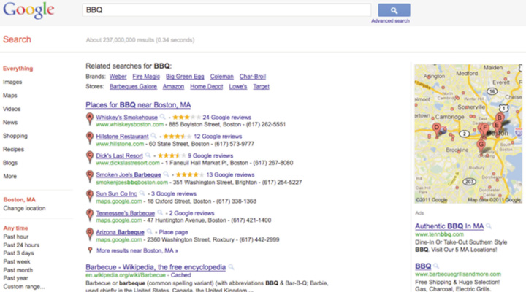](http://images.flatworldknowledge.com/gallaugher_2_0/gallaugher_2_0-fig08_012.jpg)

In this geotargeting example, the same search term is used at roughly the same time on separate computers located in Silicon Valley area (first image) and Boston (second image). Note how geotargeting impacts the search results and that the Boston-based search includes a geotargeted ad that does not show up in the Palo Alto search.

IP addresses will change depending on how and where you connect to the Internet. Connect your laptop to a hotel’s Wi-Fi when visiting a new city, and you’re likely to see ads specific to that location. That’s because your Internet service provider has changed, and the firm serving your ads has detected that you are using an IP address known to be associated with your new location.

Geotargeting via IP address is fairly accurate, but it’s not perfect. For example, some Internet service providers may provide imprecise or inaccurate information on the location of their networks. Others might be so vague that it’s difficult to make a best guess at the geography behind a set of numbers (values assigned by a multinational corporation with many locations, for example). And there are other ways locations are hidden, such as when Internet users connect to proxy servers, third-party computers that pass traffic to and from a specific address without revealing the address of the connected users.

**What’s My IP Address?**

While every operating system has a control panel or command that you can use to find your current IP address, there are also several Web sites that will quickly return this value (and a best guess at your current location). One such site is <http://ip-adress.com> (note the spelling has only one “d”). Visit this or a similar site with a desktop, laptop, and mobile phone. Do the results differ and are they accurate? Why?

**Geotargeting Evolves Beyond the IP Address**

There are several other methods of geotargeting. Firms like Skyhook Wireless, Apple, and Google can identify a location based on mapping Wi-Fi hotspots and nearby cell towers. Many mobile devices come equipped with global positioning system (GPS) chips (identifying location via the GPS satellite network). And if a user provides location values such as a home address or zip code to a Web site, then that value might be stored and used again to make a future guess at a user’s location.

Many firms build and maintain accurate location databases by regularly collecting location information from smartphones and using this data to refine maps. Phones submit data anonymously; however, this process can be controversial.

**Key Takeaways**

* More than two-thirds of Google’s revenues come from ads served on its own sites, and the vast majority of this revenue comes from search engine ads.
* Search ads on Google are both more effective (in terms of click-through rate) and more sought after by advertisers, because they are often associated with a user’s purchasing intent.
* Advertisers choose and bid on the keywords and phrases that they’d like to use to trigger the display of their ad.
* Advertisers pay for cost-per-click advertising only if an ad is clicked on. Google makes no money on CPC ads that are displayed but not clicked.
* Google determines ad rank by multiplying CPC by Quality Score. Ads with low ranks might not display at all.
* Advertisers usually don’t pay their maximum CPC. Instead, Google discounts ads to just one cent more than the minimum necessary to maintain an ad’s position on the page—a practice that encourages higher bids.
* Geotargeting occurs when computer systems identify a user’s physical location (sometimes called geolocation) for the purpose of delivering tailored ads or other content.
* Google uses IP addresses to target ads.
* Geotargeting can also be enabled by the satellite-based global positioning system (GPS) or based on estimating location from cell phone towers or Wi-Fi hotspots.

**15.5 Ad Networks—Distribution beyond Search**

**Learning Objectives**

1. Understand ad networks, and how ads are distributed and served based on Web site content.
2. Recognize how ad networks provide advertiser reach and support niche content providers.
3. Be aware of content adjacency problems and their implications.
4. Know the strategic factors behind ad network appeal and success.

Google runs ads not just in search, but also across a host of Google-owned sites like Gmail, Google News, and Blogger. It will even tailor ads for its map products and for mobile devices. But about 30 percent of Google’s revenues come from running ads on Web sites that the firm doesn’t even own. [[1]](http://catalog.flatworldknowledge.com/bookhub/reader/12375?cid=1681397#ftn.fn-1)

Next time you’re surfing online, look around the different Web sites that you visit and see how many sport boxes labeled “Ads by Google.” Those Web sites are participating in Google’s ad network, which means they’re running ads for Google in exchange for a cut of the take. Participants range from small-time bloggers to some of the world’s most highly trafficked sites. Google lines up the advertisers, provides the targeting technology, serves the ads, and handles advertiser payment collection. To participate, content providers just sign up online, put a bit of Google-supplied HTML code on their pages, and wait for Google to send them cash (Web sites typically get about seventy to eighty cents for every AdSense dollar that Google collects). [[2]](http://catalog.flatworldknowledge.com/bookhub/reader/12375?cid=1681397#ftn.fn-2)

Google originally developed AdSense to target ads based on keywords automatically detected inside the content of a Web site. A blog post on your favorite sports team, for example, might be accompanied by ads from ticket sellers or sports memorabilia vendors. AdSense and similar online ad networks provide advertisers with access to the long tail of niche Web sites by offering both increased opportunities for ad exposure as well as more-refined targeting opportunities.

Figure 15.9

[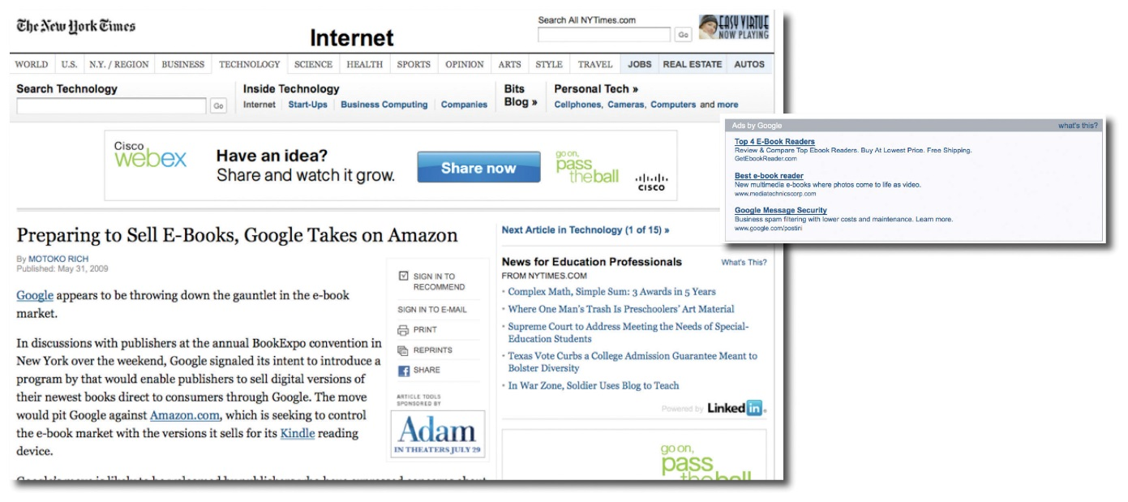](http://images.flatworldknowledge.com/gallaugher_1.4/gallaugher_1.4-fig08_013.jpg)

The images show advertising embedded around a story on the *New York Times* Web site. The page runs several ads provided by different ad networks. For example, the WebEx banner ad above the article’s headline was served by the AOL Advertising network. The “Ads by Google” box appeared at the end of the article. Note how the Google ads are related to the content of the *Times* article.

Some 65 percent of the top 200 ad-supported Web sites use AdSense for at least a portion of their ad revenue. [[3]](http://catalog.flatworldknowledge.com/bookhub/reader/12375?cid=1681397#ftn.fn-3) In 2012, Google’s AdSense program forked over $7 billion to more than 2 million publishers. There are now quite a few AdSense millionaires. [[4]](http://catalog.flatworldknowledge.com/bookhub/reader/12375?cid=1681397#ftn.fn-4) Running ads on your Web site is by no means a guaranteed path to profits. The Internet graveyard is full of firms that thought they’d be able to sustain their businesses on ads alone. But for many Web sites, ad networks can be like oxygen, sustaining them with revenue opportunities they’d never be able to achieve on their own.

AdSense content publishers ranging from the history buff behind HistoryOrb.com to the green-thumbed, silver-haired schoolteacher heading MooseysCountryGarden.com have quit their day jobs and now live off of their AdSense-fueled businesses. Handyman column writer Tim Carter saw his first-year AdSense income leap to more than $350,000. [[5]](http://catalog.flatworldknowledge.com/bookhub/reader/12375?cid=1681397#ftn.fn-5) AdSense even provided early revenue for the multimillion-dollar *TechCrunch* media empire (now owned by AOL).

Figure 15.10

[](http://images.flatworldknowledge.com/gallaugher_2_0/gallaugher_2_0-fig08_014.jpg)

Tim Carter’s Ask the Builder Web site runs ads from Google and other ad networks. Note different ad formats surrounding the content. Video ads are also integrated into many of the site’s video tutorials.

**Beware the Content Adjacency Problem**

Contextual advertising based on keywords is lucrative, but like all technology solutions it has its limitations. Vendors sometimes suffer from content adjacency problems when ads appear alongside text they’d prefer to avoid. In one particularly embarrassing example, a *New York Post* article detailed a gruesome murder where hacked up body parts were stowed in suitcases. The online version of the article included contextual advertising and was accompanied by…luggage ads. [[6]](http://catalog.flatworldknowledge.com/bookhub/reader/12375?cid=1681397#ftn.fn-6)

To combat embarrassment, ad networks provide opportunities for both advertisers and content providers to screen out potentially undesirable pairings based on factors like vendor, Web site, and category. Advertisers can also use negative keywords, which tell networks to avoid showing ads when specific words appear (e.g., setting negative keywords to “murder” or “killer” could have spared luggage advertisers from the embarrassing problem mentioned above). Ad networks also refine ad-placement software based on feedback from prior incidents (for more on content adjacency problems, see [Chapter 9 "Facebook: Building a Business from the Social Graph"](http://catalog.flatworldknowledge.com/bookhub/reader/12375?e=fwk-38086-ch07)).

Google bundles its third-party AdSense partners in with its own content properties (e.g. YouTube, Google Finance, Blogger, Gmail), calling this big pool of distribution for your ads the Google Display Network. And Google is by no means the only company to run an ad network; nor was it the first to come up with the idea. Rivals include AOL’s Advertising.com and a joint effort by Yahoo! and Microsoft Bing. Advertisers also aren’t limited to choosing just one ad network. In fact, many Web sites will serve ads from several ad networks (as well as exclusive space sold by their own sales force), oftentimes mixing several different offerings on the same page.

**Ad Networks and Competitive Advantage**

While advertisers can use multiple ad networks, there are several key strategic factors driving the industry. For Google, its ad network is a distribution play. The ability to reach more potential customers across more Web sites attracts more advertisers to Google. And content providers (the Web sites that distribute these ads) want there to be as many advertisers as possible in the ad networks that they join, since this should increase the price of advertising, the number of ads served, and the accuracy of user targeting. If advertisers attract content providers, which in turn attract more advertisers, then we’ve just described network effects! More participants bringing in more revenue also help the firm benefit from scale economies—offering a better return on investment from its ad technology and infrastructure. No wonder Google’s been on such a tear—the firm’s loaded with assets for competitive advantage!

**Key Takeaways**

* Google also serves ads through non-Google partner sites that join its ad network. These partners distribute ads for Google in exchange for a percentage of the take.
* AdSense ads are targeted based on keywords that Google detects inside the content of a Web site.
* AdSense and similar online ad networks provide advertisers with access to the long tail of niche Web sites.
* Ad networks handle advertiser recruitment, ad serving, and revenue collection, opening up revenue earning possibilities to even the smallest publishers.

**15.6 More Ad Formats and Payment Schemes**

**Learning Objectives**

1. Know the different formats and media types that Web ads can be displayed in.
2. Know the different ways ads are sold.
3. Know that games can be an ad channel under the correct conditions.

Online ads aren’t just about text ads billed in CPC. Ads running through the Google Display Network, or on most competitor networks can be displayed in several formats and media types, and can be billed in different ways. The specific ad formats supported depend on the ad network but can include the following: image (or display) ads (such as horizontally oriented banners, smaller rectangular buttons, and vertically oriented “skyscraper” ads); rich media ads (which can include animation or video and sometimes encourage user engagement or interaction); and interstitials (ads that run before a user arrives at a Web site’s contents). The industry trade group, the Internet Advertising Bureau (IAB) sets common standards for display ads so that a single creative (the design and content of the advertisement) can run unmodified across multiple ad networks and Web sites. [[1]](http://catalog.flatworldknowledge.com/bookhub/reader/12375?cid=1681397#ftn.fn-1)

And there are lots of other ways ads are sold besides cost-per-click. Most graphical display ads are sold according to the number of times the ad appears (the impression). Ad rates are quoted in CPM, meaning cost per thousand impressions (the M representing the roman numeral for one thousand). Display ads sold on a CPM basis are often used as part of branding campaigns targeted more at creating awareness than generating click-throughs. Such techniques often work best for promoting products like soft drinks, toothpaste, or movies.

Cost-per-action (CPA) ads pay whenever a user clicks through and performs a specified action such as signing up for a service, requesting material, or making a purchase. Affiliate programs are a form of cost-per-action, where vendors share a percentage of revenue with Web sites that direct purchasing customers to their online storefronts. Amazon runs the world’s largest affiliate program, and referring sites can earn 4 percent to 15 percent of sales generated from these click-throughs. Purists might not consider affiliate programs as advertising (rather than text or banner ads, Amazon’s affiliates offer links and product descriptions that point back to Amazon’s Web site), but these programs can be important tools in a firm’s promotional arsenal.

And rather than buying targeted ads, a firm might sometimes opt to become an exclusive advertiser on a site. For example, a firm could buy access to all ads served on a site’s main page; it could secure exclusive access to a region of the page (such as the topmost banner ad); or it may pay to sponsor a particular portion or activity on a Web site (say a parenting forum, or a “click-to-print” button). Such deals can be billed based on a flat rate, CPM, CPC, or any combination of metrics.

**Ads in Games?**

As consumers spend more time in video games, it’s only natural that these products become ad channels, too. Finding a way to introduce ads without eroding the game experience can be a challenge. Advertising can work in racing or other sports games (the Obama campaign famously ran virtual billboards in EA’s Burnout Paradise), but ads make less sense for games set in the past, future, or on other worlds. Branding ads often work best since click-throughs are typically not something you want disrupting your gaming experience.

Advertisers have also explored sponsorships of Web-based and mobile games. Sponsorships often work best with casual games, such as those offered on Yahoo! Games or EA’s Pogo. Firms have also created online mini games (so-called *advergames*) for longer term, immersive brand engagement (e.g., Mini Cooper’s Slide Parking and Stride Gum’s Chew Challenge). Others have tried a sort of virtual product placement integrated into experiences. A version of The Sims, for example, included virtual replicas of real-world inventory from IKEA and H&M. And Zynga has done a variety of in-game promotions that include work with Lady Gaga in Farmville and CityVille promotions of Kung Fu Panda 2.

Figure 15.11 Obama Campaign’s Virtual Billboard in EA’s Burnout Paradise

[](http://images.flatworldknowledge.com/gallaugher_1.4/gallaugher_1.4-fig08_017.jpg)

Source: Barack Obama U.S. Presidential Campaign Team, 2008.

In-game ad-serving technology also lacks the widely accepted standards of Web-based ads, so it’s unlikely that ads designed for a Wii sports game could translate into a PS4 first-person shooter.

In-game advertising shows promise, but the medium is considerably more complicated than conventional Web site ads. That complexity lowers relative ROI and will likely continue to constrain growth. As a sign of the difficulty in the space, consider that Microsoft shuttered its in-game advertising unit, Massive, just four years after acquiring the firm for an estimated $200 million to $400 million. [[2]](http://catalog.flatworldknowledge.com/bookhub/reader/12375?cid=1681397#ftn.fn-2) Game maker King.com, the firm behind Candy Crush Saga (which overtook Angry Birds and led it to become the world’s most popular game [[3]](http://catalog.flatworldknowledge.com/bookhub/reader/12375?cid=1681397#ftn.fn-3)), has also pulled advertising from all of its games to focus resources on the far-more lucrative market for in-app purchases. [[4]](http://catalog.flatworldknowledge.com/bookhub/reader/12375?cid=1681397#ftn.fn-4)

**Key Takeaways**

* Web ad formats include, but are not limited to, the following: *image* (or *display*) *ads* (such as horizontally oriented *banners*, smaller rectangular *buttons*, and vertically oriented *skyscraper ads*), *rich media ads* (which can include animation or video), and *interstitials* (ads that run before a user arrives at a Web site’s contents).
* In addition to cost-per-click, ads can be sold based on the number of times the ad appears (impressions); whenever a user performs a specified action such as signing up for a service, requesting material, or making a purchase (cost-per-action); or on an exclusive basis which may be billed at a flat rate.
* CPM (cost per thousand impressions) ads are often best suited for brand or awareness campaigns that aren’t looking to solicit a click-through or other action but rather are more focused on conveying a message to an audience.
* In-game advertising shows promise, with successful branding campaigns run as part of sports games, through in-game product placement, or via sponsorship of casual games, or in brand-focused advergames.
* A lack of standards, concerns regarding compatibility with gameplay, and the cost of developing and distributing games are all stifling the growth of in-game ads.

**15.7 Customer Profiling and Behavioral Targeting**

**Learning Objectives**

1. Be familiar with various tracking technologies and how they are used for customer profiling and ad targeting.
2. Understand why customer profiling is both valuable and controversial.
3. Recognize steps that organizations can take to help ease consumer and governmental concerns.

Advertisers are willing to pay more for ads that have a greater chance of reaching their target audience, and online firms have a number of targeting tools at their disposal. Much of this targeting occurs whenever you visit a Web site, where a behind-the-scenes software dialogue takes place between Web browser and Web server that can reveal a number of pieces of information, including IP address, the type of browser used, the computer type, its operating system, and unique identifiers, called cookies.

And remember, *any* server that serves you content can leverage these profiling technologies. You might be profiled not just by the Web site that you’re visiting (e.g., nytimes.com), but also by any ad networks that serve ads on that site (e.g., Google, AOL, Yahoo/Bing).

IP addresses are leveraged extensively in customer profiling. An IP address not only helps with geolocation, it can also indicate a browser’s employer or university, which can be further matched with information such as firm size or industry. IBM has used IP targeting to tailor its college recruiting banner ads to specific schools, for example, “There Is Life After Boston College, Click Here to See Why.” That campaign garnered click-through rates ranging from 5 to 30 percent [[1]](http://catalog.flatworldknowledge.com/bookhub/reader/12375?cid=1681397#ftn.fn-1) compared to average rates that are currently well below 1 percent for untargeted banner ads. DoubleClick once even served a banner that included a personal message for an executive at then-client Modem Media. The ad, reading “Congratulations on the twins, John Nardone,” was served across hundreds of sites, but was only visible from computers that accessed the Internet from the Modem Media corporate network. [[2]](http://catalog.flatworldknowledge.com/bookhub/reader/12375?cid=1681397#ftn.fn-2)

The ability to identify a surfer’s computer, browser, or operating system can also be used to target tech ads. For example, Google might pitch its Chrome browser to users detected running Internet Explorer, Firefox, or Safari; while Apple could target Mac ads just to Windows users.

But perhaps the greatest degree of personalization and targeting comes from cookies. Visit a Web site for the first time, and in most cases, a dialogue between server and browser takes place that goes something like this:

Server: *Have I seen you before?*

Browser: *No.*

Server: *Then take this unique string of numbers and letters (called a cookie). I’ll use it to recognize you from now on.*

The cookie is just a line of identifying text assigned and retrieved by a given Web server and stored on your computer by your browser. Upon accepting this cookie your browser has been tagged, like an animal. As you surf around the firm’s Web site, that cookie can be used to build a profile associated with your activities. If you’re on a portal like Yahoo! you might type in your zip code, enter stocks that you’d like to track, and identify the sports teams you’d like to see scores for. The next time you return to the Web site, your browser responds to the server’s “*Have I seen you before?*” question with the equivalent of “*Yes, you know me*,” and it presents the cookie that the site gave you earlier. The site can then match this cookie against your browsing profile, showing you the weather, stock quotes, sports scores, and other info that it thinks you’re interested in.

Google and others provide a service called remarketing (also called retargeting), where site operators can tag users according to which page they visit on their site. They can then use this info to serve up tailored ads and special offers to that user as they browse the Web. Visited a scuba suit page on an e-commerce site? That same Web site can target you with special promotions, custom ads, or even dynamically generated ads when searching Google or visiting any site in the Google Display Network. [[3]](http://catalog.flatworldknowledge.com/bookhub/reader/12375?cid=1681397#ftn.fn-3)

Cookies are used for lots of purposes. Retail Web sites like Amazon use cookies to pay attention to what you’ve shopped for and bought, tailoring Web sites to display products that the firm suspects you’ll be most interested in. Sites also use cookies to keep track of what you put in an online “shopping cart,” so if you quit browsing before making a purchase, these items will reappear the next time you visit. And many Web sites also use cookies as part of a “remember me” feature, storing user IDs and passwords. Beware this last one! If you check the “remember me” box on a public Web browser, the next person who uses that browser is potentially using *your* cookie, and can log in as you!

An organization can’t read cookies that it did not give you. So businessweek.com can’t tell if you’ve also got cookies from forbes.com. But you can see all of the cookies in your browser. Take a look and you’ll almost certainly see cookies from dozens of Web sites that you’ve never visited before. These are third-party cookies (sometimes called *tracking cookies*), and they are usually served by ad networks or other customer profiling firms.

By serving and tracking cookies in ads shown across partner sites, ad networks can build detailed browsing profiles that include sites visited, specific pages viewed, duration of visit, and the types of ads you’ve seen and responded to. And that surfing might give an advertising network a better guess at demographics like gender, age, marital status, and more. Visit a new parent site and expect to see diaper ads in the future, even when you’re surfing for news or sports scores!

Figure 15.12

[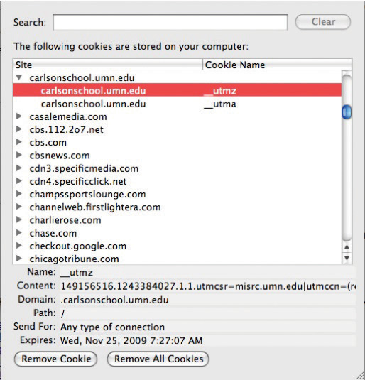](http://images.flatworldknowledge.com/gallaugher_1.4/gallaugher_1.4-fig08_018.jpg)

The Preferences setting in most Web browsers allows you to see its cookies. This browser has received cookies from several ad networks, media sites, and the University of Minnesota Carlson School of Management.

**But What If I Don’t Want a Cookie!**

If all of this creeps you out, remember that you’re in control. The most popular Web browsers allow you to block all cookies, block just third-party cookies, purge your cookie file, or even ask for your approval before accepting a cookie. Of course, if you block cookies, you block any benefits that come along with them, and some Web site features may require cookies to work properly. Also note that while deleting a cookie breaks a link between your browser and that Web site, if you supply identifying information in the future (say by logging into an old profile), the site might be able to assign your old profile data to the new cookie.

While the Internet offers targeting technologies that go way beyond traditional television, print, and radio offerings, none of these techniques is perfect. Since users are regularly assigned different IP addresses as they connect and disconnect from various physical and Wi-Fi networks, IP targeting can’t reliably identify individual users. Cookies also have their weaknesses. They’re assigned by browsers and associated with a given user’s account on that computer. That means that if several people use the same browser on the same computer without logging on to that machine as separate users, then all their Web surfing activity may be mixed into the same cookie profile. (One solution is to create different log-in accounts on that computer. Your PC will then keep separate cookies for each account.) Some users might also use different browsers on the same machine or use different computers. Unless a firm has a way to match up these different cookies assigned across browsers (say by linking cookies on separate machines to a single log-in used at multiple locations), then a site may be working with multiple, incomplete profiles.

**Big Data Analytics: Even for the Little Guy**

In order to help arm firms with the insight needed for SEO, SEM, improved Web site design, and effective online marketing and promotion, Google offers a suite of tracking and analysis tools via a service it calls Google Analytics. The base service is offered free to Web sites of all sizes, with premium offerings and support available for a fee.

Using Analytics, a Web site owner can collect statistics on their Web site’s traffic, traffic sources (search engine, Web site, geographic origin, or even e-mail or .pdf link), user behavior on site (new/returning visitor stats, pages visited, etc.), sales and advertising success, mobile use within apps, social media analysis, and more. Analytics typically involve harvesting data that browsers and servers produce on their own, along with data from pages and apps that a firm will tag in advance and data from tracking cookies used to identify users. Google Analytics has more than an 80 percent market share. [[4]](http://catalog.flatworldknowledge.com/bookhub/reader/12375?cid=1681397#ftn.fn-4)

[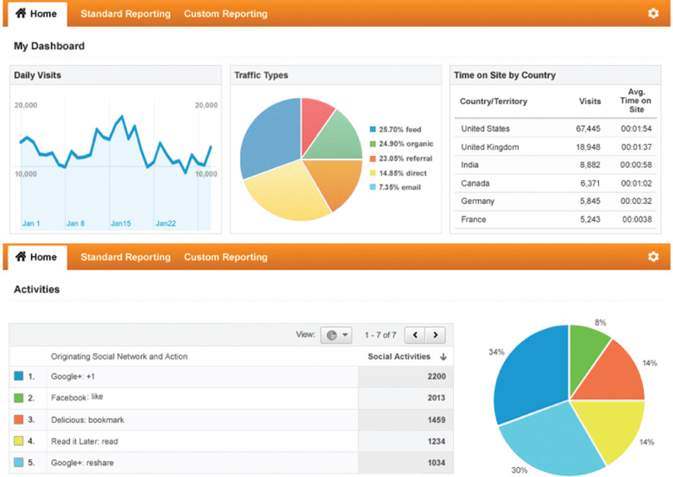](http://images.flatworldknowledge.com/gallaugher_2_0/gallaugher_2_0-fig08_x001.jpg)

Sample Screens from Google Analytics Reports

Source: Google.

**Key Takeaways**

* The communication between Web browser and Web server can identify IP address, the type of browser used, the computer type, its operating system, time and date of access, and duration of Web page visit, and can read and assign unique identifiers, called cookies—all of which can be used in customer profiling and ad targeting.
* An IP address not only helps with geolocation; it can also be matched against other databases to identify the organization providing the user with Internet access (such as a firm or university), that organization’s industry, size, and related statistics.
* A cookie is a unique line of identifying text, assigned and retrieved by a given Web server and stored on a computer by the browser, that can be used to build a profile associated with your Web activities.
* The most popular Web browsers allow you to block all cookies, block just third-party cookies, purge your cookie file, or even ask for your approval before accepting a cookie.
* Retargeting, or remarketing, allows advertisers to serve targeted ads to consumers who may have viewed a product page but did not buy that product. Google and other ad networks support retargeting.

**15.8 Profiling and Privacy**

**Learning Objectives**

1. Understand the privacy concerns that arise as a result of using third-party or tracking cookies to build user profiles.
2. Be aware of the negative consequences that could result from the misuse of third-party or tracking cookies.
3. Know the steps Google has taken to demonstrate its sensitivity to privacy issues.
4. Know the kinds of user information that Google stores, and the steps Google takes to protect the privacy of that information.

While AdSense has been wildly successful, contextual advertising has its limits. For example, what kind of useful targeting can firms really do based on the text of a news item on North Korean nuclear testing? [[1]](http://catalog.flatworldknowledge.com/bookhub/reader/12375?cid=1681397#ftn.fn-1) For more accurate targeting, Google offers what it calls “interest-based ads,” which is based on a third-party cookie that tracks browsing activity across Google properties and AdSense partner sites. AdSense builds a profile, identifying users within dozens of broad categories and over six hundred subcategories. [[2]](http://catalog.flatworldknowledge.com/bookhub/reader/12375?cid=1681397#ftn.fn-2) Of course, there’s a financial incentive to do this too. Ads deemed more interesting should garner more clicks, meaning more potential customer leads for advertisers, more revenue for Web sites that run AdSense, and more money for Google.

But while targeting can benefit Web surfers, users will resist if they feel that they are being mistreated, exploited, or put at risk. Negative backlash might also result in a change in legislation. The U.S. Federal Trade Commission has already called for more transparency and user control in online advertising and for requesting user consent (opt-in) when collecting sensitive data. [[3]](http://catalog.flatworldknowledge.com/bookhub/reader/12375?cid=1681397#ftn.fn-3) Mishandled user privacy could curtail targeting opportunities, limiting growth across the online advertising field. And with less ad support, many of the Internet’s free services could suffer.

Figure 15.13

[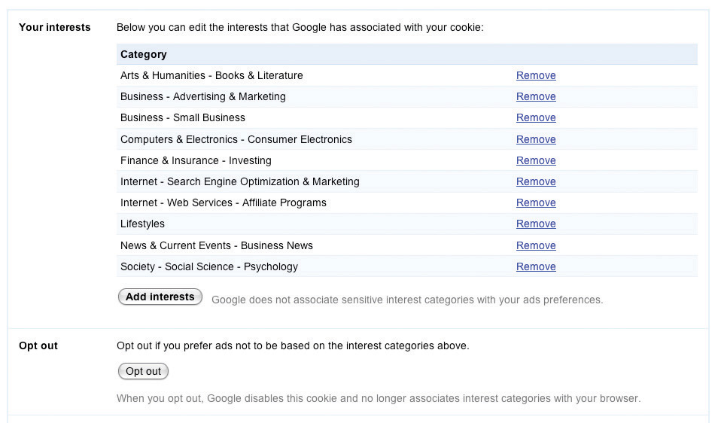](http://images.flatworldknowledge.com/gallaugher_2_0/gallaugher_2_0-fig08_020.jpg)

Here’s an example of one user’s interests, as tracked by Google’s “Interest-based Ads” and displayed in the firm’s “Ad Preferences Manager.”

Google’s roll-out of interest-based ads shows the firm’s sensitivity to these issues. The firm has also placed significant control in the hands of users, with options at program launch that were notably more robust than those of its competitors. [[4]](http://catalog.flatworldknowledge.com/bookhub/reader/12375?cid=1681397#ftn.fn-4) Each interest-based ad is accompanied by an “Ads by Google” link that will bring users to a page describing Google advertising and which provides access to the company’s “Ads Preferences Manager.” This tool allows surfers to see any of the hundreds of potential categorizations that Google has assigned to that browser’s tracking cookie. Users can remove categorizations, and even add interests if they want to improve ad targeting. Some topics are too sensitive to track, and the technology avoids profiling race, religion, sexual orientation, health, political or trade union affiliation, and certain financial categories. [[5]](http://catalog.flatworldknowledge.com/bookhub/reader/12375?cid=1681397#ftn.fn-5)

Google also allows users to install a cookie that opts them out of interest-based tracking. And since browser cookies can expire or be deleted, the firm has gone a step further, offering a browser plug-in that will remain permanent, even if a user’s opt-out cookie is purged.

**Google, Privacy Advocates, and the Law**

Google’s moves are meant to demonstrate transparency in its ad targeting technology, and the firm’s policies may help raise the collective privacy bar for the industry. While privacy advocates have praised Google’s efforts to put more control in the hands of users, many continue to voice concern over what they see as the increasing amount of information that the firm houses. [[6]](http://catalog.flatworldknowledge.com/bookhub/reader/12375?cid=1681397#ftn.fn-6) For an avid user, Google could conceivably be holding e-mail (Gmail), photos (Picasa), social media activity (Google+), a Web surfing profile (AdSense and DoubleClick), location (Google Maps), appointments (Google Calendar), music and other media (Google Play), files stored in the cloud (Google Drive), transcripts of phone messages (Google Voice), work files (Google Docs), and more.

Google insists that reports portraying it as a data-hoarding Big Brother are inaccurate. Data is not sold to third parties. Any targeting is fully disclosed, with users empowered to opt out at all levels. [[7]](http://catalog.flatworldknowledge.com/bookhub/reader/12375?cid=1681397#ftn.fn-7) Google has introduced several tools, including Google Dashboard and Google Ad Preferences Manager, that allow users to see information Google stores about them, clear their browsing history, and selectively delete collected data. [[8]](http://catalog.flatworldknowledge.com/bookhub/reader/12375?cid=1681397#ftn.fn-8) But critics counter that corporate intentions and data use policies (articulated in a Web site’s Terms of Service) can change over time, and that a firm’s good behavior today is no guarantee of good behavior in the future. [[9]](http://catalog.flatworldknowledge.com/bookhub/reader/12375?cid=1681397#ftn.fn-9) Google has modified its policy several times in the past, including changes that now allow the firm to link search history to ad targeting. It has also unified its privacy policy in a way that allows for greater profiling, sharing, and tailored services across Google offerings. [[10]](http://catalog.flatworldknowledge.com/bookhub/reader/12375?cid=1681397#ftn.fn-10)

Google does enjoy a lot of user goodwill, and it is widely recognized for its unofficial motto “Don’t Be Evil.” However, some worry that even though Google might not be evil, it could still make a mistake, and that despite its best intentions, a security breach or employee error could leave data dangerously or embarrassingly exposed.

Gaffes have repeatedly occurred. A system flaw inadvertently shared some Google Docs with contacts who were never granted access to them. [[11]](http://catalog.flatworldknowledge.com/bookhub/reader/12375?cid=1681397#ftn.fn-11) When the firm introduced its Google Buzz social networking service, many users were horrified that their most frequently used Gmail contacts were automatically added to Buzz, allowing others to see who you’re communicating with. As one report explained, “Suddenly, journalists’ clandestine contacts were exposed, secret affairs became dramatically less secret, and stalkers obtained a new tool to harass their victims. Oops.” [[12]](http://catalog.flatworldknowledge.com/bookhub/reader/12375?cid=1681397#ftn.fn-12) Google admitted that some of its “Street View” cars, while driving through neighborhoods and taking photos for Google maps, had inadvertently collected personal data, including e-mails and passwords. [[13]](http://catalog.flatworldknowledge.com/bookhub/reader/12375?cid=1681397#ftn.fn-13) Google scrambled to plug a hole that could potentially allow hackers to access the contacts, calendars, and photos on Android phones connecting to the Internet over open Wi-Fi networks. [[14]](http://catalog.flatworldknowledge.com/bookhub/reader/12375?cid=1681397#ftn.fn-14) A rogue employee was fired for violating the firm’s strict guidelines and procedures on information access. [[15]](http://catalog.flatworldknowledge.com/bookhub/reader/12375?cid=1681397#ftn.fn-15) The firm has also been accused of bypassing privacy settings in Apple’s Safari Web browser in order to better track users. [[16]](http://catalog.flatworldknowledge.com/bookhub/reader/12375?cid=1681397#ftn.fn-16)

Privacy advocates also worry that the amount of data stored by Google serves as one-stop shopping for litigators and government investigators—a concern that gained even more attention following the disclosure of the U.S. Government’s Prism surveillance program. [[17]](http://catalog.flatworldknowledge.com/bookhub/reader/12375?cid=1681397#ftn.fn-17) The counterargument points to the fact that Google has continually reflected an aggressive defense of data privacy in court cases. Following Prism disclosures, Google asked the U.S. Foreign Intelligence Surveillance Court to rescind a gag order barring the firm from revealing government information requests. [[18]](http://catalog.flatworldknowledge.com/bookhub/reader/12375?cid=1681397#ftn.fn-18) When Viacom sued Google over copyright violations in YouTube, the search giant successfully fought the original subpoena, which had requested user-identifying information. [[19]](http://catalog.flatworldknowledge.com/bookhub/reader/12375?cid=1681397#ftn.fn-19) Google has also resisted Justice Department subpoenas for search queries, while rivals have complied.[[20]](http://catalog.flatworldknowledge.com/bookhub/reader/12375?cid=1681397" \l "ftn.fn-20) Google has also claimed that it has been targeted by some foreign governments that are deliberately hacking or interfering with the firm’s services in order to quash some information sharing and to uncover dissident activity.[[21]](http://catalog.flatworldknowledge.com/bookhub/reader/12375?cid=1681397" \l "ftn.fn-21)

Google is increasingly finding itself in precedent-setting cases where the law is vague. Google’s Street View, for example, has been the target of legal action in the United States, Canada, Japan, Greece, and the United Kingdom. Varying legal environments create a challenge to the global rollout of any data-driven initiative.[[22]](http://catalog.flatworldknowledge.com/bookhub/reader/12375?cid=1681397" \l "ftn.fn-22)

Ad targeting brings to a head issues of opportunity, privacy, security, risk, and legislation. Google is now taking a more active public relations and lobbying role to prevent misperceptions and to be sure its positions are understood. While the field continues to evolve, Google’s experience will lay the groundwork for the future of personalized technology and provide a case study for other firms that need to strike the right balance between utility and privacy. Despite differences, it seems clear to Google, its advocates, and its detractors that with great power comes great responsibility.

**Key Takeaways**

* Possible consequences resulting from the misuse of customer tracking and profiling technologies include user resistance and legislation. Mishandled user privacy could curtail targeting opportunities and limit growth in online advertising. With less ad support, many of the Internet’s free services could suffer.
* Google has taken several steps to protect user privacy. The firm offers several tools that enable users not only to see information that Google collects but also to delete, pause, or modify data collection and profiling terms.
* Google’s “Ads Preferences Manager” allows surfers to see, remove, and add to any of the categorizations that Google has assigned to that browser’s tracking cookie. The technology also avoids targeting certain sensitive topics. The firm’s Privacy Dashboard provides additional access to and user control over Google’s profiling and data collection.
* Google allows users to install a cookie or plug-in that opts them out of interest-based tracking.
* Some privacy advocates have voiced concern over what they see as the increasing amount of information that Google and other firms collect.
* Even the best-intentioned and most competent firms can have a security breach that compromises stored information. Google has suffered privacy breaches from product flaws and poorly planned feature rollouts, as well as deliberate hacks and attacks. The firm has also changed policies regarding data collection and privacy as its services have evolved. Such issues may lead to further investigation, legislation, and regulation.

**15.9 Search Engines, Ad Networks, and Fraud**

**Learning Objectives**

1. Be able to identify various types of online fraud, as well as the techniques and technologies used to perpetrate these crimes.
2. Understand how firms can detect, prevent, and prosecute fraudsters.

There’s a lot of money to be made online, and this has drawn the attention of criminals and the nefarious. Online fraudsters may attempt to steal from advertisers, harm rivals, or otherwise dishonestly game the system. But bad guys beware—such attempts violate terms-of-service agreements and may lead to prosecution and jail time.

Studying ad-related fraud helps marketers, managers, and technologists understand potential vulnerabilities, as well as the methods used to combat them. This process also builds tech-centric critical thinking, valuation, and risk assessment skills.

Some of the more common types of fraud that are attempted in online advertising include the following:

* *Enriching* click fraud—when site operators generate bogus ad clicks to earn PPC income.
* *Enriching impression fraud*—when site operators generate false page views (and hence ad impressions) in order to boost their site’s CPM earnings.
* *Depleting click fraud*—clicking a rival’s ads to exhaust their PPC advertising budget.
* *Depleting impression fraud*—generating bogus impressions to exhaust a rival’s CPM ad budget.
* *Rank-based impression fraud*—on-sites where ad rank is based on click performance, fraudsters repeatedly search keywords linked to rival ads or access pages where rival ads appear. The goal is to generate impressions without clicks. This process lowers the performance rank (quality score) of a rival’s ads, possibly dropping ads from rank results, and allowing fraudsters to subsequently bid less for the advertising slots previously occupied by rivals.
* *Disbarring fraud*—attempting to frame a rival by generating bogus clicks or impressions that appear to be associated with the rival, in hopes that this rival will be banned from an ad network or punished in search engine listings.
* *Link fraud (also known as spamdexing or link farming)*—creating a series of bogus Web sites, all linking back to a page, in hopes of increasing that page’s results in organic search.
* *Keyword stuffing*—packing a Web site with unrelated keywords (sometimes hidden in fonts that are the same color as a Web site’s background) in hopes of either luring users who wouldn’t normally visit a Web site, or attracting higher-value contextual ads.

Disturbing stuff, but firms are after the bad guys and they’ve put their best geeks on the case. Widespread fraud would tank advertiser ROI and crater the online advertising market, so Google and rivals are diligently working to uncover and prosecute the crooks.

**Busting the Bad Guys**

On the surface, enriching click fraud seems the easiest to exploit. Just set up a Web site, run PPC ads on the page, and click like crazy. Each click should ring the ad network cash register, and a portion of those funds will be passed on to the perpetrating site owner—*ka ching*! But remember, each visitor is identified by an IP address, so lots of clicks from a single IP make the bad guys easy to spot.

So organized crime tried to raise the bar, running so-called click farms to spread fraud across dozens of IP addresses. *The Times of India* uncovered one such effort where Indian housewives were receiving up to twenty-five cents for each ad click made on fraudster-run Web sites. [[1]](http://catalog.flatworldknowledge.com/bookhub/reader/12375?cid=1681397#ftn.fn-1) But an unusually large number of clicks detected as coming from Indian IP addresses foiled these schemes as well.

Fraudsters then moved on to use botnets or zombie networks—hordes of surreptitiously infiltrated computers, linked and controlled by rogue software. [[2]](http://catalog.flatworldknowledge.com/bookhub/reader/12375?cid=1681397#ftn.fn-2) To create botnets, hackers exploit security holes, spread viruses, or use so-called phishing techniques to trick users into installing software that will lie dormant, awaiting commands from a central location. The controlling machine then sends out tasks for each bot (or zombie), instructing them to visit Web sites and click on ads in a way that mimics real traffic. The ZeroAccess botnet is said to have infected over 9 million PCs worldwide that were used in click fraud schemes, among other scams. [[3]](http://catalog.flatworldknowledge.com/bookhub/reader/12375?cid=1681397#ftn.fn-3)

Figure 15.14 Spread of the ZeroAccess Botnet

[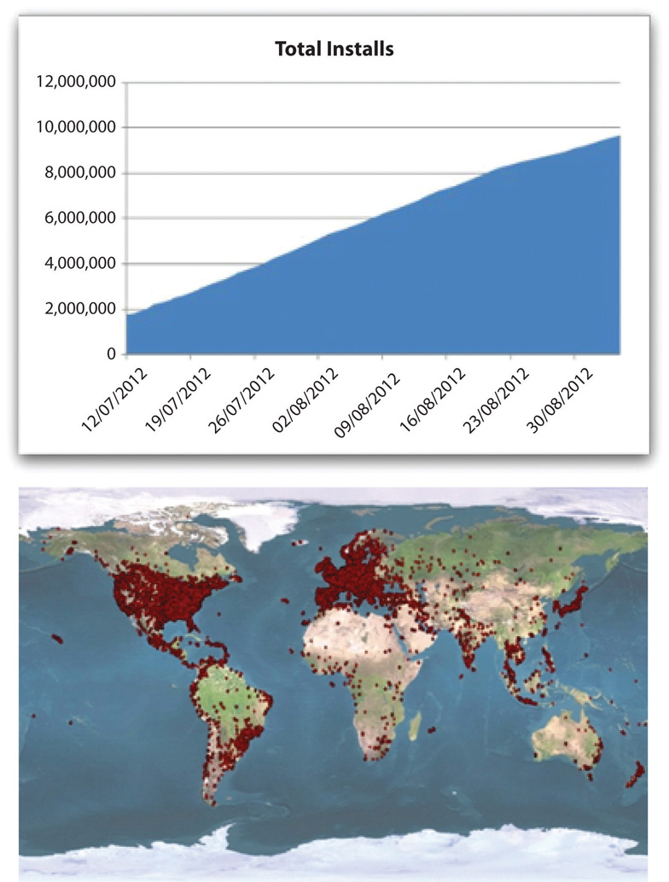](http://images.flatworldknowledge.com/gallaugher_2_0/gallaugher_2_0-fig08_x002.jpg)

Source: Sophos, <http://nakedsecurity.sophos.com/2012/09/19/zeroaccess-botnet-uncovered>.

Scary, but this is where scale, expertise, and experience come in. The more activity an ad network can monitor, the greater the chance that it can uncover patterns that are anomalous. Higher click-through rates than comparable sites? Caught. Too many visits to a new or obscure site? Caught. Clicks that don’t fit standard surfing patterns for geography, time, and day? Caught.

Sometimes the goal isn’t theft, but sabotage. Google’s Ad Traffic Quality Team backtracked through unusual patterns to uncover a protest effort targeted at Japanese credit card firms. Ad clicks were eventually traced to an incendiary blogger who incited readers to search for the Japanese word *kiyashinku* (meaning cashing credit, or credit cards), and to click the credit card firm ads that show up, depleting firm search marketing budgets. Sneaky, but uncovered and shut down, without harm to the advertisers. [[4]](http://catalog.flatworldknowledge.com/bookhub/reader/12375?cid=1681397#ftn.fn-4)

Search firm and ad network software can use data patterns and other signals to ferret out most other types of fraud, too, including rank-based impression fraud, spamdexing, and keyword stuffing. While many have tried to up the stakes with increasingly sophisticated attacks, large ad networks have worked to match them, increasing their anomaly detection capabilities across all types of fraud. [[5]](http://catalog.flatworldknowledge.com/bookhub/reader/12375?cid=1681397#ftn.fn-5) Here we see another scale and data-based advantage for Google. Since the firm serves more search results and advertisements than its rivals do, it has vastly more information on online activity. And if it knows more about what’s happening online than any other firm, it’s likely to be first to shut down anyone who tries to take advantage of the system.

**Click Fraud: How Bad Is It?**

Accounts on the actual rate of click fraud vary widely. Some third-party firms contend that nearly one in five clicks is fraudulent. [[6]](http://catalog.flatworldknowledge.com/bookhub/reader/12375?cid=1681397#ftn.fn-6) But Google adamantly disputes these headline-grabbing numbers, claiming that many such reports are based on logs that reflect false data from conditions that Google doesn’t charge for (e.g., double counting a double click, or adding up repeated use of the browser back button in a way that looks like multiple clicks have occurred). The firm also offers monitoring, analytics, and reporting tools that can uncover this kind of misperceived discrepancy.

Google contends that all invalid clicks (mistakes and fraud) represent less than 10 percent of all clicks, that the vast majority of these clicks are filtered out, and that Google doesn’t charge advertisers for clicks flagged as mistakes or suspicious. [[7]](http://catalog.flatworldknowledge.com/bookhub/reader/12375?cid=1681397#ftn.fn-7) In fact, Google says their screening bar is so high and so accurate that less than 0.02 percent of clicks are reactively classified as invalid and credited back to advertisers. [[8]](http://catalog.flatworldknowledge.com/bookhub/reader/12375?cid=1681397#ftn.fn-8)

So who’s right? While it’s impossible to identify the intention behind every click, the market ultimately pays for performance. And advertisers are continuing to flock to PPC ad networks (and to Google in particular). While that doesn’t mean that firms can stop being vigilant, it does suggest that for most firms, Google seems to have the problem under control.

**Key Takeaways**

* Fraud can undermine the revenue model behind search engines, ad networks, and the ad-based Internet. It also threatens honest competition among rivals that advertise online.
* There are many forms of online fraud, including enriching fraud (meant to line the pockets of the perpetrators), depleting fraud (meant to waste the ad budgets of rivals), disbarring fraud (meant to frame the innocent as fraudsters), and methods to lower rival ad rank performance, or gain search engine ranking algorithms.
* While fraudsters have devised ingenious ways to exploit the system (including click farms and botnets), IP addresses and detailed usage pattern monitoring increasingly reveal bogus activity.
* Fraud rates are widely disputed. However, it is clear that if widespread fraud were allowed to occur, advertisers would see lower ROI from online ad efforts, and Internet business models would suffer. The continued strength of the online advertising market suggests that while fraud may be impossible to stop completely, most fraud is under control.

**15.10 The Battle Unfolds**

**Learning Objectives**

1. Understand the challenges of maintaining growth as a business and industry mature.
2. Recognize how technology is a catalyst, causing the businesses of many firms in a variety of industries to converge and compete, and that as a result of this, Google is active on multiple competitive fronts.
3. Critically evaluate the risks and challenges of businesses that Google, Microsoft, and other firms are entering.
4. Appreciate the magnitude of this impending competition, and recognize the competitive forces that will help distinguish winners from losers.

Google has been growing like gangbusters, but the firm’s twin engines of revenue growth—ads served on search and through its ad networks—will inevitably mature. And it will likely be difficult for Google to find new growth markets that are as lucrative as these. Emerging advertising outlets such as social networks have lower click-through rates than conventional advertising, and Google has struggled to develop a presence in social media—trends suggesting that Google will have to work harder for less money.

To understand what can happen when maturity hits, look at Microsoft. The house that Gates Built is more profitable than Google (about $17 billion versus just under $11 billion in 2012) and continues to dominate the incredibly lucrative markets served by Windows and Office. But these markets haven’t grown much for over a decade. In industrialized nations, most Windows and Office purchases come not from growth, but when existing users upgrade or buy new machines. And without substantial year-on-year growth, the stock price doesn’t move.

Figure 15.15 A Comparison of Stock Price Change—Google (GOOG) versus Microsoft (MSFT) [[1]](http://catalog.flatworldknowledge.com/bookhub/reader/12375?cid=1681397#ftn.fn-1)

[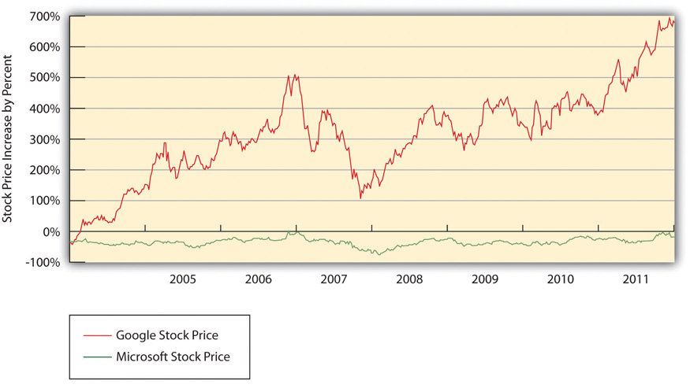](http://images.flatworldknowledge.com/gallaugher_2_0/gallaugher_2_0-fig08_021.jpg)

For big firms like Microsoft and Google, pushing stock price north requires not just new markets, but *billion-dollar* ones. Adding even $100 million in new revenues doesn’t do much for firms bringing in nearly $74 billion and $52 billion a year, respectively. That’s why you see Microsoft swinging for the fences, investing in the uncertain but potentially gargantuan markets of video games, mobile phone software, cloud computing (see [Chapter 11 "Software in Flux: Partly Cloudy and Sometimes Free"](http://catalog.flatworldknowledge.com/bookhub/reader/12375?e=fwk-38086-ch10)), music and video, and of course, search and everything else that fuels online ad revenue. Finding new billion-dollar markets is wonderful, but rare. Apple seems to have done it with the iPad. But trying to unseat a dominant leader possessing strategic resources can be ferociously expensive, with unclear prospects for success. Microsoft’s Bing group lost over $2 billion over just nine months, winning almost no share from Google despite the lavish spend. [[2]](http://catalog.flatworldknowledge.com/bookhub/reader/12375?cid=1681397#ftn.fn-2)

**Search: Google Rules, but It Ain’t Over**

PageRank is by no means the last word in search, and offerings from Google and its rivals continue to evolve. Google supplements PageRank results with news, photos, video, and other categories. Yahoo! is continually refining its search algorithms and presentation. And Microsoft’s third entry into the search market, the “decision engine” Bing, sports nifty tweaks for specific kinds of queries. Restaurant searches in Bing are bundled with ratings stars, product searches show up with reviews and price comparisons, and airline flight searches not only list flight schedules and fares, but also a projection on whether those fares are likely to go up or down. The Bing sidebar will surface additional data alongside search results, including (if logged into Facebook) friends that might have input on your query and public social media posts you might be interested in. [[3]](http://catalog.flatworldknowledge.com/bookhub/reader/12375?cid=1681397#ftn.fn-3) Bing comes with a one-hundred-million-dollar marketing budget, showing that Microsoft is serious about search. Apple also announced that the firm’s Siri service would deliver search results from Bing, not Google, offering a potentially key new channel for pumping up Bing search volume.

New tools like the Wolfram Alpha “knowledge engine” move beyond Web page rankings and instead aggregate data for comparison, formatting findings in tables and graphs. Web sites are also starting to wrap data in invisible tags that can be recognized by search engines, analysis tools, and other services. If a search engine can tell that a number on a restaurant’s Web site is, for example, either a street address, an average entrée price, or the seating capacity, it will be much easier for computer programs to accurately categorize, compare, and present this information. This is what geeks are talking about when they refer to the semantic Web. Google has begun to draw from several resources on the Web to build its own semantic Web classifications. If you search for “Taj Mahal” on the Web, it presents a summary of the famous Indian landmark, but it also asks if you’d like to see results regarding the Grammy Award–winning musician or the New Jersey casino that also share that same name. [[4]](http://catalog.flatworldknowledge.com/bookhub/reader/12375?cid=1681397#ftn.fn-4)

And with the Google Now app, the firm is trying to deliver results to you before you even ask for them. Google Now will send you personal information throughout the day—calendar reminders, weather updates. But it will also take a guess at what you might be interested in—reviews of nearby restaurants if it’s lunchtime, train timetables if you’re at a station, flight info if you’re at an airport. Land in a new city? Google will send hotel and rental car info based on confirmation messages sent to Gmail. Users have to give Google permission to access data from other services, but one can immediately see how on-demand information could be served up not only via phone but also via other products, like the Google Glass eyepiece or Google TV.

Figure 15.16 Google Goggles returns search results by photographing objects. It can even translate foreign-language text.

[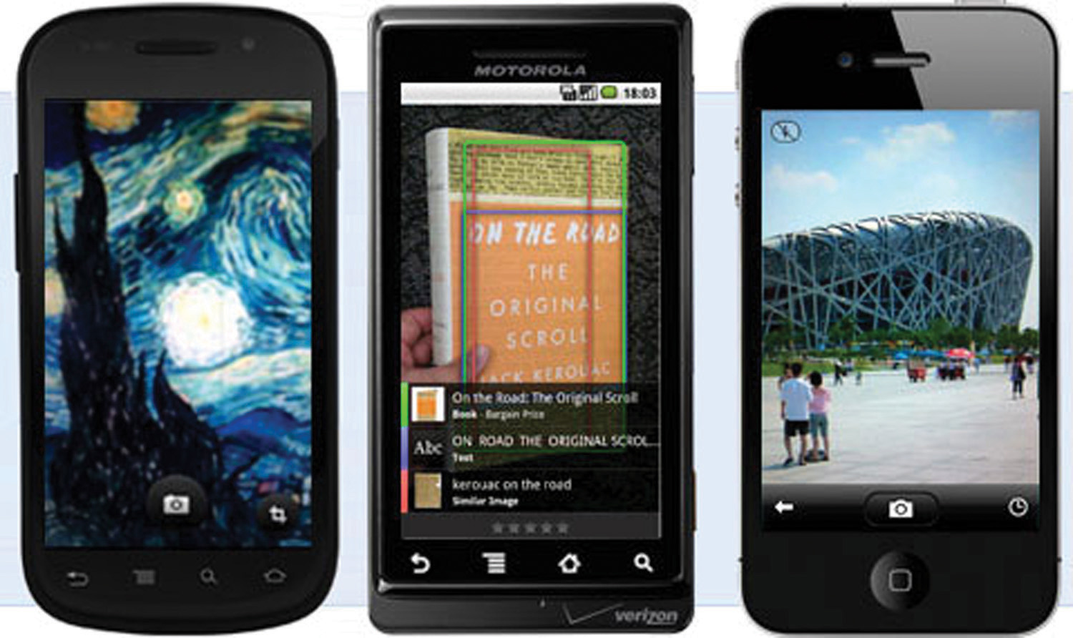](http://images.flatworldknowledge.com/gallaugher_1.3/gallaugher_1.3-fig08_022.jpg)

Source: Google.

And who says you need to use words to conduct a search? Google Goggles uses the camera in your mobile phone to “enter” search criteria. Snap a picture of a landmark, book, or piece of artwork, for example, and Google will use that image to retrieve search results. The product can even return translations of foreign text. All signs point to more innovation, more competition, and an increasingly more useful Internet!

Both Google and Microsoft are on a collision course. But there’s also an impressive roster of additional firms circling this space, each with the potential to be competitors, collaborators, merger partners, or all of the above. While wounded and shrinking, Yahoo! is still a powerhouse, ranking ahead of Google in some overall traffic statistics. Google’s competition with Apple in the mobile phone business prompted Google’s then CEO Eric Schmidt to resign from Apple’s board of directors. Meanwhile, Google’s three-quarters-of-a-billion-dollar purchase of the leading mobile advertiser AdMob was quickly followed by Apple snapping up number two mobile ad firm Quattro Wireless for $275 million. Add in Amazon, Facebook, eBay, Twitter, Salesforce.com, Netflix, the video game industry, telecom and mobile carriers, cable firms, and the major media companies and the next few years have the makings of a big, brutal fight.

**Strategic Issues**

As outlined earlier, Google enjoys major scale advantages in search, and network effects in advertising. The firm’s dominance helps grow a data asset that can be used in service improvement, all while its expertise in core markets continues to grow over time. But the strength of Google’s other competitive resources is less clear.

Within Google’s ad network, there are *switching costs* for advertisers and for content providers. Google partners have set up accounts and are familiar with the firm’s tools and analytics. Content providers would also need to modify Web sites to replace Google-served ads with those from rivals. But choosing Google doesn’t cut out the competition. Many advertisers and content providers participate in multiple ad networks, making it easier to shift business from one firm to another. This likely means that Google will have to keep advertisers by offering superior value rather than relying on lock-in.

Another vulnerability may exist with search consumers. While Google’s brand is strong, switching costs for search users are incredibly low. Move from Google.com to Bing.com and you actually save two letters of typing!

Still, there are no signs that Google’s search leadership is in jeopardy. So far users have been creatures of habit; no rival has offered technology compelling enough to woo away the Googling masses. Defeating Google with some sort of technical advantage will be difficult since Web-based innovation can often be quickly imitated. Google now rolls out over 550 tweaks to its search algorithm annually, with many features mimicking or outdoing innovations from rivals. [[5]](http://catalog.flatworldknowledge.com/bookhub/reader/12375?cid=1681397#ftn.fn-5)

Google will pay big to get its products distributed through key channels. The firm pays the Mozilla foundation about $300 million a year so that Google will be the default search option for the Firefox open source browser. [[6]](http://catalog.flatworldknowledge.com/bookhub/reader/12375?cid=1681397#ftn.fn-6) Google has shown that if it can’t buy its way into a distribution channel, it can create one. The firm’s Web browser, Chrome, has beaten out Internet Explorer to become the number one product used by Web surfers worldwide. [[7]](http://catalog.flatworldknowledge.com/bookhub/reader/12375?cid=1681397#ftn.fn-7)

**How Big Is Too Big?**

Microsoft could benefit from embedding its Bing search engine into its most popular products (imagine putting Bing in the right-mouse-click menu alongside cut, copy, and paste). But with Office above 80 percent and Windows at roughly 90 percent, [[8]](http://catalog.flatworldknowledge.com/bookhub/reader/12375?cid=1681397#ftn.fn-8) this seems unlikely. European antitrust officials have already taken action against Redmond’s bundling Windows Media Player and Internet Explorer with Windows. Add in a less favorable antitrust climate in the United States, and tying any of these products to Bing is almost certainly out of bounds.

Being big isn’t enough to violate U.S. antitrust laws. Harvard Law’s Andrew Gavil says, “You’ve got to be big, and you have to be bad. You have to be both.” [[9]](http://catalog.flatworldknowledge.com/bookhub/reader/12375?cid=1681397#ftn.fn-9) While Google has many critics, the firm also has a history of being a relentless supporter of open computing standards. And as mentioned earlier, there’s no forcing users to stick with Google—the firm must continue to win this market on its own merits.

That said, a big firm is a big target for attracting serious scrutiny. Google was forced to abandon a search advertising partnership with Yahoo! after the Department of Justice indicated its intention to block the agreement (Yahoo! and Microsoft have since inked a deal to share search technology and ad sales). The Department of Justice is also investigating a Google settlement with the Authors’ Guild, a deal in which critics have suggested that Google scored a near monopoly on certain book scanning, searching, and data serving rights. [[10]](http://catalog.flatworldknowledge.com/bookhub/reader/12375?cid=1681397#ftn.fn-10)

Does Google have an unfair advantage, favoring its own properties, like Maps, YouTube, Google+, and Zagat over rivals? Results from these properties are integrated with Google search, and the toolbar that appears across the top of most Google Web sites also provides preferred access to Google rather than rival properties. After a nearly two-year probe, one of the biggest investigations in history (generating over 9 million pages in testimony), the U.S. Federal Trade Commission (FTC) has essentially said “no,” at least for now. [[11]](http://catalog.flatworldknowledge.com/bookhub/reader/12375?cid=1681397#ftn.fn-11) The FTC voted unanimously to close its antitrust investigation without bringing charges. The ruling concluded that Google’s practices improved search for the benefit of users and that “any negative impact on actual or perceived competitors was incidental to that purpose.” [[12]](http://catalog.flatworldknowledge.com/bookhub/reader/12375?cid=1681397#ftn.fn-12)

Google does face some minor concessions from the FTC’s work. Firms like Yelp can opt out of having their results scraped by Google and incorporated into search results. Google will stop offering contractual restrictions preventing ad customers from advertising on competing search platforms. And Google must allow firms (including rivals) to license some of its key mobile patents when offered fair compensation. Of course, this is a U.S. Ruling. As of this writing, investigations in Europe (where authorities are often viewed as more aggressive) are ongoing. And there’s no guarantee that continued Google dominance might once again cause the Department of Justice to consider whether Google’s size and practices disadvantage others. While Google may escape sanction, increased antitrust scrutiny is a downside that comes along with the advantages of market-dominating scale.

**More Ads, More Places, More Formats**

Google has been a champion of increased Internet access. But altruism aside, more net access also means a greater likelihood of ad revenue.

Google’s effort to catalyze Internet use worldwide comes through on multiple fronts. In the United States, Google has supported (with varying degrees of success) efforts to offer free Wi-Fi. Google announced it would offer high-speed, fiber-optic net access to homes in select U.S. cities, with Kansas City, Kansas; Kansas City, Missouri; Provo, Utah; and Austin, Texas chosen for the first rollouts. [[13]](http://catalog.flatworldknowledge.com/bookhub/reader/12375?cid=1681397#ftn.fn-13) The experimental network offers competitively priced Internet access of up to 1GB per second—that’s a speed some one hundred times faster than many Americans have access to today. The networks are meant to be open to other service providers and Google hopes to learn and share insights on how to build high-speed networks more efficiently. Google will also be watching to see how access to ultrahigh-speed networks impacts user behavior and fuels innovation. Globally, Google is also a major backer (along with Liberty Global and HSBC) of the O3b satellite network. O3b stands for “the other three billion” of the world’s population who currently lack Internet access. O3b has begun launching multiple satellites circling the globe, blanketing underserved regions with low latency (low delay), high-speed Internet access. [[14]](http://catalog.flatworldknowledge.com/bookhub/reader/12375?cid=1681397#ftn.fn-14) Google’s experimental Project Loon hopes to bring the Internet to even more underserved, by blanketing regions with twelve-mile-high balloons that act as floating Internet relay points. [[15]](http://catalog.flatworldknowledge.com/bookhub/reader/12375?cid=1681397#ftn.fn-15)And the firm is experimenting with delivering Internet throughout South Africa via unused or “white” space in the nation’s television broadcast spectrum. With Moore’s Law dropping computing costs as world income levels rise, Google hopes to empower the currently disenfranchised masses to start surfing. Good for global economies, good for living standards, and good for Google.

Google has also successfully lobbied the U.S. government to force wireless telecom carriers to be more open, dismantling what are known in the industry as walled gardens. Before Google’s lobbying efforts, mobile carriers could act as gatekeepers, screening out hardware providers and software services from their networks. Now, paying customers of carriers that operate over the recently allocated U.S. wireless spectrum will have access to a choice of hardware and less restrictive access to Web sites and services. And Google hopes this expands its ability to compete without obstruction.

Another way Google can lower the cost of surfing is by giving away mobile phone and tablet software. That’s the thinking behind the firm’s Android offering. With Android, Google provides mobile phone vendors with a Linux-based operating system, supporting tools, standards, and an application marketplace akin to Apple’s App Store. Android itself isn’t ad-supported—there aren’t Google ads embedded in the OS. But the hope is that if manufacturers don’t have to write their own software, the cost of wireless mobile devices will go down. And cheaper devices mean that more users will have access to the mobile Internet, adding more ad-serving opportunities for Google and its partner sites. Google already controls 97 percent of fast-growing paid search on mobile devices. [[16]](http://catalog.flatworldknowledge.com/bookhub/reader/12375?cid=1681397#ftn.fn-16) One analyst estimated that Android brought in $10 per handset in search advertising in 2012, goosing advertising revenue by about $1.3 billion. [[17]](http://catalog.flatworldknowledge.com/bookhub/reader/12375?cid=1681397#ftn.fn-17) If correct, this means Android has helped Google deliver that rare, new billion-dollar opportunity that so many large firms seek. And when one considers all of Google’s mobile ad sales on all platforms, the numbers are far bigger. The firm’s mobile ad revenue for 2013 is projected to come in at $8.85 billion, or roughly 56 percent of the worldwide market. [[18]](http://catalog.flatworldknowledge.com/bookhub/reader/12375?cid=1681397#ftn.fn-18)

Developers are now leveraging tailored versions of Android on a wide range of devices, including e-book readers, tablets, televisions, set-top boxes, robots, and automobiles. Google has dabbled in selling ads for television (as well as radio and print), and there may be considerable potential in bringing variants of ad targeting technology, search, and a host of other services across these devices. Google also offers a platform for creating what the firm calls “Chromebooks”—a direct challenge to Windows in the netbook PC market. Powered by a combination of open source Linux and Google’s open source Chrome browser, the Chrome OS is specifically designed to provide a lightweight but consistent user interface for applications that otherwise live in the cloud, preferably residing on Google’s server farms (see [Chapter 11 "Software in Flux: Partly Cloudy and Sometimes Free"](http://catalog.flatworldknowledge.com/bookhub/reader/12375?e=fwk-38086-ch10)).

**Motorola Mobility**

Google’s massive, multibillion-dollar cash hoard is also allowing the firm to go on a buying spree—gobbling up seventy-nine firms in 2011 alone. [[19]](http://catalog.flatworldknowledge.com/bookhub/reader/12375?cid=1681397#ftn.fn-19) Google’s biggest deal to date is the purchase of Motorola Mobility. This makes Google a mobile phone handset manufacturer. While Google CEO Larry Page has said that Android will remain open and that Motorola Mobility will be run as a separate business, [[20]](http://catalog.flatworldknowledge.com/bookhub/reader/12375?cid=1681397#ftn.fn-20) there is risk. Google’s entry into the low-margin handset business may alienate other potential Android partners. Google has already sold off the Motorola television set-top box business, and some have suggested that handsets offer Google little additional value.

The real reason for the $12.5 billion purchase was likely to gain ownership of Motorola’s 17,000 patents—a potentially vital resource, as big firms sue one another to protect their markets. Apple has leveraged its patents to shut down Samsung tablet sales in Germany and Australia, [[21]](http://catalog.flatworldknowledge.com/bookhub/reader/12375?cid=1681397#ftn.fn-21) and Google fears that Cupertino may come knocking, claiming Android is a copy of the heavily patented iPhone. Motorola’s patents give Google an intellectual property counterpunch. (A brief side note, IP means *Internet protocol*, but is also often used to refer to *intellectual property*. When you see the term IP, be sure to consider the context so you know which IP is being talked about). However, the initially high estimates of the value of the Motorola patent portfolio remain in question, with recent U.S. court rulings in favor of Motorola awarding far less than the firm has sought. For example, Microsoft was found to have owed Motorola just $1.7 million for using Motorola’s patents in Xbox and Windows rather than the $4 billion that Motorola was seeking. [[22]](http://catalog.flatworldknowledge.com/bookhub/reader/12375?cid=1681397#ftn.fn-22)

**YouTube**

It’s tough to imagine any peer-produced video site displacing YouTube. Users go to YouTube because there’s more content, while amateur content providers go there seeking more users (classic two-sided network effects). This critical advantage was the main reason why Google paid $1.65 billion for what was then just a twenty-month-old start-up. In terms of query volume alone, YouTube, not Bing or Yahoo!, is the Internet’s second largest search engine. But mobile video competition is heating up as Twitter’s Vine and Facebook-owned Instagram Video (with 130 million users just over a year after Facebook’s purchase) battle to be the preferred platform for snippets of socially shared video.[[23]](http://catalog.flatworldknowledge.com/bookhub/reader/12375?cid=1681397" \l "ftn.fn-23) While the mobile upstarts attack at the low end of the Internet video market with shorter, mostly webcam-made videos, YouTube is looking to move a portion of its content beyond online amateur hour. The site now “rents” hundreds of TV shows and movies at prices ranging from $.99 to $3.99. It’s also been offering seed grants of several million dollars to producers of original content for YouTube.[[24]](http://catalog.flatworldknowledge.com/bookhub/reader/12375?cid=1681397" \l "ftn.fn-24) YouTube even poached a senior Netflix executive to help grow the premium content business, and the Google TV consumer electronics platform is now run within the YouTube group.[[25]](http://catalog.flatworldknowledge.com/bookhub/reader/12375?cid=1681397" \l "ftn.fn-25)

YouTube’s popularity comes at a price. Even with falling bandwidth and storage costs, at forty-eight hours of video uploaded to YouTube *every minute*, the cost to store and serve this content is cripplingly large.[[26]](http://catalog.flatworldknowledge.com/bookhub/reader/12375?cid=1681397" \l "ftn.fn-26) Analysts estimate that for YouTube to break even, it would need to achieve an ad CPM of $9.48 on each of the roughly seventy-five billion streams it’ll serve up this year. A tough task. Most user-generated content sports CPM rates south of a buck.[[27]](http://catalog.flatworldknowledge.com/bookhub/reader/12375?cid=1681397" \l "ftn.fn-27) The specifics of YouTube’s financials aren’t broken out. Even as a public company, Google can keep mum about YouTube specifics. Says the firm’s CFO, “We know our cost position, but nobody else does.”[[28]](http://catalog.flatworldknowledge.com/bookhub/reader/12375?cid=1681397" \l "ftn.fn-28)

It may be in Google’s interest to allow others to think of YouTube as more of a money pit than it really is. That perception might keep rivals away longer, allowing the firm to solidify its dominant position while getting the revenue model right. Google offers several YouTube ad models, including traditional banner and text ads, ads transparently layered across the bottom 20 percent of a video, preroll commercials that appear before the selected video, and more. Mobile ad revenues on YouTube tripled when YouTube access was shifted from native in the iOS to requiring a Google-created app. Before that, Google couldn’t show ads that were in Apple’s native iOS app. Overall mobile viewership in YouTube is up tenfold in three years and now accounts for over 25 percent of global views. Some analysts have suggested that YouTube is 10 percent of Google’s revenue while mobile is 20 to 25 percent of that and growing. If true, YouTube mobile is a billion-dollar business, with YouTube overall headed to $20 billion in revenue by 2020.[[29]](http://catalog.flatworldknowledge.com/bookhub/reader/12375?cid=1681397" \l "ftn.fn-29)

**Google Wallet**

Google Wallet is another example of how the search giant is looking to deliver value through mobile devices. Google Wallet allows phones to replace much of the “stuff” inside your wallet. It can be used to pay for goods, store gift cards, collect and redeem coupons and special offers, and manage loyalty programs. To use the service, users simply wave phones at an NFC (near field communication)-equipped payment terminal (with transaction confirmed and secured by typing in a PIN). Fifteen retailers (including Macy’s, Subway, Walgreens, Toys “R” Us, Peet’s Coffee and Tea, and Footlocker) were announced as payment-accepting partners, and Wallet has the capability to work with some 300,000 retail registers that are already using MasterCard’s PayPass contactless payment terminals.[[30]](http://catalog.flatworldknowledge.com/bookhub/reader/12375?cid=1681397" \l "ftn.fn-30) Phones will have to be equipped with an NFC chip, and only one model from one carrier was available at announcement, although a limited version of Wallet will be available by using an NFC sticker that can be attached to the back of non-NFC mobile devices. Google also envisions billboards and storefronts that can communicate with Wallet and distribute offers, Web links, and more—just wave your phone at a sign to get a deal. The product is less about becoming the “Bank of Google”—Wallet links to existing credit cards (although Google offers a prepaid card, too), and at rollout Google said there aren’t any payment fees for the service. But Google hopes Wallet will be a way to promote new revenue channels, such as growing its Google Offers coupon service (a Groupon and LivingSocial competitor).[[31]](http://catalog.flatworldknowledge.com/bookhub/reader/12375?cid=1681397" \l "ftn.fn-31) Google could sell advertisers couponing services distributed via search, online ads, NFC-equipped signs, and geolocation; have the deals and promotions delivered to a Google Wallet account; and allow deals to be quickly redeemed via NFC swipe at a retailer. Could this grow to be a billion-dollar market, too? Emerging technologies like NFC are sure to attract competitors and innovation.

Getting to that vision is going to be tough. Nearly two years after launch, and spending roughly $300 million acquiring startups and bringing technology and expertise into the firm, Wallet is still struggling. Most consumers can’t use the app. In the United States, only weakling carrier Sprint supports it. Verizon, AT&T, and T-Mobile are teaming up on a mobile payments service called Isis and are blocking Google Wallet on their phones.[[32]](http://catalog.flatworldknowledge.com/bookhub/reader/12375?cid=1681397" \l "ftn.fn-32) Walmart, Target, and BestBuy bring big-box retail heft and thousands of nationwide outlets to yet another competitor—the consortium-backed MCX mobile payment platform. And upstart Square is already facilitating $15 billion in transactions a year, although only a small portion comes through the firm’s Square Wallet app. In another sign that establishing a payments platform is hard, Google also shuttered its PayPal competitor, Google Checkout, migrating abandoned customers to services provided by other firms.[[33]](http://catalog.flatworldknowledge.com/bookhub/reader/12375?cid=1681397" \l "ftn.fn-33)

Figure 15.17 Google Wallet

[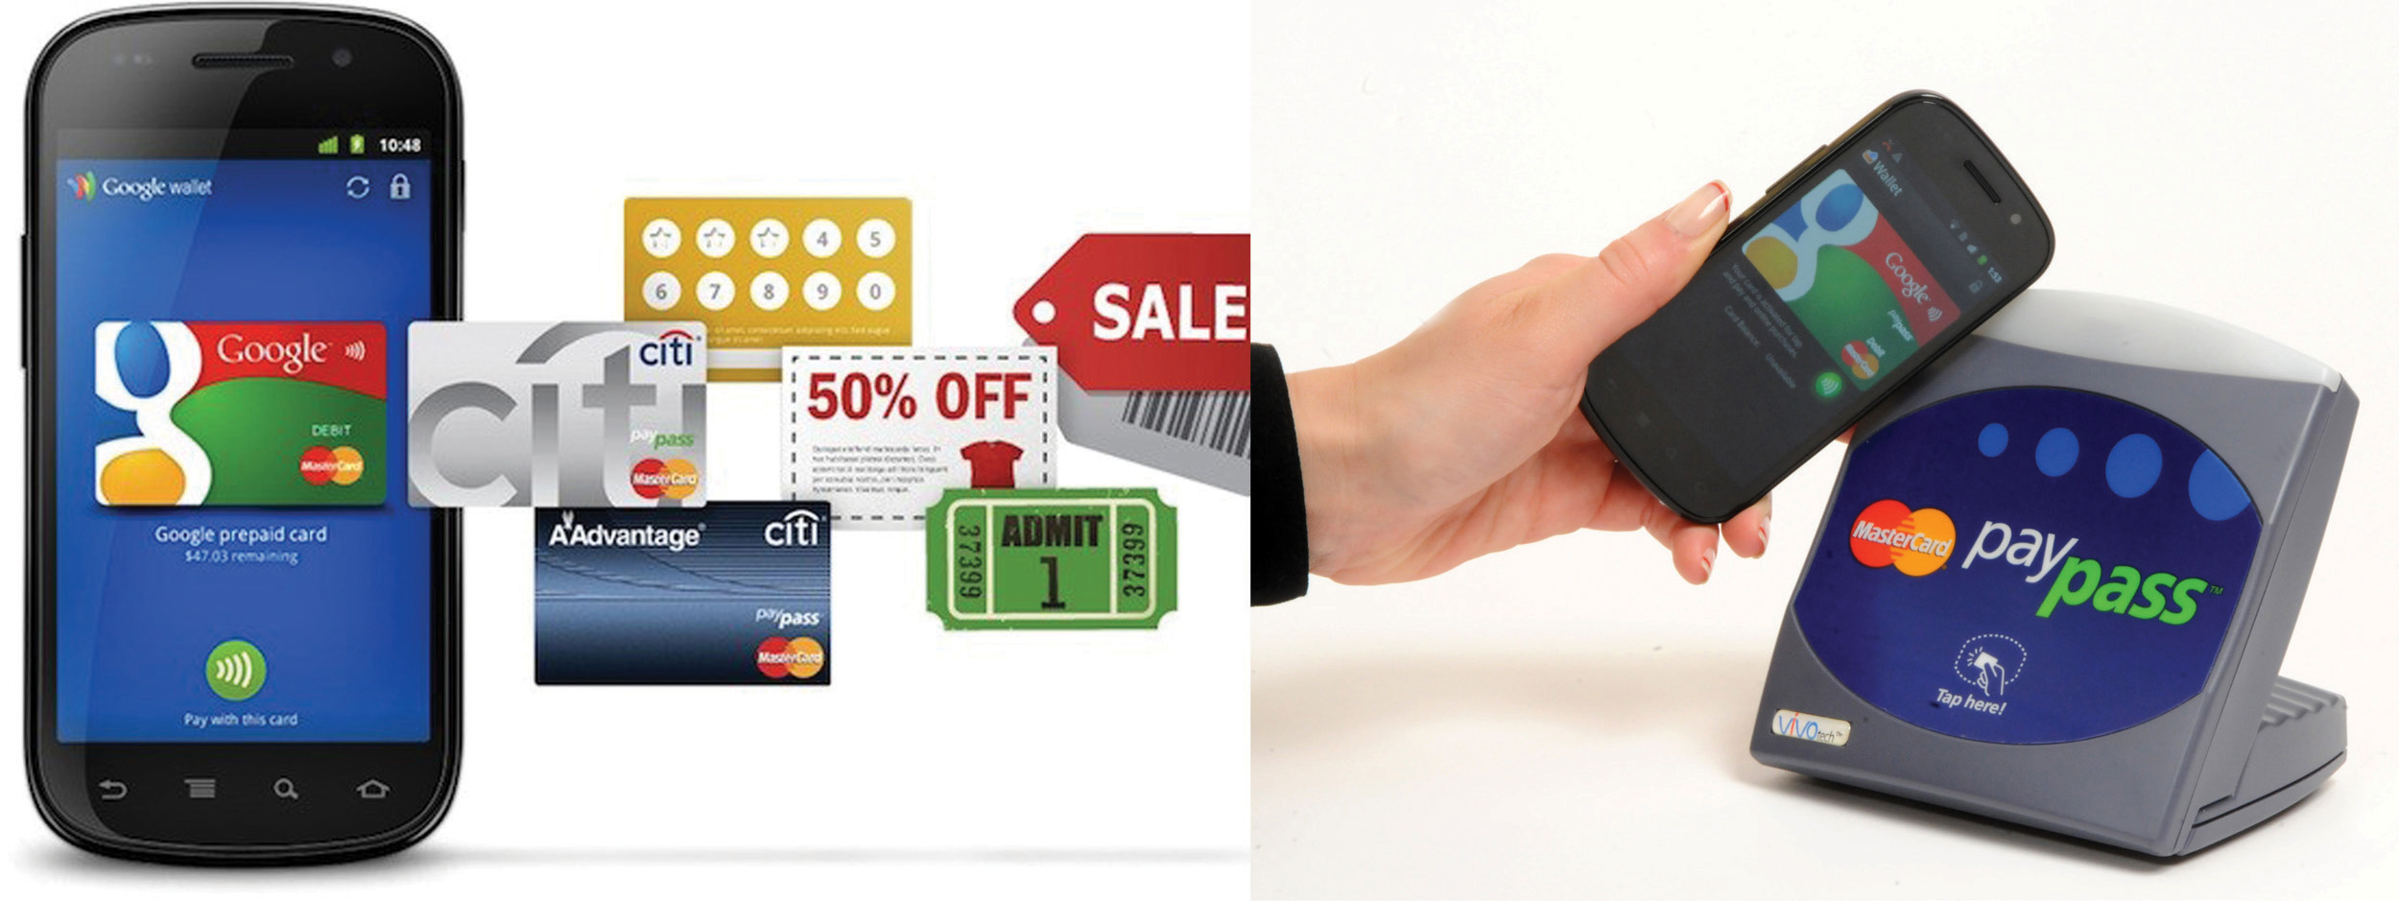](http://images.flatworldknowledge.com/gallaugher_1.4/gallaugher_1.4-fig08_023.jpg)

Source: Google.

**Social: Google+**

Google’s success in social media has been mixed. Its two biggest successes—YouTube and Blogger—were both acquired from other firms. Internally-developed Orkut has for years ranked as the top social network in Brazil but is unheard of throughout most of the rest of the world; and Google-hatched Buzz and Wave were both dismal failures. But with Google+ the firm may have finally created a service with staying power.

Google+ rolled out in summer 2011 as an integrated collection of social products associated with a user’s Google profile. Stream is a newsfeed. Hangouts is a video chat service that can support groups, and enables screen sharing and group document editing. Messenger offers group texting. Circles helps manage sharing contacts (so you can share a given item with just ‘friends,’ ‘business contacts,’ or any other sharing circles you want to create). Google+ also offers Events (integrated with a user’s Google Calendar); Communities, for discussions; Pages for organizations and firms; and +1 endorsements (akin to Facebook “Likes”), which influence in individual’s personalized search results. Other Google services are being merged with or migrated to Google+. Photos was based on Google’s Picasa service, and the two will eventually be merged. Google Places is now Google+ Local. All told, Google+ offers up a set of features similar to those found in Facebook, Twitter, Tumblr, Skype, and Group.me. Google has also cut experiments that haven’t worked (Sparks recommendations, Games).[[34]](http://catalog.flatworldknowledge.com/bookhub/reader/12375?cid=1681397" \l "ftn.fn-34) Google+ had about 190 million active users when Facebook was claiming more than a billion. But more notably, Google+ users spend about 11 minutes a month on the service, versus the over 400 minutes a typical user spends on Facebook[[35]](http://catalog.flatworldknowledge.com/bookhub/reader/12375?cid=1681397" \l "ftn.fn-35) and 190 minutes spent on Twitter.[[36]](http://catalog.flatworldknowledge.com/bookhub/reader/12375?cid=1681397" \l "ftn.fn-36)

Making a hit of Google+ could eventually help the firm serve more ads, grow additional revenue lines and gain additional data and insight that can be used to help in search, content recommendations, and ad targeting. Competing in winner-take-most markets where network effects dominate will be tough, but Google brings a number of assets to the table and seems committed to growing the effort. CEO Larry Page has even stated that Google will tie employee bonuses to the success of the firm’s social efforts.

**What’s Google Up To?**

With all this innovation, it’s tough to stay current with Google’s cutting edge product portfolio. But the company does offer “beta” releases of some projects, and invites the public to try out and comment on its many experiments. To see a current list of many of the firm’s offerings, check out <http://www.google.com/options>.

Experimentation and innovation are deeply ingrained in Google’s tech-centric culture, and this can produce both hits and misses. While Google introduces scores of products each year,[[37]](http://catalog.flatworldknowledge.com/bookhub/reader/12375?cid=1681397" \l "ftn.fn-37)it has also cancelled several along the way, including Jaiku (which couldn’t beat Twitter), Google Video (which was superseded by the YouTube acquisition), the aforementioned social flops Wave and Buzz, the payments offering Checkout, and a bunch more you’ve likely not heard of, like Dodgeball, Notebook, Catalog Search, and Mashup Editor.[[38]](http://catalog.flatworldknowledge.com/bookhub/reader/12375?cid=1681397" \l "ftn.fn-38) But the firm’s relentless commitment to developing new products and services, coupled with wildly profitable core businesses, allows Google to survive the flops and push the edge of what’s possible. The firm’s secretive lab, Google X, is working on all sorts of gee-whiz offerings, including self-driving cars, space elevators, and refrigerators that can order your groceries when they run low.[[39]](http://catalog.flatworldknowledge.com/bookhub/reader/12375?cid=1681397" \l "ftn.fn-39) As another example, consider the firm’s Project Glass, which has already been distributed to thousands of initial “Explorers,” introduces a new screen for information—one that you wear like a pair of glasses, providing a heads-up display for queries and information.

How It Feels (through Glass)

**Apps and Innovation**

Google’s “apps” are mostly Web-based software-as-a-service offerings. Apps include an Office-style suite that sports a word processor, presentation tool, and spreadsheet, all served through a browser. While initially clunky, the products are constantly being refined. The spreadsheet product, for example, has been seeing new releases every two weeks, with features such as graphing and pivot tables inching it closer in capabilities to desktop alternatives.[[40]](http://catalog.flatworldknowledge.com/bookhub/reader/12375?cid=1681397" \l "ftn.fn-40) And new browser standards, such as HTML 5, will make it even easier for what lives in the browser to mimic what you’re currently using on your desktop, even allowing apps to be used offline when net access isn’t available. That’ll be critical as long as Internet access is less reliable than your hard drive, but online collaboration is where these products can really excel (no pun intended). Most Google apps allow not only group viewing, but also collaborative editing, common storage, and version control. And it seems Google isn’t stopping at Office files, video, and photos—Google’s cloud will hold your music and other media, too. Google’s Play service allows you to upload thousands of the tracks that you already own to what some have called a sort of “locker in the sky.” Users can stream the tracks over the Internet, sync frequently played songs and albums for offline play, and even share tracks with friends via Google+ (friends usually get one full listen for free).[[41]](http://catalog.flatworldknowledge.com/bookhub/reader/12375?cid=1681397" \l "ftn.fn-41) And Google Drive offers several gigs of free cloud-based storage that can be shared and synced across computers.

Unknown is how much money Google will make off all of this. Consumers and small businesses have free access to these products, with usage for up to fifty users funded by in-app ads. But is there much of a market serving ads to people working on spreadsheets? Enterprises can gain additional, ad-free licenses for a fee. While users have been reluctant to give up Microsoft Office, many have individually migrated to Google’s Web-based e-mail and calendar tools. Google’s enterprise apps group will now do the same thing for organizations, acting as a sort of outsourcer by running e-mail, calendar, and other services for a firm and all while handling upgrades, spam screening, virus protection, backup, and other administrative burdens. Virgin America, Jaguar, National Geographic, and Genentech are among the Google partners that have signed on to make the firm’s app offerings available to thousands. Google Play doesn’t just hold your music; it’s also an iTunes-like marketplace where you can buy all sorts of media: movies, TV shows, books, and apps. Google Drive is free (the first 15 GB is shared between Drive, Photos, and Gmail), but if you want more, you’ll have to pay.

And of course, Microsoft won’t let Google take this market without a fight. Microsoft has experimented with offering simplified, free, ad-supported, Web-based, online options for Word, Excel, PowerPoint, and OneNote; Office 365 offers more robust online tools, ad free, for a low monthly subscription cost; and Microsoft can also migrate an organization’s applications like e-mail and calendaring off corporate computers and onto Microsoft’s server farms. Apple has also stepped up to bat. The firm continues to build billion-dollar data centers and has introduced iWork Cloud, browser versions of its word processor, spreadsheet functionality, and presentation apps that in initial demos were nearly as feature rich as desktop offerings. Don’t look for anyone to yield ground soon. As the cloud becomes the new hard drive, Web-based services will be key to creating a durable switching cost asset.

**Google’s Global Reach and the Censorship Challenge**

In the spring of 2010, Google clashed publicly with the government of China, a nation that many consider to be the world’s most potentially lucrative market. For the previous four years and at the request of the Chinese government, Google had censored results returned from the firm’s google.cn domain (e.g., an image search on the term “Tiananmen” showed kite flying on google.cn, but protestors confronting tanks on google.com). However, when reports surfaced of Chinese involvement in hacking attempts against Google and at least twenty other U.S. companies and human rights dissidents, the firm began routing google.cn traffic outside the country. The days that followed saw access to a variety of Google services blocked within China, restricted by what many call the government’s “Great Firewall of China.”

Speaking for Google, the firm’s deputy counsel Nicole Wong states, “We are fundamentally guided by the belief that more information for our users is ultimately better.” But even outside of China, Google continues to be challenged by its interest in providing unfettered access to information on one hand, and the radically divergent laws, regulations, and cultural expectations of host nations on the other. Google has been prompted to block access to its services at some point in at least twenty-five of one hundred countries the firm operates in.

The kind of restriction varies widely. French, German, and Polish law requires Google to prohibit access to Nazi content. Turkish law requires Google to block access to material critical of the nation’s founder. Access in Thailand is similarly blocked from content mocking that nation’s king. In India, Google has been prompted to edit forums or remove comments flagged by the government as violating restrictions against speech that threatens public order or is otherwise considered indecent or immoral. At the extreme end of the spectrum, Vietnam, Saudi Arabia, and Iran have aggressively moved to restrict access to wide swaths of Internet content.

Google usually waits for governments to notify it that offensive content must be blocked. This moves the firm from actively to reactively censoring access. Still, this doesn’t isolate the company from legal issues. Italian courts went after YouTube executives after a video showing local teenagers tormenting an autistic child remained online long enough to garner thousands of views.

In the United States, Google’s organic results often reveal content that would widely be viewed as offensive. In the most extreme cases, the firm has run ads alongside these results with the text, “Offensive Search Results: We’re disturbed about these results as well. Please read our note here.”

Other Internet providers have come under similar scrutiny, and technology managers will continue to confront similar ethically charged issues as they consider whether to operate in new markets. But Google’s dominant position puts it at the center of censorship concerns. The threat is ultimately that the world’s chief information gateway might also become “the Web’s main muzzle.”

It’s not until considered in its entirety that one gets a sense of what Google has the potential to achieve. It’s possible that increasing numbers of users worldwide will adopt light, cheap netbooks and other devices powered by free Google software (Android, Google’s Chrome browser, Google TV, and Chrome OS). Productivity apps, e-mail, calendaring, and collaboration tools will all exist in the cloud, accessible through any browser, with files stored on Google’s servers in a way that minimizes hard drive needs. Google will entertain you, help you find the information you need, help you shop, handle payment, and more. And the firms you engage online may increasingly turn to Google to replace their existing hardware and software infrastructure with corporate computing platforms like Google Apps Engine (see [Chapter 11 "Software in Flux: Partly Cloudy and Sometimes Free"](http://catalog.flatworldknowledge.com/bookhub/reader/12375?e=fwk-38086-ch10)). All of this would be based on open standards, but switching costs, scale, and increasing returns from expertise across these efforts could yield enormous advantages.

Studying Google allowed us to learn about search and the infrastructure that powers this critical technology. We’ve studied the business of ads, covering search advertising, ad networks, and ad targeting in a way that blends strategic and technology issues. And we’ve covered the ethical, legal, growth, and competitive challenges that Google and its rivals face. Studying Google in this context should not only help you understand what’s happening today, it should also help you develop critical thinking skills for assessing the opportunities and threats that will emerge across industries as technologies continue to evolve.

**Key Takeaways**

* For over a decade, Google’s business has been growing rapidly, but that business is maturing.
* Slower growth will put pressure on the firm’s stock price, so a firm Google’s size will need to pursue very large, risky, new markets—markets that are also attractive to well-financed rivals, smaller partners, and entrepreneurs.
* Rivals continue to innovate in search. Competing with technology is extremely difficult since it is often easy for a firm to mimic the innovations of a pioneer with a substitute offering. Microsoft, with profits to invest in infrastructure, advertising, and technology, may pose Google’s most significant, conventional threat.
* Although Microsoft has many distribution channels (Windows, Internet Explorer, Office) for its search and other services, European and U.S. regulators will likely continue to prevent the firm from aggressive product and service bundling.
* Google is investing heavily in methods that promote wider Internet access. These include offering free software to device manufacturers and several telecommunications and lobbying initiatives meant to lower the cost of getting online. The firm hopes that more users spending more time online will allow it to generate more revenue through ads and perhaps other services.
* Google Wallet uses NFC communications to allow mobile phones to make credit and debit card payments, manage loyalty programs, redeem coupons, and more. Payments are linked to existing credit cards. Google does charge for transaction fees but plans to use Wallet as a way to sell other services such as those offered by its Google Offers coupon and deal program. The service is challenged in part because telecom carriers and retailers offer competing efforts, and limited users aren’t enough to attract new vendor sign-ups (i.e., a problem creating two-sided network effects).
* Google+ has become a large social network, in part because of Google’s ability to integrate the service with other offerings. However, it still significantly lags behind Facebook and Twitter in user engagement and overall users.
* YouTube demonstrates how a firm can create a large and vastly influential business in a short period of time but also that businesses that host and serve large files of end-user content can be costly.
* Google, Microsoft, and smaller rivals are also migrating applications to the Web, allowing Office-style software to execute within a browser, with portions of this computing experience and storage happening off a user’s computer, “in the cloud” of the Internet. Revenue models for this business are also uncertain.
* With scale and influence comes increased governmental scrutiny. Google has increasingly become a target of antitrust regulators. The extent of this threat is unclear. Google’s extreme influence is clear. However, the firm’s software is based on open standards; competitors have a choice in ad networks, search engines, and other services; switching costs are relatively low; users and advertisers aren’t locked into exclusive contracts for the firm’s key products and services; and there is little evidence of deliberate, predatory pricing or other “red-flag” activity that usually brings government regulation.