Introduction
For this assessment, I have been tasked with analysing a dataset of around roughly 6000 different network sessions, being tasked with firstly analysing the data, creating graphs of varying type to show what the data being collected, then preparing all of the found data in order to allow the AI to be trained to create predictions based on the already provided data and then finally, we train the AI to make predictions of what would happen if new pieces of data were added into the Dataset which would help with Security and a better overall understanding of how a system is being affected / attacked by different types of network traffic.

Part 1: Dataset Understanding and Exploration
Using the Dataset we have been provided in order to complete this assessment, we see that for the 6000~ different network session that are being tracked and recorded, there are 19 different attributes that are present in the Dataset which has data being recorded inside, for example Packet Session ID, Device Type, Login Attempts, Failed Logins, Bytes sent and Packet Rate etc. We see these different attributes by running the command df.info()
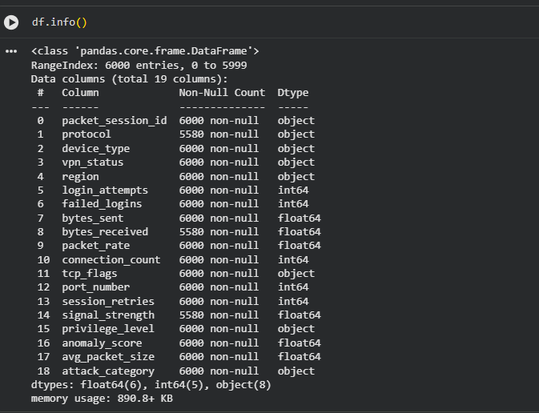
(Figure 1.1; Different Attributes in Dataset)
Next, we start to create different graphs for certain attribute types of data that are present in the dataset. Firstly, we create a heatmap that shows us the correlation that different attributes have with one another. These allow us to read the heatmap and see how different attributes affect one another. Reading the Heatmap, Red shows an extremely high Correlation (1.0), mostly only found when cross referenced with the exact same attribute as each other. Orange to white shows a high correlation, anywhere from around 0.8 to a 0.5 and is where some of our different attributes tie together. For Example, Average Packet Size and Packet Rate have a correlation with one another around 0.5, showing up as white on the heatmap. These have a high correlation to one another as a main way of monitoring network traffic is by watching packet sizes, with normal traffic being usually somewhat large whereas an attacker or malicious threat would send a high amount of smaller packets, essentially flooding the network, making it work harder to complete more requests quicker.
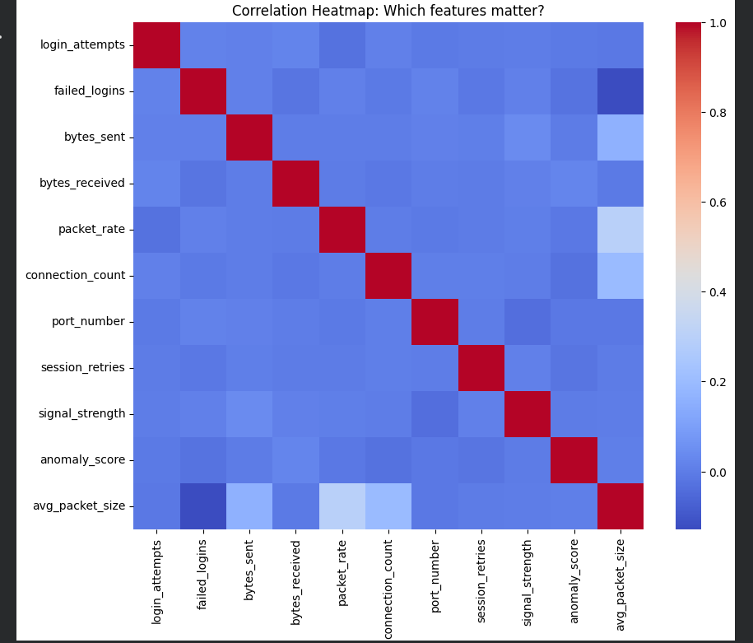
(Figure 1.2; Heatmap for Correlation)
Next, we create a bar chart graph, showing the two different types of “attacks” that are being seen in the network through the dataset. The two different types are Benign and Brute Force attacks. Benign “attacks” are in reality, just a normal user going about their business on the network, for example logging into their account and casually just looking over things. These are evident by the low numbers of failed login attempts and a steady packet rate that rarely changes size, with the traffic flowing in a logical flow. However, Brute Force attacks are often the complete opposite of the Benign counterpart. These consist of Trial and Error, with people often using scripts and or bots to enter passwords for an account at an alarmingly high rate. The way we identify a brute force attack mostly comes from the amount of failed login attempts in comparison to a normal users, often being exceptionally higher depending on the complexity of a user’s password. In this dataset, out of the 6000 different network sessions, by their different attributes, 4161 are found to be benign whereas 1839 are found to be Brute Force Attacks.
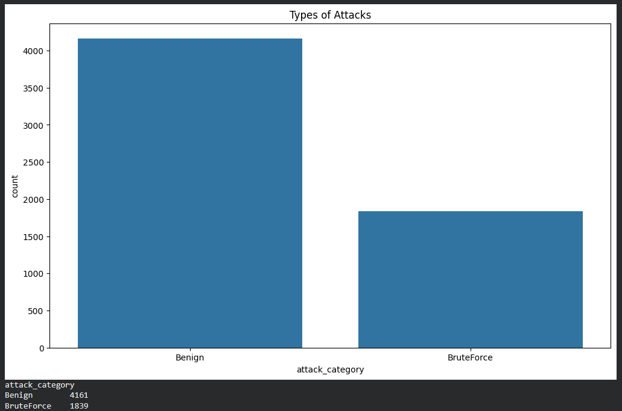
(Figure 1.3, Bar Chart of Attack Types)
The Next Two Graphs, a Histogram and a Boxplot, both center around the Average Size of packets from the networks dataset, with the Histogram showing the distribution of the sizes of the different packets, and the box plot showing the outliers being found in the packet sizes. The Histogram is shown as a bell curve, or as normal distribution with a slight positive skew. This is evident when seeing that the peak of the curve is shown around the 370 mark of the amount of the packets at the size of around 280-290. This shows that while the majority of the packets stay around the same size, some have larger data pulls, resulting in the skew.
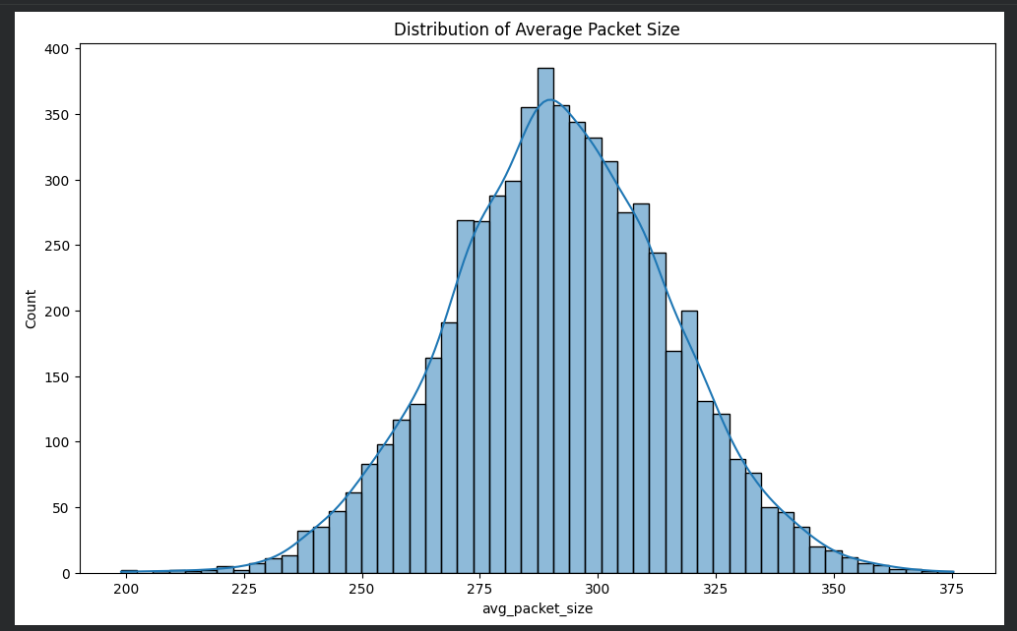
(Figure 1.4; Histogram of Packet Size Distribution)
The Boxplot shows us how all of the data is spread out, with the median sitting centrally at approximately 290 bytes per packet. The Boxplot also shows the presence of outliers on both sides of the spectrum, ranging anywhere from 230 bytes all the way up to 350 bytes. These results further confirm the positive skew on the Histogram previous and also shows that these outliers may be of concern, and should get further investigation. These Results also help us to choose the model we use later in the data preparation process.
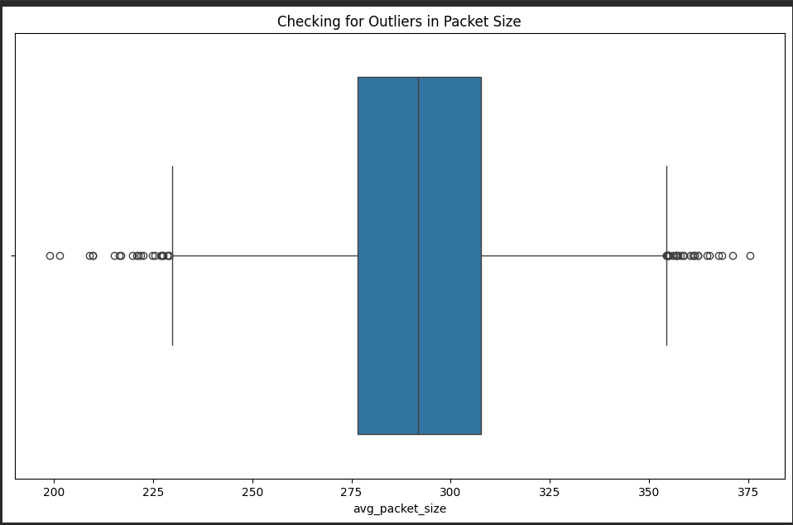

(Figure 1.5; Boxplot identifying outliers in packet size)
Finally, I created a scatterplot that shows the Average Packet Size and the Amount of packets sent and splitting them by the type of attack they are, which were previously mentioned, Benign and Brute Force. In this Scatter Plot, we look for big groups or clusters of dots, as this is seen as normal behaviour, while outliers and straight lines are often seen as scripts, or large amounts of packets which could be seen as a security concern for the network.
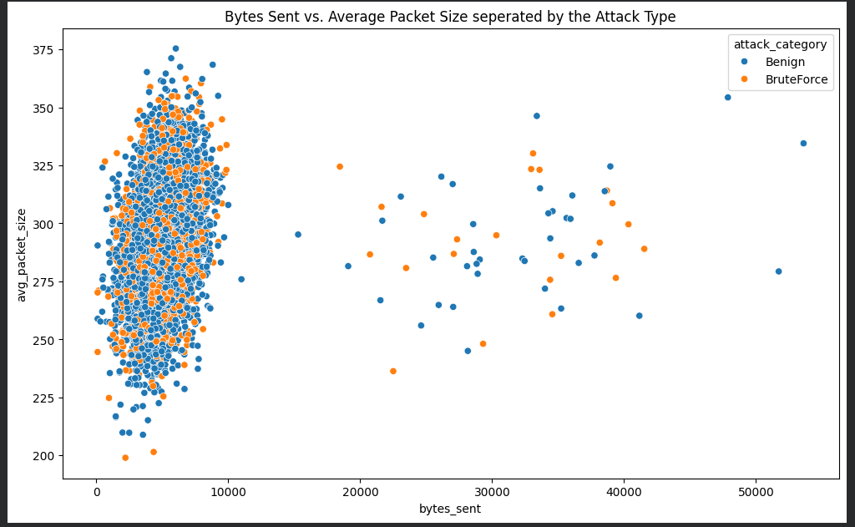
(Figure 1.6, Scatter plot graph showing packet sizes by attack types)
Part 2: Data Preparation and Methodology
For Data Preparation, we have to fill in missing values that are present in the dataset, create 2 new different attributes for the dataset that still maintain a relevance to the actual data that is present in the dataset and finally create 2 models for the dataset, which we had previously mentioned would be done in Part 1.
To start, in order to clean up and fill in missing values in the dataset, we look at the different types of data, mainly Numerical and Categorical data. For columns like “Signal Strength”(Numerical Data) , we fill these columns in with the median, based of the previous data found in the boxplot graph present in Part 1. We choose the Median as its not as skewed as the average / mean would be. When we are working on columns such as the Column for “Protocol”(Categorical Data) , we choose the mode as we do not want to just fill in the Dataset with Fake Data and instead choose the mode as it would be the safest guess for the missing value.
After we fill in the missing values, we start to create our new attributes for the Dataset. The first attribute we created was an Attribute called “Total Traffic”. We do this by adding the already created attributes of “Bytes Sent” and “Bytes Received” and creating a single amount for the 2 different attributes of the data in the session. The next attribute I created was an Attribute called “Failure Ratio”. We use the two attributes of “Failed Logins” and “Login Attempts”, dividing them and getting the numerical value for the attribute. This allows the AI to defer between someone casually logging in with a 0.0 / 0.1 ratio and someone Brute forcing and using scripts to access accounts with a 0.9 / 1.0 ratio.
Next, we encode the Data, then scale it. For Example, we encode the column of “Attack Category” and change the different types into numbers, 0 for Benign and 1 for Brute Force, which allows the AI interpret what it means, instead of just seeing a string of letters being presented to it. With Scaling, we alter the amount of data being presented to the AI in a big clump, so that it is not overwhelmed with the bigger numbers, completely bypassing something with less amounts of Data, but having double or even triple the impact on the Data.
Finally, we split the Dataset into different amounts and different categories. We leave 80% of the 6000 different rows in a set for Training, while the other 20% of the Data goes to another set for Testing. The training set is what the AI will use to study the already created data and find patterns present in it, while the Testing set is used for getting the AI to check through unseen rows and find the pattern that it has been trained to find, like identifying brute force attacks that are in the Network etc.
Part 3: Training the AI and Results
In order for us to train the AI, we create 2 different models of Random Forest. We previously mentioned that we would use this model type due to the Data that the boxplot and histogram presented us with in Part 1. These 2 different models are for “Classification” and then “Regression” labelled as “y_class” and “y_reg” in the code.
The first forest, used to classify attack types, uses the previously fed data that shows that a high “Failure Ratio” tied with higher “Packet Rates” indicates an attack on the network. Using the different trees present in the forest, it gathers the result each individual tree gives and sees whether the outcome is higher for the option of a malicious attack or if it’s just normal user traffic. In order to properly evaluate the result, we use a confusion matrix. This tracks True Positives where the AI correctly identifies the Attack / User Behaviour and True Negatives where the AI incorrectly identifies the Attack / User Behaviour. Then by analysing the matrix, we can see the overall accuracy of the AI, which would reveal if its prone to false positves. The Second Model, the Regression Forest, is used to predict the size of a data packet in the network. Similarly to the Classification Forest, it takes all of the estimated sizes that each tree gives it in the forest, then divides it by the amount of trees in the forest to find the average of the estimates, using that as the prediction of size for the packets. This forest uses attributes such as Protocol, Device type and the Total Traffic that was just created. We then get the results using MSE (Mean Squared Error) and R-Squared Score. MSE calculates the average squared difference between the AI's predicted packet size and the actual packet size found in the testing set. Lower MSE results indicate that the AI and its "guesses" are consistently close to the real world values. R-Squared Score represents how much of the variation in packet sizes can be explained by our model.
Finally, we Analyse the results that we got from the tests. In the Classification Forest, there was 841 correct identifications of Benign “attacks”, 6 False positives, 349 False Negatives of actual Brute Force attacks and 4 correct identifications of Brute Force attacks. Although these results are not the results we had hoped for, this is when we would keep adding more data to let the AI learn more. In the Regressor Forest, the MRE was 246.52 and R-Squared score was a 0.54. This means that the AI is missing the packet size by roughly 15 or 16 bytes, which is extremely precise and the variation detection is moderately able to tell the reason for the differentiation in Packet Size.
Conclusion:
In conclusion, this AI does not perform extremely well, therefore requiring more training in order for it to be able to better analyse data that it is being given. The Data overviews shows the important areas that are being used in a high volume in order for this AI to be trained aswell as providing user with information on what each piece of data is used for.

