Security Architecture Report
Nathan Mooney B00169691

Introduction:
For this Project, I have been tasked with using AWS to set up WinLocal Giveaways new website and cloud services for the Website. This is to allow the WinLocal team to move all their systems from their old server systems to a fully online database that can be accessed through the AWS websites. In the brief, we are asked to create a diagram for the proposed AWS service that will be created, A PoC (Proof of Concept) of the services that have been shown, two extra pieces that can be added to the AWS service that WinLocal is using and finally analyze the PoC and cross check what has been created and the sustainability pillar.

Task 1: AWS Architecture Diagram
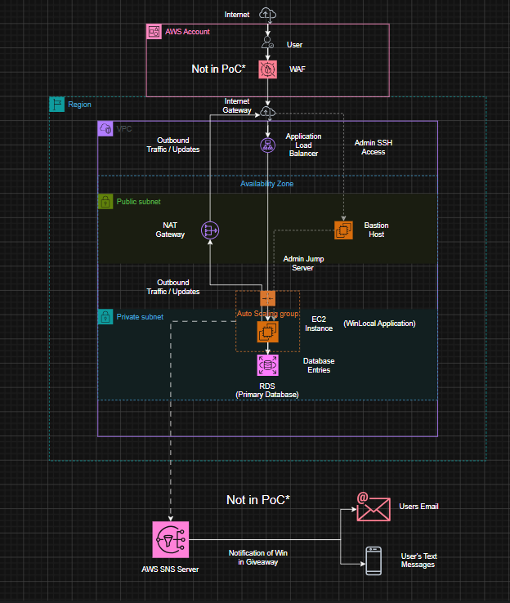
(Figure 1.1; Diagram of Proposed PoC Services)
In the Diagram, the proposed services show the VPC, Load Balancers, Nat Gateways, a Bastion host, an EC2 Instance, an Auto Scaling Group and an RDS System etc. These are shown as the main services that will be created when making the PoC, while an AWS SNS Server and a WAF (Web Application Firewall) are add-ons that can be added to System after the original PoC is created as they’re are not needed in order for the system to actually run and instead are extra services that improve quality of life and/or security of the system.
Task 2: Proof of Concept (PoC)
The objective of creating this AWS system is to show that when the WinLocal system has a location where important information is stored, high security for the Website and when the website is put under stress due to high amounts of Traffic, the auto scaling group creates more instances to alleviate the stress on a single server.
I started by creating the Virtual Private Cloud (VPC) for WinLocal and creating Public and Private Subnets, isolating the different tiers of the VPC, improving the security present in the system. We also set up Security Groups whilst creating the VPC, defining where traffic can come into the system, where it goes and what should be blocked. This will help when setting up boundaries where public traffic stops and where internal traffic can progress by, most notably involving the Bastion Host being used as a jump server into the private subnet from the public subnet for admin access to the WinLocal Ec2 instance. This limits the amount of attacks that can affect our EC2 instance as it is not public facing.
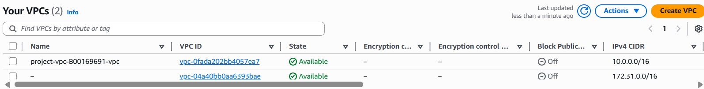
(Figure 2.1; Evidence of VPC)
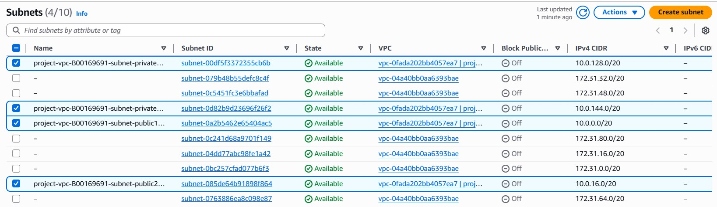
(Figure 2.2; Evidence of Subnets in the VPC)
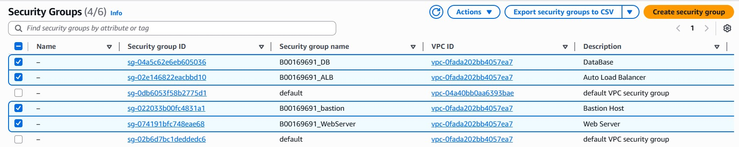
(Figure 2.3; Evidence of Security Groups and their Purpose in the VPC)
After creating the VPC, subnets and the Security Groups, I created my EC2 instances, which are the Bastion Host previously mentioned and the actual EC2 Instance being used as the WinLocal Giveaways website. For the EC2 instance, we use an application load balancer to monitor the amount of traffic that is entering the website ensuring that the server does not become overwhelmed by too many people entering the website at the same time. If it becomes overwhelmed that is when the auto-scaling group that has been created will make copies of the instance to spread traffic across the instances, limiting the pressure of the traffic on a single server. These instances are only created once the original instance has reached 60 percent CPU utilisation, due to the settings we have put onto the Auto Scaling Group.
To create these new instances, we use an AMI image of the original instance and give it to the Auto-Scaling Group so that the new instances are the same layout as the original instance. An AMI image is like a blueprint in the way it tells the server to be created, including its software, operating system etc. These are also used as a way of disaster prevention and can facilitate a rollback or back-up when necessary.
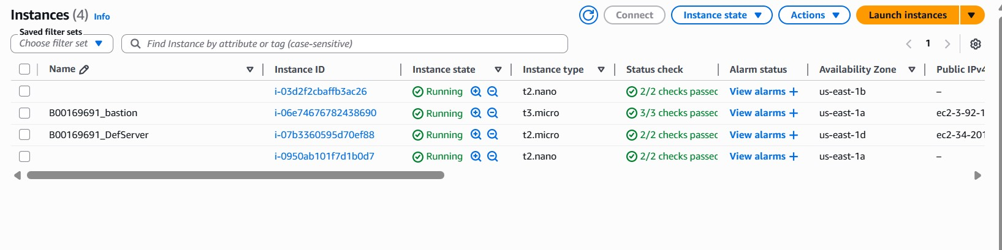
(Figure 2.4; EC2 Instances and Auto Scaling Instances)
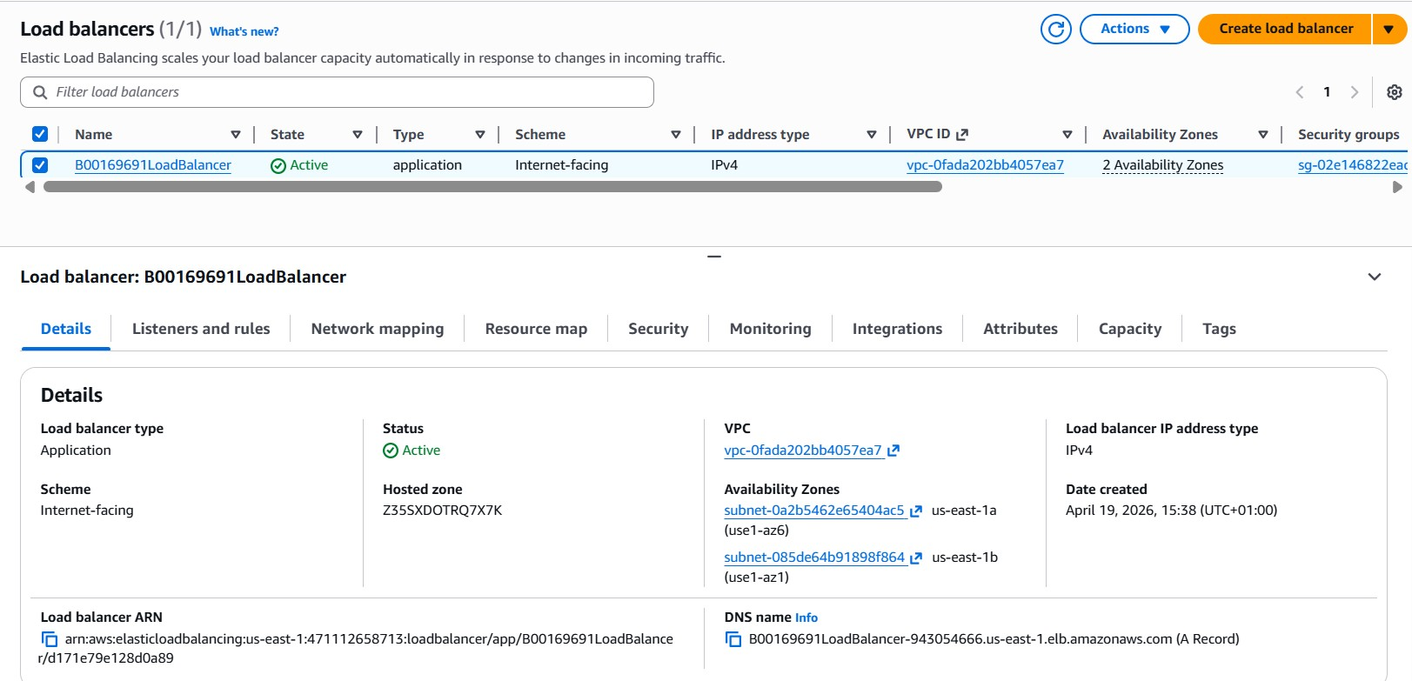
(Figure 2.5; Application Load Balancer)
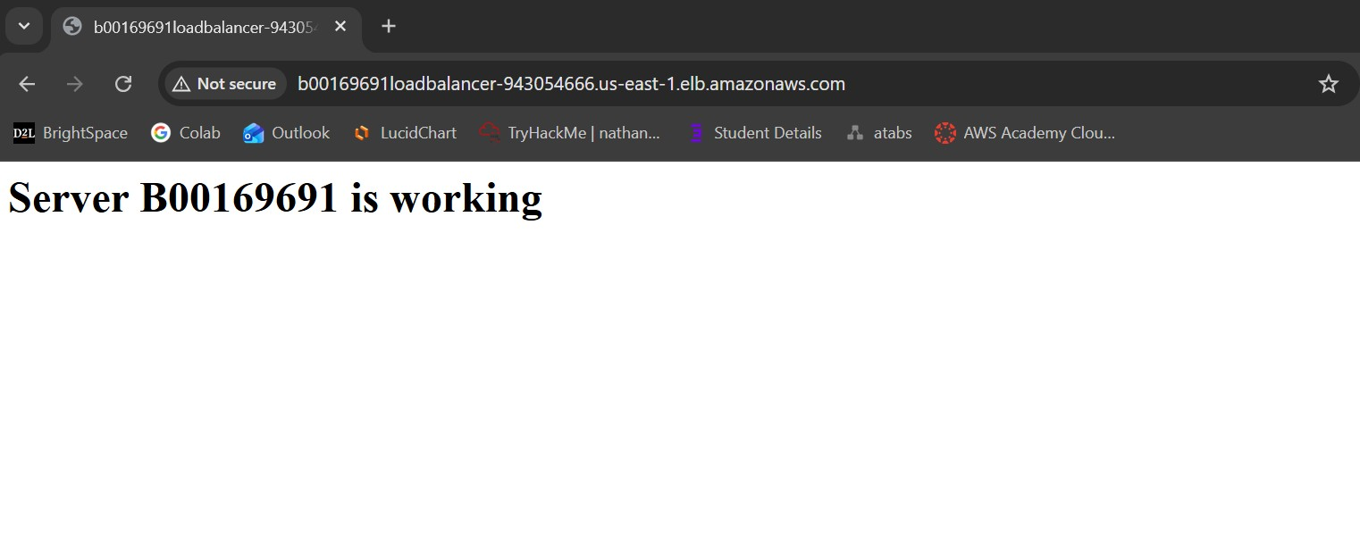
(Figure 2.6; EC2 Instance for WinLocal Giveaways Website Working)

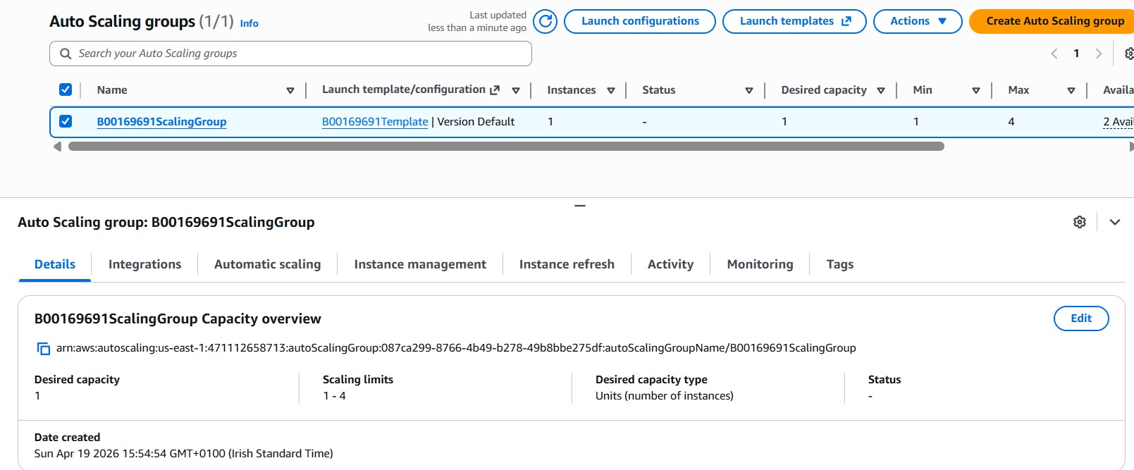
(Figure 2.7; Auto Scaling Group)
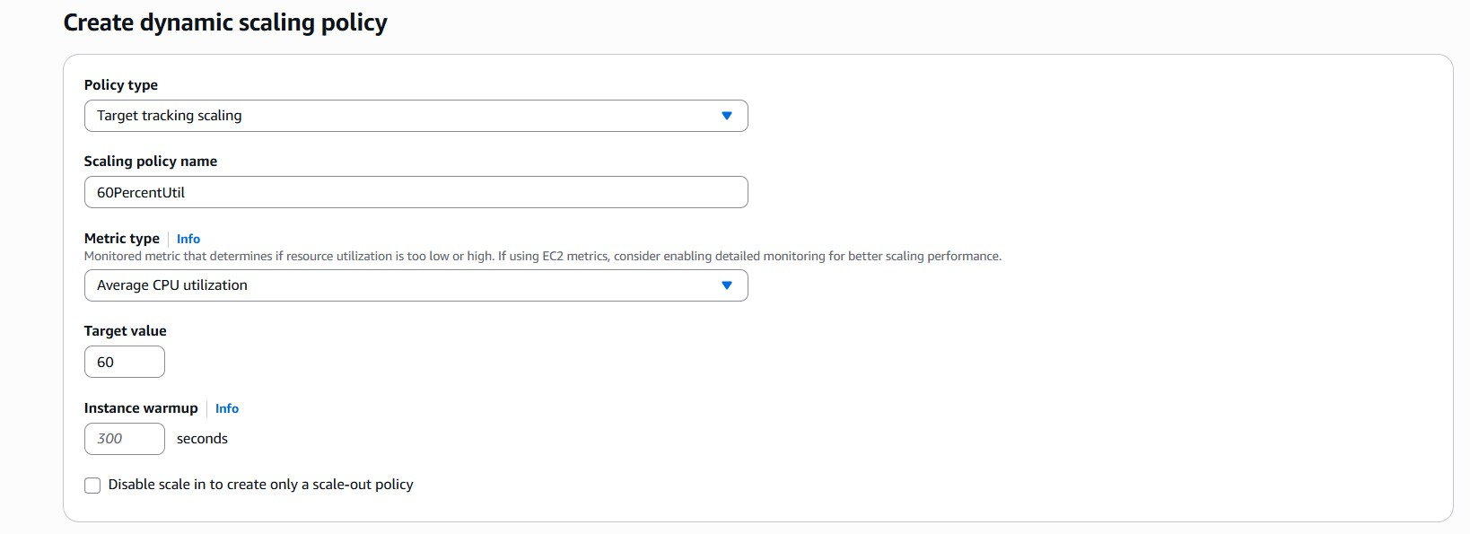
(Figure 2.8; Evidence of Scaling Policy for 60 percent CPU utilisation)
Lastly, I created the RDS Primary Database and the S3 Bucket Back-Up website for WinLocal Giveaways. The RDS is implemented into the system as a way for the website to store important user information such as credit card details, shipping details, names, and phone numbers for future use if a user is to win a giveaway. This RDS is in the private subnet of the system, so that it is harder for an attacker to reach it and obtain information from it, like how I have set up the EC2 instance for the WinLocal Website. The RDS can also automatically scale depending on how much storage is needed by the company and creates back-ups of information that is stored ensuring that data is taken care of effectively.
The S3 Bucket used as a back-up website for the original EC2 instance is implemented for disaster recovery, similarly to the Auto Scaled Instances created by the Auto Scaling Group. If the original website is to do go down, users trying to access the website will be directed to the website on the S3 Bucket, showing that the original instance is currently unavailable. This is better than alternatively just receiving an error message such as a 404 or timeout message due to them not being able to access the website.
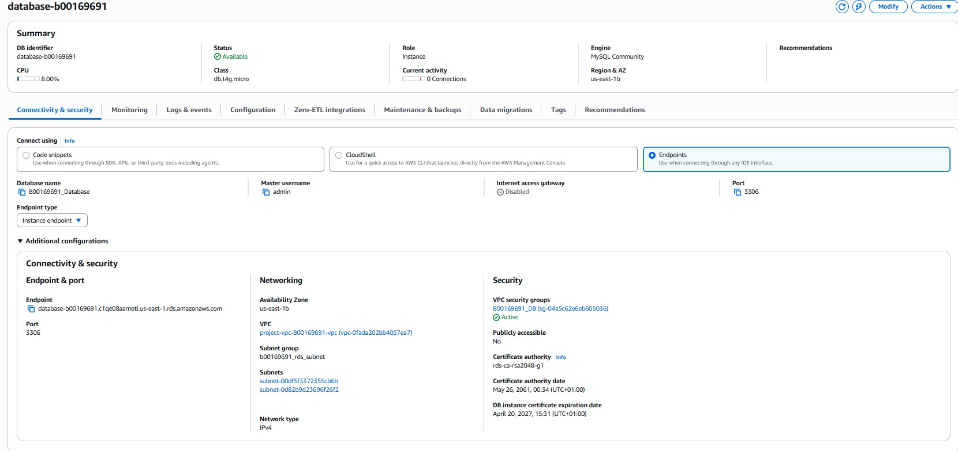
(Figure 2.9; RDS endpoint Information)
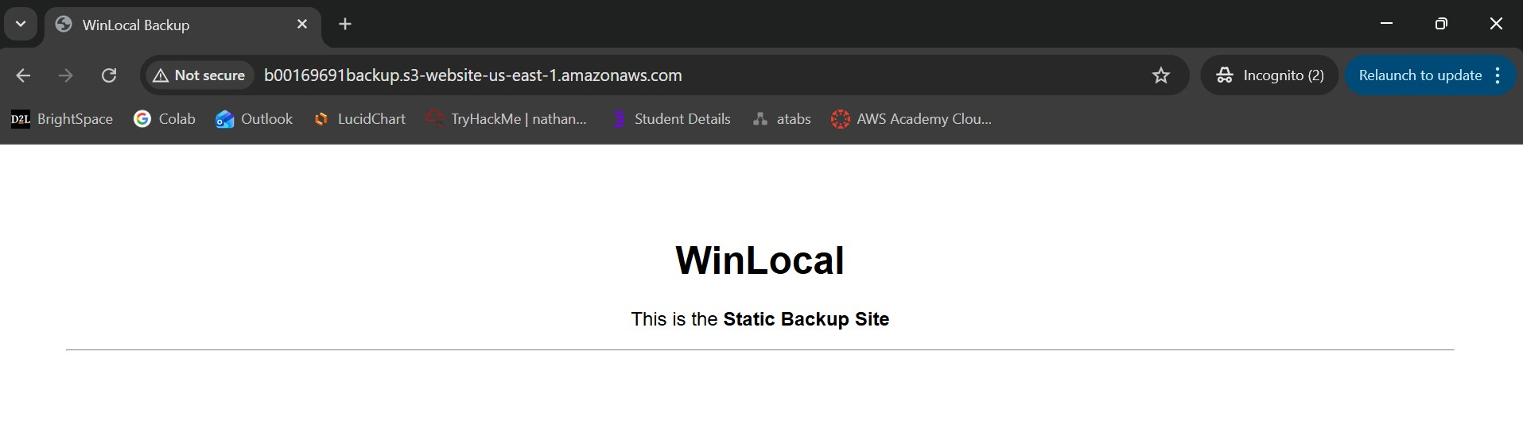
(Figure 2.10; S3 Bucket Static Backup Website)

By implementing these services, each of the issues posed to the WinLocal Giveaways team have been solved. Issue 1, regarding the Websites availability and load balancing have been solved with the implementation of the Auto Scaling Group for more instances to lessen the pressure of traffic, Application Load Balancer which is used to distribute traffic, increasing reliability and availability of the website and the static backup website that is used when the website has gone down, informing users of when it will be back and what to do whilst it is down.
Issue 2 is solved by the implementation of Network Segmentation and the migration of data to Amazon RDS system. Since the network is segmented, the RDS is placed into a private subnet so it does not have a public facing entry, making it harder for attackers to get access to it, and the use of the RDS system means that the storage amount can be automatically changed depending on the individual requirements of the WinLocal team.
Issue 3 is fixed when the Auto Scaling Group is created. Using the AMI image of the original instance allows the auto scaling group to create replicas of the original instance, which means that new instances are consistent with what WinLocal requires in order for their websites to run smoothly and efficiently.
Finally, Issue 4s worry of Network Security is fixed with the addition of Network Segmentation, the use of security groups and IAM and the Bastion Host. Servers are now in private subnets, becoming harder to access by attackers, security groups only allow certain traffic to enter these private subnets depending on specific ips, the bastion host acts as a jump server for admin access that requires certain credentials to access and IAM Management prevents user gaining access to accounts without verifying their identities.

Task 3: Justification of additional AWS Services
The additional AWS Services I have included in my diagram were a WAF (Web Application Firewall) and an AWS SNS System. These additions help the WinLocal Team with both security of the overall system as well as contacting users that use their platform.
The Web Application Firewall is used to detect and deter malicious traffic that is attempting to connect to the system of WinLocal Giveaways. Policies are set on WAF and depending on these policies set, different types of traffic will be stopped from entering the system as it is deemed as malicious or a threat, for example, an attempted DDOS attack can be stopped with the policies on a WAF that limits the amount of packets that come from a certain IP Address.
The proposed SNS server is a way for users to be contacted about their results in giveaways that they have entered through the website. The SNS system can send a user a notification through either their phone number provided or their email, stating that they have won a giveaway and that they need further details for delivery of the giveaway winnings or if they have not won anything at all. Using an SNS system also allows for the same message to be sent to multiple accounts all at the same time, making sure that everyone is aware of the outcome of an event e.g. the giveaway they have entered.

Task 4: Sustainability (AWS Well-Architected Framework)
Implementing each of these different services helps WinLocal Giveaways with their sustainability, but the most essential elements of sustainability in the system are:
- Maximising utilisation in the Auto Scaling Group – By creating a dynamic scaling policy to create new instances at 60 percent utilisation, it ensured the EC2 instances are running at an efficient load and not sat idle wasting electricity, instead only being used when there is user demand. Extra instances are terminated when not needed, lessening the electricity usage.
- Implementation of S3 Bucket Lifecycle policies – Instead of holding onto excessive amounts of data that may never be used again, delete data after a set period of time or move it to something like Amazon S3 Glacier, as storing it here requires less electricity that storing it on a standard S3 bucket deployment.
- Instance Schedulers - Introducing a schedule that terminates instances during times of the year where traffic is much slower than other times, such as having a schedule to lessen the number of instances during the spring in comparison to the amount that will be needed during Christmas etc. This helps to limit carbon emissions.
Conclusion:
In conclusion, this proposed AWS system is a much better alternative to the on premises network that WinLocal is currently using as it solves the issues that they have pointed out, allowing them to worry less about how the network is being affected and allows them to focus on the giveaways themselves

