Practical 2: Write a program in Java that has Boolean function returning a string to display whether it is Leap year or not.
//Java program to find Leap Year
//Class for leap-year dealing
public class Practical2 {
//Method to check leap year
public static void isLeapYear(int year){
//Flag to take a non-leap year
boolean is_leap_year = false;
//If year is divisible by 4
if(year % 4 ==0){
is_leap_year = true;
//To identify whether it is a century year or not
if(year % 100 != 0){
//Checking if year is divisible by 400 therfore century leap year
if(year % 400 == 0){
is_leap_year = true;
}
else{
is_leap_year = false;
}
}
}
//We land here when corresponding if fails
//If year is not divisible by 4
else{
//Flag dealing Non leap Year
is_leap_year = false;
}
if(!is_leap_year)
System.out.println(year + ": Non Leap-year");
else
System.out.println(year+": Leap-year");
}
//Main Driver Code
public static void main(String args[]){
//Calling our function by
//passing century year not divisible by 400
isLeapYear(2000);
//Calling our function by
//passing Non-century year
isLeapYear(2002);
}
}
Output:-
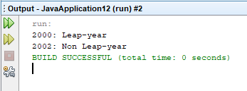

Date:- 23/09/2025

Practical 1: Write a program in java to create a class for employee record with two constructors, first default constructor to initialize all variables, second constructor to accept the employee details and a method to display employee details.
class Employee {
int e_no;
double e_sal;
String e_name;
Employee(){
e_no=101;
e_sal=2090.50;
e_name="AAAA";}
Employee(int empno, double empsal, String empname){
e_no=empno;
e_sal=empsal;
e_name=empname;}
void show(){
System.out.println("Enter employee id - "+e_no);
System.out.println("Enter employee salary - "+e_sal);
System.out.println("Enter employee name - "+e_name);}}
public class EmployeeRecord{
public static void main(String[] args){
Employee e1=new Employee();
e1.show();
Employee e2=new Employee(102, 50050, "BBBB");
e2.show();}}
Output:-
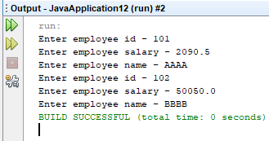 Date:- 15/09/2025

