Practical 4: Write a program in java that creates an abstract class called Shape. Create subclass that calculate and displays area of Rectangle and Traingle.
abstract class AShape{
int l, b, h, ba;
abstract int area();
}
class Rectangle extends AShape{
Rectangle(int x, int y){
l=x;
b=y;
}
int area(){
return l*b ;
}
}
class Traingle extends AShape{
Traingle(int x, int y){
h=x;
ba=y;
}
int area(){
return ((h*ba)*1/2);
}
}
public class Shape {
public static void main(String args[]){
AShape a1=new Rectangle(20, 40);
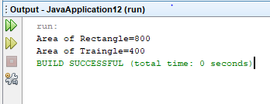
System.out.println("Area of Rectangle="+a1.area());
AShape a2=new Traingle(20, 40);
System.out.println("Area of Traingle="+a2.area());
}
}

