Sometime due to shortage of data we need to hire experience peoples to generate relevant data for machine learning to build efficient prediction model and the data generated by humans can be costly and may contains error. So to generate such synthesis dataset we can make use Generative Adversial Network which can be trained with small amount of data and then generate a GAN model. Later this GAN model can be used to generate new images which is often called as FAKE or COPIED images.

In this project we are using GAN model to generate synthesis image for Diabetic retinopathy. Diabetic retinopathy causes severe damage to eyes and to study this severity we are building GAN model using FUNDUS RETINA image dataset from KAGGLE. This dataset contains five types of images which are classified into 5 different clusters/classes NO DR, MODERATE, SEVERE, MILD, Proliferative DR. To perform deep study we need to have different types of images and using GAN we can generate such images and then using CNN neural network we can predict class of GAN images.

Using below code we are generating GAN images and then using CNN model predicting severity class. Read comments to understand code

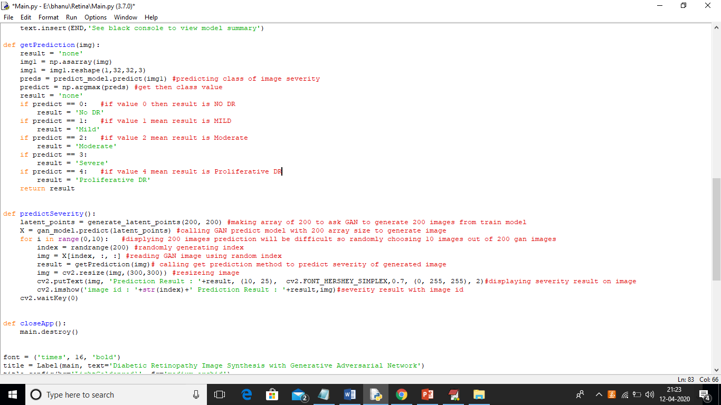

Screen shots

To run project double click on ‘run.bat’ file to get below screen

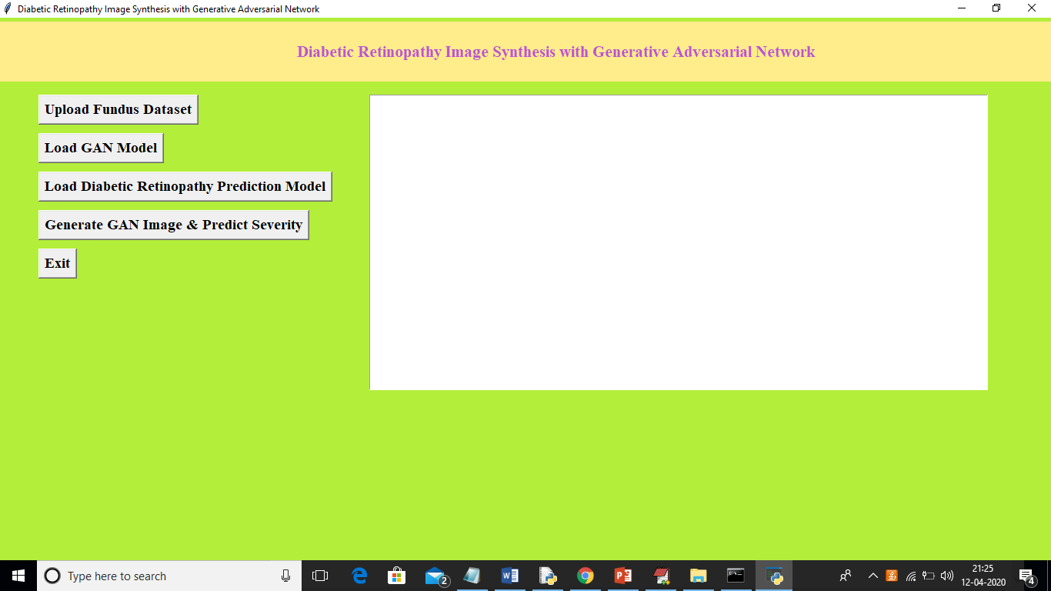

In above screen click on ‘Upload Fundus dataset’ button to load dataset

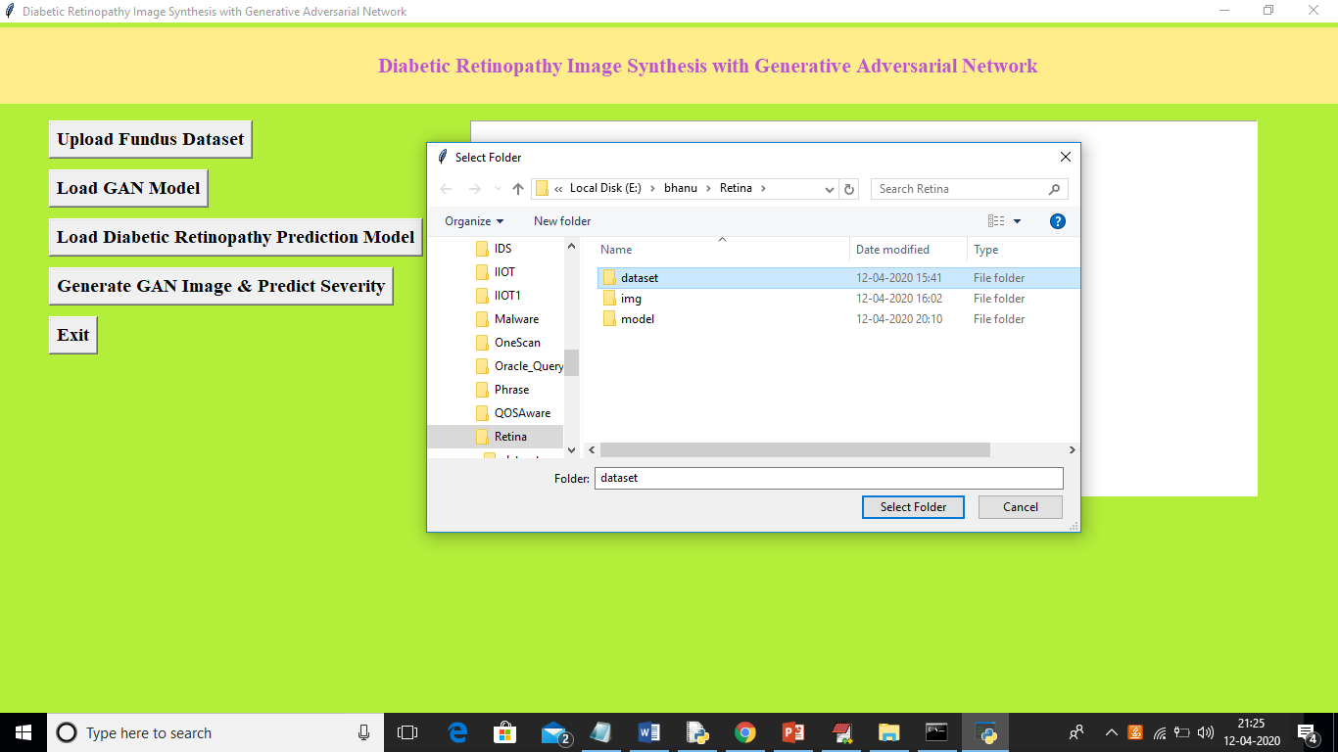

In above screen I am uploading ‘dataset’ folder which contains FUNDUS images of 5 categories and after upload dataset will get below screen

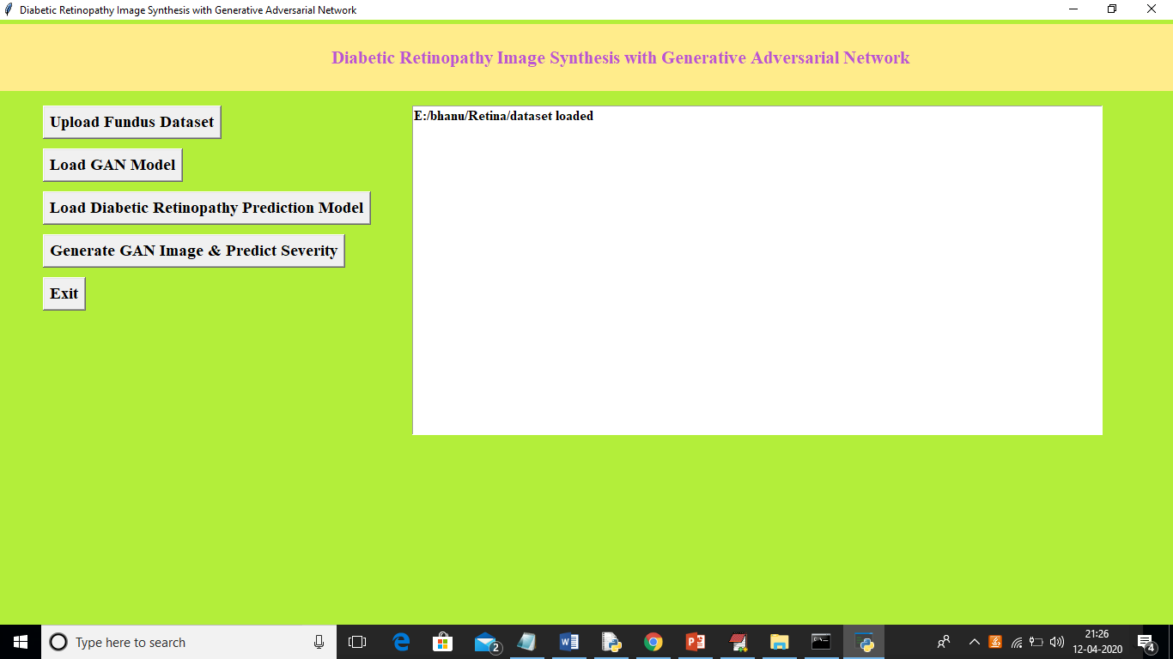

In above screen we can see dataset loaded and now click on ‘Load GAN Model’ button to load GAN model and generate some synthesis images

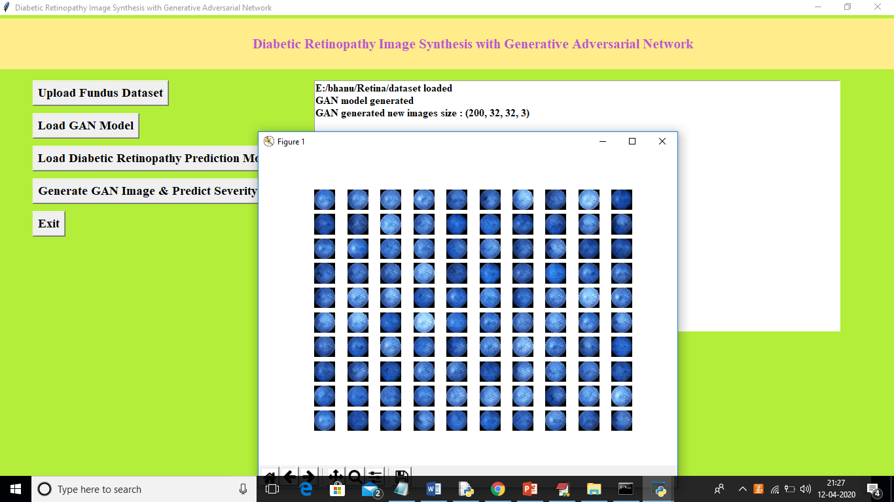

In above screen we can see GAN images and in above screen text area we can see GAN generated 200 images with size 32 X 32 and 3 means the images are in colour format not grey. Now click on ‘Load Diabetic Retinopathy Prediction Model’ button to generate and load prediction model to predict severity in GAN images

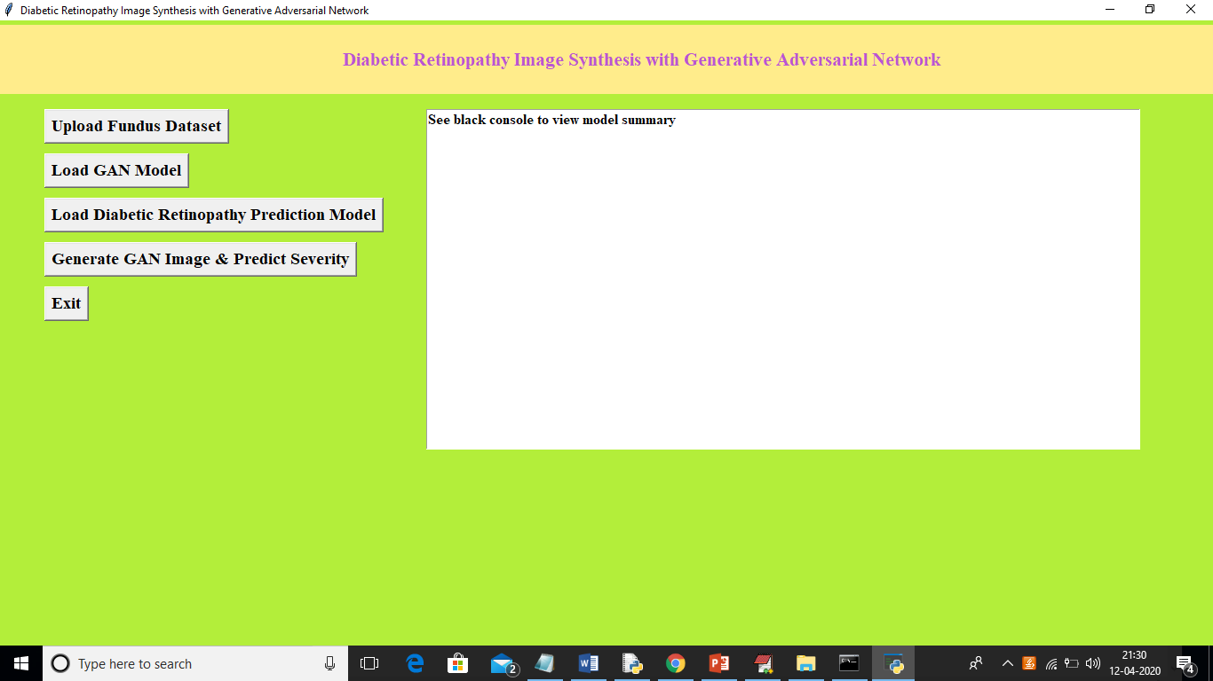

In above screen we got message as to see black console to view model summary and below is the console screen

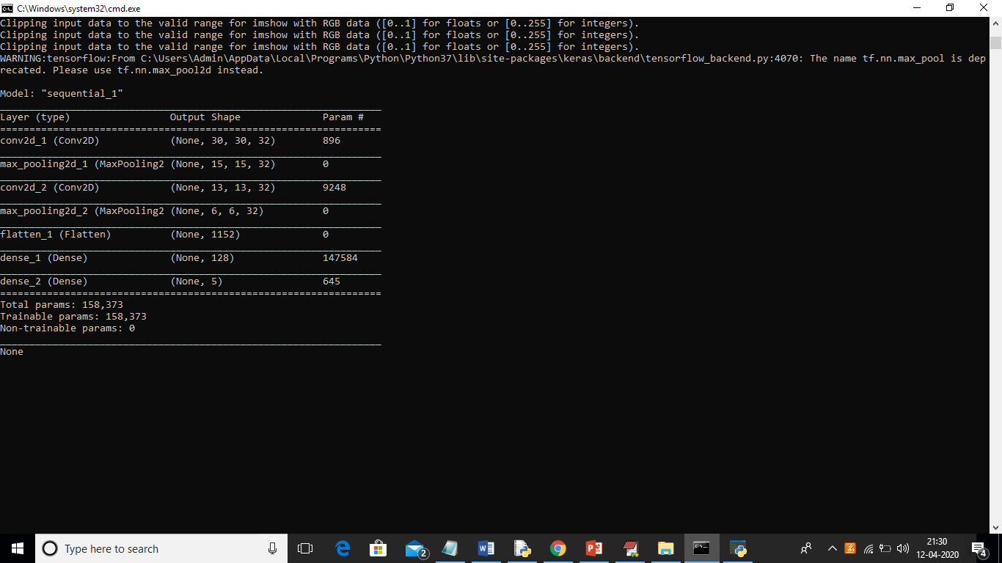

In above screen CNN create multi layers and each layer has different image shape features. Now click on ‘Generate GAN Image & Predict Severity’ button to generate some images and predict severity of those images. Here GAN generate 200 images but it’s difficult to display all 200 images so I am display 10 random images from 200 GAN images.

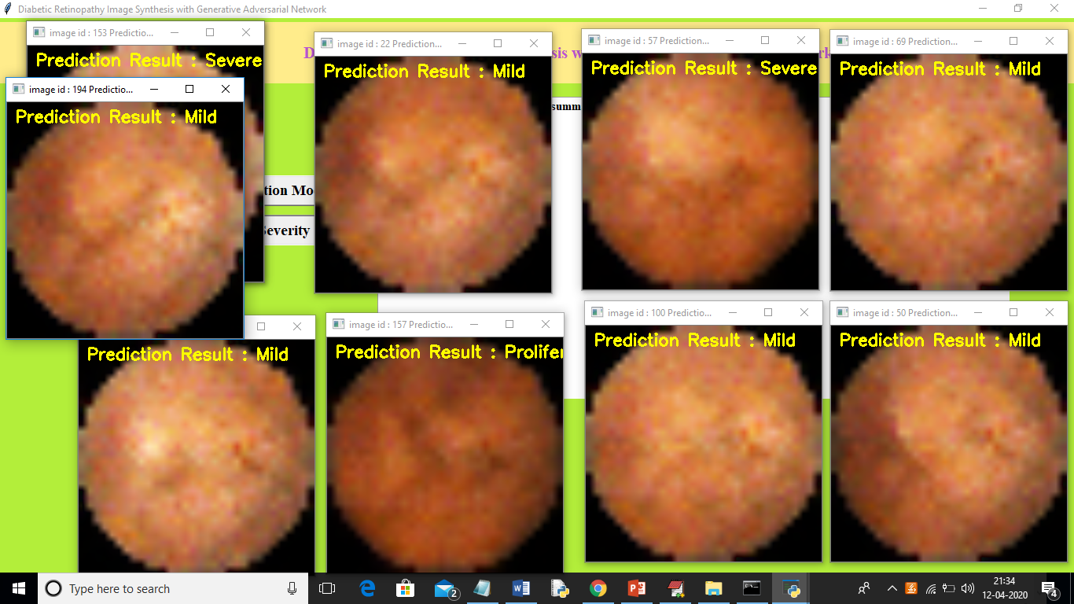

In above screen CNN predicted severity from images generated by GAN model. From 200 images I am displaying only 10 images. In below screen we can see moderate class prediction also

