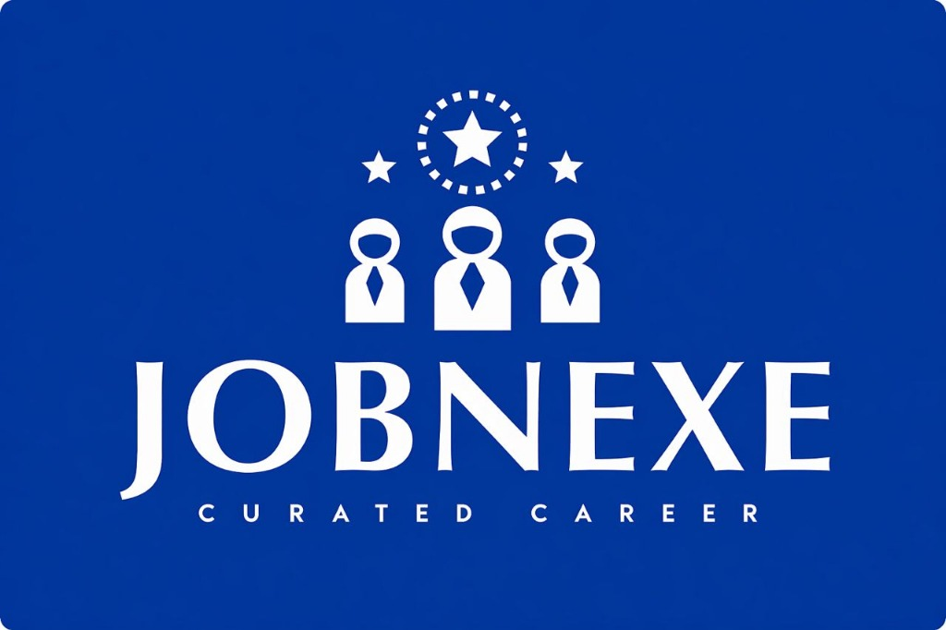
BLUE COLLAR RECRUITMENT AUSTRALIA
OFFICIAL NOTICE OF EMPLOYER SELECTION & TRADE SPONSORSHIP
Licensed Recruitment & Workforce Deployment | Suite 213/35-37 Doody St, Alexandria NSW 2015 | ABN 67 105 263 151
CANDIDATE: Nnamdi Iroagba
EMAIL: niroagba022@uniport.edu.ng
APPLIED ROLE: SITE ENGINEER – FIFO (PERTH, WA)
DOCUMENT REF: ESF-APP-53-2026

1. ASSIGNED SPONSORING HOST EMPLOYER
Host Mining Employer | Target FIFO Trade Stream | Allocated Slots | Sponsorship Status
MACA Limited | SITE ENGINEER – FIFO (PERTH, WA) | 3 Active Positions | Active Sponsor (Approved 482)
Total Host Employer Positions Available: 3 | Total Nominated Candidate Pool: 5 qualified candidates (Sum of slots + 2). Slots are locked in order of signed document submission and ticket commencement.
OFFICIAL AUSTRALIAN VISA SPONSORSHIP VERIFICATION:
You can verify approved Australian visa sponsors on the official public register: https://www.workvisalawyers.com.au/images/Approved-Sponsor-List-2025.pdf
Notice: The most recent official public list was released in 2025 (against 2026).

2. CANDIDATE SELECTION DECLARATION
I, Nnamdi Iroagba, formally confirm my selection of MACA LIMITED as my nominated sponsoring employer for the position of SITE ENGINEER – FIFO (PERTH, WA). I understand that upon completion of prerequisite competency tickets with CertHero RTO, MACA LIMITED will proceed with my Subclass 482 visa nomination and Australian site mobilisation.

_______________________________  Candidate Signature | _______________________________  Date of Signing

