**HackSMU II**

**Registrants**

98 Registrants

13 Schools

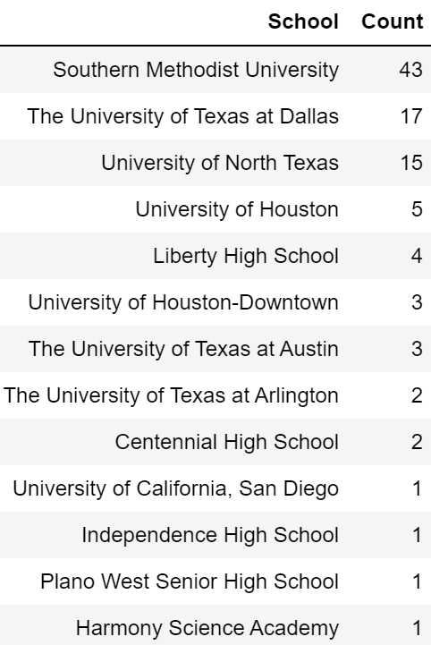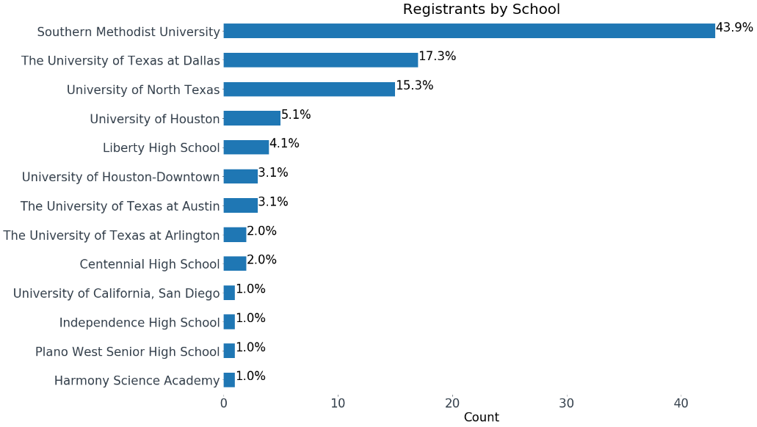

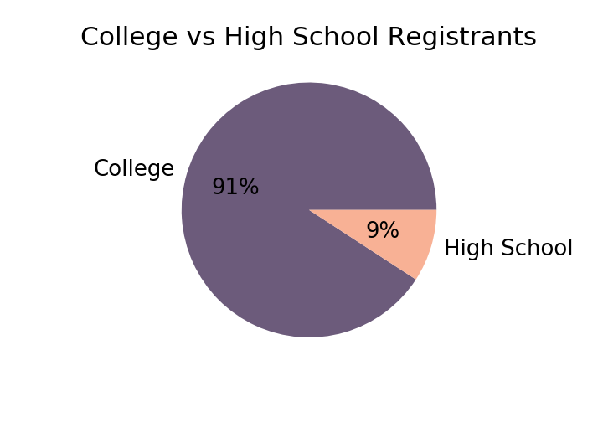

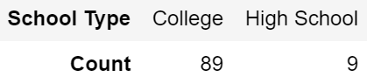

**Participants**

71 Participants Checked In

9 Schools

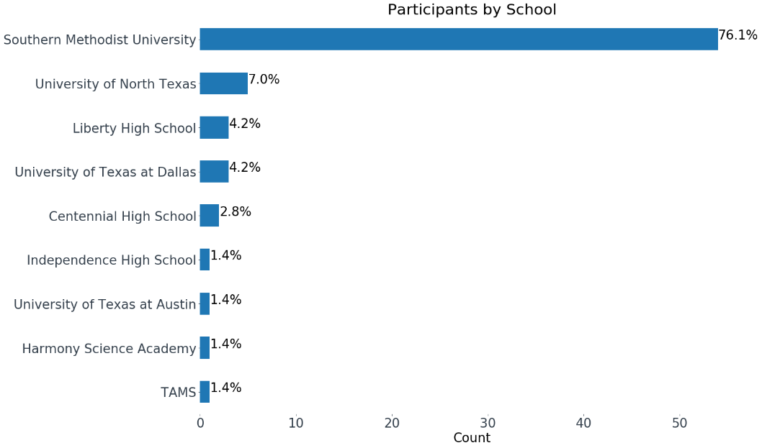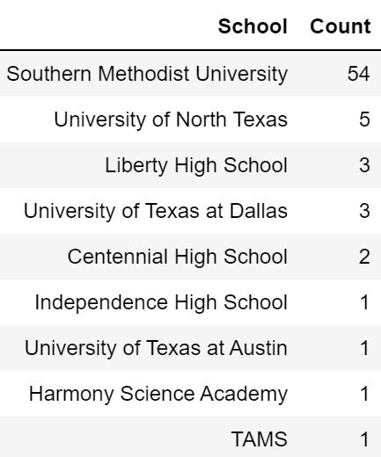

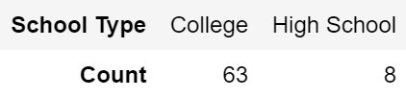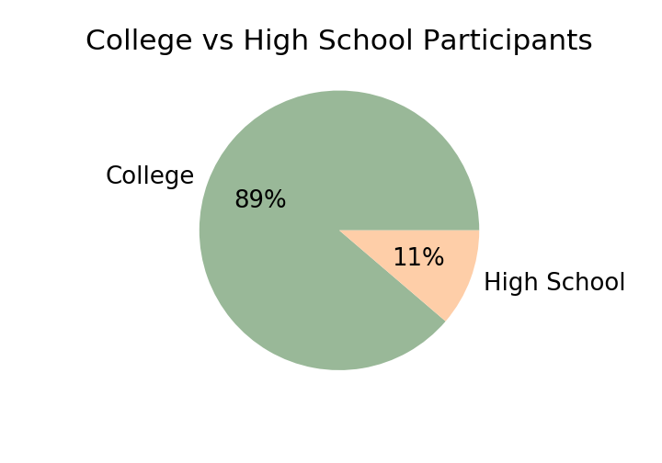

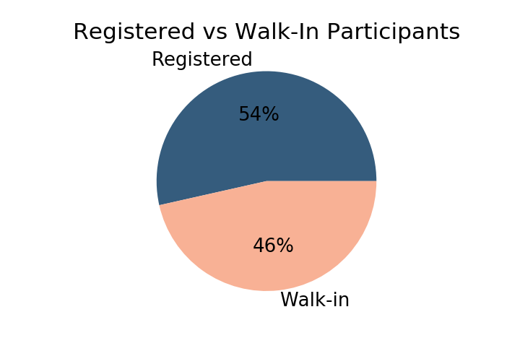

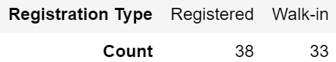

**Submissions**

12 Submissions

|  |
| --- |
| [Smart Route](https://hacksmu-ii.devpost.com/submissions/139842-smart-route) |
| [TrafficAlert by Nate Farm](https://hacksmu-ii.devpost.com/submissions/139918-trafficalert-by-nate-farm) |
| [CustomerRiskAnalyzer](https://hacksmu-ii.devpost.com/submissions/139922-customerriskanalyzer) |
| [Like a Good Neighbor](https://hacksmu-ii.devpost.com/submissions/139979-like-a-good-neighbor) |
| [Outbreak](https://hacksmu-ii.devpost.com/submissions/139984-outbreak) |
| [Car Catcher](https://hacksmu-ii.devpost.com/submissions/139985-car-catcher) |
| [Spanish Homework Conjugator](https://hacksmu-ii.devpost.com/submissions/139986-spanish-homework-conjugator) |
| [DietDine](https://hacksmu-ii.devpost.com/submissions/139992-dietdine) |
| [hide-and-duck](https://hacksmu-ii.devpost.com/submissions/139993-hide-and-duck) |
| [ScrumBuddy](https://hacksmu-ii.devpost.com/submissions/139999-scrumbuddy) |
| [ProtectYourEyes](https://hacksmu-ii.devpost.com/submissions/140009-protect-your-eyes) |
| [DriverDirect](https://hacksmu-ii.devpost.com/submissions/140038-driverdirect) |