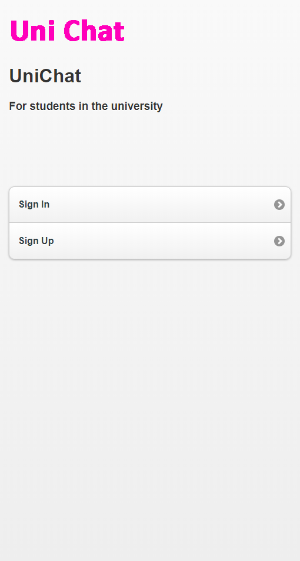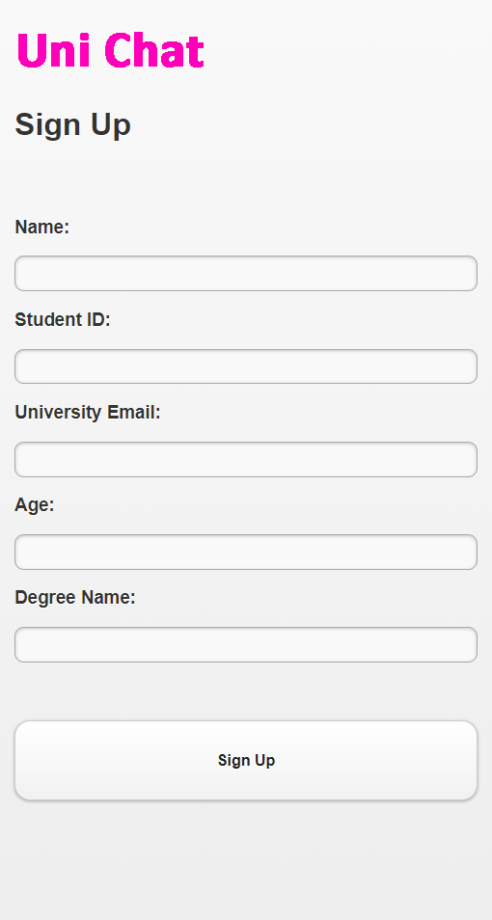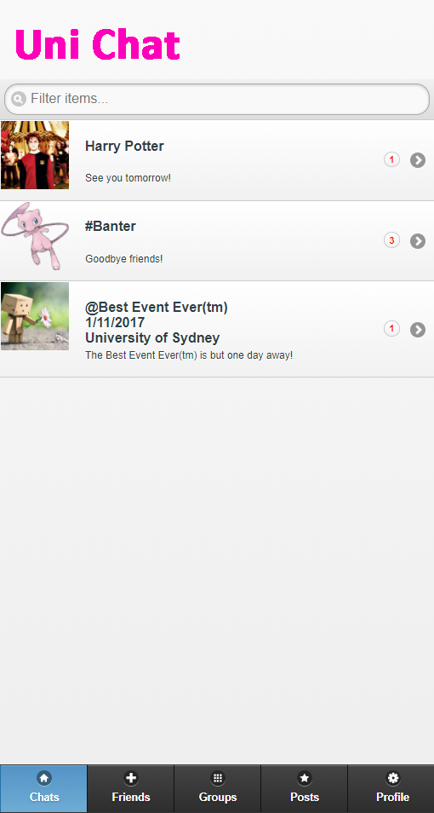

The chat tab is the home page of Uni Chat app. The user has quick access to their chats.

The sign-up page contains all the fields that a user needs to put in to sign up to the Uni Chat service.

Front page of the Uni Chat app has the option to either login or sign up.

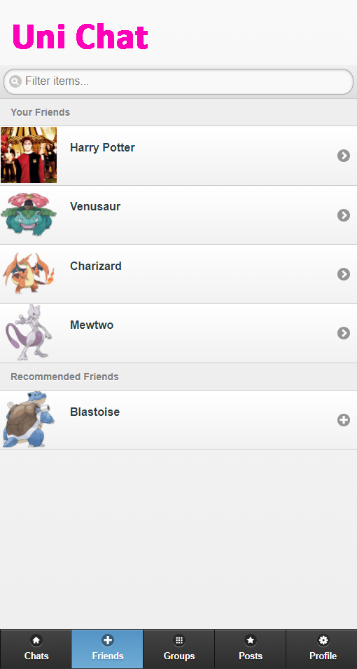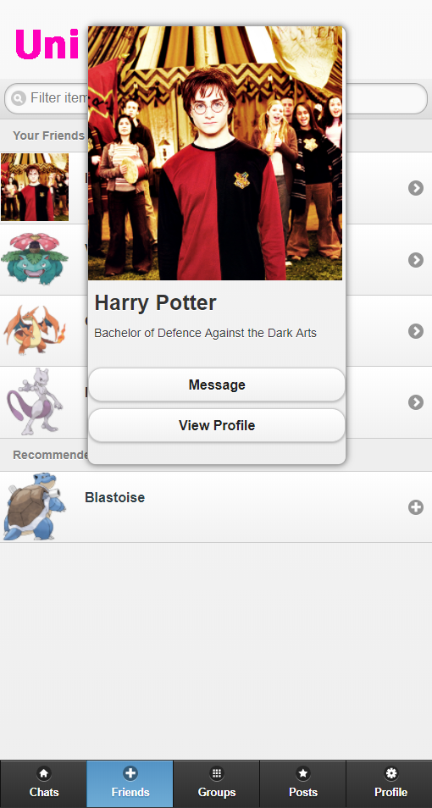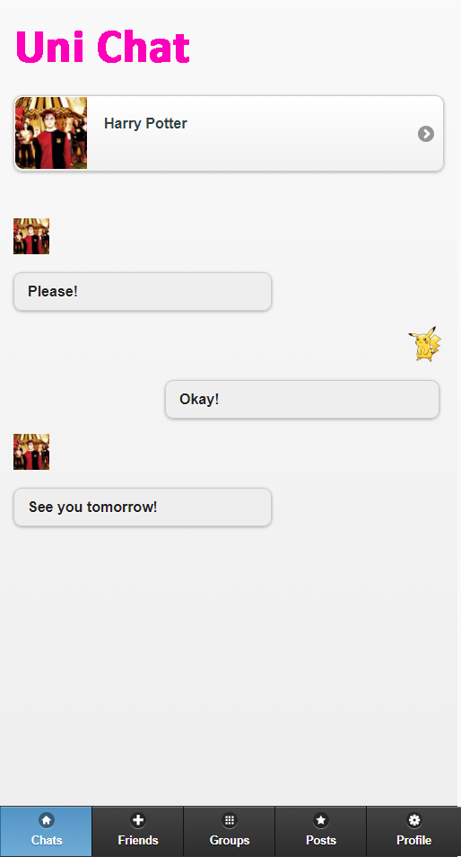

When the user taps on one on their friends they have the option to message or view their profile.

The friends tab shows the user’s friends as well as recommended friends.

Example of one of that chats that the user can enter into.

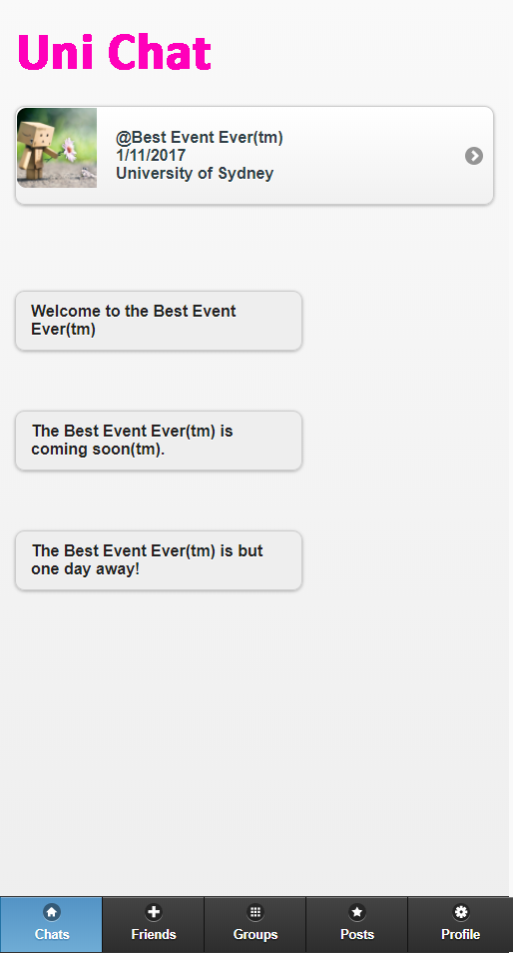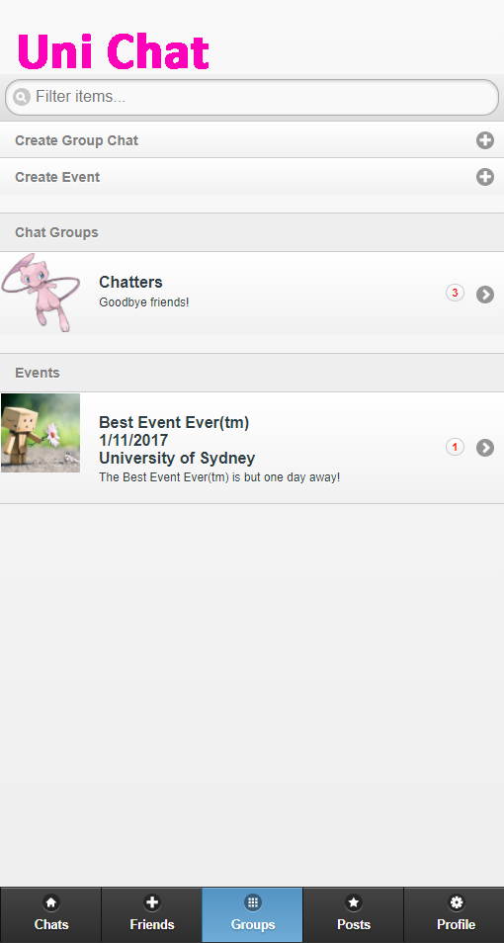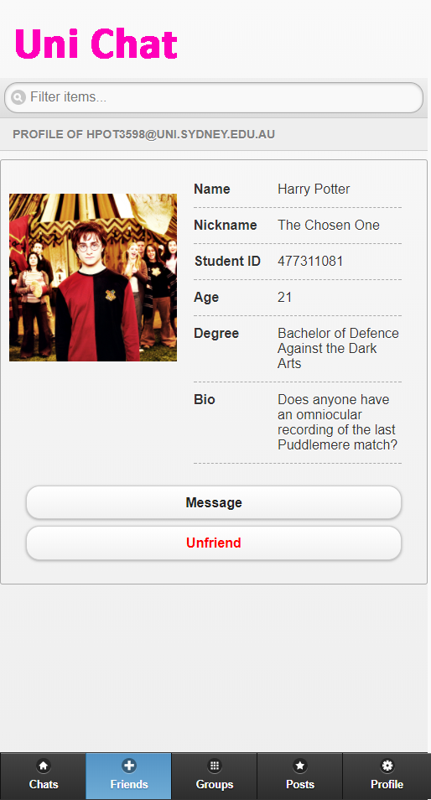

The event page is a special sort of chat with reminders.

The group tab contains access to chat groups and event groups.

The profile page of a friend contains the option to message as well as unfriend them.

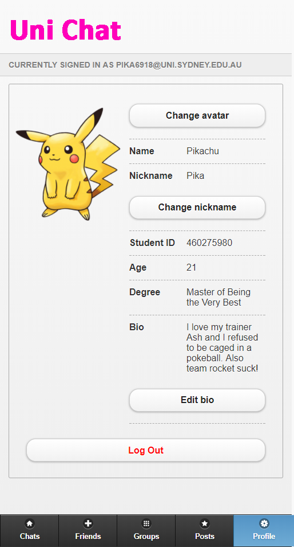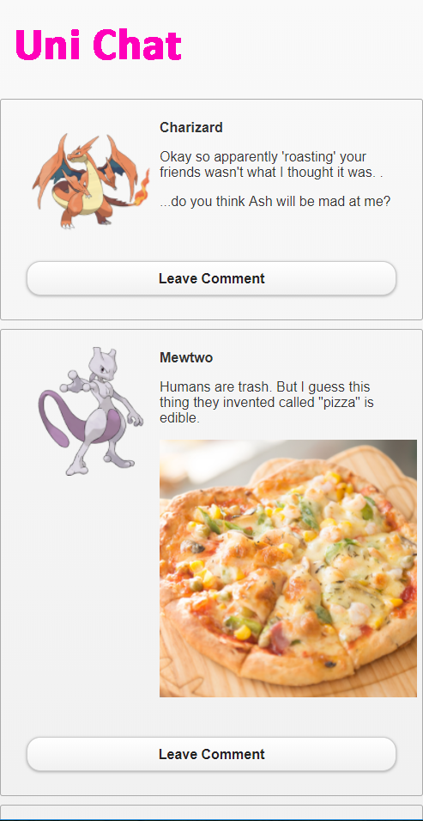

Profile page of the Uni Chat user. The user can edit their profile or logout.

The post tab contains all the posts that are visible to the user.