CS 5542 - Project Assignment 3
Integrated System Report and Final System Enhancement
  - Team Members: Ibrahim Alborno, Immanuel Olaoye

1. Introduction
The goal of this project was to design and implement a fully integrated AI system by combining the semester project foundation with the enhancements developed in Labs 6 through 9. Rather than treating each lab as an isolated activity, this project required us to merge all major components into one end-to-end application that demonstrates data handling, retrieval, reasoning, domain adaptation, application deployment, reproducibility, and system evaluation.
Our final system is a domain-adapted AI assistant for operating systems question answering. It combines a structured knowledge source, retrieval and preprocessing support, model adaptation with LoRA fine-tuning, an AI agent workflow, a FastAPI backend, a Streamlit frontend, evaluation modules, monitoring utilities, and reproducibility support. The completed project demonstrates how multiple AI system layers can be integrated into a single application pipeline.
This report explains the system architecture, how each lab component was incorporated, what enhancements were added, how the final system was evaluated, and how team contributions were divided.

2. Problem Domain and Motivation
General-purpose AI systems often produce broad or inconsistent answers when asked questions from a specific academic area. In operating systems education, students benefit from responses that are structured, technically relevant, and aligned with core course concepts such as deadlock, process scheduling, memory management, synchronization, paging, and process behavior.
The motivation of this project was to create a domain-adapted assistant that improves the quality of responses for operating systems questions. Instead of relying only on a general model, the system uses a domain-focused dataset, retrieval components, and model adaptation techniques so that answers are more relevant and useful to students.
The project also served as an opportunity to build a larger integrated AI system. In addition to response generation, the final application demonstrates backend/frontend coordination, retrieval support, monitoring, evaluation, and tool-based reasoning workflow.

3. Final Integrated System Overview
The final integrated system combines the following major components:
- Dataset and knowledge base construction
- Data ingestion and preprocessing modules
- Retrieval pipeline and embedding support
- Domain adaptation using LoRA fine-tuning
- AI agent reasoning and tool integration
- FastAPI backend for request handling
- Streamlit frontend for interactive use
- Snowflake integration for structured data access
- Evaluation and monitoring support
- Reproducibility and deployment documentation
The project was designed so that these components work together in one application pipeline rather than existing as disconnected features.

4. System Architecture
The final system architecture is organized into six major layers:
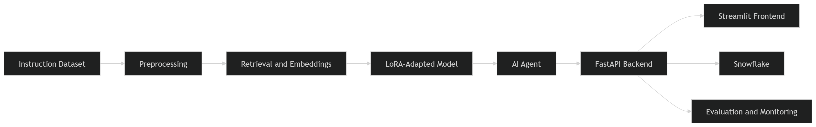

1. Data Layer
The data layer contains the operating systems instruction dataset, processed knowledge content, and any structured data sources stored for retrieval or analytics purposes.

2. Preprocessing and Knowledge Construction Layer
This layer handles ingestion, cleaning, formatting, chunking, and preparation of domain-specific content so that it can be used in retrieval and model adaptation workflows.

3. Retrieval and Embedding Layer
This layer converts knowledge resources into searchable representations using embeddings and supports retrieval of relevant context for answering user queries.

4. Model Adaptation and Reasoning Layer
This layer contains the LoRA fine-tuning workflow and the AI agent logic. The adapted model generates domain-focused answers, while the agent decides how to use tools such as retrieval, database lookup, summarization, or response generation.

5. Application Layer
The FastAPI backend processes incoming requests, routes them through the system, and returns results. The Streamlit frontend allows users to enter operating systems questions and view the generated responses.

6. Support and Evaluation Layer
This layer includes monitoring tools, evaluation scripts, configuration support, logging, and reproducibility documentation.

5. Project Foundation
The base of the system is a domain-specific operating systems question-answering application. The project uses an instruction-style dataset stored in JSON format, where each example contains an instruction, optional input, and output. This dataset supports the domain adaptation workflow by providing operating systems examples for fine-tuning.
The operating systems domain was selected because it provides a clear academic focus and allows the system to respond to concept-heavy technical questions. In the final version of the system, the dataset is expanded to include multiple operating systems concepts such as deadlock, memory management, process scheduling, synchronization, paging, and resource allocation.
The project foundation also includes the application framework. The FastAPI backend acts as the service layer, while the Streamlit frontend provides the user-facing interface. These pieces form the base structure that the later labs extend and improve.

6. Lab 6 - AI Agent Integration and Tool-Based Workflow
Lab 6 introduced the AI agent reasoning layer. The purpose of this phase was to make the system more than a static question-answering script by allowing it to interpret user requests, determine the appropriate processing path, and use tools dynamically.
In the final system, the AI agent supports multi-step reasoning and tool orchestration. Depending on the type of user query, the agent can:
- retrieve relevant operating systems context
- query structured information
- summarize retrieved content
- route the question to the adapted model
- combine intermediate results into a final response
This lab contributed significantly to the intelligence of the final project because it made the application workflow more dynamic and modular. Rather than relying on one fixed response path, the agent enables the system to choose the most appropriate tools for the query.

7. Lab 7 - Reproducibility and Deployment Readiness
Lab 7 focused on reproducibility, environment management, and project organization. This phase was important because a working project is not enough if other users cannot install, configure, and run it.
To address reproducibility, the final system includes:
- organized repository structure
- requirements and dependency management
- environment configuration support
- setup and run instructions
- consistent project organization
- supporting scripts for training and evaluation
This phase also improved deployment readiness by making the system easier to run across different environments. The project structure now clearly separates frontend, backend, training, dataset, evaluation, and monitoring components.

8. Lab 8 - Domain Adaptation and Model Improvement
Lab 8 focused on model adaptation. This was one of the most important technical parts of the project because it changed the system from a generic AI interface into a more specialized operating systems assistant.
The final system uses LoRA (Low-Rank Adaptation) with the PEFT library to fine-tune the model efficiently without retraining the full base model. The instruction dataset is used to guide the model toward producing more relevant operating systems answers.
The domain adaptation process improved the system by:
- increasing relevance to operating systems questions
- improving structure and clarity of answers
- reducing generic responses
- making outputs more aligned with the academic domain
This phase demonstrates that model enhancement can be integrated into an application-centered project rather than existing only as a separate training exercise.

9. Lab 9 - Application Enhancement, Monitoring, and Evaluation
Lab 9 focused on strengthening the application itself. In the final system, this phase contributed:
- stronger frontend-backend communication
- improved application stability
- monitoring support
- evaluation support
- cleaner workflow integration
The Streamlit frontend was refined so users could interact with the project more naturally. The FastAPI backend was improved to better handle application requests and response flow. Monitoring utilities were added so the system's behavior could be observed more effectively, and evaluation scripts were incorporated so response quality and system behavior could be assessed more systematically.
This lab helped transform the project from a prototype into a more complete, demonstration-ready integrated system.

10. Retrieval Pipeline and Knowledge Support
A major requirement of the integrated project was the inclusion of retrieval and knowledge support. In the final system, the retrieval pipeline processes operating systems content into a searchable form using embeddings. When a user submits a question, the system can retrieve relevant domain context and use it to improve the quality of the response.
The retrieval pipeline improves the application by grounding outputs in domain-relevant content. This makes the assistant more useful for technical educational tasks because the system can use retrieved information instead of relying only on a general model response.
The retrieval modules are integrated into the agent workflow so that the application can decide when additional context is needed and use retrieval accordingly.

11. Snowflake Integration
Another key requirement of the project was structured data integration. In the final system, Snowflake is used as a data warehouse layer for storing and accessing structured project data. This allows the system to support queries or analytics tasks involving stored domain information, system data, or processed knowledge records.
Snowflake integration demonstrates that the application is not limited to a simple frontend-model interaction. It shows how enterprise-style data infrastructure can be incorporated into an AI workflow. The AI agent and backend can access this structured layer when needed, which strengthens the integrated nature of the project.

12. Evaluation and Experimental Results
The final system was evaluated from multiple perspectives:
- response relevance
- response structure
- domain specificity
- application stability
- retrieval usefulness
- tool usage behavior
- end-to-end system consistency
Qualitative evaluation showed that responses after domain adaptation were more relevant to operating systems topics and more structured than generic baseline answers. Queries supported by retrieval produced more grounded responses when additional context was needed. The agent workflow improved flexibility by allowing the system to use tools dynamically rather than relying on a single response path.
Application testing also showed improved stability after integrating the backend, frontend, evaluation, and monitoring components. The final system was able to support end-to-end interaction in a more reliable way than earlier phases of the project.
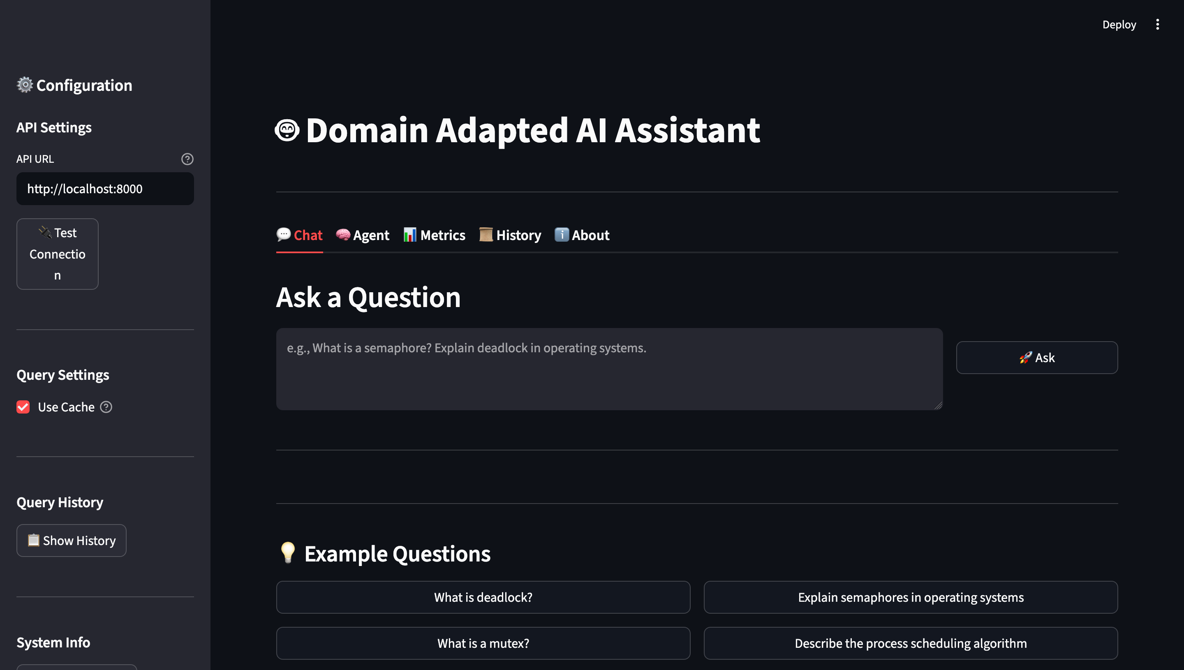

13. Reproducibility
Another important requirement of the project was that another team should be able to reproduce the system. The final system supports reproducibility through:
- repository organization
- setup instructions
- dependency management
- documented run flow
- separated training/application/evaluation modules
A general reproduction process is:
- Clone the repository.
- Install dependencies from the requirements file.
- Configure required environment variables and credentials.
- Build or load the knowledge base and retrieval resources.
- Configure Snowflake access if needed.
- Run the LoRA fine-tuning workflow or load the adapted model.
- Start the FastAPI backend.
- Launch the Streamlit frontend.
- Run evaluation scripts and test queries.
These steps make the system easier for another user to understand, reproduce, and test.

14. GitHub Repository Contents
The final repository includes:
- ingestion and preprocessing scripts
- retrieval modules
- embedding support
- AI agent implementation and tools
- domain adaptation code
- application interface code
- Snowflake integration scripts
- evaluation and monitoring scripts
- README with setup instructions
- system architecture diagram
- contribution documentation

15. Team Contributions
The contribution percentages for the final project total 100%.
Member | Contribution Description | Contribution %
Ibrahim Alborno | Worked on backend integration, model connection, monitoring, debugging API behavior, system testing, documentation alignment, and support for the final integrated pipeline. | 50%
Immanuel Olaoye | Worked on Streamlit interface design, frontend flow, response display, testing for stability and consistency, evaluation support, and user interaction improvements. | 50%

16. Conclusion
This project demonstrates the successful integration of the semester project foundation with Labs 6 through 9 into one complete AI application. The final system combines domain-specific data, retrieval support, model adaptation, AI agent reasoning, application deployment, reproducibility, evaluation, and structured data integration.
The completed project is more than a standalone demo. It shows how a modern AI system can be built by connecting multiple components into a unified workflow. Through domain adaptation and system integration, the operating systems assistant became more useful, more structured, and more technically focused than a generic baseline application.
Overall, this project achieved the goal of creating a nearly demonstration-ready integrated AI system that reflects the major technical themes of the course.

