|  |  |
| --- | --- |
| **Ex. No:** | **Online Food Ordering System** |
| **Date:** |

**Aim:**

To develop a Web Application for Online Food Ordering System.

1. **Introduction**

This document aims at defining the overall software requirements for “Online Food Ordering System”. Efforts have been made to define all requirements exhaustively and accurately .Online food ordering is the process of ordering food through the internet via a web application. A customer can choose to have the food delivered or for pick-up by the customer himself. The process goes on as, the customer logging in the application viewing items and adding it to cart and proceeding to pay for the items. Payment is then administered by paying with a credit card or debit card or net banking through the payment gateway or by cash-on-delivery. The online food ordering system connects the local restaurants and provides the customers an easy way to interact with the restaurants through the application. Ordering food online is designed to be more flexible and robust. Flexible in the sense the application can be used by anyone because it is filled with the pictures for most part of the application, navigation is taken care by an API familiar to all, it uses Google Maps, which most people must have used. The interface will also be user-friendly so anyone could easily interact with the application. Robust in the sense the application could deal with huge number of orderings simultaneously. The final product will have no more features that are specified in this software requirement specification document.

* 1. **Purpose**

This document describes the capabilities, functional and non-functional requirements of the web application “Online Food Ordering System”. It also states the various constraints that the system will abide to. The intended audience for this document is the development team, the testing team and the end users.

* 1. **Scope**

The Web Application “Online Food Ordering System” is developed to help people order food from the comfort of the home without having to wait in restaurants. This allows people to order food from the restaurants nearby the people’s location. This helps the restaurants to simplify their daily operations also maintain healthy relationship with the customers.

* 1. **Definitions, Acronyms and Abbreviations**

The following acronyms are used throughout the document:

* DB – Data Base
* DBA – Data Base Administrator
* OS – Operating System
* ID – Identification
  1. **References**
* <https://ieeexplore.ieee.org/document/278253>
* <https://en.wikipedia.org/wiki/Online_food_ordering>
* <https://www.orderingonlinesystem.com/>
* <https://www.academia.edu/22293120/DESIGN_AND_IMPLEMENTATION_OF_ONLINE_FOOD_ORDERING_SYSTEM>
  1. **Overview**

The rest of this SRS document describes the various system requirements, interfaces, features and functionalities in detail.

1. **Overall Description**

The customer logs in to the Web Application and scrolls through the menu for his favorite item of food, when he is satisfied with an item in the menu, he could go on looking for other items by adding the current item to the cart, else he could directly proceed to confirm the order where the order goes to the specified restaurant, where it is picked up by the employee and the customer is billed for all the items that is in his cart.

* 1. **Product Perspective**

The application will be Windows based, self contained software product that can accessed using a browser.

* + 1. **System Interfaces**
* Keyboard
* Mouse
* Touch Screen Display
  + 1. **User Interface**

The Web Application is user-friendly menu based interface which is designed to provide the following screens.

1. The Online Food Ordering Application homepage.

It has a welcome screen with Login and Register functions.

1. Register Menu for those who are unregistered
2. Menu for the type of food like food for breakfast, lunch, etc..,
3. The Cart where the selected items land on.
4. Payment screen for paying off the bill.
5. Confirmation or Cancel order Page.
   * 1. **Hardware Interfaces**

* Screen resolution of at least 800×600 is required to properly view the complete webpage. Higher resolution would be better.
* Standalone system with a network connection.
  + 1. **Software Interfaces**
* Any Operating system (Linux, Unix, Windows, MAC OS)
* A Browser
  + 1. **Communication Interfaces :** None
    2. **Memory**

At least 64MB of RAM and 2GB of disk space is more than enough for the application to run.

* + 1. **Operations**

This product will not release any automated aspects of the database. Database backup and recovery will also have to be handled by the DBA. However the system will provide a ‘RESET SYSTEM’ function that will delete (upon confirmation from the administrator) all the existing information from the database

* + 1. **Site Adaptation Requirements**

The terminals at client site will have to support the hardware and software interfaces that are specified in above section.

* 1. **Product Functions**

The system will allow access only to authorized users with specific roles say Customer, System Administrator, Restaurant Administrator. Users can access functions in the application based on their roles.

A summary of the major functions, that the software will perform are listed below:

Login function enable only authorized access.

1. User – Role : Application Administrator, with supreme rights to access all information about restaurants and customers
2. User – Role : Restaurant Administrator, with access to information about orders and the customers who placed the orders. Has the right to reject orders.
3. User – Role : Customer, who can view and also modify his own information and the available items in the menu to place an order
   1. **User Characteristics**

The user has the ability to add/delete food items in his/her own cart, confirm/cancel his/her own order and also complaint about the bugs or misbehavior of the system.

* 1. **Constraints**

The information about the customers should be kept safe. To achieve the system should be developed secure and also the credentials of critical roles like Application Administrator should be kept safe, secure and highly confidential.

* 1. **Assumptions and Dependencies**

All the Customers should register on that website and must have an account in that online food ordering system Web Application to order food.

* 1. **Apportioning of requirements**

Not Required

1. **Specific Requirements**
   1. **External Interface Requirements**
      1. **User Interfaces**

The application will have a user-friendly menu based interface. It will provide the following screens.

1. The Online Food Ordering Application homepage.

It has a welcome screen with Login and Register functions. Login functions are for normal user, restaurant administrator and Application administrator. Those with credentials can choose whichever login they can access.

1. Register Menu for those who are unregistered.

This screen captures user details and creates an account for the user if necessary details are provided.

1. User Account Screen:

This screen provides options such as menu items, My Order, Cart, Payment, Report and Logout

1. Restaurant Administrator Screen:

There are options for restaurant administrators such as pick up order, total orders, resolve complaints and logout.

1. Application Administrator Screen:

This screen provides options for editing information, resolving bugs, maintenance, update menu, approve accounts and logout

* + 1. **Hardware Interfaces**
* Screen resolution of at least 800×600 required for proper and complete viewing of screen. Higher resolutions would be better.
* Standalone systems with network connection.
  + 1. **Software Interfaces**
* Any kind of Operating System (Linux, Unix, Windows, MAC OS )
* A Browser
  + 1. **Communication Interfaces :** None
  1. **Classes / Objects**
     1. **Online Food Ordering System**
        1. **Attributes**
           1. string food_Name
           2. int food_id
           3. int food_price
           4. string food_category
           5. int food_quantity
        2. **Functions**
           1. **Register()**

This function is used to create a new account in the Online Food Ordering System. An User/Restaurant Administrator has to enter his personal details like name, address, phone number, username, password in order to create an account

* + - * 1. **Order_Food_Items()**

This function is used to add/remove the required food items into the cart and helps to order the food item.

* + - * 1. **Cancel_Order()**

This function is used to remove the food items from the cart and cancel the order before payment phase.

* + 1. **Class User**
       1. **Attributes**
          1. string name
          2. int user_id
          3. string address
          4. long phone_number
          5. string username
          6. string password
       2. **Functions**
          1. **Login()**

A user must login to the system to fully access the web application.

* + - * 1. **Select Item / Book Restaurant()**

A user can order his food by selecting the food items from the menu tab from a particular restaurant.

* + - * 1. **View_total_bill()**

A user can view the total bill and pay for his food using any of the options like net banking / debit card / credit card.

* + - * 1. **Place_Order()**

This function is called to confirm the order

* + - * 1. **Logout()**

The user can logout closing his session in the application.

* + 1. **Class Restaurant admin**
       1. **Attributes**
          1. string username
          2. string password
       2. **Functions**
          1. **Login()**

A restaurant administrator must login to access the contents of the web application.

* + - * 1. **Select_items / Book_restaurant()**

This function is used by the restaurant administrator to update the available items in the restaurant menu and to update the new restaurants.

* + - * 1. **View_total_bill()**

This function enables the restaurant administrator to manage the order payments whether to pick-up or reject and to check the total orders in a specific time.

* + - * 1. **PlaceOrder()**

This function enables the restaurant administrator to receive the placed order and move forward the delivery.

* + - * 1. **Logout()**

The restaurant administrator can logout from the web application.

* + 1. **Class Application Administrator**
       1. **Attributes**
          1. string username
          2. string password
       2. **Functions**
          1. **Login()**

The Application administrator must login with his highly confidential credentials to access the application.

* + - * 1. **ManageMenu()**

Using this function, the administrator can manage the items uploaded by the restaurants.

* + - * 1. **ManageOrder()**

This function enables the administrator to deny access to orders to a restaurant based on the complaints about it.

* + - * 1. **ManageProfile()**

This function enables the administrator to monitor the profiles of the users and restaurant administrators.

* + - * 1. **Report()**

This function enables an administrator to look for the bugs in the platform and take measures to fix the bugs.

* + - * 1. **Maintanence()**

This enables the administrator to fix the bugs, add new features and enhance the user interfaces.

* + - * 1. **Logout()**

The administrator logs out of the application.

* 1. **Design Constraints :** None
  2. **Software System Attributes**
     1. **Security**

This application is password protected. Users will have to enter the correct and valid credentials to enter and access the application. The login process differs for users with different roles in the application.

* + 1. **Maintainability**

This application is designed to be easily maintainable. There will be GUI interface to update databases and some easy to use interface to incorporate new modules.

* + 1. **Portability**

This is a platform independent Web Application so it is highly portable. It could run easily in any browser.

* 1. **Other Requirements**

None

**4. UML DIAGRAMS**

**USE CASE DIAGRAM**

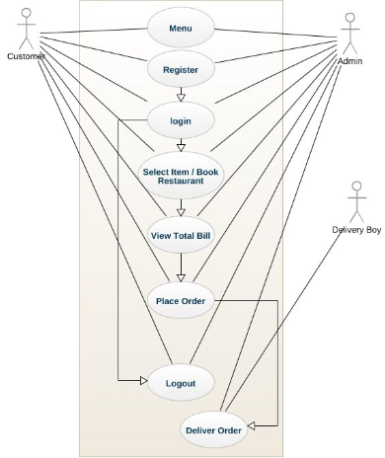

**CLASS DIAGRAM**

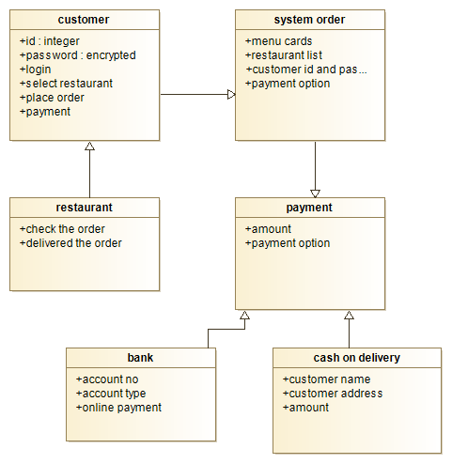

**ACTIVITY DIAGRAM**

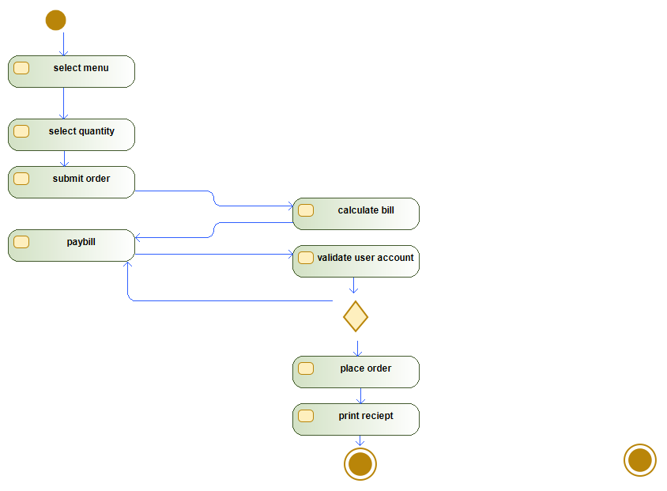

**SEQUENCE DIAGRAM**

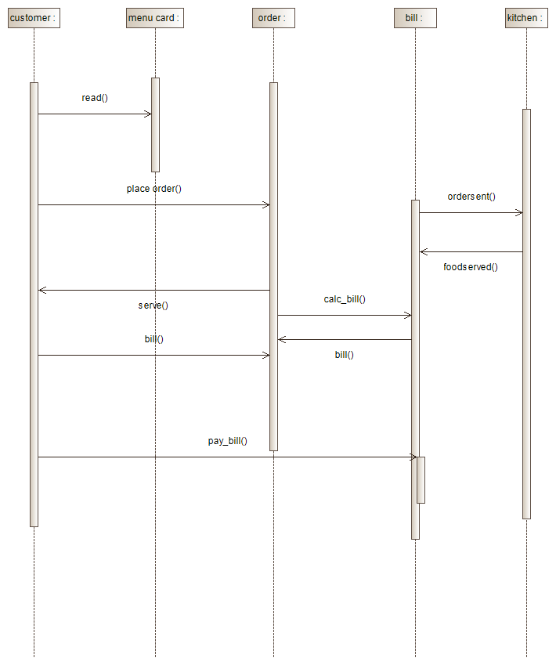

**COLLABORATION DIAGRAM**

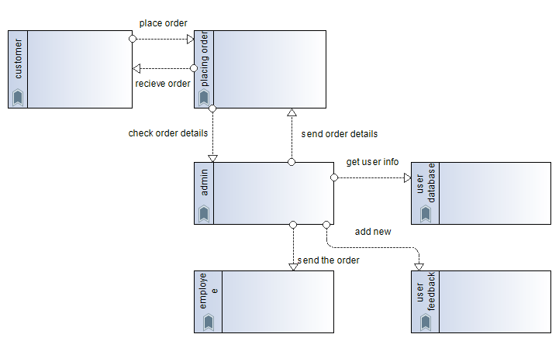

**5. Source Code & Screenshots**

**5.1 Login.php**

<?php

session_start();

if(isset($_SESSION['admin_sid']) || isset($_SESSION['customer_sid']))

{

header("location:index.php");

}

else{

?>

<!DOCTYPE html>

<html lang="en">

<head>

<meta http-equiv="Content-Type" content="text/html; charset=UTF-8">

<meta name="viewport" content="width=device-width, initial-scale=1, maximum-scale=1.0, user-scalable=no">

<meta http-equiv="X-UA-Compatible" content="IE=edge">

<meta name="msapplication-tap-highlight" content="no">

<title>Login</title>

<!-- Favicons-->

<link rel="icon" href="images/favicon/favicon-32x32.png" sizes="32x32">

<!-- Favicons-->

<link rel="apple-touch-icon-precomposed" href="images/favicon/apple-touch-icon-152x152.png">

<!-- For iPhone -->

<meta name="msapplication-TileColor" content="#00bcd4">

<meta name="msapplication-TileImage" content="images/favicon/mstile-144x144.png">

<!-- For Windows Phone -->

<!-- CORE CSS-->

<link href="css/materialize.min.css" type="text/css" rel="stylesheet" media="screen,projection">

<link href="css/style.min.css" type="text/css" rel="stylesheet" media="screen,projection">

<!--Custome CSS-->

<link href="css/custom/custom.min.css" type="text/css" rel="stylesheet" media="screen,projection">

<link href="css/layouts/page-center.css" type="text/css" rel="stylesheet" media="screen,projection">

<!-- INCLUDED PLUGIN CSS ON THIS PAGE -->

<link href="js/plugins/perfect-scrollbar/perfect-scrollbar.css" type="text/css" rel="stylesheet" media="screen,projection">

</head>

<body class="cyan">

<!-- Start Page Loading -->

<div id="loader-wrapper">

<div id="loader"></div>

<div class="loader-section section-left"></div>

<div class="loader-section section-right"></div>

</div>

<!-- End Page Loading -->

<div id="login-page" class="row">

<div class="col s12 z-depth-4 card-panel">

<form method="post" action="routers/router.php" class="login-form" id="form">

<div class="row">

<div class="input-field col s12 center">

<p class="center login-form-text">Login for Food Ordering System</p>

</div>

</div>

<div class="row margin">

<div class="input-field col s12">

<i class="mdi-social-person-outline prefix"></i>

<input name="username" id="username" type="text">

<label for="username" class="center-align">Username</label>

</div>

</div>

<div class="row margin">

<div class="input-field col s12">

<i class="mdi-action-lock-outline prefix"></i>

<input name="password" id="password" type="password">

<label for="password">Password</label>

</div>

</div>

<div class="row">

<a href="javascript:void(0);" onclick="document.getElementById('form').submit();" class="btn waves-effect waves-light col s12">Login</a>

</div>

<div class="row">

<div class="input-field col s6 m6 l6">

<p class="margin medium-small"><a href="register.php">Register Now!</a></p>

</div>

</div>

</div>

**5.2 Register.php**

<?php

session_start();

if(isset($_SESSION['admin_sid']) || isset($_SESSION['customer_sid']))

{

header("location:index.php");

}

else{

?>

<!DOCTYPE html>

<html lang="en">

<head>

<meta http-equiv="Content-Type" content="text/html; charset=UTF-8">

<meta name="viewport" content="width=device-width, initial-scale=1, maximum-scale=1.0, user-scalable=no">

<meta http-equiv="X-UA-Compatible" content="IE=edge">

<meta name="msapplication-tap-highlight" content="no">

<title>Register</title>

<!-- Favicons-->

<link rel="icon" href="images/favicon/favicon-32x32.png" sizes="32x32">

<!-- Favicons-->

<link rel="apple-touch-icon-precomposed" href="images/favicon/apple-touch-icon-152x152.png">

<!-- For iPhone -->

<meta name="msapplication-TileColor" content="#00bcd4">

<meta name="msapplication-TileImage" content="images/favicon/mstile-144x144.png">

<!-- For Windows Phone -->

<!-- CORE CSS-->

<link href="css/materialize.min.css" type="text/css" rel="stylesheet" media="screen,projection">

<link href="css/style.min.css" type="text/css" rel="stylesheet" media="screen,projection">

<!--Custome CSS-->

<link href="css/custom/custom.min.css" type="text/css" rel="stylesheet" media="screen,projection">

<link href="css/layouts/page-center.css" type="text/css" rel="stylesheet" media="screen,projection">

<link href="js/plugins/perfect-scrollbar/perfect-scrollbar.css" type="text/css" rel="stylesheet" media="screen,projection">

<style type="text/css">

.input-field div.error{

position: relative;

top: -1rem;

left: 0rem;

font-size: 0.8rem;

color:#FF4081;

-webkit-transform: translateY(0%);

-ms-transform: translateY(0%);

-o-transform: translateY(0%);

transform: translateY(0%);

}

.input-field label.active{

width:100%;

}

.left-alert input[type=text] + label:after,

.left-alert input[type=password] + label:after,

.left-alert input[type=email] + label:after,

.left-alert input[type=url] + label:after,

.left-alert input[type=time] + label:after,

.left-alert input[type=date] + label:after,

.left-alert input[type=datetime-local] + label:after,

.left-alert input[type=tel] + label:after,

.left-alert input[type=number] + label:after,

.left-alert input[type=search] + label:after,

.left-alert textarea.materialize-textarea + label:after{

left:0px;

}

.right-alert input[type=text] + label:after,

.right-alert input[type=password] + label:after,

.right-alert input[type=email] + label:after,

.right-alert input[type=url] + label:after,

.right-alert input[type=time] + label:after,

.right-alert input[type=date] + label:after,

.right-alert input[type=datetime-local] + label:after,

.right-alert input[type=tel] + label:after,

.right-alert input[type=number] + label:after,

.right-alert input[type=search] + label:after,

.right-alert textarea.materialize-textarea + label:after{

right:70px;

}

</style>

</head>

<body class="cyan">

<!-- Start Page Loading -->

<div id="loader-wrapper">

<div id="loader"></div>

<div class="loader-section section-left"></div>

<div class="loader-section section-right"></div>

</div><div id="login-page" class="row">

<div class="col s12 z-depth-4 card-panel">

<form class="formValidate" id="formValidate" method="post" action="routers/register-router.php" novalidate="novalidate" class="col s12">

<div class="row">

<div class="input-field col s12 center">

<h4>Register</h4>

<p class="center">Join us now!</p>

</div>

</div>

<div class="row margin">

<div class="input-field col s12">

<i class="mdi-social-person-outline prefix"></i>

<input name="username" id="username" type="text" data-error=".errorTxt1">

<label for="username" class="center-align">Username</label>

<div class="errorTxt1"></div>

</div>

</div>

<div class="row margin">

<div class="input-field col s12">

<i class="mdi-social-person prefix"></i>

<input name="name" id="name" type="text" data-error=".errorTxt2">

<label for="name" class="center-align">Name</label>

<div class="errorTxt2"></div>

</div>

</div>

<div class="row margin">

<div class="input-field col s12">

<i class="mdi-action-lock-outline prefix"></i>

<input name="password" id="password" type="password" data-error=".errorTxt3">

<label for="password">Password</label>

<div class="errorTxt3"></div>

</div>

</div>

<div class="row margin">

<div class="input-field col s12">

<i class="mdi-communication-phone prefix"></i>

<input name="phone" id="phone" type="number" data-error=".errorTxt4">

<label for="phone">Phone</label>

<div class="errorTxt4"></div>

</div>

</div>

<div class="row">

<div class="input-field col s12">

<a href="javascript:void(0);" onclick="document.getElementById('formValidate').submit();" class="btn waves-effect waves-light col s12">Login</a>

</div>

<div class="input-field col s12">

<p class="margin center medium-small sign-up">Already have an account? <ahref="login.php">Login</a></p>

</div>

</div>

</form>

</div>

</div>

<!-- =========================Scripts============================ -->

<!-- jQuery Library -->

<script type="text/javascript" src="js/plugins/jquery-1.11.2.min.js"></script>

<!--materialize js-->

<script type="text/javascript" src="js/materialize.min.js"></script>

<!--scrollbar-->

<script type="text/javascript" src="js/plugins/perfect-scrollbar/perfect-scrollbar.min.js"></script>

<script type="text/javascript" src="js/plugins/jquery-validation/jquery.validate.min.js"></script>

<script type="text/javascript" src="js/plugins/jquery-validation/additional-methods.min.js"></script>

<!--plugins.js - Some Specific JS codes for Plugin Settings-->

<script type="text/javascript" src="js/plugins.min.js"></script>

<!--custom-script.js - Add your own theme custom JS-->

<script type="text/javascript" src="js/custom-script.js"></script>

<script type="text/javascript">

$("#formValidate").validate({

rules: {

username: {

required: true,

minlength: 5

},

name: {

required: true,

minlength: 5

},

password: {

required: true,

minlength: 5

},

phone: {

required: true,

minlength: 4

},

},

messages: {

username: {

required: "Enter username",

minlength: "Minimum 5 characters are required."

},

name: {

required: "Enter name",

minlength: "Minimum 5 characters are required."

},

password: {

required: "Enter password",

minlength: "Minimum 5 characters are required."

},

phone:{

required: "Specify contact number.",

minlength: "Minimum 4 characters are required."

},

},

errorElement : 'div',

errorPlacement: function(error, element) {

var placement = $(element).data('error');

if (placement) {

$(placement).append(error)

} else {

error.insertAfter(element);

}

}

});

</script>

</body>

</html>

<?php

}

?>

**5.3 Orders.php**

<?php

include 'includes/connect.php';

include 'includes/wallet.php';

if($_SESSION['customer_sid']==session_id())

{

?>

<!DOCTYPE html>

<html lang="en">

<head>

<meta http-equiv="Content-Type" content="text/html; charset=UTF-8">

<meta name="viewport" content="width=device-width, initial-scale=1, maximum-scale=1.0, user-scalable=no">

<meta http-equiv="X-UA-Compatible" content="IE=edge">

<meta name="msapplication-tap-highlight" content="no">

<title>Past Orders</title>

<!-- Favicons-->

<link rel="icon" href="images/favicon/favicon-32x32.png" sizes="32x32">

<!-- Favicons-->

<link rel="apple-touch-icon-precomposed" href="images/favicon/apple-touch-icon-152x152.png">

<!-- For iPhone -->

<meta name="msapplication-TileColor" content="#00bcd4">

<meta name="msapplication-TileImage" content="images/favicon/mstile-144x144.png">

<!-- For Windows Phone -->

<!-- CORE CSS-->

<link href="css/materialize.min.css" type="text/css" rel="stylesheet" media="screen,projection">

<link href="css/style.min.css" type="text/css" rel="stylesheet" media="screen,projection">

<!--Custome CSS-->

<link href="css/custom/custom.min.css" type="text/css" rel="stylesheet" media="screen,projection">

<!-- INCLUDED PLUGIN CSS ON THIS PAGE -->

<link href="js/plugins/perfect-scrollbar/perfect-scrollbar.css" type="text/css" rel="stylesheet" media="screen,projection">

</head>

<body>

<!-- Start Page Loading -->

<div id="loader-wrapper">

<div id="loader"></div>

<div class="loader-section section-left"></div>

<div class="loader-section section-right"></div>

</div>

<!-- End Page Loading -->

<!-- //////////////////////////////////////////////////////////////////////////// -->

<!-- START HEADER -->

<header id="header" class="page-topbar">

<!-- start header nav-->

<div class="navbar-fixed">

<nav class="navbar-color">

<div class="nav-wrapper">

<ul class="left">

<li><h1 class="logo-wrapper"><a href="index.php" class="brand-logo darken-1"><imgsrc="images/materialize-logo.png" alt="logo"></a><span class="logo-text">Logo</span></h1></li>

</ul>

<ul class="right hide-on-med-and-down">

<li><a href="#" class="waves-effect waves-block waves-light"><i class="mdi-editor-attach-money"><?php echo $balance;?></i></a>

</li>

</ul>

</div>

</nav>

</div>

<!-- end header nav-->

</header>

<!-- END HEADER -->

<!-- //////////////////////////////////////////////////////////////////////////// -->

<!-- START MAIN -->

<div id="main">

<!-- START WRAPPER -->

<div class="wrapper">

<!-- START LEFT SIDEBAR NAV-->

<aside id="left-sidebar-nav">

<ul id="slide-out" class="side-nav fixed leftside-navigation">

<li class="user-details cyan darken-2">

<div class="row">

<div class="col col s4 m4 l4">

<imgsrc="images/avatar.jpg" alt="" class="circle responsive-imgvalign profile-image">

</div>

<div class="col col s8 m8 l8">

<ul id="profile-dropdown" class="dropdown-content">

<li><a href="routers/logout.php"><i class="mdi-hardware-keyboard-tab"></i> Logout</a>

</li>

</ul>

</div>

<div class="col col s8 m8 l8">

<a class="btn-flat dropdown-button waves-effect waves-light white-text profile-btn" href="#" data-activates="profile-dropdown"><?php echo $name;?> <i class="mdi-navigation-arrow-drop-down right"></i></a>

<p class="user-roal"><?php echo $role;?></p>

</div>

</div>

</li>

<li class="bold"><a href="index.php" class="waves-effect waves-cyan"><i class="mdi-editor-border-color"></i> Order Food</a>

</li>

<li class="no-padding">

<ul class="collapsible collapsible-accordion">

<li class="bold"><a class="collapsible-header waves-effect waves-cyan active"><i class="mdi-editor-insert-invitation"></i> Orders</a>

<div class="collapsible-body">

<ul>

<li class="<?php

if(!isset($_GET['status'])){

echo 'active';

}?>

"><a href="orders.php">All Orders</a>

</li>

<?php

$sql = mysqli_query($con, "SELECT DISTINCT status FROM orders WHERE customer_id = $user_id;;");

while($row = mysqli_fetch_array($sql))

echo '<li class='.(isset($_GET['status'])?($status == $_GET['status'] ? 'active' : ''): '').'><a href="orders.php?status='.$row['status'].'">'.$row['status'].'</a>

</li>';

</ul>

</div>

</li>

</ul>

</li>

<li class="no-padding">

<ul class="collapsible collapsible-accordion">

<li class="bold"><a class="collapsible-header waves-effect waves-cyan"><i class="mdi-action-question-answer"></i> Tickets</a>

?>

**ScreenShots**

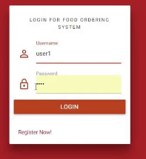

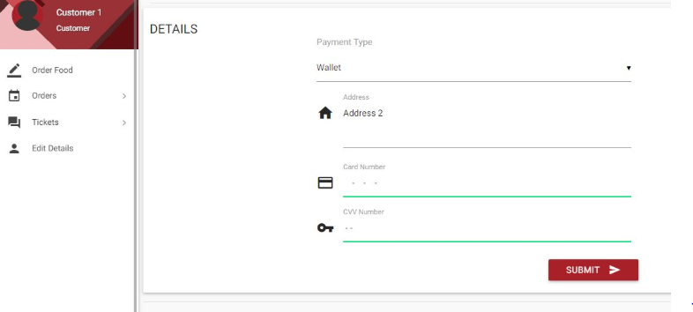

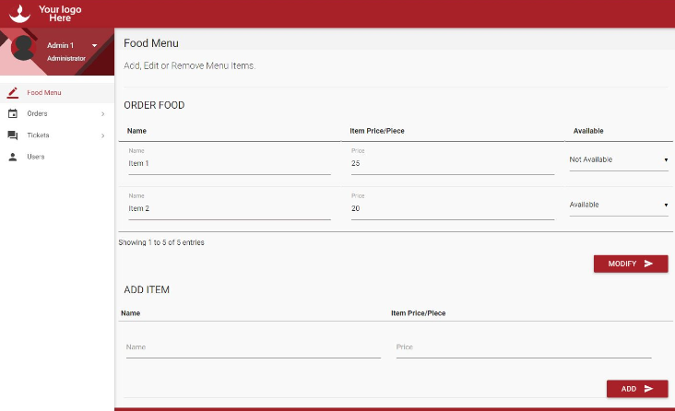

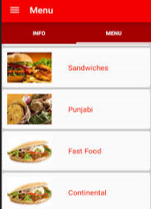

**6. Conclusion**

With our “Online Food Ordering System”, restaurants can promote their business online by posting up the menu in our Web Application. Users can easily place orders from the comfort of home without the need to visit the shop. The orders are tracked online using a very familiar interface. The interface would be easy to use, so all people may make use of our application. The database of the users and restaurants are kept secure highly confidential and in a way that is easy to maintain.

**EVALUATION**

|  |  |  |  |
| --- | --- | --- | --- |
| S.NO | DESCRIPTION | WEIGHTAGE | MARKS AWARDED |
| 1. | PROBLEM STATEMENT | 25 |  |
| 2. | DESIGN | 25 |  |
| 3. | IMPLEMENTATION | 40 |  |
| 4. | VIVA | 10 |  |
|  | TOTAL | 100 |  |