CENG 317

Software Controlled Drone (SCD)

Build Instruction

Pramit Roy

N01074838

Dec 07, 2016

Introduction:

The purpose of this project is to learn how to control a drone remotely without using default controller instead using an RF breakout board. In order to do that as of current project progress remote connection between two RF modules have been established. Two different RF modules are under use such as nrf24l01 and XBee Pro.

System diagram:

LED

Switch

Digital data

Module-B

Module-A

Upon pressing switch connected to Module-A LED in Module-B lights up.

Budget:

|  |  |  |  |  |  |
| --- | --- | --- | --- | --- | --- |
| **Material Estimates** | **Price per Unit** | **Units** | **Retailer** | **Total Price(Shipping + Tax)** | **Notes** |
| 1. **A microcomputer**   **(Raspberry Pi)** | >$50.00 | 1 | CanaKit | >$80.00 | Case and SD card not included |
| 1. **Breakout Board** | >$25.99 | 1 | CanadaRobotix | >$37 |  |
| 1. **ArduinoUno** | >$28.00 | 1 | CanadaRobotix | >$40 |  |
| 1. **PCB parts kit (AD/DA converter with built in light & temp sensors, real time clock ds3231, parts from electronics kit, etc.)** | >$30 | 1 | Humber | >0.00 | Acquired from Humber for free as it was included in semester fees |
| 1. **USB to Ethernet** | >$14.00 | 1 | Newegg | >$20.00 | Required to use with Humber computers |
| 1. **Lite Hawk High Roller Mini RC Multi-rotor Air Vehicle** | >$49.99 | 1 | BestBuy | >$56.00 |  |
| 1. **Lithium AA Batteries** | >$3.00 | 4 | Home Depot | >$15.00 |  |
| **Phase 1 Total** | >$248.00 |  |  |  |  |

Time commitment:

Upon collecting all materials the project can be built within 5-6 hours.

Mechanical assembly:

nrf24l01:

RF module is connected to an Arduino Uno board according following diagram.

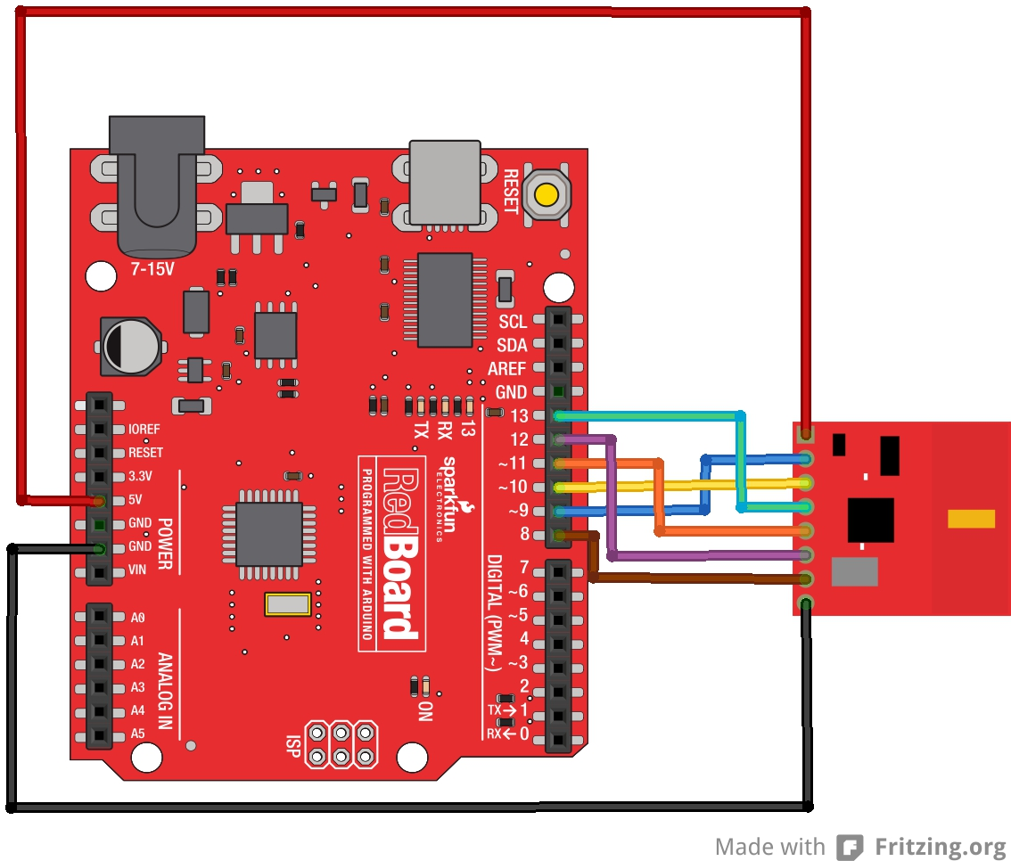

* 3.3V → VCC
* GND → GND
* D8 → IRQ
* D9 → CE
* D10 → CSN
* D11 → MOSI
* D12 → MISO
* D13 → SCK

Arduino board is connected to a PC using USB cable.

XBee Pro:

XBee RF module is already installed on the XBee board. XBee board is connected to a PC using USB cable. A switch is connected to a DIO port of the sender and an LED is connected to the same DIO port of the receiver.

Soldering:

An eight pin header is soldered to the nrf24l01 module for connectivity convenience.

Power up:

nrf24l01:

On power up Arduino IDE needs to be installed for supplying necessary code to the RF module.

XBee Pro:

XCTU software is required for this platform.

Testing:

Using two of the same RF modules programming one as sender and the other as receiver connection is established. XBee platform is used for testing. On pressing the button on the sender module the RSSI LED on the receiver responds. This verifies established connection between the two modules.

Additional test is conducted using nrf24l01 module to scan 2.4 GHz radio signal interference in its different channels.