**Local Network Scan Report**

*This report documents a local network scan conducted on 2025-09-22 to identify open ports and assess potential security risks on my PC and router. The scans were performed using Nmap and PowerShell commands.*

**Table 1: Basic information about the scanned network**

|  |  |
| --- | --- |
| **Item** | **Value** |
| Date | 2025-09-22 |
| Local IP | 10.10.10.1 |
| Subnet | 10.10.10.0/24 |

**Localhost Scan**

|  |  |  |  |  |
| --- | --- | --- | --- | --- |
| **Device** | **Port** | **Service** | **State** | **Notes** |
| Local PC | 135 | msrpc | Open | Standard Windows service |
| Local PC | 139 | netbios-ssn | Open | Standard Windows file sharing |
| Local PC | 445 | microsoft-ds | Open | Standard SMB file sharing |
| Local PC | Other | TCP ports | Closed | 997 other TCP ports closed |

Figure 1: Screenshot of localhost port scan (localhost_scan.txt)

Observation: Only standard Windows networking services are exposed. No unusual ports found.

**Network Scan (Ping sweep)**

|  |  |  |  |
| --- | --- | --- | --- |
| **Device** | **IP Address** | **Status** | **Notes** |
| My PC | 10.10.10.1 | Up | Only responding host on network |

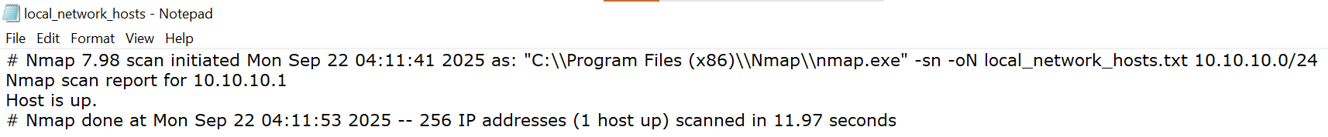

Figure 2: Screenshot of local network hosts scan (local_network_hosts.txt)

Observation: Other devices did not respond, likely blocked by firewall.

**Router Scan**

|  |  |  |  |  |
| --- | --- | --- | --- | --- |
| **Device** | **Port** | **Service** | **State** | **Notes** |
| Router | 80 | http | Open | Router admin interface |
| Router | 443 | https | Open | Router admin interface (secure) |
| Router | Other | TCP | Closed/Filtered | Most other ports closed |

Figure 3: Screenshot of router port scan (router_ports.txt)

Observation: Standard router management ports exposed. No unusual services detected.

**Network reconnaissance summary:**

- Local PC exposes 3 standard Windows networking ports (135, 139, 445)

- Router exposes management ports (80, 443) only

- No unusual or high-risk ports detected

- All other devices either did not respond or have ports closed/filtered

- Overall network exposure is low and typical for a private network