Raspberry Pi USB Security Camera System:

1. Installing and configuring “motion” on a Raspberry Pi

Before installing any packages, you’ll first need to obtain a webcam that is compatible with the Raspberry Pi. If you’re planning on using it in conjunction with a USB Wi-Fi dongle, it would be wise to use a powered USB hub to meet all power needs. I used a Logitech C300 webcam, but the quality is a bit on the low side. However, a complete list of compatible USB webcams can be found here: <http://elinux.org/RPi_USB_Webcams>

A webcam such as the Logitech C300 works right out of the box, so plug it into the powered USB hub and check to make sure it is being detected:

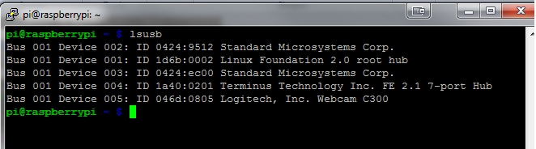

Once the webcam is being connected and being recognized by the RPi, you can install the “motion” package, which allows the user to stream from the webcam to the localhost over the RPi, by default. This will be enabled later for streaming over the internet. The guide I used for this next part can be found here:

<http://techspect.co.uk/2013/how-to-raspberry-pi-webcam-server-stream/>

**$ sudo apt-get install motion**

As soon as motion finished installing, there were some configuration options that I changed to set it up to stream over the internet. TO edit these settings, you’ll need to access the motion configuration file:

**$ sudo nano /etc/motion/motion.conf**

Navigate through this file to view the different configuration options. The following setting will need to be changed for streaming over the internet.

* daemon OFF 🡪 ON #allows it to run in the background
* webcam_localhost ON 🡪 OFF #stream places other than to localhost
* control_localhost ON 🡪 OFF

The rest of the settings here can be left alone for now, unless you want to change the quality of the streaming or the port for the webcam to listen on. I set the following values:

* webcam_port 8081 #port to be specified later, default for webcam
* width 640 #640x480, medium quality. Can adjust these values higher if your webcam
* height 480 #supports it.
* target_dir /tmp/motion #default storage location for .jpg files that are captured

Now, although we set motion to run in daemon mode, it won’t do so until we restart the RPi. For now, we can enter the following command to start motion:

**$ sudo service motion start** #start motion server (stop, restart also can be used when needed)

As of right now, we can only access the webcam stream on the localhost, so obtain the IP address of your RPi. Use eth0 for Ethernet and wlan0 for Wi-Fi:

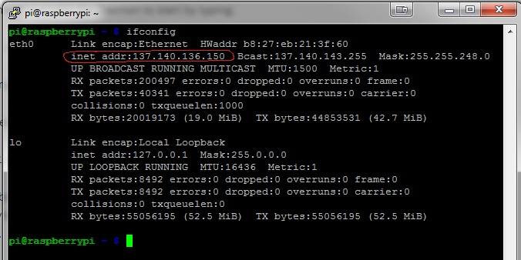

The address with the red circle around it is the one you want. Open a web browser (preferably Firefox, though IE will work as well. I had trouble getting it to stream in Chrome so avoid it). Enter this IP in the address bar with the port number appended to it like so:

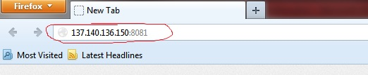

The stream should appear in the browser window. If it does not, double check the configuration settings listed above. The .jpg images captured will be saved to the default directory “/tmp/motion”. This again can be changed in the “/etc/motion/motion.conf” file:

* target_dir /tmp/motion