**Train Ticket Reservation System**

DATABASE MANAGEMENT SYSTEMS PROJECT

Group Members-

1. AS2021403 - D.P.G.A.H. Kulathilaka ………………………..
2. AS2021367 - T.G.D.S. Chathuranga .………………………..
3. AS2021573 - M.A.S.E.R. Wijerathna ………………………..
4. AS2021457 - R.M.D.D. Malinda ………………………..
5. AS2021517 - P.T.S. Karunarathna ………………………..
6. AS2021535 - H.R.S.U. Ranasinghe ………………………..
7. AS2021637 - M.A. Sathsarani ………………………..
8. AS2021359 - G.P.G. Pasqual ………………………..

CONTENTS

* Need OF a Solution
* Exploring Relationships
* Building Diagrams
* Assembling Ideas to a Reality
* Testing Phase

NEED of A SOLUTION

In today's fast-paced world, efficient and user-friendly train travel booking systems are crucial for both passengers and train operators. Traditional booking methods can be time-consuming, inconvenient, and lack real-time information. This proposal outlines the design and implementation of a modern train ticket booking system leveraging a robust database management system (DBMS) to address these challenges and create a seamless travel experience.

# **PROBLEMS CURRENTLY FACING**

1. **Inefficient booking process**: Long queues at counters, and outdated technology lead to frustration and delays for passengers.
2. **Lack of real-time information**: Inaccurate or delayed schedule updates, limited seat availability information, and minimal train progress updates hinder informed travel decisions.
3. **Inflexible booking options**: Difficulty managing bookings, limited cancellation policies, and limited booking channels create inconvenience and inflexibility.
4. **Poor communication**: Delayed or unavailable information about emergencies, schedule changes, and disruptions significantly impact passenger journeys.

# **HOW AN OPTIMIZED DATABASE HELPS**

1. **Streamline booking process**: Implement online and mobile booking options, enable self-service ticket management, and provide real-time seat availability.
2. **Enhance data management**: Create a centralized database for train schedules, fares, user information, and booking details, ensuring accuracy and efficiency.
3. **Improve user experience**: Offer user-friendly interfaces, multiple payment options, personalized booking histories, and real-time train progress updates.
4. **Strengthen communication**: Integrate an emergency alert system to keep passengers informed about delays, cancellations, and track disruptions.

EXPLORING RELATIONSHIPS

Understanding Relationships Related to the System.

**ER Diagram**

# **Relations Explanation**

* CUSTOMER - LOGIN Relation

CUSTOMERs can only make one LOGIN but LOGINs can have many CUSTOMERs.

* STAFF – LOGIN Relation

STAFF can only make one LOGIN but LOGINs can have many CUSTOMERs.

* STAFF – ROLE Relation

One STAFF member can have only one ROLE but one ROLE can be assigned to many STAFF members.

* CUSTOMER – BOOKING Relation

CUSTOMERs can book many BOOKINGs but one BOOKING can have only one customer.

* BOOKING – PAYMENT Relation

PAYMENT is necessary to place a BOOKING and BOOKING can have only one PAYMENT and vice versa.

* BOOKING – TRAIN Relation

One BOOKING can have only one TRAIN but TRAIN can have many BOOKINGs.

* TRAIN – EMERGENCY Relation

TRAINs can encounter many EMERGENCYs, and EMERGENCY can occur to many TRAINs.

* TRAIN – STATION Relation

Many TRAINs can start or end from a STATION, but TRAIN can have only one starting STATION and ending STATION.

* STATION – SCHEDULE Relation

One STATION has only one SCHEDULE and a SCHEDULE can have only one STATION.

* TRAIN – SCHEDULE Relation

SCHEDULE consists of many TRAINs, but TRAIN can have only one SCHEDULE.

building diagrams

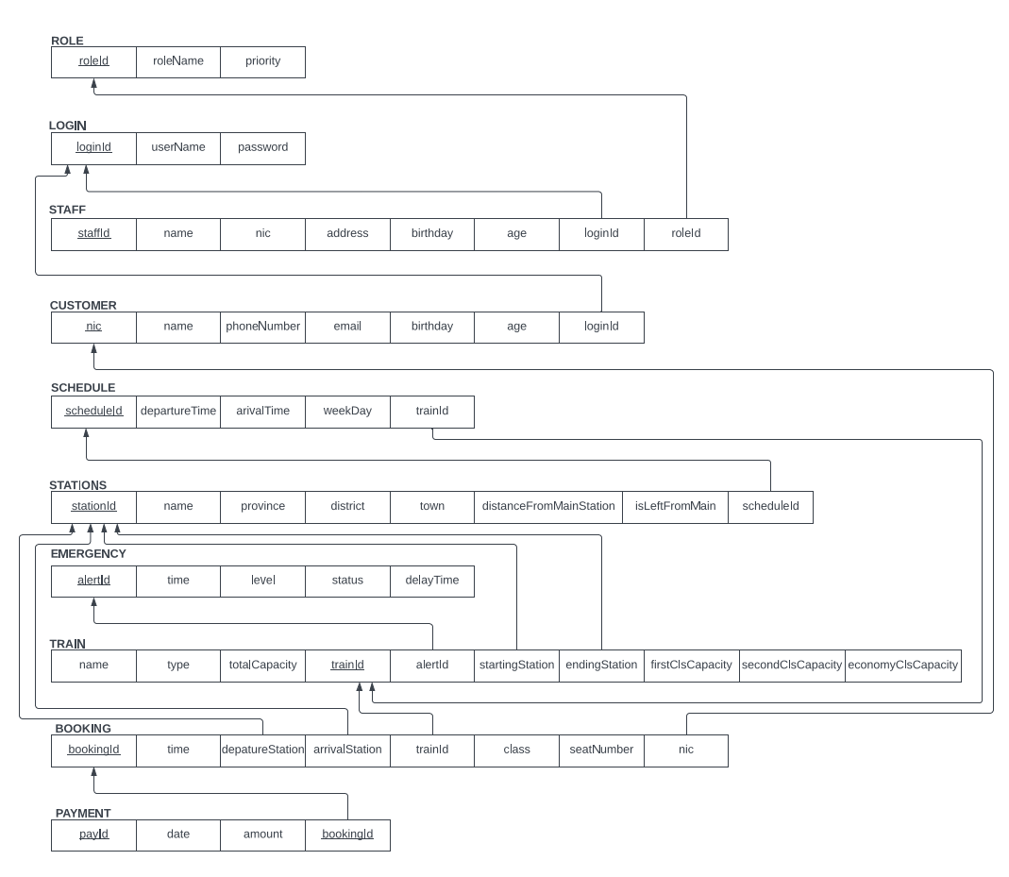Entity Relations to Relational Schemas