3. ANALYSIS OF EFFICIENCY OF THE OPTICAL INTERNET

3.1. The generalized model of expenses for creation of the optical Internet

In this chapter the generalized model of expenses for creation of the optical Internet for a standard apartment house is considered. All values will be enlarged, for calculation of the maximum quantity of expenses. Costs of purchase of the optical cable, the equipment, various costs of route construction, mounting of the optical cable and equipment setup will enter here.
The optical Internet will be built on the GPON technology. The maximum length of the route – 20 km (fig. 3.1).

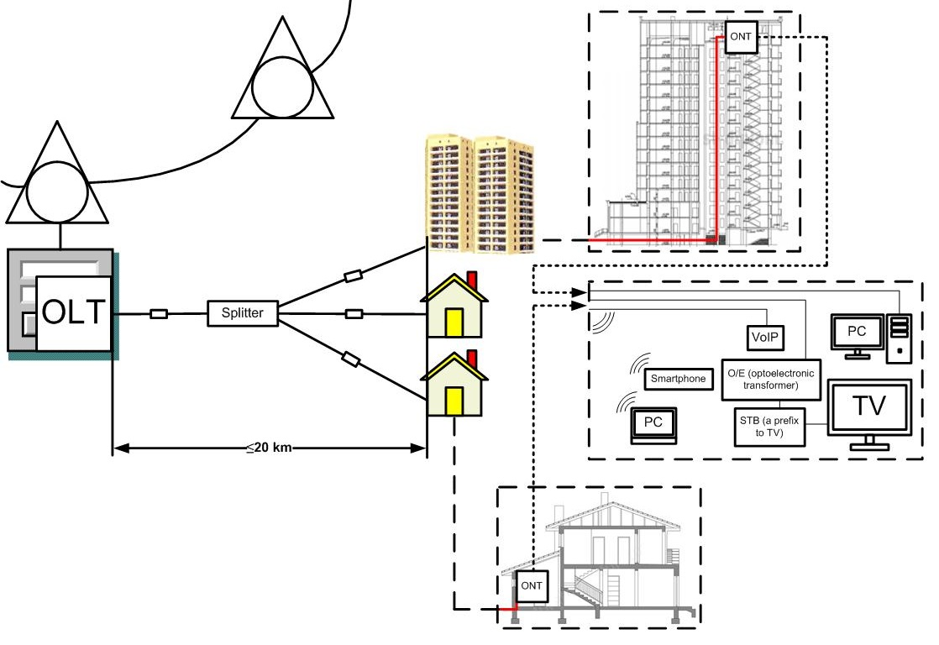
Fig. 3.1. The generalized model of creation of the optical Internet on the GPON technology

We will consider calculation of cost of expenses for FTTH construction for a standard apartment house with 392 apartments.
Calculation for compilation of the estimate of capital expenditure for the equipment
Calculation of quantity of stands and cross connects:
. (3.1)
Calculation of quantity of Patch Cord FC/PC with a length of 5 m:
– quantity of optical fibers;
. (3.2)
Calculation of quantity of ONT:
One port of the optical linear terminal (OLT) can service to 64 optical exchange service stations (ONT).
(3.3)
Calculation of quantity of power supply units:
(3.4)

Table 3.1

Estimate of capital expenditure for the equipment
№ | Equipment name | Quantity, pcs | Unit cost,  USD | Total cost,  USD
 | 1 | 2 | 3 | 4
1. | ETS-V RACK stand | 1 | 1 600 | 1 600
2. | Cross connect optical (10FC) | 1 | 1 250 | 1 250
3. | Optical Line Terminal (LTP-8X) | 1 | 1 300 | 1 300
4. | Optical Network Terminal (NTP-RG-1402) | 448 | 200 | 89 600
5. | Power supply unit | 1 | 430 | 430
6. | Patch Cord FC/PC – 5 m | 14 | 27 | 378
 | Total: |  |  | 94 558
7. | Cost of the unaccounted equipment (measuring equipment, etc.) | 10% |  | 9 455,8
 | Total: |  |  | 104 014
8. | Tare and package | 0,3% |  | 312,0414
9. | Transportation costs | 6% |  | 6 240,828
 | Total: |  |  | 110 567
10. | Procuring and warehouse expenditures | 2,5% |  | 2 764,167
 | Total: |  |  | 113 331
11. | Mounting and equipment setup | 18% from equipment cost |  | 18 772,48
 | In total according to the estimate: |  |  | 132 053

Calculation for compilation of the estimate of capital expenditure for the linear constructions
Calculation of necessary number of the station cable:
- length of the station cable;
– number of terminal points;

(3.5)

Calculation of necessary quantity of the cable which is laid out in a house:
– the cable length, a multiroom house laid out in one entrance;
– quantity of entrances in a multiroom house;

(3.6)

Calculation of quantity of polyethylene sleeves:
Length of the route is L = 20 km;
Construction cable length ;

(3.7)

Calculation of quantity of optical splitters:
– quantity of entrances in a multiroom house;

(3.8)

Table 3.2

Estimate of expenses for the linear constructions
№ | Name of expenses | Quantity | Unit cost,  USD | Total cost,  USD
1. | Cable acquisition for the following conditions of a spacer:
1. | — in the station | 0,1 км | 450 | 45
1. | — in the city telephone sewerage | 20 км | 450 | 9 000
1. | — in a house | 1,4 км | 450 | 63
1. | Optical sleeves | 4 | 200 | 800
1. | Optical splitters | 15 | 50 | 750
Total: |  |  |  | 10 658
2. | Tare and package | 0,3% |  | 31,974
3. | Transportation costs | 13,1% |  | 1 396,198
Total: |  |  |  | 12 086,17
4. | Procuring and warehouse operations in case of cable laying |  | 5,5% | 664,7395
Total: |  |  |  | 12 750,91
5. | Construction and installation works |  | 50% | 6 375,456
In total according to the estimate: |  |  |  | 19 126,37

Calculation for compilation of the estimate of expenses for execution of installation and construction works
- construction cable length;
;
Calculation of number of construction lengths:

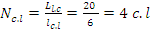 (3.9)

Table 3.3

Estimate of expenses for execution of installation and construction works
№ | Name of operations | Units of measure |  | Quantity | Unit cost,  USD | Total cost,  USD
1. | Measurement of the optical cable on a site | con.lenght |  | 4 | 7 | 28
2. | Cable laying in the sewerage | km |  | 20 | 70 | 1 400
3. | Cable laying in a house | km |  | 1,4 | 50 | 70
4. | Mounting of a direct sleeve | optical sleeve |  | 4 | 45 | 180
5. | Measurement of parameters when mounting sleeves | con.lenght |  | 4 | 2,3 | 9,2
 | Total: |  |  |  |  |  | 1 687,2
6. | Contingencies |  | 3% of a total cost |  |  |  | 50,616
7. | Overhead costs |  | 200% of a total cost |  |  |  | 3 374,4
 | Total: |  |  |  |  |  | 5 112,216
8. | Plan accumulation |  | 18% of the amount of direct and overhead costs |  |  |  | 920,1989
In total according to the estimate: |  |  |  |  |  |  | 6 032,415

Results of capital expenditure are reduced in table 3.4.

Table 3.4
Calculation of capital expenditure for a projected section
№ | Name of capital expenditure | Capital expenditure, USD
1. | Equipment | 132 053
2. | Linear and cable constructions | 19 126,36719
3. | Installation and construction works | 6 032,41
Total: |  | 157 212

Calculation of connection cost for one subscriber
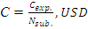 (3.10)

where – capital expenditure for construction of the optical Internet for a standard apartment house;
– number of the connected subscribers;

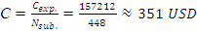. (3.11)

3.2. Assessment of efficiency of the optical Internet

The review considered above and the analysis of the optical Internet, the creation principles of optical access networks and the generalized model of expenses for creation of the optical Internet show on relevance of development of the optical Internet though costs of one subscriber have, approximately, 350 US dollars.
It is necessary to mark that this amount on the one hand seems big, and on the other hand if to consider possibility of operation of the optical Internet with a speed up to several tens Gbps and for reception of signals of TV broadcasting by request of the subscriber extremely important value is created.
Thus, the subscriber has an opportunity of access to any kinds of services, at any time, in any volume and in any place.
If conditionally to estimate representation to the subscriber 2 Megabit flows on a subscriber premises network with use of xDSL of technology for the amount of 2 000 sums in 1 hour (60 minutes), the average subscriber, working within 5 hours shall pay 10 000 sums. By provision to the subscriber only services the Internet in case of a data exchange rate in 1 Gbps, it is possible to receive conditionally in 1 000 times more exchange rates. Thus if to define a rate in 1 hour of 5 000 sums, in 5 hours the subscriber shall pay 25 000 sums. It is finite the conditional comparing. In the conditions of developed market economy subscribers need a high speed exchange of information and, naturally, payment for services the Internet will be determined by traffic. Naturally the subscriber will shall pay for traffic monthly in ten times more, than at a speed of 2 Mbps. If to include in traffic also TV broadcasting, the operator will be naturally stimulated to reduce a rate for traffic that bigger number of subscribers could work on the optical Internet.
That, what was considered, is the economic side of a question. Besides, the subscriber gets access to high-quality any services in any place, at any time and in any volume. Only the optical Internet can give such opportunity.
Such simplified approach of an assessment of efficiency of the optical Internet will allow to see advantages it in comparison with xDSL technology. If to consider that annually the traffic increases in two and more times, it isn't difficult to imagine future efficiency of the optical Internet.
Conclusion to chapter

After compilation of the generalized model of expenses for creation of the optical Internet for a standard apartment house, it was clarified that for this model, about 157 212 USD - are necessary quantity of expenses, and for support with the optical Internet of one subscriber turned out about 350 USD. Also, necessary to mark that the optical Internet is the most effective solution for access to the Internet, in comparison with other technologies of access.

