ST3131 Regression Analysis Assignment A03037401W Ng Zheng Chong
AY 2025/2026, Semester 2

Part 0: Introduction
The Singapore public housing (HDB) resale market is shaped by a complex interplay of physical characteristics, location, and lease tenure. The primary objective of this report is to identify the best-fitting linear regression model for predicting the resale price of HDB flats based on the transaction data for July 2020. This goal is practically significant: an accurate pricing model supports buyers, sellers, valuers, and policymakers in making evidence-based decisions in one of the world's most densely transacted public housing markets. The dataset contains 2,456 observations extracted from data.gov.sg, each representing one completed resale transaction in July 2020. The response variable is resale_price (in SGD). Ten feature variables are available: month, town, flat_type, block, street_name, storey_range, floor_area_sqm, flat_model, lease_commence_date, and remaining_lease. The report proceeds in two main parts. Part I presents an Exploratory Data Analysis (EDA) of the variables, examining distributions, relationships, and data-quality issues. Part II covers model building, beginning with an initial OLS model (M0) using all available regressors, followed by diagnostic checks and remediation, and concluding with a final selected model (M_{N}). Model adequacy is evaluated through residual diagnostics, Variance Inflation Factor (VIF) analysis, and information criteria (AIC/BIC).

Part I: Exploratory Data Analysis
Before analysis, the following pre-processing steps were applied. (i) Two observations were removed: the sole MULTI-GENERATION flat and the sole Type S2 flat model, each being a singleton class unusable for regression. This left 2,454 observations. (ii) The month column was dropped, as every record has the value 2020-07. (iii) Three high-cardinality or identifier columns (block, street_name, and storey_range) were removed or transformed. (iv) storey_range (a string such as '04 TO 06') was converted to a numeric average_storey by averaging the lower and upper bound of each range, providing an ordinal continuous proxy. (v) remaining_lease (stored as a string like '56 years 7 months') was parsed into a numeric remaining_lease_years variable in terms of years. (vi) town (26 categories) was recoded into region (5 categories: Central, North, North-East, East, West) using the Urban Redevelopment Authority's official planning regions, substantially reducing dimensionality while preserving geographic meaning. Thereafter, town, block, street_name, storey_range, remaining_lease were dropped.
The raw resale_price distribution is right-skewed (Figure 1), with a long tail of high-value flats (mainly Executive and premium Central-region units). A log transformation, ln(resale_price), produced a visibly more symmetric, approximately normal distribution, justifying its use as the response in all subsequent models.
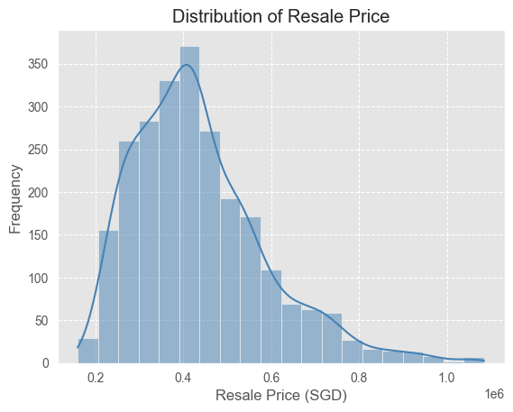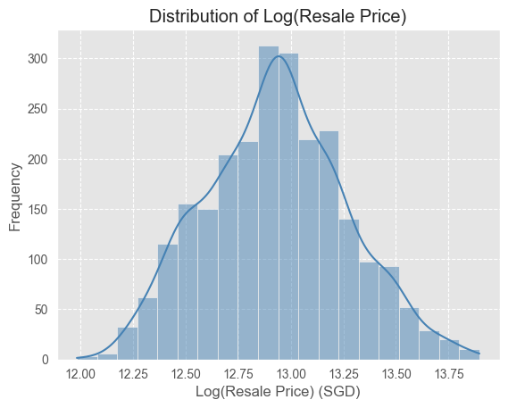
Figure 1: Histogram of resale_price and log(resale_price)
Several important patterns emerged from descriptive plots (Figure 2):
- flat_type: Box plots reveal a clear positive gradient, 1 ROOM < 2 ROOM < 3 ROOM < 4 ROOM < 5 ROOM < EXECUTIVE, reflecting the strong size-price relationship.
- floor_area_sqm: A positive linear association with resale_price is evident, though residual variance appears to fan out at larger floor areas, suggesting mild heteroscedasticity.
- average_storey: A weaker but positive relationship exists. Most observations cluster below storey 20, with sparse data at higher floors.
- lease_commence_date / remaining_lease_years: Newer leases command higher prices. A notable price spike occurs at 2018 commencement. Critically, these two variables are near-perfectly collinear (Chi-squared test of independence, p < 0.05), as remaining_lease is algebraically determined by lease_commence_date given a fixed 99-year maximum lease.

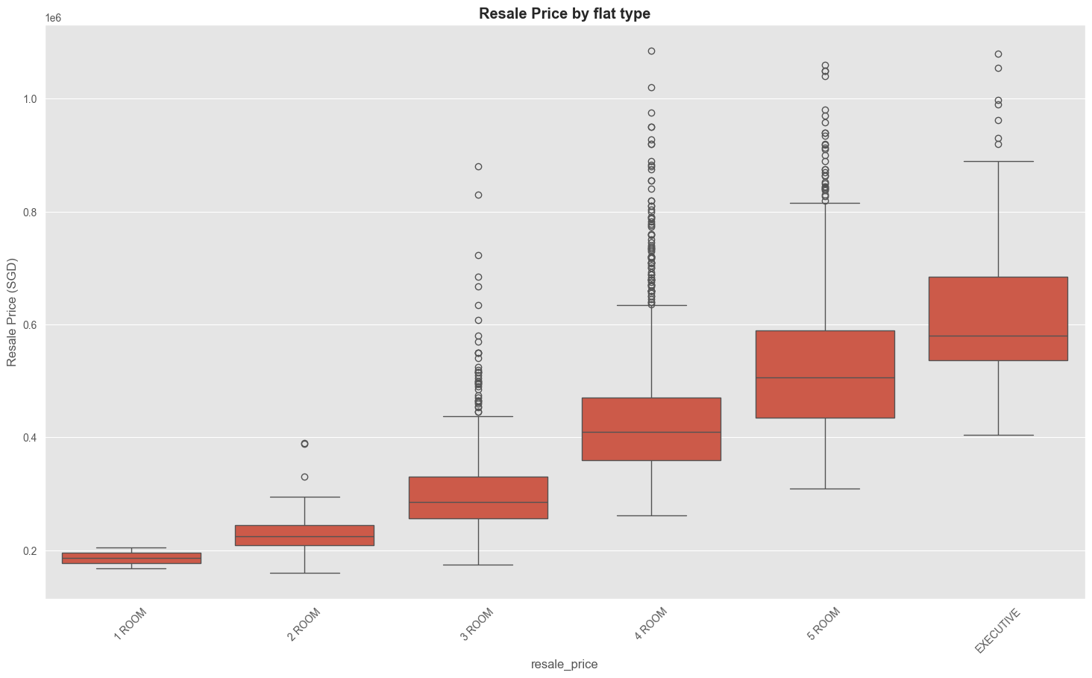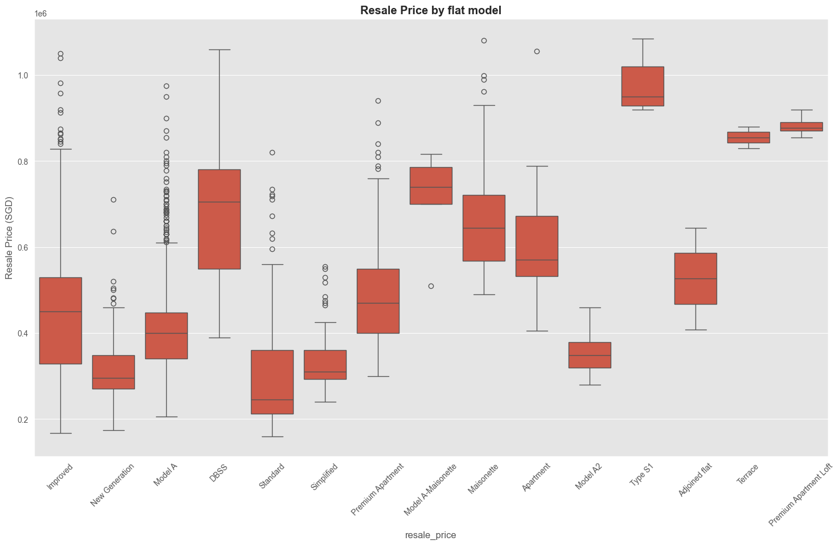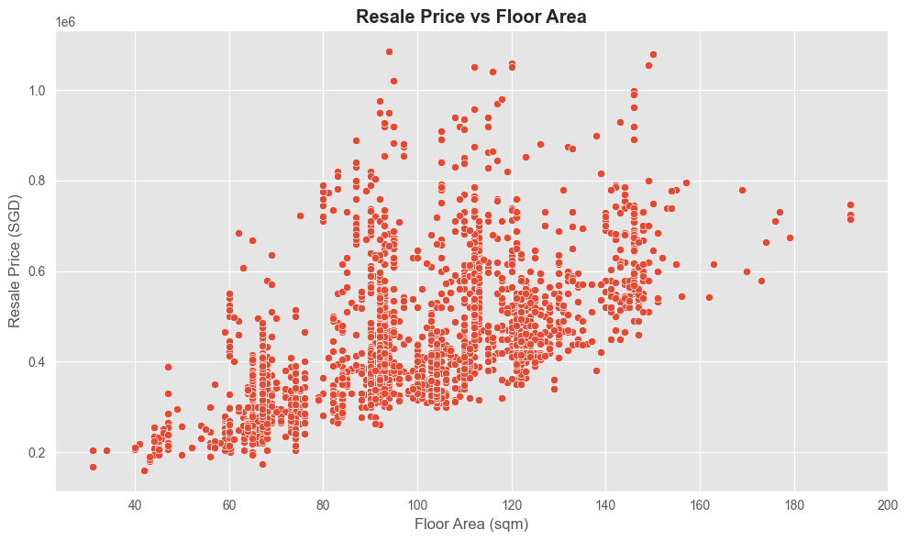

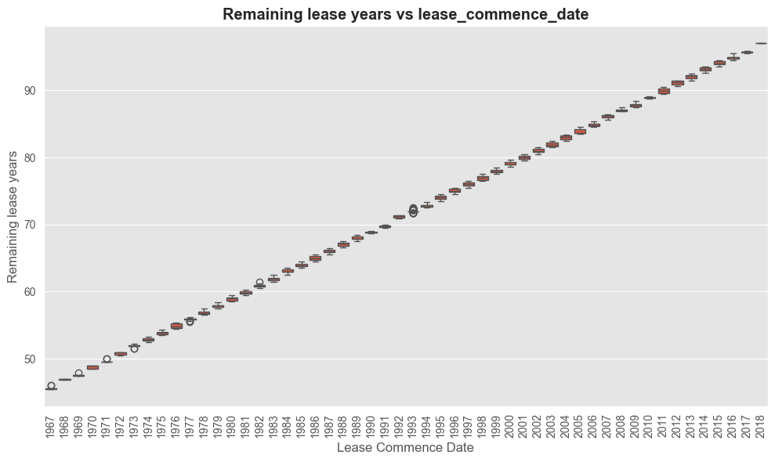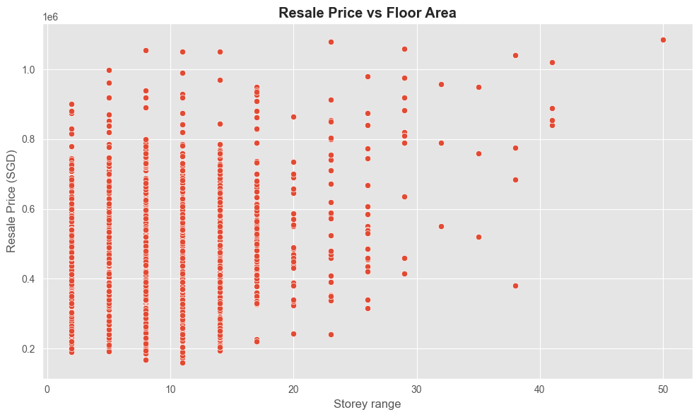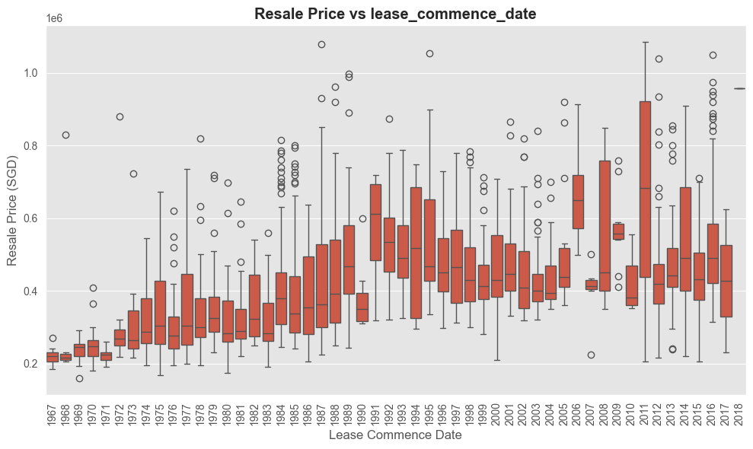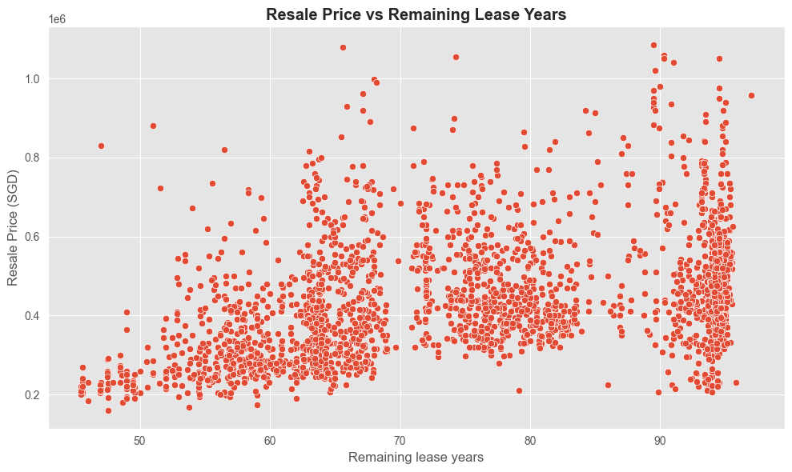
Figure 2: Plots between predictor and response variables

Part II: Model Building

2.1 Initial Model M₀: Full OLS with Log-Transformed Response
The initial model M₀ regresses ln(resale_price) on all available post-processing predictors: flat_type, flat_model, region, floor_area_sqm, average_storey, remaining_lease_years, and lease_commence_date. Categorical predictors are one-hot encoded yielding 27 parameters (excluding intercept).
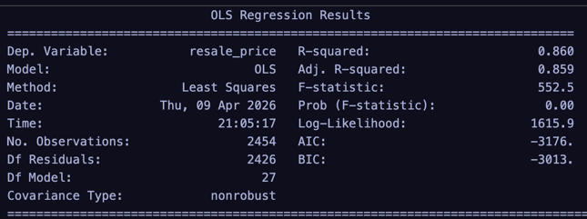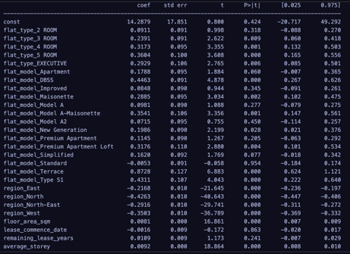

Table 2: M₀ overall model statistics.
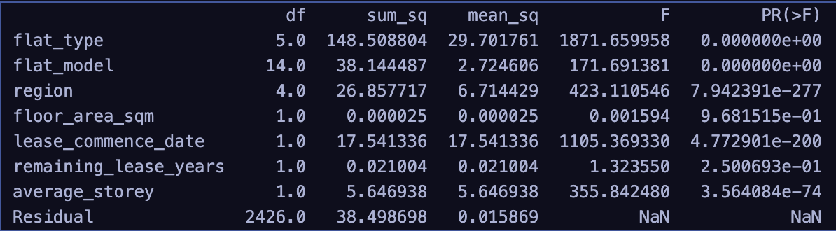
Table 3: M₀ ANOVA
The F-statistic of 552.5 (p < 0.001) indicates that the model as a whole is highly significant. The R² of 0.860 indicate that the model explains approximately 86% of the variation in log resale price.
Standardised residuals were examined against each numerical predictor and via a Normal Q-Q plot:
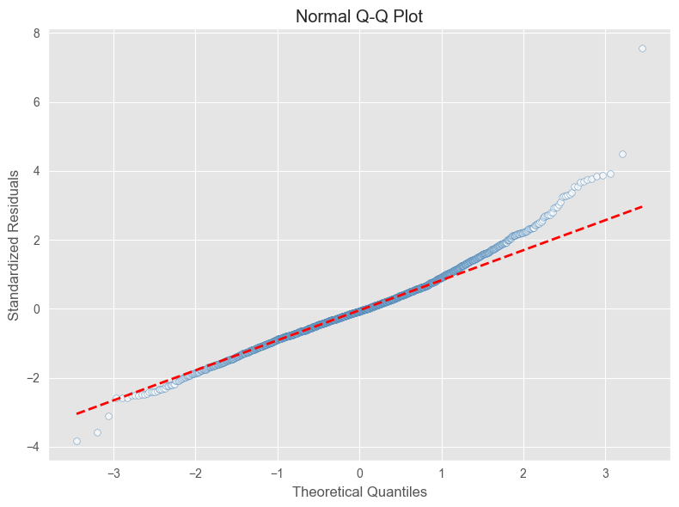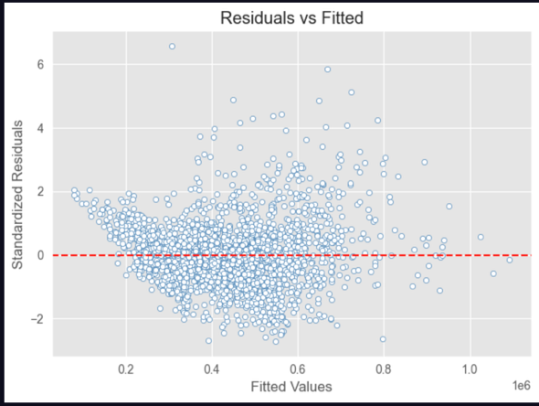
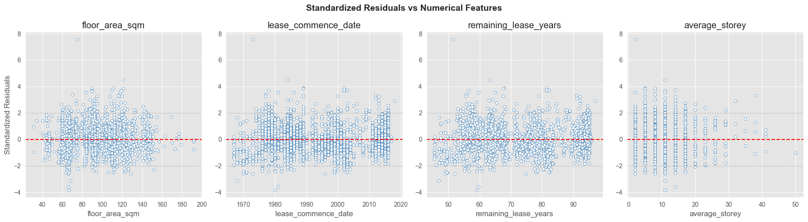
Figure 3: QQPlot and Residual Plots
- Normality: The Q-Q plot shows a slightly light-tailed distribution with a few outliers.
- Linearity: Residual-vs-predictor plots show no systematic curvature, supporting the linearity assumption.
- Homoscedasticity: A slight funnel pattern is visible in the residuals vs. floor_area_sqm plot, indicating mild heteroscedasticity for larger flats.
Several observations had a standardised residual exceeding 3, but were still kept as they might be useful. Cook's Distance was computed for all observations: no point exceeded the threshold of 1, so no influential observations were removed.
VIF values for M₀ revealed severe multicollinearity (Table 4). lease_commence_date had VIF = 2,841, and several flat_type and flat_model dummies had VIFs in the hundreds. This aligns with the EDA finding that lease_commence_date and remaining_lease_years are near-perfectly collinear (r ≈ 1), and that flat_type and flat_model are structurally associated.
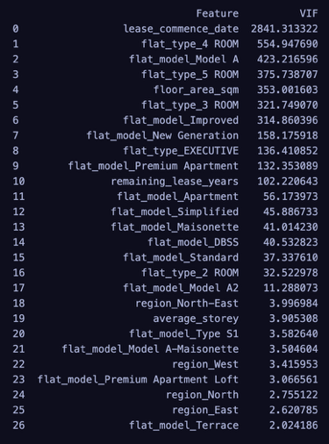

Table 4: VIF comparison between M₀ and Mₙ (selected features).

2.2 Model M₂: Ridge Regression
To address the multicollinearity in M₀, Ridge Regression was explored as an intermediate step. Using leave-one-out cross-validation (RidgeCV) across α ∈ [0.1, 100], the optimal regularisation parameter was found to be α = 0.4. A Ridge trace plot confirmed that coefficient shrinkage was stable and monotone. However, the Ridge test R² (0.8573) and RMSE (0.1252) were virtually identical to M₀ test R² (0.8572) and RMSE (0.1253). This indicated that regularisation alone, without removing collinear variables, offered negligible practical improvement.
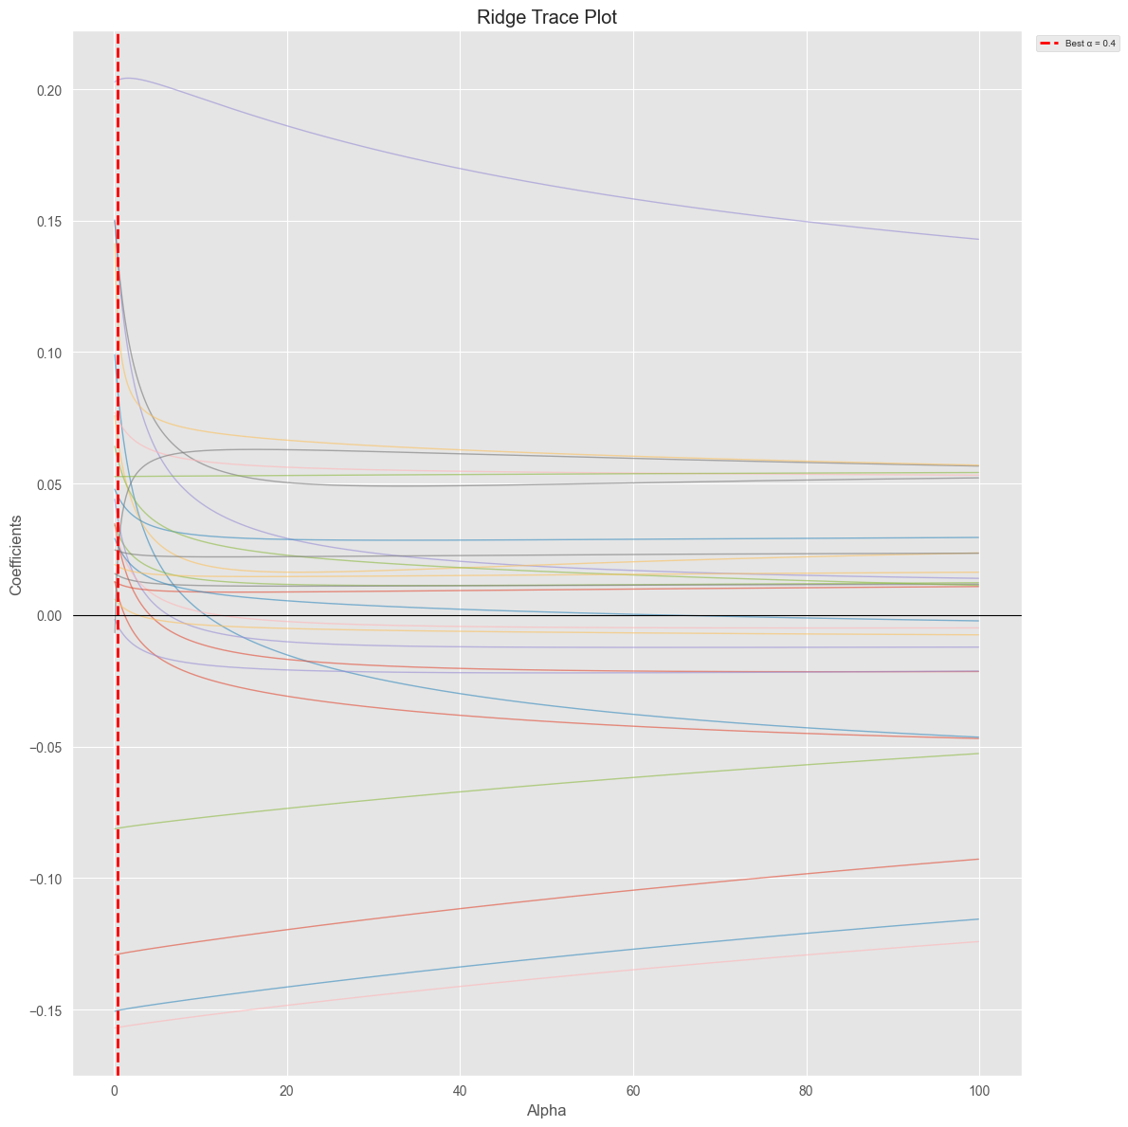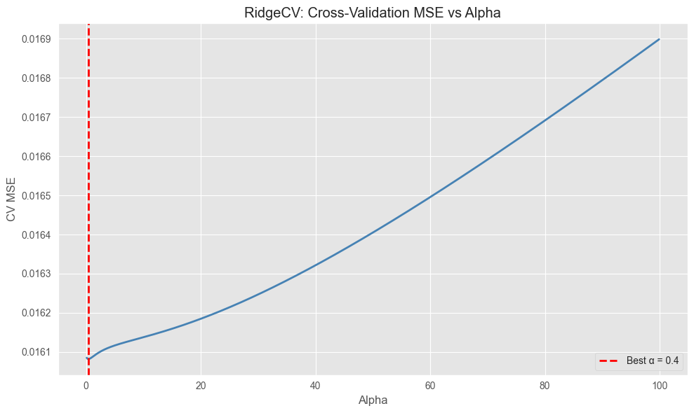
Figure 4: Ridge Trace and RidgeCV Plot

2.3 Model M₃: Forward-Selected OLS on Reduced Predictors
Given the multicollinearity findings, the following variable removal strategy was adopted: (i) lease_commence_date was dropped in favour of remaining_lease_years, as the two are near-perfectly collinear and remaining_lease_years is the more directly interpretable lease metric; (ii) flat_type was dropped because it is structurally associated with flat_model (chi-squared p < 0.05), and flat_model carries richer model-specific information.
Forward stepwise selection (minimising AIC at each step) was then run over the remaining candidate predictors: floor_area_sqm, flat_model, region, remaining_lease_years, and average_storey. The selection procedure added features in the following order (Table 5):
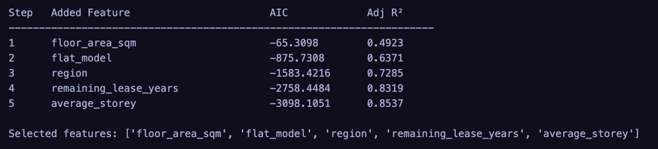
Table 5: Forward selection steps with AIC and adjusted R².
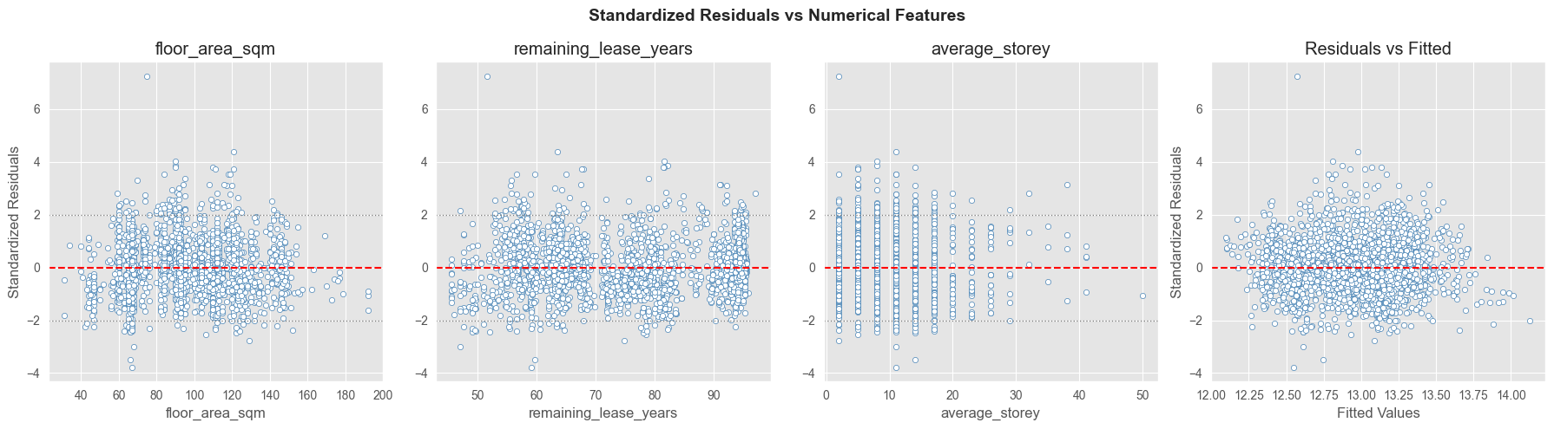
Figure 5: Residual plots for model 3
Residual diagnostics for M₃ confirm that the model assumptions are reasonably satisfied. The residual-vs-predictor plots for the three numerical features (floor_area_sqm, remaining_lease_years, average_storey) show no systematic pattern, supporting linearity. The mild heteroscedasticity pattern observed in M₀ persists but is slightly attenuated. No Cook's Distance exceeded 1, confirming the absence of unduly influential observations. VIF values are substantially reduced in M₃ (Table 4), with the highest being 65.3 for remaining_lease_years, a meaningful improvement over M₀, though moderate collinearity remains an acknowledged limitation.

2.4 Model M₄: Weighted Least Squares (IRLS)
The mild heteroscedasticity identified in M₀ and persisting in M₃ motivated the exploration of Weighted Least Squares (WLS) as a remediation strategy. WLS was applied to the same predictor set as M₃ (flat_model, region, floor_area_sqm, remaining_lease_years, average_storey). Weights were estimated via Iteratively Reweighted Least Squares (IRLS): at each iteration, the squared OLS residuals were regressed on the predictors to model the variance function, and observation weights were set to the reciprocal of the fitted variance. Weights were capped at the 99th percentile to prevent explosive upweighting of near-zero variance observations.
The IRLS procedure did not converge within 100 iterations, as evidenced by the persistently large maximum weight changes (approaching 10⁶) across all iterations. This indicates that the variance function could not be stably estimated from the data, likely because the heteroscedasticity in the log-transformed response is too mild and irregular to support a reliable parametric variance model via OLS on squared residuals. Consequently, M₄ did not yield a stable or meaningfully improved fit over M₃, and the WLS approach was not pursued further. The final selected model remains M₃, which balances goodness-of-fit, parsimony, and interpretability without requiring non-convergent iterative weighting.

2.5 Final Model Interpretation
Quantitative predictor: floor_area_sqm: Holding all other variables constant, each additional square metre of floor area is associated with an increase of approximately 0.0105 in log resale price.This aligns with the intuitive expectation that larger flats command higher prices, independent of flat type or model.
Categorical predictor: region: Relative to the Central region, flats in the North-East and East regions are associated with approximately 0.296 and 0.224 lower log resale prices respectively. This reflects the well-documented price premium of centrally located HDB flats, driven by proximity to the CBD, amenities, and transport infrastructure.

Conclusion
This report proposed and evaluated several linear models for predicting HDB resale prices in Singapore using July 2020 transaction data. Beginning with a full OLS model M₀ (adjusted R² = 0.859), we identified severe multicollinearity, particularly between lease_commence_date and remaining_lease_years, and between flat_type and flat_model. Ridge regression provided negligible improvement. The final model M₃, selected via forward AIC minimisation on a reduced predictor set, regresses ln(resale_price) on flat_model, region, floor_area_sqm, remaining_lease_years, and average_storey. M₃ attains an adjusted R² of 0.854 with substantially reduced multicollinearity and superior parsimony, and is identified as the best linear model for this dataset.
M₃ achieves a comparable adjusted R² to M₀ (0.854 vs 0.859) with 7 fewer parameters, substantially reduced multicollinearity, and better parsimony. The slight AIC increase is an acceptable trade-off for a model with far less collinearity and superior interpretability.
The fitted equation of the final model M₃ is therefore:

