CBO Circulars Access Guide
Follow these steps to access CBO circulars on the Banki Portal.
Banki Portal → Department → Compliance → CBO Circulars

1 Open the Banki Portal
Open the Banki Portal and click Department in the top menu.
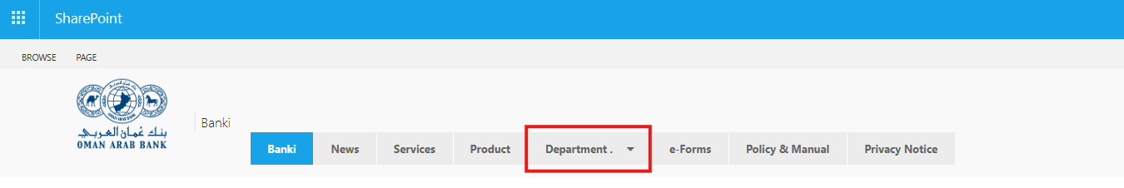

2 Select Compliance
From the Department menu, click Compliance.
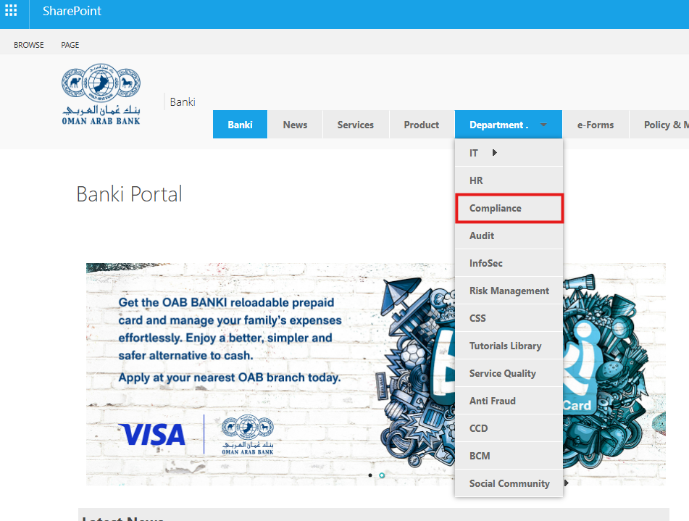

3 Open CBO Circulars
On the Compliance page, scroll down and click the CBO Circulars tile on the right.
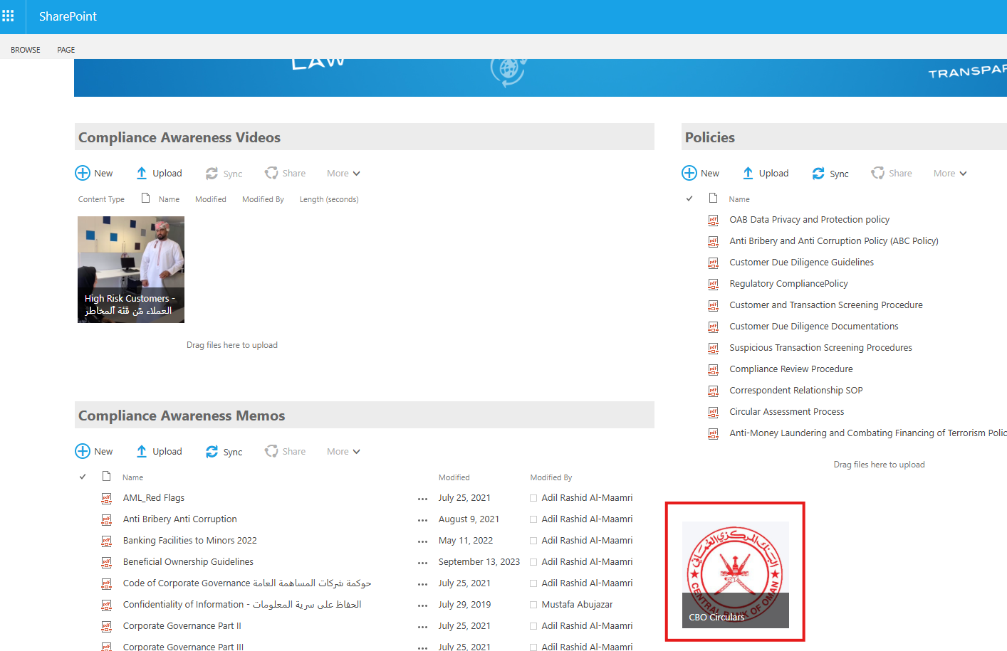

4 View the CBO Regulatory Library
The CBO Regulatory Library opens. Use the search field to find a circular by date, reference, subject or business line.


