

TECHNICAL COMPONENT DOCUMENT
MFT/SFTP Reusable File Transfer Component

PURPOSE OF THIS DOCUMENT:
• To document the implemented design and usage of the reusable SFTP upload and download component.
• To define the current workflow arguments, configuration loading, credential retrieval, file validation, logging, status handling, and exception behavior.
• To explain how the component can be invoked from any RPA process without hardcoding the host, port, credential, or file paths.
• To document the implemented flow from configuration initialization through upload/download completion and exception rethrow.
This document describes the reusable SFTP file transfer workflow and the supporting configuration test flow included in the project. Main.xaml is used as a test runner to initialize Config and invoke the reusable workflow. Other RPA processes can invoke Framework\SFTP_FileTransfer.xaml directly and pass the same arguments. The component retrieves credentials securely from Orchestrator and performs either upload or download based on the requested action.
Item | Details
Component / Process Name | MFT/SFTP Reusable File Transfer Component
Prepared By | Nahiyan Juma Said Al Balushi
Requester / Owner | Mustafa Abujazar
Version | 1.0
Date | 04/05/2026
Status | Draft
Document Type | Reusable Component Technical Documentation

DOCUMENT HISTORY
Date | Version | Role | Name | Comments
04/05/2026 | 1.0 | Prepared By | Nahiyan Juma Said Al Balushi | Initial draft created for reusable SFTP/MFT upload and download component.
[TBD] | [TBD] | Reviewed By | [TBD] | [To be confirmed]
[TBD] | [TBD] | Approved By | [TBD] | [To be confirmed]

I. INTRODUCTION
1.1 Purpose
The purpose of this document is to define the implemented reusable UiPath component that connects to an SFTP server and performs file upload or file download based on dynamic workflow arguments. The component is intended to be reused inside different automation processes where files must be transferred to or from an SFTP location.
1.2 Objective
Create reusable SFTP upload and download logic that can be invoked from any UiPath process.
Avoid hardcoding the action type, host, port, credential asset name, local path, and remote path.
Retrieve the SFTP username and password securely from an Orchestrator Credential Asset.
Check whether the required local or remote file exists before starting the transfer.
Return the transfer result through the out_Status argument.
Write step-level logs for configuration initialization, credential retrieval, transfer routing, completion, and failures.
Handle failures by logging the error, setting out_Status to Failed, and rethrowing the exception to the calling process.
1.3 Component Scope
In Scope | Out of Scope
• SFTP connection using host, port, and an Orchestrator Credential Asset name.  • Configuration-driven test invocation through Main.xaml and InitConfig.xaml.  • Dynamic upload and download based on in_ActionType.  • Local and remote file availability checks.  • Step-level logging.  • out_Status result handling.  • Exception logging and rethrow to the calling process. | • Full business process logic.  • Business approval workflow.  • End-to-end scheduling.  • Business-specific validation after transfer.  • Downstream processing of downloaded files.  • File deletion or archival.  • Retry handling unless added later as an enhancement.

II. COMPONENT OVERVIEW
# | Item | Description
1 | Component Name | MFT/SFTP Reusable File Transfer Component
2 | Component Type | Reusable UiPath workflow invoked through Invoke Workflow File.
3 | Purpose | Upload or download a file through SFTP based on workflow arguments.
4 | Connection Type | SFTP
5 | SFTP Host/IP | Configuration-driven. Current test value: 10.101.3.97.
6 | Port | Configuration-driven. Current test value: 22.
7 | Authentication Method | Orchestrator Credential Asset retrieved by Get Credential using in_CredentialName.
8 | Required Actions | Upload and Download based on in_ActionType.
9 | Configuration Source | The test runner reads Data\Config.xlsx. Settings and Constants are loaded locally; the Assets sheet is resolved through Get Asset.
10 | Remote Path | in_RemoteFolderPath contains the full remote file path. The existing argument name is retained.
11 | Local Path | in_LocalFolderPath contains the full local file path. The existing argument name is retained.
12 | Schedule | No fixed schedule. The reusable component runs only when invoked by a calling process.
13 | Access Status | Firewall access request raised / pending approval. Recorded connectivity result: TcpTestSucceeded = False.
14 | Output Confirmation | out_Status returns Success or Failed. Failures are also rethrown to the calling process.
III. HOW THIS COMPONENT WILL BE USED
The reusable workflow can be invoked directly from another RPA process. In the included test flow, Main.xaml first checks whether Config is Nothing. When configuration is not initialized, Main invokes Framework\InitConfig.xaml. InitConfig reads the Settings and Constants sheets into a Dictionary(Of String, Object), reads the Assets sheet, and uses Get Asset to resolve the configured credential asset name. Main then invokes Framework\SFTP_FileTransfer.xaml and passes the current arguments. Inside the reusable workflow, Get Credential retrieves the SFTP username and secure password, the action type is normalized, and the upload or download branch is executed.
Example Use Case:
• Main.xaml initializes Config only when Config Is Nothing.
• InitConfig.xaml reads Settings and Constants from Data\Config.xlsx.
• InitConfig.xaml reads the Assets sheet and uses Get Asset to resolve the SFTP Credential Asset name.
• Main.xaml invokes SFTP_FileTransfer.xaml with ActionType, Host, Port, RemoteFolderPath, LocalFolderPath, CredentialName, and Status.
• SFTP_FileTransfer.xaml retrieves the credential, validates the required file, performs the transfer, logs the result, and returns Success or Failed.
IV. INPUT ARGUMENTS
Argument Name | Direction | Data Type | Mandatory | Description | Example / Current Value
in_ActionType | In | String | Yes | Defines the requested transfer action. Accepted values: Upload or Download. | Download
in_SftpHost | In | String | Yes | SFTP host name or IP address. | 10.101.3.97
in_Port | In | Int32 | Yes | SFTP port number. | 22
in_RemoteFolderPath | In | String | Yes | Full remote SFTP file path used for the file check and download. For upload, the workflow derives the remote folder from this value. | /remote/folder/file.ext
in_LocalFolderPath | In | String | Yes | Full local file path used for the local file check and upload. For download, the workflow derives the local destination folder from this value. | C:\Data\file.ext
in_CredentialName | In | String | Yes | Name of the Orchestrator Credential Asset used by Get Credential. | Reuters_Credentials
V. OUTPUT ARGUMENTS
Argument Name | Direction | Data Type | Description
out_Status | Out | String | Returns Success when the upload/download completes. Returns Failed in the exception handler before the exception is rethrown.

VI. COMPONENT LOGIC / TO-BE STEPS
Step | Component Step | Description / Expected Action
1 | Start / calling process | The calling process starts the flow. The included Main.xaml is used as a test runner.
2 | Initialize configuration when required | Main checks Config Is Nothing and invokes InitConfig.xaml only when configuration has not yet been loaded.
3 | Read local configuration sheets | InitConfig reads Settings and Constants from Data\Config.xlsx and adds each Name/Value pair to out_Config.
4 | Resolve configured Orchestrator assets | InitConfig reads the Assets sheet, uses Get Asset for the configured text asset, and stores the returned value in out_Config.
5 | Invoke the reusable SFTP workflow | Main passes in_ActionType, in_SftpHost, in_Port, in_RemoteFolderPath, in_LocalFolderPath, in_CredentialName, and receives out_Status.
6 | Start component and normalize action | The component writes its start log and converts the action type to a normalized upload or download value.
7 | Retrieve SFTP credential | Get Credential uses in_CredentialName and returns the username and secure password.
8 | Prepare path values | The workflow prepares the remote upload folder and local download folder from the supplied full file paths.
9 | Upload branch - validate local file | When ActionType is Upload, the workflow checks whether in_LocalFolderPath exists.
10 | Upload or throw exception | If the local file is missing, the workflow logs and throws an exception. Otherwise, it connects and uploads the file to the derived remote folder.
11 | Download branch - connect and validate remote file | When ActionType is Download, the workflow connects to SFTP and checks whether in_RemoteFolderPath exists.
12 | Download or throw exception | If the remote file is missing, the workflow logs and throws an exception. Otherwise, it downloads the file to the derived local folder.
13 | Invalid action type | If the action is neither Upload nor Download, the workflow logs the error, sets out_Status to Failed, and throws an exception.
14 | Successful completion | After a successful upload or download, the workflow logs File Transfer Completed and sets out_Status to Success.
15 | Failure handling | The Catch block logs the exception message and sets out_Status to Failed.
16 | Rethrow and end | The original exception is rethrown to the calling process. Main logs the returned status when execution completes successfully.

VII. HIGH LEVEL FLOW
The current diagram below is retained as a draft. It will be updated separately after confirmation to reflect Main.xaml, InitConfig.xaml, Get Asset, Get Credential, the current workflow arguments, and the implemented upload/download exception flow.
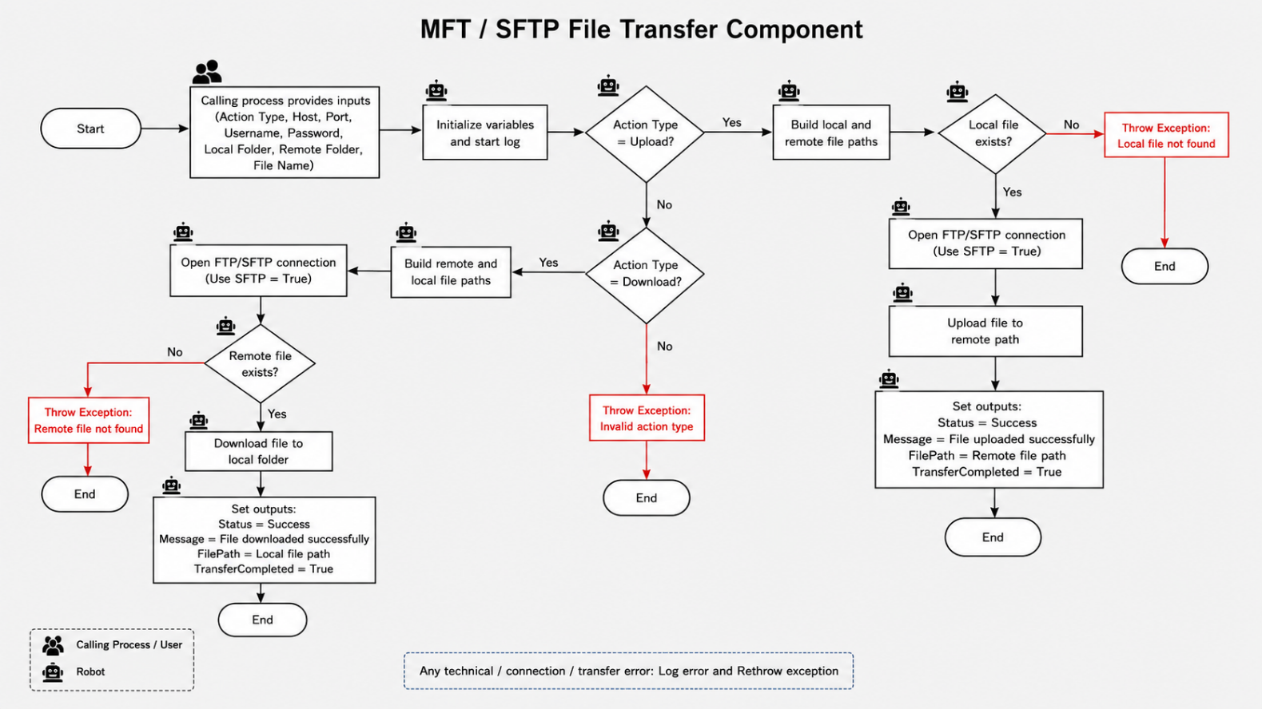
VIII. BUSINESS RULES
• The component must support both Upload and Download based on the in_ActionType argument.
• The current workflow inputs are in_ActionType, in_SftpHost, in_Port, in_RemoteFolderPath, in_LocalFolderPath, and in_CredentialName.
• Credentials must not be hardcoded. in_CredentialName identifies the Orchestrator Credential Asset used by Get Credential.
• Although the existing arguments are named in_RemoteFolderPath and in_LocalFolderPath, the implemented flow uses them as full file paths.
• For Download, the component must check the remote file before downloading.
• For Upload, the component must check the local file before uploading.
• If the required file is not found, no retry is performed. The component logs the issue and throws an exception.
• A successful transfer sets out_Status to Success. The exception handler sets out_Status to Failed and rethrows the exception.
• No deletion, archival, file-pattern matching, or downstream processing is included in the current component.
IX. EXCEPTION HANDLING
9.1 Validation / Operational Exceptions
# | Exception Name | Scenario | Action to be Taken
VAL-01 | Remote file not found | Download action requested but the file at in_RemoteFolderPath does not exist. | Log a warning, throw an exception, set out_Status to Failed in Catch, and rethrow to the calling process.
VAL-02 | Invalid action type | in_ActionType is not Upload or Download. | Log an error, set out_Status to Failed, throw an exception, and rethrow to the calling process.
VAL-03 | Local file not found | Upload action requested but the file at in_LocalFolderPath does not exist. | Log a warning, throw an exception, set out_Status to Failed in Catch, and rethrow to the calling process.

9.2 Technical / System Exceptions
# | Error Name | Scenario | Action to be Taken
1 | Unable to connect to SFTP server | Network, host, port, or server connectivity fails. | Catch the exception, log the message, set out_Status to Failed, and rethrow.
2 | Firewall access issue | Port 22 connectivity fails. The recorded Test-NetConnection result is False. | Follow up the firewall request. The workflow will log the resulting connection error and rethrow it.
3 | Credential retrieval or authentication failure | The Credential Asset is missing, inaccessible, or rejected by the SFTP server. | Log the failure, validate the Orchestrator asset and permissions, set Failed, and rethrow.
4 | Remote path inaccessible | The remote path does not exist or cannot be accessed. | Log the technical error, confirm the configured full remote file path and access, then rethrow.
5 | Permission denied | The account does not have the required remote read/write permission. | Log the error, request the required permission, set Failed, and rethrow.
6 | Upload failure | The upload fails after the SFTP connection is opened. | Log the exception, set out_Status to Failed, and rethrow.
7 | Download failure | The download fails after the remote file check. | Log the exception, set out_Status to Failed, and rethrow.
8 | Network timeout or interruption | The connection or transfer times out or is interrupted. | Log the exception, set out_Status to Failed, and rethrow. No retry is implemented.
9 | Unexpected system error | Any other unhandled UiPath, package, runtime, or transfer error occurs. | Log the exception message, set out_Status to Failed, and rethrow the original exception.

X. LOGGING REQUIREMENTS
The implemented workflows write step-level logs during configuration initialization, credential retrieval, action routing, connection attempts, file checks, successful completion, and exception handling. The reusable component does not return a separate message argument; detailed failure information is preserved through the rethrown exception.
Step | Sample Log Message
Configuration | [INFO] Initializing settings...
Start | [INFO] SFTP Component Started
Credential | [INFO] Credential Retrieved Successfully
Action routing | [INFO] Resolved ActionType: upload / download
Connection | [INFO] Connecting to SFTP Server...
Local file missing | [WARN] Local file not found
Remote file missing | [WARN] Remote file not found
Completion | [INFO] File Transfer Completed
Failure | [ERROR] SFTP Component Failed: {ExceptionMessage}

XI. ACCESS AND TESTING STATUS
Item | Current Status
SFTP Host/IP | 10.101.3.97 (current configuration/test value)
Port | 22 (current configuration/test value)
Configuration | Data\Config.xlsx with Settings, Constants, and Assets sheets.
Credential Handling | Get Asset resolves the Credential Asset name; Get Credential retrieves the username and password.
Connectivity Test | Test-NetConnection 10.101.3.97 -Port 22
Connectivity Result | Recorded result: TcpTestSucceeded = False
Firewall Request | Raised / pending approval
Test File Paths | Provided through Config or directly by the calling process as full local and remote file paths.

