**Starvation**

You only wanted peace and a prosperous life when you moved to the frontier with your family. Your children were excited but your wife was worried about staying safe but she put her faith in you. At first you only had to stay away from the beasts in the forest, but ever since the war broke out resources have been tight. You find yourself facing the savage beasts more and more just to feed your family.

**Objective:**

There is a finite amount of resources that will eventually run out throughout the game; you must outlive your opponent to win. If your whole family dies, you fall to despair and lose the game.

**Setup:**

* Grab **all the cards with “Human” written on them**; you control the humans.
* Place an **Actions Card** near you to look at later.
* Place your **Cards with “Hunger” face-up in front of you**. These are your Hunger Cards; place a coin on the “Hungry” section on each one.
* Keep your **remaining** **cards in your hand**. These correspond to the characters on your Hunger Cards; they hold descriptions to help imagine the character, along with **Passive Abilities** that are applied whenever the character performs an action.
* **If not already done:** Spread out 5 tree tokens in the middle of the table, between you and the other player. This is the forest.
* Place 3 Food Tokens near you; this area is known as **your Stock.**
* Place extra tokens and items in box, use box as discard pile as well.
* Both players roll a die after setup, highest goes first; reroll on ties.

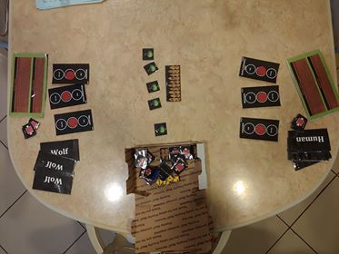

**Turn Order:**

* Return any alive humans to your hand if they finished their action last round.
* Perform actions: any of the alive humans may perform 1 action, but they are vulnerable to attack during the wolves’ turn. Place the Character Card down face-up and perform the action **(see Actions Card)**.Leave them there until the next round.
* Hidden Actions: Some human actions are hidden actions, meaning humans can do them from the safety of their home; meaning that Humans can perform the action without being vulnerable to attack from the wolves for the next turn. Human hidden actions are marked as such on the **Action Cards.**
* To perform a hidden action, place the card doing the action face down and announce what action you are doing.
* Apply Starvation: Shift the coin on all your Hunger Cards downward. Full -> Hungry, Hungry -> Starving, Starving -> Death.
* Feed Family: Use food tokens to move coin up on Hunger Cards of alive Humans; **each token moves coin once**. Starving > Hungry, Hungry > Full. Discard used food tokens. **You are able to feed your family at any point during your turn.**