**Starvation**

Those foreign creatures came and took down your hunting ground, building some sort of structure where trees used to stand. They continue to take what your family has depended on for generations while acting hostile to any animals that enter their territory. As matriarch of your pack, you must ensure your family’s health is secured at any costs.

**Objective:**

There is a finite amount of resources that will eventually run out throughout the game; you must outlive your opponent to win. If your whole family dies, you fall to despair and lose the game.

**Setup:**

* Grab **all the cards with “Wolf” written on them**; you control the humans.
* Place an **Actions Card** near you to look at later.
* Place your **Cards with “Hunger” face-up in front of you**. These are your Hunger Cards; place a coin on the “Hungry” section on each one.
* Keep your **remaining** **cards in your hand**. These correspond to the characters on your Hunger Cards; they hold descriptions to help imagine the character, along with **Passive Abilities** that are applied whenever the character performs an action.
* **If not already done:** Spread out 5 tree tokens in the middle of the table, between you and the other player. This is the forest.
* Place 3 Food Tokens near you; this area is known as **your Stock.**
* Place extra tokens and items in box, use box as discard pile as well.
* Both players roll a die after setup, highest goes first; reroll on ties.

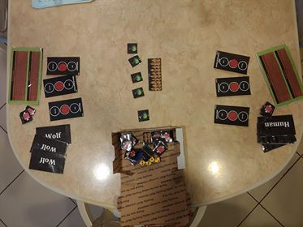

**Turn Order:**

* Return any alive wolves to your hand if they finished their action last round.
* Perform actions: any of the alive wolves may perform 1 action, but they are vulnerable to attack during the humans’ turn. Place the Character Card down face-up and perform the action **(see Actions Card)**.Leave them there until the next round.
* Apply Starvation: Shift the coin on all your Hunger Cards downward. Full > Hungry, Hungry > Starving, Starving > Death.
* Feed Family: Use food tokens to move coin up on Hunger Cards of alive Wolves; **each token moves coin once**. Starving > Hungry, Hungry > Full. Discard used food tokens. **You are able to feed your family at any point during your turn.**