# PT Bintang Toedjoe

## We are Consumer Health Company Bintang Toedjoe

PT. Bintang Toedjoe was founded in Garut, West Java, on April 29 1946 by Tan Jun She (a sinshe), Tjia Pu Tjien and Hioe On Tjan. The name was chosen based on the number of Tan Jun She's daughters, namely seven daughters. With only traditional equipment and a few employees at that time, PT Bintang Toedjoe succeeded in producing over-the-counter (OTC) medicines that could meet the people's need for medicines, including Puyer no. 16 (headache medicine number 16) which is still consumed by Indonesian people today and has been exported to several countries. With this good growth, PT. Bintang Toedjoe moved from Garut to Krekot, Jakarta, before moving to Cempaka Putih in 1974. During the 1970s, PT Bintang Toedjoe produced its prescription drugs, while in 1985, PT Bintang Toedjoe became part of the Kalbe Group and grew rapidly. PT Bintang Toedjoe has built a reputation as an active pharmaceutical factory for the Nutraceutical market (food supplements and herbal medicines) and OTC products, both domestic and international markets, such as the Philippines, Myanmar, Nigeria, Mongolia, Hong Kong, Sri Lanka, Cambodia, Yemen, Malaysia, India and New Zealand. As the Cempaka Putih office became inadequate due to the company's production expansion, PT Bintang Toedjoe decided to move to the Pulogadung Industrial Area in 1993, while the Pulomas factory began operating in June and July 2002. Eventually, the Head Office was also moved to Pulomas in September 2022. As it currently employs about 1,000 people as a whole, PT Bintang Toedjoe has become one of the largest consumer health companies in Indonesia, producing both medicines and supplements. In 2020, PT Bintang Toedjoe built a modern factory with the most advanced technology in Cikarang, completed with a 2 Ha Herbal Garden which has a variety of herbal plants. This is PT Bintang Toedjoe for Indonesia and the world.

## PANCA SRADA

1. Trust is the glue of life

We honor individuals and treat them as we want to be treated. We believe that all individuals have the internal capacity to live the best of their lives and to contribute to their fullest potential. We value openness and honesty

1. Mindfulness is the foundation of our action

We are mindful for our stakeholders needs. We are mindful towards our communities and environment. We uphold our values in every action and decisions.

1. Innovation is the key of our success

We place great value on entrepreneurship and becoming the ‘first mover’. We are passionate in improving better life through innovation based on consumer needs using science and technology. We continuously invent new ways of doing business to win the market.

1. Strive to be the best

We inspire and enable people to achieve challenging goals. We encourage excellent execution. We promote continuous learning and improvement.

1. Interconnectedness is a universal way of life

We promote multicultural team work in a fun and loving working climate. We believe the success of our company depends on the well being of our employees and their families. We contribute to our communities and use resource from our environment in a responsible manner for sustainability

## History

1. 1946: PT Bintang Toedjoe was founded by Tan Jun She in Garut, West Java.
2. 1950: As time went by, PT Bintang Toedjoe continued to grow and moved to Krekot, Pasar Baru, Jakarta
3. 1974: Moved to Cempaka Putih and Started producing prescription drugs
4. 1985: Expanded the OTC market segment and Nutraceutical Products
5. 1992: Moved to JIEP, Pulogadung, and obtained CPOB and ISO 9001 Certificates
6. 2002: The Head Office moved to Pulomas and began operating factories in Pulogadung and Pulomas
7. 2015: The world's first cough medicine in thermoforming tube packaging
8. 2017: Groundbreaking for the construction of a new factory in Cikarang, West Java, Which is equipped with robot technology and a viewing gallery
9. 2020: The new factory, equipped with robot technology and the Indonesian Herbal Garden in Cikarang have started operating

## 7C Working Culture

1. Commitment: Dedication to provide the best results
2. Creative: Creating something innovative and different from others
3. Competence: Opportunity to continue learning and growing
4. Character: Upholding the values of integrity based on the spirit of PKK (Professional, Contribution, Solidarity)
5. Communication: Having an effective communication
6. Collaboration: Synergistic collaboration to achieve goals
7. Contribution: Be involved and play a role in the company's progress which can have a big impact and benefits on society

## Vision

To be a global leading consumer healthcare company through innovative and high quality products, supported by advance technology and excellent management.

## Mission

To provide health for better quality of life to everyone

## Innovation

### 2.2 MW Solar Panel On Site as Power House for Factory

Electrical energy is one of the main sources of life, as it helps us during our daily activities. However, we must also realize that 56% of electrical energy originates from coal Steam Power Plants, which produce emission gas of CO2 that can damage the environment. The government has a strategy to maintain the environment in this country, by utilizing renewable energy and the potential of energy in a region specifically.

PT Bintang Toedjoe has provided a contribution to the nation. One form of this dedication for the country in preserving its land is the utilization of renewable energy, including solar energy. With the vast amount of solar energy in Indonesia, we utilize this with the Solar Panel Innovation that turns the heat energy of sunlight to electrical energy. Undoubtedly, the capacity of PT Bintang Toedjoe solar panel could reach up to 2.2 MW, becoming the largest in Central Cikarang, Bekasi Region.

There are many benefits that we have gained from this Solar Panel Innovation. These include an electrical energy harvest of 2.55 GWH per year, and a contribution to the environment for lowering the CO2 formation up to 2.671 tons or a CO2 decrease from the photosynthesis process of 146,000 trees. This is one of our innovations that we have done for a stronger and growing Indonesia.

### Winning International Award for Packaging Innovation

Packaging is a material that protects the product from physical harms (such as shock, temperature, pressure, etc.) and contaminations (such as dust, steam, chemical substance, etc.). This will allow the product to remain sterile and secure until its expired date. As the time goes by, packaging is also used as a promotional medium to market the product and encourage customers to buy it through innovative features in the packaging, instead of just keeping the product safe.

During this decade, Bintang Toedjoe has conducted an innovation in its product packaging, through thermoforming technology. Bintang Toedjoe has created a tube-shaped packaging known as Thermoforming Pack, which has several benefits as follow:

1. **Self service** that becomes the signature of the product compared to others.
2. **Consumer Affluence** which provides the product with convenience, reliability and prestige in high quality.
3. **Company and Brand Image** which make Bintang Toedjoe recognizable to customers through its innovative packaging.
4. **Innovation Opportunity** which provides Bintang Toedjoe with many awards, both locally and internationally, through its developed Thermoforming Pack.

This is what Bintang Toedjoe can offer for Indonesia.

### Innovation in The Utilization of Red Gingers

﻿Red ginger is an indigenous herbal plant of Indonesia. It has many beneficial effects such as anti inflammatory, anti microbial, analgetic, anti hyperglycemic, wound healing, anti acne, hair growth activity, male infertility, anti aging, uric acid lowering, plasma lipid lowering, and anti hypertensive. Because of the many benefits that we become aware of, PT Bintang Toedjoe makes the right move to utilize red gingers as one of the main ingredients for its recent products.

PT Bintang Toedjoe has made an innovation breakthrough through a red ginger ecosystem that involves farmers, private parties, academic institutions, and the government. Its objective is to preserve and develop red ginger as an indigenous herbal plant of Indonesia with many benefits, similar to Korea and its ginseng. With this ecosystem, we can contribute to the prosperity of the farmers, the acceleration of red ginger research, the reduction of CO2 emission up to 29,470 kg per year, and the preservation of quality for PT Bintang Toedjoe as the brand that is synonymous to community development and earth preservation programs.

Aside from the red ginger ecosystem, PT Bintang Toedjoe has currently managed to conduct innovations in developing red ginger-based products. For Business to Business products, PT Bintang Toedjoe has red ginger liquid extract, powder extract and essential oil. As for Business to Consumer products, PT Bintang Toedjoe has Bejo Jahe Merah, Bejo Sujamer, dan Komix Herbal.

### AGV end to end integration

Generally, a supply chain process begins with the raw material supply process, followed by the production process and the distribution process of finished goods. Each process has a material flow sequence from raw materials to finished goods, utilizing both land and sea heavy vehicles. However, we have never encountered an integrated material flow process from suppliers, factories, to distributors in one production line.

PT Bintang Toedjoe has implemented a joint innovation in constructing an integrated line from raw materials to finished goods, with PT Global Chemindo Megatrading as the supplier and PT Enseval Putera Megatrading as the distributor. These ingredients will be automatically transported using an AGV (Automated Guided Vehicle) integrated with an ERP system.

By implementing this end-to-end collaboration system, we are able to reduce the risk potentials. This can maintain the quality of raw materials and finished goods, streamline supply chain operations, accelerate the lead time to market, decrease the potential of work accidents, and reduce the CO2 emission caused by conventional vehicles.

## Awards

### Best Social Impact Initiative – Corporate Social Initiative

30 December 2024

Top Three

Awarded by **Kementerian Perindustrian Republik Indonesia**

PT Bintang Toedjoe won an award in the Halal scope, namely Top 3 Best Social Impact Initiative - Corporate Social Initiative given by the Ministry of Industry of the Republic of Indonesia at the Indonesia Halal Industry Award 2024. This award is a clear proof of the company's commitment to support the various halal products of PT Bintang Toedjoe.

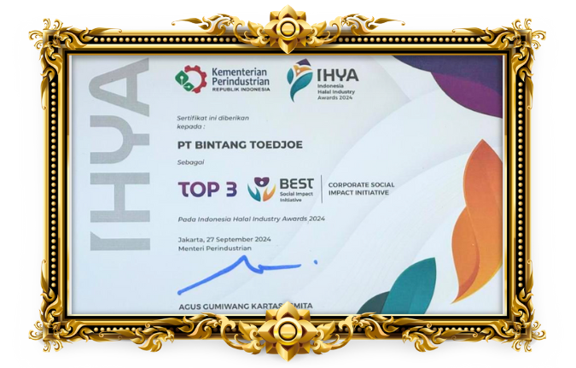

The Top 3 Best Social Impact Initiative - Corporate Social Initiative award is given for the achievements of companies that have successfully contributed and implemented the responsibilities of consumers, stakeholders, namely employees, shareholders, communities and also the environment that are closely related to halal products.

This achievement is certainly inseparable from the participation of the entire team who work together actively in the company. Hopefully this award can be a motivation to continue to be better in the future.

Bintang Toedjoe… Better… Better… Better… Pasti Kelas Dunia!!

### Management Forum Quality Assurance and Regulatory Affairs (MFQARA Forum)

19 December 2024

Quality Assurance and Regulatory Affairs

Awarded by **Kalbe Corporate Manufacturing, Quality Assurance & Regulatory Affair**

Thursday, December 19, 2024 PT Bintang Toedjoe won the an award at the MFQARA Forum XV event held at Kalventis, Pulomas.

MFQARA Forum XV is an annual forum to exchange information on technology, innovation, quality, and sustainability initiated by Kalbe Corporate Manufacturing, Quality Assurance & Regulatory Affairs.

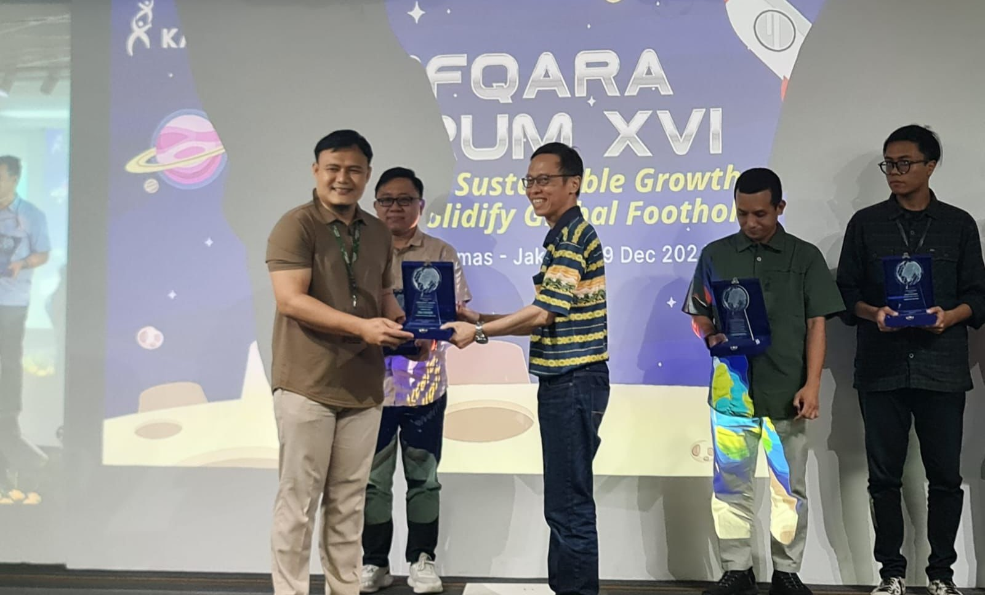

The event was enlivened with awards PT Bintang Toedjoe Pulogadung site won the Zero Accident Award from the Ministry of Manpower, Environmental Management (PROPER) Green Candidate from KLH RI, 3 Stars from the Indonesian Conference & Competition Occupation Safety Health, TKMPN 2024: QCI Gold, Platinum, Diamond, and Most Improved KPI Manufacturing.

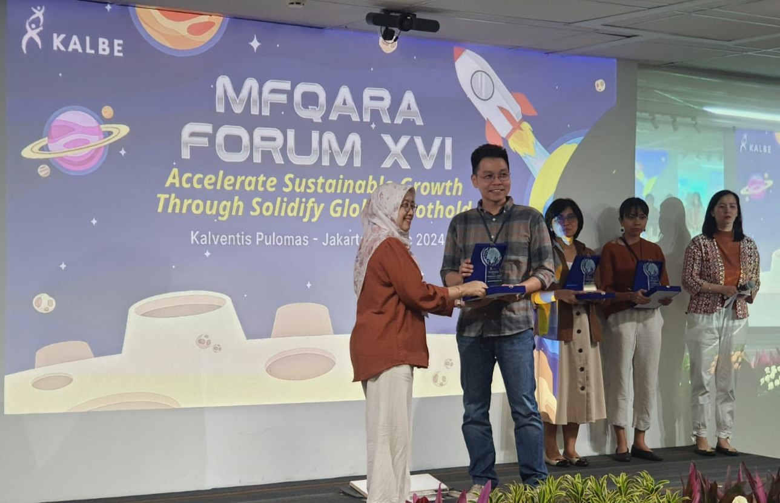

In addition, PT Bintang Toedjoe Site Cikarang won the Environmental Management Award (PROPER) Gold Candidate from KLH RI, 3 Stars from Indonesian Conference & Competition Occupation Safety Health, Excellent Awards from International Quality & Productivity Convention (IQPC) Philippines, Highest Rank (Galaxy) at Innovation Management Awards at Indonesia Quality Excellence Festive 2024, TKMPN 2024: QCI Gold, Platinum, Diamond, and Highest Reduce Failure Cost - Time.

It is hoped that PT Bintang Toedjoe can continue to maintain the achievements that have been made, and become even better in the following year.

### Risk Management & Audit (RM&A)

10 December 2024

Runner-Up

Awarded by **KALBE**

Jakarta - On December 10, 2024, one of PT Bintang Toedjoe's employees, Emilia Phang, received an award as Runner-up RM&A Winners 2024.  This event was organized by Kalbe as a form of appreciation for the work program related to Risk Management throughout 2024. The criteria in the assessment as Runner-Up RM&A Winners 2024, among others: Activeness in briefing events such as Best Practice Sharing & Risk Management Forum, participation in Risk Register (RR) revisit, Implementation of Audit Recommendations, participation in Risk Management discussions.

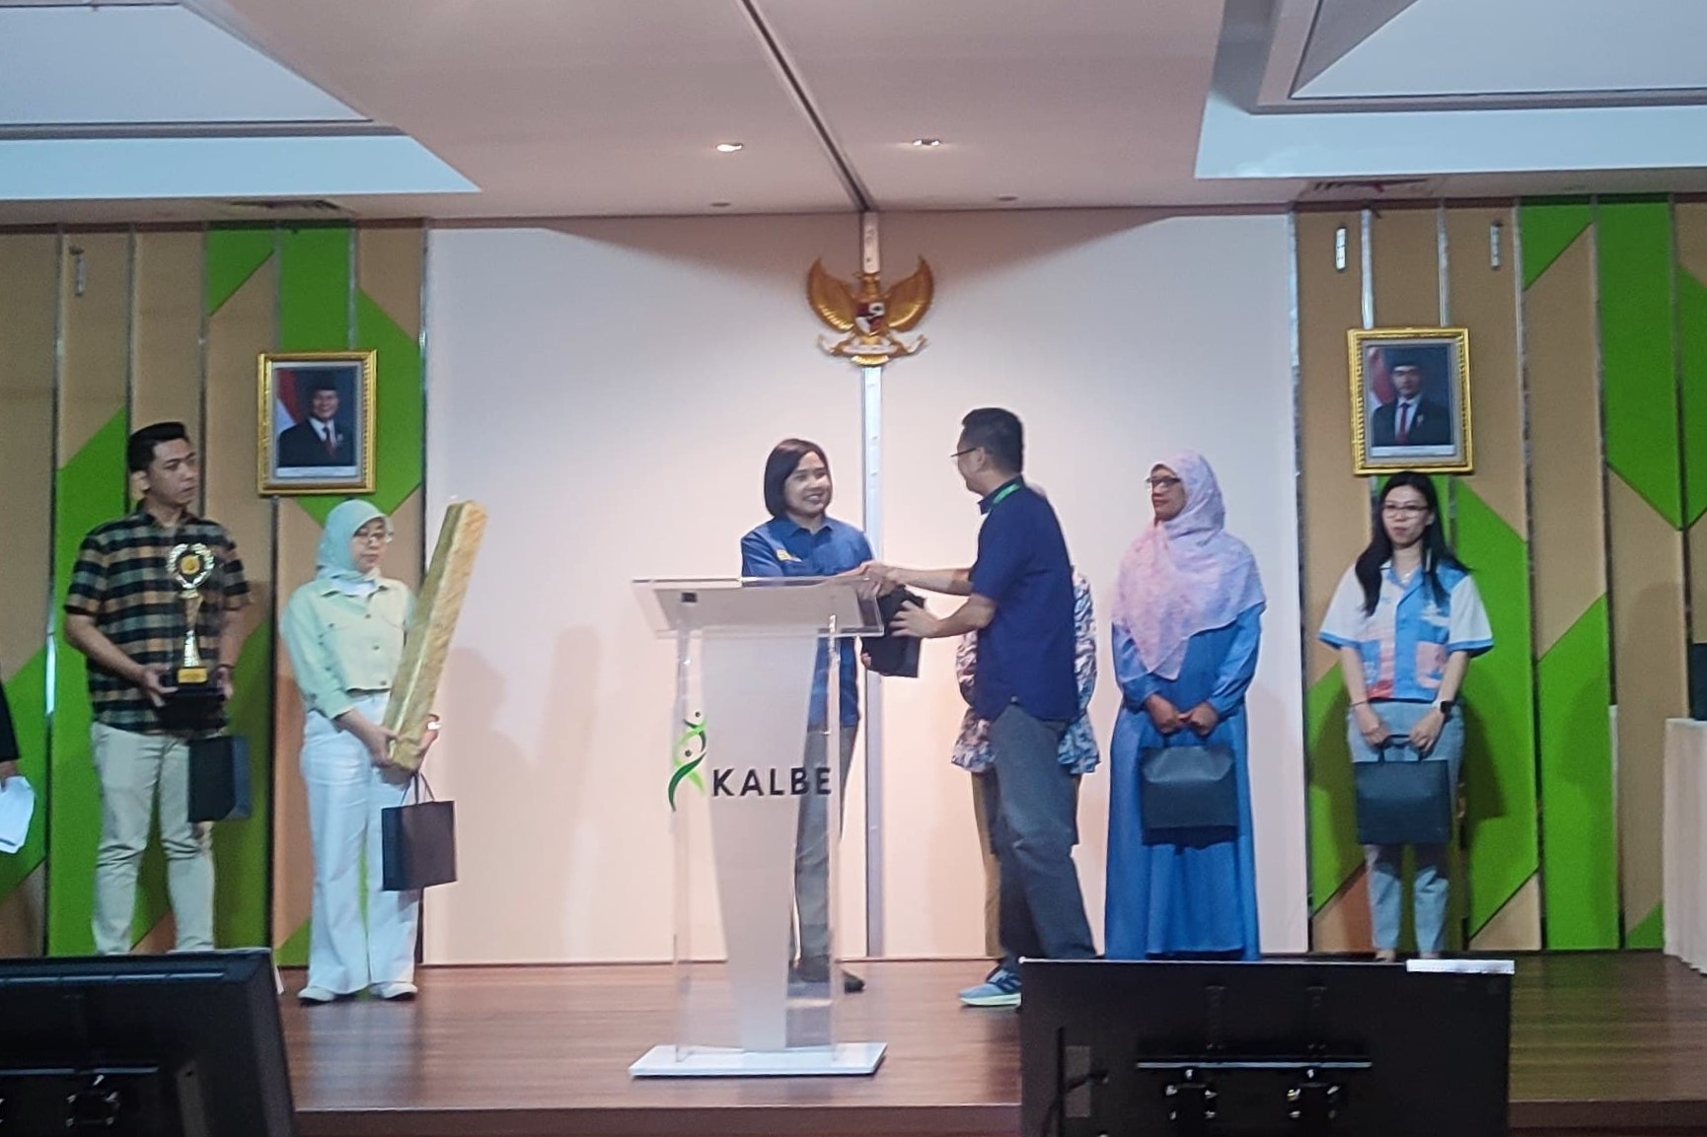

Risk Management itself is an act of identifying inherent risks in a planned and structured manner, and preparing various approaches to control them so that business objectives (both financial and non-financial) that have been set can be achieved. The criteria for assessment in the award is that the PIC Risk Management & Audit (RM&A) in each SBU is responsible for facilitating the preparation of Business Process Mapping (BPM), Risk Register (RR), reporting through the Audit & Risk Management Integrated System (ARMIS) which is accompanied by conducting reviews, monitoring, and auditing the implementation of risk control in each process in the department or division.

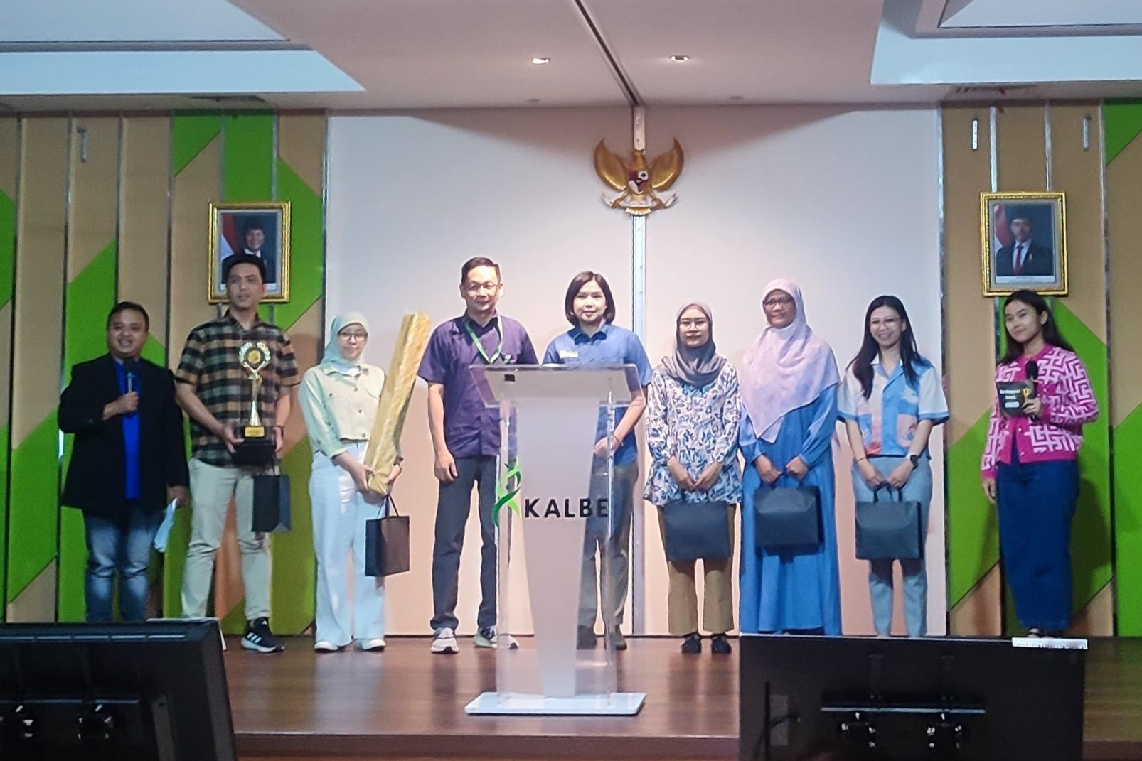

This award shows PT Bintang Toedjoe's commitment to implementing Risk Management in its business operations. The hope is that with a consistent and sustainable implementation of Risk Management, the company can have more certainty in achieving its business goals.

## Sustainability

### Strengthening the Benefits of Partnership Through the Social Return on Investment (SRoI) Survey

In order to strengthen the successful implementation of the partnership, there is an assessment of benefits of partnership through the Social Return on Investment (SRoI) study in one location of a farmer partner. The SRoI measures and calculates the concept of social investment value in a wide range. The value is measured by the ratio of Net Present Value (NPV) towards the Value of Investment (VI). The result of the measurement shows that every value of 1 rupiah has an impact of 1,98 million rupiah for stakeholders of the red ginger ecosystem program.

### Mentoring and Education on Red Ginger Cultivation to Red Ginger Farmer Partners

The partnership between PT Bintang Toedjoe and farmers does not only include the assurance of red ginger purchase, but also a joint commitment in maintaining the quality and production of their red ginger. This is implemented through accompaniment and training / education for farmers to achieve the same goal. During the accompaniment, PT Bintang Toedjoe will also involve government installations in providing them with training, such as BALITRO.

### Komix Herbal Invited Gen-Z to Get to Know Herbal through “the Healthy Generation Herbal Generation” Talkshow in Belitung

BELITUNG - PT Bintang Toedjoe through the Komix Herbal brand held a Goes To School Talkshow, which on this occasion was presented at MAN 1 Belitung. This activity, which has a roadshow concept, was again educating about medicine, especially herbal medicine, which was attended by students representing organizations, (4/12/2024).

With the theme of the Healthy Generation Herbal Generation, this talkshow that collaboration between Komix Herbal and several number of speakers, such as the BNN of Belitung Regency, the PC Indonesian Pharmacist Association (IAI) of Belitung Regency, Loka POM of Belitung, and Pos Belitung.

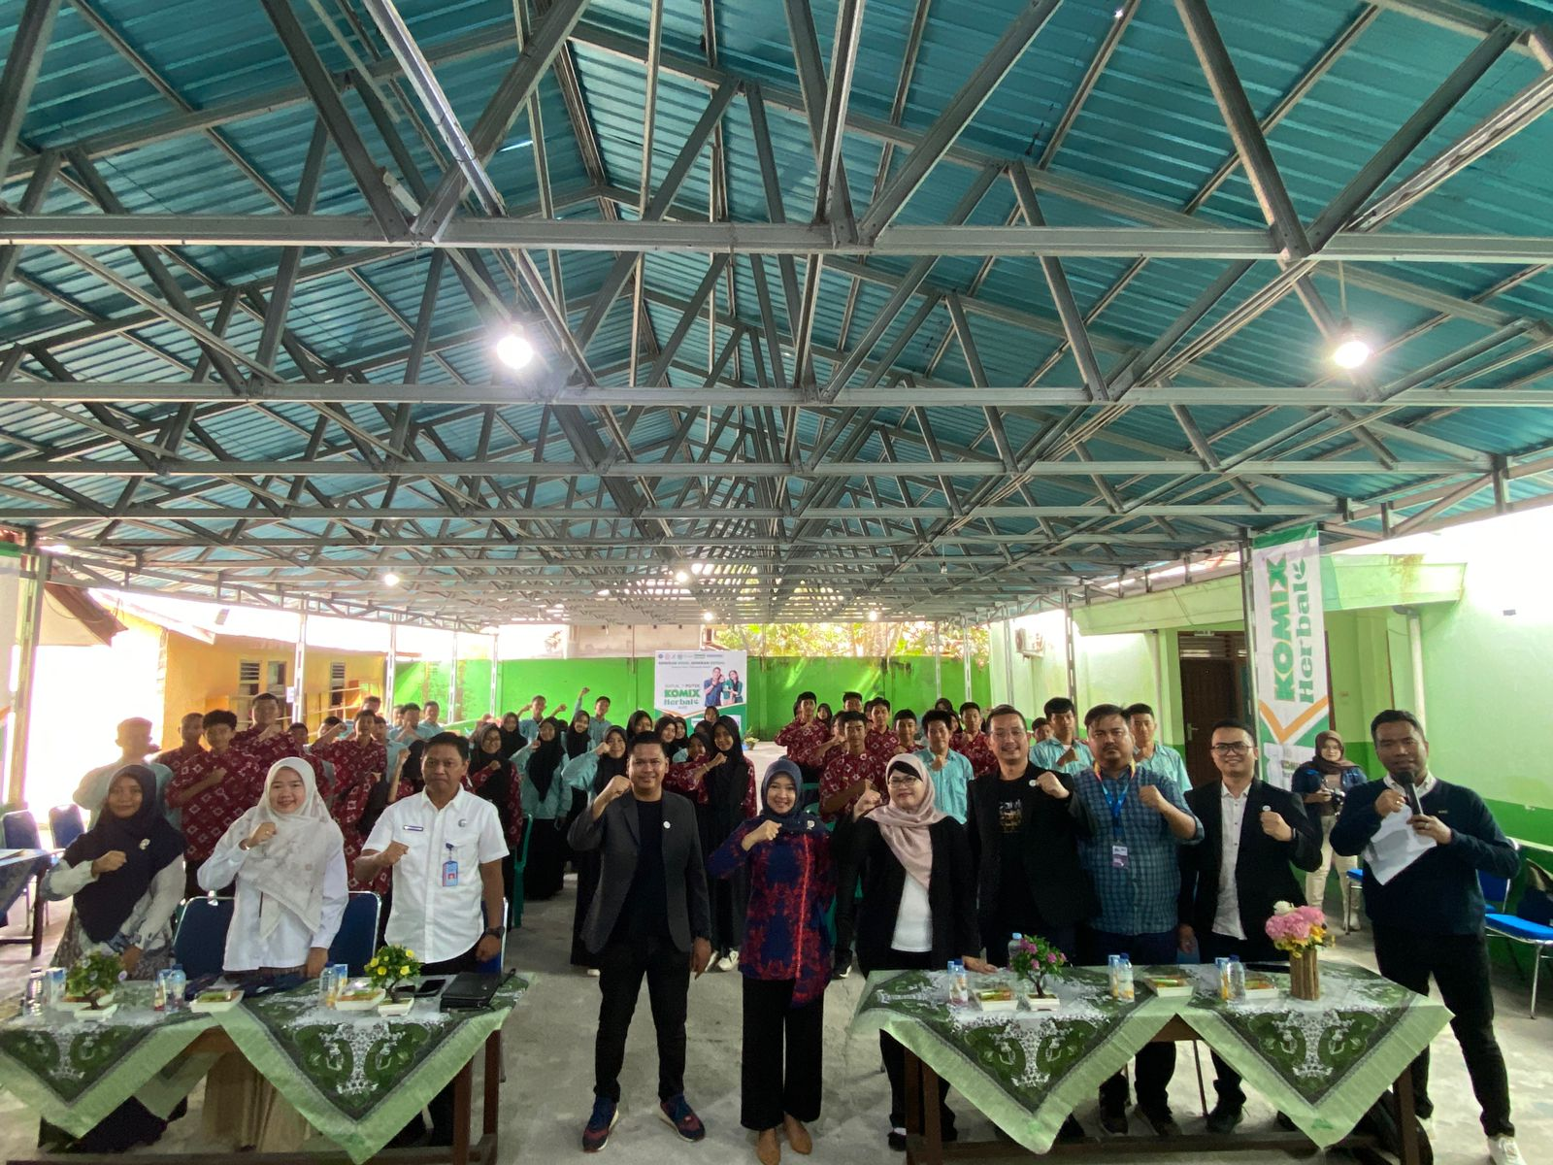

Here the speakers convey information according to their fields, apt. Septia Monalisa, S.Farm., Chairperson of PC IAI Belitung Regency explained about the classification of herbal medicines and their benefits. "Herbal medicines to improve health levels as rehabilitative or health recovery and also as curative (healing diseases)", she explained.

In addition, Mona added an explanation about self-medication of medicines and herbs, including their relationship to DAGUSIBU (Get, Use, Save, Throw Away) of medicines and herbs.

The speaker from Loka POM of Belitung, Tiara Wiladatika, SKM., explained about the classification of natural medicines, their certification and registration.

"Natural medicines consist of herbal medicine, standardized herbal medicine (OHT) and phytopharmaca. Herbal medicine is a concoction that comes from traditional knowledge. If OHT, its efficacy is scientifically proven with pre-clinical tests and standardized materials. While the last one, phytopharmaca is herbal medicine to maintain health whose efficacy is scientifically tested with pre-clinical and clinical tests."

In addition, Tiara also explained about the drug logos on the market for over-the-counter (OTC) drug logos, limited over-the-counter (OTC) drug logos, prescription drug logos and narcotic drug logos.

Tiara added, before using a natural medicine, it would be better to screen it first with CEK KLIK, namely Check the Packaging, Label, Marketing Authorization, and Expiration Date.

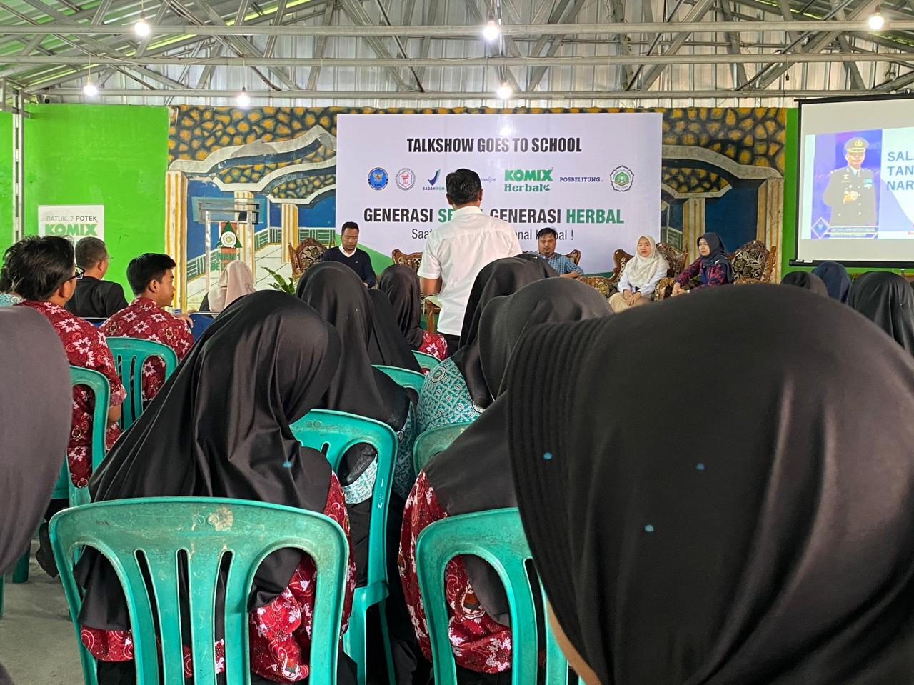

Meanwhile, Content Manage of Pos Belitung, Teddy Malaka, reviewed media and herbs, and used media wisely. Teddy invited Gen-Z not to easily believe hoaxes and spread fake news in the media.

"Verify Information before Distributing. If necessary, ask competent sources. Check whether the source is/are credible or not," added Teddy.

The next speaker, Kompol Agus Handoko, S.H., Head of BNN of Belitung Regency, discussed drugs and their abuse. He added tips on how to avoid the dangers of drugs.

"All the foundations are Imtaq: faith and piety. Prohibitions that are not allowed should not be done. And secondly, be disciplined in using gadgets. Don't just give up, you have to think positively."

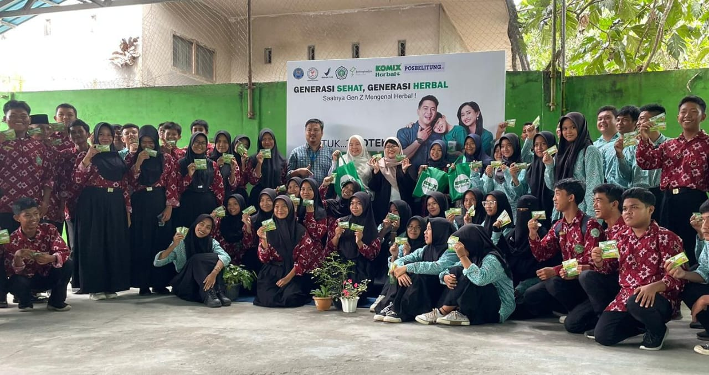

Head of LOB 2 & Public Relations of  PT Bintang Toedjoe, Andry Mahyudi in his speech conveyed why talk about herbs.

“As we know that Korea has ginseng that is very world-famous. So our dream, Bintang Toedjoe was how to make this red ginger as one of Indonesia's native herbal plants that has great potential to go global. In addition, the advancement of digital technology was currently developing very rapidly, which can also cause legal problems due to the spread of inaccurate news”, said Andry.

The hope was that with herbal education from various sources, Gen-Z will be wiser about information by filtering it before sharing.

Komix Herbal is a herbal cough medicine made from natural red ginger and lagundi leaves. Lagundi leaves (Vitex Negundo) are one of the herbs that contain active compounds such as flavonoids, alkaloids, and triterpenoids which have anti-inflammatory, antispasmodic, and expectorant effects. Due to these effects, lagundi leaves have been used in traditional medicine to relieve coughs.

### Present in Pangkalpinang, Komix Herbal Invites Vocational School of Pharmacy SMKN 5 to Learn about Herbs

PANGKALPINANG - PT Bintang Toedjoe through the Komix Herbal brand again held a Goes To School Talkshow, this time targeted the pharmacy vocational school, namely SMKN 5 Pangkalpinang. This roadshow concept activity once again educates about medicine and herbs and was attended by students representing organizations, Tuesday (11/19/2024).

Titled Healthy Generation Herbal Generation, this talkshow with Komix Herbal collaborates with a number of speakers, namely the PC Ikatan Apoteker Indonesia Kota Pangkalpinang, Balai POM Pangkalpinang, Bangka Pos, and BNNK Pangkalpinang.

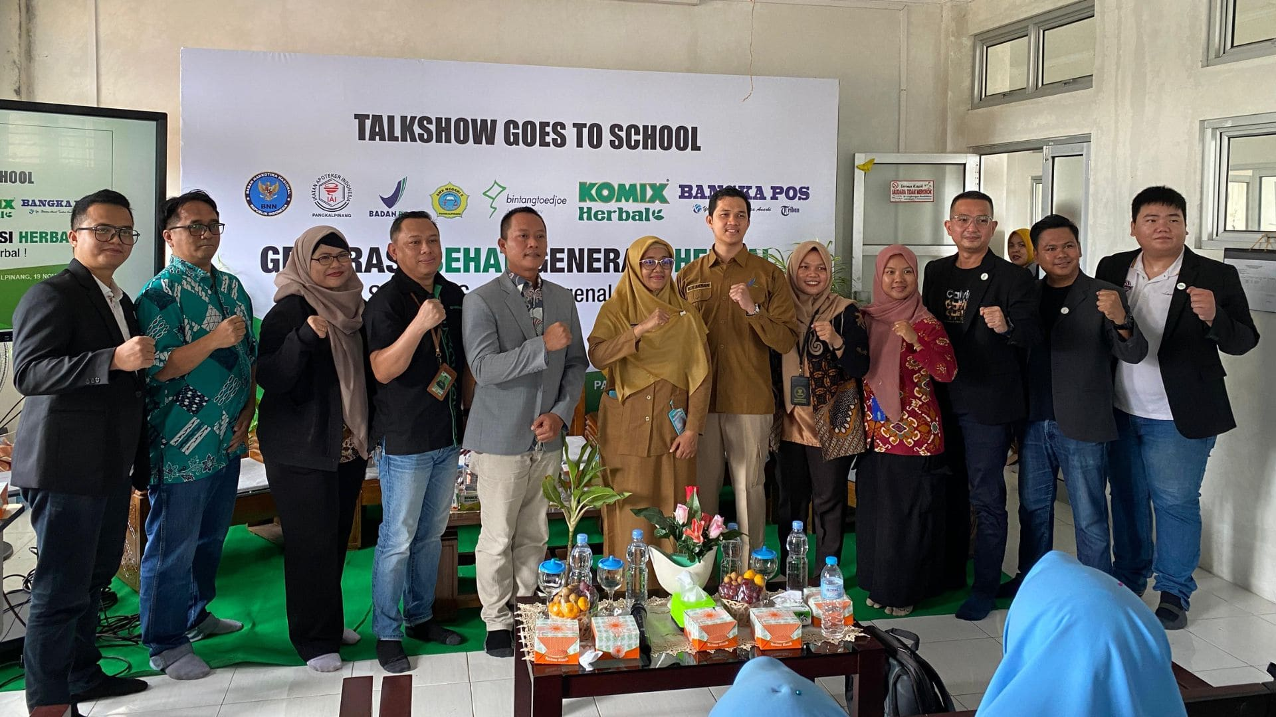

Here the speakers conveyed information according to their fields, apt. Bernadus Reco, Chairperson of the PC IAI Kota Pangkal Pinang explained self-medication of drugs and herbs. Moreover, chemical drugs and herbal medicines work differently. "The way herbs work is more to encourage the body to improve its health, then eliminate the disease. So on average herbal medicines do not have an immediate effect, but require a process," he explained. Therefore, Reco added to be more careful when taking herbal medicines that immediately give an instant reaction.

The speaker from the Balai POM Pangkalpinang , M. Herpi Akbar said that natural medicines that were to be used should be screened first with CEK KLIK, namely Check Packaging, Label, Marketing Authorization, and Expiration Date. Herpi also invited participants to do CEK KLIK together through the BPOM check website or through BPOM Mobile.

### PT Bintang Toedjoe Environmental Management Policy

PT Bintang Toedjoe is committed in environmental protection, where all the management ranks, employees, and parties which work for or on behalf of PT Bintang Toedjoe have a commitment to achieve the best possible performance in the management of the environment, based on the Environmental Management System of ISO 14001:2015, and become a priority in every operational activity with the emphasis of the following matters:

* Controlling and evaluating environmental impacts with the Life Cycle Assessment (LCA) method.
* Preventing the environmental pollution and increasing efforts of sustainable environmental performance through the Green Building, Green Procurement, Green Processes and 3R (Reduce, Reuse, Recycle), in order to achieve an environmentally friendly industry (Green Manufacturing).
* Fulfilling the needs and hopes of stakeholders by producing environmentally friendly products and abiding to all regulations and other requirements regarding the environment.
* Creating a nature conservation to protect biodiversity.
* Conducting the principles of community empowerment through support and participation of economically sustainable development programs to help achieve community independence.

In this innovation blog, PT Bintang Toedjoe has conducted several innovation breakthroughs in water management. The first innovation is Rain Water Harvesting, by utilizing rainwater from rooftops that is channeled through a rainwater treatment plant, to make sure that the rainwater is adequate. After confirming its adequacy, the water is transported into a water storage tank before being distributed to cooling towers and boilers. There are around 3,829 m3 of rainwater that can potentially be harvested.

Our second innovation in water management is recycle water, where we reuse water that has been utilized before. The used water will be channeled into wastewater treatment and sewage treatment plant installations. After undergoing the water treatment process and receiving the adequate result, the water will be transported into the pipe installation and will be recycled for non-production needs such as for cooling towers, boilers, and flushing toilets. There are around 2,384 m3 of recycled water that can potentially be harvested every year.

In total, PT Bintang Toedjoe can save its water use for about 6,213 m3 per year, or similar to the water needs of one village with 247 people.

### Environmental Policies of PT Bintang Toedjoe

In line with the vision and mission of PT Bintang Toedjoe, our manufacturing operations are strongly committed to improving environmental management performance in accordance with applicable regulations. To uphold this commitment, the company has established various environmental policies and mechanisms focusing on environmental issues and corporate social responsibility. We are dedicated to ensuring that all our activities not only meet stringent environmental standards but also positively contribute to the community and the surrounding environment.

### SDG's Policy, Health & Closely

Nowadays, sustainable social, economic, and environmental developments has become the main focus of all nations around the world. PT Bintang Toedjoe has a commitment to be involved in both global and national effort for the welfare of the society. We are also committed to take part in achieving Sustainable Development Goals, as well as social, economic, and environmental developments during its implementation. In order to implement the contribution in achieving the Regulation of the President No. 59 of 2017 and the Regulation of the President No. 18 of 2020, PT Bintang Toedjoe Operasional Bisnis Manufacturing has implemented several policies as follow:

* Being committed in conducting company activities based on four Main Pillars, consisting of Social, Economy, Environmental, and Life & Governance, along with 17 indicators in them.
* Creating and prioritizing competent human resources to achieve Sustainable Development Goals.
* Establishing strategic and work plans that prioritize the four main pillars of Sustainable Development Goals.
* Abiding to regulations regarding Sustainable Development Goals.
* Monitoring and evaluating company performances in implementing the programs of Sustainable Development Goals.
* Involving all management ranks in implementing the programs of Sustainable Development Goals.
* Collaborating with stakeholders from outside the company, such as government institutions, the public, and public organizations to actively contribute in implementing, monitoring, and evaluating the programs of Sustainable Development Goals.

These sustainable development efforts are not only established in the SDG’s policy of PT Bintang Toedjoe, but also become a corporate entity within Kalbe Group. These sustainable development commitments are also establishewithin the nine main pillars of Kalbe Group, the internal pillars (ERAT) and the external pillars (SEHAT), consisting of:

## Contact Us

### Head Office

Jl. Jend. Ahmad Yani No. 2 Pulomas Jakarta 13210

### Factory

1. Jl. Rawa Sumur Barat II K-9 Kawasan Industri Pulogadung Jakarta 13930
2. Kawasan Greenland International Industrial Center (GIIC) Blok BB No. 7, Desa Sukamahi, Kecamatan Cikarang Pusat Kab. Bekasi Jawa Barat 17530

# Products

## Extra Joss Active

### Product Detail

**Indication**  
Helps to maintain stamina and refreshing the body (Health Supplement)

**Dosage / Usage Recommendation**  
1-3 times daily, 1 sachet per serving

**Warnings & Precautions**

* Not recommended for children, pregnant woman, lactating mothers and hypertensive patients
* Each sachet contains 50 mg caffeine
* Excessive caffeine intake may cause sleeplessness, palpitation and other similar side effect
* Contains Aspartame and Acesulfame-K
* Contains Phenylalanine, not recommended for phenylketonuria patients

**Packaging**  
Serving per container: 6 sachet @4g

### Composition

|  |  |
| --- | --- |
| Caffeine | 50 mg |
| Ginseng Powder Extract (Equal to 350 mg Ginseng Powder) | 35 mg |
| Vitamin B6 HCl | 15 mg |
| Vitamin B8 | 10 mg |
| Vitamin B9 | 100 mcg |
| Vitamin B3 | 16 mg |
| Vitamin B12 | 1 mcg |
| Royal Jelly | 2 mg |
| Vitamin B5 | 5 mg |
| Vitamin B2 |  |

## Extra Joss Laki Anggur

### Detail Product

**Indication**  
Helps to maintain stamina and refreshing the body (Health Supplement)

**Varian**

1. Mango Flavour
2. Grape Flavour

**Dosage / Usage Recommendation**  
1-3 times daily, 1 sachet per serving

**Warnings & Precautions**

* Not recommended for hypertensive and diabetic patients
* Not recommended for children, pregnant women, and lactating mothers
* Please follow the usage recommendation
* Contains Aspartame and Acesulfame-K as artificial sweetener
* Contains Phenylalanine, not recommended for phenylketonuria patients

**Packaging**

* Servings per container : 6 sachet @4 g
* Servings per container : 12 sachet @4 g

### Composition

|  |  |
| --- | --- |
| Caffeine | 50 mg |
| Ginseng Powder Extract (Equal to 350 mg Ginseng Powder) | 35 mg |
| Vitamin B3 | 15 mg |
| Vitamin B6 | 2 mg |
| Vitamin B12 | 2.14 mcg |
| Royal Jelly | 2 mg |

## Extra Joss Laki Mangga

### Detail Product:

**Indication**  
Helps to maintain stamina and refreshing the body (Health Supplement)

**Varian**

1. Mango Flavour
2. Grape Flavour

**Dosage / Usage Recommendation**  
1-3 times daily, 1 sachet per serving

**Warnings & Precautions**

* Not recommended for hypertensive and diabetic patients
* Not recommended for children, pregnant women, and lactating mothers
* Please follow the usage recommendation
* Contains Aspartame and Acesulfame-K as artificial sweetener
* Contains Phenylalanine, not recommended for phenylketonuria patients

**Packaging**

* Servings per container : 6 sachet @4 g
* Servings per container : 12 sachet @4 g

### Composition:

|  |  |
| --- | --- |
| Caffeine | 50 mg |
| Ginseng Powder Extract (Equal to 350 mg Ginseng Powder) | 35 mg |
| Vitamin B3 | 15 mg |
| Vitamin B6 | 2 mg |
| Vitamin B12 | 2.14 mcg |
| Royal Jelly | 2 mg |

## Komix Rasa Jeruk Nipis

### Detail Product

Cough Syrup

**Indication**  
Helps to relief cough

**Varian**

* Peppermint Flavour
* Ginger Flavour
* Lime Flavour

**Dosage / Usage Recommendation**  
Adult: 3 times daily 1-2 sachets

**Packaging**  
Box, 30 sachet @7 ml

### Composition

|  |  |
| --- | --- |
| Guaifenesin | 100 mg |
| Dextromethorphan HBr | 15 mg |
| CTM | 2 mg |

## Komix Rasa Peppermint

### Detail Product

Cough Syrup

**Indication**  
Helps to relief cough

**Varian**

* Peppermint Flavour
* Ginger Flavour
* Lime Flavour

**Dosage / Usage Recommendation**  
Adult: 3 times daily 1-2 sachets

**Packaging**  
Box, 30 sachet @7 ml

### Composition

|  |  |
| --- | --- |
| Guaifenesin | 100 mg |
| Dextromethorphan HBr | 15 mg |
| CTM | 2 mg |

## Komix Rasa Jahe

### Detail Product

Cough Syrup

**Indication**  
Helps to relief cough

**Varian**

* Peppermint Flavour
* Ginger Flavour
* Lime Flavour

**Dosage / Usage Recommendation**  
Adult: 3 times daily 1-2 sachets

**Packaging**  
Box, 30 sachet @7 ml

### Composition

|  |  |
| --- | --- |
| Guaifenesin | 100 mg |
| Dextromethorphan HBr | 15 mg |
| CTM | 2 mg |

## Komix OBH

### Detail Product

Cough and Cold Medicine in sachet format

**Indication**  
Helps to relief cough with phlegm and cold

**Dosage / Usage Recommendation**

* Adult and children >12 years old: 3 times daily 2 sachets
* Children 6-12 years old: 3 times daily 1 sachet

**Warnings & Precautions**

* Use with caution for liver and kidney dysfunction patients, glaucoma, prostate hypertrophy, hyperthyroid, and urine retention
* Not recommended for children under 6 years old, except by physician order
* Not recommended for usage with Central Nervous System suppresant
* Don't drive or operate machinery during consumption of this medicine

**Packaging**

* Box, 30 sachet @7 ml
* Box, 5 sachet @7 ml

### Composition

|  |  |
| --- | --- |
| Succus liquiritiae | 167 mg |
| Guaifenesin | 100 mg |
| CTM | 2 mg |
| Phenylephrine HCl | 10 mg |

## Komix OBH Kid Rasa Madu

### Detail Product

Kids cough and cold medicine  in sachet format (single dose) with honey flavor

**Indication**  
Help relieves cough with phlegm and cold for kids

**Dosage / Usage Recommendation**  
Children 6-12 years old: 3 times daily 1 sachet

**Warnings & Precautions**

* Use with caution for liver and kidney dysfunction patietns, glaucoma, prostate hypertrophy, hyperthyroid, and urine retention
* Not recommended for children under 6 years old, except by physician order
* Not recommended for usage with Central Nervous System suppresant

**Packaging**

* Box, 10 sachet @ 5 ml
* Box, 30 sachet @ 5 ml

### Composition

|  |  |
| --- | --- |
| Phenylephrine HCl | 5 mg |
| Succus liquiritiae | 167 mg |
| Guaifenesin | 50 mg |
| CTM | 2 mg |

## Komix Kid Rasa Strawberry

### Detail Product

Cough Syrup

**Benefits**  
To relieve cough

**Dosage**Children 6-12 years: 3 times a day, 1 sachet

**Packaging**

* Box, 10 sachets @5 ml
* Box, 30 sachets @5 ml

### Composition

|  |  |
| --- | --- |
| Guaifenesin | 50 mg |
| Dextromethorphan HBr | 7.5 mg |
| CTM | 1 mg |

## Bejo Herbal

Herbal drink with red ginger to relieve common cold in syrup format  
  
**Indication**  
Helps to relief common cold, bloating, muscle stiffness, headache, sausea, dizziness, and helps to maintain body immune system.

**Dosage / Usage Recommendation**

* 1 Sachet per serving, could be drink directly or dilute in 100 mL warm water
* 1 sachet 3-5 times daily after meal

**Warnings & Precautions**  
Not recommended for pregnant women and kdiney dysfunction patients

**Packaging**

* Pack, 6 sachet @15 ml
* Pack, 12 sachet @15 ml

### Composition

|  |  |
| --- | --- |
| Honey | 7.5 g |
| Zingeberis officinalis Rhizoma Extract | 80 mg |
| Foeniculi Fructus | 25 mg |
| Menthae arvensis Folium | 5 mg |
| Piper retrofracti Fructus | 12.5 mg |

## Bejo Anak

Herbal drink for kids with red ginger to relieve common cold in syrup format with honey flavor  
  
**Indication**  
Helps to relief common cold, bloating, headache, nausea, and dizziness in children

**Dosage / Usage Recommendation**

* 1 Sachet per serving, could be drink directly or dilute in 100 mL warm water
* For children 2-12 years old : 1 sachet 3-5 times daily after meal

**Warnings & Precautions**

* Contains sucralose as sweetener
* Not recommended for children under 2 years old

**Packaging**  
Box, 5 & 12 sachet @ 10 ml

### Composition

|  |  |
| --- | --- |
| Zingiber officinale var. Rubrum Rosch Rhizoma (Red Ginger) | 40 mg |
| Foeniculi Fructus (Fennel) | 12.5 mg |
| Methae arvensis Folium (Mint) | 2.5 mg |
| Piper retrofracti Fructus (Javanese Chili) | 6.25 mg |
| Honey | 3750 mg |

## EJ Sport Banana

**Indication :**

Helps maintain stamina when exercising

**Dosage/ Usage Recommendation :**

1-2 tubes per day, can be taken before and or during exercise

**Superiority :**

* Single Dose
* Easy to Carry
* Efficacy
* Boost Energy
* Sporty design
* Innovation Packaging

**Storage :**

Store at temperatures below 30º C (room temperature)

**Packaging :**

Tube

1 Pack @5 tube @50 ml

### Composition

|  |  |
| --- | --- |
| Vitamin B5 | 5 mg |
| Dextrose | 18 gr |
| L Carnitine | 100 mg |
| Maltodextrine | 12 gr |
| Vitamin B3 | 15 mg |
| Vitamin B6 | 1.2 mg |

## EJ Sport Orange

**Indication :**

Helps maintain stamina when exercising

**Dosage/ Usage Recommendation :**

1-2 tubes per day, can be taken before and or during exercise

**Superiority :**

* Single Dose
* Easy to Carry
* Efficacy
* Boost Energy
* Sporty design
* Innovation Packaging

**Storage :**

Store at temperatures below 30º C (room temperature)

**Packaging :**

Tube

1 Pack @5 tube @50 ml

### Composition

|  |  |
| --- | --- |
| Vitamin B5 | 5 mg |
| Dextrose | 18 gr |
| L Carnitine | 100 mg |
| Maltodextrine | 12 gr |
| Vitamin B3 | 15 mg |
| Vitamin B6 | 1.2 mg |

## Komix Herbal Tube (Original)

Herbal Cough Medicine in tube format (single dose) with Lagundi Leaves and Red Ginger

Indication: Help relieves cough with phlegm

Varian: Original, Lemon Flavour

Dosage / Usage Recommendation:

* Adult: 3 times daily 1 tube
* Children: 1/2 adult dose

Warnings & Precautions:

* Contains Acesulfame K and sucralose as artificial sweetener
* Not recommended for infants under 1 year old

Packaging: Box, 4 tube @15 ml

### Composition

|  |  |
| --- | --- |
| Lagundi | 200 mg |
| Red Ginger | 30 mg |
| Thymi Herba | 100 mg |
| Licorice | 167 mg |
| Peppermint Oil | 11 mg |
| Honey | 3000 mg |

## Komix Herbal Sachet (Original)

Cough syrup relieves cough

**Efficacy**

Helps relieve cough with phlegm

**Flavor Variant**

1. Original
2. Peppermint Flavor
3. Ginger Flavor
4. Lime Flavor

**Recommended**

* Adults: 3x a day 1 sachet
* Children: 1/2 adult dose

**Caution for packaging use**

* Contains artificial sweeteners Acesulfame-K and Sucralose
* This product should not be used in infants under 1 year old

**Packaging**

* Box, 6 sachets @15 ml

### Composition

|  |  |
| --- | --- |
| Lagundi | 200 mg |
| Red Ginger | 30 mg |
| Thymi Herba | 100 mg |
| Licorice | 167 mg |
| Peppermint Oil | 11 mg |
| Honey | 3000 mg |

## Komix Herbal Kids Tube (Strawberry)

Herbal Cough Medicine for kids in tube format (single dose) with strawberry flavor **Indication** Help relieves cough with phlegm in children **Usage and Reccomendation :** Kids (> 2 Y.O) : 3 times daily 1 Tube **Warnings & Precautions** Not recommended for children under 2 years old **Packaging** Box, 4 tube @15 ml

### Composition

|  |  |
| --- | --- |
| Lagundi | 100 mg |
| Red Ginger | 15 mg |
| Thymi Herba | 50 mg |
| Licorice | 83.5 mg |
| Peppermint Oil | 5.5 mg |
| Honey | 1500 mg |

## Slasi

Powder drink to alleviating common ailments  
  
**Indication**  
Helps to alleviating common ailments such as dry throat, ulcer, cheilitis

**Dosage / Usage Recommendation**

* Adult: 1-3 times daily 1 sachet
* Children above 10 years old: 1-3 times daily 1/2 sachet
* Usage directions: Dilute 1 sachet in 200 mL cold water (stir, if needed)

**Warnings & Precautions**

* Contains Aspartame as artificial sweetener
* This product contains phenylalanine, not recommended for phenylketonuria patients and pregnant woman with high phenylalanine level
* Not recommended for usage with anti-diabetic agent
* Not recommended for pregnant women, lactating mothers, and children under 10 years old

**Packaging**

* Sheet, 12 sachet @ 7 gram
* Box, 6 sachet @ 7 gram

### Composition

|  |  |
| --- | --- |
| Imperata Cylindrica Rhizome Extract | 500 mg |
| Citrus Aurantifolia Fructus Extract | 350 mg |
| Ocimum Basilicum | 300 mg |
| Aloe Vera Folium Extract | 20 mg |

## Puyer 16

OTC

**Indication**  
Helps to relief tootache and headache

**Dosage / Usage Recommendation**  
Adult 3 times daily 1 sachet, after meal.

**Warnings & Precautions**  
If the fever is not getting better after 2 days of consumption or if the aches not getting better in 5 days, please consult with physician. Use with caution for liver and kidney dysfunction patients, infants, pregnant women, and lactating mothers

**Packaging**  
Sachet @ 1gr

### Composition

|  |  |
| --- | --- |
| Paracetamol | 400 mg |
| Acetylsalicylic Acid | 250 mg |
| Caffeine | 50 mg |

## Waisan

OTC

**Indication**  
Helps to relief symptoms related to excess stomach acid, gastritis, gastric ulcer, duodenal ulcer, with symptoms like nausea, gastric pain, heartburn, bloating and feeling of fullness in stomach

**Dosage / Usage Recommendation**  
Adult and children >12 years old : 3-4 times daily 1-2 sachet

**Warnings & Precautions**  
Not recommended for children under 6 years old, not recommended to use continuosly for 2 weeks, except by physician order

**Packaging**  
Box, 12 sachet @ 1g

### Composition

|  |  |
| --- | --- |
| Hydrotalcite | 200 mg |
| Mg(OH)2 | 150 mg |
| Simethicone | 50 mg |

## Femmy Fyber

High fiber drink with prebiotic inulin with Mix Berry flavor to maintain healthdigestion and maintain ideal body weight, low in calories (60 ccal) and using stevia's natural sugar **Dosage / Usage Recommendation** Usage directions: Dilute 1 stickpack in 150 mL cold water, stir well for about 2 minutes, consume directly **Packaging** Pack, 7 sachet @15 gram

### Composition

|  |  |
| --- | --- |
| Psyllium Husk |  |
| Fruits and Vegetables Extract |  |
| Fruits and Vegetables Extract |  |
| Gojiberry Extract |  |
| Red Beet Powder |  |
| Spirulina |  |
| Inulin |  |
| Asam Gelugur |  |
| Ascorbic Acid Antioxidant |  |
| Lycopene |  |
| Carrageenan |  |
| Anti-caking Silicon Dioxide |  |
| Premix Vitamin |  |
| Natural Sweetener Steviol Glycoside |  |
| Vitamin D |  |
| Lipase EnzymS |  |

## Femmy Estrocal

Yoghurt flavoured powder drink that helps to maintain bones and joints health

**Indication**  
Helps to maintain joints and bones

**Dosage / Usage Recommendation**  
Once daily 1 stickpack. Usage directions: Dilute 1 stickpack in 300 mL cold water, stir well for about 2 minutes

**Warnings & Precautions**

* Contains aspartame and acesulfame-K as artificial sweetener
* This product contains phenylalanine, not recommended for phenylketonuria patients and pregnant woman with high phenylalanine level
* Not recommended for infants under 1 year old
* Not recommended for children, pregnant women and lactating mothers
* Please follow the usage recommendation

**Packaging**  
Contents 12 stickpack @ 7 g

### Composition

|  |  |
| --- | --- |
| Calcium | 500 mg |
| Glucosamine | 250 mg |
| Vitamin D3 | 66.6 UI |

## Femmy Mensana

Herbs powder drink to relief menstruation  
  
**Indication**

* Helps to relief menstruation
* Helps to refreshing the body
* Helps to relief pain, stomach cramp and aches during menstruation

**Dosage / Usage Recommendation**  
Adult : Twice daily 1 stickpack

**Warnings & Precautions**

* Contains aspartame and acesulfame-K as artificial sweetener
* This product contains phenylalanine, not recommended for phenylketonuria patients
* Not recommended for children under 12 years old, pregnant women and lactating mothers

**Packaging**  
Box, 6 & 12 stickpack @ 6 gram

### Composition

|  |  |
| --- | --- |
| Tamarindi pulpa | 750 mg |
| Paullinia cupana extract | 145 mg (~32 md caffesine) |
| Agni casti fructus | 20 mg |
| Curcuma domestica rhizoma | 250 mg |
| Zingiberis rosch rhizoma | 100 mg |

## Femmy Skin

Kiwi flavoured powder drink that helps to maintain healthy skin

**Indication**  
Helps to maintain healthy skin

**Dosage / Usage Recommendation**

* Dilute 1 stickpack in 300 mL cold water, stir well.
* Adult : Twice daily 1 stickpack

**Warnings & Precautions**

* Contains aspartame as artificial sweetener
* This product contains phenylalanine, not recommended for phenylketonuria patients
* Not recommended for infants under 1 year old

**Packaging**  
Box, 6 & 12 stickpack @ 6 gram

### Composition

|  |  |
| --- | --- |
| Olive Fruit Extract (Hytolive) | 40 mg |
| Collagen | 1000 mg |
| Kiwi Extract | 30 mg |
| Vit E | 15 mg |

## Red Ginger Powder

Redgine Red Ginger Simplicia Powder is made from dried red ginger rhizome with characteristic of red ginger taste and aroma. Perfect to be used as additional ingredient in food and beverage products.

**Indication** Increase endurance and maintain health (prevent/treat colds, relieve flatulence/nausea, improve digestion, and warm the body), anti inflammation, analgetic, anti hyperglicemic, plasma lipid lowering, uric acid lowering, wound healing, anti bacterial, male infertility

**Dosage / Usage Recommendation** 1 gram powder (1 spoon) mixed with a cup of hot water or hot milk. Adjust as needed.

**Warnings & Precautions** Store in a cool & dry place

**Packaging** 100 gr

### Composition

|  |  |
| --- | --- |
| Red Ginger Powder | 100 % |

## Red Ginger Instant Powder with Palm Sugar

Redgine Red Ginger Instant Powder is made from fresh red ginger rhizome. Enriched with palm sugar, it is best to be mixed with tea, coffee, milk, or even brewed alone. Indication Increase endurance and maintain health (prevent/treat colds, relieve flatulence/nausea, improve digestion, and warm the body), anti inflammation, analgetic, anti hyperglicemic, plasma lipid lowering, uric acid lowering, wound healing, anti bacterial, male infertility Dosage / Usage Recommendation 20 gram powder (3-4 spoon) mixed with a cup of water or milk (200ml, hot/cold) Adjust as needed. Warnings & Precautions Store in a cool & dry place Packaging 100 gr

### Composition

|  |  |
| --- | --- |
| Palm Sugar | 5 % |
| Sugar, Red Ginger | 40 % |

## Red Ginger Powder Extract Standardized

Redgine Red Ginger Powder Extract Standardized is double encapsulated extract powder that contains not less than 0.8% 6-Gingerol, with mild and sweet red ginger taste. It is good for digestive system, to ease stomachache and alleviate nausea. **Indication:** Increase endurance and maintain health (prevent/treat colds, relieve flatulence/nausea, improve digestion, and warm the body), anti inflammation, analgetic, anti hyperglicemic, plasma lipid lowering, uric acid lowering, wound healing, anti bacterial, male infertility, anti aging, anti acne, anti hypertensive, hair growth activity **Dosage/Usage Recommendation:** 1 litre drinking water or milk (hot/cold). Adjust as needed. **Warning & Precautions:** Store in a cool & dry place **Packaging**: 100 gr

### Composition

|  |  |
| --- | --- |
| Red Ginger Powder Extract Standardized | 100 % |

## Red Ginger Powder Extract Premium

Jahe Merah Ekstrak Bubuk Premium adalah ekstrak jahe merah berbentuk serbuk yang menonjolkan aroma (top note) dan rasa jahe merah yang kuat. **Khasiat** Jahe merah adalah tanaman asli Indonesia yang khasiatnya terbukti turun-temurun untuk meningkatkan daya tahan tubuh dan menjaga kesehatan(mencegah / mengobati masuk angin, meredakan perut kembung / mual, melancarkan pencernaan, menghangatkan tubuh). **Anjuran** Cocok untuk pembuatan makanan / minuman yang memerlukan jahe merah kualitas terbaik. Karena konsentrasinya yang pekat, hanya diperlukan 1 gram (1/4 sendok teh) Ekstrak untuk membuat 1 liter larutan jahe. Jahe Merah Ekstrak Bubuk Premium larut sempurna dalam air dan tidak meninggalkan ampas

**Perhatian untuk pemakaian kemasan** Bubuk harus disimpan di kemasan tertutup, di tempat yang sejuk dan kering. Untuk menjaga kualitas ekstrak.

**Kemasan** 100 gr

### Composition

|  |  |
| --- | --- |
| Red Ginger Powder Extract Premium | 100 % |

## Red Ginger Liquid Extract

Redgine Red Ginger Liquid Extract Standardized is dark brown liquid extract with characteristic aroma and taste of red ginger. Contains 1.5-3.0% 6-Gingerol, this liquid extract may improve digestion, relieve nausea, and act as antioxidant. **Indication:** Increase endurance and maintain health (prevent/treat colds, relieve flatulence/nausea, improve digestion, and warm the body), anti inflammation, analgetic, anti hyperglicemic, plasma lipid lowering, uric acid lowering, wound healing, anti bacterial, male infertility **Warning & Precautions:** Store in a cool & dry place **Packaging**: 1 Kg

### Composition

|  |  |
| --- | --- |
| Red Ginger Liquid Extract Standardized | 100 % |

## Red Ginger Oil

Redgine Red Ginger Oil has fresh, warm, and citrus aroma. This oil contains zingiberene and can be used in home care products, perfume, and essential oil to provide stimulating and warming effects. **Indication**: Increase endurance and maintain health (prevent/treat colds, relieve flatulence/nausea, improve digestion, and warm the body), anti inflammation, analgetic, anti hyperglicemic, plasma lipid lowering, uric acid lowering, wound healing, anti bacterial, male infertility. **Warning & Precaution:** Store in a cool & dry place **Packaging**: 1 L

### Composition

|  |  |
| --- | --- |
| Red Ginger Oil | 100 % |

## Red Ginger Oil Premium

Redgine Red Ginger Oil Premium contains higher zingiberene and has warm, woody ginger aroma. A suitable essential oil choice to calm and uplift mood. It can also be used in home care products and perfume. **Indication:** Increase endurance and maintain health (prevent/treat colds, relieve flatulence/nausea, improve digestion, and warm the body), anti inflammation, analgetic, anti hyperglicemic, plasma lipid lowering, uric acid lowering, wound healing, anti bacterial, male infertility. **Warning & Precaution:** Store in a cool & dry place **Packaging:** 1L

### Composition

|  |  |
| --- | --- |
| Red Ginger Oil Premium | 100 % |

## Red Ginger Essential Oil

Redgine Red Ginger Essential Oil has warm and relaxing aroma. It can be used topically as massage oil to relieve pain and muscle sore. It also helps you to alleviate nausea. **Indication :** As aromatherapy oil that gives fresh and warm sensation. As massage oil that helps relieve back muscle pain. **Suggested Use :** For diffuser/ humidifier : Add 3-5 drops to 100 mL of water. As massage oil : Apply onto desired area. For sensitive skin, dilute 1-2 drops in a carrier oil. **Caution** : For external use only. Possible skin sensitivity. Not intended to use on open wounds. Store in a dry place below 30 ºC and protect from direct sunlight. **Packaging** : 10 ml

### Composition

|  |  |
| --- | --- |
| Oleum Zingiber officinale var. Rubrum (red ginger oil) | 100 % |

## Redgine Red Ginger & Citronella Blend Essential Oil

The perfect blended essential oil with a combination of premium red ginger essential oil dan citronella essential oil. This product provides a warm and soothing sensation which is suitable when you catch a cold. In addition, it is also effective in repelling insects and relieving muscle pain. **Indication :** As aromatherapy oil that gives fresh and warm sensation. As massage oil that helps relieve back muscle pain. As insect repellent **Suggested Use :** For diffuser/ humidifier : Add 3-5 drops to 100 mL of water. As massage oil : Apply onto desired area. For sensitive skin, dilute 1-2 drops in a carrier oil. **Caution** : For external use only. Possible skin sensitivity. Not intended to use on open wounds. Store in a dry place below 30 ºC and protect from direct sunlight. **Packaging :** 10 ml

## Composition

|  |  |
| --- | --- |
| Oleum Zingiber officinale var. Rubrum (red ginger oil) | 70 % |
| Oleum Cymbopogon nardus (citronella oil) | 30 % |

### Red-G Ginhawa

**Indication** Helps to relief common cold, bloating, muscle stiffness, headache, nausea, dizziness, and helps to maintain body immune system **Dosage / Usage Recommendation** 1 Sachet per serving, could be drink directly or dilute in 100 mL warm water 1 sachet 3-5 times daily after meal

**Warnings & Precautions** Please consult your physician if symptoms presist Keep out of reach of children Not recommended for pregnant women and patients with renal dysfunction

**Packaging** Servings per container: 12 sachets @15 mL

### Composition

|  |  |
| --- | --- |
| Zingiber officinale var. Rubrum Rosch Rhizoma (Red ginger) | 80 mg |
| Foeniculi vulgare Fructus (Fennel) | 25 mg |
| Methae arvensis Folium (Mint) | 5 mg |
| Piper retrofracti Fructus (Javanese chilli peppers) | 12.5 mg |
| Mel depuratum (Honey) | 4500 mg |

## Herbasip

**Indication** Helps to relief common cold, bloating, muscle stiffness, headache, sausea, dizziness, and helps to maintain body immune system. **Dosage / Usage Recommendation** 1 Sachet per serving, could be drink directly or dilute in 100 mL warm water 1 sachet 3-5 times daily after meal For children : 1/2 adult dose

**Warnings & Precautions** Not recommended for pregnant women, breastfeeding mothers and children below 12 years Keep away from the reach of children

**Packaging** Servings per container: 12 sachets @15 mL

### Composition

|  |  |
| --- | --- |
| Zingiber officinale var. Rubrum Rosch Rhizoma (Red ginger) | 80 mg |
| Foeniculi vulgare Fructus (Fennel) | 25 mg |
| Methae arvensis Folium (Mint) | 5 mg |
| Piper retrofracti Fructus (Javanese chilli peppers) | 12.5 mg |
| Mel depuratum (Honey) | 3750 mg |