XYZ Platform
Design Document

Brown Brothers Harriman & Co.
Internal Investment Banking Platform

Field | Value
Version | 1.0
Date | 2026-06-24
Stack | Django 4.2 | PostgreSQL 16 | Redis 7 | Celery 5 | Airflow 2.9 | Plotly Dash
Status | Active Development
Classification | Confidential & Proprietary

Table of Contents
- 1. Overview
- 2. System Architecture
- 3. Data Flow Diagram
- 4. Django Applications
- 5. Data Model (Entity Relationship)
- 6. ETL Pipelines (Airflow)
- 7. Interactive Dashboards (Plotly Dash)
- 8. REST API
- 9. Infrastructure & Deployment
- 10. CI/CD Pipeline
- 11. Security
- 12. Observability

1. Overview

1.1 Purpose
The XYZ Platform is an internal investment banking application for Brown Brothers Harriman & Co. that provides client and account management, portfolio dashboards with real-time analytics, risk metrics computation (VaR, Sharpe, drawdown), and ETL pipeline monitoring via Apache Airflow.

1.2 Users
Role | Access Level
Superuser (admin) | Full Django admin, all views, DAG triggering
Staff (relationship managers) | Client views, portfolio dashboard, analytics
Read-only analysts | Dashboards and risk metric views

1.3 Technology Stack
Layer | Technology
Web Framework | Django 4.2.13
API | Django REST Framework 3.15
Database | PostgreSQL 16
Cache / Broker | Redis 7
Task Queue | Celery 5.4 + django-celery-beat
Orchestration | Apache Airflow 2.9.2 (LocalExecutor)
Dashboards | Plotly Dash 2.17 via django-plotly-dash
WebSockets | Django Channels 4.1 + channels-redis
Static Files | WhiteNoise 6.7
Containerization | Docker Compose
Reverse Proxy | Nginx (TLS, rate limiting)
CI/CD | GitHub Actions
Error Tracking | Sentry (production)

2. System Architecture
The platform follows a layered architecture with Django serving as the application layer, PostgreSQL as the primary data store, Redis for caching and message brokering, and Airflow for ETL pipeline orchestration.
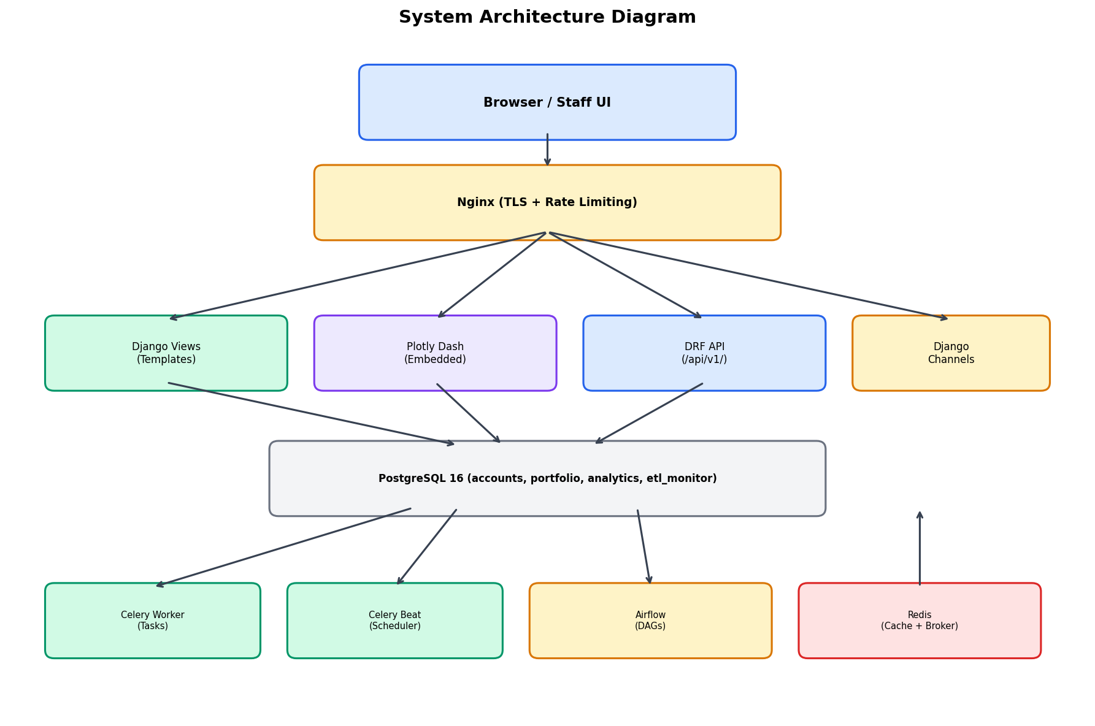

2.1 Request Flow
All requests are TLS-terminated at Nginx, rate-limited, and proxied to Gunicorn. Django handles authentication, routing, and ORM queries against PostgreSQL. Plotly Dash apps are served as iframes, and WebSocket connections upgrade through Django Channels.
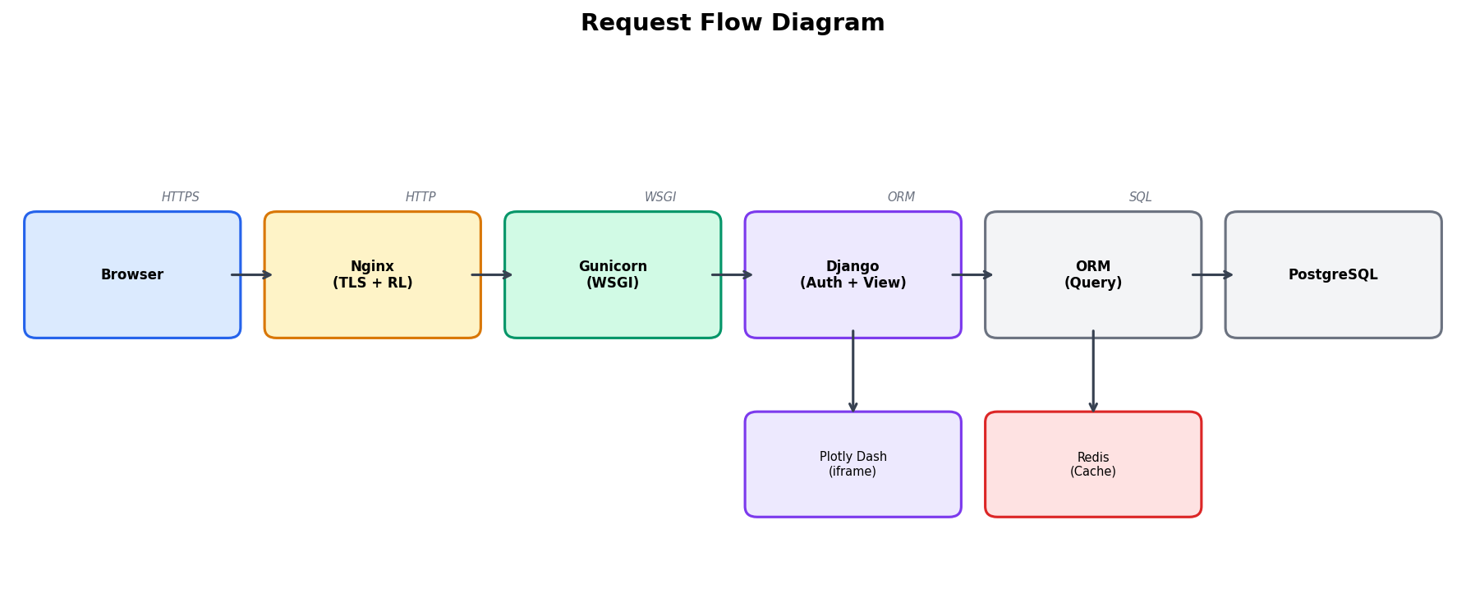

3. Data Flow Diagram
Data flows from external sources (market data providers, custody systems) through Airflow ETL pipelines into PostgreSQL data stores, and is then consumed by the Django presentation layer (dashboards, views, APIs) for display to end users.
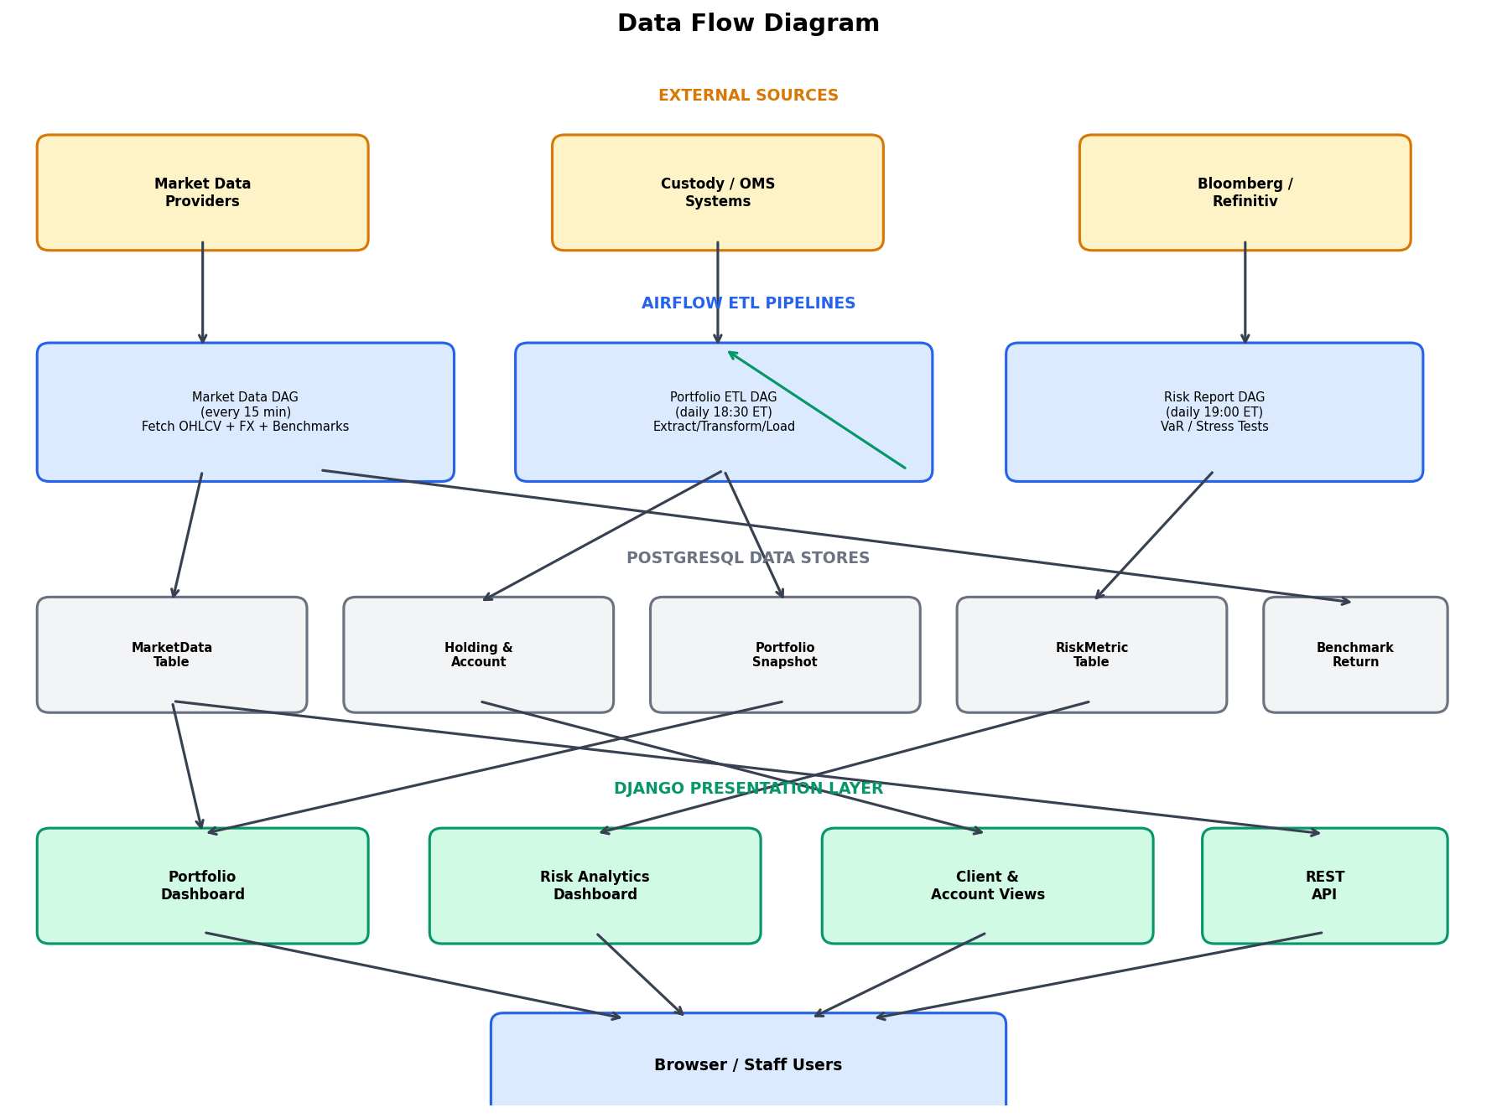

4. Django Applications

4.1 Accounts App
Core entity hierarchy: Client -> Account -> Holding / Transaction. Provides list/detail views for clients and accounts, plus full CRUD via DRF API.
URL Pattern | View | Purpose
/clients/ | ClientListView | List active clients, filter by name/tier
/clients/<pk>/ | ClientDetailView | Client profile + accounts + recent transactions
/clients/account/<num>/ | AccountDetailView | Holdings and transaction history

4.2 Portfolio App
Aggregated portfolio metrics with daily AUM snapshots. Main landing page embeds Plotly Dash.
URL Pattern | View | Purpose
/ and /dashboard/ | PortfolioDashboardView | KPI cards + Plotly Dash iframe
/api/snapshot/ | PortfolioSnapshotAPIView | JSON AUM trend data (default 90 days)

4.3 Analytics App
Market data storage and risk metric computation. Provides dashboards for VaR, Sharpe, drawdown, and correlation analysis.
URL Pattern | View | Purpose
/analytics/ | AnalyticsDashboardView | Risk KPI cards + Plotly Dash iframe
/analytics/risk/ | RiskMetricListView | Paginated risk metrics
/analytics/market-data/<ticker>/ | MarketDataAPIView | OHLCV JSON for a ticker

4.4 ETL Monitor App
Airflow pipeline monitoring with DAG run history, failure alerting, and manual trigger support. Celery tasks sync Airflow state every 5 minutes.
URL Pattern | View | Purpose
/etl/ | ETLDashboardView | Latest DAG runs + unacknowledged alerts
/etl/runs/ | DAGRunListView | Paginated DAG run history
/etl/trigger/<dag_id>/ | TriggerDAGView | POST to trigger a DAG (permission required)
/etl/api/alerts/ | PipelineAlertsAPIView | JSON unacknowledged alerts

5. Data Model

5.1 Entity Relationship Diagram
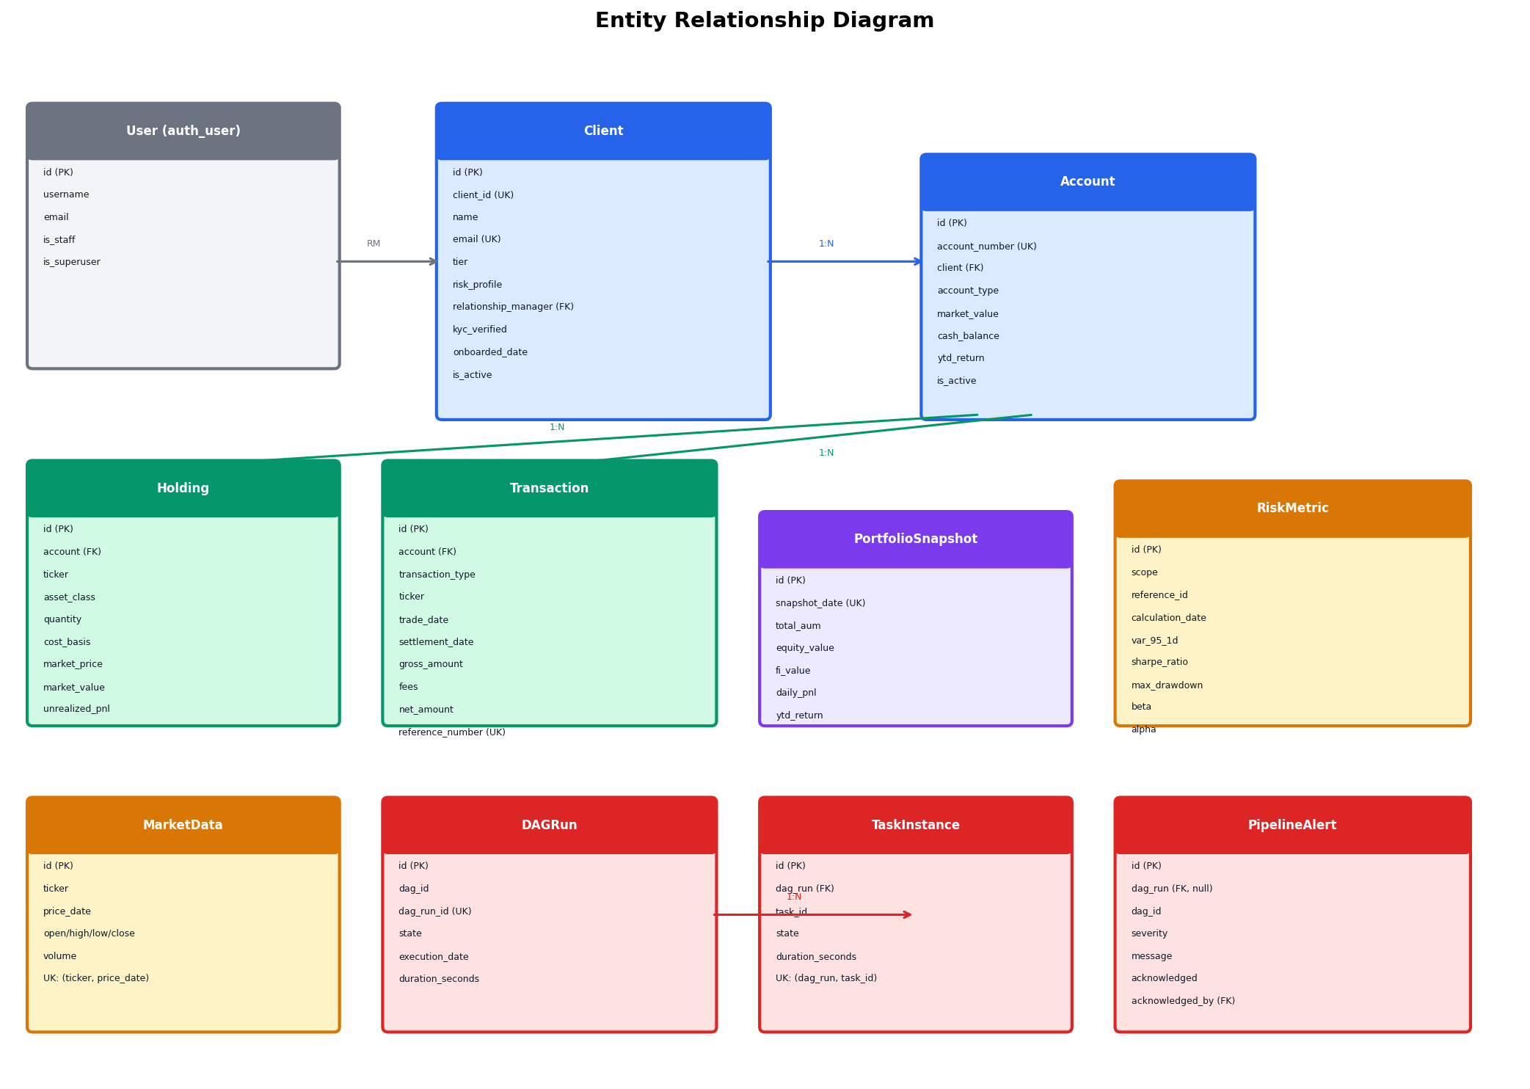

5.2 Key Enumerations
Field | Values
Client.tier | UHNW, HNW, MA, INST
Client.risk_profile | CONSERVATIVE, MODERATE, AGGRESSIVE, VERY_AGGRESSIVE
Account.account_type | DISC, ADV, CUST, TRUST, RET
Holding.asset_class | EQ, FI, ALT, CASH, RE, COMM
Transaction.type | BUY, SELL, DIV, INT, FEE, TFI, TFO, DEP, WIT
RiskMetric.scope | ACCOUNT, PORTFOLIO, SECURITY
DAGRun.state | queued, running, success, failed, skipped
PipelineAlert.severity | CRITICAL, WARNING, INFO

5.3 Database Indexes
Table | Index | Purpose
Client | (tier, is_active) | Filter clients by tier
Holding | (account, ticker) UNIQUE | Prevent duplicate positions
Transaction | (account, trade_date) | Query recent trades per account
Transaction | (ticker, trade_date) | Cross-account ticker lookup
MarketData | (ticker, -price_date) | Latest price fetch
RiskMetric | (scope, ref_id, date, lookback) UNIQUE | Prevent duplicate metrics
DAGRun | (dag_id, -execution_date) | Latest runs per DAG

6. ETL Pipelines (Airflow)
Three DAGs orchestrate the data pipeline. All use PostgreSQL connections and follow an extract-validate-transform-load pattern with idempotent upserts (ON CONFLICT DO UPDATE).

6.1 Pipeline Flowcharts
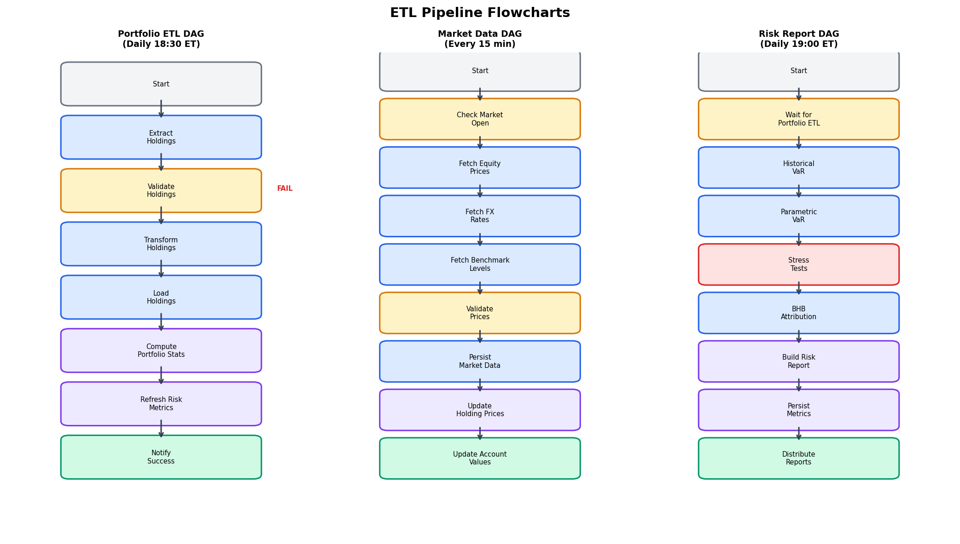

6.2 DAG Schedule Summary
DAG | Schedule | Timeout | Retries
portfolio_etl_dag | Mon-Fri 18:30 ET | 2 hours | 2 x 5 min
market_data_dag | Every 15 min (market hours) | 10 minutes | 3 x 2 min
risk_report_dag | Tue-Sat 00:00 UTC | 3 hours | 1 x 10 min

6.3 Pipeline Dependency Chain
Market Data DAG (intraday) -> Portfolio ETL DAG (18:30 ET) -> Risk Report DAG (19:00 ET). The Risk Report DAG uses an ExternalTaskSensor to wait for Portfolio ETL completion.

6.4 Stress Test Scenarios
Scenario | Equity Shock | Credit Spread | Volatility
GFC 2008 | -42% | +5% | 2.5x
COVID 2020 | -34% | +2.5% | 4x
Taper Tantrum 2013 | -6% | +130 bps rates | -
Rate Rise 300bps | -18% | +300 bps rates | -

7. Interactive Dashboards (Plotly Dash)
Dashboard | Mount Path | Key Components
PortfolioDashApp | /django_plotly_dash/app/PortfolioDashApp/ | AUM trend, asset allocation sunburst, attribution bar, rolling return
RiskAnalyticsApp | /django_plotly_dash/app/RiskAnalyticsApp/ | VaR fan chart, drawdown, correlation heatmap, efficient frontier
ETLMonitorApp | /django_plotly_dash/app/ETLMonitorApp/ | Gantt timeline, success rate bar, duration box plot

8. REST API
Base URL: /api/v1/ | Authentication: Session + Basic | Pagination: 50 per page
Endpoint | ViewSet | Methods | Features
/api/v1/accounts/clients/ | ClientViewSet | CRUD | Search, ordering
/api/v1/accounts/clients/{id}/aum_summary/ | Custom action | GET | Returns total AUM
/api/v1/accounts/accounts-list/ | AccountViewSet | CRUD | Filter, ordering
/api/v1/accounts/transactions/ | TransactionViewSet | Read-only | Filter, ordering
/api/v1/analytics/market-data/ | MarketDataViewSet | Read-only | Search, filter
/api/v1/analytics/risk-metrics/ | RiskMetricViewSet | Read-only | Filter, ordering

9. Infrastructure & Deployment

9.1 Docker Services
Service | Image | Port (Dev) | Purpose
db | postgres:16-alpine | 3000 | Primary database
redis | redis:7-alpine | 3001 | Cache + Celery broker
django | Custom (Python 3.11) | 3002 | Web application
celery-worker | Same as django | - | Background tasks
celery-beat | Same as django | - | Periodic scheduler
airflow-webserver | Custom (Airflow 2.9) | 3003 | Airflow UI
airflow-scheduler | Same as airflow | - | DAG execution
nginx | Custom (nginx) | 80, 443 | Reverse proxy (prod)

9.2 Production Configuration
Component | Setting
Gunicorn | 8 workers, gthread, 4 threads/worker, 120s timeout
Celery | 8 concurrency
PostgreSQL | shared_buffers=512MB, effective_cache_size=2GB
Redis | Password-protected, persistence enabled
Nginx | TLS 1.2/1.3, rate limiting (5 login/min, 60 API/min)
Django | Non-root user (xyz:xyz), static collected at build

10. CI/CD Pipeline
Platform: GitHub Actions (.github/workflows/ci-cd.yml)
Stage | Trigger | Actions
Lint | All pushes/PRs | Black, Flake8 (max-line=120), isort
Test | After lint | pytest + coverage, PostgreSQL + Redis services
Build | Push only | Multi-arch Docker build, push to GHCR
Deploy Staging | develop branch | SSH pull + docker compose up + migrate
Deploy Production | main branch | Blue-green deploy, Slack notification

11. Security

11.1 Application Security
Control | Implementation
Authentication | Django session auth, @login_required on all views
CSRF | CsrfViewMiddleware + CSRF_TRUSTED_ORIGINS
CORS | django-cors-headers, whitelist-only in production
Secrets | Environment variables via .env, never committed
Password Policy | 4 validators (similarity, min length, common, numeric)

11.2 Production Hardening
Control | Setting
HSTS | Enabled with preload
Secure Cookies | SESSION_COOKIE_SECURE=True, CSRF_COOKIE_SECURE=True
SSL Redirect | SECURE_SSL_REDIRECT=True
X-Frame-Options | DENY (prod), SAMEORIGIN (dev for Dash iframes)
Rate Limiting | Login: 5 req/min, API: 60 req/min (Nginx)
Container Security | Non-root user (xyz:xyz), minimal base image

12. Observability

12.1 Logging
Logger | Level | Handlers
Root | INFO | Console
django | WARNING | Console + Rotating File
apps | DEBUG | Console + Rotating File
dags | INFO | Console + Rotating File
Log files rotate at 10 MB with 5 backups (logs/xyz_platform.log).

12.2 Health Checks
Component | Method
Django | curl /admin/login/ (Docker healthcheck)
Nginx | /health/ -> 200 OK
PostgreSQL | pg_isready
Redis | redis-cli ping
Airflow | curl /health

12.3 Error Tracking
Sentry integration in production (if SENTRY_DSN is set). Celery task failures are logged and retried. Airflow failures auto-create CRITICAL PipelineAlert records.

© Brown Brothers Harriman & Co. — Confidential & Proprietary. For internal use only.

