1. Print all characters whose age is greater than 10 but less than 20

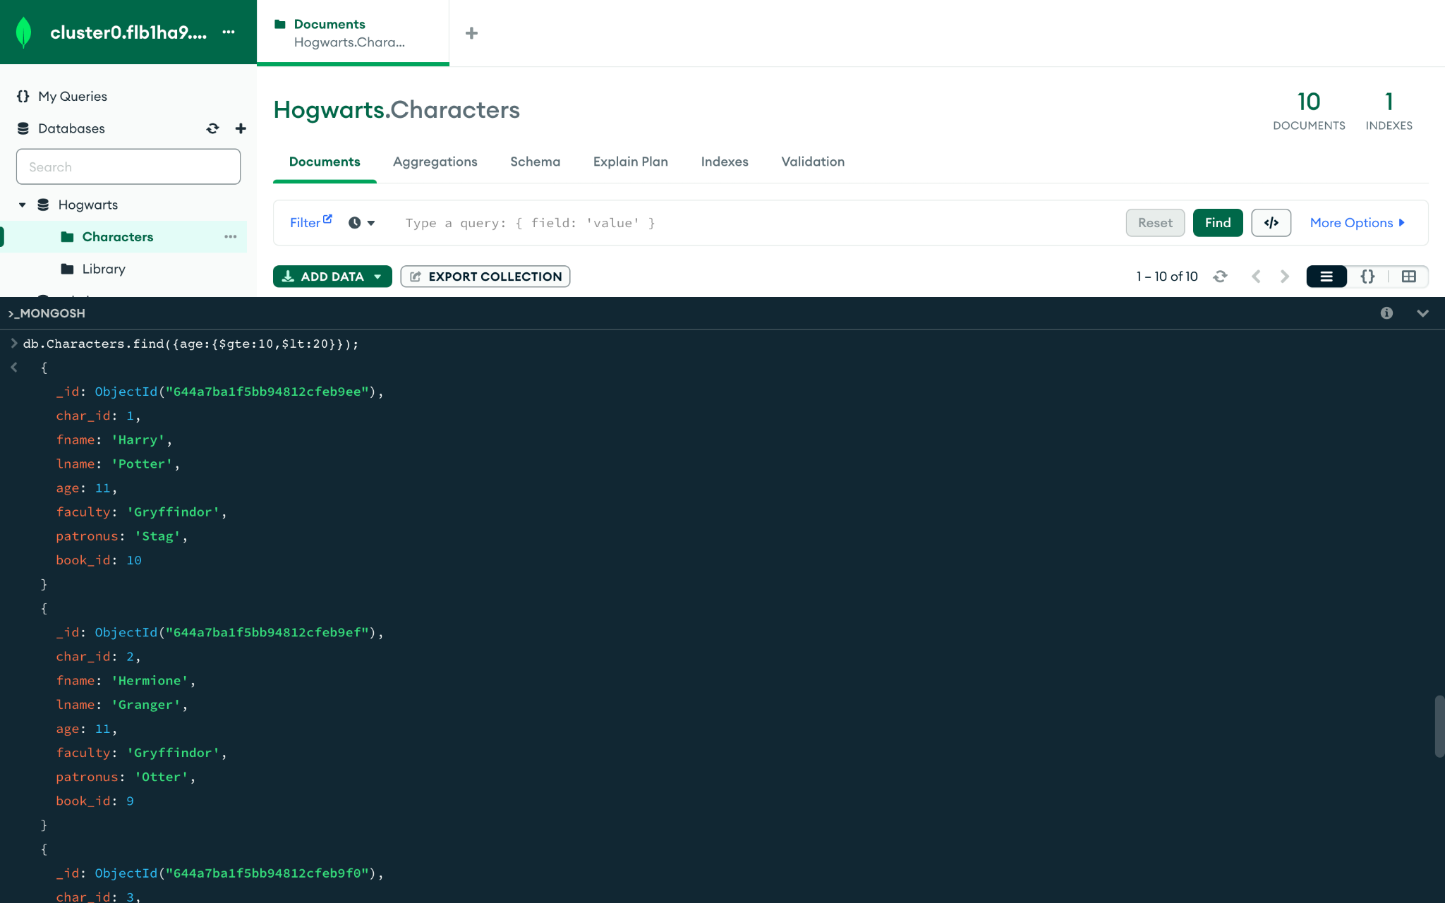

1. Print all characters whose age is less than 30 and not equal to 11

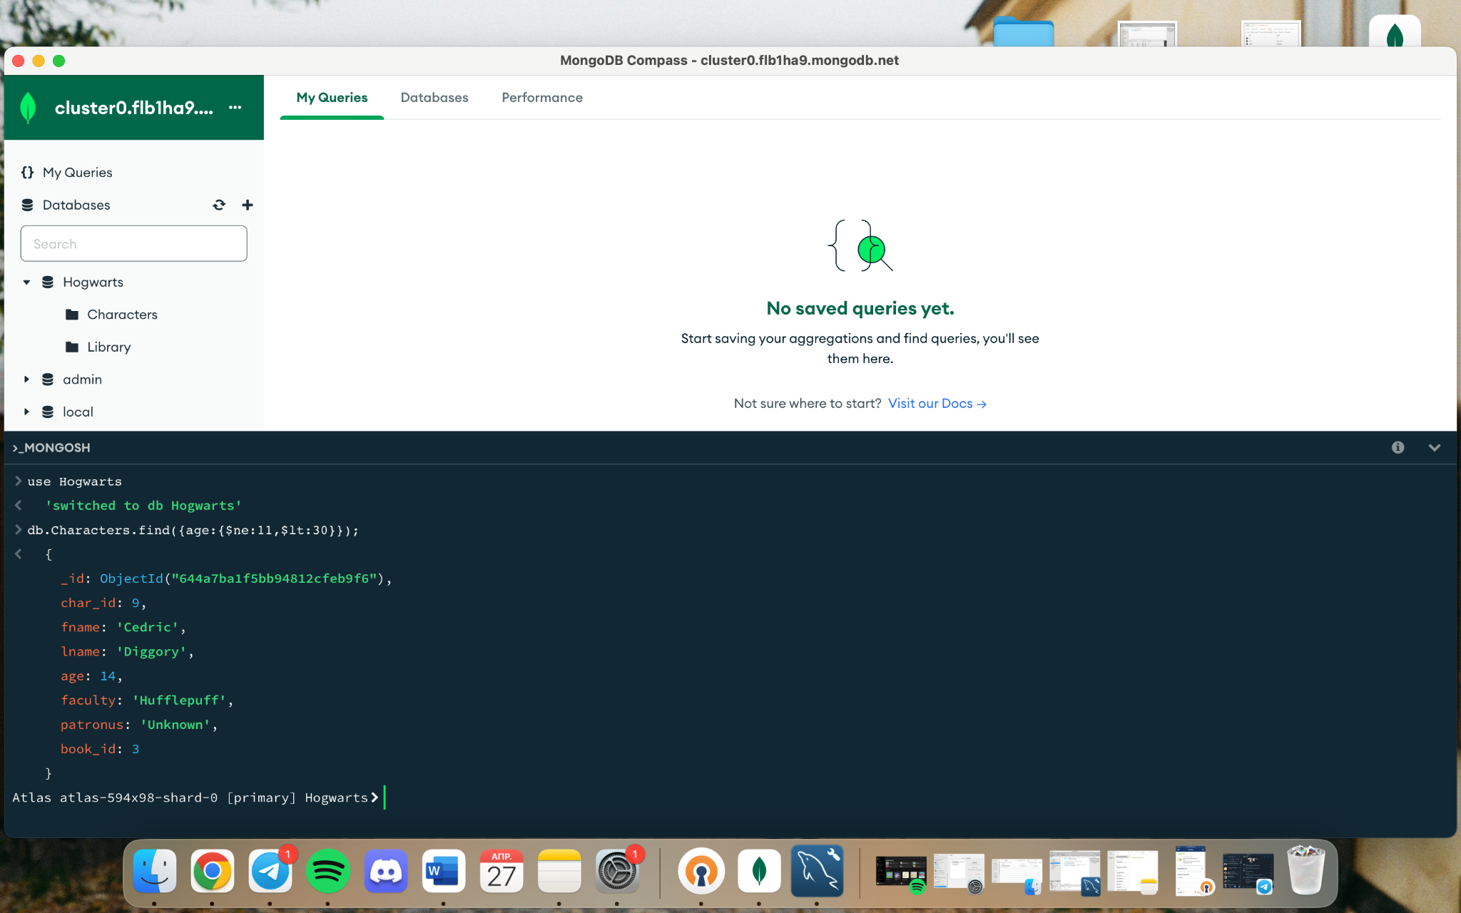

1. Add +1 year to age for all characters

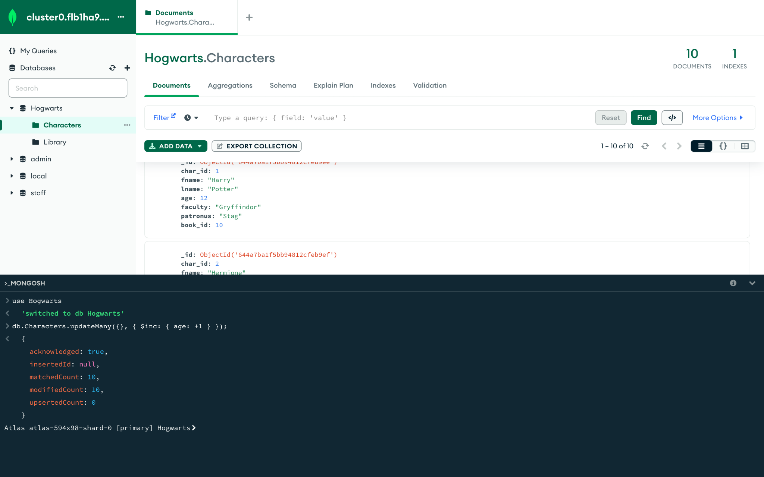

1. Count the total number of characters whose age is over 11

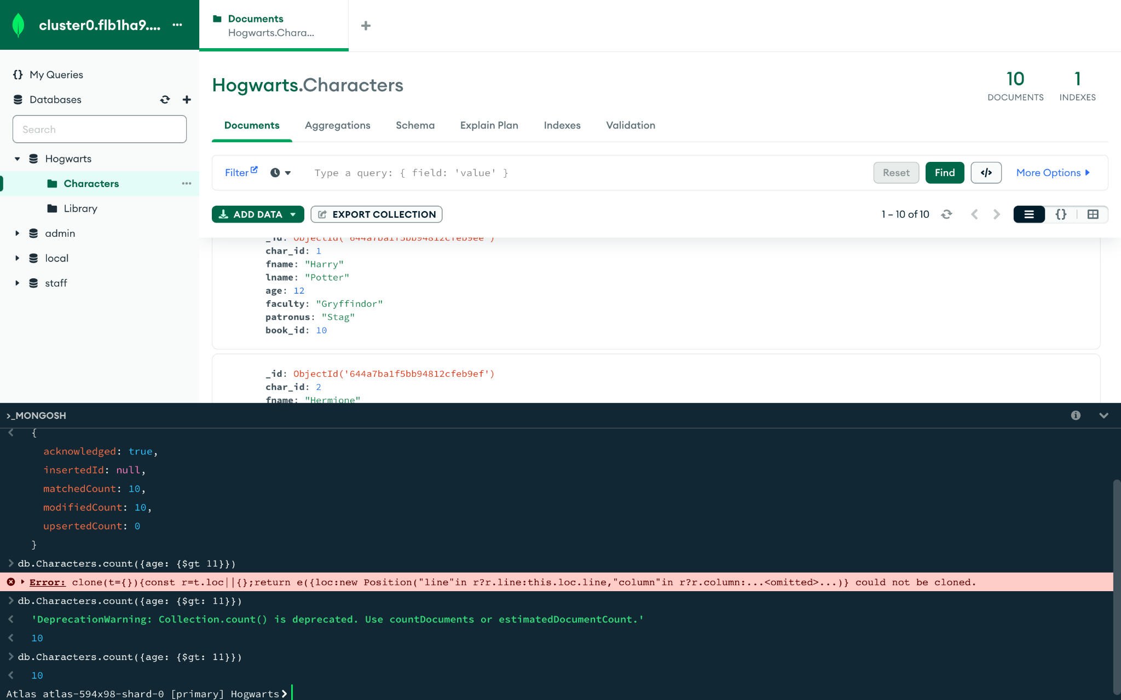

1. Delete information about the book 'Quidditch Through The Ages'

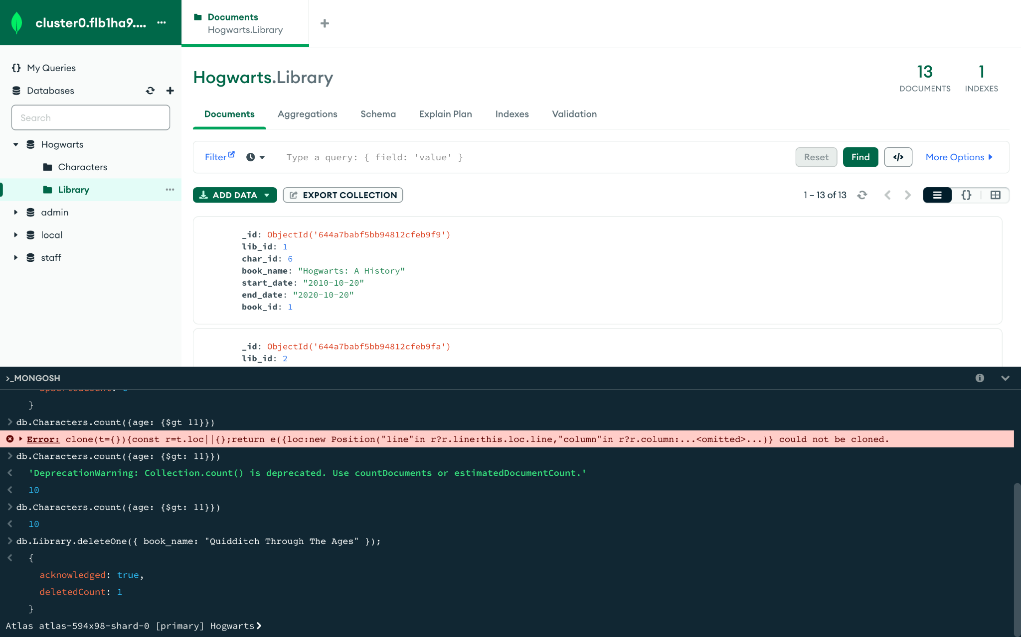

1. Print information about everyone in books whose titles contain the word “The” anywhere

