Nenana river ice from VIIRS 375 m, run 22: run 19 with Gaussian (run 17) labels (v2)
Version 2: adds the fraction statistics without rules (VIIRS-predicted vs Landsat-derived class fractions), the 2D CNN fraction model, the VIIRS outcome figures with Landsat, the run 16 map and the hand labels next to them, and new prediction images (river ice in pink, no boxes).

Contents

1. Summary
model | state acc rule50 | state acc rule90 | fraction MAE pp (mean) | R² water | R² ice | R² snow | R² snow-free
RF | 0.771 | 0.860 | 7.8 | 0.81 | 0.86 | 0.77 | 0.85
UNet++ | 0.740 | 0.757 | 8.6 | 0.77 | 0.74 | 0.73 | 0.79
2D CNN | 0.807 | 0.880 | 5.7 | 0.93 | 0.93 | 0.78 | 0.86

- Fractions (no rules): 2D CNN matches the Landsat-derived fractions best, mean error 5.7 percentage points on the river + buffer pixels of the 6 left-out days (water 2.8, ice 3.4, snow 8.3, snow-free land 8.2 pp).
- States (rules): RF 0.771 (rule50) / 0.860 (rule90), UNet++ 0.740 (rule50) / 0.757 (rule90), 2D CNN 0.807 (rule50) / 0.880 (rule90).
- Snow and snow-free land are the hardest fractions; water and ice are the closest.
- All scores compare against the run 16 Landsat map (a model prediction), not against ground truth; the hand labels are the ground truth and are shown next to the maps.

2. Labels: Landsat fractions per VIIRS pixel
- Source: the run 16 Landsat 30 m map of the day (run 16 RF prediction: river, ice, snow, forest, shrub, bare). It is a prediction, not ground truth; the hand labels are the ground truth.
- Spatial step: each VIIRS pixel weighs the Landsat pixels around its centre with a Gaussian (sigma = 375 m / 2.8 = 134 m, cut at 2 sigma; Oleson et al. 1995). A VIIRS pixel is used only if >= 98 % of it is mapped.
- Class step: river -> open water, ice -> ice, snow -> snow, forest + shrub + bare -> snow-free land.
- States: river ice-free if open / (open + ice) > 0.5 (rule90: > 0.9); land snow-covered if snow / (snow + snow-free) > 0.5 (rule90: snow-free only if < 0.1); pixels with < 1 % river take the ratio of the whole day.
- Area: VIIRS pixels of the water mask alaska_occ_375m.tif (occurrence >= 0.05, 988 px) plus a 1-pixel buffer (678 px).
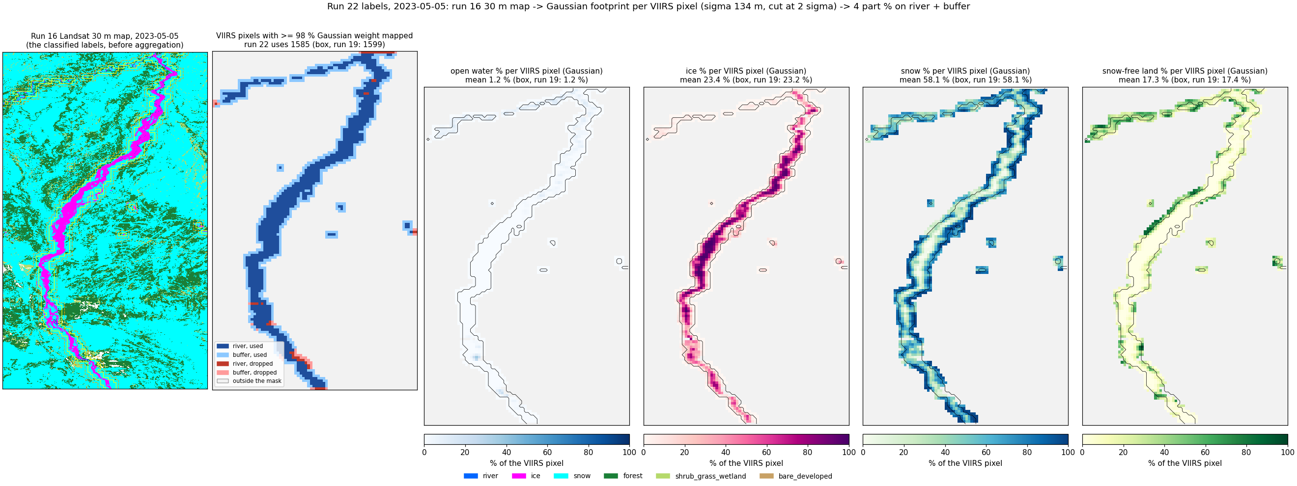
2023-05-05 (spring break-up): run 16 map -> Gaussian-weighted fractions per VIIRS pixel (all panels from the run 16 map).
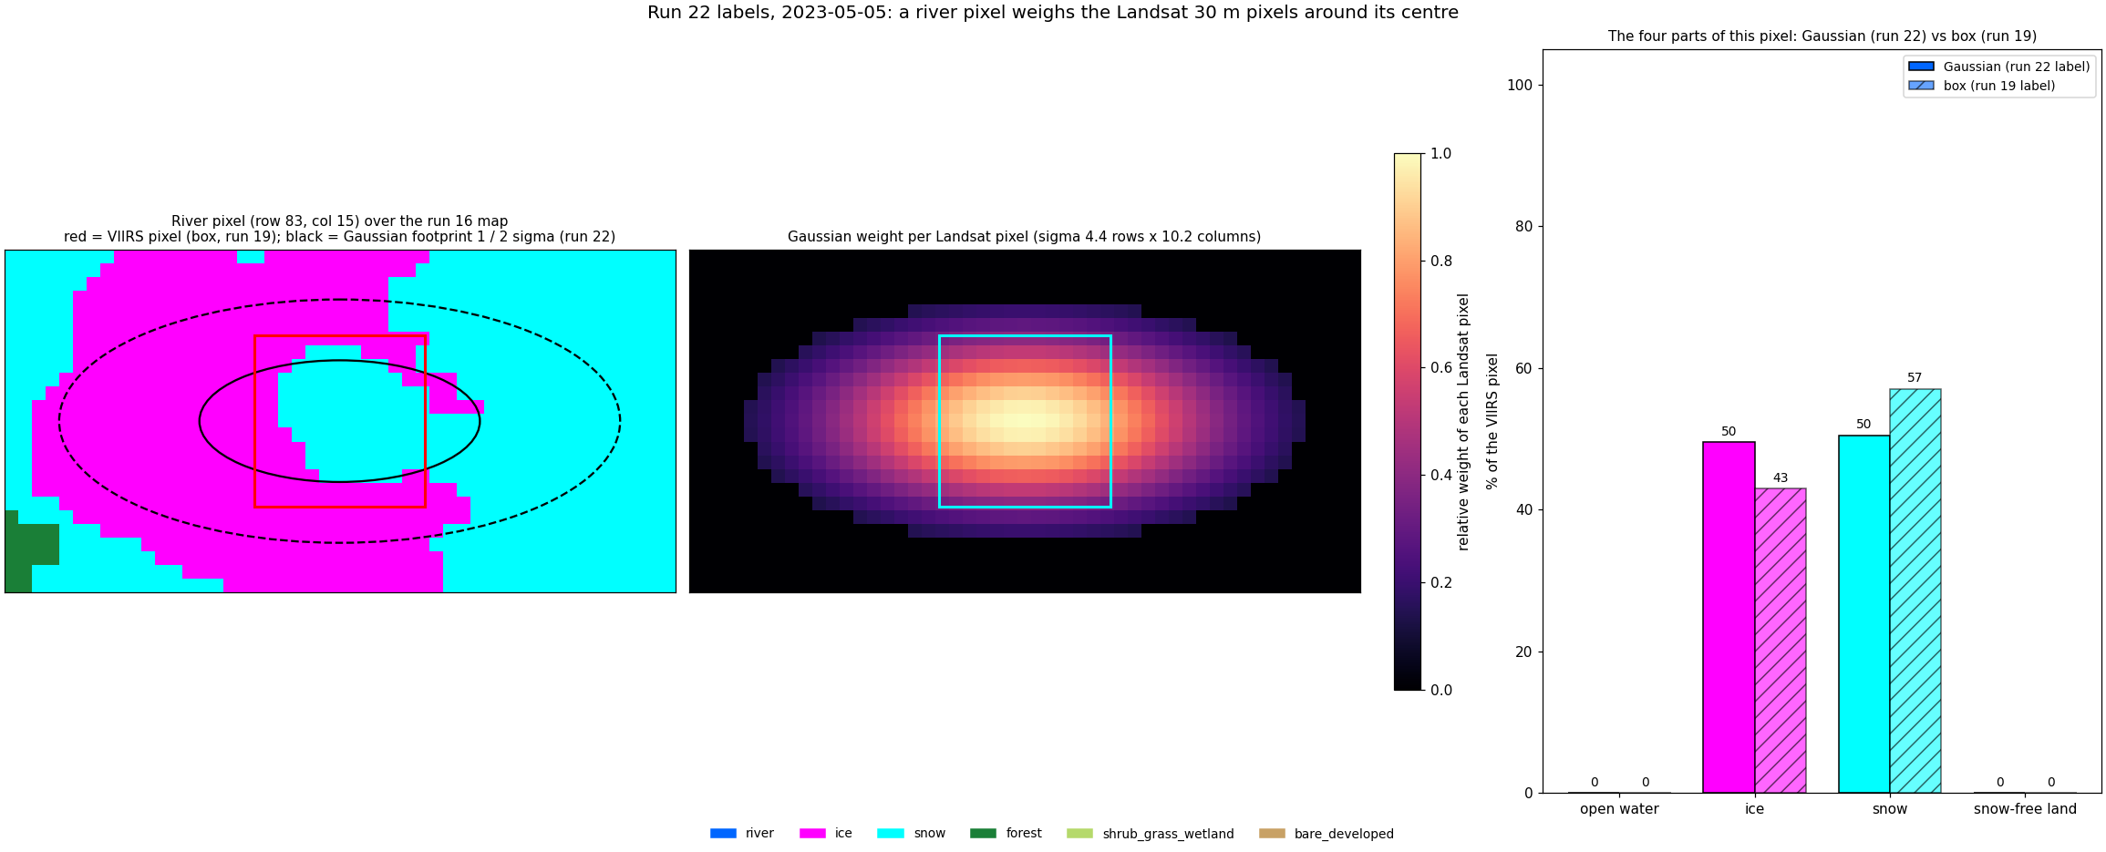
2023-05-05: the Landsat pixels behind single VIIRS pixels and their fractions.
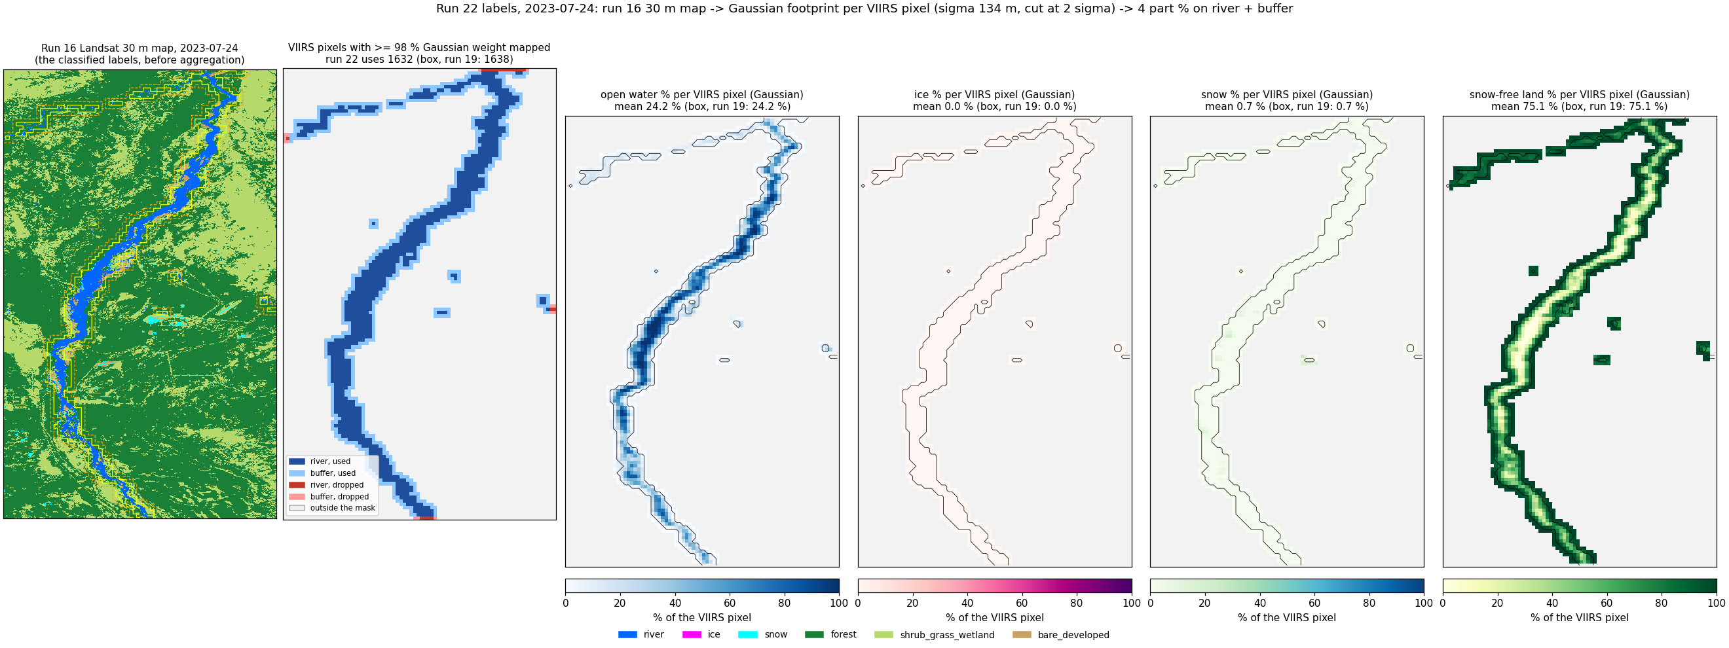
2023-07-24 (summer): run 16 map -> Gaussian-weighted fractions per VIIRS pixel (all panels from the run 16 map).
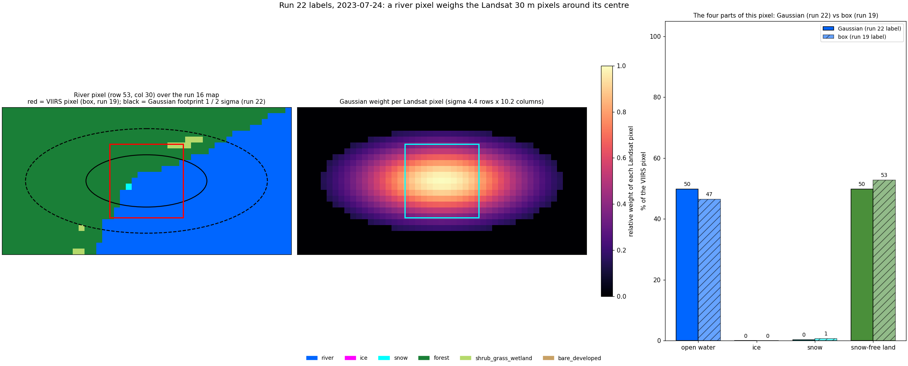
2023-07-24: the Landsat pixels behind single VIIRS pixels and their fractions.
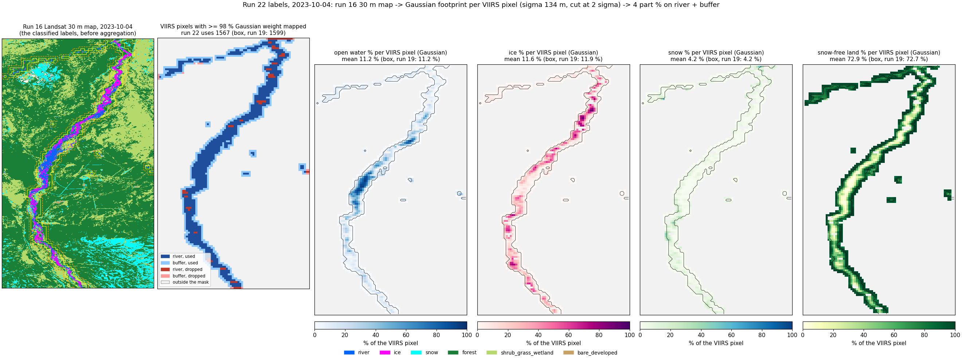
2023-10-04 (autumn freeze-up): run 16 map -> Gaussian-weighted fractions per VIIRS pixel (all panels from the run 16 map).
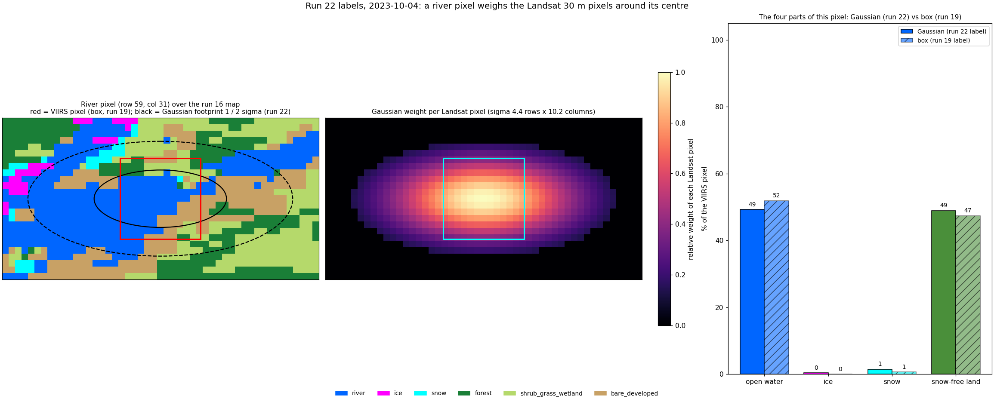
2023-10-04: the Landsat pixels behind single VIIRS pixels and their fractions.
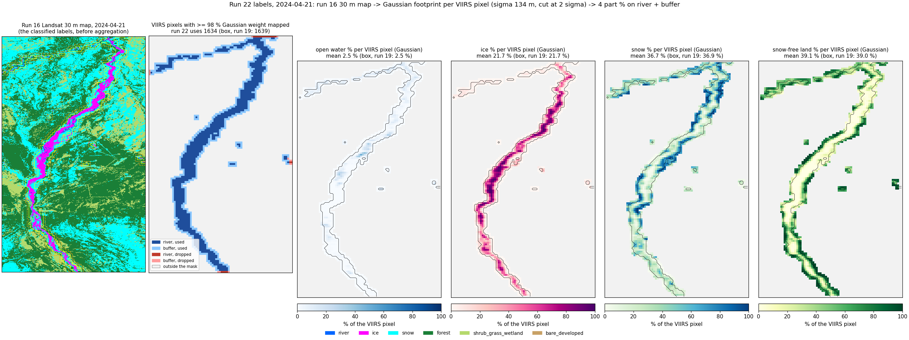
2024-04-21 (spring break-up): run 16 map -> Gaussian-weighted fractions per VIIRS pixel (all panels from the run 16 map).
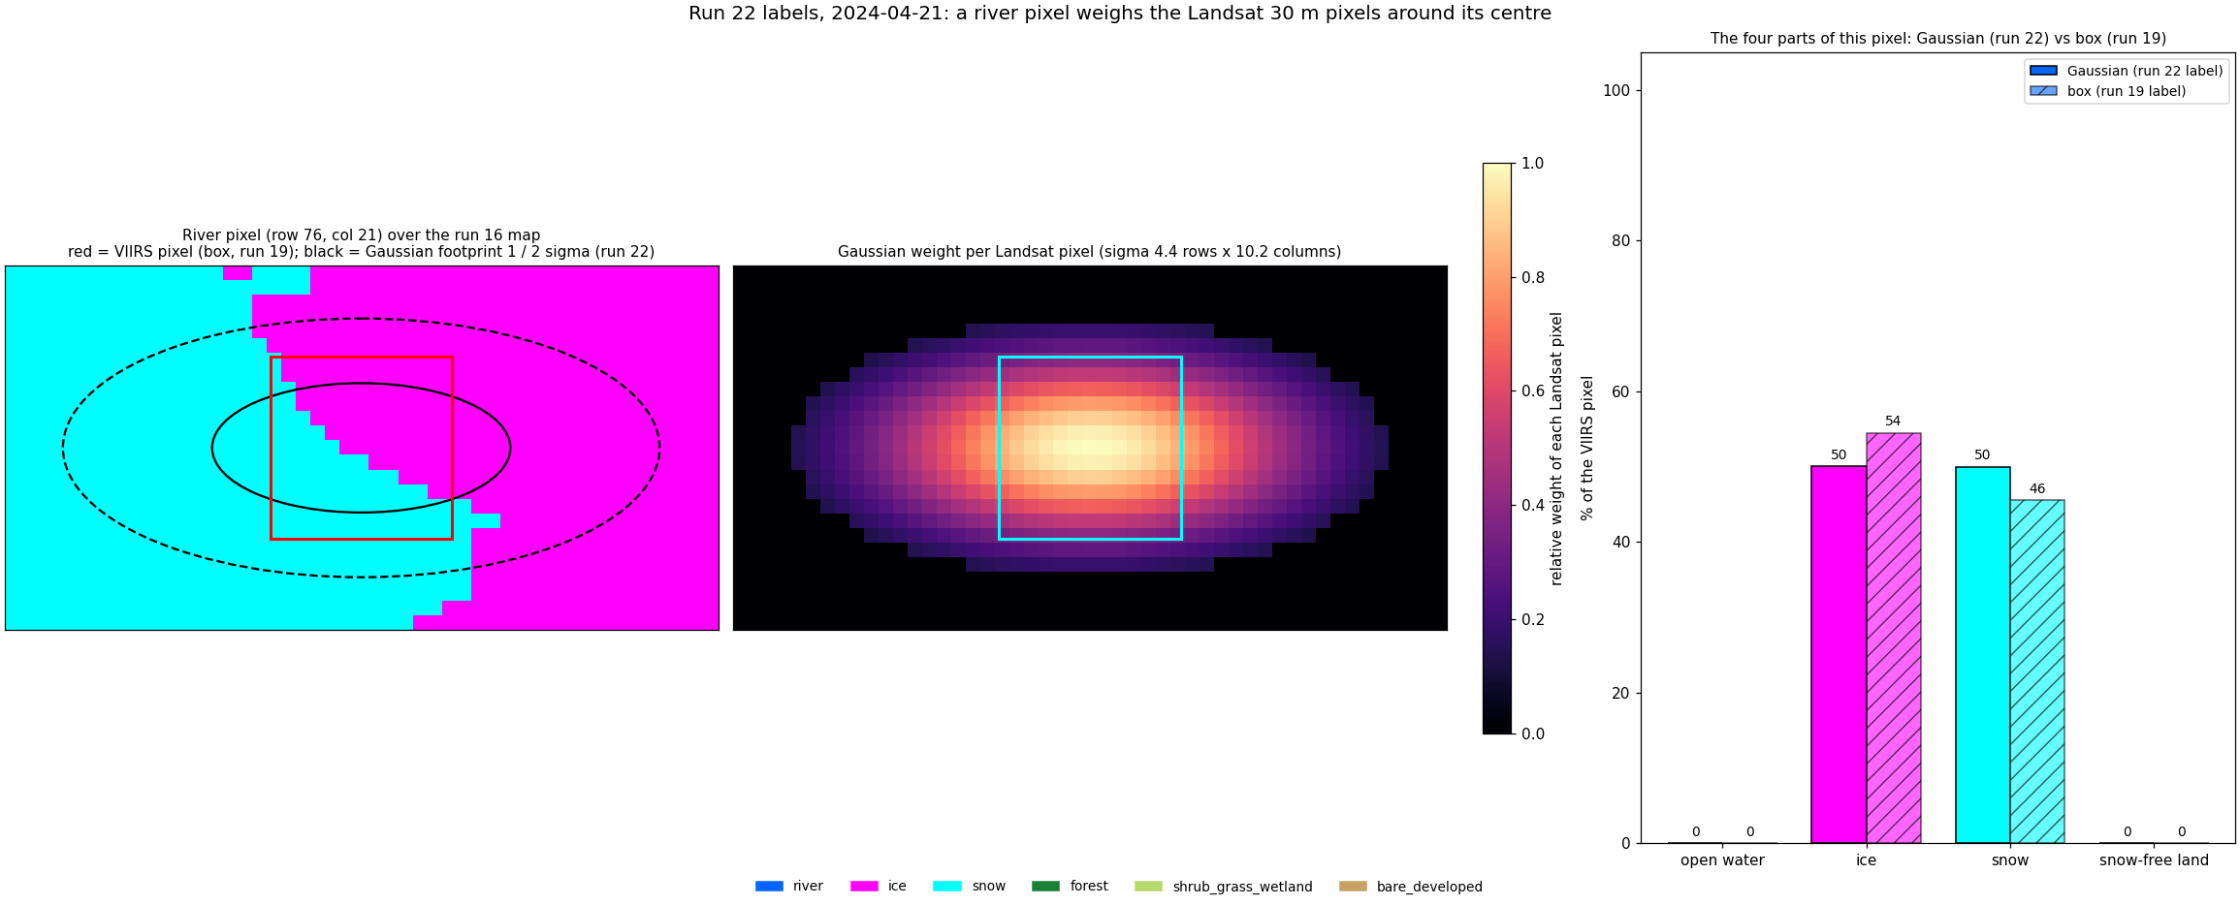
2024-04-21: the Landsat pixels behind single VIIRS pixels and their fractions.
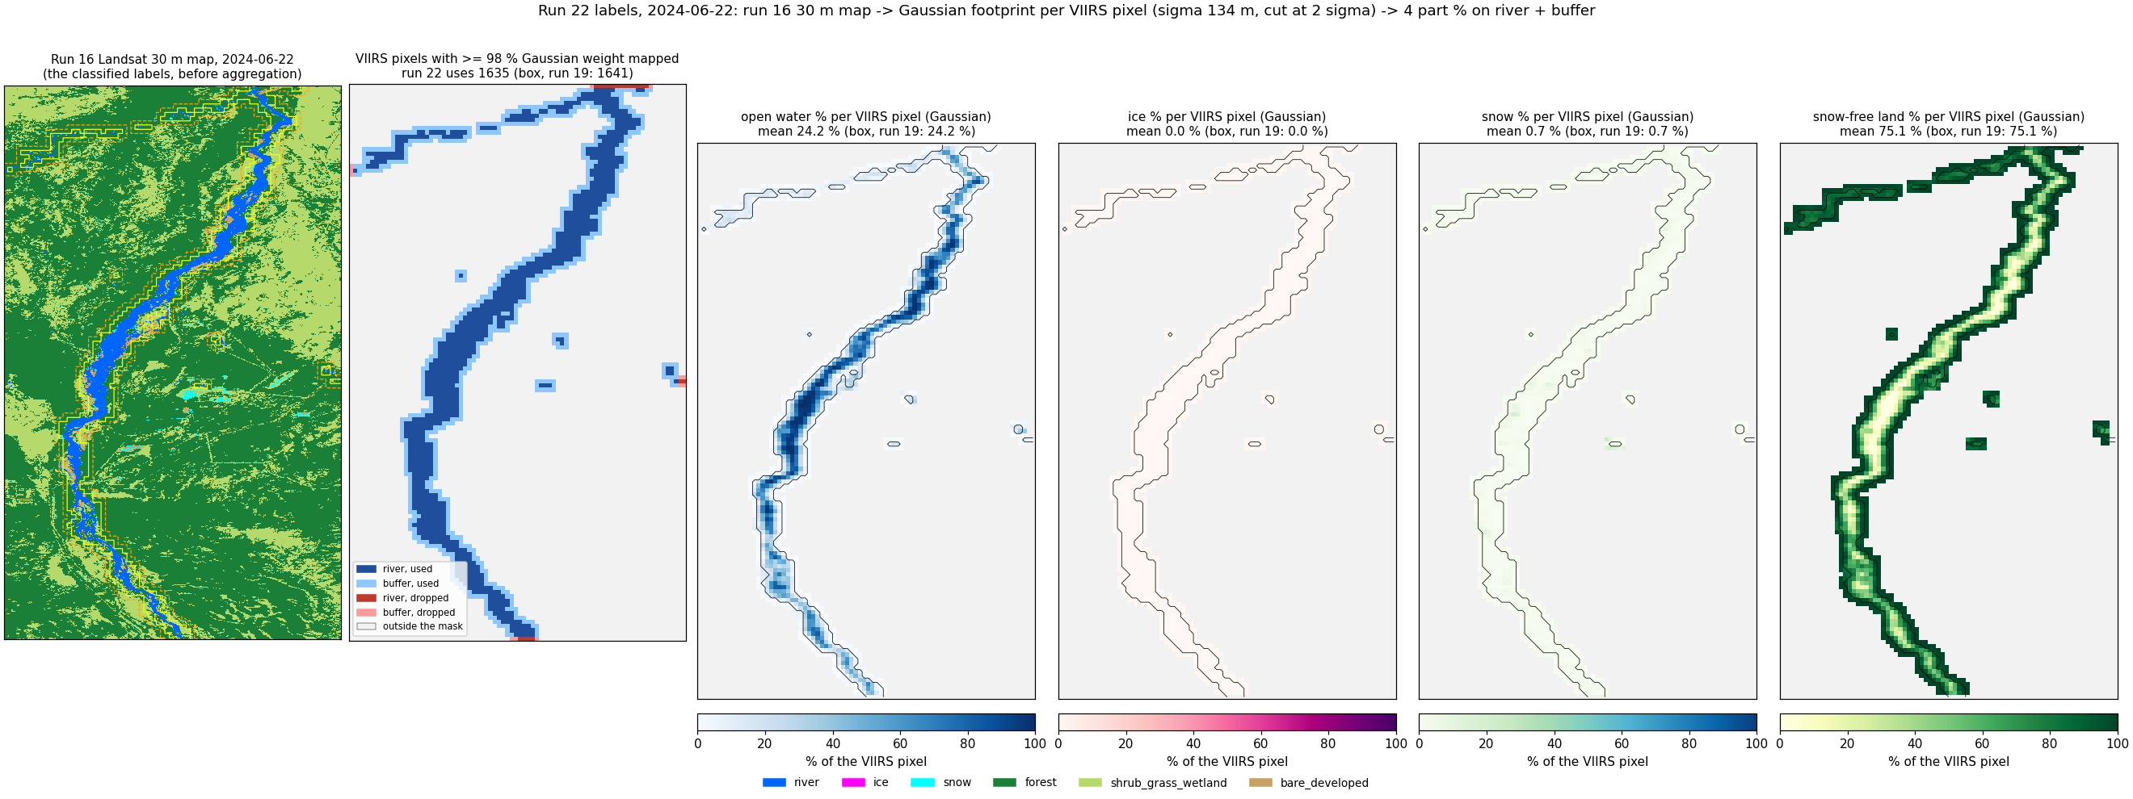
2024-06-22 (summer): run 16 map -> Gaussian-weighted fractions per VIIRS pixel (all panels from the run 16 map).
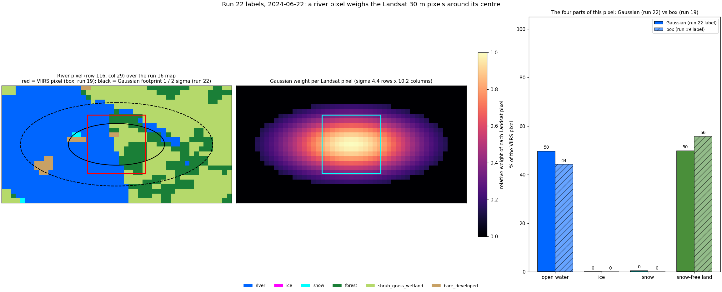
2024-06-22: the Landsat pixels behind single VIIRS pixels and their fractions.
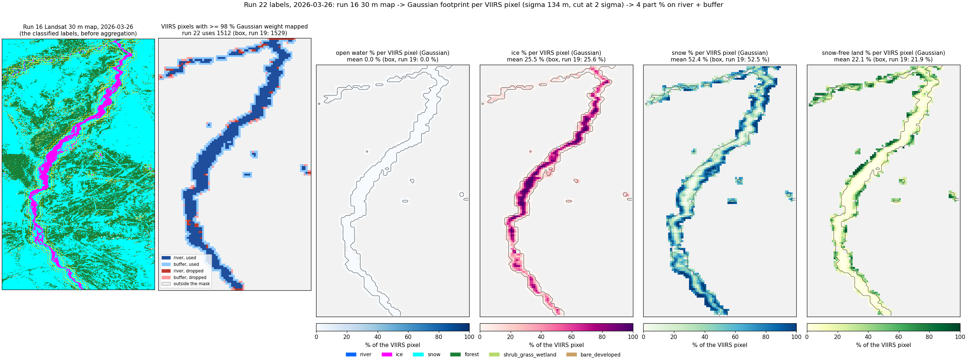
2026-03-26 (late winter): run 16 map -> Gaussian-weighted fractions per VIIRS pixel (all panels from the run 16 map).
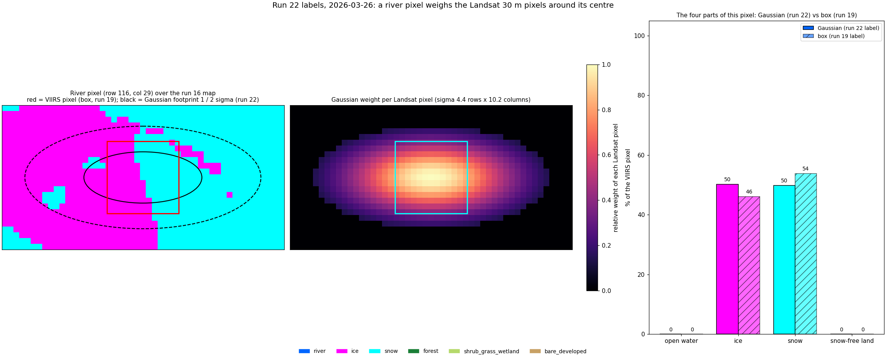
2026-03-26: the Landsat pixels behind single VIIRS pixels and their fractions.

3. State scores (rules)
RF, UNet++ and 2D CNN predict the four states at once from VIIRS (I1-I5, NDVI_I, NDSI_I, I4-I5, sun / view zenith, JRC water occurrence and zone share, water-mask occurrence; RF adds 3 x 3 mean / std). Leave-one-date-out over the 6 labelled days.
rule50: model | accuracy | macro F1 | F1 1 open river, no-snow land | F1 2 open river, snow land | F1 3 ice river, no-snow land | F1 4 ice river, snow land
RF | 0.771 | 0.619 | 0.85 | 0.17 | 0.60 | 0.85
UNet++ | 0.740 | 0.569 | 0.83 | 0.12 | 0.55 | 0.78
2D CNN | 0.807 | 0.630 | 0.89 | 0.12 | 0.65 | 0.85

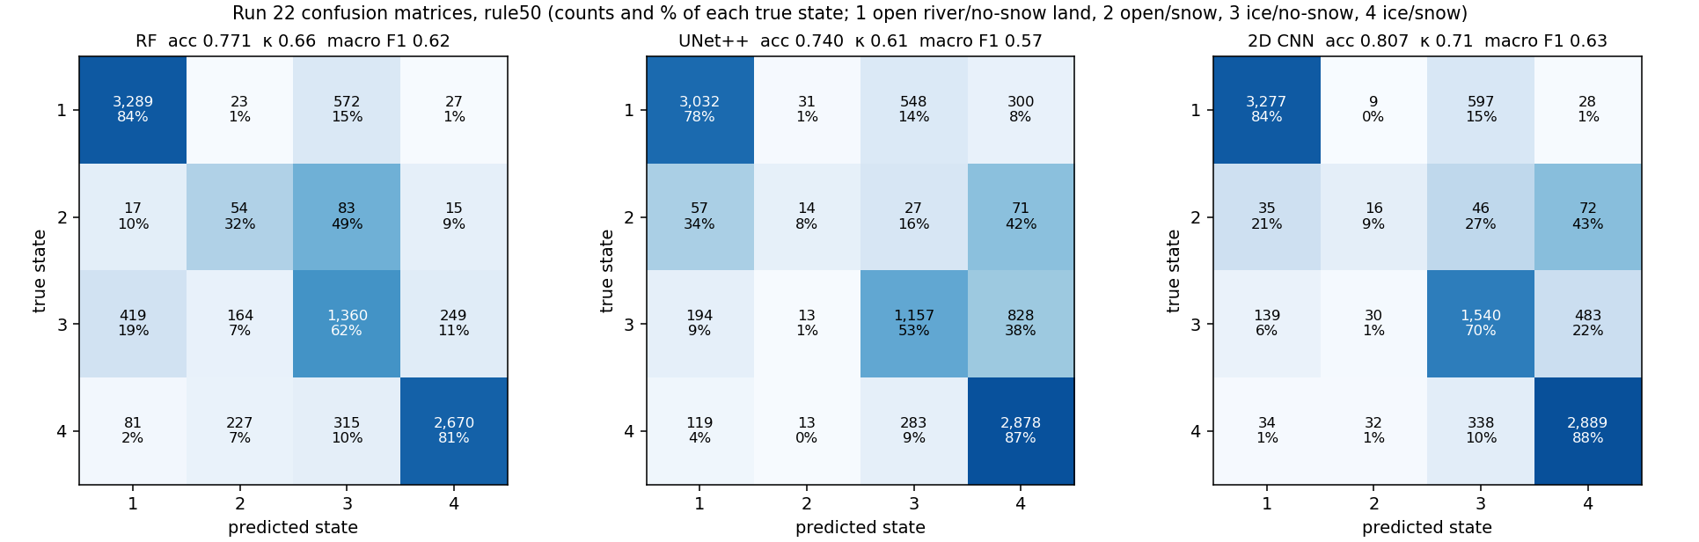
Run 22: confusion matrices, rule50 (rows: run 16-derived state, columns: predicted from VIIRS).
rule90: model | accuracy | macro F1 | F1 1 open river, no-snow land | F1 2 open river, snow land | F1 3 ice river, no-snow land | F1 4 ice river, snow land
RF | 0.860 | 0.671 | 0.88 | 0.17 | 0.70 | 0.93
UNet++ | 0.757 | 0.459 | 0.83 | 0.02 | 0.16 | 0.83
2D CNN | 0.880 | 0.674 | 0.93 | 0.14 | 0.72 | 0.92

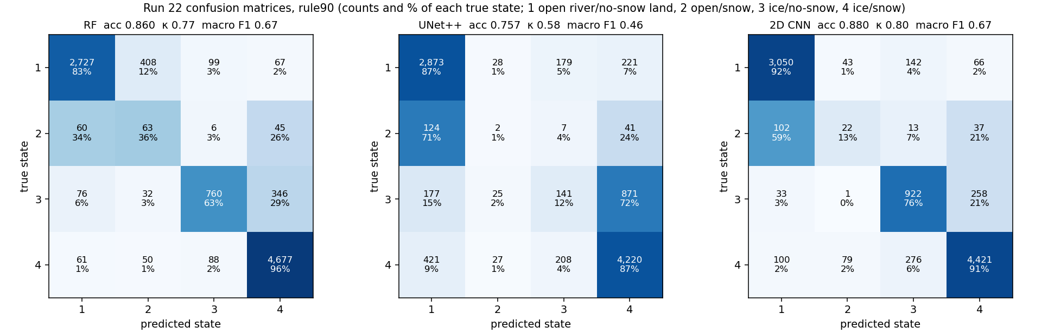
Run 22: confusion matrices, rule90 (rows: run 16-derived state, columns: predicted from VIIRS).
date | season | RF acc50 / acc90 | UNet++ acc50 / acc90 | 2D CNN acc50 / acc90
2023-05-05 | spring break-up | 0.76 / 0.97 | 0.74 / 0.85 | 0.80 / 0.97
2023-07-24 | summer | 0.97 / 0.74 | 0.85 / 0.86 | 0.97 / 0.92
2023-10-04 | autumn freeze-up | 0.65 / 0.68 | 0.47 / 0.29 | 0.66 / 0.70
2024-04-21 | spring break-up | 0.39 / 0.83 | 0.62 / 0.67 | 0.63 / 0.77
2024-06-22 | summer | 1.00 / 0.96 | 0.94 / 0.88 | 1.00 / 0.96
2026-03-26 | late winter | 0.86 / 0.99 | 0.81 / 0.99 | 0.77 / 0.96

4. Fraction statistics without rules
For every VIIRS pixel the four class fractions predicted from VIIRS (RF, UNet++ and 2D CNN fraction models, trained on 5 days and tested on the 6th) are compared directly with the Landsat-derived fractions (the run 16 map aggregated to 375 m, Gaussian-weighted weights). No rule and no state: MAE and RMSE in percentage points, bias = VIIRS - Landsat, R², Pearson r.

4.1 River + buffer
model | class | pixels | Landsat mean % | VIIRS mean % | MAE pp | RMSE pp | bias pp | R² | r
RF | open water | 9,565 | 10.7 | 8.8 | 5.1 | 9.6 | -1.9 | 0.81 | 0.93
RF | ice | 9,565 | 13.5 | 10.6 | 5.0 | 9.2 | -3.0 | 0.86 | 0.95
RF | snow | 9,565 | 25.1 | 27.6 | 10.2 | 14.9 | +2.5 | 0.77 | 0.88
RF | snow-free land | 9,565 | 50.6 | 53.0 | 10.8 | 14.6 | +2.3 | 0.85 | 0.93
UNet++ | open water | 9,565 | 10.7 | 8.2 | 5.1 | 10.3 | -2.5 | 0.77 | 0.89
UNet++ | ice | 9,565 | 13.5 | 10.3 | 6.4 | 12.4 | -3.2 | 0.74 | 0.87
UNet++ | snow | 9,565 | 25.1 | 30.0 | 11.1 | 16.4 | +4.9 | 0.73 | 0.87
UNet++ | snow-free land | 9,565 | 50.6 | 51.5 | 12.0 | 17.3 | +0.8 | 0.79 | 0.89
2D CNN | open water | 9,565 | 10.7 | 10.2 | 2.8 | 5.7 | -0.5 | 0.93 | 0.97
2D CNN | ice | 9,565 | 13.5 | 12.0 | 3.4 | 6.4 | -1.5 | 0.93 | 0.97
2D CNN | snow | 9,565 | 25.1 | 31.0 | 8.3 | 14.7 | +5.9 | 0.78 | 0.93
2D CNN | snow-free land | 9,565 | 50.6 | 46.8 | 8.2 | 14.1 | -3.9 | 0.86 | 0.94

4.2 Whole image
model | class | pixels | Landsat mean % | VIIRS mean % | MAE pp | RMSE pp | bias pp | R² | r
RF | open water | 58,466 | 1.8 | 2.5 | 1.9 | 4.2 | +0.7 | 0.81 | 0.93
RF | ice | 58,466 | 2.2 | 2.5 | 1.6 | 4.0 | +0.3 | 0.87 | 0.95
RF | snow | 58,466 | 28.7 | 27.7 | 9.8 | 15.1 | -1.0 | 0.83 | 0.91
RF | snow-free land | 58,466 | 67.3 | 67.3 | 9.8 | 14.5 | +0.0 | 0.85 | 0.93
UNet++ | open water | 58,466 | 1.8 | 1.6 | 1.1 | 4.4 | -0.2 | 0.80 | 0.89
UNet++ | ice | 58,466 | 2.2 | 2.0 | 1.3 | 5.2 | -0.3 | 0.78 | 0.89
UNet++ | snow | 58,466 | 28.7 | 31.4 | 10.4 | 18.1 | +2.7 | 0.75 | 0.87
UNet++ | snow-free land | 58,466 | 67.3 | 65.0 | 10.8 | 18.7 | -2.3 | 0.76 | 0.87
2D CNN | open water | 58,466 | 1.8 | 2.3 | 1.1 | 2.9 | +0.5 | 0.91 | 0.95
2D CNN | ice | 58,466 | 2.2 | 2.3 | 0.9 | 2.9 | +0.1 | 0.93 | 0.97
2D CNN | snow | 58,466 | 28.7 | 35.5 | 9.6 | 18.1 | +6.8 | 0.75 | 0.91
2D CNN | snow-free land | 58,466 | 67.3 | 60.0 | 10.1 | 18.4 | -7.3 | 0.76 | 0.91

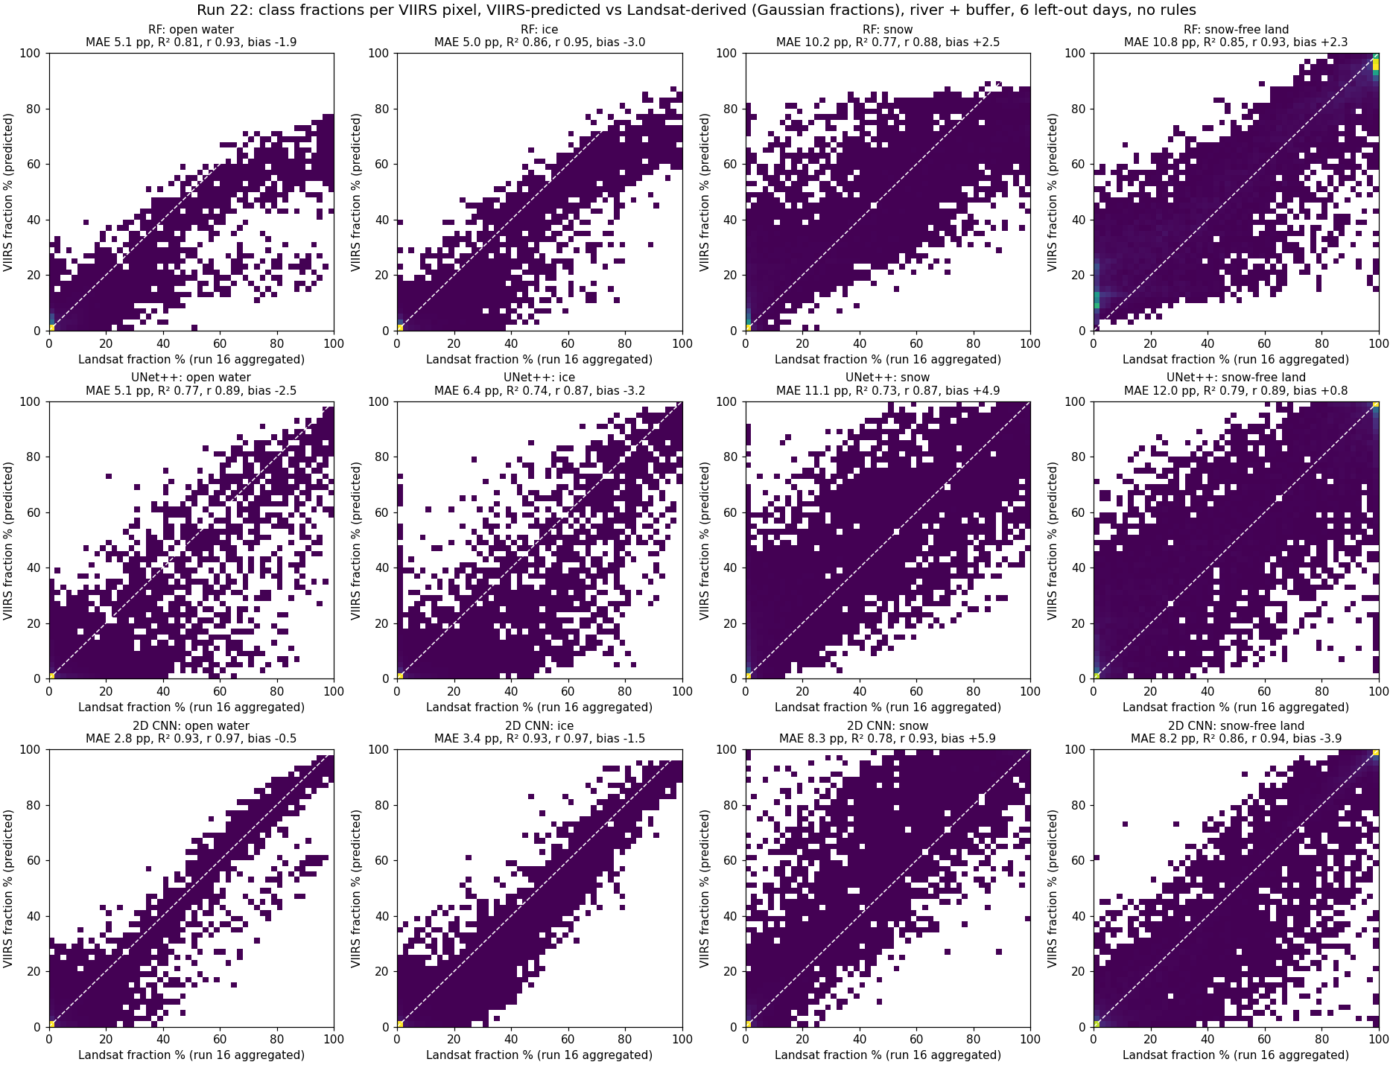
Landsat-derived vs VIIRS-predicted fraction per pixel (river + buffer, 6 left-out days); dashed = 1:1.

4.3 Per day (river + buffer), MAE pp water / ice / snow / snow-free land
date | season | RF | UNet++ | 2D CNN
2023-05-05 | spring break-up | 2.9 / 6.5 / 14.9 / 14.6 | 1.4 / 7.4 / 14.3 / 11.9 | 1.3 / 3.3 / 12.6 / 9.9
2023-07-24 | summer | 8.2 / 1.5 / 5.3 / 8.3 | 10.1 / 3.7 / 8.6 / 13.3 | 2.5 / 0.5 / 2.5 / 4.2
2023-10-04 | autumn freeze-up | 7.1 / 7.7 / 13.1 / 11.0 | 7.5 / 9.1 / 11.8 / 14.6 | 6.0 / 4.5 / 4.2 / 7.3
2024-04-21 | spring break-up | 3.8 / 6.7 / 13.9 / 12.5 | 3.6 / 9.9 / 15.2 / 14.1 | 4.6 / 4.9 / 10.3 / 12.1
2024-06-22 | summer | 6.5 / 0.6 / 1.1 / 6.2 | 7.0 / 0.6 / 0.9 / 6.9 | 2.5 / 0.1 / 0.6 / 2.5
2026-03-26 | late winter | 1.6 / 7.3 / 13.6 / 12.6 | 0.4 / 8.0 / 16.1 / 11.0 | 0.0 / 7.3 / 20.5 / 13.7

5. VIIRS outcome: fractions and states predicted from VIIRS
One row per model: VIIRS (I2/I2/I1, the model input), Landsat true colour of the same day, the run 16 map, the hand labels (where they exist), the four predicted fractions and the predicted state map. The zoom shows 5 x 5 VIIRS pixels with the same layers and the predicted % per pixel.
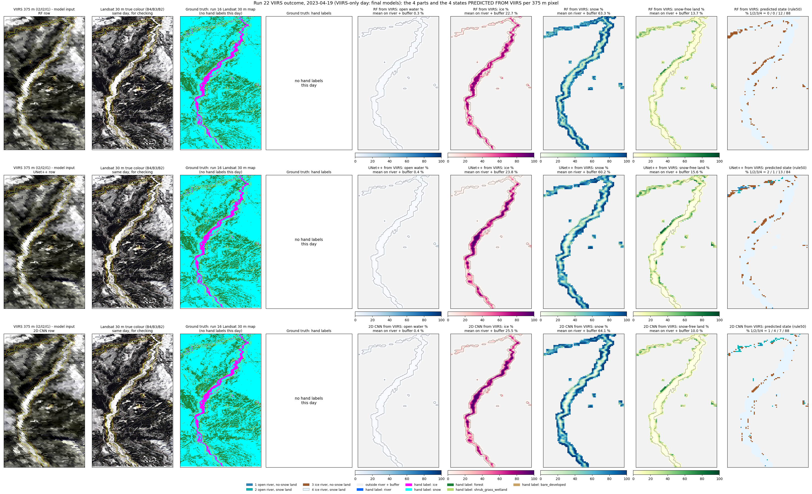
2023-04-19 (spring, snow): VIIRS outcome.
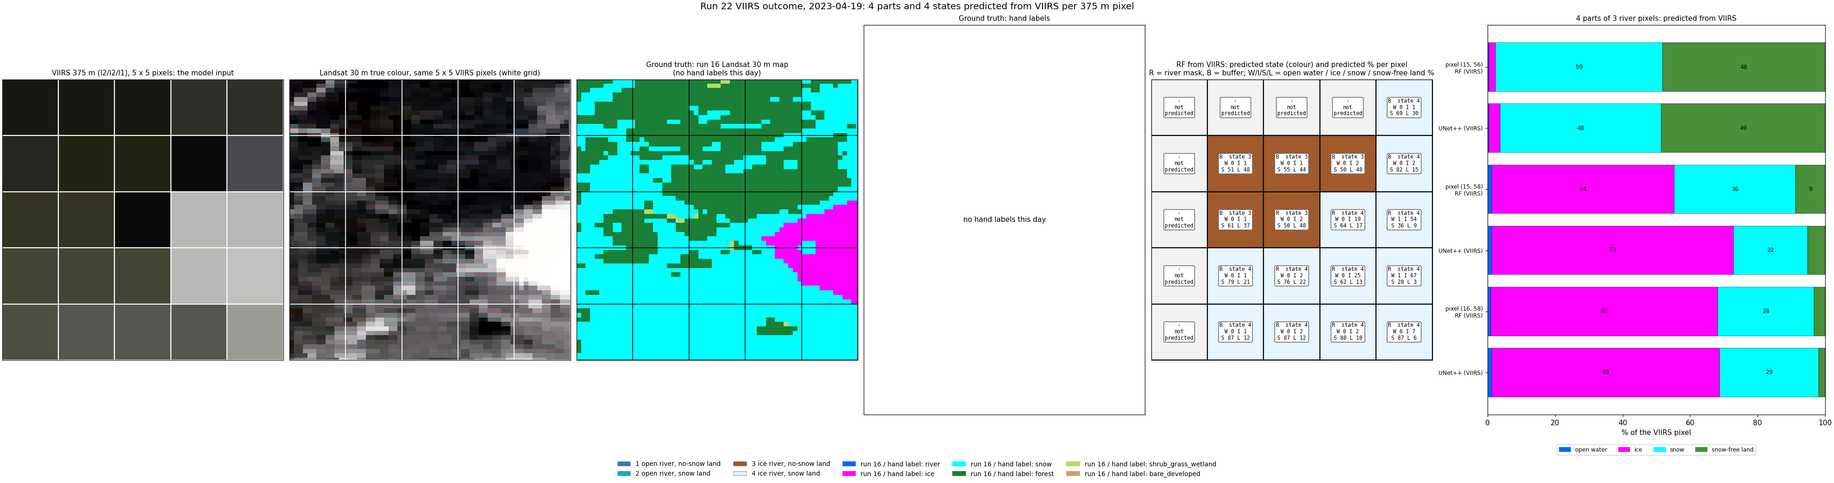
2023-04-19: VIIRS outcome, zoom.
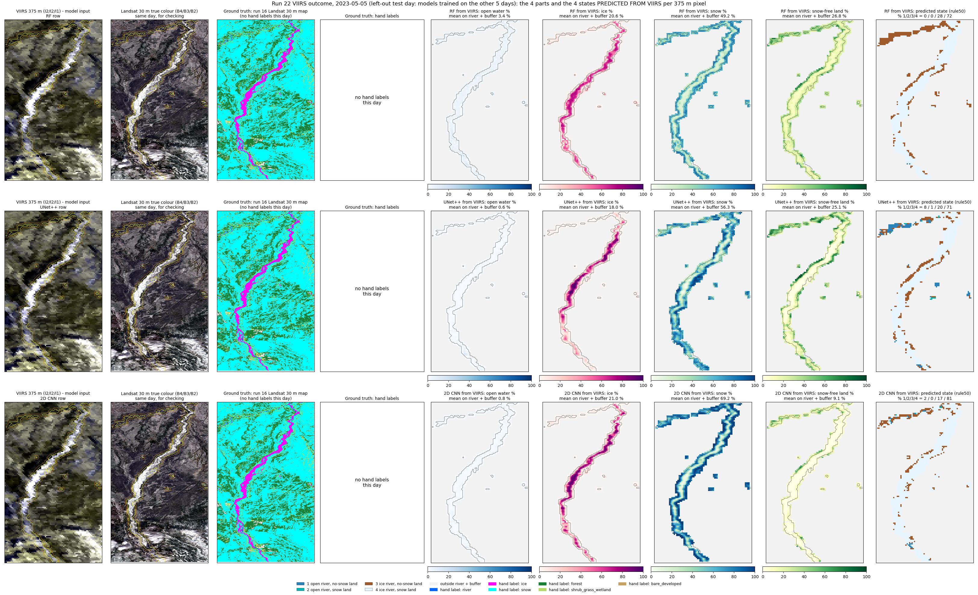
2023-05-05 (spring break-up): VIIRS outcome.
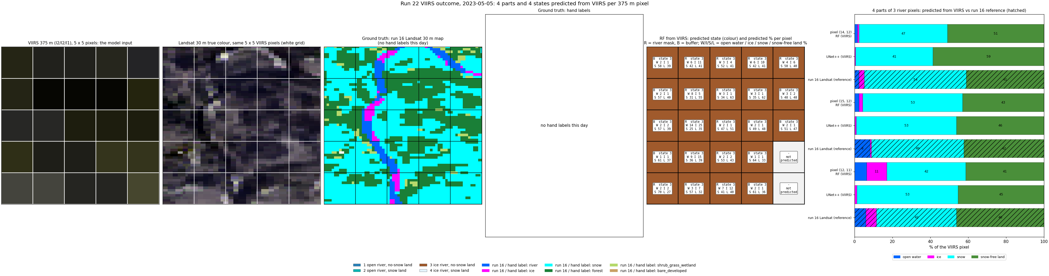
2023-05-05: VIIRS outcome, zoom.
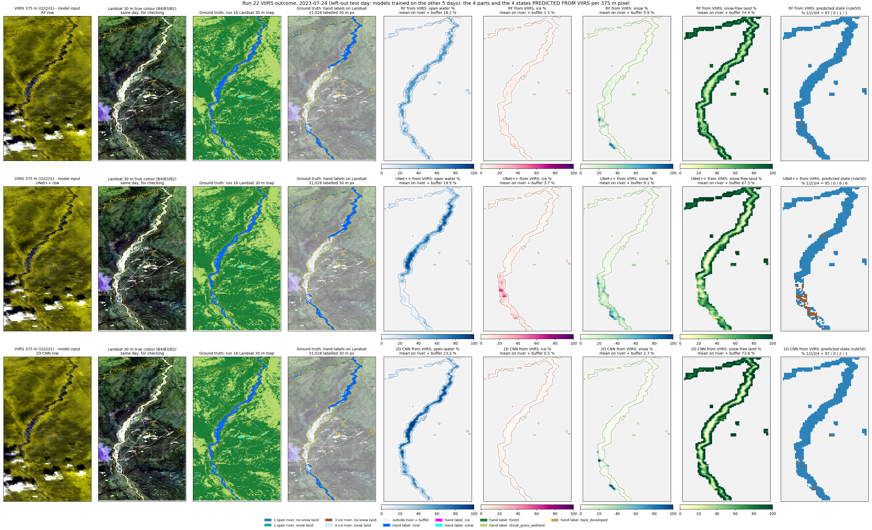
2023-07-24 (summer): VIIRS outcome.
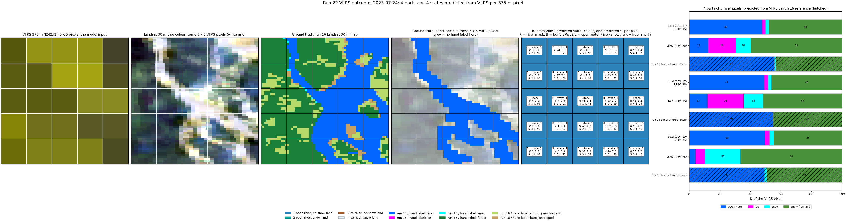
2023-07-24: VIIRS outcome, zoom.
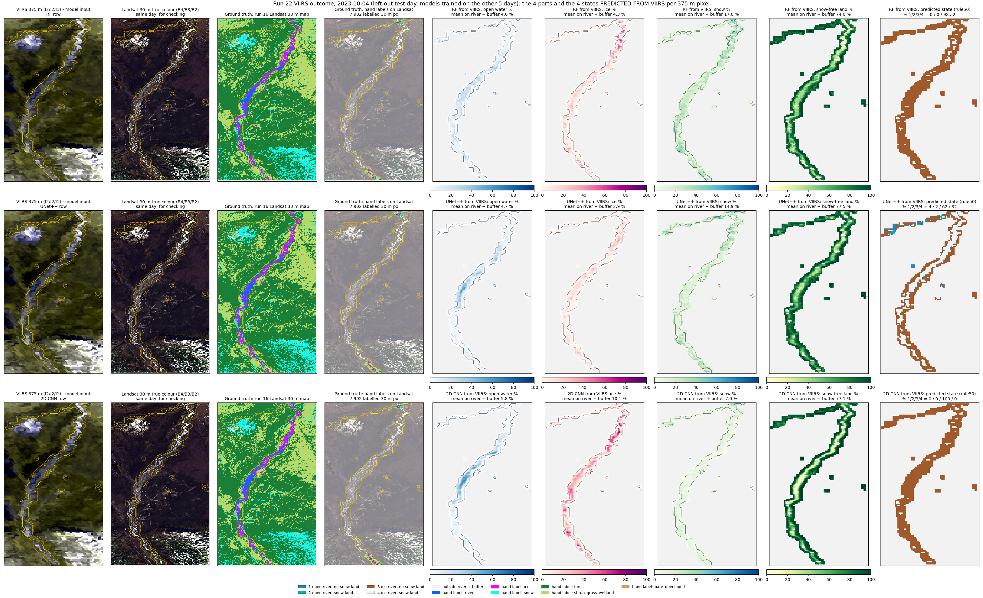
2023-10-04 (autumn freeze-up): VIIRS outcome.
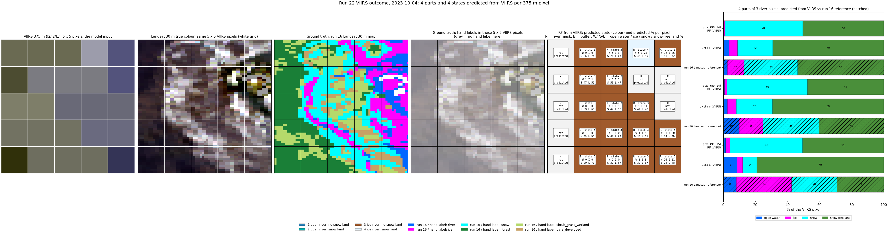
2023-10-04: VIIRS outcome, zoom.
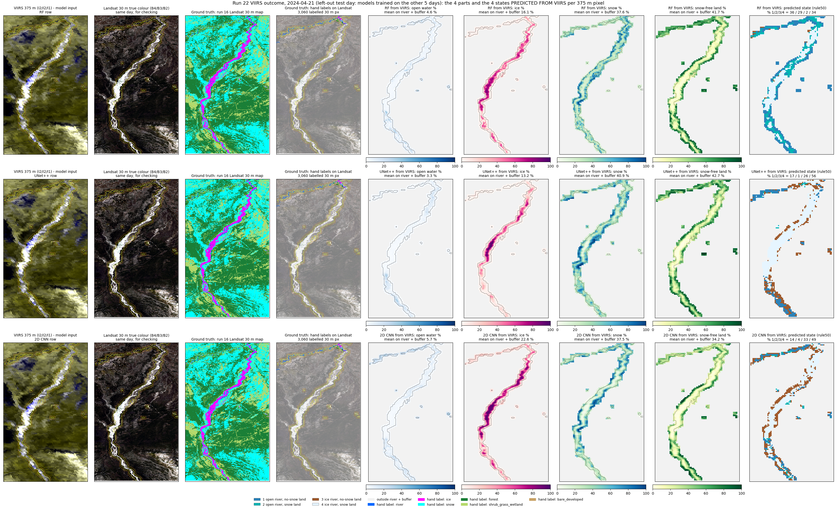
2024-04-21 (spring break-up): VIIRS outcome.
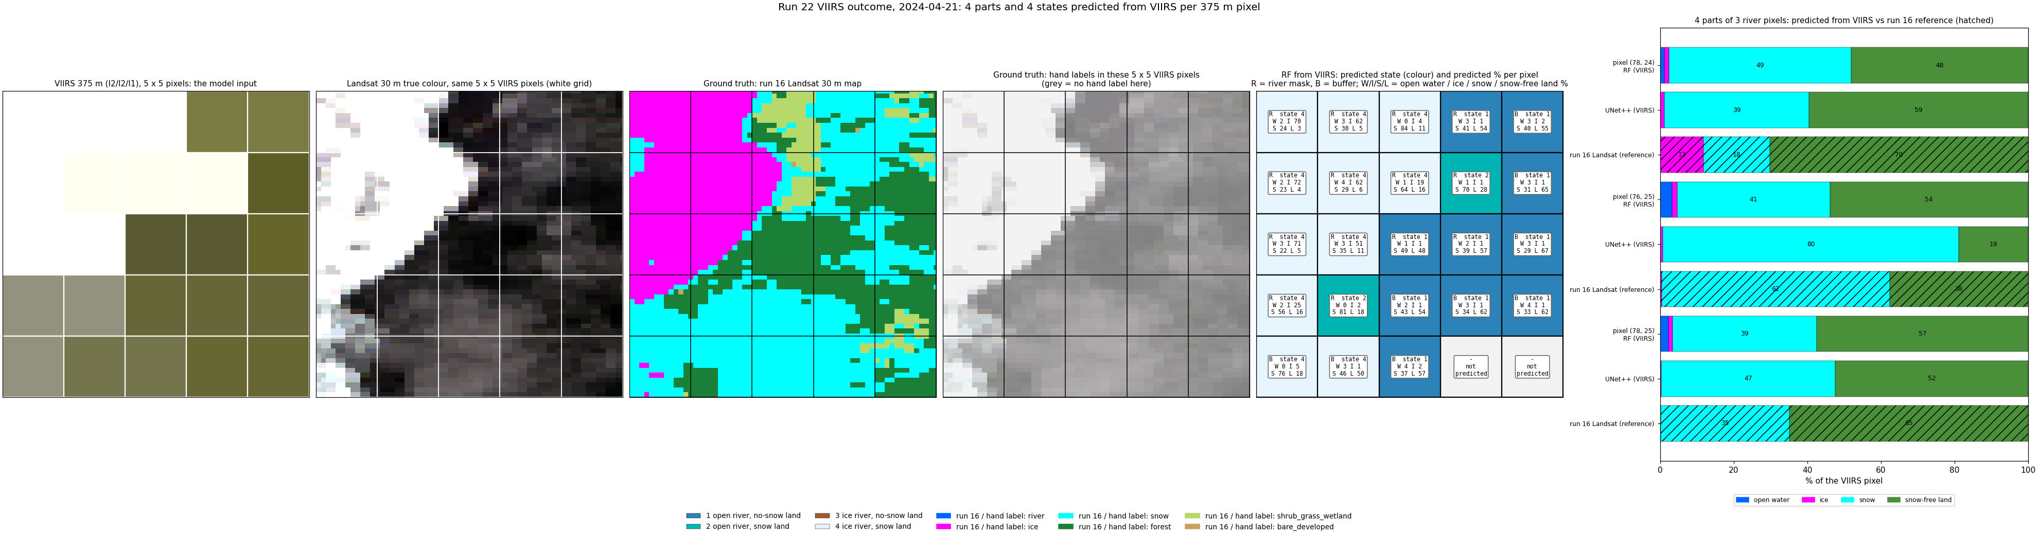
2024-04-21: VIIRS outcome, zoom.
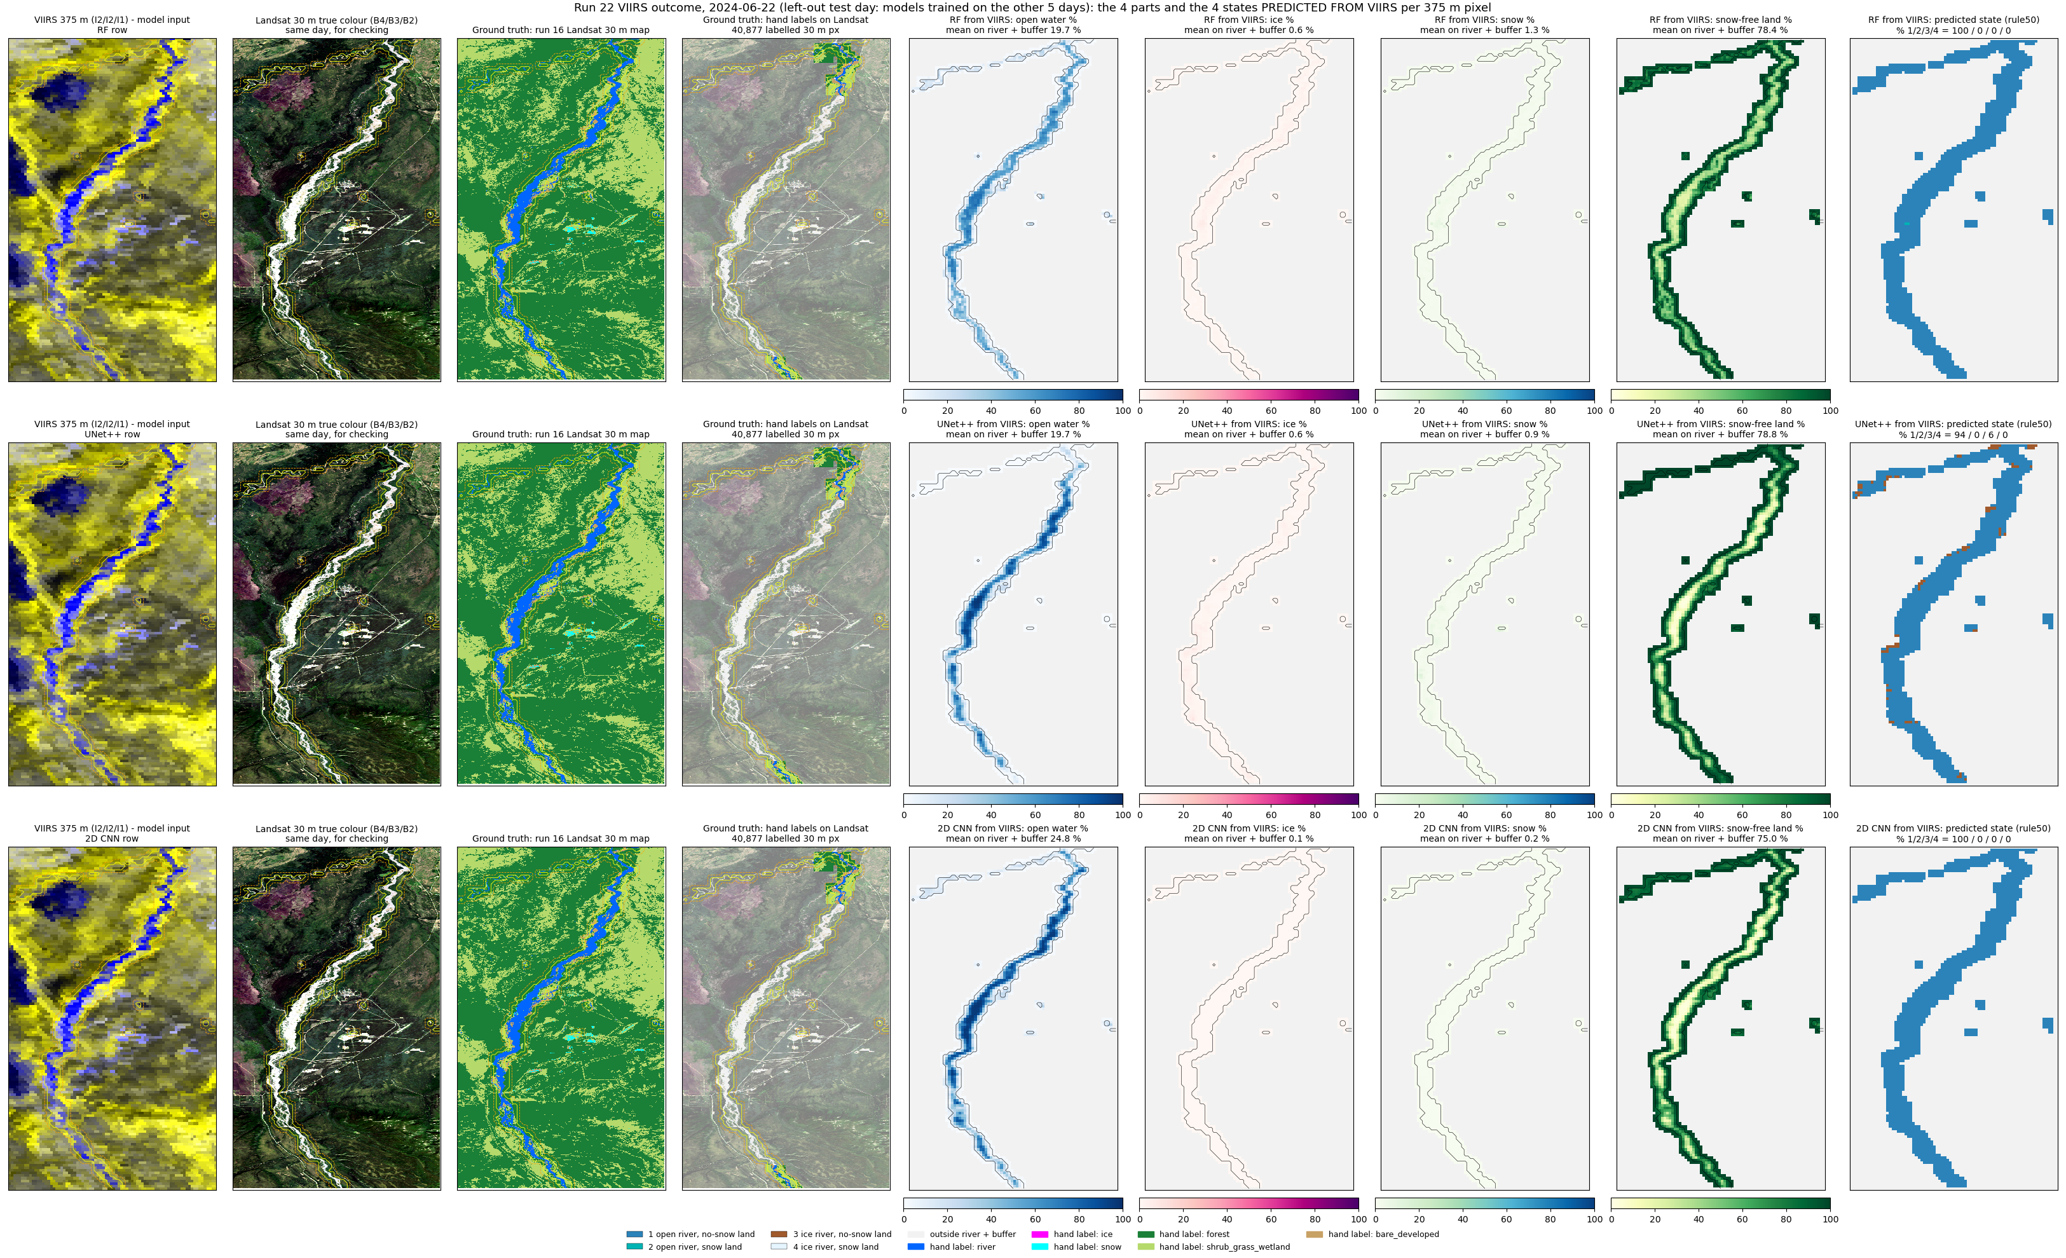
2024-06-22 (summer): VIIRS outcome.
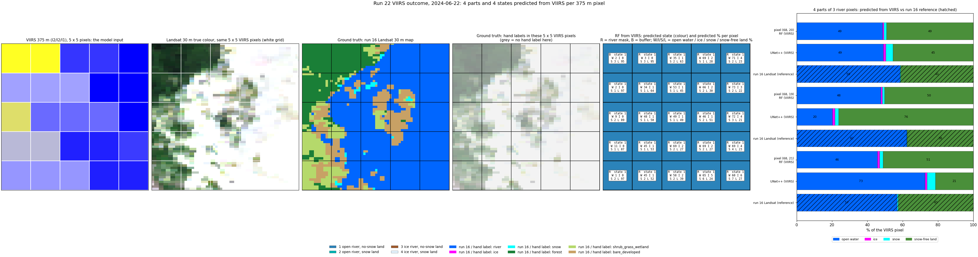
2024-06-22: VIIRS outcome, zoom.
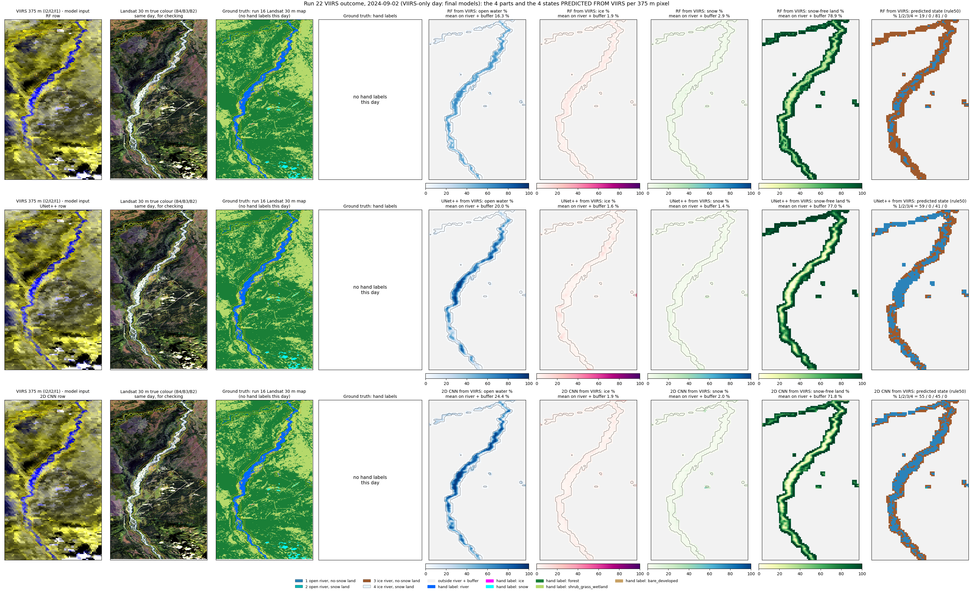
2024-09-02 (late summer): VIIRS outcome.
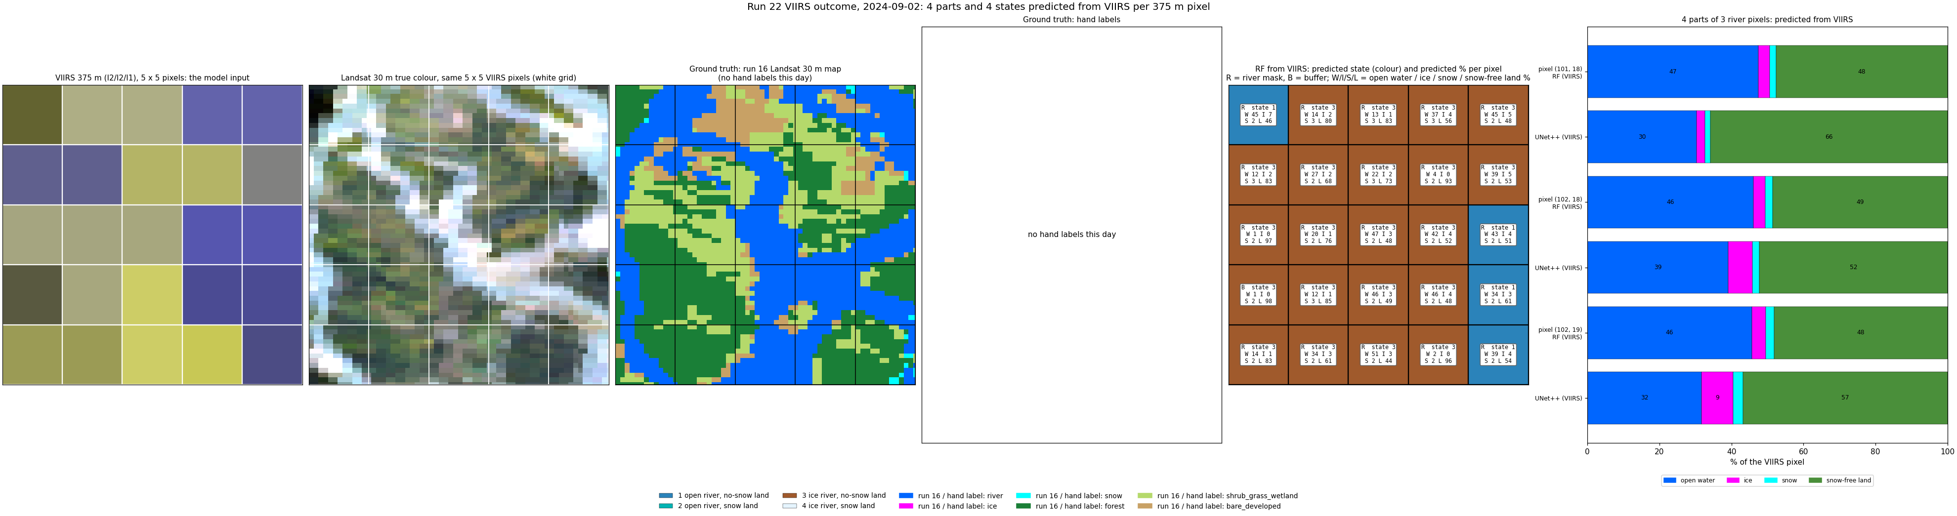
2024-09-02: VIIRS outcome, zoom.
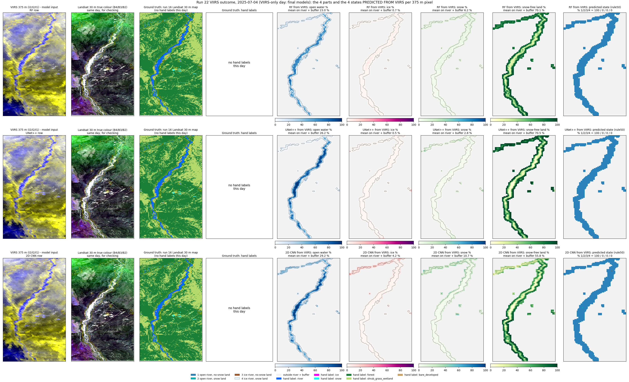
2025-07-04 (summer): VIIRS outcome.
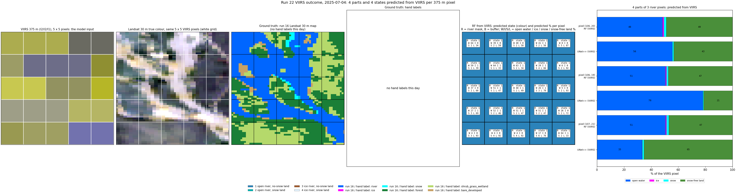
2025-07-04: VIIRS outcome, zoom.
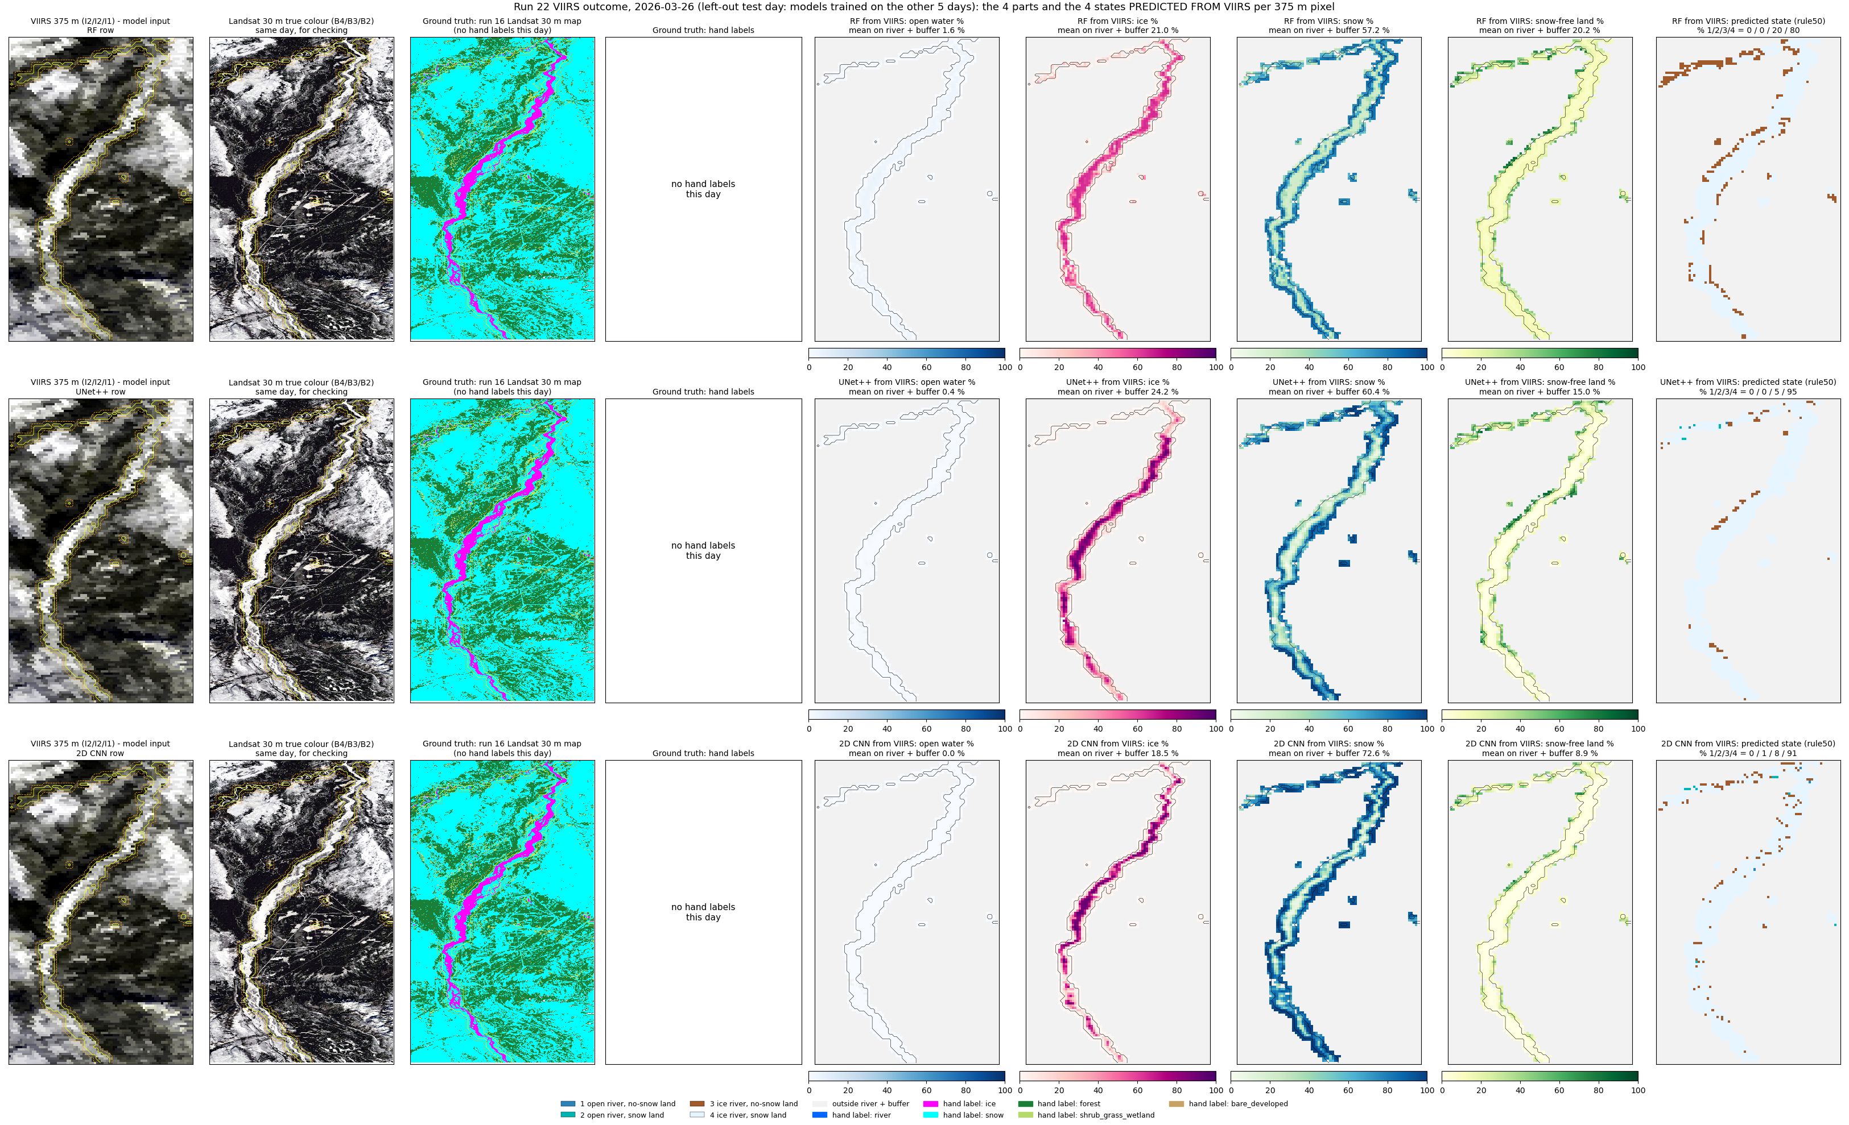
2026-03-26 (late winter): VIIRS outcome.
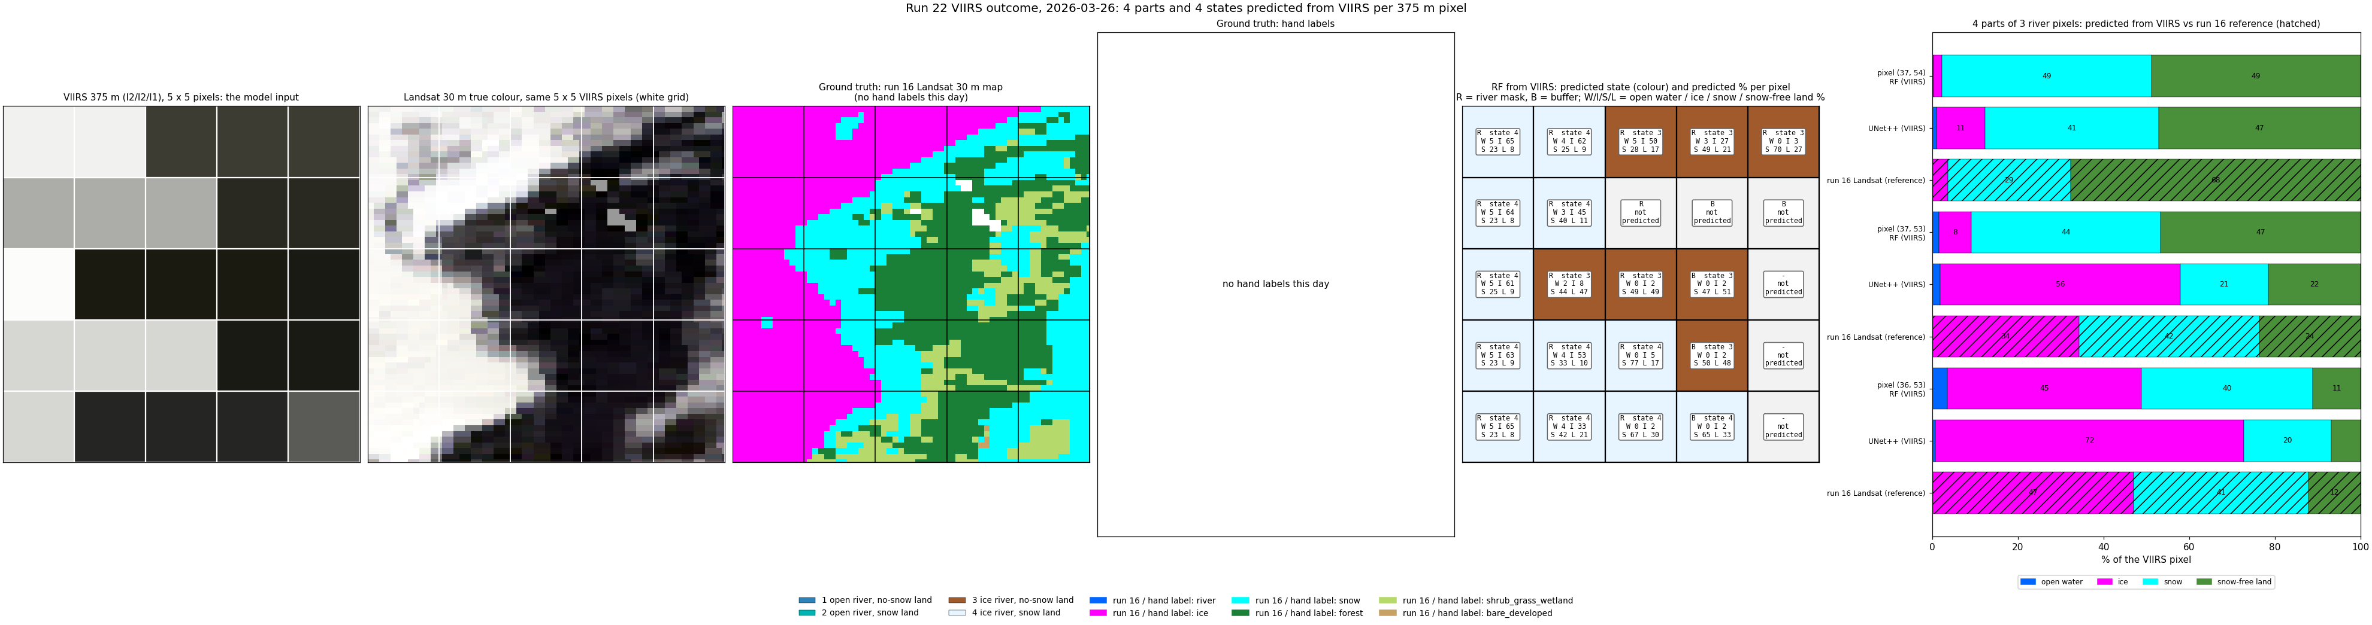
2026-03-26: VIIRS outcome, zoom.
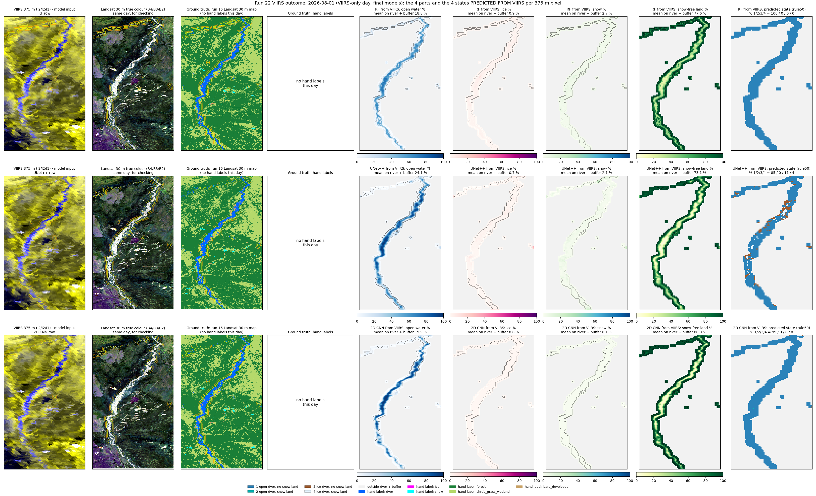
2026-08-01 (summer): VIIRS outcome.
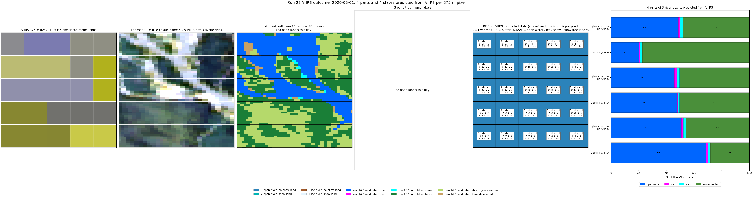
2026-08-01: VIIRS outcome, zoom.

6. Prediction images (v2)
VIIRS, Landsat, the run 16 map and the state maps (run 16-derived on labelled days, then RF, UNet++, 2D CNN). State 3 is pink; ice-covered states on pixels with more than 10 % water are shown as river ice (pink), each panel using its own water fraction. rule50 shown; rule90 versions are in predict/images_v2/.
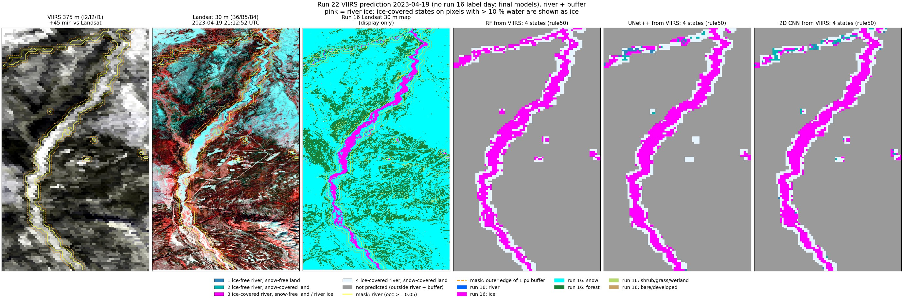
2023-04-19 (spring, snow, VIIRS only, final models).
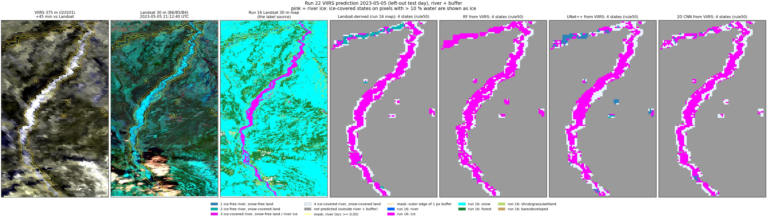
2023-05-05 (spring break-up, left-out test day).
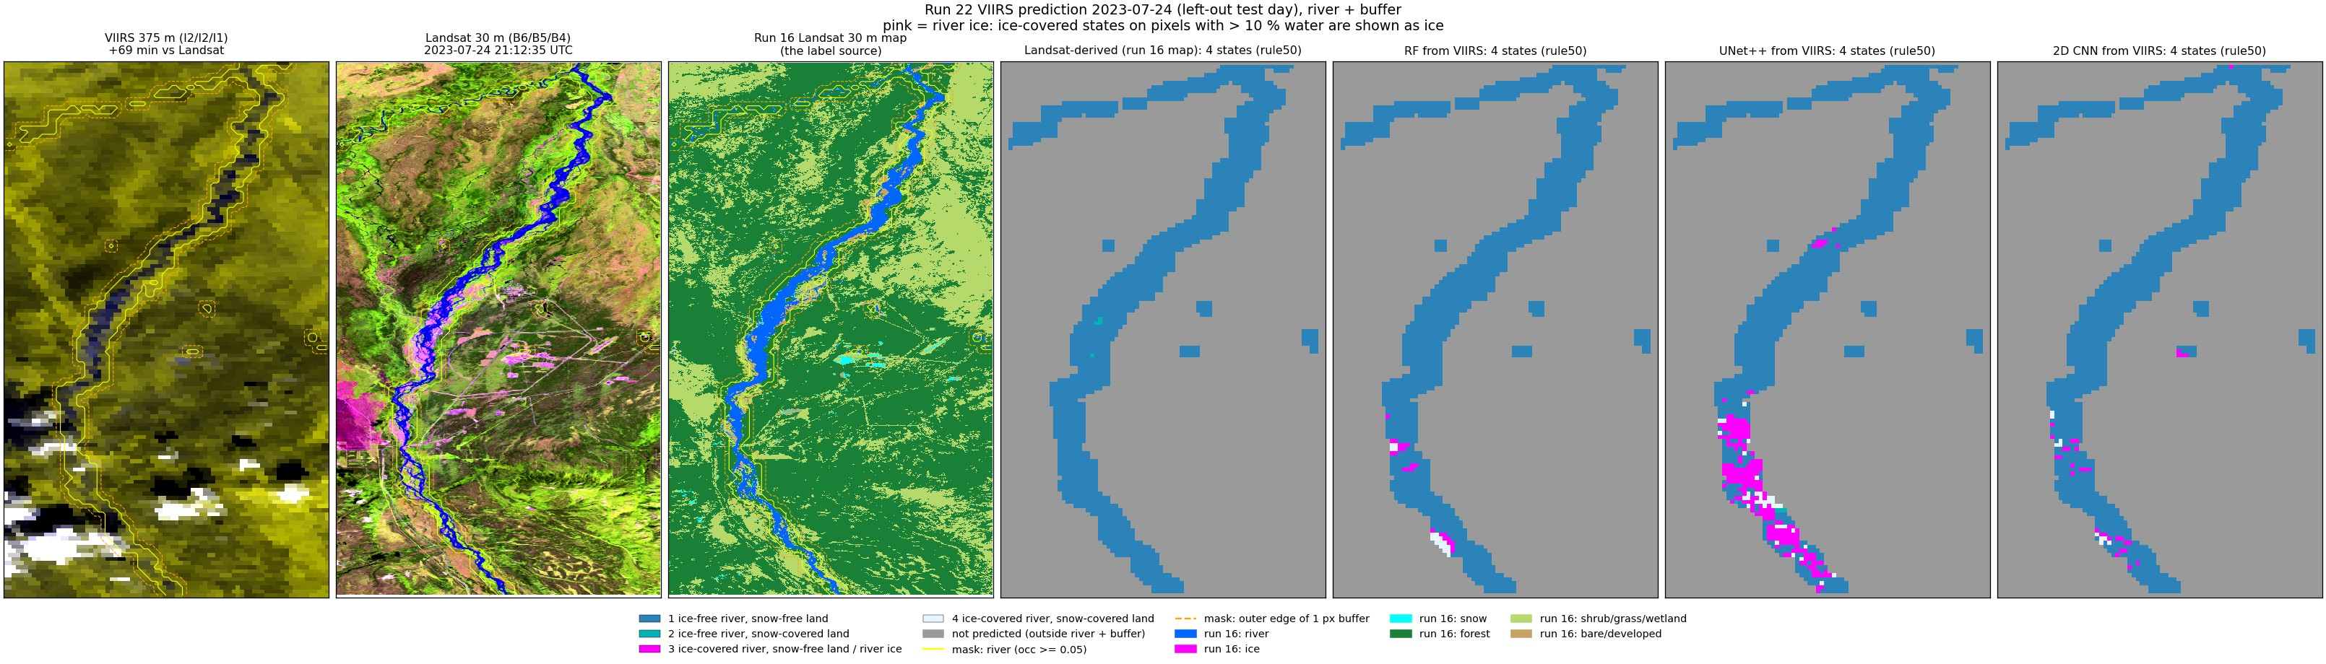
2023-07-24 (summer, left-out test day).
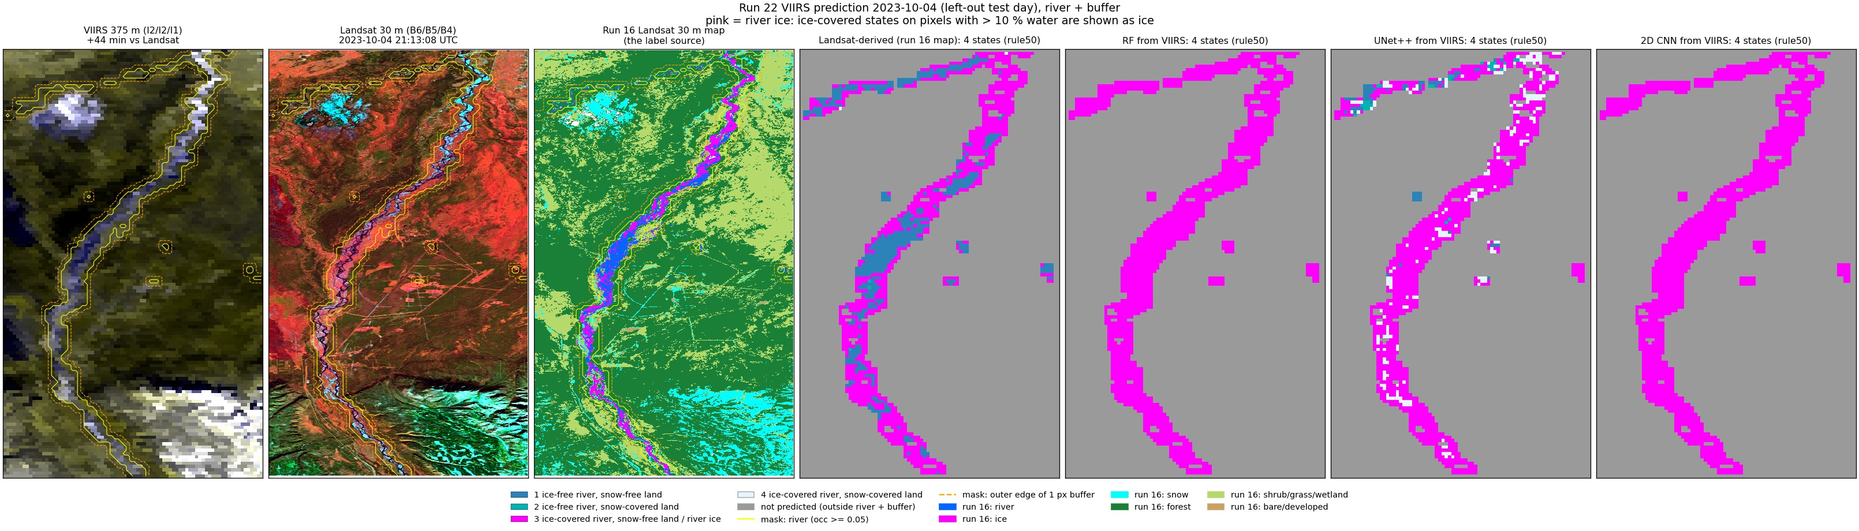
2023-10-04 (autumn freeze-up, left-out test day).
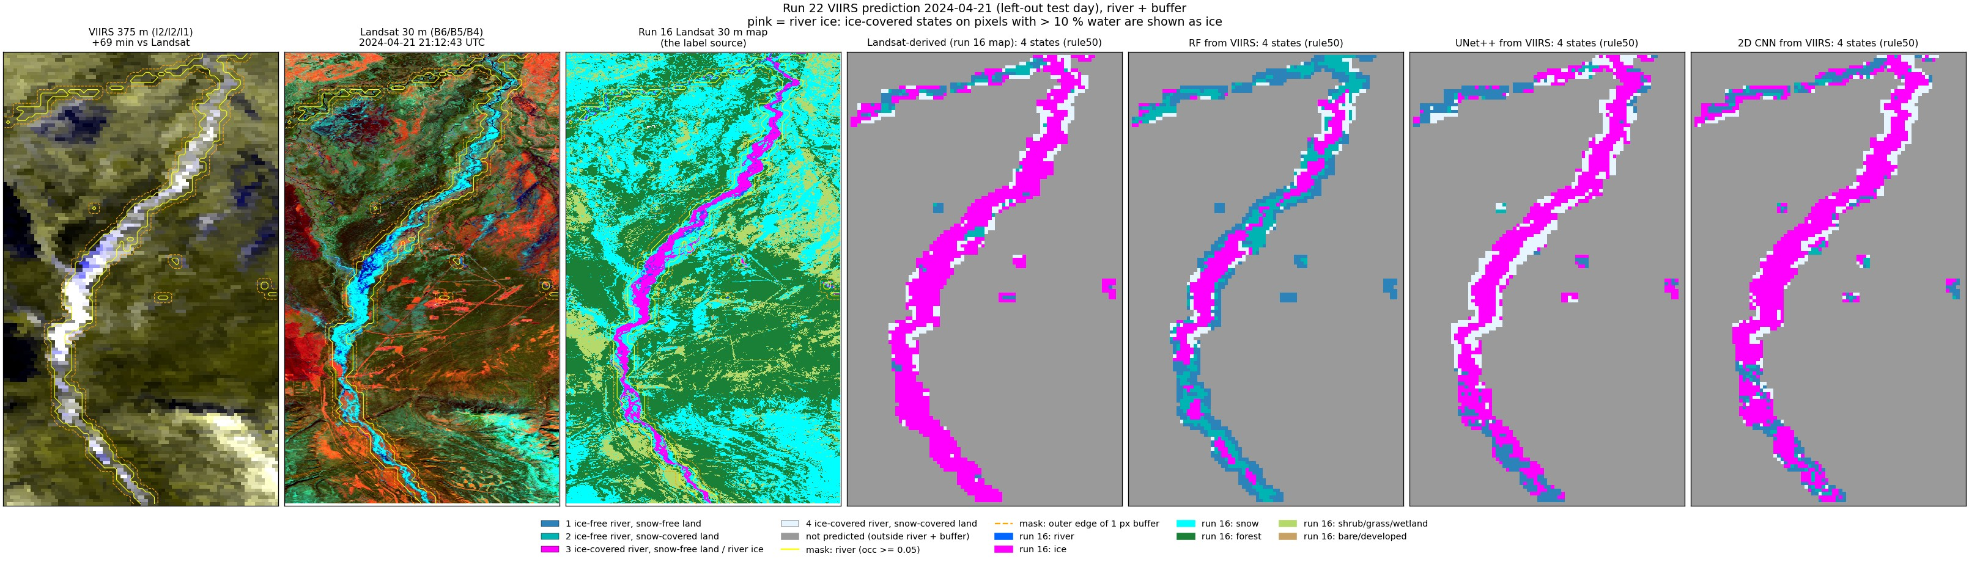
2024-04-21 (spring break-up, left-out test day).
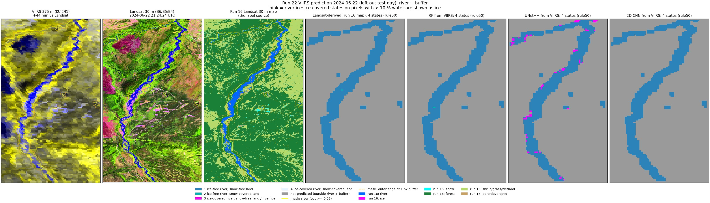
2024-06-22 (summer, left-out test day).
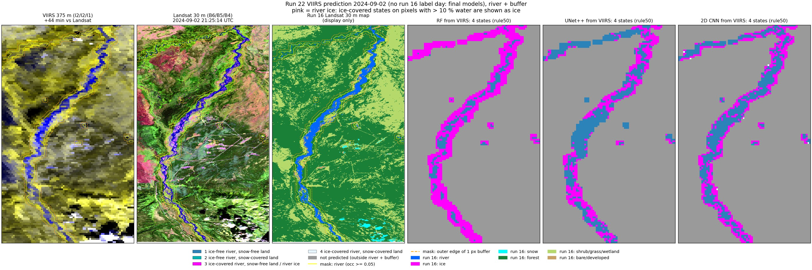
2024-09-02 (late summer, VIIRS only, final models).
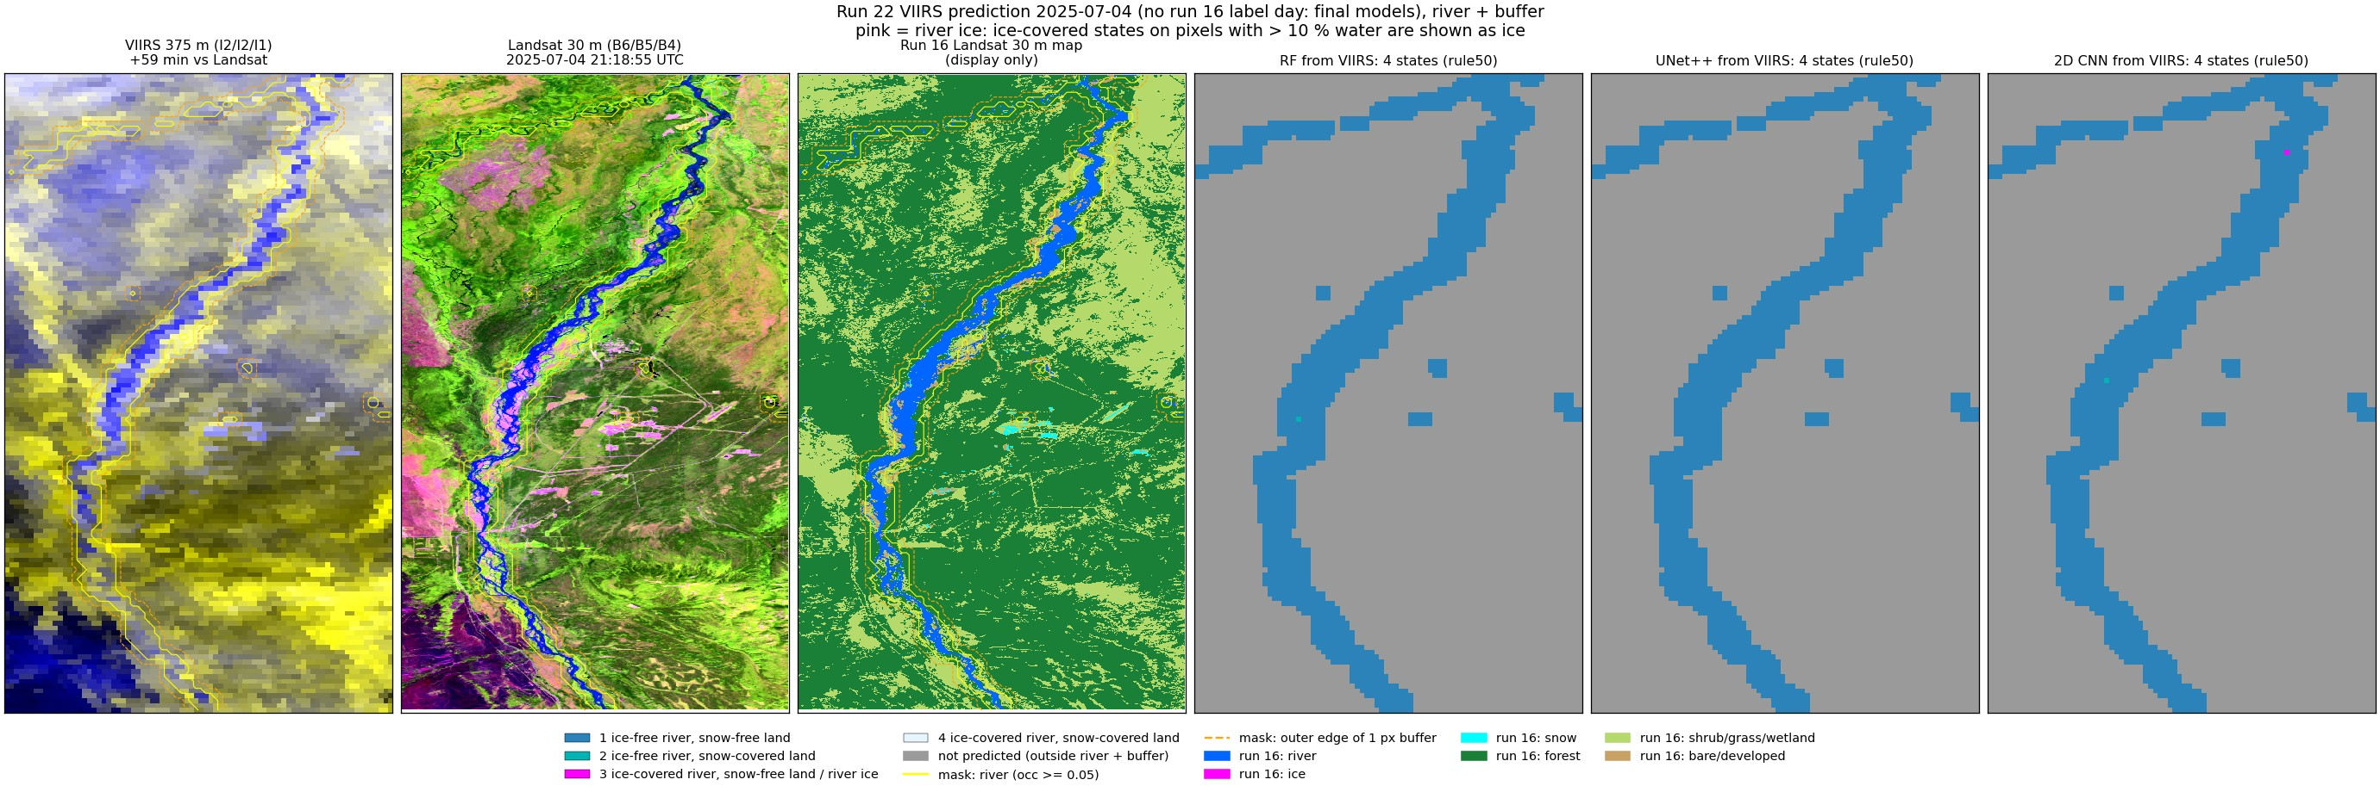
2025-07-04 (summer, VIIRS only, final models).
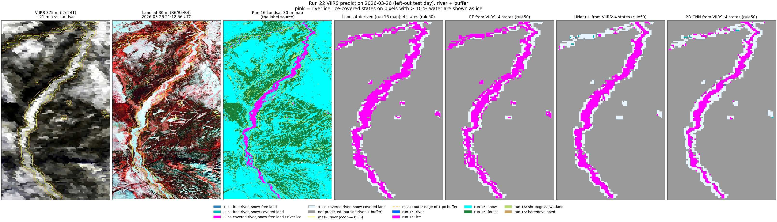
2026-03-26 (late winter, left-out test day).
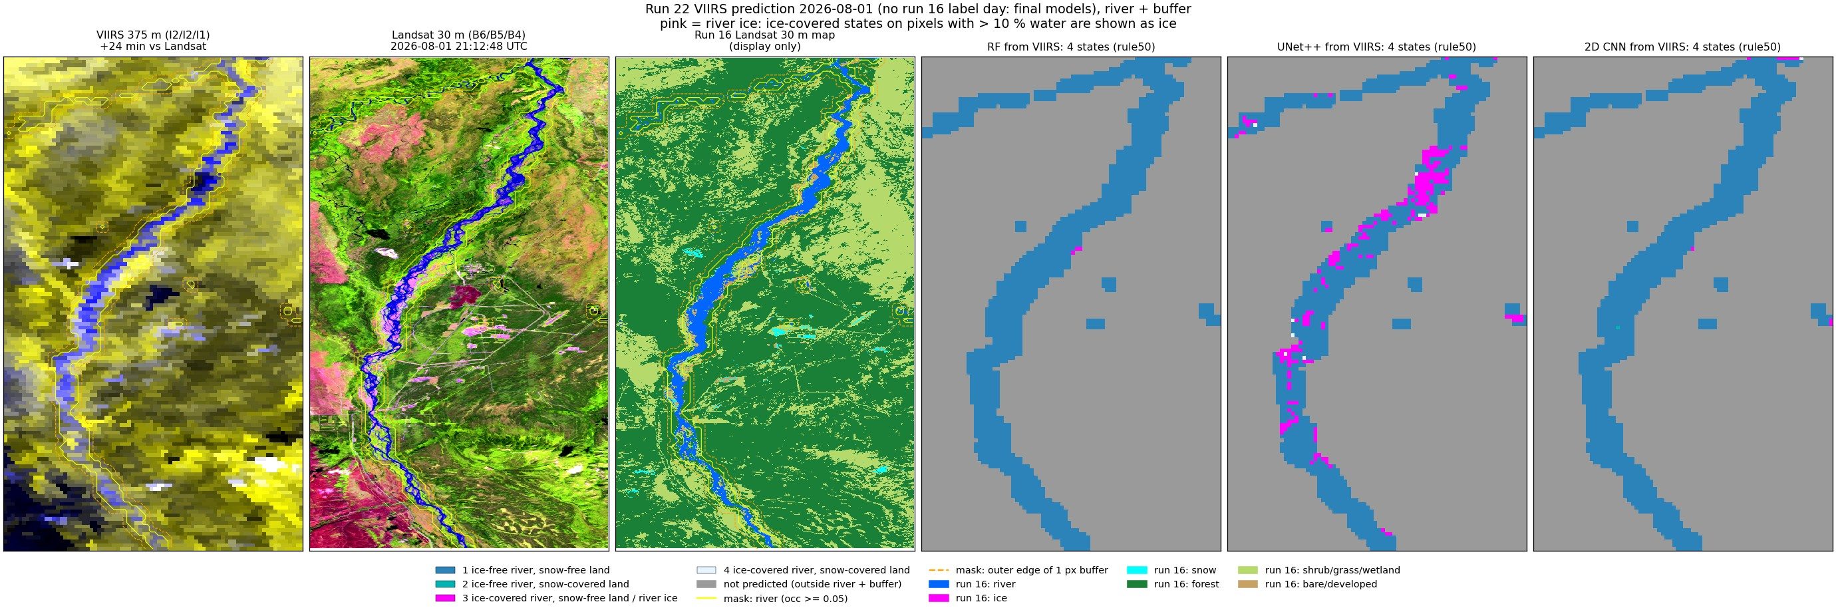
2026-08-01 (summer, VIIRS only, final models).

7. Things to know
- All accuracies are agreement with the run 16 map (a Landsat model), not with the ground; the hand labels cover only 4 days and small polygons.
- The state models and the fraction models are separate models, so a pixel's state and its fractions can disagree.
- Only 6 labelled days; ice and break-up come from 2-3 of them.
- No cloud mask on VIIRS.

8. Files
what | where (~/Desktop/nenana_crops/daksh/)
state models | viirs_river_states.py (RIVER_BUFFER=1, RIVER_LABELS=psf)
fraction models | viirs_states.py (RF, UNet++), make_cnn_pct.py (2D CNN)
fraction statistics | fraction_stats.py -> output/22_viirs_river_gauss/fraction_stats/ (stats.json, stats.csv, scatter.png)
figures | make_aggregation_figs*.py, make_viirs_outcome_figs.py, make_pred_images_v2.py
this report | report/word_content_v2.py + report/build_word.js

