Nenana river ice from VIIRS 375 m: run 22, run 19 with Gaussian (run 17) labels
Run 19 repeated with one change: the label of each VIIRS pixel comes from run 17's Gaussian-weighted class shares (sigma = 375 m / 2.8 = 134 m, cut at 2 sigma; Oleson et al. 1995) instead of the box count of the Landsat pixels inside the VIIRS pixel. Same river + 1 px buffer mask, inputs, models, dates and leave-one-date-out testing.

Contents

1. Summary
model | run 22 rule50 acc / F1 | run 22 rule90 | run 19 rule50 | run 19 rule90
RF | 0.771 / 0.619 | 0.860 / 0.671 | 0.794 / 0.644 | 0.818 / 0.662
UNet++ | 0.740 / 0.569 | 0.757 / 0.459 | 0.714 / 0.535 | 0.742 / 0.477
2D CNN | 0.807 / 0.630 | 0.880 / 0.674 | 0.812 / 0.655 | 0.854 / 0.664

- Gaussian labels help the strict rule90 for every model (best 2D CNN); rule50 stays about the same.
- The Gaussian footprint reaches past the VIIRS box, so labels at river edges are smoother and a few more edge pixels fail the >= 98 % check (9,565 scored pixels vs 9,645 in run 19).
- The yellow totals boxes in the prediction images still come from the run 18 (box) % models.

2. Labels: box (run 19) vs Gaussian (run 22)
- Box (runs 18-20): every Landsat pixel inside the VIIRS pixel counts equally (144-169 pixels).
- Gaussian (runs 17, 22): Landsat pixels are weighted by a Gaussian around the VIIRS pixel centre (sigma 134 m = 4.4 rows x 10.2 columns of Landsat pixels), cut at 2 sigma, so pixels just outside the box count a little and pixels at the box corners less.
- The shares are turned into open water / ice / snow / snow-free land % and the states exactly as in run 19.
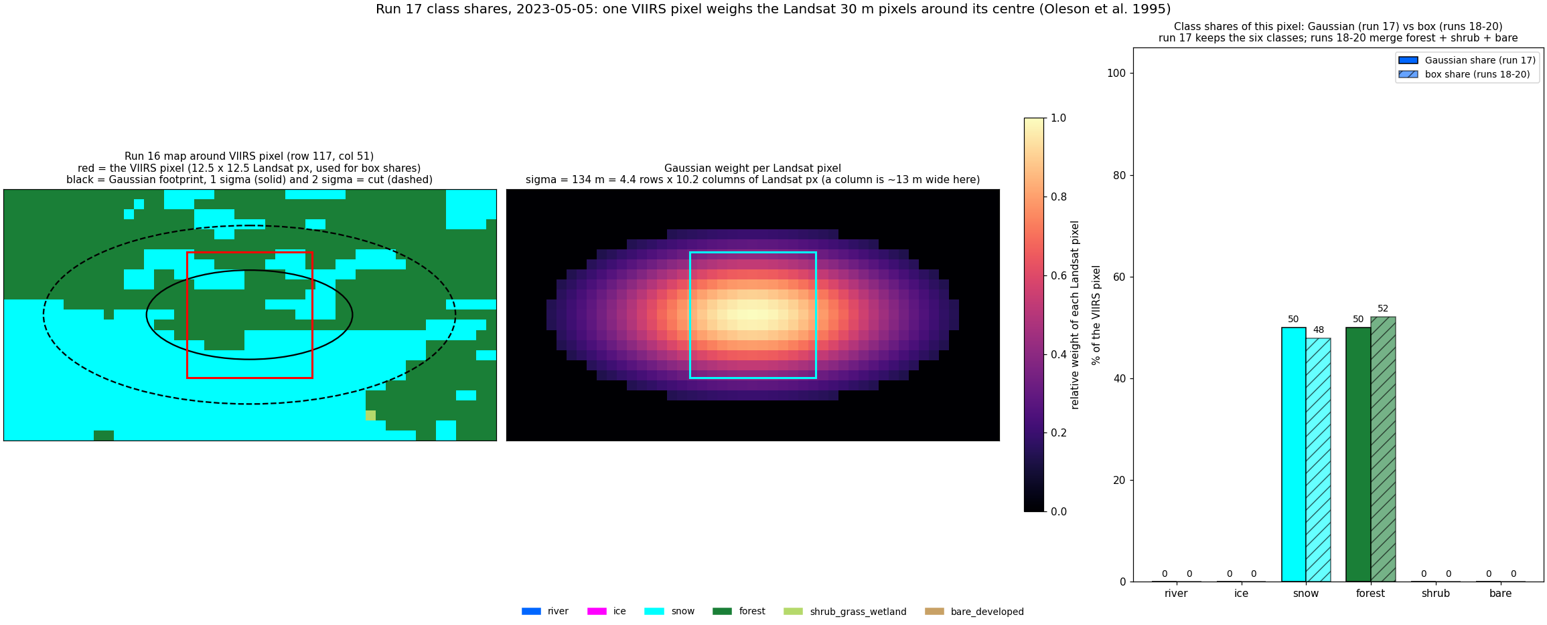
2023-05-05: one VIIRS pixel, Gaussian footprint vs box (the run 22 vs run 19 label).

3. Run 22: four states on the river + 1 px buffer, Gaussian labels
Same water mask as run 19: alaska_occ_375m.tif, river = occurrence >= 0.05 (988 px) plus a 1-pixel buffer (678 px). Labels from the Gaussian shares.
Models predict the four states at once (one 4-class model per rule), trained and scored only on these pixels: RF classifier with the run 16 settings (depth 16, min leaf 20, sqrt, 300 trees, balanced_subsample; 21 inputs, so no top-25 selection); UNet++ (resnet18, 4-class cross-entropy on mask pixels, 1500 steps, flips, flip TTA); 2D CNN (4 conv 3 x 3 layers 32-64-64-64 with batch norm and ReLU, dropout 0.1, 1 x 1 output, no down-sampling, so each pixel sees 9 x 9 VIIRS pixels = 3.4 km; 97k parameters; same training as UNet++).
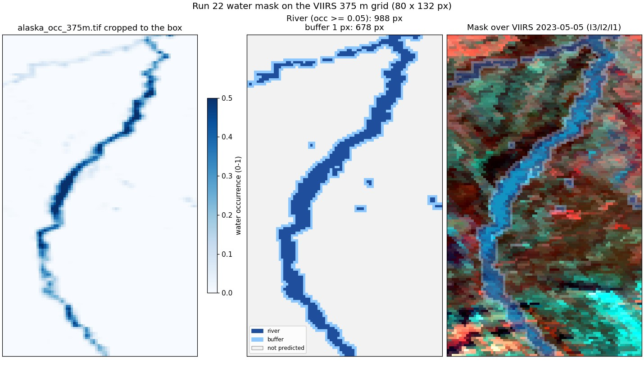
Run 22: the water mask cropped to the image and the predicted area.

rule50
model | accuracy | macro F1
RF | 0.771 | 0.619
UNet++ | 0.740 | 0.569
2D CNN | 0.807 | 0.630

state | true px | RF F1 | RF prec | RF rec | UNet++ F1 | UNet++ prec | UNet++ rec | 2D CNN F1 | 2D CNN prec | 2D CNN rec
1 open river, no-snow land | 3,911 | 0.85 | 0.86 | 0.84 | 0.83 | 0.89 | 0.78 | 0.89 | 0.94 | 0.84
2 open river, snow land | 169 | 0.17 | 0.12 | 0.32 | 0.12 | 0.20 | 0.08 | 0.12 | 0.18 | 0.09
3 ice river, no-snow land | 2,192 | 0.60 | 0.58 | 0.62 | 0.55 | 0.57 | 0.53 | 0.65 | 0.61 | 0.70
4 ice river, snow land | 3,293 | 0.85 | 0.90 | 0.81 | 0.78 | 0.71 | 0.87 | 0.85 | 0.83 | 0.88

RF confusion, rule50 (rows true, columns predicted)
true \ predicted | 1 | 2 | 3 | 4
1 open river, no-snow land | 3,289 | 23 | 572 | 27
2 open river, snow land | 17 | 54 | 83 | 15
3 ice river, no-snow land | 419 | 164 | 1,360 | 249
4 ice river, snow land | 81 | 227 | 315 | 2,670

UNet++ confusion, rule50 (rows true, columns predicted)
true \ predicted | 1 | 2 | 3 | 4
1 open river, no-snow land | 3,032 | 31 | 548 | 300
2 open river, snow land | 57 | 14 | 27 | 71
3 ice river, no-snow land | 194 | 13 | 1,157 | 828
4 ice river, snow land | 119 | 13 | 283 | 2,878

2D CNN confusion, rule50 (rows true, columns predicted)
true \ predicted | 1 | 2 | 3 | 4
1 open river, no-snow land | 3,277 | 9 | 597 | 28
2 open river, snow land | 35 | 16 | 46 | 72
3 ice river, no-snow land | 139 | 30 | 1,540 | 483
4 ice river, snow land | 34 | 32 | 338 | 2,889

rule90
model | accuracy | macro F1
RF | 0.860 | 0.671
UNet++ | 0.757 | 0.459
2D CNN | 0.880 | 0.674

state | true px | RF F1 | RF prec | RF rec | UNet++ F1 | UNet++ prec | UNet++ rec | 2D CNN F1 | 2D CNN prec | 2D CNN rec
1 open river, no-snow land | 3,301 | 0.88 | 0.93 | 0.83 | 0.83 | 0.80 | 0.87 | 0.93 | 0.93 | 0.92
2 open river, snow land | 174 | 0.17 | 0.11 | 0.36 | 0.02 | 0.02 | 0.01 | 0.14 | 0.15 | 0.13
3 ice river, no-snow land | 1,214 | 0.70 | 0.80 | 0.63 | 0.16 | 0.26 | 0.12 | 0.72 | 0.68 | 0.76
4 ice river, snow land | 4,876 | 0.93 | 0.91 | 0.96 | 0.83 | 0.79 | 0.87 | 0.92 | 0.92 | 0.91

RF confusion, rule90 (rows true, columns predicted)
true \ predicted | 1 | 2 | 3 | 4
1 open river, no-snow land | 2,727 | 408 | 99 | 67
2 open river, snow land | 60 | 63 | 6 | 45
3 ice river, no-snow land | 76 | 32 | 760 | 346
4 ice river, snow land | 61 | 50 | 88 | 4,677

UNet++ confusion, rule90 (rows true, columns predicted)
true \ predicted | 1 | 2 | 3 | 4
1 open river, no-snow land | 2,873 | 28 | 179 | 221
2 open river, snow land | 124 | 2 | 7 | 41
3 ice river, no-snow land | 177 | 25 | 141 | 871
4 ice river, snow land | 421 | 27 | 208 | 4,220

2D CNN confusion, rule90 (rows true, columns predicted)
true \ predicted | 1 | 2 | 3 | 4
1 open river, no-snow land | 3,050 | 43 | 142 | 66
2 open river, snow land | 102 | 22 | 13 | 37
3 ice river, no-snow land | 33 | 1 | 922 | 258
4 ice river, snow land | 100 | 79 | 276 | 4,421

Confusion matrices and other metrics
Rows = true state, columns = predicted state; each cell shows the pixel count and the % of that true state (recall). Balanced accuracy = mean recall over the states present; Cohen κ = agreement beyond chance; weighted F1 = F1 weighted by the number of true pixels per state.
rule | model | accuracy | balanced acc | Cohen κ | macro prec | macro rec | macro F1 | weighted F1
rule50 | RF | 0.771 | 0.648 | 0.660 | 0.616 | 0.648 | 0.619 | 0.783
rule50 | UNet++ | 0.740 | 0.565 | 0.606 | 0.592 | 0.565 | 0.569 | 0.736
rule50 | 2D CNN | 0.807 | 0.628 | 0.710 | 0.642 | 0.628 | 0.630 | 0.808
rule90 | RF | 0.860 | 0.693 | 0.770 | 0.689 | 0.693 | 0.671 | 0.871
rule90 | UNet++ | 0.757 | 0.466 | 0.579 | 0.469 | 0.466 | 0.459 | 0.729
rule90 | 2D CNN | 0.880 | 0.679 | 0.802 | 0.672 | 0.679 | 0.674 | 0.880

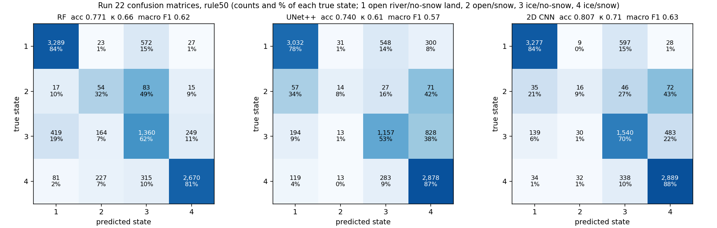
Run 22: confusion matrices, rule50, every model (leave-one-date-out).
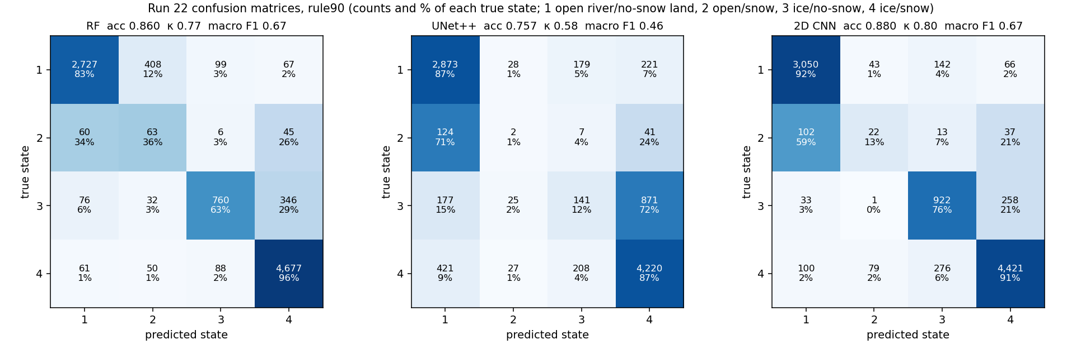
Run 22: confusion matrices, rule90, every model (leave-one-date-out).
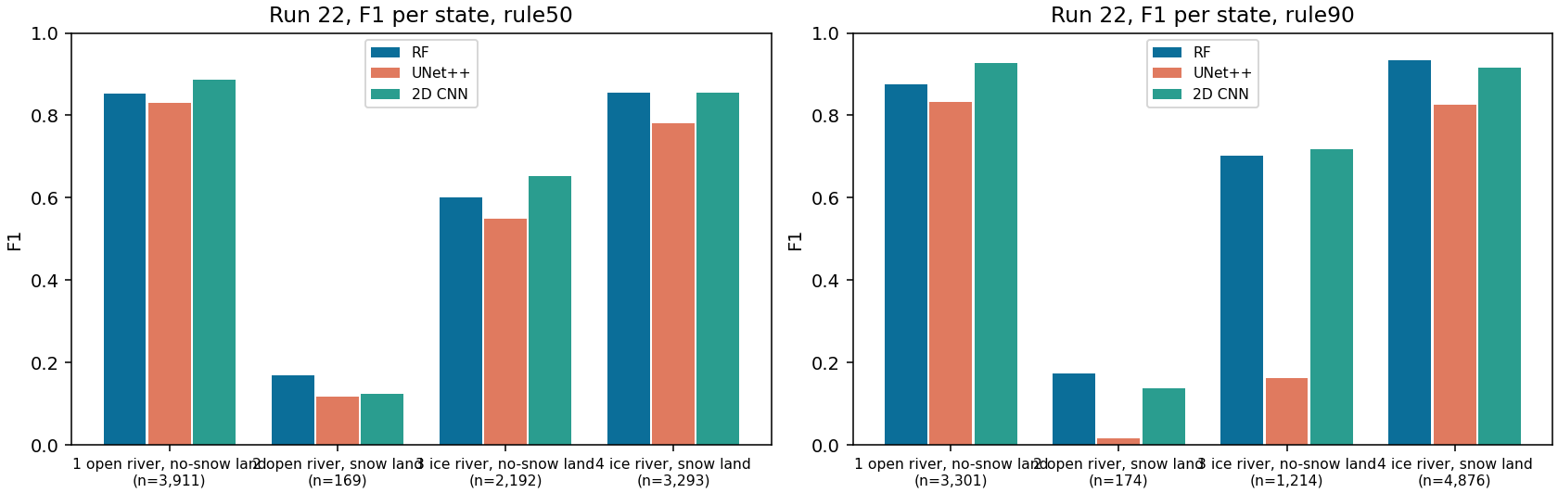
Run 22: F1 per state and model (n = true pixels).

Accuracy per date
date | px | RF 50 | RF 90 | UNet++ 50 | UNet++ 90 | 2D CNN 50 | 2D CNN 90
2023-05-05 | 1,585 | 0.76 | 0.97 | 0.74 | 0.85 | 0.80 | 0.97
2023-07-24 | 1,632 | 0.97 | 0.74 | 0.85 | 0.86 | 0.97 | 0.92
2023-10-04 | 1,567 | 0.65 | 0.68 | 0.47 | 0.29 | 0.66 | 0.70
2024-04-21 | 1,634 | 0.39 | 0.83 | 0.62 | 0.67 | 0.63 | 0.77
2024-06-22 | 1,635 | 1.00 | 0.96 | 0.94 | 0.88 | 1.00 | 0.96
2026-03-26 | 1,512 | 0.86 | 0.99 | 0.81 | 0.99 | 0.77 | 0.96

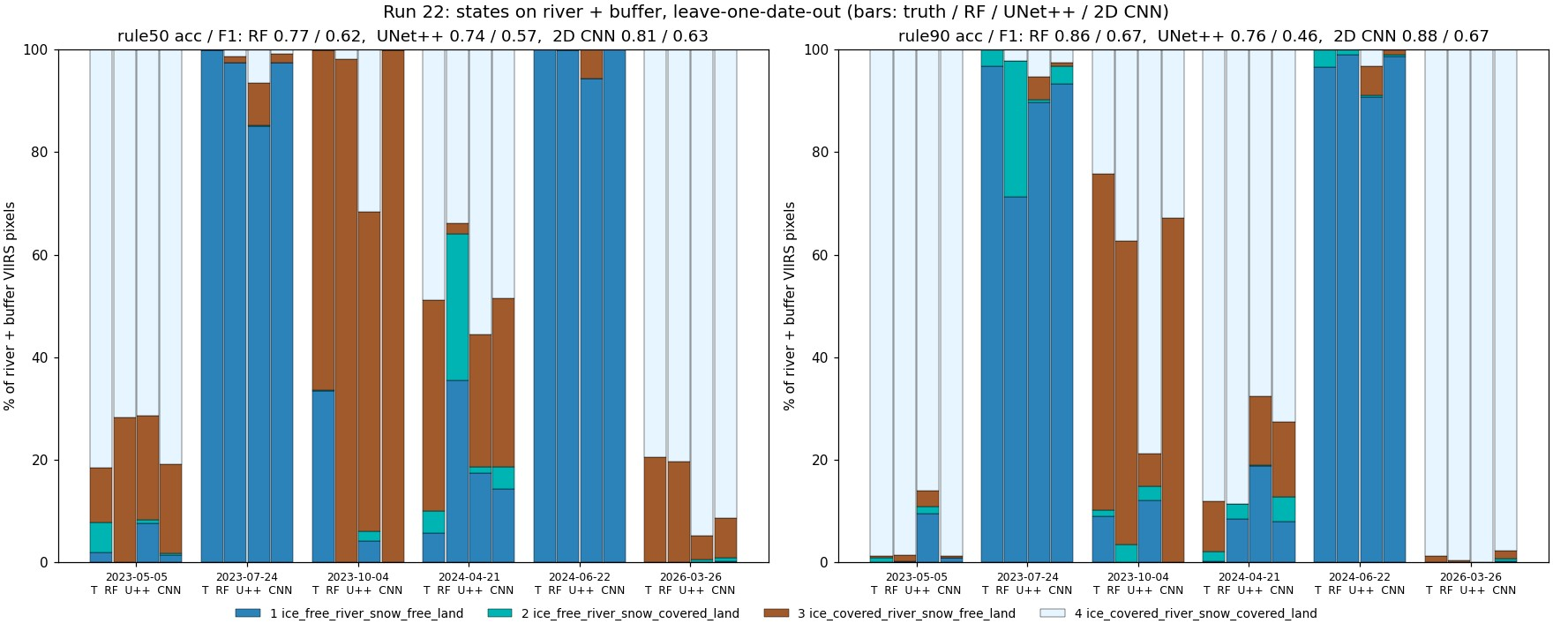
Run 22: states per date, truth and every model.

Prediction images with the water / land split
Each image starts with VIIRS (I3/I2/I1) and Landsat 30 m of the same day side by side, for visual checking. Landsat is shown in bands B6/B5/B4 (SWIR1 / NIR / red), the same bands as VIIRS I3/I2/I1, so colours compare directly: ice and snow are cyan, open water dark blue, vegetation green / red. Landsat exists for all 10 dates (the README of each Patches folder gives its time; VIIRS passed 21-69 min later). Our masks are drawn on both: yellow line = river (occurrence >= 0.05), orange dashed line = outer edge of the 1-pixel buffer (run 19 only). On days without a run 16 map, Landsat is only shown, never used as truth or input. Third panel: the run 16 Landsat 30 m map (six classes) - the label source on the 6 labelled days; on the 4 other days the run 16 model applied to that Landsat scene in run 17, shown for comparison only.
Then one map per model with all four predicted states. Yellow box: water (river) % vs land %, water split into open water / ice, land split into snow / no snow, for the predicted area and for the whole VIIRS image (the % comes from the run 18 % models; for the 2D CNN a % model of the same design). The six labelled days are left-out test days; the four VIIRS-only days are predicted by final models trained on all six labelled days.
date | source | area | water % | open / ice % of water | land % | snow / no snow % of land
2023-05-05 | Landsat truth | river + buffer | 24.6 | 5 / 95 | 75.4 | 77 / 23
2023-05-05 | Landsat truth | whole VIIRS image | 4.1 | 5 / 95 | 95.9 | 73 / 27
2023-05-05 | RF | river + buffer | 24.1 | 12 / 88 | 75.9 | 65 / 35
2023-05-05 | RF | whole VIIRS image | 6.8 | 20 / 80 | 93.2 | 64 / 36
2023-05-05 | UNet++ | river + buffer | 17.3 | 3 / 97 | 82.7 | 67 / 33
2023-05-05 | UNet++ | whole VIIRS image | 3.1 | 6 / 94 | 96.9 | 66 / 34
2023-05-05 | 2D CNN | river + buffer | 21.7 | 4 / 96 | 78.3 | 88 / 12
2023-05-05 | 2D CNN | whole VIIRS image | 3.6 | 4 / 96 | 96.4 | 85 / 15
2023-07-24 | Landsat truth | river + buffer | 24.2 | 100 / 0 | 75.8 | 1 / 99
2023-07-24 | Landsat truth | whole VIIRS image | 4.0 | 100 / 0 | 96.0 | 0 / 100
2023-07-24 | RF | river + buffer | 20.6 | 92 / 8 | 79.4 | 7 / 93
2023-07-24 | RF | whole VIIRS image | 4.5 | 92 / 8 | 95.5 | 6 / 94
2023-07-24 | UNet++ | river + buffer | 20.8 | 89 / 11 | 79.2 | 11 / 89
2023-07-24 | UNet++ | whole VIIRS image | 4.7 | 78 / 22 | 95.3 | 10 / 90
2023-07-24 | 2D CNN | river + buffer | 23.7 | 98 / 2 | 76.3 | 4 / 96
2023-07-24 | 2D CNN | whole VIIRS image | 4.0 | 97 / 3 | 96.0 | 4 / 96
2023-10-04 | Landsat truth | river + buffer | 22.9 | 49 / 51 | 77.1 | 5 / 95
2023-10-04 | Landsat truth | whole VIIRS image | 3.7 | 50 / 50 | 96.3 | 6 / 94
2023-10-04 | RF | river + buffer | 10.3 | 48 / 52 | 89.7 | 18 / 82
2023-10-04 | RF | whole VIIRS image | 1.8 | 49 / 51 | 98.2 | 13 / 87
2023-10-04 | UNet++ | river + buffer | 8.5 | 54 / 46 | 91.5 | 16 / 84
2023-10-04 | UNet++ | whole VIIRS image | 1.5 | 53 / 47 | 98.5 | 10 / 90
2023-10-04 | 2D CNN | river + buffer | 15.9 | 36 / 64 | 84.1 | 8 / 92
2023-10-04 | 2D CNN | whole VIIRS image | 2.7 | 37 / 63 | 97.3 | 11 / 89
2024-04-21 | Landsat truth | river + buffer | 24.2 | 10 / 90 | 75.8 | 48 / 52
2024-04-21 | Landsat truth | whole VIIRS image | 4.0 | 11 / 89 | 96.0 | 36 / 64
2024-04-21 | RF | river + buffer | 21.8 | 19 / 81 | 78.2 | 48 / 52
2024-04-21 | RF | whole VIIRS image | 6.7 | 50 / 50 | 93.3 | 29 / 71
2024-04-21 | UNet++ | river + buffer | 16.7 | 16 / 84 | 83.3 | 49 / 51
2024-04-21 | UNet++ | whole VIIRS image | 3.1 | 19 / 81 | 96.9 | 32 / 68
2024-04-21 | 2D CNN | river + buffer | 28.2 | 20 / 80 | 71.8 | 52 / 48
2024-04-21 | 2D CNN | whole VIIRS image | 8.9 | 39 / 61 | 91.1 | 39 / 61
2024-06-22 | Landsat truth | river + buffer | 24.2 | 100 / 0 | 75.8 | 1 / 99
2024-06-22 | Landsat truth | whole VIIRS image | 4.0 | 100 / 0 | 96.0 | 0 / 100
2024-06-22 | RF | river + buffer | 21.4 | 97 / 3 | 78.6 | 2 / 98
2024-06-22 | RF | whole VIIRS image | 3.8 | 97 / 3 | 96.2 | 1 / 99
2024-06-22 | UNet++ | river + buffer | 18.4 | 97 / 3 | 81.6 | 1 / 99
2024-06-22 | UNet++ | whole VIIRS image | 3.1 | 96 / 4 | 96.9 | 0 / 100
2024-06-22 | 2D CNN | river + buffer | 24.8 | 100 / 0 | 75.2 | 0 / 100
2024-06-22 | 2D CNN | whole VIIRS image | 4.9 | 99 / 1 | 95.1 | 0 / 100
2026-03-26 | Landsat truth | river + buffer | 25.5 | 0 / 100 | 74.5 | 70 / 30
2026-03-26 | Landsat truth | whole VIIRS image | 4.2 | 0 / 100 | 95.8 | 67 / 33
2026-03-26 | RF | river + buffer | 23.6 | 7 / 93 | 76.4 | 74 / 26
2026-03-26 | RF | whole VIIRS image | 5.2 | 8 / 92 | 94.8 | 66 / 34
2026-03-26 | UNet++ | river + buffer | 29.1 | 1 / 99 | 70.9 | 82 / 18
2026-03-26 | UNet++ | whole VIIRS image | 5.2 | 2 / 98 | 94.8 | 79 / 21
2026-03-26 | 2D CNN | river + buffer | 18.4 | 0 / 100 | 81.6 | 89 / 11
2026-03-26 | 2D CNN | whole VIIRS image | 3.0 | 0 / 100 | 97.0 | 88 / 12
2023-04-19 | RF | river + buffer | 23.0 | 1 / 99 | 77.0 | 82 / 18
2023-04-19 | RF | whole VIIRS image | 4.7 | 3 / 97 | 95.3 | 77 / 23
2023-04-19 | UNet++ | river + buffer | 24.0 | 1 / 99 | 76.0 | 80 / 20
2023-04-19 | UNet++ | whole VIIRS image | 4.5 | 6 / 94 | 95.5 | 76 / 24
2023-04-19 | 2D CNN | river + buffer | 25.9 | 1 / 99 | 74.1 | 86 / 14
2023-04-19 | 2D CNN | whole VIIRS image | 4.6 | 5 / 95 | 95.4 | 78 / 22
2024-09-02 | RF | river + buffer | 18.2 | 90 / 10 | 81.8 | 4 / 96
2024-09-02 | RF | whole VIIRS image | 3.3 | 90 / 10 | 96.7 | 2 / 98
2024-09-02 | UNet++ | river + buffer | 22.1 | 92 / 8 | 77.9 | 2 / 98
2024-09-02 | UNet++ | whole VIIRS image | 4.9 | 77 / 23 | 95.1 | 1 / 99
2024-09-02 | 2D CNN | river + buffer | 26.3 | 93 / 7 | 73.7 | 3 / 97
2024-09-02 | 2D CNN | whole VIIRS image | 5.4 | 82 / 18 | 94.6 | 2 / 98
2025-07-04 | RF | river + buffer | 23.7 | 97 / 3 | 76.3 | 8 / 92
2025-07-04 | RF | whole VIIRS image | 7.7 | 98 / 2 | 92.3 | 6 / 94
2025-07-04 | UNet++ | river + buffer | 26.8 | 98 / 2 | 73.2 | 3 / 97
2025-07-04 | UNet++ | whole VIIRS image | 6.2 | 82 / 18 | 93.8 | 3 / 97
2025-07-04 | 2D CNN | river + buffer | 33.4 | 87 / 13 | 66.6 | 16 / 84
2025-07-04 | 2D CNN | whole VIIRS image | 8.8 | 70 / 30 | 91.2 | 24 / 76
2026-08-01 | RF | river + buffer | 19.7 | 96 / 4 | 80.3 | 3 / 97
2026-08-01 | RF | whole VIIRS image | 3.6 | 96 / 4 | 96.4 | 2 / 98
2026-08-01 | UNet++ | river + buffer | 25.7 | 97 / 3 | 74.3 | 3 / 97
2026-08-01 | UNet++ | whole VIIRS image | 5.7 | 81 / 19 | 94.3 | 2 / 98
2026-08-01 | 2D CNN | river + buffer | 20.0 | 100 / 0 | 80.0 | 0 / 100
2026-08-01 | 2D CNN | whole VIIRS image | 3.3 | 99 / 1 | 96.7 | 0 / 100

States, % of predicted pixels (1 / 2 / 3 / 4), rule50
date | source | 1 | 2 | 3 | 4
2023-05-05 | Landsat truth | 2.0 | 5.7 | 10.8 | 81.5
2023-05-05 | RF | 0.1 | 0.0 | 28.1 | 71.8
2023-05-05 | UNet++ | 7.6 | 0.8 | 20.3 | 71.4
2023-05-05 | 2D CNN | 1.5 | 0.3 | 17.4 | 80.8
2023-07-24 | Landsat truth | 99.8 | 0.2 | 0.0 | 0.0
2023-07-24 | RF | 97.4 | 0.0 | 1.2 | 1.4
2023-07-24 | UNet++ | 85.0 | 0.2 | 8.3 | 6.5
2023-07-24 | 2D CNN | 97.4 | 0.0 | 1.7 | 0.9
2023-10-04 | Landsat truth | 33.4 | 0.2 | 66.2 | 0.2
2023-10-04 | RF | 0.0 | 0.0 | 98.1 | 1.9
2023-10-04 | UNet++ | 4.2 | 1.9 | 62.3 | 31.7
2023-10-04 | 2D CNN | 0.0 | 0.0 | 99.9 | 0.1
2024-04-21 | Landsat truth | 5.7 | 4.3 | 41.2 | 48.8
2024-04-21 | RF | 35.6 | 28.5 | 2.0 | 34.0
2024-04-21 | UNet++ | 17.4 | 1.2 | 25.7 | 55.6
2024-04-21 | 2D CNN | 14.3 | 4.3 | 32.8 | 48.6
2024-06-22 | Landsat truth | 99.9 | 0.1 | 0.0 | 0.0
2024-06-22 | RF | 99.9 | 0.1 | 0.0 | 0.0
2024-06-22 | UNet++ | 94.3 | 0.0 | 5.7 | 0.0
2024-06-22 | 2D CNN | 100.0 | 0.0 | 0.0 | 0.0
2026-03-26 | Landsat truth | 0.0 | 0.0 | 20.6 | 79.4
2026-03-26 | RF | 0.0 | 0.0 | 19.6 | 80.4
2026-03-26 | UNet++ | 0.1 | 0.4 | 4.6 | 94.8
2026-03-26 | 2D CNN | 0.2 | 0.7 | 7.7 | 91.3
2023-04-19 | RF | 0.0 | 0.0 | 11.7 | 88.3
2023-04-19 | UNet++ | 0.8 | 1.4 | 13.9 | 83.9
2023-04-19 | 2D CNN | 1.1 | 3.8 | 7.9 | 87.1
2024-09-02 | RF | 19.1 | 0.0 | 80.9 | 0.0
2024-09-02 | UNet++ | 48.3 | 0.0 | 51.7 | 0.0
2024-09-02 | 2D CNN | 55.2 | 0.1 | 44.7 | 0.1
2025-07-04 | RF | 99.9 | 0.1 | 0.0 | 0.0
2025-07-04 | UNet++ | 100.0 | 0.0 | 0.0 | 0.0
2025-07-04 | 2D CNN | 99.9 | 0.1 | 0.1 | 0.0
2026-08-01 | RF | 99.8 | 0.0 | 0.2 | 0.0
2026-08-01 | UNet++ | 85.3 | 0.0 | 9.2 | 5.5
2026-08-01 | 2D CNN | 99.4 | 0.1 | 0.2 | 0.4

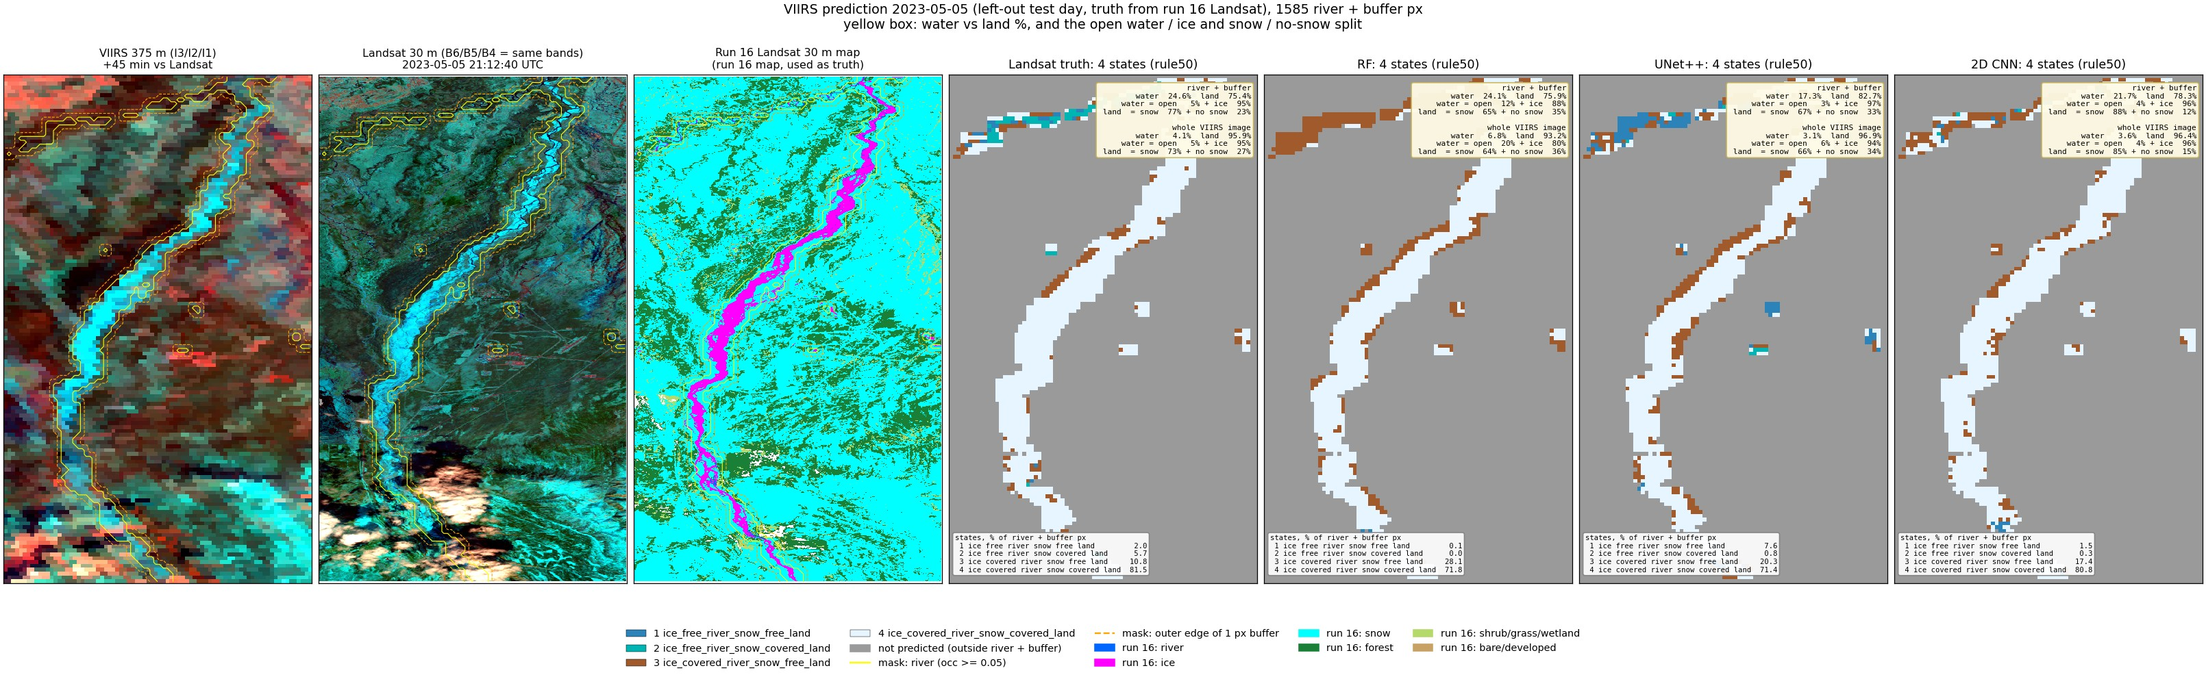
Run 22, 2023-05-05 (spring break-up, left-out test day): predicted states (rule50) and the water / land split.
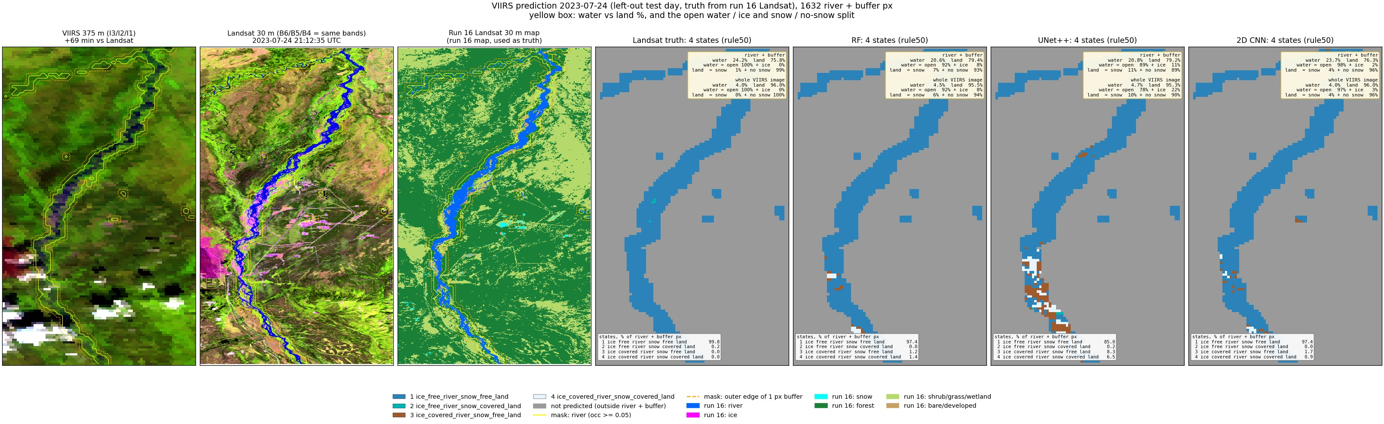
Run 22, 2023-07-24 (summer, left-out test day): predicted states (rule50) and the water / land split.
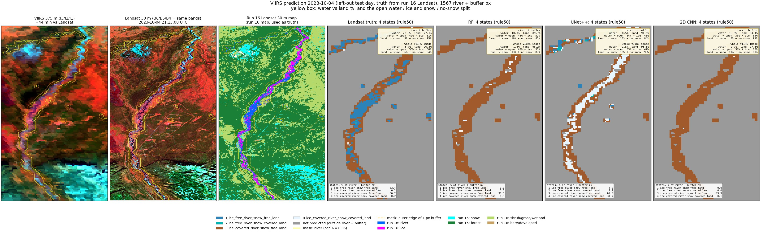
Run 22, 2023-10-04 (autumn freeze-up, left-out test day): predicted states (rule50) and the water / land split.
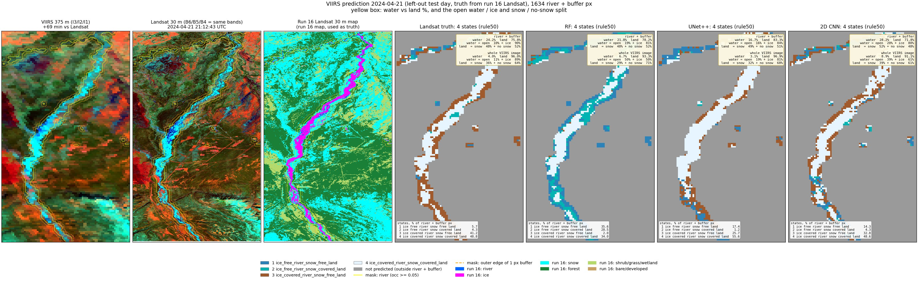
Run 22, 2024-04-21 (spring break-up, left-out test day): predicted states (rule50) and the water / land split.
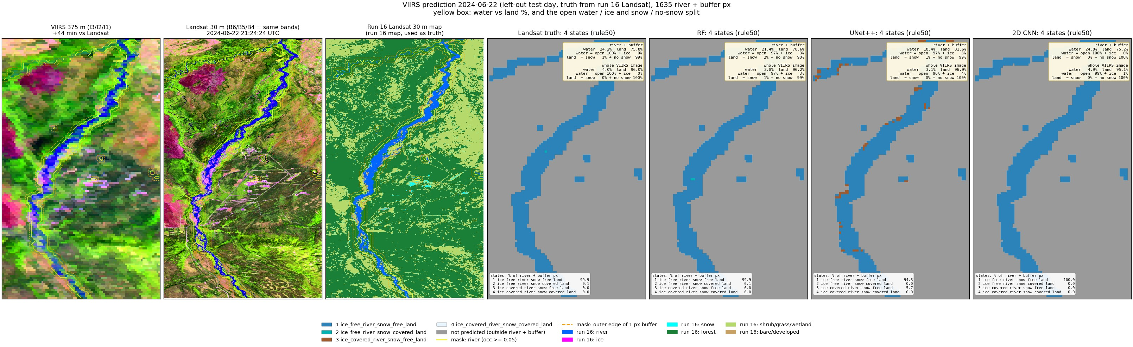
Run 22, 2024-06-22 (summer, left-out test day): predicted states (rule50) and the water / land split.
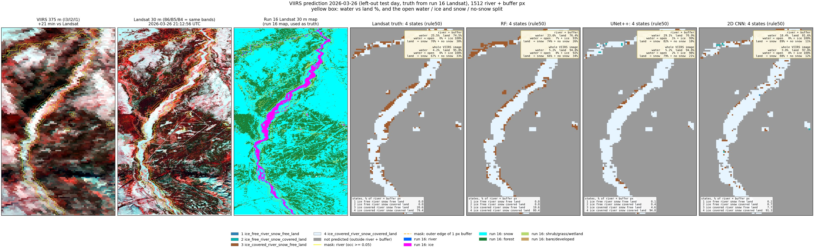
Run 22, 2026-03-26 (late winter, left-out test day): predicted states (rule50) and the water / land split.
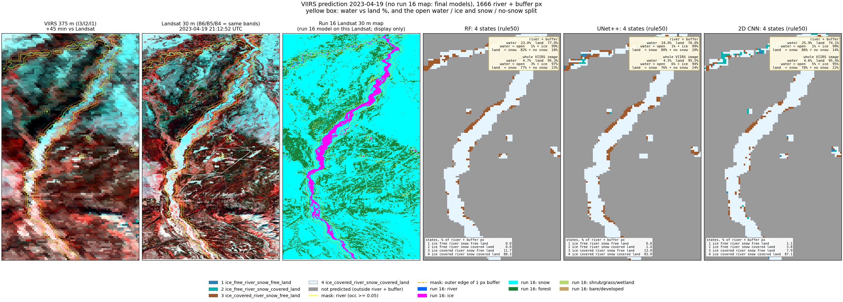
Run 22, 2023-04-19 (spring, snow, VIIRS only, final models): predicted states (rule50) and the water / land split.
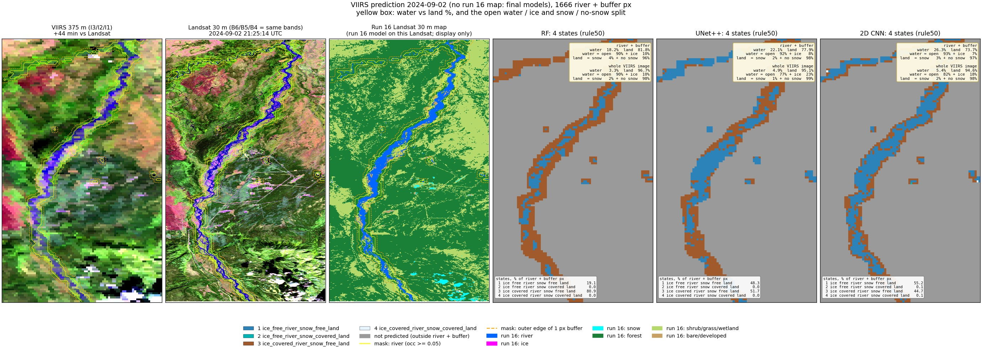
Run 22, 2024-09-02 (late summer, VIIRS only, final models): predicted states (rule50) and the water / land split.
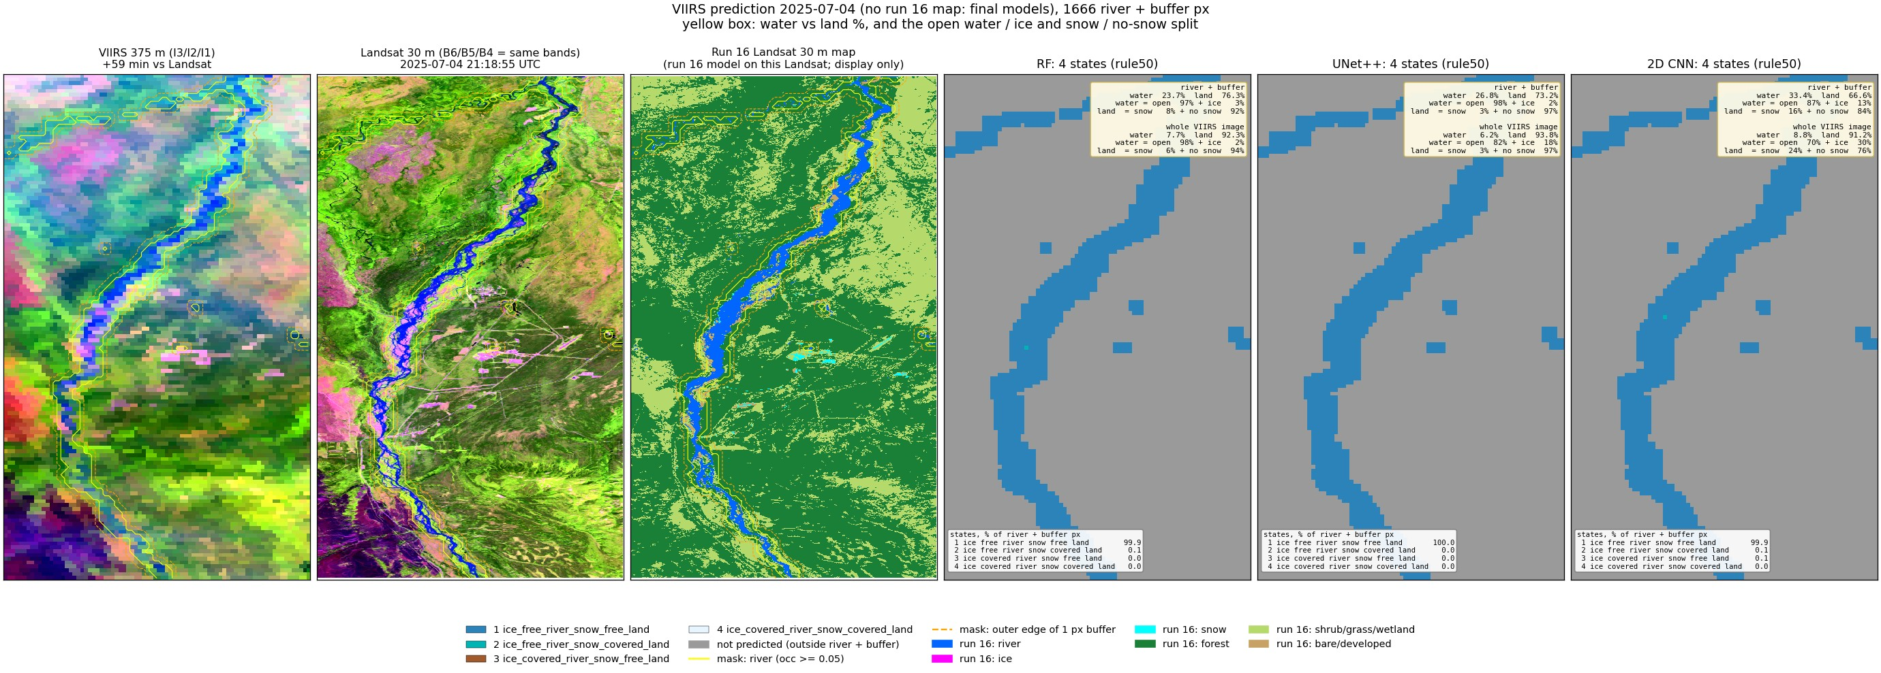
Run 22, 2025-07-04 (summer, VIIRS only, final models): predicted states (rule50) and the water / land split.
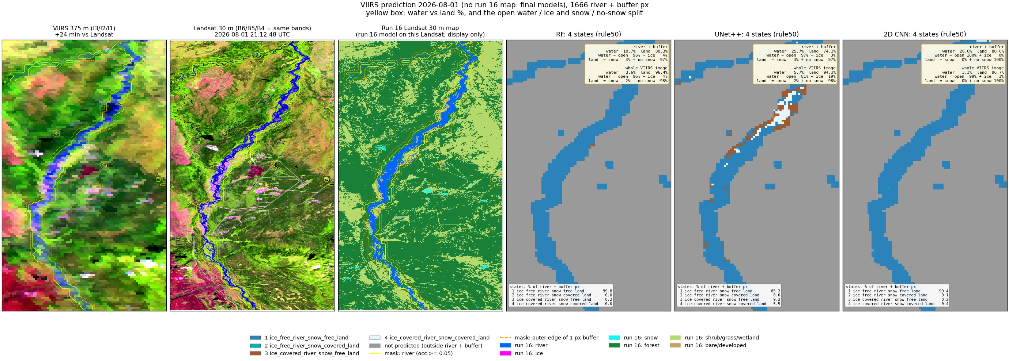
Run 22, 2026-08-01 (summer, VIIRS only, final models): predicted states (rule50) and the water / land split.

4. Per date, run 22 vs run 19 (rule50 accuracy)
date | RF run 22 / run 19 | UNet++ run 22 / run 19 | 2D CNN run 22 / run 19
2023-05-05 | 0.76 / 0.76 | 0.74 / 0.76 | 0.80 / 0.75
2023-07-24 | 0.97 / 0.97 | 0.85 / 0.80 | 0.97 / 0.96
2023-10-04 | 0.65 / 0.68 | 0.47 / 0.46 | 0.66 / 0.72
2024-04-21 | 0.39 / 0.55 | 0.62 / 0.59 | 0.63 / 0.67
2024-06-22 | 1.00 / 1.00 | 0.94 / 0.86 | 1.00 / 0.99
2026-03-26 | 0.86 / 0.80 | 0.81 / 0.82 | 0.77 / 0.77

