Nenana river ice: Random Forest vs UNet++ on Landsat 30 m
RiverProject · daksh models · 2026-10-27
Random Forest and UNet++ models classify every Landsat 30 m pixel of the Nenana study box as river (open water), ice, snow or land, trained only on the hand-drawn label polygons, which are taken as ground truth. This report has every model's scores and confusion matrix, the labelled pixels per class, the model settings and the main figures.

Contents
Contents
1. Summary
2. Data
2.1 Datasets
2.2 Where the labels and images come from
2.3 How the dates are used
2.4 Labelled pixels per class
3. Models and evaluation
Tasks
How scores are measured
4. Results: exclude_daksh
Overview
Every model: scores and confusion matrix
5. Results: with_daksh
Overview
Every model: scores and confusion matrix
6. Results: external_test_daksh
Overview
Every model: scores and confusion matrix
7. River/land state per 375 m block
8. Test images: ground truth vs Random Forest vs UNet++
8.1 with_daksh: cross-validated, all 5 labelled dates
8.2 external_test_daksh: trained on the patch dates, tested on 2024-03-12
8.3 Dates without labels
8.4 Prediction maps
8.5 Whole box: true colour, hand labels, RF, UNet++
9. Files and how to rerun
Inside each task folder
Scripts
10. Things to know when reading the results

1. Summary
- Random Forest wins almost everywhere. Four classes, spatial cross-validation on the 4 patch dates: RF 0.952 accuracy / 0.750 macro F1, UNet++ 0.943 / 0.701. UNet++ only matches or edges RF on river vs not river (0.962 vs 0.957).
- River and land are easy (F1 about 0.96); ice (about 0.72) and snow (about 0.3 to 0.4) are hard: only 1,732 ice and 564 snow labelled pixels.
- Splitting the task does not help: two binary models merged to four classes score about the same as one four-class model; one-vs-rest models find ice no better than the four-class RF, and snow worse.
- Adding the labelled daksh date (with_daksh) costs about 1 point, mostly because the daksh image has no temperature band, so those models use 9 inputs instead of 11.
- The models do not carry over to a new winter date: trained on the patch dates and tested on the daksh 2024-03-12 labels, four-class accuracy is 0.34 (RF) and 0.47 (UNet++). RF calls most ice snow; none of the patch dates is midwinter.
- On unlabelled dates UNet++ marks much land as river and clouds come out as snow or ice.

2. Data

2.1 Datasets
Dataset (folder) | Training dates | Scored on | Inputs
1_exclude_daksh | 4 patch dates | spatial cross-validation | 11
2_with_daksh | 4 patch dates + daksh 2024-03-12 | spatial cross-validation | 9
3_external_test_daksh | 4 patch dates | daksh 2024-03-12 labels (external cohort) | 9

11 inputs: surface reflectance SR_B2 to SR_B7, surface temperature ST_B10, JRC water occurrence, NDWI, NDSI, NDVI. 9 inputs: blue, green, red, NIR, SWIR1, water occurrence, NDWI, NDSI, NDVI (the daksh image has no SWIR2 and no temperature; its Level-1 numbers are converted to reflectance with the Landsat Collection 2 constants and the sun angle). The unlabelled daksh dates 2024-04-20 and 2024-04-29, and 2026-03-26 and 2023-05-05, are only predicted.

2.2 Where the labels and images come from
Date | Season | QGIS group | Labels | Imagery
2023-07-24 | summer | mathus_naira | patches/nenana_20230724/labels/labels_2023-07-24.shp | patch _sr.tif + _thermal.tif
2023-10-04 | freeze-up | mathus_naira | patches/nenana_20231004/labels/ | patch
2024-04-21 | breakup | mathus_naira | patches/nenana_20240421/labels/ | patch
2024-06-22 | summer | mathus_naira | patches/nenana_20240622/labels/ | patch
2024-03-12 | winter | daksh | ~/labels_20240312.gpkg (3 polygons) | nenana_crops/20240312/landsat_20240312_box.tif
2024-04-20, 2024-04-29 | spring | daksh | none (predicted only) | nenana_crops/<date>/landsat_*_box.tif
2026-03-26, 2023-05-05 | midwinter, breakup | not in project | none (predicted only) | ~/Desktop/Patches/nenana_<date>/

patches/ = ~/Desktop/RiverProject/Matus/narrow_rivers/patches. Label classes (class_id): 1 river (open water), 2 ice, 3 snow, 4 land; codes 0 and 9 are ignored. Study box lon -149.338 to -149.069, lat 64.094 to 64.535. Every date is on the same 995 x 1635 grid (0.00027027 degrees, EPSG:4326), so the same row and column is the same place on every date. The daksh image stores Level-1 numbers, converted to reflectance with (DN x 2.0e-5 - 0.1) / cos(sun zenith), the sun zenith read from the image (stored x 100); pixels with missing imagery are skipped.

2.3 How the dates are used
Only dates with labels are trained on: in with_daksh the 4 patch dates + 2024-03-12; the unlabelled dates are only predicted. All labelled dates are pooled into one training set, so one model per task learns summer, freeze-up, breakup and (with daksh) winter at once. Each pixel is an example whose inputs come from its own date's image and whose label comes from its own date's polygons; a date's image is never paired with another date's labels. UNet++ draws each training crop from one date, and its input scaling (band means and spreads) is computed from the training dates only.
Pixels labelled on more than one date: polygons of different dates often cover the same ground. Of the 85,890 labelled pixels in with_daksh, 49,688 locations are labelled on one date, 13,005 on two and 3,250 on three or more.
- Training: each (date, location) is its own example with that date's inputs and label. The same spot can be river in July, ice in October and snow in March; all are correct and all are used. Nothing is averaged or merged across dates.
- Cross-validation: a 64-row band is in the same fold on every date, so a tested location is held out of training on all dates. A model cannot score well by remembering a place from another date.
- External test: the 2024-03-12 pixels share 1,108 location-date pairs with patch-date labels, mostly with another class. It tests a new date and season, not new ground.
Dates | Shared pixels | Same class on both
2023-07-24 & 2023-10-04 | 2,301 | 29%
2023-07-24 & 2024-03-12 | 327 | 2%
2023-07-24 & 2024-04-21 | 1,955 | 78%
2023-07-24 & 2024-06-22 | 8,710 | 62%
2023-10-04 & 2024-03-12 | 130 | 28%
2023-10-04 & 2024-04-21 | 372 | 74%
2023-10-04 & 2024-06-22 | 7,943 | 76%
2024-03-12 & 2024-04-21 | 241 | 49%
2024-03-12 & 2024-06-22 | 410 | 7%
2024-04-21 & 2024-06-22 | 1,769 | 71%

2.4 Labelled pixels per class

1. exclude_daksh: trained and cross-validated on the 4 patch dates
Date | Group | River | Ice | Snow | Land | Total | Used for
2023-07-24 | mathus_naira | 31,021 | 0 | 0 | 7 | 31,028 | train
2023-10-04 | mathus_naira | 974 | 1,308 | 521 | 5,217 | 8,020 | train
2024-04-21 | mathus_naira | 1,886 | 424 | 43 | 728 | 3,081 | train
2024-06-22 | mathus_naira | 6,110 | 0 | 0 | 37,119 | 43,229 | train
Training total |  | 39,991 | 1,732 | 564 | 43,071 | 85,358

2. with_daksh: trained and cross-validated on the 4 patch dates + daksh 2024-03-12
Date | Group | River | Ice | Snow | Land | Total | Used for
2023-07-24 | mathus_naira | 31,021 | 0 | 0 | 7 | 31,028 | train
2023-10-04 | mathus_naira | 974 | 1,308 | 521 | 5,217 | 8,020 | train
2024-03-12 | daksh | 0 | 342 | 150 | 40 | 532 | train
2024-04-21 | mathus_naira | 1,886 | 424 | 43 | 728 | 3,081 | train
2024-06-22 | mathus_naira | 6,110 | 0 | 0 | 37,119 | 43,229 | train
Training total |  | 39,991 | 2,074 | 714 | 43,111 | 85,890

3. external_test_daksh: trained on the 4 patch dates, tested on daksh 2024-03-12
Date | Group | River | Ice | Snow | Land | Total | Used for
2023-07-24 | mathus_naira | 31,021 | 0 | 0 | 7 | 31,028 | train
2023-10-04 | mathus_naira | 974 | 1,308 | 521 | 5,217 | 8,020 | train
2024-03-12 | daksh | 0 | 342 | 150 | 40 | 532 | test
2024-04-21 | mathus_naira | 1,886 | 424 | 43 | 728 | 3,081 | train
2024-06-22 | mathus_naira | 6,110 | 0 | 0 | 37,119 | 43,229 | train
Training total |  | 39,991 | 1,732 | 564 | 43,071 | 85,358
Test total |  | 0 | 342 | 150 | 40 | 532

Pixels per class of each task
Task | exclude_daksh (= external training) | with_daksh | external test
Four classes (river, ice, snow, land) | river 39,991, ice 1,732, snow 564, land 43,071 | river 39,991, ice 2,074, snow 714, land 43,111 | river 0, ice 342, snow 150, land 40
Binary: snow vs no snow (snow = ice + snow) | no_snow 83,062, snow 2,296 | no_snow 83,102, snow 2,788 | no_snow 40, snow 492
Binary: river vs not river (river = open water + ice) | not_river 43,635, river 41,723 | not_river 43,825, river 42,065 | not_river 190, river 342
One vs rest: river | not_river 45,367, river 39,991 | not_river 45,899, river 39,991 | not_river 532, river 0
One vs rest: ice | not_ice 83,626, ice 1,732 | not_ice 83,816, ice 2,074 | not_ice 190, ice 342
One vs rest: snow | not_snow 84,794, snow 564 | not_snow 85,176, snow 714 | not_snow 382, snow 150
One vs rest: land | not_land 42,287, land 43,071 | not_land 42,779, land 43,111 | not_land 492, land 40

3. Models and evaluation
 | Random Forest | UNet++
Library | scikit-learn 1.9 | segmentation-models-pytorch 0.6, PyTorch 2.14, RTX 3080
Architecture | 300 trees, minimum 2 samples per leaf | UNet++ with ResNet-34 encoder (ImageNet weights)
Sees | one pixel's inputs | 256 x 256 px neighbourhood (shape, texture)
Class imbalance | balanced_subsample class weights | cross-entropy weighted by 1/sqrt(class frequency)
Training | all labelled pixels of the training folds | 1,500 steps x 8 crops centred near labels, 90-degree turns and flips, AdamW lr 1e-3, one-cycle, mixed precision; loss only on labelled pixels
Saved | refitted when needed | unetpp_final.pt (weights + input scaling)

Tasks
Folder | Classes | From the hand labels
four_class_river_ice_snow_land | river, ice, snow, land | as drawn
binary/snow_vs_no_snow | no_snow, snow | snow = ice + snow; no_snow = river + land
binary/river_vs_not_river | not_river, river | river = open water + ice; not_river = snow + land
binary/combined_to_four_class | river, ice, snow, land | the two binary answers merged (no training)
one_vs_rest/<class>_vs_rest | not_<class>, <class> | one class vs everything else (river, ice, snow, land)

Why three set-ups: one four-class model must trade the classes off against each other; two binary models answer the two questions that define the river/land states (is it frozen, is it snowy); one-vs-rest models show how well each class can be found on its own, which matters for the rare classes (ice 1.7k px, snow 0.6k px against 40k river and 43k land).

How scores are measured
Datasets 1 and 2: 5-fold spatial cross-validation. The box is cut into east-west bands 64 rows (about 1.9 km) tall; band i belongs to fold i mod 5 on every date. Each fold's model trains on the other 4 folds and is scored on its own; training pixels within 12 rows of the test band are dropped. Every labelled pixel is scored once by a model that never saw it. Afterwards one final model per task is trained on all labels and draws the maps.
Dataset 3 (external cohort): one model trained on all labelled pixels of the 4 patch dates, scored on the 532 labelled pixels of daksh 2024-03-12, a date, season and labeller it never saw. Only 532 pixels and no river, so read it as a check of carrying over to a new date, not a precise number.
Why spatial folds: a random pixel split would score pixels whose neighbours from the same polygon were in training, which inflates the numbers. Scores are always the cross-validated (or external) ones, never scores on training pixels, and they cover the labelled areas only; on the unlabelled dates there is nothing to score against.
Confusion matrices: rows = true class (hand label), columns = predicted class.

4. Results: exclude_daksh
Trained and cross-validated on the 4 patch dates. Folder output/1_exclude_daksh/.

Overview
Task | Model | Accuracy | Macro F1
Four classes (river, ice, snow, land) | Random Forest | 0.952 | 0.750
Four classes (river, ice, snow, land) | UNet++ | 0.943 | 0.701
Binary: snow vs no snow (snow = ice + snow) | Random Forest | 0.993 | 0.930
Binary: snow vs no snow (snow = ice + snow) | UNet++ | 0.953 | 0.738
Binary: river vs not river (river = open water + ice) | Random Forest | 0.957 | 0.957
Binary: river vs not river (river = open water + ice) | UNet++ | 0.962 | 0.962
Binary snow + river merged back to four classes | Random Forest | 0.951 | 0.737
Binary snow + river merged back to four classes | UNet++ | 0.919 | 0.674
One vs rest: river | Random Forest | 0.962 | 0.961
One vs rest: river | UNet++ | 0.961 | 0.960
One vs rest: ice | Random Forest | 0.989 | 0.855
One vs rest: ice | UNet++ | 0.924 | 0.631
One vs rest: snow | Random Forest | 0.993 | 0.644
One vs rest: snow | UNet++ | 0.932 | 0.518
One vs rest: land | Random Forest | 0.962 | 0.962
One vs rest: land | UNet++ | 0.966 | 0.966

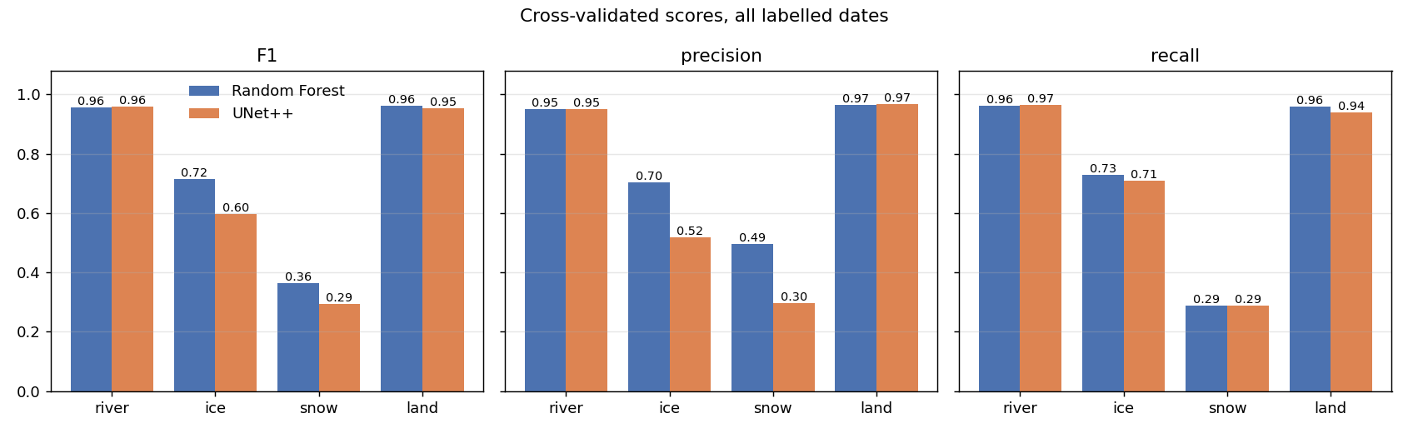
Four classes: F1, precision and recall per class, RF vs UNet++.
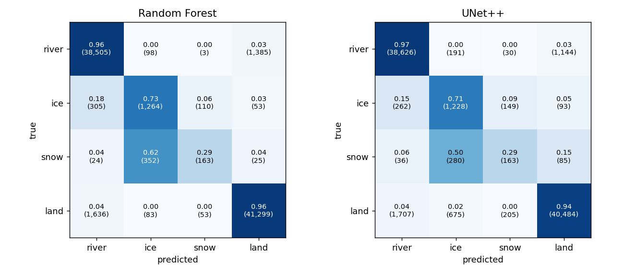
Four classes: confusion matrices, row-normalised, with pixel counts.

Every model: scores and confusion matrix

Four classes (river, ice, snow, land) · Random Forest
Accuracy 0.952, macro F1 0.750. Folder 1_exclude_daksh/four_class_river_ice_snow_land/random_forest/.
Class | Pixels | Precision | Recall | F1
river | 39,991 | 0.951 | 0.963 | 0.957
ice | 1,732 | 0.703 | 0.730 | 0.716
snow | 564 | 0.495 | 0.289 | 0.365
land | 43,071 | 0.966 | 0.959 | 0.962

true \ predicted | river | ice | snow | land
river | 38,505 | 98 | 3 | 1,385
ice | 305 | 1,264 | 110 | 53
snow | 24 | 352 | 163 | 25
land | 1,636 | 83 | 53 | 41,299

Four classes (river, ice, snow, land) · UNet++
Accuracy 0.943, macro F1 0.701. Folder 1_exclude_daksh/four_class_river_ice_snow_land/unet_plus_plus/.
Class | Pixels | Precision | Recall | F1
river | 39,991 | 0.951 | 0.966 | 0.958
ice | 1,732 | 0.517 | 0.709 | 0.598
snow | 564 | 0.298 | 0.289 | 0.293
land | 43,071 | 0.968 | 0.940 | 0.954

true \ predicted | river | ice | snow | land
river | 38,626 | 191 | 30 | 1,144
ice | 262 | 1,228 | 149 | 93
snow | 36 | 280 | 163 | 85
land | 1,707 | 675 | 205 | 40,484

Binary: snow vs no snow (snow = ice + snow) · Random Forest
Accuracy 0.993, macro F1 0.930. Folder 1_exclude_daksh/binary/snow_vs_no_snow/random_forest/.
Class | Pixels | Precision | Recall | F1
no_snow | 83,062 | 0.995 | 0.998 | 0.997
snow | 2,296 | 0.932 | 0.805 | 0.864

true \ predicted | no_snow | snow
no_snow | 82,927 | 135
snow | 447 | 1,849

Binary: snow vs no snow (snow = ice + snow) · UNet++
Accuracy 0.953, macro F1 0.738. Folder 1_exclude_daksh/binary/snow_vs_no_snow/unet_plus_plus/.
Class | Pixels | Precision | Recall | F1
no_snow | 83,062 | 0.996 | 0.955 | 0.975
snow | 2,296 | 0.349 | 0.878 | 0.500

true \ predicted | no_snow | snow
no_snow | 79,307 | 3,755
snow | 280 | 2,016

Binary: river vs not river (river = open water + ice) · Random Forest
Accuracy 0.957, macro F1 0.957. Folder 1_exclude_daksh/binary/river_vs_not_river/random_forest/.
Class | Pixels | Precision | Recall | F1
not_river | 43,635 | 0.964 | 0.951 | 0.957
river | 41,723 | 0.949 | 0.963 | 0.956

true \ predicted | not_river | river
not_river | 41,488 | 2,147
river | 1,559 | 40,164

Binary: river vs not river (river = open water + ice) · UNet++
Accuracy 0.962, macro F1 0.962. Folder 1_exclude_daksh/binary/river_vs_not_river/unet_plus_plus/.
Class | Pixels | Precision | Recall | F1
not_river | 43,635 | 0.968 | 0.958 | 0.963
river | 41,723 | 0.957 | 0.967 | 0.962

true \ predicted | not_river | river
not_river | 41,806 | 1,829
river | 1,397 | 40,326

Binary snow + river merged back to four classes · Random Forest
Accuracy 0.951, macro F1 0.737. Folder 1_exclude_daksh/binary/combined_to_four_class/random_forest/.
Class | Pixels | Precision | Recall | F1
river | 39,991 | 0.949 | 0.963 | 0.956
ice | 1,732 | 0.729 | 0.712 | 0.721
snow | 564 | 0.457 | 0.236 | 0.311
land | 43,071 | 0.966 | 0.958 | 0.962

true \ predicted | river | ice | snow | land
river | 38,529 | 78 | 3 | 1,381
ice | 323 | 1,234 | 130 | 45
snow | 30 | 352 | 133 | 49
land | 1,736 | 29 | 25 | 41,281

Binary snow + river merged back to four classes · UNet++
Accuracy 0.919, macro F1 0.674. Folder 1_exclude_daksh/binary/combined_to_four_class/unet_plus_plus/.
Class | Pixels | Precision | Recall | F1
river | 39,991 | 0.962 | 0.960 | 0.961
ice | 1,732 | 0.642 | 0.836 | 0.726
snow | 564 | 0.047 | 0.291 | 0.080
land | 43,071 | 0.969 | 0.893 | 0.930

true \ predicted | river | ice | snow | land
river | 38,374 | 333 | 126 | 1,158
ice | 171 | 1,448 | 83 | 30
snow | 48 | 321 | 164 | 31
land | 1,305 | 155 | 3,141 | 38,470

One vs rest: river · Random Forest
Accuracy 0.962, macro F1 0.961. Folder 1_exclude_daksh/one_vs_rest/river_vs_rest/random_forest/.
Class | Pixels | Precision | Recall | F1
not_river | 45,367 | 0.968 | 0.960 | 0.964
river | 39,991 | 0.955 | 0.964 | 0.959

true \ predicted | not_river | river
not_river | 43,542 | 1,825
river | 1,454 | 38,537

One vs rest: river · UNet++
Accuracy 0.961, macro F1 0.960. Folder 1_exclude_daksh/one_vs_rest/river_vs_rest/unet_plus_plus/.
Class | Pixels | Precision | Recall | F1
not_river | 45,367 | 0.965 | 0.960 | 0.963
river | 39,991 | 0.955 | 0.961 | 0.958

true \ predicted | not_river | river
not_river | 43,569 | 1,798
river | 1,567 | 38,424

One vs rest: ice · Random Forest
Accuracy 0.989, macro F1 0.855. Folder 1_exclude_daksh/one_vs_rest/ice_vs_rest/random_forest/.
Class | Pixels | Precision | Recall | F1
not_ice | 83,626 | 0.994 | 0.995 | 0.994
ice | 1,732 | 0.737 | 0.695 | 0.716

true \ predicted | not_ice | ice
not_ice | 83,197 | 429
ice | 528 | 1,204

One vs rest: ice · UNet++
Accuracy 0.924, macro F1 0.631. Folder 1_exclude_daksh/one_vs_rest/ice_vs_rest/unet_plus_plus/.
Class | Pixels | Precision | Recall | F1
not_ice | 83,626 | 0.996 | 0.926 | 0.960
ice | 1,732 | 0.186 | 0.818 | 0.303

true \ predicted | not_ice | ice
not_ice | 77,417 | 6,209
ice | 316 | 1,416

One vs rest: snow · Random Forest
Accuracy 0.993, macro F1 0.644. Folder 1_exclude_daksh/one_vs_rest/snow_vs_rest/random_forest/.
Class | Pixels | Precision | Recall | F1
not_snow | 84,794 | 0.995 | 0.999 | 0.997
snow | 564 | 0.511 | 0.204 | 0.292

true \ predicted | not_snow | snow
not_snow | 84,684 | 110
snow | 449 | 115

One vs rest: snow · UNet++
Accuracy 0.932, macro F1 0.518. Folder 1_exclude_daksh/one_vs_rest/snow_vs_rest/unet_plus_plus/.
Class | Pixels | Precision | Recall | F1
not_snow | 84,794 | 0.996 | 0.935 | 0.964
snow | 564 | 0.039 | 0.399 | 0.072

true \ predicted | not_snow | snow
not_snow | 79,295 | 5,499
snow | 339 | 225

One vs rest: land · Random Forest
Accuracy 0.962, macro F1 0.962. Folder 1_exclude_daksh/one_vs_rest/land_vs_rest/random_forest/.
Class | Pixels | Precision | Recall | F1
not_land | 42,287 | 0.958 | 0.966 | 0.962
land | 43,071 | 0.966 | 0.958 | 0.962

true \ predicted | not_land | land
not_land | 40,832 | 1,455
land | 1,790 | 41,281

One vs rest: land · UNet++
Accuracy 0.966, macro F1 0.966. Folder 1_exclude_daksh/one_vs_rest/land_vs_rest/unet_plus_plus/.
Class | Pixels | Precision | Recall | F1
not_land | 42,287 | 0.958 | 0.974 | 0.966
land | 43,071 | 0.974 | 0.959 | 0.966

true \ predicted | not_land | land
not_land | 41,189 | 1,098
land | 1,787 | 41,284

5. Results: with_daksh
Trained and cross-validated on the 4 patch dates + daksh 2024-03-12. Folder output/2_with_daksh/.

Overview
Task | Model | Accuracy | Macro F1
Four classes (river, ice, snow, land) | Random Forest | 0.944 | 0.731
Four classes (river, ice, snow, land) | UNet++ | 0.931 | 0.666
Binary: snow vs no snow (snow = ice + snow) | Random Forest | 0.991 | 0.928
Binary: snow vs no snow (snow = ice + snow) | UNet++ | 0.977 | 0.835
Binary: river vs not river (river = open water + ice) | Random Forest | 0.950 | 0.950
Binary: river vs not river (river = open water + ice) | UNet++ | 0.951 | 0.951
Binary snow + river merged back to four classes | Random Forest | 0.943 | 0.733
Binary snow + river merged back to four classes | UNet++ | 0.931 | 0.695
One vs rest: river | Random Forest | 0.955 | 0.955
One vs rest: river | UNet++ | 0.965 | 0.965
One vs rest: ice | Random Forest | 0.985 | 0.847
One vs rest: ice | UNet++ | 0.940 | 0.677
One vs rest: snow | Random Forest | 0.991 | 0.651
One vs rest: snow | UNet++ | 0.967 | 0.566
One vs rest: land | Random Forest | 0.957 | 0.957
One vs rest: land | UNet++ | 0.964 | 0.964

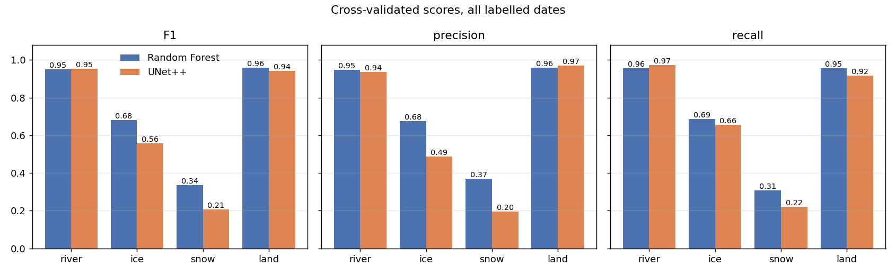
Four classes: F1, precision and recall per class, RF vs UNet++.
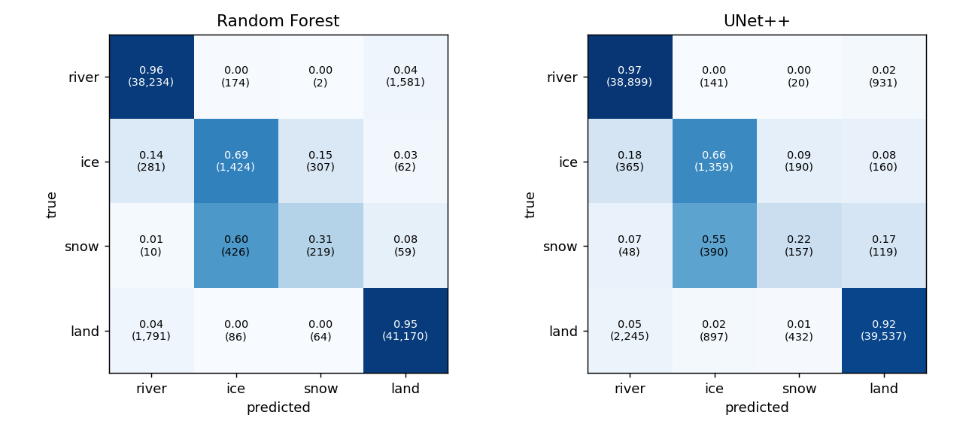
Four classes: confusion matrices, row-normalised, with pixel counts.

Every model: scores and confusion matrix

Four classes (river, ice, snow, land) · Random Forest
Accuracy 0.944, macro F1 0.731. Folder 2_with_daksh/four_class_river_ice_snow_land/random_forest/.
Class | Pixels | Precision | Recall | F1
river | 39,991 | 0.948 | 0.956 | 0.952
ice | 2,074 | 0.675 | 0.687 | 0.681
snow | 714 | 0.370 | 0.307 | 0.335
land | 43,111 | 0.960 | 0.955 | 0.958

true \ predicted | river | ice | snow | land
river | 38,234 | 174 | 2 | 1,581
ice | 281 | 1,424 | 307 | 62
snow | 10 | 426 | 219 | 59
land | 1,791 | 86 | 64 | 41,170

Four classes (river, ice, snow, land) · UNet++
Accuracy 0.931, macro F1 0.666. Folder 2_with_daksh/four_class_river_ice_snow_land/unet_plus_plus/.
Class | Pixels | Precision | Recall | F1
river | 39,991 | 0.936 | 0.973 | 0.954
ice | 2,074 | 0.488 | 0.655 | 0.559
snow | 714 | 0.196 | 0.220 | 0.208
land | 43,111 | 0.970 | 0.917 | 0.943

true \ predicted | river | ice | snow | land
river | 38,899 | 141 | 20 | 931
ice | 365 | 1,359 | 190 | 160
snow | 48 | 390 | 157 | 119
land | 2,245 | 897 | 432 | 39,537

Binary: snow vs no snow (snow = ice + snow) · Random Forest
Accuracy 0.991, macro F1 0.928. Folder 2_with_daksh/binary/snow_vs_no_snow/random_forest/.
Class | Pixels | Precision | Recall | F1
no_snow | 83,102 | 0.995 | 0.996 | 0.995
snow | 2,788 | 0.883 | 0.840 | 0.861

true \ predicted | no_snow | snow
no_snow | 82,792 | 310
snow | 447 | 2,341

Binary: snow vs no snow (snow = ice + snow) · UNet++
Accuracy 0.977, macro F1 0.835. Folder 2_with_daksh/binary/snow_vs_no_snow/unet_plus_plus/.
Class | Pixels | Precision | Recall | F1
no_snow | 83,102 | 0.992 | 0.984 | 0.988
snow | 2,788 | 0.619 | 0.760 | 0.682

true \ predicted | no_snow | snow
no_snow | 81,798 | 1,304
snow | 670 | 2,118

Binary: river vs not river (river = open water + ice) · Random Forest
Accuracy 0.950, macro F1 0.950. Folder 2_with_daksh/binary/river_vs_not_river/random_forest/.
Class | Pixels | Precision | Recall | F1
not_river | 43,825 | 0.955 | 0.948 | 0.951
river | 42,065 | 0.946 | 0.953 | 0.949

true \ predicted | not_river | river
not_river | 41,525 | 2,300
river | 1,971 | 40,094

Binary: river vs not river (river = open water + ice) · UNet++
Accuracy 0.951, macro F1 0.951. Folder 2_with_daksh/binary/river_vs_not_river/unet_plus_plus/.
Class | Pixels | Precision | Recall | F1
not_river | 43,825 | 0.971 | 0.931 | 0.951
river | 42,065 | 0.931 | 0.971 | 0.951

true \ predicted | not_river | river
not_river | 40,819 | 3,006
river | 1,231 | 40,834

Binary snow + river merged back to four classes · Random Forest
Accuracy 0.943, macro F1 0.733. Folder 2_with_daksh/binary/combined_to_four_class/random_forest/.
Class | Pixels | Precision | Recall | F1
river | 39,991 | 0.947 | 0.956 | 0.952
ice | 2,074 | 0.679 | 0.659 | 0.669
snow | 714 | 0.372 | 0.333 | 0.352
land | 43,111 | 0.961 | 0.955 | 0.958

true \ predicted | river | ice | snow | land
river | 38,246 | 165 | 2 | 1,578
ice | 316 | 1,367 | 336 | 55
snow | 18 | 400 | 238 | 58
land | 1,802 | 80 | 63 | 41,166

Binary snow + river merged back to four classes · UNet++
Accuracy 0.931, macro F1 0.695. Folder 2_with_daksh/binary/combined_to_four_class/unet_plus_plus/.
Class | Pixels | Precision | Recall | F1
river | 39,991 | 0.928 | 0.969 | 0.948
ice | 2,074 | 0.703 | 0.703 | 0.703
snow | 714 | 0.140 | 0.265 | 0.183
land | 43,111 | 0.972 | 0.917 | 0.944

true \ predicted | river | ice | snow | land
river | 38,769 | 208 | 22 | 992
ice | 398 | 1,459 | 119 | 98
snow | 109 | 351 | 189 | 65
land | 2,488 | 58 | 1,016 | 39,549

One vs rest: river · Random Forest
Accuracy 0.955, macro F1 0.955. Folder 2_with_daksh/one_vs_rest/river_vs_rest/random_forest/.
Class | Pixels | Precision | Recall | F1
not_river | 45,899 | 0.962 | 0.953 | 0.957
river | 39,991 | 0.947 | 0.957 | 0.952

true \ predicted | not_river | river
not_river | 43,740 | 2,159
river | 1,729 | 38,262

One vs rest: river · UNet++
Accuracy 0.965, macro F1 0.965. Folder 2_with_daksh/one_vs_rest/river_vs_rest/unet_plus_plus/.
Class | Pixels | Precision | Recall | F1
not_river | 45,899 | 0.973 | 0.961 | 0.967
river | 39,991 | 0.956 | 0.970 | 0.963

true \ predicted | not_river | river
not_river | 44,116 | 1,783
river | 1,209 | 38,782

One vs rest: ice · Random Forest
Accuracy 0.985, macro F1 0.847. Folder 2_with_daksh/one_vs_rest/ice_vs_rest/random_forest/.
Class | Pixels | Precision | Recall | F1
not_ice | 83,816 | 0.993 | 0.992 | 0.992
ice | 2,074 | 0.685 | 0.717 | 0.701

true \ predicted | not_ice | ice
not_ice | 83,132 | 684
ice | 586 | 1,488

One vs rest: ice · UNet++
Accuracy 0.940, macro F1 0.677. Folder 2_with_daksh/one_vs_rest/ice_vs_rest/unet_plus_plus/.
Class | Pixels | Precision | Recall | F1
not_ice | 83,816 | 0.994 | 0.943 | 0.968
ice | 2,074 | 0.256 | 0.786 | 0.386

true \ predicted | not_ice | ice
not_ice | 79,068 | 4,748
ice | 443 | 1,631

One vs rest: snow · Random Forest
Accuracy 0.991, macro F1 0.651. Folder 2_with_daksh/one_vs_rest/snow_vs_rest/random_forest/.
Class | Pixels | Precision | Recall | F1
not_snow | 85,176 | 0.994 | 0.997 | 0.995
snow | 714 | 0.397 | 0.251 | 0.307

true \ predicted | not_snow | snow
not_snow | 84,904 | 272
snow | 535 | 179

One vs rest: snow · UNet++
Accuracy 0.967, macro F1 0.566. Folder 2_with_daksh/one_vs_rest/snow_vs_rest/unet_plus_plus/.
Class | Pixels | Precision | Recall | F1
not_snow | 85,176 | 0.994 | 0.973 | 0.983
snow | 714 | 0.095 | 0.345 | 0.149

true \ predicted | not_snow | snow
not_snow | 82,845 | 2,331
snow | 468 | 246

One vs rest: land · Random Forest
Accuracy 0.957, macro F1 0.957. Folder 2_with_daksh/one_vs_rest/land_vs_rest/random_forest/.
Class | Pixels | Precision | Recall | F1
not_land | 42,779 | 0.954 | 0.960 | 0.957
land | 43,111 | 0.960 | 0.954 | 0.957

true \ predicted | not_land | land
not_land | 41,086 | 1,693
land | 1,971 | 41,140

One vs rest: land · UNet++
Accuracy 0.964, macro F1 0.964. Folder 2_with_daksh/one_vs_rest/land_vs_rest/unet_plus_plus/.
Class | Pixels | Precision | Recall | F1
not_land | 42,779 | 0.955 | 0.974 | 0.964
land | 43,111 | 0.973 | 0.955 | 0.964

true \ predicted | not_land | land
not_land | 41,650 | 1,129
land | 1,942 | 41,169

6. Results: external_test_daksh
Trained on the 4 patch dates, tested on daksh 2024-03-12. Folder output/3_external_test_daksh/.

Overview
Task | Model | Accuracy | Macro F1
Four classes (river, ice, snow, land) | Random Forest | 0.338 | 0.180
Four classes (river, ice, snow, land) | UNet++ | 0.470 | 0.247
Binary: snow vs no snow (snow = ice + snow) | Random Forest | 0.927 | 0.527
Binary: snow vs no snow (snow = ice + snow) | UNet++ | 0.662 | 0.537
Binary: river vs not river (river = open water + ice) | Random Forest | 0.406 | 0.367
Binary: river vs not river (river = open water + ice) | UNet++ | 0.539 | 0.534
Binary snow + river merged back to four classes | Random Forest | 0.335 | 0.173
Binary snow + river merged back to four classes | UNet++ | 0.395 | 0.302
One vs rest: river | Random Forest | 0.996 | 0.499
One vs rest: river | UNet++ | 0.959 | 0.489
One vs rest: ice | Random Forest | 0.391 | 0.347
One vs rest: ice | UNet++ | 0.630 | 0.577
One vs rest: snow | Random Forest | 0.348 | 0.346
One vs rest: snow | UNet++ | 0.291 | 0.239
One vs rest: land | Random Forest | 0.927 | 0.505
One vs rest: land | UNet++ | 0.921 | 0.780

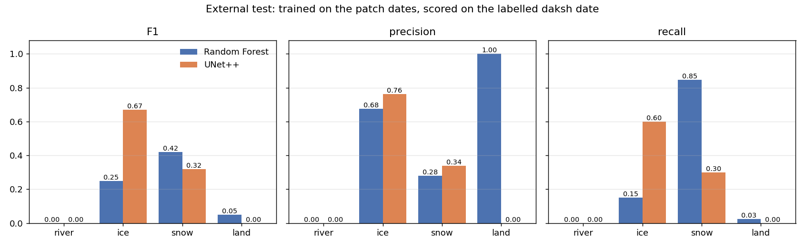
Four classes: F1, precision and recall per class, RF vs UNet++.
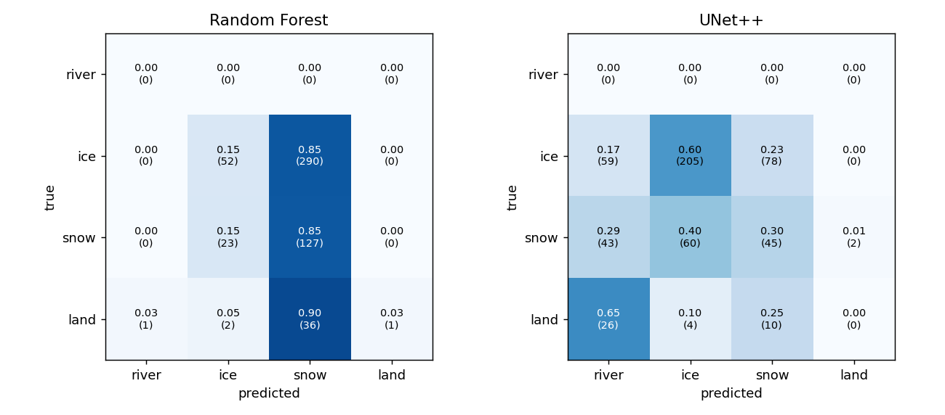
Four classes: confusion matrices, row-normalised, with pixel counts.

Every model: scores and confusion matrix

Four classes (river, ice, snow, land) · Random Forest
Accuracy 0.338, macro F1 0.180. Folder 3_external_test_daksh/four_class_river_ice_snow_land/random_forest/.
Class | Pixels | Precision | Recall | F1
river | 0 | 0.000 | 0.000 | 0.000
ice | 342 | 0.675 | 0.152 | 0.248
snow | 150 | 0.280 | 0.847 | 0.421
land | 40 | 1.000 | 0.025 | 0.049

true \ predicted | river | ice | snow | land
river | 0 | 0 | 0 | 0
ice | 0 | 52 | 290 | 0
snow | 0 | 23 | 127 | 0
land | 1 | 2 | 36 | 1

Four classes (river, ice, snow, land) · UNet++
Accuracy 0.470, macro F1 0.247. Folder 3_external_test_daksh/four_class_river_ice_snow_land/unet_plus_plus/.
Class | Pixels | Precision | Recall | F1
river | 0 | 0.000 | 0.000 | 0.000
ice | 342 | 0.762 | 0.599 | 0.671
snow | 150 | 0.338 | 0.300 | 0.318
land | 40 | 0.000 | 0.000 | 0.000

true \ predicted | river | ice | snow | land
river | 0 | 0 | 0 | 0
ice | 59 | 205 | 78 | 0
snow | 43 | 60 | 45 | 2
land | 26 | 4 | 10 | 0

Binary: snow vs no snow (snow = ice + snow) · Random Forest
Accuracy 0.927, macro F1 0.527. Folder 3_external_test_daksh/binary/snow_vs_no_snow/random_forest/.
Class | Pixels | Precision | Recall | F1
no_snow | 40 | 0.667 | 0.050 | 0.093
snow | 492 | 0.928 | 0.998 | 0.962

true \ predicted | no_snow | snow
no_snow | 2 | 38
snow | 1 | 491

Binary: snow vs no snow (snow = ice + snow) · UNet++
Accuracy 0.662, macro F1 0.537. Folder 3_external_test_daksh/binary/snow_vs_no_snow/unet_plus_plus/.
Class | Pixels | Precision | Recall | F1
no_snow | 40 | 0.176 | 0.950 | 0.297
snow | 492 | 0.994 | 0.638 | 0.777

true \ predicted | no_snow | snow
no_snow | 38 | 2
snow | 178 | 314

Binary: river vs not river (river = open water + ice) · Random Forest
Accuracy 0.406, macro F1 0.367. Folder 3_external_test_daksh/binary/river_vs_not_river/random_forest/.
Class | Pixels | Precision | Recall | F1
not_river | 190 | 0.367 | 0.916 | 0.524
river | 342 | 0.724 | 0.123 | 0.210

true \ predicted | not_river | river
not_river | 174 | 16
river | 300 | 42

Binary: river vs not river (river = open water + ice) · UNet++
Accuracy 0.539, macro F1 0.534. Folder 3_external_test_daksh/binary/river_vs_not_river/unet_plus_plus/.
Class | Pixels | Precision | Recall | F1
not_river | 190 | 0.404 | 0.605 | 0.484
river | 342 | 0.696 | 0.503 | 0.584

true \ predicted | not_river | river
not_river | 115 | 75
river | 170 | 172

Binary snow + river merged back to four classes · Random Forest
Accuracy 0.335, macro F1 0.173. Folder 3_external_test_daksh/binary/combined_to_four_class/random_forest/.
Class | Pixels | Precision | Recall | F1
river | 0 | 0.000 | 0.000 | 0.000
ice | 342 | 0.732 | 0.120 | 0.206
snow | 150 | 0.288 | 0.907 | 0.437
land | 40 | 1.000 | 0.025 | 0.049

true \ predicted | river | ice | snow | land
river | 0 | 0 | 0 | 0
ice | 1 | 41 | 300 | 0
snow | 0 | 14 | 136 | 0
land | 1 | 1 | 37 | 1

Binary snow + river merged back to four classes · UNet++
Accuracy 0.395, macro F1 0.302. Folder 3_external_test_daksh/binary/combined_to_four_class/unet_plus_plus/.
Class | Pixels | Precision | Recall | F1
river | 0 | 0.000 | 0.000 | 0.000
ice | 342 | 0.786 | 0.386 | 0.518
snow | 150 | 0.284 | 0.280 | 0.282
land | 40 | 0.263 | 0.900 | 0.407

true \ predicted | river | ice | snow | land
river | 0 | 0 | 0 | 0
ice | 40 | 132 | 104 | 66
snow | 37 | 36 | 42 | 35
land | 2 | 0 | 2 | 36

One vs rest: river · Random Forest
Accuracy 0.996, macro F1 0.499. Folder 3_external_test_daksh/one_vs_rest/river_vs_rest/random_forest/.
Class | Pixels | Precision | Recall | F1
not_river | 532 | 1.000 | 0.996 | 0.998
river | 0 | 0.000 | 0.000 | 0.000

true \ predicted | not_river | river
not_river | 530 | 2
river | 0 | 0

One vs rest: river · UNet++
Accuracy 0.959, macro F1 0.489. Folder 3_external_test_daksh/one_vs_rest/river_vs_rest/unet_plus_plus/.
Class | Pixels | Precision | Recall | F1
not_river | 532 | 1.000 | 0.959 | 0.979
river | 0 | 0.000 | 0.000 | 0.000

true \ predicted | not_river | river
not_river | 510 | 22
river | 0 | 0

One vs rest: ice · Random Forest
Accuracy 0.391, macro F1 0.347. Folder 3_external_test_daksh/one_vs_rest/ice_vs_rest/random_forest/.
Class | Pixels | Precision | Recall | F1
not_ice | 190 | 0.360 | 0.911 | 0.516
ice | 342 | 0.673 | 0.102 | 0.178

true \ predicted | not_ice | ice
not_ice | 173 | 17
ice | 307 | 35

One vs rest: ice · UNet++
Accuracy 0.630, macro F1 0.577. Folder 3_external_test_daksh/one_vs_rest/ice_vs_rest/unet_plus_plus/.
Class | Pixels | Precision | Recall | F1
not_ice | 190 | 0.477 | 0.389 | 0.429
ice | 342 | 0.692 | 0.763 | 0.726

true \ predicted | not_ice | ice
not_ice | 74 | 116
ice | 81 | 261

One vs rest: snow · Random Forest
Accuracy 0.348, macro F1 0.346. Folder 3_external_test_daksh/one_vs_rest/snow_vs_rest/random_forest/.
Class | Pixels | Precision | Recall | F1
not_snow | 382 | 0.642 | 0.207 | 0.313
snow | 150 | 0.259 | 0.707 | 0.379

true \ predicted | not_snow | snow
not_snow | 79 | 303
snow | 44 | 106

One vs rest: snow · UNet++
Accuracy 0.291, macro F1 0.239. Folder 3_external_test_daksh/one_vs_rest/snow_vs_rest/unet_plus_plus/.
Class | Pixels | Precision | Recall | F1
not_snow | 382 | 0.727 | 0.021 | 0.041
snow | 150 | 0.282 | 0.980 | 0.438

true \ predicted | not_snow | snow
not_snow | 8 | 374
snow | 3 | 147

One vs rest: land · Random Forest
Accuracy 0.927, macro F1 0.505. Folder 3_external_test_daksh/one_vs_rest/land_vs_rest/random_forest/.
Class | Pixels | Precision | Recall | F1
not_land | 492 | 0.927 | 1.000 | 0.962
land | 40 | 1.000 | 0.025 | 0.049

true \ predicted | not_land | land
not_land | 492 | 0
land | 39 | 1

One vs rest: land · UNet++
Accuracy 0.921, macro F1 0.780. Folder 3_external_test_daksh/one_vs_rest/land_vs_rest/unet_plus_plus/.
Class | Pixels | Precision | Recall | F1
not_land | 492 | 0.983 | 0.931 | 0.956
land | 40 | 0.485 | 0.800 | 0.604

true \ predicted | not_land | land
not_land | 458 | 34
land | 8 | 32

7. River/land state per 375 m block
A single pixel cannot be 'frozen river with snowy land', so the box is cut into 375 m blocks (12.5 Landsat pixels). In each block: river frozen if predicted ice outnumbers open water; land snowy if predicted snow outnumbers bare land; blocks with fewer than 3 river or ice pixels are 'no river'. States: ice_free_river_snow_free_land, ice_free_river_snow_covered_land, ice_covered_river_snow_free_land, ice_covered_river_snow_covered_land. Scored on blocks where the hand labels hold both river and land.
Dataset | From | Model | Blocks | Accuracy | Macro F1
1_exclude_daksh | four classes | Random Forest | 190 | 0.911 | 0.525
1_exclude_daksh | four classes | UNet++ | 190 | 0.868 | 0.527
2_with_daksh | four classes | Random Forest | 208 | 0.894 | 0.565
2_with_daksh | four classes | UNet++ | 208 | 0.865 | 0.517
3_external_test_daksh | four classes | Random Forest | 18 | 0.611 | 0.262
3_external_test_daksh | four classes | UNet++ | 18 | 0.278 | 0.119

State confusion: 1_exclude_daksh, four classes, Random Forest (accuracy 0.911)
true \ predicted | open / bare | open / snowy | frozen / bare | frozen / snowy
open / bare | 159 | 0 | 0 | 1
open / snowy | 3 | 0 | 0 | 0
frozen / bare | 5 | 3 | 11 | 0
frozen / snowy | 0 | 0 | 5 | 3

State confusion: 3_external_test_daksh, four classes, Random Forest (accuracy 0.611)
true \ predicted | open / bare | open / snowy | frozen / bare | frozen / snowy
open / bare | 0 | 0 | 0 | 0
open / snowy | 0 | 0 | 0 | 0
frozen / bare | 1 | 0 | 0 | 2
frozen / snowy | 4 | 0 | 0 | 11

open = ice-free river, frozen = ice-covered river; bare = snow-free land, snowy = snow-covered land.

8. Test images: ground truth vs Random Forest vs UNet++
Each figure is one labelled date, zoomed on a 3.6 x 3.6 km area holding many labels (up to two areas per date). Top row: the true-colour image, then what Random Forest and UNet++ predicted on the labelled pixels when they were tested (cross-validated: each pixel predicted by a model that never saw it; external: the model never saw the date). Bottom row: the ground truth (hand labels), then the full Random Forest and UNet++ maps. The accuracy in the titles is for all labelled pixels of that date. River blue, ice magenta, snow cyan, land brown. Four-class models.

8.1 with_daksh: cross-validated, all 5 labelled dates
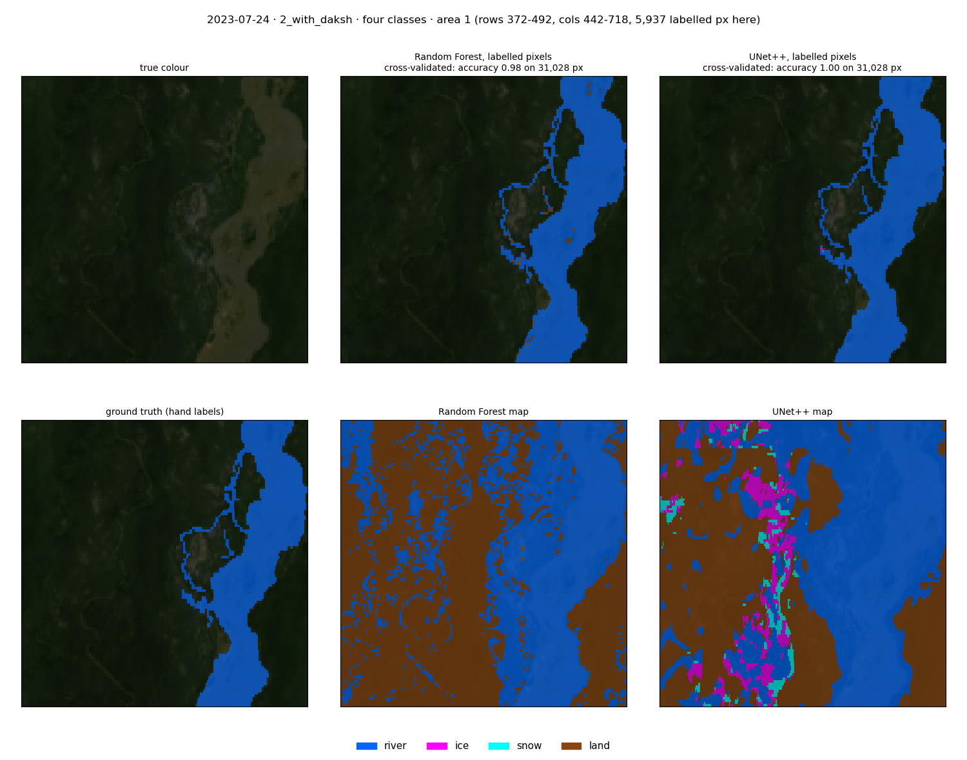
2023-07-24 (summer), area 1: image, RF and UNet++ test predictions (top); ground truth, RF and UNet++ maps (bottom).
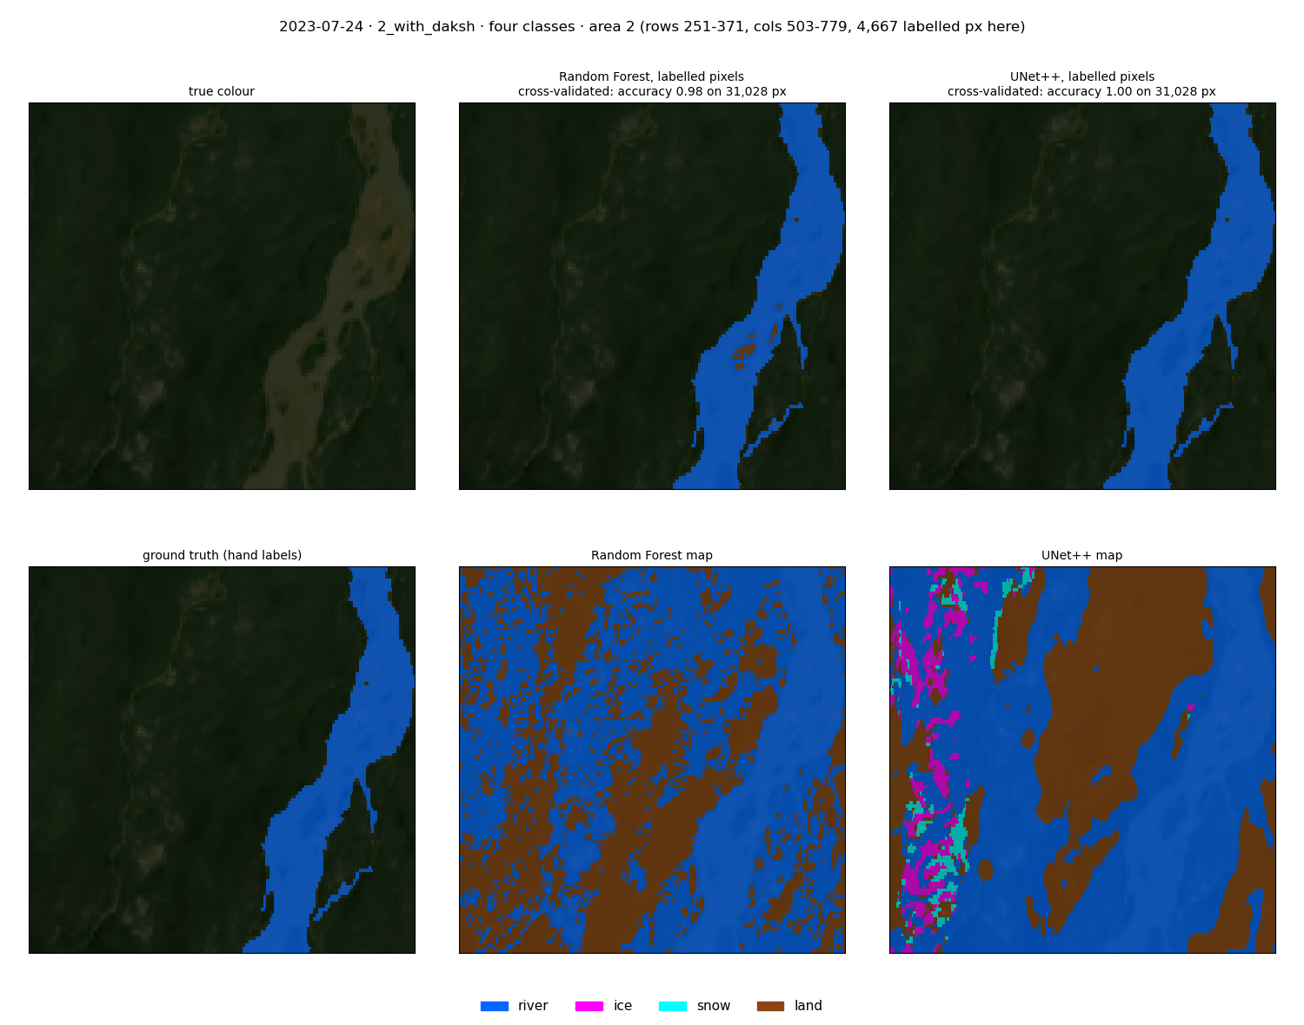
2023-07-24 (summer), area 2: image, RF and UNet++ test predictions (top); ground truth, RF and UNet++ maps (bottom).
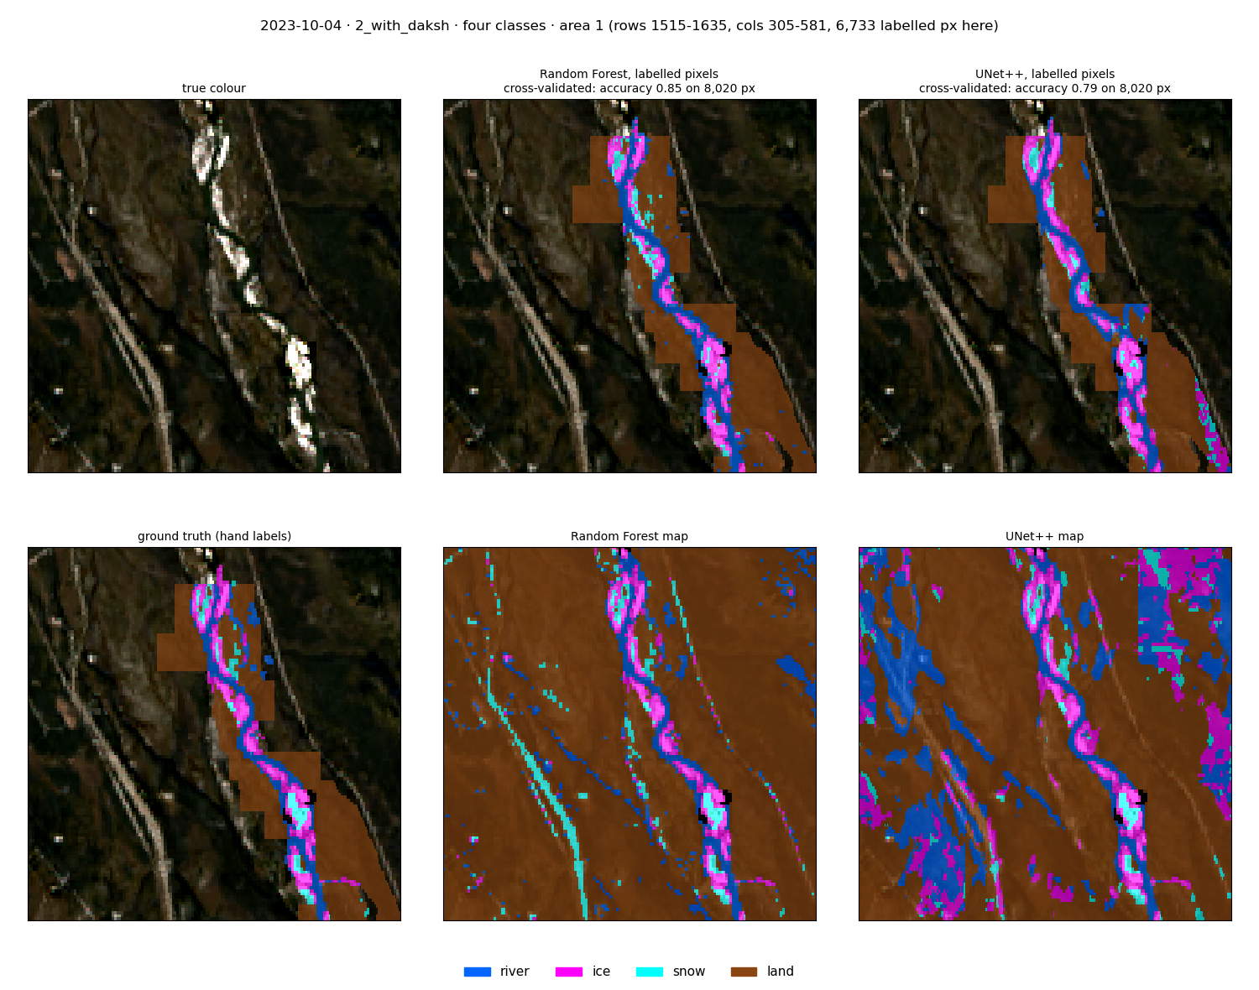
2023-10-04 (freeze-up), area 1: image, RF and UNet++ test predictions (top); ground truth, RF and UNet++ maps (bottom).
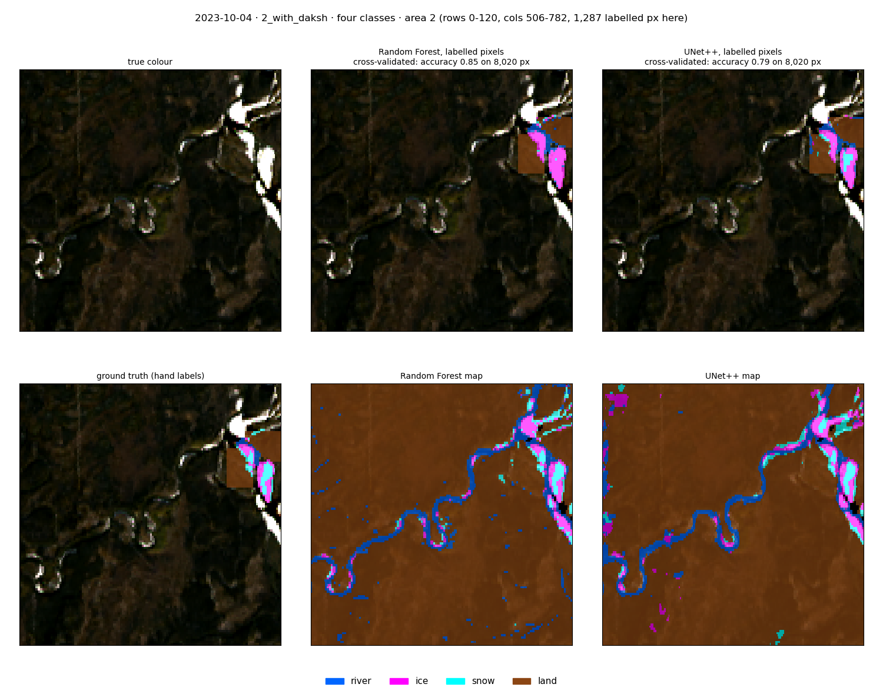
2023-10-04 (freeze-up), area 2: image, RF and UNet++ test predictions (top); ground truth, RF and UNet++ maps (bottom).
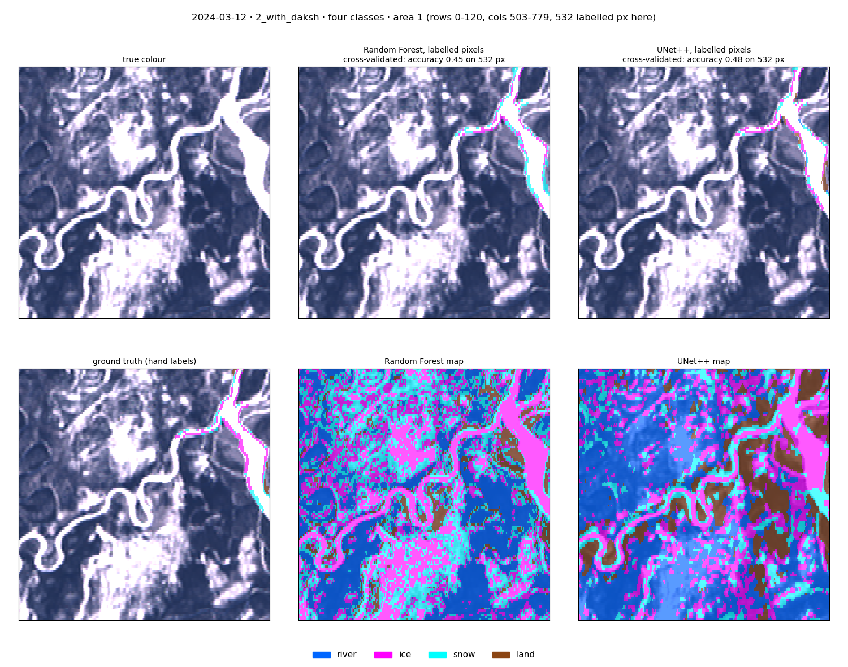
2024-03-12 (winter, daksh), area 1: image, RF and UNet++ test predictions (top); ground truth, RF and UNet++ maps (bottom).
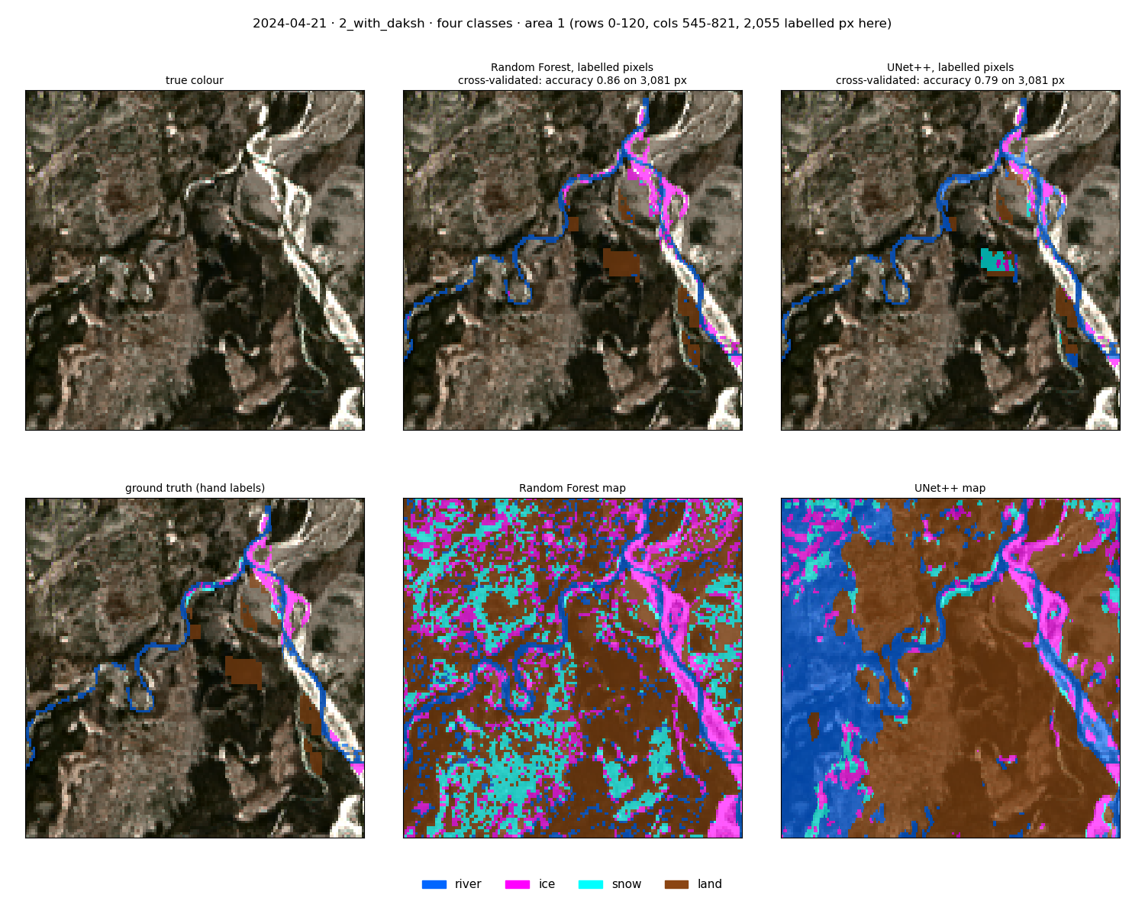
2024-04-21 (breakup), area 1: image, RF and UNet++ test predictions (top); ground truth, RF and UNet++ maps (bottom).
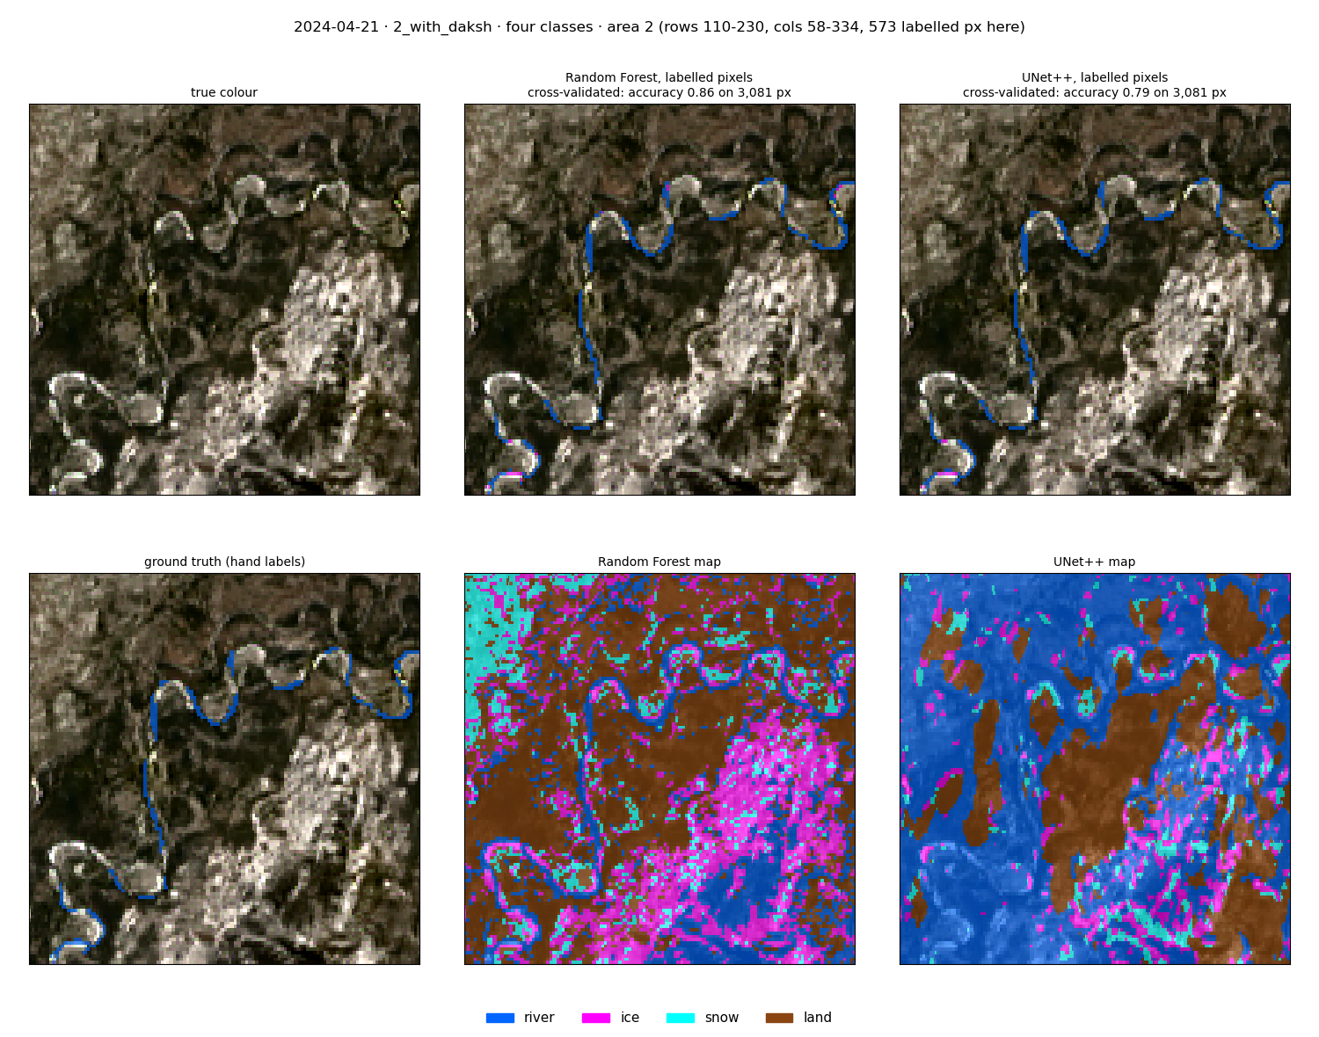
2024-04-21 (breakup), area 2: image, RF and UNet++ test predictions (top); ground truth, RF and UNet++ maps (bottom).
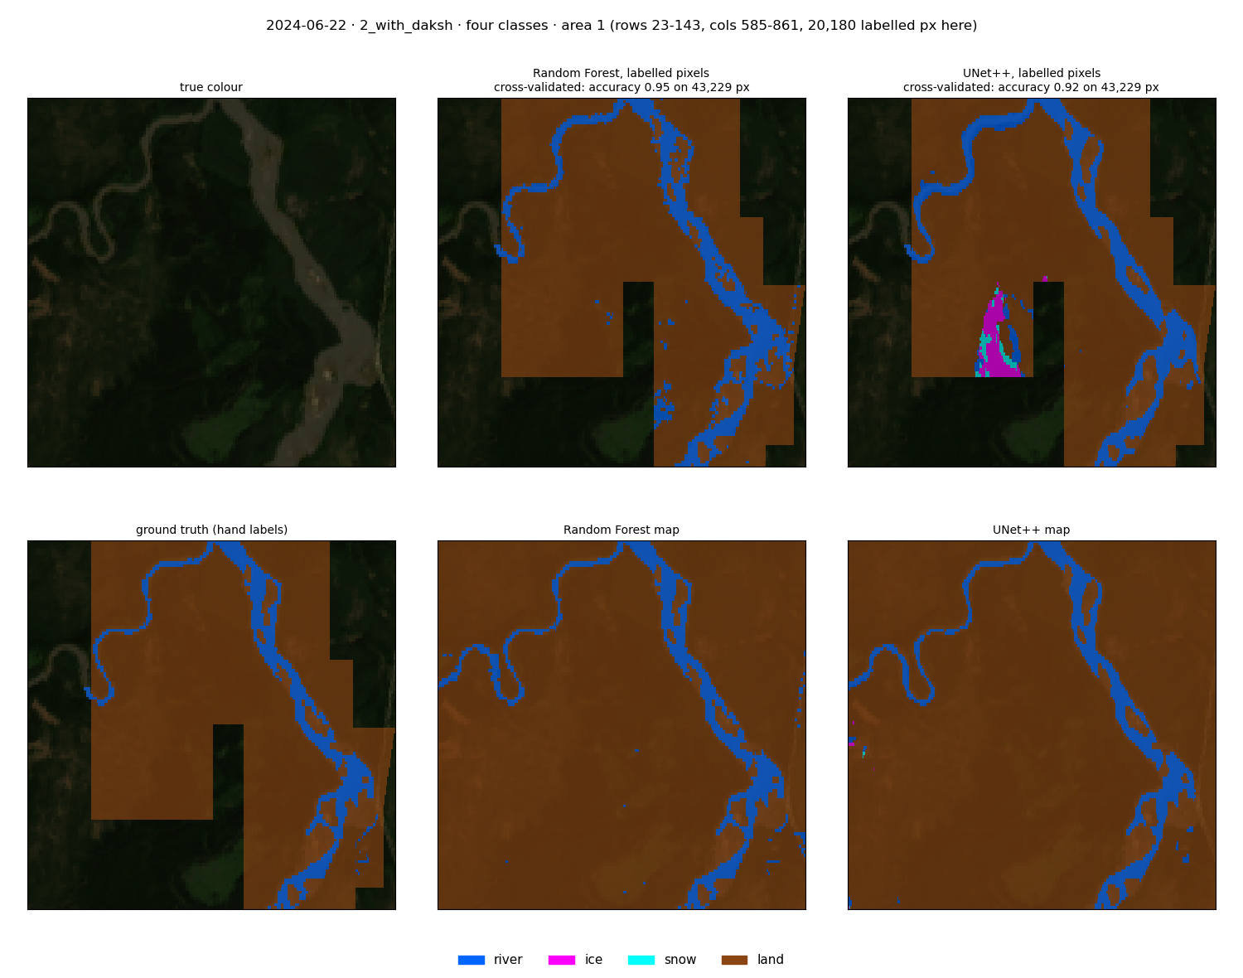
2024-06-22 (summer), area 1: image, RF and UNet++ test predictions (top); ground truth, RF and UNet++ maps (bottom).
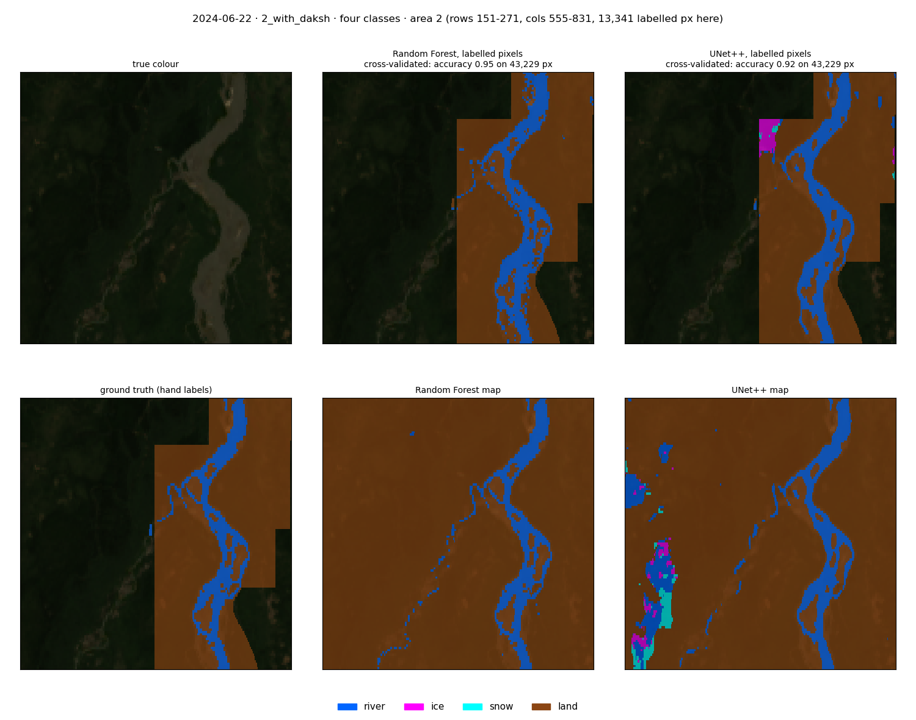
2024-06-22 (summer), area 2: image, RF and UNet++ test predictions (top); ground truth, RF and UNet++ maps (bottom).

8.2 external_test_daksh: trained on the patch dates, tested on 2024-03-12
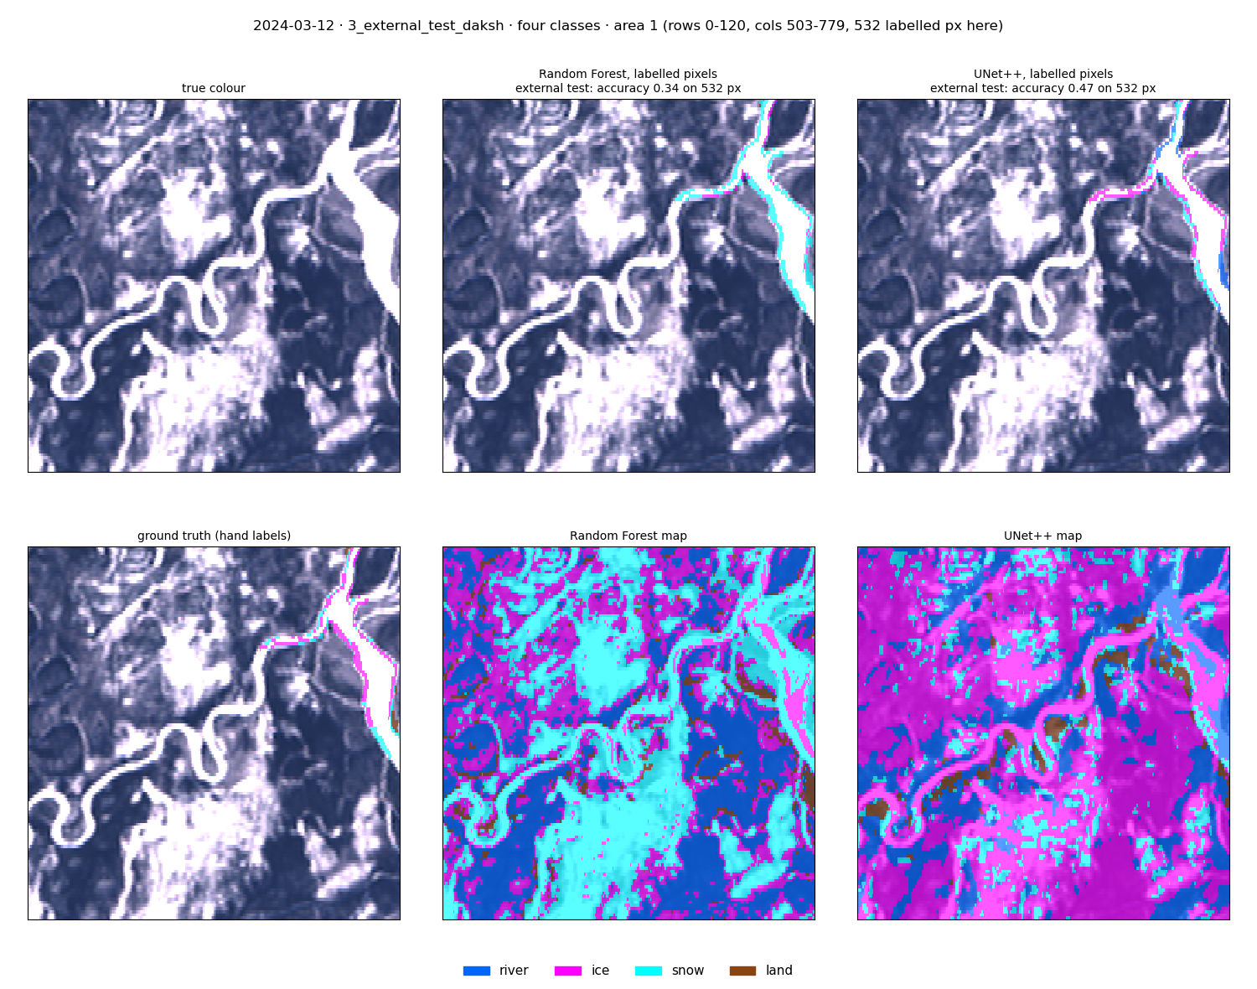
2024-03-12 (winter, daksh), external test: models trained without this date. RF calls most ice snow; UNet++ finds more ice but marks land as river.

8.3 Dates without labels
No ground truth exists here, so these show only what the models find: true colour, RF classes, UNet++ classes, and the river/land state masks of both (with_daksh four-class models). State colours: open/snow-free blue, open/snowy light cyan, frozen/snow-free orange, frozen/snowy magenta.
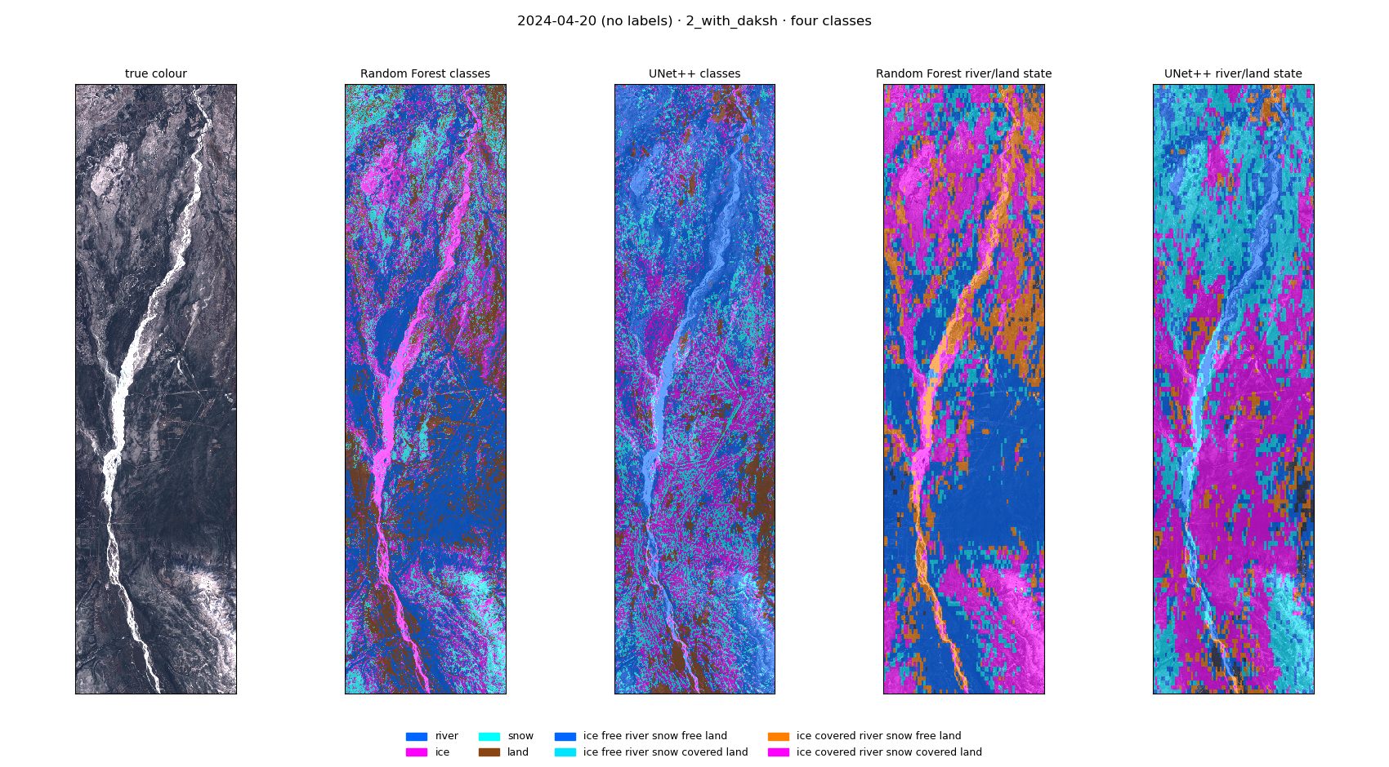
2024-04-20 (spring, daksh), no labels: true colour, RF, UNet++, RF state, UNet++ state.
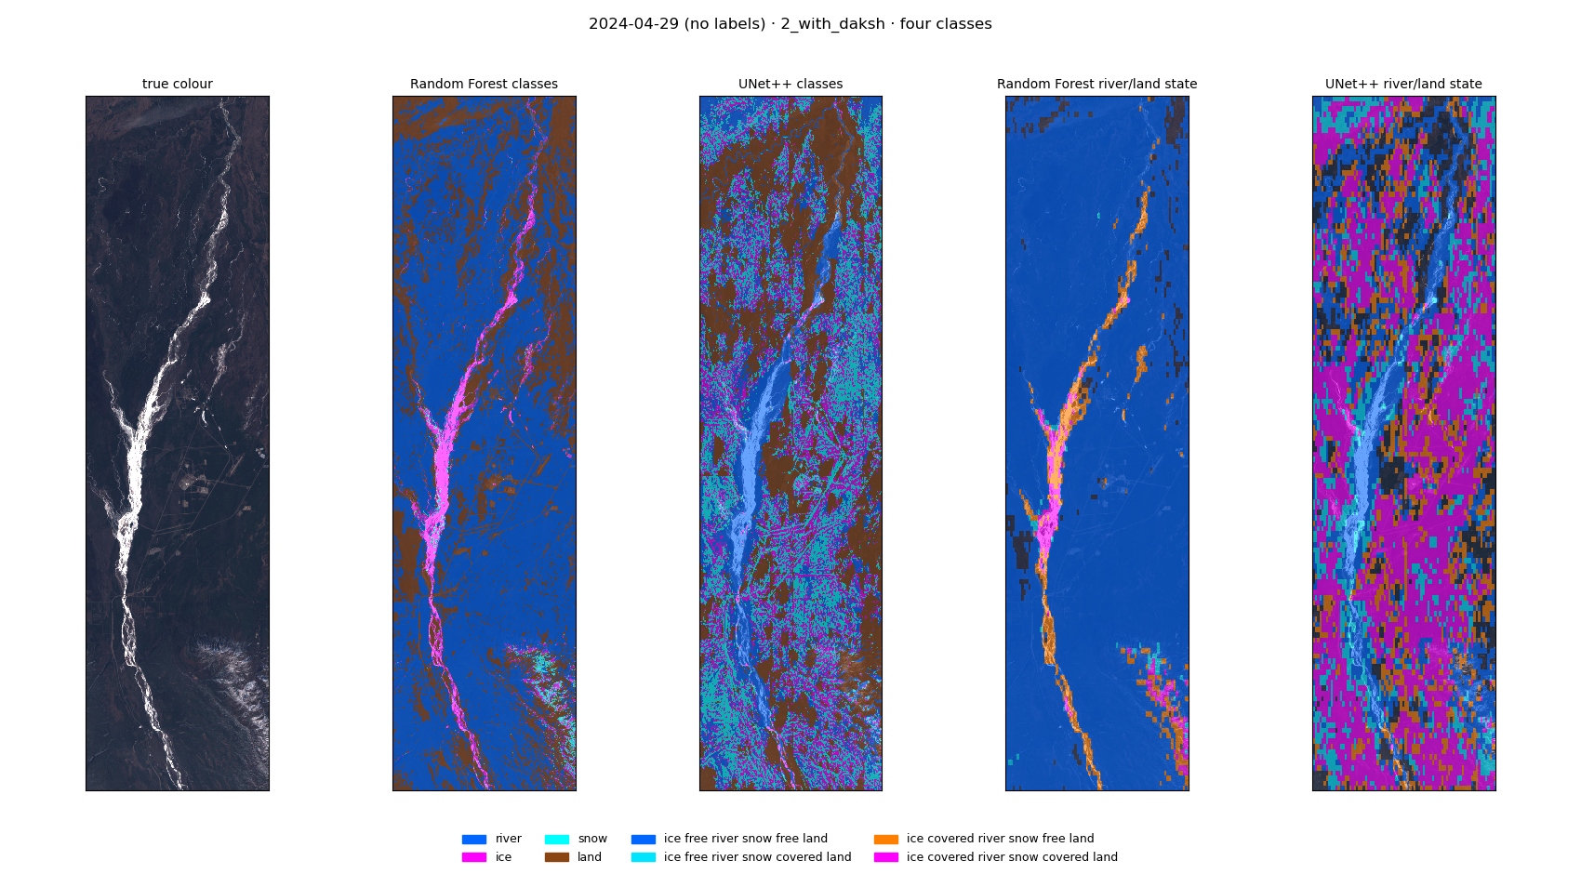
2024-04-29 (spring, daksh), no labels: true colour, RF, UNet++, RF state, UNet++ state.
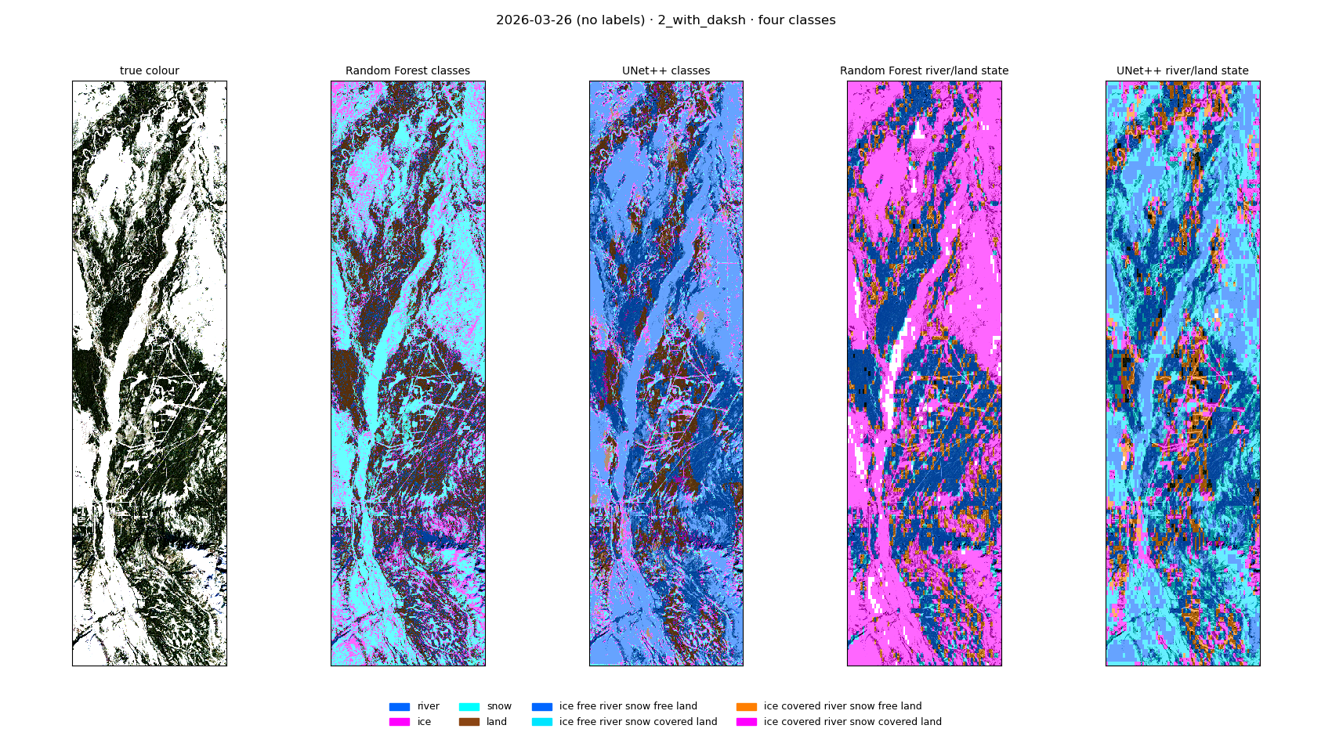
2026-03-26 (midwinter), no labels: true colour, RF, UNet++, RF state, UNet++ state.
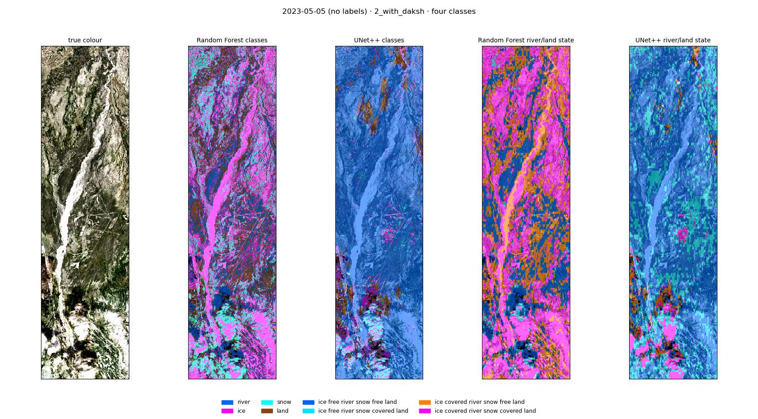
2023-05-05 (breakup), no labels: true colour, RF, UNet++, RF state, UNet++ state.

8.4 Prediction maps
Image | image with the predicted classes (with_daksh four-class models). River blue, ice magenta, snow cyan, land brown.
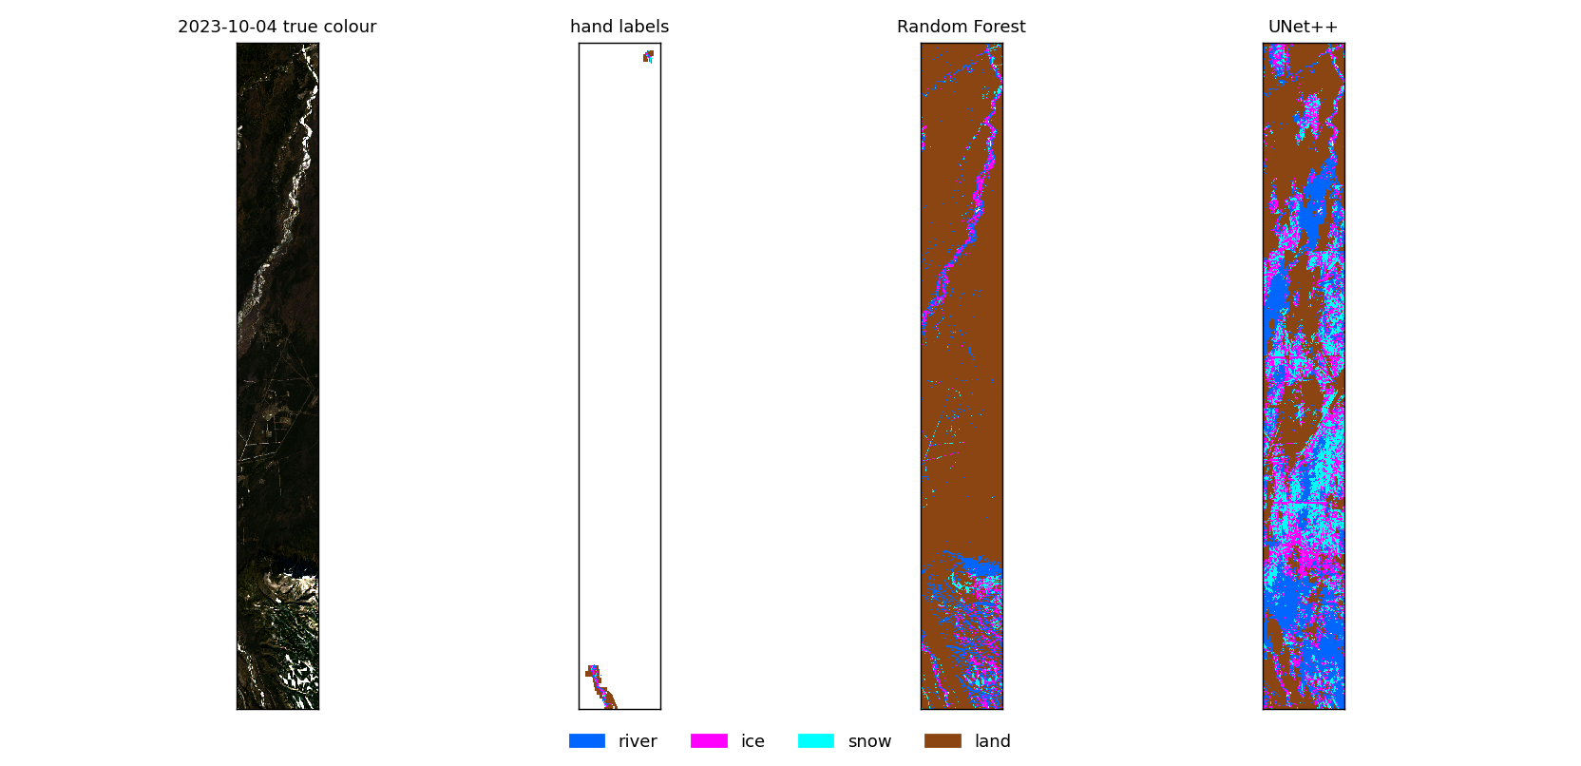
2023-10-04 (freeze-up), zoom on the labels: true colour, hand labels, RF, UNet++ (with_daksh).
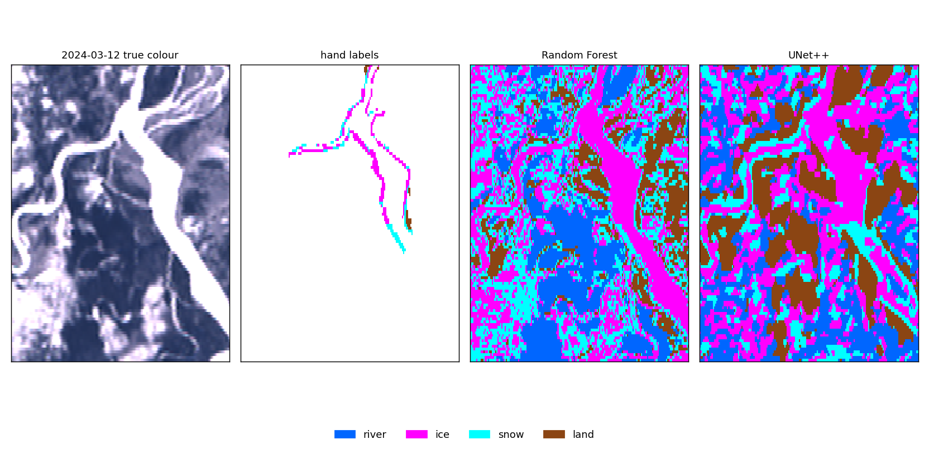
2024-03-12 (winter, daksh), zoom on the labels (with_daksh).
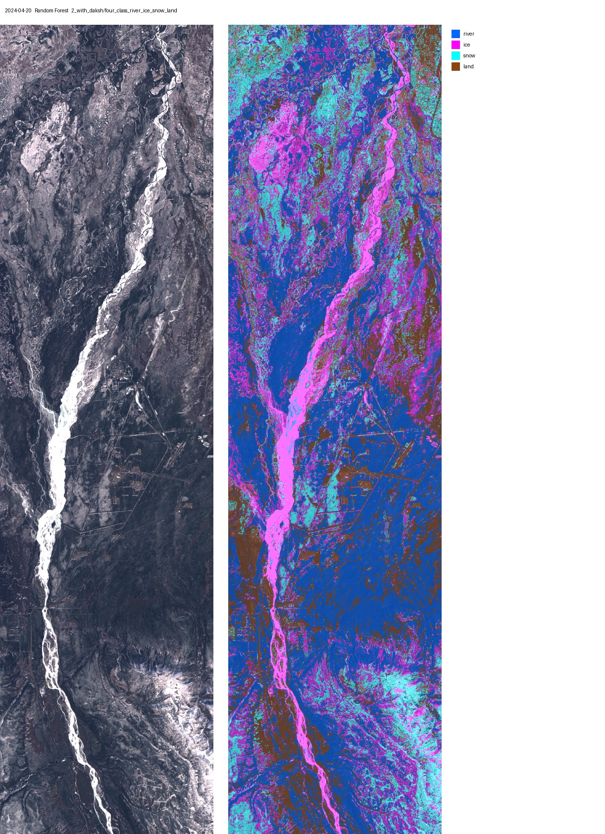
2024-04-20 (unlabelled daksh date), Random Forest, with_daksh.
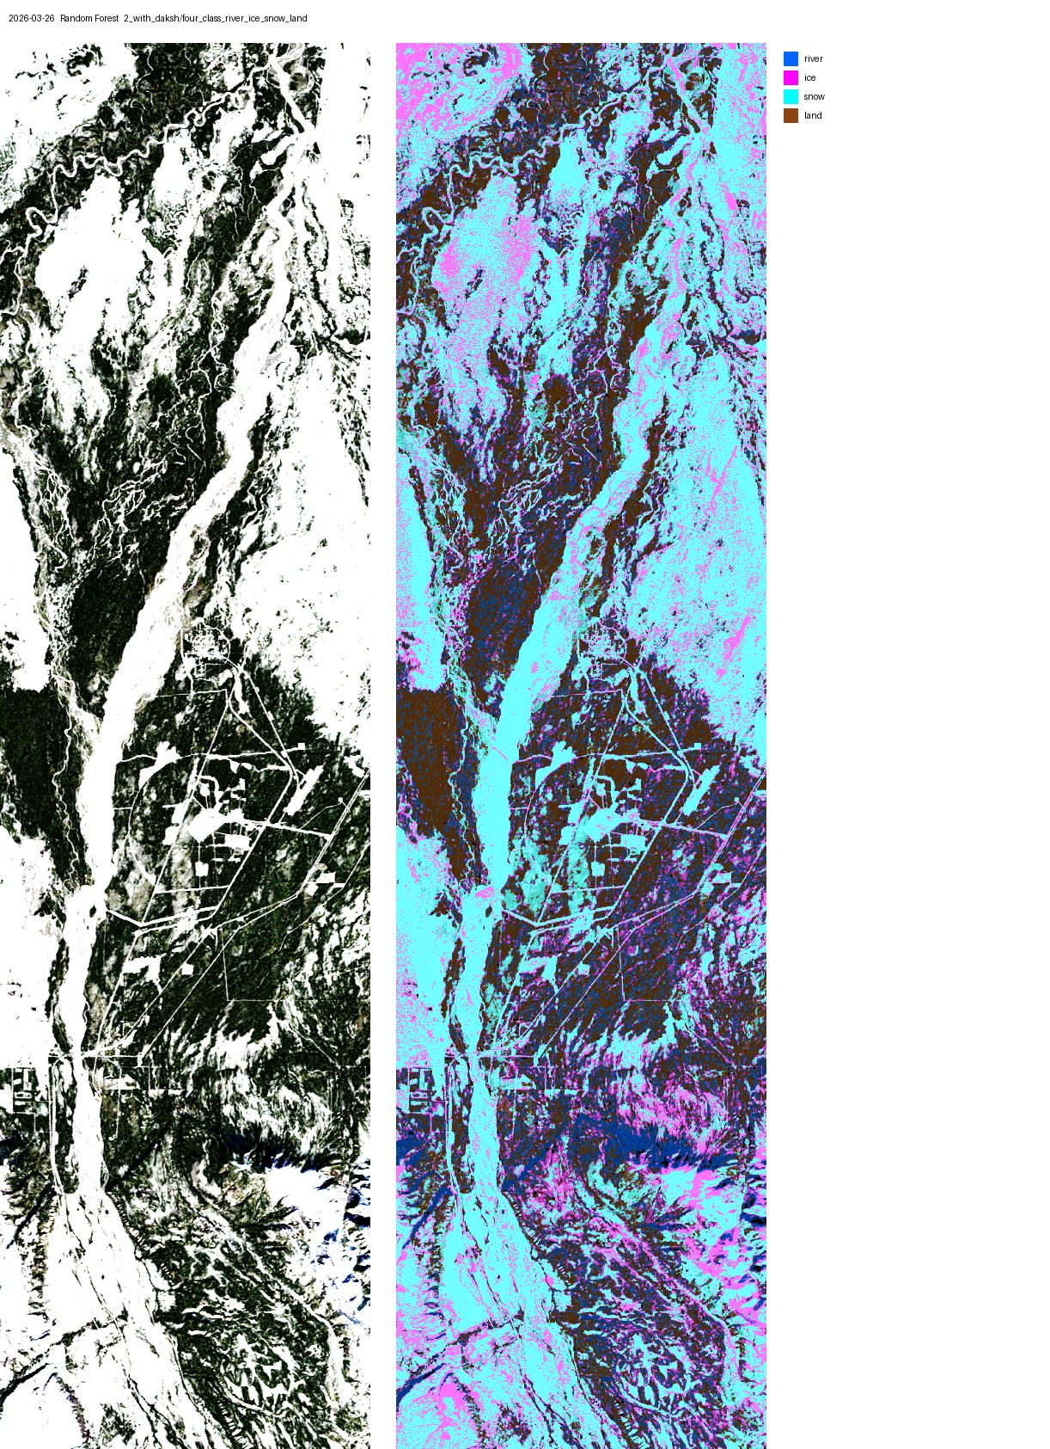
2026-03-26 (unlabelled, midwinter), Random Forest, with_daksh.
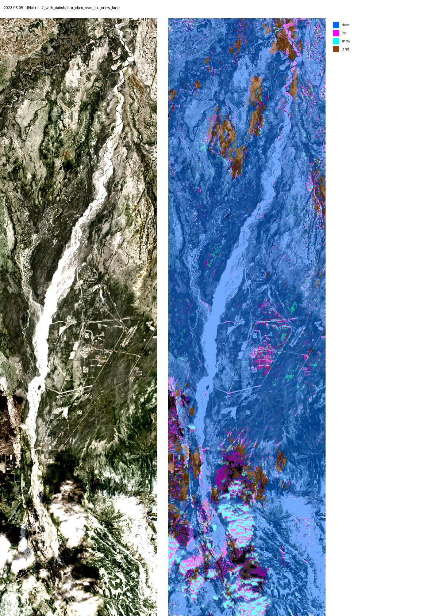
2023-05-05 (unlabelled, breakup), UNet++, with_daksh.
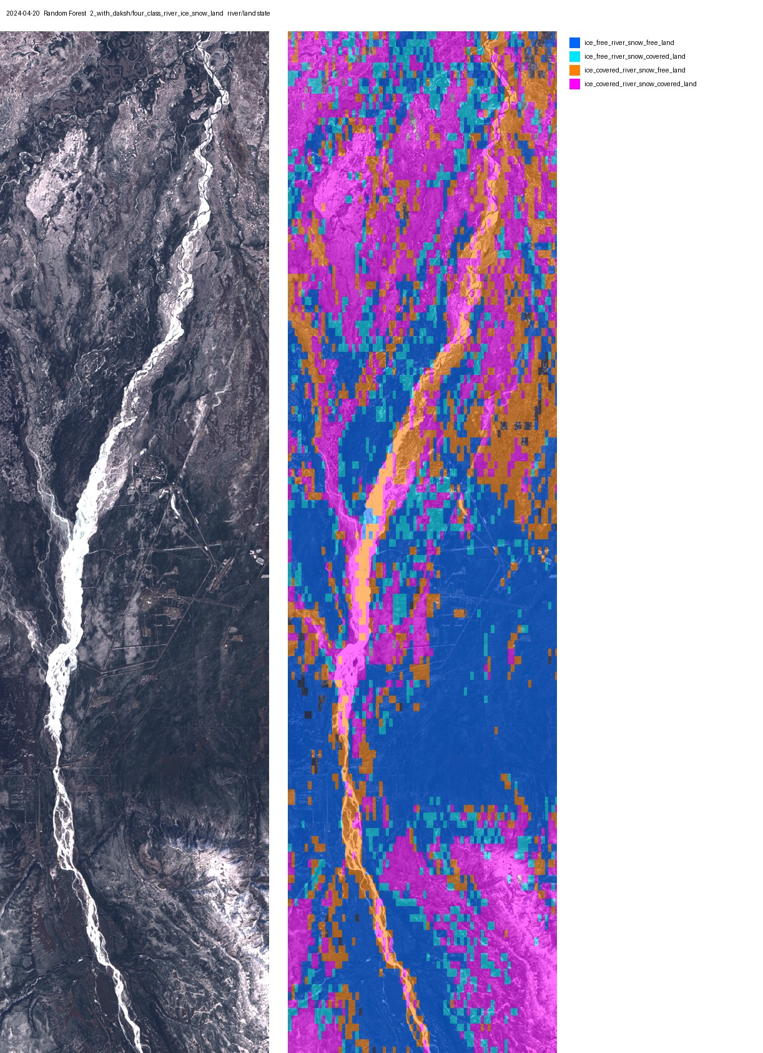
2024-04-20 river/land state mask, Random Forest, with_daksh.

8.5 Whole box: true colour, hand labels, RF, UNet++
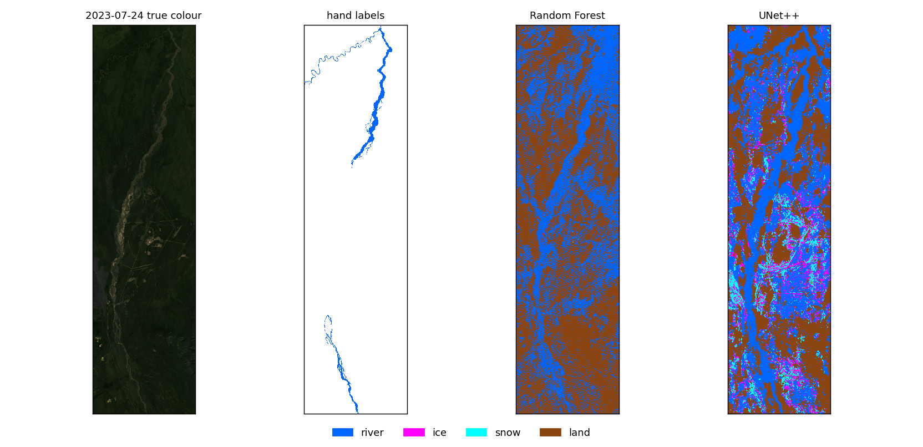
2023-07-24 (summer), whole study box (with_daksh four-class).
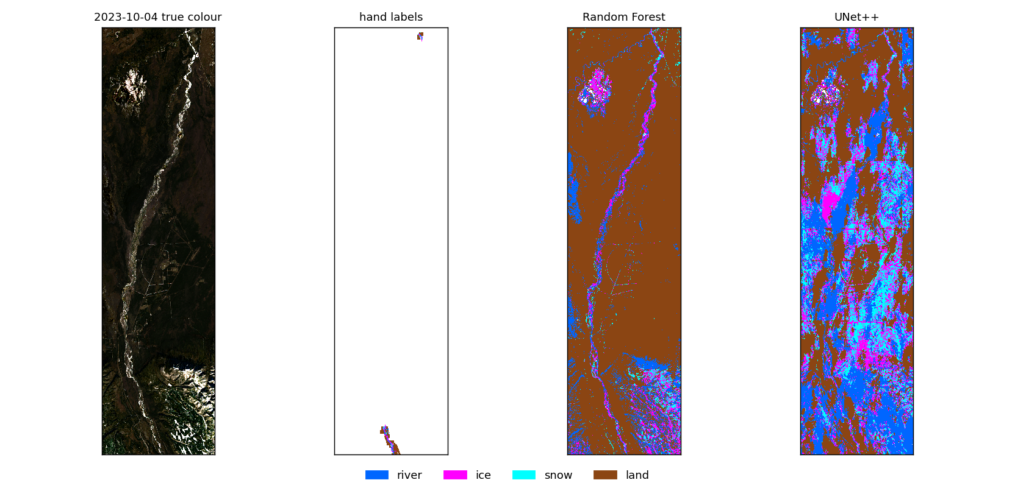
2023-10-04 (freeze-up), whole study box (with_daksh four-class).
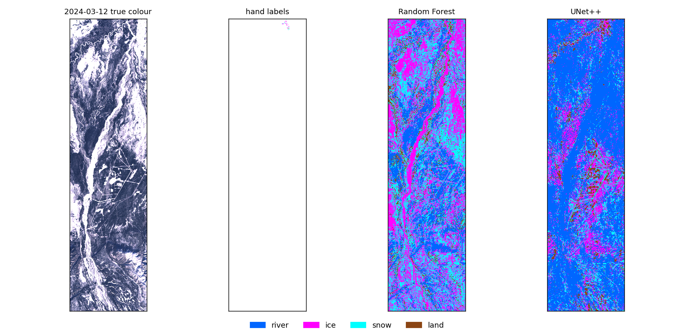
2024-03-12 (winter, daksh), whole study box (with_daksh four-class).
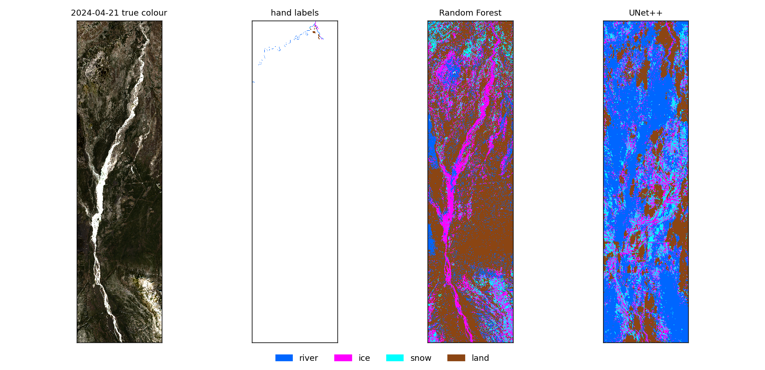
2024-04-21 (breakup), whole study box (with_daksh four-class).
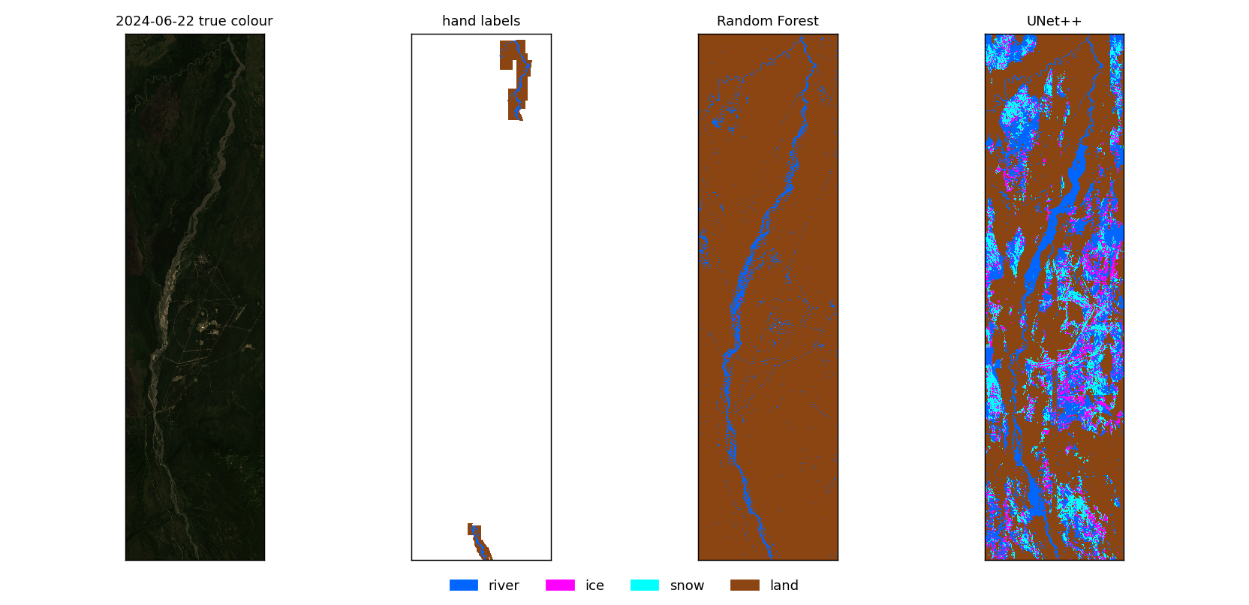
2024-06-22 (summer), whole study box (with_daksh four-class).
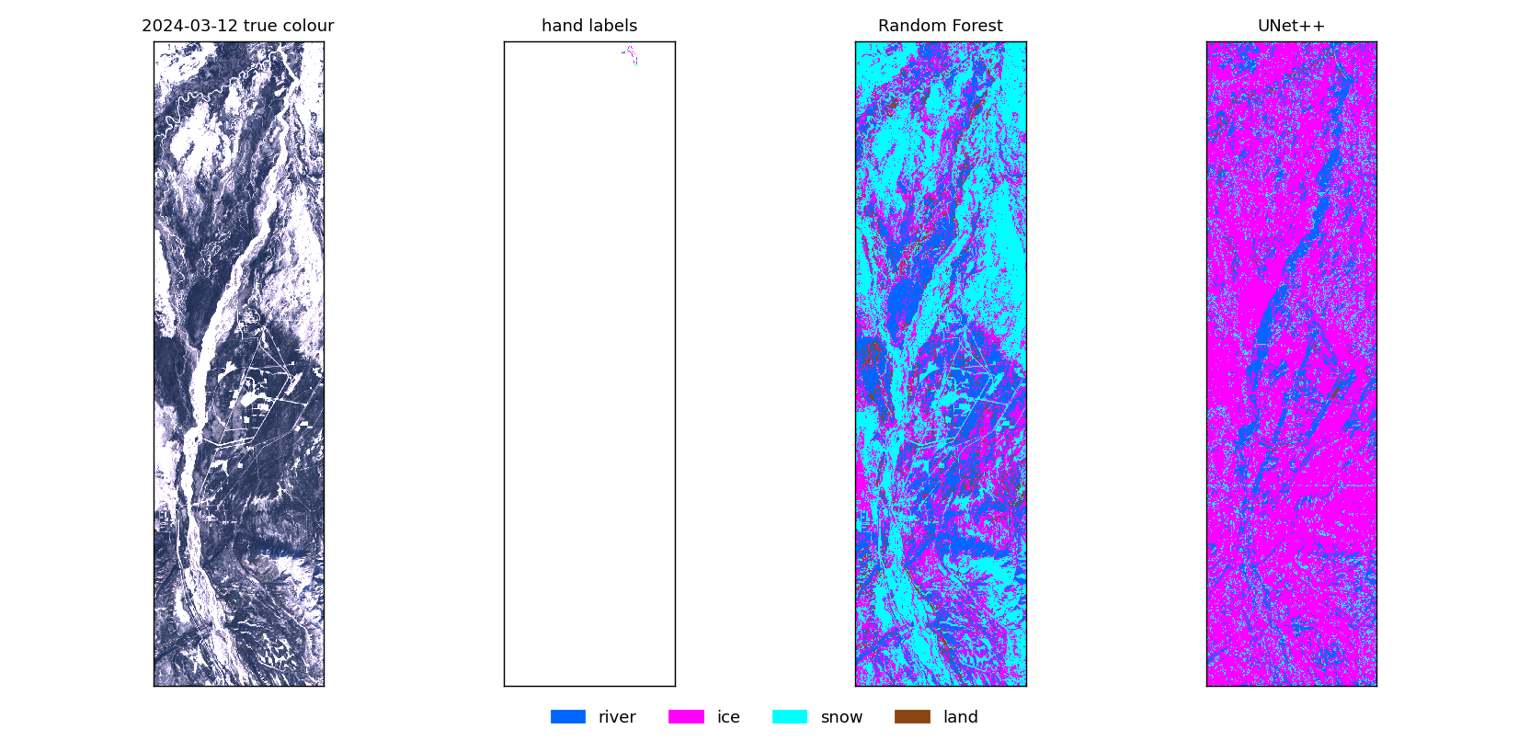
2024-03-12, whole study box, external test models (trained without this date).
Every map of every model and dataset is also a full-resolution JPEG in its task folder's images/ (new_ = unlabelled date, _state = river/land state mask).

9. Files and how to rerun
All in ~/Desktop/nenana_crops/daksh/. README.md explains each file; output/RESULTS.md has every number in this report; each model folder has model_info.txt (method, settings, inputs, dates, pixels, scores, confusion matrix). Folders: output/<1_exclude_daksh | 2_with_daksh | 3_external_test_daksh>/<task folder>/.

Inside each task folder
Path | What it is
random_forest/, unet_plus_plus/ | one folder per model
<model>/model_info.txt | the model in one page: method and settings, inputs, training/test dates and pixels per class, scores, confusion matrix, files
<model>/metrics.txt | precision, recall, F1 per class, accuracy, macro F1, confusion matrix; all dates, then per date; RF also lists input importance
<model>/oof.npz | the cross-validated prediction of every labelled pixel (date, row, col, true, predicted)
<model>/pred_<date>.tif + .qml | final model's 30 m map for every date; the .qml gives QGIS the class colours
<model>/scene_mask_<date>.tif | (four-class, combined) river/land state mask
<model>/scene_mask_metrics.txt | (four-class) state-mask scores on blocks where the labels hold both river and land
<model>/scene_classes.csv | (four-class, combined) one summary state for the whole box per date; coarse, use the mask
<model>/unetpp_final.pt | UNet++ final weights + input scaling
evaluation/scores.png, confusion.png | F1/precision/recall per class and both confusion matrices, RF vs UNet++
evaluation/summary.csv | every score of both models in one table
evaluation/compare_<date>.png, zoom_<date>.png | true colour, hand labels, RF, UNet++; whole box and zoomed on the labels
new_dates/<date>/<model>_pred.tif | maps of the unlabelled dates 2026-03-26 and 2023-05-05
images/*.jpg | full-resolution JPEGs, image next to image + mask

Colours: river blue, ice magenta, snow cyan, land brown, 'not ...' grey. State mask: open/snow-free blue, open/snowy light cyan, frozen/snow-free orange, frozen/snowy magenta.

Scripts
Environment ~/venvs/river-ml (PyTorch with CUDA, segmentation-models-pytorch, scikit-learn, GDAL); PY=~/venvs/river-ml/bin/python.
Script | Does
data.py | dates, inputs, label mapping per task, spatial folds, folder names, score tables, map writing
train_rf.py --task --dataset | RF cross-validation + final maps
train_unetpp.py --task --dataset | UNet++ cross-validation + final maps (--iters, --encoder)
external_test.py --task | train on the patch dates, score on the daksh labels
combine.py --dataset | binary snow + river -> four classes, scored on the cross-validated predictions
scene_mask.py --dataset | river/land state masks + their scores
evaluate.py --task --dataset | figures in evaluation/ (--task combined too)
predict_new.py --task --dataset [--dates] | maps for unlabelled dates
images.py --dataset | all JPEGs
summarise.py | model_info.txt in every model folder + output/RESULTS.md
add_to_project.py | adds the maps to all_patches.qgz (close QGIS first)
run_all.sh, run_rest.sh, run_external.sh | the full runs, about 4 hours on the RTX 3080
report/test_panels.py, word_content.py, build_word.js | this report and its test figures

One model by hand: $PY train_rf.py --task ind_ice --dataset with_daksh, then train_unetpp.py and evaluate.py with the same arguments. Task names: four, snow, river, ind_river, ind_ice, ind_snow, ind_land; datasets: exclude_daksh, with_daksh, external_daksh.

10. Things to know when reading the results
- Rare classes: ice (1,732 px) and snow (564 px, 714 with daksh) come from only 2023-10-04, 2024-04-21 and 2024-03-12, so their scores move a lot with each new polygon.
- 2023-07-24 holds 31,021 of the 39,991 river pixels, so it shapes what the models call river. On the unlabelled dates the models mark some vegetated land as river.
- Clouds were never labelled, so models call them snow or ice.
- with_daksh has no temperature input, which the exclude_daksh Random Forest ranked among its 4 most important inputs; compare the two datasets with that in mind.
- Per-date macro F1 only averages classes present on that date (a summer date has no ice or snow).
- The external test has only 532 pixels and no river.
- VIIRS is not used yet.

