Nenana river ice: Random Forest on Landsat 30 m, every run
RiverProject · daksh models · 2026-11-03
Random Forest models classify every Landsat 30 m pixel of the Nenana study box. They are trained only on the hand-drawn label polygons, which are the ground truth. Four-class runs predict river (open water), ice, snow and land; six-class runs split land into forest, shrub/grass/wetland and bare/developed using NLCD 2016. This report has every Random Forest run (01, 03, 05 to 15): what it changes, its inputs and settings, its scores and confusion matrix on every dataset, plus the labelled pixels, the method, figures of ground truth against predictions, and the files. Runs 02 and 04 were not Random Forest and are left out.

Contents

1. Summary
- Best six-class scores without per-date help: run 11 (feature search) 0.965 accuracy / 0.836 macro F1 and run 10 (terrain + context + NLCD) 0.962 / 0.826, 5-fold spatial cross-validation on the 4 patch dates. With the daksh date added, run 10 is best (0.958 / 0.822).
- Run 12 scores higher (0.969 / 0.837) but part of that gain comes from the per-date sun angles, which tell the forest which date a pixel is from; it is reported, not used as the best model.
- Best four-class model: run 05 (all bands) 0.961 / 0.755, up from 0.952 / 0.750 for the 11-input baseline (run 01).
- NLCD land cover as an input is the biggest single gain for six classes: 0.822 / 0.663 (run 06) to 0.962 / 0.819 (run 07).
- Limited model (run 13: 25 inputs, depth 16, 20 px leaves): 0.947 / 0.808, training accuracy only 0.025 above CV, so it barely overfits; it costs about 1.5 points against run 10.
- River on land: the forced penalty of run 15 cuts river on NLCD land from 22% to 4% on 2024-04-21 and from 89% to 28% on 2024-04-29, for 0.001 accuracy (0.942 / 0.797 with daksh). These are the cleanest maps.
- River, forest and shrub are easy (F1 0.94 to 0.98). Ice (about 0.70 to 0.77) and snow (about 0.40) are hard: only 1,732 ice and 564 snow labelled pixels.
- No model carries over to a new winter date: trained on the patch dates and tested on daksh 2024-03-12, accuracy is 0.30 to 0.39 for every run. Most ice is called snow; none of the training dates is midwinter.

2. Every run at a glance
Accuracy / macro F1. exclude_daksh and with_daksh: 5-fold spatial cross-validation. External: trained on the 4 patch dates, tested on daksh 2024-03-12 (532 px, no river). Runs 08, 09 have no external test. Runs 02 and 04 were not Random Forest and are left out.
Run | What changes | Classes | exclude_daksh | with_daksh | External test
01 | Four classes, 11 inputs (baseline) | 4 | 0.952 / 0.750 | 0.944 / 0.731 | 0.338 / 0.180
03 | Four classes, river corridor only | 4 | 0.940 / 0.739 | 0.927 / 0.725 | 0.329 / 0.173
05 | Four classes, all bands | 4 | 0.961 / 0.755 | 0.957 / 0.745 | 0.299 / 0.191
06 | Six classes, all bands | 6 | 0.822 / 0.663 | 0.817 / 0.653 | 0.301 / 0.144
07 | Six classes, all bands + NLCD input | 6 | 0.962 / 0.819 | 0.958 / 0.813 | 0.305 / 0.147
08 | Six classes, tuned (no NLCD input) | 6 | 0.823 / 0.667 | 0.815 / 0.659 | -
09 | Six classes, tuned + NLCD input | 6 | 0.961 / 0.825 | 0.957 / 0.819 | -
10 | Six classes, terrain + context + NLCD | 6 | 0.962 / 0.826 | 0.958 / 0.822 | 0.312 / 0.144
11 | Six classes, feature-group search | 6 | 0.965 / 0.836 | 0.955 / 0.813 | 0.386 / 0.159
12 | Six classes, all bands + sun/illumination angles + NLCD | 6 | 0.969 / 0.837 | 0.968 / 0.835 | 0.303 / 0.142
13 | Six classes, limited parameters | 6 | 0.947 / 0.808 | 0.943 / 0.798 | 0.307 / 0.142
14 | Six classes, limited + tuned river penalty | 6 | 0.947 / 0.808 | 0.943 / 0.798 | 0.307 / 0.142
15 | Six classes, limited + forced river penalty (600 m) | 6 | 0.947 / 0.808 | 0.942 / 0.797 | 0.307 / 0.142

3. Data

3.1 Datasets
Dataset (folder) | Training dates | Scored on
1_exclude_daksh | 4 patch dates | 5-fold spatial cross-validation
2_with_daksh | 4 patch dates + daksh 2024-03-12 | 5-fold spatial cross-validation
3_external_test_daksh | 4 patch dates | daksh 2024-03-12 labels (external cohort)

3.2 Where the labels and images come from
Date | Season | Group | Labels | Imagery
2023-07-24 | summer | mathus_naira | patches/nenana_20230724/labels/ | patch _sr.tif + _thermal.tif
2023-10-04 | freeze-up | mathus_naira | patches/nenana_20231004/labels/ | patch
2024-04-21 | breakup | mathus_naira | patches/nenana_20240421/labels/ | patch
2024-06-22 | summer | mathus_naira | patches/nenana_20240622/labels/ | patch
2024-03-12 | winter | daksh | ~/labels_20240312.gpkg | nenana_crops/20240312/landsat_20240312_box.tif
2024-04-20, 2024-04-29 | spring | daksh | none (predicted only) | nenana_crops/<date>/
2026-03-26, 2023-05-05 | midwinter, breakup | new dates | none (predicted only) | ~/Desktop/Patches/nenana_<date>/

patches/ = ~/Desktop/RiverProject/Matus/narrow_rivers/patches. Hand-label classes: 1 river (open water), 2 ice, 3 snow, 4 land; 0 and 9 ignored. Study box lon -149.338 to -149.069, lat 64.094 to 64.535; every date on the same 995 x 1635 grid (EPSG:4326, 0.00027027 degrees), so a row and column is the same place on every date. The daksh image is Level-1 and is converted to reflectance with (DN x 2.0e-5 - 0.1) / cos(sun zenith).

3.3 How the dates are used
All labelled dates are pooled into one training set. Each pixel is an example with its own date's inputs and its own date's label; a date's image is never paired with another date's labels. Unlabelled dates are only predicted.
- The same ground labelled on several dates (it can be river in July, ice in October, snow in March) gives one example per date. Nothing is merged across dates.
- Cross-validation folds are 64-row east-west bands, the same band in the same fold on every date, so a tested place is held out on all dates and cannot be remembered from another date.
Dates | Shared labelled pixels | Same class on both
2023-07-24 & 2023-10-04 | 2,301 | 29%
2023-07-24 & 2024-03-12 | 327 | 2%
2023-07-24 & 2024-04-21 | 1,955 | 78%
2023-07-24 & 2024-06-22 | 8,710 | 62%
2023-10-04 & 2024-03-12 | 130 | 28%
2023-10-04 & 2024-04-21 | 372 | 74%
2023-10-04 & 2024-06-22 | 7,943 | 76%
2024-03-12 & 2024-04-21 | 241 | 49%
2024-03-12 & 2024-06-22 | 410 | 7%
2024-04-21 & 2024-06-22 | 1,769 | 71%

3.4 Labelled pixels per class, four classes

1. exclude_daksh: trained and cross-validated on the 4 patch dates
Date | Group | River | Ice | Snow | Land | Total | Used for
2023-07-24 | mathus_naira | 31,021 | 0 | 0 | 7 | 31,028 | train
2023-10-04 | mathus_naira | 974 | 1,308 | 521 | 5,217 | 8,020 | train
2024-04-21 | mathus_naira | 1,886 | 424 | 43 | 728 | 3,081 | train
2024-06-22 | mathus_naira | 6,110 | 0 | 0 | 37,119 | 43,229 | train
Training total |  | 39,991 | 1,732 | 564 | 43,071 | 85,358

2. with_daksh: trained and cross-validated on the 4 patch dates + daksh 2024-03-12
Date | Group | River | Ice | Snow | Land | Total | Used for
2023-07-24 | mathus_naira | 31,021 | 0 | 0 | 7 | 31,028 | train
2023-10-04 | mathus_naira | 974 | 1,308 | 521 | 5,217 | 8,020 | train
2024-03-12 | daksh | 0 | 342 | 150 | 40 | 532 | train
2024-04-21 | mathus_naira | 1,886 | 424 | 43 | 728 | 3,081 | train
2024-06-22 | mathus_naira | 6,110 | 0 | 0 | 37,119 | 43,229 | train
Training total |  | 39,991 | 2,074 | 714 | 43,111 | 85,890

3. external_test_daksh: trained on the 4 patch dates, tested on daksh 2024-03-12
Date | Group | River | Ice | Snow | Land | Total | Used for
2023-07-24 | mathus_naira | 31,021 | 0 | 0 | 7 | 31,028 | train
2023-10-04 | mathus_naira | 974 | 1,308 | 521 | 5,217 | 8,020 | train
2024-03-12 | daksh | 0 | 342 | 150 | 40 | 532 | test
2024-04-21 | mathus_naira | 1,886 | 424 | 43 | 728 | 3,081 | train
2024-06-22 | mathus_naira | 6,110 | 0 | 0 | 37,119 | 43,229 | train
Training total |  | 39,991 | 1,732 | 564 | 43,071 | 85,358

3.5 Labelled pixels per class, six classes
River, ice and snow as drawn; land-label pixels split by NLCD 2016 (land pixels NLCD calls water are left out). Counts from the with_daksh run 10 evaluation.
Date | River | Ice | Snow | Forest | Shrub/grass/wet | Bare/dev | Total
2023-07-24 | 31,021 | 0 | 0 | 5 | 2 | 0 | 31,028
2023-10-04 | 974 | 1,308 | 521 | 2,184 | 2,703 | 157 | 7,847
2024-03-12 | 0 | 342 | 150 | 35 | 1 | 0 | 528
2024-04-21 | 1,886 | 424 | 43 | 654 | 53 | 0 | 3,060
2024-06-22 | 6,110 | 0 | 0 | 19,330 | 12,868 | 2,569 | 40,877
Total | 39,991 | 2,074 | 714 | 22,208 | 15,627 | 2,726 | 83,340

4. Classes, inputs and method

4.1 Six classes
Class | From | Map colour
river | hand label 1 (open water) | blue
ice | hand label 2 | magenta
snow | hand label 3 | cyan
forest | land label + NLCD 41 deciduous, 42 evergreen, 43 mixed | dark green
shrub_grass_wetland | land label + NLCD 51, 52 shrub, 71 grass, 72 sedge, 81 pasture, 90 woody, 95 emergent wetland | light green
bare_developed | land label + NLCD 21-24 developed, 31 barren | tan

Four-class runs use river, ice, snow and land (land brown). NLCD Alaska 2016 comes from Earth Engine USGS/NLCD_RELEASES/2016_REL/2016_AK, resampled to the box grid (output/nlcd/).

4.2 Input groups
Group | Inputs | Runs
raw bands | blue, green, red, NIR, SWIR1 (+ SWIR2, surface temperature in exclude_daksh) | all
band pairs | normalized difference (a-b)/(a+b) and difference a-b of every reflectance band pair | 05+
indices | NDWI, NDSI, NDVI, MNDWI, EVI, SAVI, MSAVI, BSI, visible brightness, NIR+SWIR, AWEI_nsh, AWEI_sh, tasseled cap | 01 (3), 05+
texture | mean and std in 3x3 and 7x7 windows of NDVI, NDSI, NDWI, NIR, blue | 05+
JRC water occurrence | how often each pixel was water 1984-2021 | 01, 03 only
NLCD | 10 yes/no land-cover groups | 07, 09-15
terrain | Copernicus GLO-30 DEM: elevation, slope, northness, eastness, height above valley floor (300 m, 1 km) | 10, 11
distance to water | distance to the nearest NLCD water pixel (m) | 10, 11
context | MNDWI, NDWI, NDVI, brightness averaged over 15x15 and 31x31 px | 10
illumination | slope, northness, eastness, cos(sun incidence), shadowed; sun elevation/azimuth per date (12 only) | 12-15

4.3 How scores are measured
Datasets 1 and 2: 5-fold spatial cross-validation. The box is cut into east-west bands 64 rows (about 1.9 km) tall; band i is in fold i mod 5 on every date. Each fold's model trains on the other 4 folds (dropping pixels within 12 rows of the test band) and is scored on its own fold, so every labelled pixel is scored once by a model that never saw it. Settings (leaf size, max_features, input count, depth, penalty strength) are always chosen inside the training folds. Then one final model is trained on all labels and draws the maps.
Dataset 3 (external cohort): one model trained on the 4 patch dates, scored on the 532 labelled pixels of daksh 2024-03-12, a date, season and labeller it never saw. No river there, so read it as a carry-over check.
All Random Forests use class_weight balanced_subsample (rare classes weigh more). Macro F1 = the mean F1 of the classes, so ice and snow count as much as river. Confusion matrices: rows = hand label, columns = prediction.

4.4 River penalty (runs 14, 15)
NLCD water covers only 57% of the hand-labelled river (the channel has moved since 2016), so a hard water mask would delete real river. Instead, on pixels NLCD calls land, the forest's river probability is multiplied by w = 1 within 60 m of NLCD water and w = max(0.1, exp(-(distance - 60 m) / scale)) further out; the pixel then takes the most likely class. River can still win where the bands are sure. Run 14 tuned the scale per fold (it chose no penalty every time); run 15 fixes it at 600 m. 'no fix' maps = same forest without this step.

5. Every run: settings, scores and confusion matrices

Run 01: Four classes, 11 inputs (baseline)
The first model: a few bands and three indices, plus the JRC water-occurrence layer.
Classes | 4
Inputs | 11 (exclude_daksh): SR_B2-SR_B7, ST_B10, JRC water occurrence, NDWI, NDSI, NDVI; 9 with daksh (no SWIR2, no temperature)
Settings | 300 trees, min 2 samples per leaf, balanced_subsample
Folder | output/<dataset>/four_class_river_ice_snow_land/random_forest

Run 01 · exclude_daksh
Accuracy 0.952, macro F1 0.750.
Class | Pixels | Precision | Recall | F1
river | 39,991 | 0.951 | 0.963 | 0.957
ice | 1,732 | 0.703 | 0.730 | 0.716
snow | 564 | 0.495 | 0.289 | 0.365
land | 43,071 | 0.966 | 0.959 | 0.962

true \ predicted | river | ice | snow | land
river | 38,505 | 98 | 3 | 1,385
ice | 305 | 1,264 | 110 | 53
snow | 24 | 352 | 163 | 25
land | 1,636 | 83 | 53 | 41,299

Run 01 · with_daksh
Accuracy 0.944, macro F1 0.731.
Class | Pixels | Precision | Recall | F1
river | 39,991 | 0.948 | 0.956 | 0.952
ice | 2,074 | 0.675 | 0.687 | 0.681
snow | 714 | 0.370 | 0.307 | 0.335
land | 43,111 | 0.960 | 0.955 | 0.958

true \ predicted | river | ice | snow | land
river | 38,234 | 174 | 2 | 1,581
ice | 281 | 1,424 | 307 | 62
snow | 10 | 426 | 219 | 59
land | 1,791 | 86 | 64 | 41,170

Run 01 · external_test
Accuracy 0.338, macro F1 0.180.
Class | Pixels | Precision | Recall | F1
river | 0 | 0.000 | 0.000 | 0.000
ice | 342 | 0.675 | 0.152 | 0.248
snow | 150 | 0.280 | 0.847 | 0.421
land | 40 | 1.000 | 0.025 | 0.049

true \ predicted | river | ice | snow | land
river | 0 | 0 | 0 | 0
ice | 0 | 52 | 290 | 0
snow | 0 | 23 | 127 | 0
land | 1 | 2 | 36 | 1

Run 03: Four classes, river corridor only
Whether limiting the model to the river and its banks helps (it does not: it loses context).
Classes | 4
Inputs | as run 01
Settings | as run 01; trained and predicted only inside the river + 150 m banks
Folder | output/4_river_corridor_150m/<dataset>/four_class_river_ice_snow_land/random_forest

Run 03 · exclude_daksh
Accuracy 0.940, macro F1 0.739.
Class | Pixels | Precision | Recall | F1
river | 39,677 | 0.958 | 0.967 | 0.963
ice | 1,703 | 0.704 | 0.730 | 0.717
snow | 553 | 0.533 | 0.264 | 0.353
land | 18,006 | 0.929 | 0.921 | 0.925

true \ predicted | river | ice | snow | land
river | 38,381 | 94 | 0 | 1,202
ice | 311 | 1,243 | 112 | 37
snow | 24 | 354 | 146 | 29
land | 1,339 | 74 | 16 | 16,577

Run 03 · with_daksh
Accuracy 0.927, macro F1 0.725.
Class | Pixels | Precision | Recall | F1
river | 39,677 | 0.954 | 0.960 | 0.957
ice | 2,045 | 0.676 | 0.665 | 0.671
snow | 703 | 0.369 | 0.351 | 0.360
land | 18,046 | 0.916 | 0.907 | 0.911

true \ predicted | river | ice | snow | land
river | 38,087 | 176 | 4 | 1,410
ice | 279 | 1,360 | 365 | 41
snow | 10 | 393 | 247 | 53
land | 1,548 | 82 | 54 | 16,362

Run 03 · external_test
Accuracy 0.329, macro F1 0.173.
Class | Pixels | Precision | Recall | F1
river | 0 | 0.000 | 0.000 | 0.000
ice | 342 | 0.662 | 0.137 | 0.228
snow | 150 | 0.277 | 0.847 | 0.417
land | 40 | 1.000 | 0.025 | 0.049

true \ predicted | river | ice | snow | land
river | 0 | 0 | 0 | 0
ice | 0 | 47 | 295 | 0
snow | 0 | 23 | 127 | 0
land | 1 | 1 | 37 | 1

Run 05: Four classes, all bands
Every band set against every other band instead of 3 hand-picked indices.
Classes | 4
Inputs | all bands: raw bands, normalized difference and difference of every band pair, EVI, SAVI, MSAVI, BSI, brightness, AWEI, tasseled cap, 3x3 and 7x7 texture (mean, std); no water mask, no JRC
Settings | 500 trees; min_samples_leaf and max_features chosen by spatial CV
Folder | output/5_rf_all_bands/<dataset>/four_class_river_ice_snow_land/random_forest

Run 05 · exclude_daksh
Accuracy 0.961, macro F1 0.755.
Class | Pixels | Precision | Recall | F1
river | 39,991 | 0.970 | 0.964 | 0.967
ice | 1,732 | 0.681 | 0.760 | 0.718
snow | 564 | 0.497 | 0.284 | 0.361
land | 43,071 | 0.969 | 0.975 | 0.972

true \ predicted | river | ice | snow | land
river | 38,560 | 166 | 1 | 1,264
ice | 250 | 1,316 | 125 | 41
snow | 18 | 347 | 160 | 39
land | 930 | 104 | 36 | 42,001

Run 05 · with_daksh
Accuracy 0.957, macro F1 0.745.
Class | Pixels | Precision | Recall | F1
river | 39,991 | 0.970 | 0.961 | 0.966
ice | 2,074 | 0.665 | 0.789 | 0.721
snow | 714 | 0.436 | 0.255 | 0.322
land | 43,111 | 0.967 | 0.973 | 0.970

true \ predicted | river | ice | snow | land
river | 38,426 | 212 | 3 | 1,350
ice | 199 | 1,636 | 198 | 41
snow | 11 | 469 | 182 | 52
land | 969 | 144 | 34 | 41,964

Run 05 · external_test
Accuracy 0.299, macro F1 0.191.
Class | Pixels | Precision | Recall | F1
river | 0 | 0.000 | 0.000 | 0.000
ice | 342 | 0.410 | 0.094 | 0.152
snow | 150 | 0.280 | 0.847 | 0.421
land | 40 | 0.000 | 0.000 | 0.000

true \ predicted | river | ice | snow | land
river | 0 | 0 | 0 | 0
ice | 0 | 32 | 310 | 0
snow | 0 | 23 | 127 | 0
land | 0 | 23 | 17 | 0

Run 06: Six classes, all bands
Land split into forest / shrub-grass-wetland / bare-developed with NLCD 2016 (labels only, not inputs).
Classes | 6
Inputs | as run 05
Settings | as run 05
Folder | output/6_rf_six_classes/<dataset>/six_class/random_forest

Run 06 · exclude_daksh
Accuracy 0.822, macro F1 0.663.
Class | Pixels | Precision | Recall | F1
river | 39,991 | 0.969 | 0.970 | 0.969
ice | 1,732 | 0.685 | 0.771 | 0.725
snow | 564 | 0.476 | 0.346 | 0.400
forest | 22,173 | 0.743 | 0.738 | 0.741
shrub_grass_wetland | 15,626 | 0.641 | 0.637 | 0.639
bare_developed | 2,726 | 0.490 | 0.517 | 0.503

true \ predicted | river | ice | snow | forest | shrub/grass/wet | bare/dev
river | 38,780 | 182 | 6 | 330 | 243 | 450
ice | 241 | 1,336 | 135 | 7 | 10 | 3
snow | 19 | 338 | 195 | 0 | 7 | 5
forest | 291 | 48 | 27 | 16,365 | 4,942 | 500
shrub/grass/wet | 240 | 39 | 28 | 4,854 | 9,954 | 511
bare/dev | 443 | 8 | 19 | 465 | 381 | 1,410

Run 06 · with_daksh
Accuracy 0.817, macro F1 0.653.
Class | Pixels | Precision | Recall | F1
river | 39,991 | 0.969 | 0.967 | 0.968
ice | 2,074 | 0.673 | 0.801 | 0.731
snow | 714 | 0.467 | 0.304 | 0.368
forest | 22,208 | 0.742 | 0.727 | 0.734
shrub_grass_wetland | 15,627 | 0.638 | 0.637 | 0.637
bare_developed | 2,726 | 0.450 | 0.515 | 0.480

true \ predicted | river | ice | snow | forest | shrub/grass/wet | bare/dev
river | 38,672 | 215 | 8 | 330 | 235 | 531
ice | 197 | 1,662 | 197 | 9 | 8 | 1
snow | 13 | 464 | 217 | 3 | 14 | 3
forest | 295 | 84 | 15 | 16,149 | 5,039 | 626
shrub/grass/wet | 235 | 40 | 13 | 4,826 | 9,956 | 557
bare/dev | 478 | 6 | 15 | 461 | 361 | 1,405

Run 06 · external_test
Accuracy 0.301, macro F1 0.144.
Class | Pixels | Precision | Recall | F1
river | 0 | 0.000 | 0.000 | 0.000
ice | 342 | 0.429 | 0.096 | 0.158
snow | 150 | 0.279 | 0.840 | 0.419
forest | 35 | 0.000 | 0.000 | 0.000
shrub_grass_wetland | 1 | 0.000 | 0.000 | 0.000
bare_developed | 0 | 0.000 | 0.000 | 0.000

true \ predicted | river | ice | snow | forest | shrub/grass/wet | bare/dev
river | 0 | 0 | 0 | 0 | 0 | 0
ice | 0 | 33 | 309 | 0 | 0 | 0
snow | 0 | 24 | 126 | 0 | 0 | 0
forest | 0 | 20 | 15 | 0 | 0 | 0
shrub/grass/wet | 0 | 0 | 1 | 0 | 0 | 0
bare/dev | 0 | 0 | 0 | 0 | 0 | 0

Run 07: Six classes, all bands + NLCD input
NLCD also given as an input, so the forest knows the land type.
Classes | 6
Inputs | run 05 inputs + NLCD 2016 land cover as 10 yes/no inputs
Settings | as run 05
Folder | output/7_rf_six_classes_nlcd_input/<dataset>/six_class/random_forest

Run 07 · exclude_daksh
Accuracy 0.962, macro F1 0.819.
Class | Pixels | Precision | Recall | F1
river | 39,991 | 0.975 | 0.971 | 0.973
ice | 1,732 | 0.688 | 0.778 | 0.730
snow | 564 | 0.475 | 0.323 | 0.384
forest | 22,173 | 0.976 | 0.983 | 0.979
shrub_grass_wetland | 15,626 | 0.971 | 0.969 | 0.970
bare_developed | 2,726 | 0.883 | 0.872 | 0.878

true \ predicted | river | ice | snow | forest | shrub/grass/wet | bare/dev
river | 38,822 | 179 | 6 | 304 | 374 | 306
ice | 228 | 1,347 | 134 | 11 | 11 | 1
snow | 16 | 345 | 182 | 10 | 6 | 5
forest | 253 | 45 | 21 | 21,806 | 47 | 1
shrub/grass/wet | 201 | 36 | 20 | 221 | 15,147 | 1
bare/dev | 311 | 7 | 20 | 1 | 9 | 2,378

Run 07 · with_daksh
Accuracy 0.958, macro F1 0.813.
Class | Pixels | Precision | Recall | F1
river | 39,991 | 0.975 | 0.966 | 0.970
ice | 2,074 | 0.675 | 0.807 | 0.735
snow | 714 | 0.476 | 0.294 | 0.364
forest | 22,208 | 0.976 | 0.982 | 0.979
shrub_grass_wetland | 15,627 | 0.969 | 0.971 | 0.970
bare_developed | 2,726 | 0.856 | 0.869 | 0.862

true \ predicted | river | ice | snow | forest | shrub/grass/wet | bare/dev
river | 38,634 | 215 | 3 | 315 | 436 | 388
ice | 190 | 1,674 | 185 | 14 | 10 | 1
snow | 13 | 464 | 210 | 15 | 7 | 5
forest | 251 | 82 | 14 | 21,819 | 36 | 6
shrub/grass/wet | 205 | 38 | 12 | 201 | 15,171 | 0
bare/dev | 334 | 6 | 17 | 0 | 0 | 2,369

Run 07 · external_test
Accuracy 0.305, macro F1 0.147.
Class | Pixels | Precision | Recall | F1
river | 0 | 0.000 | 0.000 | 0.000
ice | 342 | 0.412 | 0.102 | 0.164
snow | 150 | 0.284 | 0.840 | 0.425
forest | 35 | 0.000 | 0.000 | 0.000
shrub_grass_wetland | 1 | 0.000 | 0.000 | 0.000
bare_developed | 0 | 0.000 | 0.000 | 0.000

true \ predicted | river | ice | snow | forest | shrub/grass/wet | bare/dev
river | 0 | 0 | 0 | 0 | 0 | 0
ice | 0 | 35 | 307 | 0 | 0 | 0
snow | 0 | 24 | 126 | 0 | 0 | 0
forest | 0 | 26 | 9 | 0 | 0 | 0
shrub/grass/wet | 0 | 0 | 1 | 0 | 0 | 0
bare/dev | 0 | 0 | 0 | 0 | 0 | 0

Run 08: Six classes, tuned (no NLCD input)
How far tuning alone gets the six-class model without NLCD as input.
Classes | 6
Inputs | as run 06
Settings | best of: leaf 5/10/20/40 x max_features sqrt/0.1/0.2, class weights, top-20/35 inputs, OOB class weights
Folder | output/8_best_six_class/<dataset>/six_class

Run 08 · exclude_daksh
Accuracy 0.823, macro F1 0.667.
Class | Pixels | Precision | Recall | F1
river | 39,991 | 0.970 | 0.970 | 0.970
ice | 1,732 | 0.692 | 0.798 | 0.741
snow | 564 | 0.478 | 0.346 | 0.401
forest | 22,173 | 0.746 | 0.735 | 0.741
shrub_grass_wetland | 15,626 | 0.641 | 0.643 | 0.642
bare_developed | 2,726 | 0.493 | 0.525 | 0.508

true \ predicted | river | ice | snow | forest | shrub/grass/wet | bare/dev
river | 38,774 | 181 | 7 | 331 | 244 | 454
ice | 202 | 1,382 | 128 | 9 | 9 | 2
snow | 18 | 339 | 195 | 0 | 7 | 5
forest | 308 | 47 | 30 | 16,301 | 4,992 | 495
shrub/grass/wet | 242 | 39 | 29 | 4,753 | 10,047 | 516
bare/dev | 434 | 9 | 19 | 454 | 380 | 1,430

Run 08 · with_daksh
Accuracy 0.815, macro F1 0.659.
Class | Pixels | Precision | Recall | F1
river | 39,991 | 0.975 | 0.959 | 0.967
ice | 2,074 | 0.662 | 0.786 | 0.719
snow | 714 | 0.431 | 0.399 | 0.414
forest | 22,208 | 0.761 | 0.711 | 0.735
shrub_grass_wetland | 15,627 | 0.640 | 0.656 | 0.648
bare_developed | 2,726 | 0.390 | 0.587 | 0.469

true \ predicted | river | ice | snow | forest | shrub/grass/wet | bare/dev
river | 38,354 | 281 | 15 | 297 | 259 | 785
ice | 141 | 1,631 | 283 | 9 | 6 | 4
snow | 9 | 411 | 285 | 1 | 5 | 3
forest | 253 | 84 | 32 | 15,784 | 5,162 | 893
shrub/grass/wet | 210 | 45 | 26 | 4,278 | 10,254 | 814
bare/dev | 381 | 10 | 21 | 382 | 332 | 1,600

Run 08 · Search (5-fold spatial CV) · exclude_daksh
search output
kind=rf, leaf=20, mf=sqrt macro F1 0.659 accuracy 0.818 (40 s)
kind=rf, leaf=20, mf=0.1 macro F1 0.660 accuracy 0.817 (31 s)
kind=rf, leaf=20, mf=0.2 macro F1 0.658 accuracy 0.819 (64 s)
kind=rf, leaf=40, mf=sqrt macro F1 0.645 accuracy 0.810 (38 s)
kind=rf, leaf=40, mf=0.1 macro F1 0.644 accuracy 0.809 (30 s)
kind=rf, leaf=40, mf=0.2 macro F1 0.647 accuracy 0.811 (60 s)
kind=rf, leaf=5, mf=0.1, cw=balanced macro F1 0.666 accuracy 0.823 (23 s)
kind=rf, leaf=5, mf=0.1, cw=None macro F1 0.641 accuracy 0.819 (37 s)
kind=topk, leaf=5, mf=0.1, k=20 macro F1 0.657 accuracy 0.821 (31 s)
kind=topk, leaf=5, mf=0.1, k=35 macro F1 0.665 accuracy 0.821 (36 s)
kind=oobw, leaf=5, mf=0.1 macro F1 0.659 accuracy 0.818 (41 s)
best: kind=rf, leaf=5, mf=0.1 macro F1 0.667 accuracy 0.823

Run 08 · Search (5-fold spatial CV) · with_daksh
search output
kind=rf, leaf=20, mf=sqrt macro F1 0.647 accuracy 0.810 (36 s)
kind=rf, leaf=20, mf=0.1 macro F1 0.647 accuracy 0.811 (27 s)
kind=rf, leaf=20, mf=0.2 macro F1 0.645 accuracy 0.809 (50 s)
kind=rf, leaf=40, mf=sqrt macro F1 0.637 accuracy 0.803 (34 s)
kind=rf, leaf=40, mf=0.1 macro F1 0.636 accuracy 0.801 (26 s)
kind=rf, leaf=40, mf=0.2 macro F1 0.636 accuracy 0.804 (49 s)
kind=rf, leaf=10, mf=0.2, cw=balanced macro F1 0.653 accuracy 0.812 (38 s)
kind=rf, leaf=10, mf=0.2, cw=None macro F1 0.627 accuracy 0.811 (56 s)
kind=topk, leaf=10, mf=0.2, k=20 macro F1 0.641 accuracy 0.809 (48 s)
kind=topk, leaf=10, mf=0.2, k=35 macro F1 0.645 accuracy 0.811 (63 s)
kind=oobw, leaf=10, mf=0.2 macro F1 0.652 accuracy 0.821 (58 s)
best: kind=rf, leaf=10, mf=0.2 macro F1 0.659 accuracy 0.815

Run 09: Six classes, tuned + NLCD input
The run 08 search with NLCD as input.
Classes | 6
Inputs | as run 07
Settings | the run 08 search with NLCD inputs
Folder | output/9_best_six_class_nlcd_input/<dataset>/six_class

Run 09 · exclude_daksh
Accuracy 0.961, macro F1 0.825.
Class | Pixels | Precision | Recall | F1
river | 39,991 | 0.980 | 0.964 | 0.972
ice | 1,732 | 0.678 | 0.805 | 0.736
snow | 564 | 0.448 | 0.397 | 0.421
forest | 22,173 | 0.972 | 0.983 | 0.978
shrub_grass_wetland | 15,626 | 0.970 | 0.966 | 0.968
bare_developed | 2,726 | 0.850 | 0.909 | 0.878

true \ predicted | river | ice | snow | forest | shrub/grass/wet | bare/dev
river | 38,559 | 241 | 8 | 342 | 413 | 428
ice | 150 | 1,395 | 167 | 10 | 9 | 1
snow | 14 | 316 | 224 | 2 | 5 | 3
forest | 232 | 52 | 45 | 21,802 | 36 | 6
shrub/grass/wet | 179 | 47 | 35 | 269 | 15,095 | 1
bare/dev | 210 | 8 | 21 | 0 | 9 | 2,478

Run 09 · with_daksh
Accuracy 0.957, macro F1 0.819.
Class | Pixels | Precision | Recall | F1
river | 39,991 | 0.981 | 0.958 | 0.969
ice | 2,074 | 0.664 | 0.786 | 0.720
snow | 714 | 0.441 | 0.384 | 0.410
forest | 22,208 | 0.977 | 0.985 | 0.981
shrub_grass_wetland | 15,627 | 0.965 | 0.976 | 0.970
bare_developed | 2,726 | 0.818 | 0.913 | 0.863

true \ predicted | river | ice | snow | forest | shrub/grass/wet | bare/dev
river | 38,292 | 276 | 7 | 351 | 523 | 542
ice | 152 | 1,630 | 272 | 10 | 9 | 1
snow | 8 | 415 | 274 | 10 | 3 | 4
forest | 214 | 85 | 27 | 21,865 | 14 | 3
shrub/grass/wet | 166 | 41 | 25 | 146 | 15,246 | 3
bare/dev | 211 | 8 | 17 | 0 | 0 | 2,490

Run 09 · Search (5-fold spatial CV) · exclude_daksh
search output
kind=rf, leaf=20, mf=sqrt macro F1 0.815 accuracy 0.956 (37 s)
kind=rf, leaf=20, mf=0.1 macro F1 0.814 accuracy 0.955 (32 s)
kind=rf, leaf=20, mf=0.2 macro F1 0.822 accuracy 0.960 (64 s)
kind=rf, leaf=40, mf=sqrt macro F1 0.799 accuracy 0.948 (34 s)
kind=rf, leaf=40, mf=0.1 macro F1 0.798 accuracy 0.947 (30 s)
kind=rf, leaf=40, mf=0.2 macro F1 0.808 accuracy 0.952 (61 s)
kind=rf, leaf=10, mf=sqrt, cw=balanced macro F1 0.819 accuracy 0.958 (25 s)
kind=rf, leaf=10, mf=sqrt, cw=None macro F1 0.803 accuracy 0.958 (38 s)
kind=topk, leaf=10, mf=sqrt, k=20 macro F1 0.810 accuracy 0.945 (36 s)
kind=topk, leaf=10, mf=sqrt, k=35 macro F1 0.812 accuracy 0.948 (41 s)
kind=oobw, leaf=10, mf=sqrt macro F1 0.805 accuracy 0.958 (42 s)
best: kind=rf, leaf=10, mf=sqrt macro F1 0.825 accuracy 0.961

Run 09 · Search (5-fold spatial CV) · with_daksh
search output
kind=rf, leaf=20, mf=sqrt macro F1 0.807 accuracy 0.951 (29 s)
kind=rf, leaf=20, mf=0.1 macro F1 0.806 accuracy 0.949 (26 s)
kind=rf, leaf=20, mf=0.2 macro F1 0.808 accuracy 0.952 (49 s)
kind=rf, leaf=40, mf=sqrt macro F1 0.793 accuracy 0.942 (29 s)
kind=rf, leaf=40, mf=0.1 macro F1 0.792 accuracy 0.942 (26 s)
kind=rf, leaf=40, mf=0.2 macro F1 0.795 accuracy 0.945 (48 s)
kind=rf, leaf=10, mf=0.2, cw=balanced macro F1 0.812 accuracy 0.954 (34 s)
kind=rf, leaf=10, mf=0.2, cw=None macro F1 0.799 accuracy 0.957 (54 s)
kind=topk, leaf=10, mf=0.2, k=20 macro F1 0.791 accuracy 0.936 (43 s)
kind=topk, leaf=10, mf=0.2, k=35 macro F1 0.807 accuracy 0.951 (55 s)
kind=oobw, leaf=10, mf=0.2 macro F1 0.799 accuracy 0.954 (57 s)
best: kind=rf, leaf=10, mf=0.2 macro F1 0.819 accuracy 0.957

Run 10: Six classes, terrain + context + NLCD
Lets the forest learn where a river can be (low, flat, near water, part of a long strip).
Classes | 6
Inputs | run 07 inputs + distance to NLCD water, DEM elevation, slope, northness, eastness, height above the valley floor (300 m, 1 km), MNDWI/NDWI/NDVI/brightness averaged over 15x15 and 31x31 px
Settings | 500 trees; leaf and max_features chosen by spatial CV
Folder | output/10_rf_six_classes_terrain/<dataset>/six_class/random_forest

Run 10 · exclude_daksh
Accuracy 0.962, macro F1 0.826.
Class | Pixels | Precision | Recall | F1
river | 39,991 | 0.979 | 0.969 | 0.974
ice | 1,732 | 0.681 | 0.793 | 0.733
snow | 564 | 0.432 | 0.376 | 0.402
forest | 22,173 | 0.974 | 0.981 | 0.977
shrub_grass_wetland | 15,626 | 0.966 | 0.967 | 0.966
bare_developed | 2,726 | 0.902 | 0.910 | 0.906

true \ predicted | river | ice | snow | forest | shrub/grass/wet | bare/dev
river | 38,749 | 226 | 3 | 314 | 440 | 259
ice | 163 | 1,374 | 178 | 8 | 8 | 1
snow | 17 | 325 | 212 | 2 | 5 | 3
forest | 255 | 38 | 45 | 21,749 | 80 | 6
shrub/grass/wet | 188 | 44 | 32 | 252 | 15,110 | 0
bare/dev | 205 | 11 | 21 | 2 | 6 | 2,481

Run 10 · with_daksh
Accuracy 0.958, macro F1 0.822.
Class | Pixels | Precision | Recall | F1
river | 39,991 | 0.977 | 0.965 | 0.971
ice | 2,074 | 0.681 | 0.779 | 0.726
snow | 714 | 0.419 | 0.384 | 0.401
forest | 22,208 | 0.973 | 0.980 | 0.977
shrub_grass_wetland | 15,627 | 0.963 | 0.967 | 0.965
bare_developed | 2,726 | 0.888 | 0.896 | 0.892

true \ predicted | river | ice | snow | forest | shrub/grass/wet | bare/dev
river | 38,606 | 233 | 3 | 337 | 514 | 298
ice | 160 | 1,615 | 283 | 9 | 6 | 1
snow | 13 | 411 | 274 | 6 | 7 | 3
forest | 276 | 61 | 50 | 21,771 | 47 | 3
shrub/grass/wet | 203 | 41 | 23 | 245 | 15,112 | 3
bare/dev | 252 | 11 | 21 | 0 | 0 | 2,442

Run 10 · external_test
Accuracy 0.312, macro F1 0.144.
Class | Pixels | Precision | Recall | F1
river | 0 | 0.000 | 0.000 | 0.000
ice | 342 | 0.683 | 0.082 | 0.146
snow | 150 | 0.281 | 0.913 | 0.430
forest | 35 | 0.000 | 0.000 | 0.000
shrub_grass_wetland | 1 | 0.000 | 0.000 | 0.000
bare_developed | 0 | 0.000 | 0.000 | 0.000

true \ predicted | river | ice | snow | forest | shrub/grass/wet | bare/dev
river | 0 | 0 | 0 | 0 | 0 | 0
ice | 0 | 28 | 314 | 0 | 0 | 0
snow | 0 | 13 | 137 | 0 | 0 | 0
forest | 0 | 0 | 35 | 0 | 0 | 0
shrub/grass/wet | 0 | 0 | 1 | 0 | 0 | 0
bare/dev | 0 | 0 | 0 | 0 | 0 | 0

Run 11: Six classes, feature-group search
Which input groups actually help: add one group at a time, keep it only if macro F1 rises.
Classes | 6
Inputs | best groups found: band differences + NLCD + thermal + terrain + brightness + distance to water (35 inputs)
Settings | greedy forward search over 14 input groups; final 500 trees, max_features 0.1, leaf 5
Folder | output/11_feature_search/<dataset>/six_class

Run 11 · exclude_daksh
Accuracy 0.965, macro F1 0.836.
Class | Pixels | Precision | Recall | F1
river | 39,991 | 0.977 | 0.969 | 0.973
ice | 1,732 | 0.721 | 0.810 | 0.763
snow | 564 | 0.493 | 0.369 | 0.422
forest | 22,173 | 0.978 | 0.985 | 0.982
shrub_grass_wetland | 15,626 | 0.966 | 0.977 | 0.971
bare_developed | 2,726 | 0.921 | 0.886 | 0.903

true \ predicted | river | ice | snow | forest | shrub/grass/wet | bare/dev
river | 38,770 | 150 | 4 | 353 | 510 | 204
ice | 173 | 1,403 | 138 | 9 | 8 | 1
snow | 19 | 315 | 208 | 8 | 11 | 3
forest | 268 | 37 | 24 | 21,839 | 5 | 0
shrub/grass/wet | 189 | 33 | 27 | 118 | 15,259 | 0
bare/dev | 281 | 7 | 21 | 1 | 0 | 2,416

Run 11 · with_daksh
Accuracy 0.955, macro F1 0.813.
Class | Pixels | Precision | Recall | F1
river | 39,991 | 0.970 | 0.958 | 0.964
ice | 2,074 | 0.685 | 0.853 | 0.760
snow | 714 | 0.544 | 0.262 | 0.353
forest | 22,208 | 0.975 | 0.981 | 0.978
shrub_grass_wetland | 15,627 | 0.958 | 0.977 | 0.967
bare_developed | 2,726 | 0.866 | 0.840 | 0.853

true \ predicted | river | ice | snow | forest | shrub/grass/wet | bare/dev
river | 38,308 | 222 | 3 | 462 | 646 | 350
ice | 173 | 1,769 | 117 | 8 | 7 | 0
snow | 22 | 475 | 187 | 16 | 11 | 3
forest | 327 | 76 | 16 | 21,789 | 0 | 0
shrub/grass/wet | 237 | 33 | 9 | 83 | 15,265 | 0
bare/dev | 416 | 7 | 12 | 0 | 0 | 2,291

Run 11 · external_test
Accuracy 0.386, macro F1 0.159.
Class | Pixels | Precision | Recall | F1
river | 0 | 0.000 | 0.000 | 0.000
ice | 342 | 0.611 | 0.257 | 0.362
snow | 150 | 0.303 | 0.773 | 0.435
forest | 35 | 0.000 | 0.000 | 0.000
shrub_grass_wetland | 1 | 0.000 | 0.000 | 0.000
bare_developed | 0 | 0.000 | 0.000 | 0.000

true \ predicted | river | ice | snow | forest | shrub/grass/wet | bare/dev
river | 0 | 0 | 0 | 0 | 0 | 0
ice | 0 | 88 | 254 | 0 | 0 | 0
snow | 1 | 33 | 116 | 0 | 0 | 0
forest | 0 | 23 | 12 | 0 | 0 | 0
shrub/grass/wet | 0 | 0 | 1 | 0 | 0 | 0
bare/dev | 0 | 0 | 0 | 0 | 0 | 0

Run 11 · Feature search: last rounds and best F1 per class · exclude_daksh
search output
diff_pairs+nlcd+thermal+terrain+brightness+tasseled 0.833 0.964 0.972 0.761 0.416 0.980 0.971 0.896 (23 s)
diff_pairs+nlcd+thermal+terrain+brightness+tex3 0.827 0.965 0.974 0.758 0.380 0.981 0.971 0.897 (29 s)
diff_pairs+nlcd+thermal+terrain+brightness+tex7 0.823 0.965 0.975 0.756 0.358 0.982 0.970 0.896 (29 s)
diff_pairs+nlcd+thermal+terrain+brightness+dist_water 0.834 0.964 0.973 0.764 0.415 0.982 0.971 0.899 (21 s)
diff_pairs+nlcd+thermal+terrain+brightness+context 0.818 0.964 0.973 0.741 0.334 0.980 0.971 0.907 (22 s)
--> keep dist_water: diff_pairs+nlcd+thermal+terrain+brightness+dist_water macro F1 0.834
diff_pairs+nlcd+thermal+terrain+brightness+dist_water+bands 0.832 0.965 0.974 0.756 0.412 0.982 0.973 0.897 (20 s)
diff_pairs+nlcd+thermal+terrain+brightness+dist_water+nd_pairs 0.829 0.965 0.974 0.750 0.402 0.981 0.972 0.898 (26 s)
diff_pairs+nlcd+thermal+terrain+brightness+dist_water+veg_soil 0.832 0.963 0.971 0.754 0.427 0.979 0.969 0.894 (18 s)
diff_pairs+nlcd+thermal+terrain+brightness+dist_water+water_idx 0.831 0.963 0.972 0.761 0.406 0.981 0.970 0.896 (13 s)
diff_pairs+nlcd+thermal+terrain+brightness+dist_water+tasseled 0.832 0.963 0.972 0.760 0.414 0.980 0.968 0.896 (22 s)
diff_pairs+nlcd+thermal+terrain+brightness+dist_water+tex3 0.830 0.965 0.974 0.759 0.391 0.981 0.970 0.904 (26 s)
diff_pairs+nlcd+thermal+terrain+brightness+dist_water+tex7 0.827 0.966 0.975 0.759 0.378 0.982 0.971 0.898 (26 s)
diff_pairs+nlcd+thermal+terrain+brightness+dist_water+context 0.825 0.965 0.974 0.747 0.363 0.980 0.971 0.917 (25 s)
best combination: diff_pairs+nlcd+thermal+terrain+brightness+dist_water macro F1 0.834
best F1 per class seen in the search (and the combination that gave it):
river 0.975 diff_pairs+nlcd+thermal+terrain+brightness+tex7
ice 0.768 diff_pairs+nlcd+thermal+terrain+dist_water
snow 0.427 diff_pairs+nlcd+thermal+terrain+brightness+dist_water+veg_soil
forest 0.982 diff_pairs+nlcd+thermal+terrain+brightness+dist_water+bands
shrub_grass_wetland 0.973 diff_pairs+nlcd+thermal+bands
bare_developed 0.917 diff_pairs+nlcd+thermal+terrain+brightness+dist_water+context

Run 12: Six classes, all bands + sun/illumination angles + NLCD
Illumination: slopes facing away from the sun look darker. Note: sun elevation/azimuth are one value per date, so with 4-5 dates they partly tell the forest which date a pixel is from.
Classes | 6
Inputs | run 05 inputs + NLCD + per-date sun elevation and azimuth + per-pixel slope, northness, eastness, cos(incidence), shadowed (from the DEM)
Settings | 500 trees; leaf and max_features chosen by spatial CV
Folder | output/12_rf_six_classes_bands_angles_nlcd/<dataset>/six_class/random_forest

Run 12 · exclude_daksh
Accuracy 0.969, macro F1 0.837.
Class | Pixels | Precision | Recall | F1
river | 39,991 | 0.988 | 0.971 | 0.980
ice | 1,732 | 0.683 | 0.796 | 0.735
snow | 564 | 0.448 | 0.394 | 0.419
forest | 22,173 | 0.977 | 0.989 | 0.983
shrub_grass_wetland | 15,626 | 0.977 | 0.977 | 0.977
bare_developed | 2,726 | 0.901 | 0.963 | 0.931

true \ predicted | river | ice | snow | forest | shrub/grass/wet | bare/dev
river | 38,843 | 212 | 5 | 327 | 322 | 282
ice | 168 | 1,378 | 165 | 12 | 9 | 0
snow | 16 | 313 | 222 | 2 | 8 | 3
forest | 145 | 53 | 39 | 21,926 | 8 | 2
shrub/grass/wet | 87 | 49 | 44 | 176 | 15,269 | 1
bare/dev | 49 | 12 | 21 | 6 | 12 | 2,626

Run 12 · with_daksh
Accuracy 0.968, macro F1 0.835.
Class | Pixels | Precision | Recall | F1
river | 39,991 | 0.989 | 0.971 | 0.980
ice | 2,074 | 0.680 | 0.789 | 0.730
snow | 714 | 0.427 | 0.388 | 0.406
forest | 22,208 | 0.979 | 0.988 | 0.984
shrub_grass_wetland | 15,627 | 0.977 | 0.981 | 0.979
bare_developed | 2,726 | 0.897 | 0.966 | 0.931

true \ predicted | river | ice | snow | forest | shrub/grass/wet | bare/dev
river | 38,833 | 222 | 5 | 323 | 319 | 289
ice | 143 | 1,636 | 275 | 10 | 9 | 1
snow | 14 | 410 | 277 | 3 | 7 | 3
forest | 136 | 82 | 33 | 21,938 | 14 | 5
shrub/grass/wet | 81 | 43 | 39 | 124 | 15,337 | 3
bare/dev | 50 | 13 | 20 | 2 | 7 | 2,634

Run 12 · external_test
Accuracy 0.303, macro F1 0.142.
Class | Pixels | Precision | Recall | F1
river | 0 | 0.000 | 0.000 | 0.000
ice | 342 | 0.527 | 0.085 | 0.146
snow | 150 | 0.277 | 0.873 | 0.421
forest | 35 | 0.000 | 0.000 | 0.000
shrub_grass_wetland | 1 | 0.000 | 0.000 | 0.000
bare_developed | 0 | 0.000 | 0.000 | 0.000

true \ predicted | river | ice | snow | forest | shrub/grass/wet | bare/dev
river | 0 | 0 | 0 | 0 | 0 | 0
ice | 0 | 29 | 313 | 0 | 0 | 0
snow | 0 | 19 | 131 | 0 | 0 | 0
forest | 0 | 7 | 28 | 0 | 0 | 0
shrub/grass/wet | 0 | 0 | 1 | 0 | 0 | 0
bare/dev | 0 | 0 | 0 | 0 | 0 | 0

Run 13: Six classes, limited parameters
A small model that cannot memorise the training pixels; training vs CV accuracy reported.
Classes | 6
Inputs | run 12 inputs without the per-date sun constants; only the top 25, ranked inside each training fold
Settings | top 10/15/20/25 inputs x max_depth 8/12/16, min_samples_leaf 20, 300 trees; best: 25 inputs, depth 16
Folder | output/13_rf_six_classes_limited/<dataset>/six_class/random_forest

Run 13 · exclude_daksh
Accuracy 0.947, macro F1 0.808.
Class | Pixels | Precision | Recall | F1
river | 39,991 | 0.983 | 0.953 | 0.968
ice | 1,732 | 0.642 | 0.774 | 0.702
snow | 564 | 0.362 | 0.457 | 0.404
forest | 22,173 | 0.958 | 0.961 | 0.959
shrub_grass_wetland | 15,626 | 0.940 | 0.946 | 0.943
bare_developed | 2,726 | 0.800 | 0.957 | 0.871

true \ predicted | river | ice | snow | forest | shrub/grass/wet | bare/dev
river | 38,121 | 312 | 26 | 393 | 489 | 650
ice | 119 | 1,340 | 258 | 7 | 8 | 0
snow | 9 | 290 | 258 | 2 | 2 | 3
forest | 285 | 68 | 72 | 21,312 | 436 | 0
shrub/grass/wet | 163 | 67 | 72 | 540 | 14,784 | 0
bare/dev | 77 | 10 | 26 | 0 | 5 | 2,608

Run 13 · with_daksh
Accuracy 0.943, macro F1 0.798.
Class | Pixels | Precision | Recall | F1
river | 39,991 | 0.983 | 0.951 | 0.967
ice | 2,074 | 0.630 | 0.660 | 0.644
snow | 714 | 0.326 | 0.521 | 0.401
forest | 22,208 | 0.961 | 0.961 | 0.961
shrub_grass_wetland | 15,627 | 0.938 | 0.950 | 0.944
bare_developed | 2,726 | 0.792 | 0.964 | 0.870

true \ predicted | river | ice | snow | forest | shrub/grass/wet | bare/dev
river | 38,015 | 343 | 16 | 385 | 546 | 686
ice | 109 | 1,368 | 579 | 8 | 9 | 1
snow | 6 | 328 | 372 | 1 | 4 | 3
forest | 272 | 76 | 87 | 21,344 | 429 | 0
shrub/grass/wet | 192 | 46 | 68 | 481 | 14,839 | 1
bare/dev | 67 | 11 | 19 | 0 | 0 | 2,629

Run 13 · external_test
Accuracy 0.307, macro F1 0.142.
Class | Pixels | Precision | Recall | F1
river | 0 | 0.000 | 0.000 | 0.000
ice | 342 | 0.587 | 0.079 | 0.139
snow | 150 | 0.280 | 0.900 | 0.427
forest | 35 | 0.000 | 0.000 | 0.000
shrub_grass_wetland | 1 | 0.000 | 0.000 | 0.000
bare_developed | 0 | 0.000 | 0.000 | 0.000

true \ predicted | river | ice | snow | forest | shrub/grass/wet | bare/dev
river | 0 | 0 | 0 | 0 | 0 | 0
ice | 0 | 27 | 315 | 0 | 0 | 0
snow | 0 | 15 | 135 | 0 | 0 | 0
forest | 0 | 4 | 31 | 0 | 0 | 0
shrub/grass/wet | 0 | 0 | 1 | 0 | 0 | 0
bare/dev | 0 | 0 | 0 | 0 | 0 | 0

Run 13 · Limited search: CV vs training accuracy · exclude_daksh
search output
limited search on exclude_daksh: 5-fold spatial CV, six classes, min_samples_leaf 20, sqrt, 300 trees
top_k depth CV acc macroF1 train acc gap
10 8 0.895 0.737 0.913 0.019 (25 s)
10 12 0.916 0.767 0.943 0.027 (26 s)
10 16 0.920 0.775 0.950 0.030 (26 s)
15 8 0.926 0.784 0.944 0.018 (25 s)
15 12 0.936 0.799 0.960 0.023 (27 s)
15 16 0.937 0.800 0.963 0.026 (28 s)
20 8 0.931 0.789 0.950 0.019 (28 s)
20 12 0.943 0.805 0.964 0.020 (31 s)
20 16 0.944 0.806 0.967 0.023 (32 s)
25 8 0.934 0.790 0.956 0.023 (31 s)
25 12 0.946 0.807 0.970 0.023 (35 s)
25 16 0.947 0.808 0.972 0.025 (52 s)
best: top 25 inputs, depth 16, macro F1 0.808

Run 13 · Limited search: CV vs training accuracy · with_daksh
search output
limited search on with_daksh: 5-fold spatial CV, six classes, min_samples_leaf 20, sqrt, 300 trees
top_k depth CV acc macroF1 train acc gap
10 8 0.900 0.749 0.925 0.025 (31 s)
10 12 0.909 0.762 0.942 0.033 (47 s)
10 16 0.910 0.761 0.946 0.036 (46 s)
15 8 0.911 0.768 0.938 0.027 (34 s)
15 12 0.927 0.783 0.956 0.029 (35 s)
15 16 0.929 0.786 0.959 0.030 (40 s)
20 8 0.923 0.776 0.944 0.021 (38 s)
20 12 0.938 0.793 0.961 0.024 (32 s)
20 16 0.939 0.795 0.965 0.025 (30 s)
25 8 0.929 0.779 0.951 0.022 (29 s)
25 12 0.941 0.796 0.966 0.025 (32 s)
25 16 0.943 0.798 0.968 0.026 (33 s)
best: top 25 inputs, depth 16, macro F1 0.798

Run 14: Six classes, limited + tuned river penalty
Stop river appearing on land. The tuner chose no penalty in every fold, so run 14 = run 13.
Classes | 6
Inputs | as run 13
Settings | as run 13; then P(river) lowered on NLCD land far from NLCD water, strength tuned per fold
Folder | output/14_rf_six_classes_river_fix/<dataset>/six_class/random_forest

Run 14 · exclude_daksh
Accuracy 0.947, macro F1 0.808.
Class | Pixels | Precision | Recall | F1
river | 39,991 | 0.983 | 0.953 | 0.968
ice | 1,732 | 0.642 | 0.774 | 0.702
snow | 564 | 0.362 | 0.457 | 0.404
forest | 22,173 | 0.958 | 0.961 | 0.959
shrub_grass_wetland | 15,626 | 0.940 | 0.946 | 0.943
bare_developed | 2,726 | 0.800 | 0.957 | 0.871

true \ predicted | river | ice | snow | forest | shrub/grass/wet | bare/dev
river | 38,121 | 312 | 26 | 393 | 489 | 650
ice | 119 | 1,340 | 258 | 7 | 8 | 0
snow | 9 | 290 | 258 | 2 | 2 | 3
forest | 285 | 68 | 72 | 21,312 | 436 | 0
shrub/grass/wet | 163 | 67 | 72 | 540 | 14,784 | 0
bare/dev | 77 | 10 | 26 | 0 | 5 | 2,608

Same forests without the river penalty: accuracy 0.947, macro F1 0.808.

Run 14 · with_daksh
Accuracy 0.943, macro F1 0.798.
Class | Pixels | Precision | Recall | F1
river | 39,991 | 0.983 | 0.951 | 0.967
ice | 2,074 | 0.630 | 0.660 | 0.644
snow | 714 | 0.326 | 0.521 | 0.401
forest | 22,208 | 0.961 | 0.961 | 0.961
shrub_grass_wetland | 15,627 | 0.938 | 0.950 | 0.944
bare_developed | 2,726 | 0.792 | 0.964 | 0.870

true \ predicted | river | ice | snow | forest | shrub/grass/wet | bare/dev
river | 38,015 | 343 | 16 | 385 | 546 | 686
ice | 109 | 1,368 | 579 | 8 | 9 | 1
snow | 6 | 328 | 372 | 1 | 4 | 3
forest | 272 | 76 | 87 | 21,344 | 429 | 0
shrub/grass/wet | 192 | 46 | 68 | 481 | 14,839 | 1
bare/dev | 67 | 11 | 19 | 0 | 0 | 2,629

Same forests without the river penalty: accuracy 0.943, macro F1 0.798.

Run 14 · external_test
Accuracy 0.307, macro F1 0.142.
Class | Pixels | Precision | Recall | F1
river | 0 | 0.000 | 0.000 | 0.000
ice | 342 | 0.587 | 0.079 | 0.139
snow | 150 | 0.280 | 0.900 | 0.427
forest | 35 | 0.000 | 0.000 | 0.000
shrub_grass_wetland | 1 | 0.000 | 0.000 | 0.000
bare_developed | 0 | 0.000 | 0.000 | 0.000

true \ predicted | river | ice | snow | forest | shrub/grass/wet | bare/dev
river | 0 | 0 | 0 | 0 | 0 | 0
ice | 0 | 27 | 315 | 0 | 0 | 0
snow | 0 | 15 | 135 | 0 | 0 | 0
forest | 0 | 4 | 31 | 0 | 0 | 0
shrub/grass/wet | 0 | 0 | 1 | 0 | 0 | 0
bare/dev | 0 | 0 | 0 | 0 | 0 | 0

Same forests without the river penalty: accuracy 0.307, macro F1 0.142.

Run 14 · river on NLCD land · exclude_daksh
Date | No penalty | With penalty
2023-07-24 | 24.7 % | 24.7 %
2023-10-04 | 2.4 % | 2.4 %
2024-04-21 | 23.0 % | 23.0 %
2024-06-22 | 2.2 % | 2.2 %
2026-03-26 | 3.5 % | 3.5 %
2023-05-05 | 18.3 % | 18.3 %

Run 14 · river on NLCD land · with_daksh
Date | No penalty | With penalty
2023-07-24 | 11.4 % | 11.4 %
2023-10-04 | 3.3 % | 3.3 %
2024-04-21 | 21.8 % | 21.8 %
2024-06-22 | 1.5 % | 1.5 %
2024-03-12 | 1.4 % | 1.4 %
2024-04-20 | 33.5 % | 33.5 %
2024-04-29 | 89.1 % | 89.1 %
2026-03-26 | 4.2 % | 4.2 %
2023-05-05 | 18.1 % | 18.1 %

Run 15: Six classes, limited + forced river penalty (600 m)
River on land removed from the maps at almost no cost in score.
Classes | 6
Inputs | as run 13
Settings | as run 13; river penalty always on, scale 600 m
Folder | output/15_rf_six_classes_river_forced/<dataset>/six_class/random_forest

Run 15 · exclude_daksh
Accuracy 0.947, macro F1 0.808.
Class | Pixels | Precision | Recall | F1
river | 39,991 | 0.984 | 0.953 | 0.968
ice | 1,732 | 0.642 | 0.774 | 0.702
snow | 564 | 0.362 | 0.457 | 0.404
forest | 22,173 | 0.957 | 0.962 | 0.960
shrub_grass_wetland | 15,626 | 0.939 | 0.946 | 0.943
bare_developed | 2,726 | 0.798 | 0.957 | 0.871

true \ predicted | river | ice | snow | forest | shrub/grass/wet | bare/dev
river | 38,093 | 312 | 26 | 400 | 504 | 656
ice | 119 | 1,340 | 258 | 7 | 8 | 0
snow | 9 | 290 | 258 | 2 | 2 | 3
forest | 271 | 68 | 73 | 21,325 | 436 | 0
shrub/grass/wet | 159 | 67 | 72 | 540 | 14,788 | 0
bare/dev | 74 | 10 | 26 | 0 | 6 | 2,610

Same forests without the river penalty: accuracy 0.947, macro F1 0.808.

Run 15 · with_daksh
Accuracy 0.942, macro F1 0.797.
Class | Pixels | Precision | Recall | F1
river | 39,991 | 0.984 | 0.950 | 0.966
ice | 2,074 | 0.630 | 0.660 | 0.644
snow | 714 | 0.326 | 0.521 | 0.401
forest | 22,208 | 0.960 | 0.961 | 0.961
shrub_grass_wetland | 15,627 | 0.936 | 0.950 | 0.943
bare_developed | 2,726 | 0.790 | 0.965 | 0.869

true \ predicted | river | ice | snow | forest | shrub/grass/wet | bare/dev
river | 37,981 | 343 | 16 | 392 | 566 | 693
ice | 109 | 1,368 | 579 | 8 | 9 | 1
snow | 6 | 328 | 372 | 1 | 4 | 3
forest | 267 | 76 | 87 | 21,349 | 429 | 0
shrub/grass/wet | 182 | 46 | 68 | 484 | 14,846 | 1
bare/dev | 65 | 11 | 19 | 0 | 0 | 2,631

Same forests without the river penalty: accuracy 0.943, macro F1 0.798.

Run 15 · external_test
Accuracy 0.307, macro F1 0.142.
Class | Pixels | Precision | Recall | F1
river | 0 | 0.000 | 0.000 | 0.000
ice | 342 | 0.587 | 0.079 | 0.139
snow | 150 | 0.280 | 0.900 | 0.427
forest | 35 | 0.000 | 0.000 | 0.000
shrub_grass_wetland | 1 | 0.000 | 0.000 | 0.000
bare_developed | 0 | 0.000 | 0.000 | 0.000

true \ predicted | river | ice | snow | forest | shrub/grass/wet | bare/dev
river | 0 | 0 | 0 | 0 | 0 | 0
ice | 0 | 27 | 315 | 0 | 0 | 0
snow | 0 | 15 | 135 | 0 | 0 | 0
forest | 0 | 4 | 31 | 0 | 0 | 0
shrub/grass/wet | 0 | 0 | 1 | 0 | 0 | 0
bare/dev | 0 | 0 | 0 | 0 | 0 | 0

Same forests without the river penalty: accuracy 0.307, macro F1 0.142.

Run 15 · Penalty strength vs score · exclude_daksh
search output
forced river penalty scan, exclude_daksh: 5-fold spatial CV (top 25, depth 16)
scale m CV acc macroF1 river F1 river recall
None 0.947 0.808 0.968 0.953
1200.0 0.947 0.808 0.968 0.953
600.0 0.947 0.808 0.968 0.953
300.0 0.947 0.808 0.968 0.952
150.0 0.946 0.807 0.967 0.950

Run 15 · Penalty strength vs score · with_daksh
search output
forced river penalty scan, with_daksh: 5-fold spatial CV (top 25, depth 16)
scale m CV acc macroF1 river F1 river recall
None 0.943 0.798 0.967 0.951
1200.0 0.943 0.798 0.967 0.950
600.0 0.942 0.797 0.966 0.950
300.0 0.942 0.797 0.966 0.949
150.0 0.942 0.797 0.965 0.947

Run 15 · river on NLCD land · exclude_daksh
Date | No penalty | With penalty
2023-07-24 | 24.7 % | 10.1 %
2023-10-04 | 2.4 % | 0.4 %
2024-04-21 | 23.0 % | 4.3 %
2024-06-22 | 2.2 % | 1.2 %
2026-03-26 | 3.5 % | 0.4 %
2023-05-05 | 18.3 % | 4.4 %

Run 15 · river on NLCD land · with_daksh
Date | No penalty | With penalty
2023-07-24 | 11.4 % | 5.4 %
2023-10-04 | 3.3 % | 0.7 %
2024-04-21 | 21.8 % | 4.4 %
2024-06-22 | 1.5 % | 1.0 %
2024-03-12 | 1.4 % | 0.2 %
2024-04-20 | 33.5 % | 7.6 %
2024-04-29 | 89.1 % | 28.5 %
2026-03-26 | 4.2 % | 0.4 %
2023-05-05 | 18.1 % | 4.6 %

6. Other tasks with the run 01 Random Forest
Run 01 also trained Random Forests on split versions of the task (same 11 / 9 inputs, same evaluation).
Task | Dataset | Accuracy | Macro F1
Four classes (river, ice, snow, land) | 1_exclude_daksh | 0.952 | 0.750
Four classes (river, ice, snow, land) | 2_with_daksh | 0.944 | 0.731
Four classes (river, ice, snow, land) | 3_external_test_daksh | 0.338 | 0.180
Binary: snow vs no snow (snow = ice + snow) | 1_exclude_daksh | 0.993 | 0.930
Binary: snow vs no snow (snow = ice + snow) | 2_with_daksh | 0.991 | 0.928
Binary: snow vs no snow (snow = ice + snow) | 3_external_test_daksh | 0.927 | 0.527
Binary: river vs not river (river = open water + ice) | 1_exclude_daksh | 0.957 | 0.957
Binary: river vs not river (river = open water + ice) | 2_with_daksh | 0.950 | 0.950
Binary: river vs not river (river = open water + ice) | 3_external_test_daksh | 0.406 | 0.367
Binary snow + river merged back to four classes | 1_exclude_daksh | 0.951 | 0.737
Binary snow + river merged back to four classes | 2_with_daksh | 0.943 | 0.733
Binary snow + river merged back to four classes | 3_external_test_daksh | 0.335 | 0.173
One vs rest: river | 1_exclude_daksh | 0.962 | 0.961
One vs rest: river | 2_with_daksh | 0.955 | 0.955
One vs rest: river | 3_external_test_daksh | 0.996 | 0.499
One vs rest: ice | 1_exclude_daksh | 0.989 | 0.855
One vs rest: ice | 2_with_daksh | 0.985 | 0.847
One vs rest: ice | 3_external_test_daksh | 0.391 | 0.347
One vs rest: snow | 1_exclude_daksh | 0.993 | 0.644
One vs rest: snow | 2_with_daksh | 0.991 | 0.651
One vs rest: snow | 3_external_test_daksh | 0.348 | 0.346
One vs rest: land | 1_exclude_daksh | 0.962 | 0.962
One vs rest: land | 2_with_daksh | 0.957 | 0.957
One vs rest: land | 3_external_test_daksh | 0.927 | 0.505

Two binary models merged to four classes score about the same as one four-class model; one-vs-rest models find ice no better and snow worse.

River/land state per 375 m block (run 01)
Each 375 m block: river frozen if predicted ice outnumbers open water; land snowy if snow outnumbers bare land. Scored on blocks where the labels hold both river and land.
Dataset | From | Accuracy | Macro F1
1_exclude_daksh | four classes | 0.911 | 0.525
2_with_daksh | four classes | 0.894 | 0.565
3_external_test_daksh | four classes | 0.611 | 0.262

7. Ground truth vs Random Forest
Each figure: true colour | hand labels (ground truth) | what the Random Forest predicted on the labelled pixels when tested (cross-validated: each pixel predicted by a model that never saw it) | the final map. Zoomed on the labels. Accuracy in the title is for that date's labelled pixels.

7.1 Four classes, run 05 (exclude_daksh)
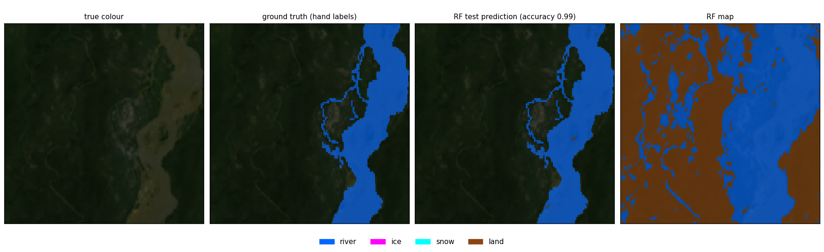
2023-07-24 (summer), four classes, run 05.
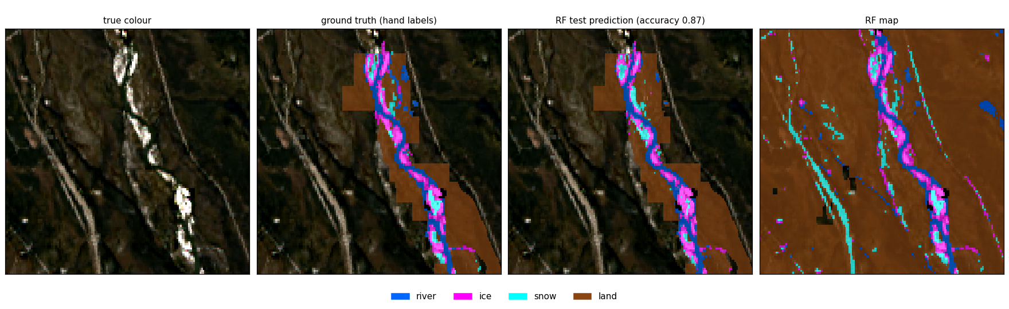
2023-10-04 (freeze-up), four classes, run 05.
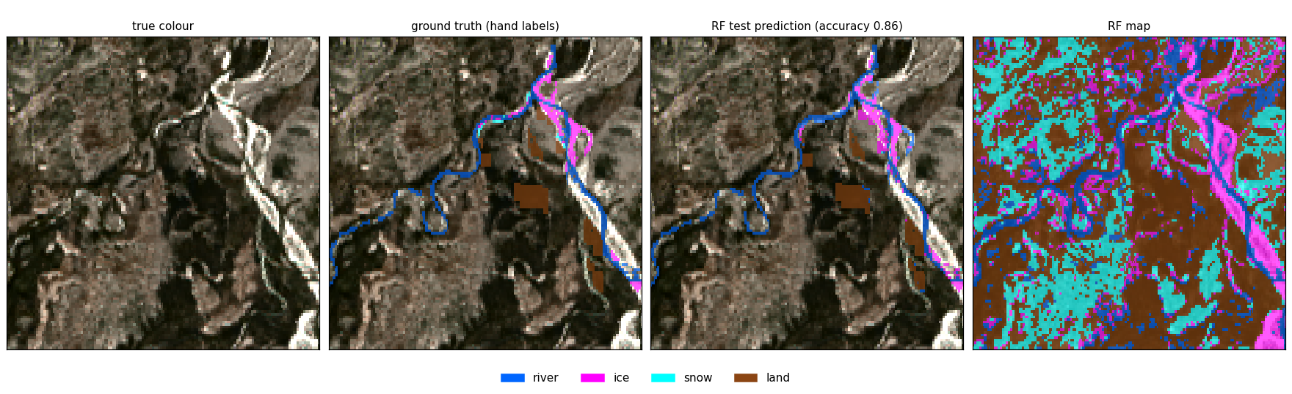
2024-04-21 (breakup), four classes, run 05.
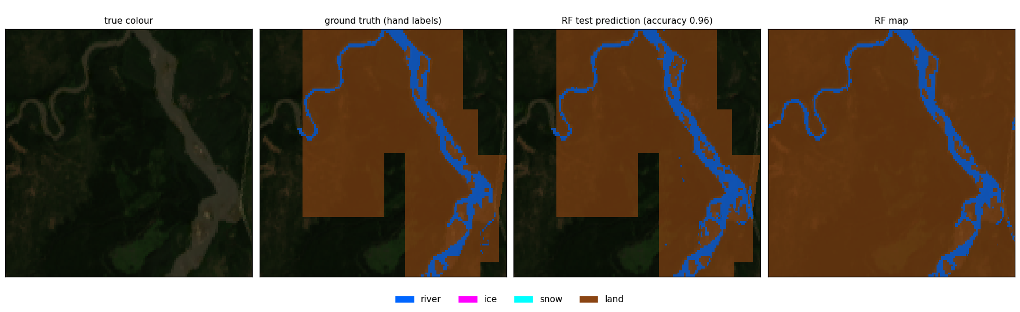
2024-06-22 (summer), four classes, run 05.

7.2 Six classes, run 10 (exclude_daksh)
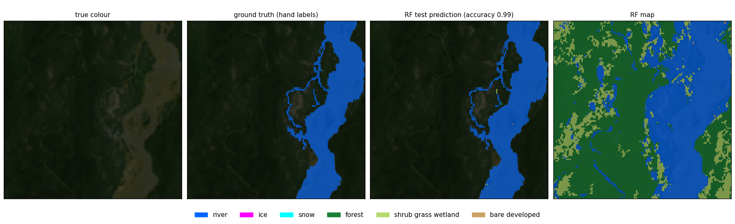
2023-07-24 (summer), six classes, run 10.
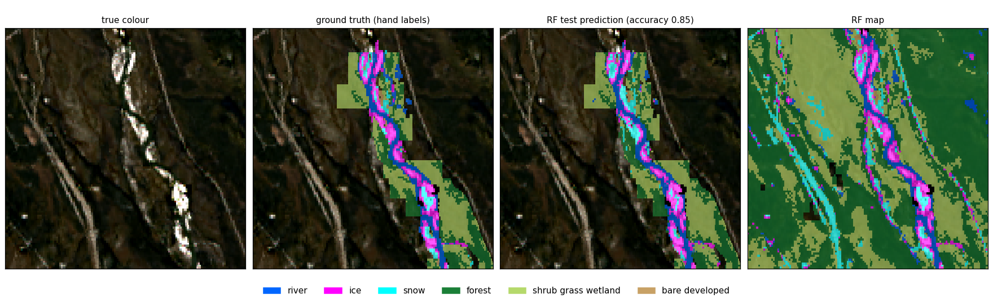
2023-10-04 (freeze-up), six classes, run 10.
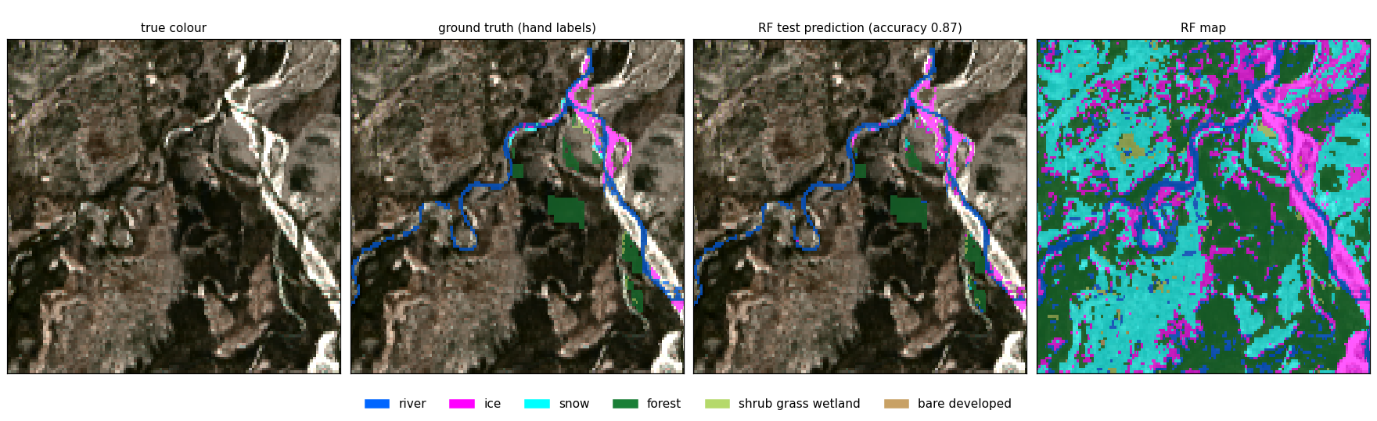
2024-04-21 (breakup), six classes, run 10.
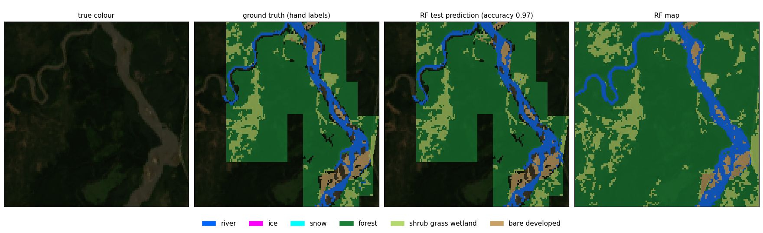
2024-06-22 (summer), six classes, run 10.

7.3 External cohort: daksh 2024-03-12, never seen in training
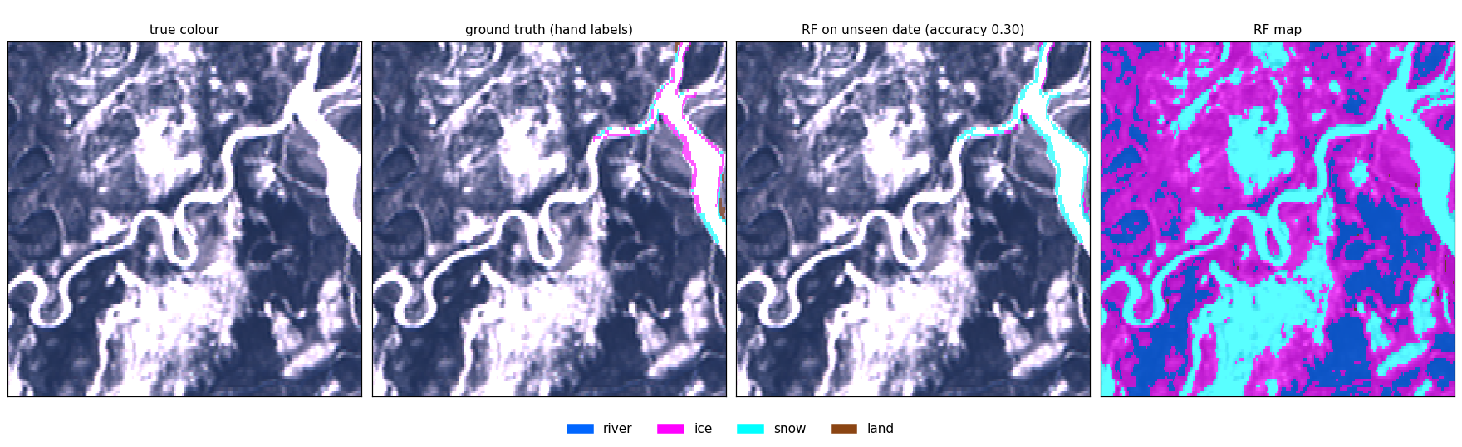
2024-03-12 (winter), four classes, run 05 trained on the patch dates only.
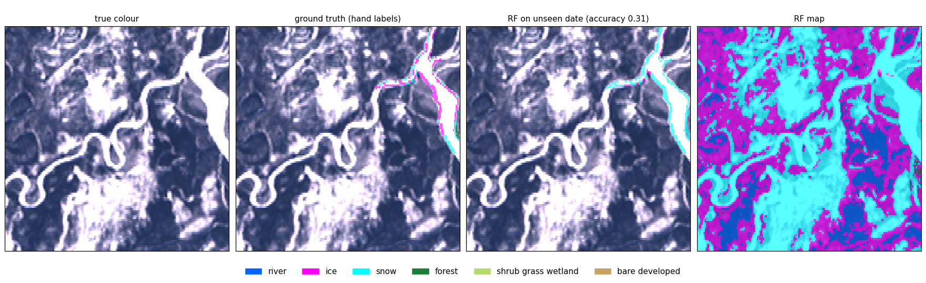
2024-03-12 (winter), six classes, run 10 trained on the patch dates only. Most ice is called snow.

8. Maps of dates without labels
No ground truth here; these show what the six-class run 10 model finds (whole box).
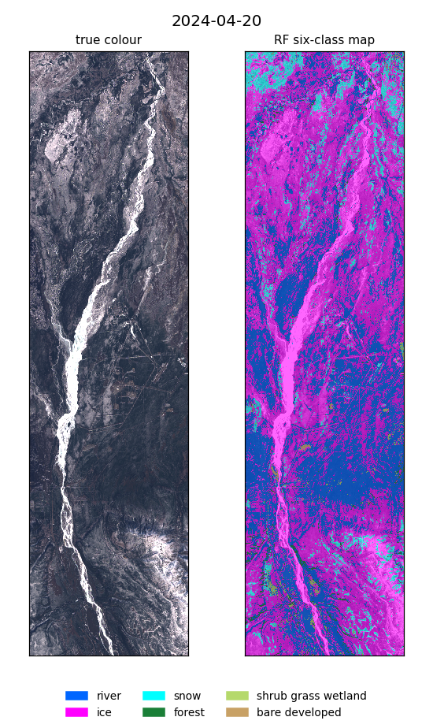
2024-04-20 (spring, daksh), six classes, run 10.
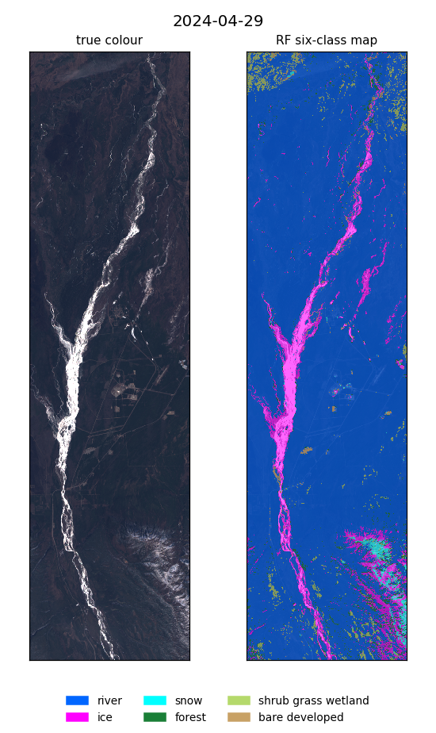
2024-04-29 (spring, daksh), six classes, run 10.
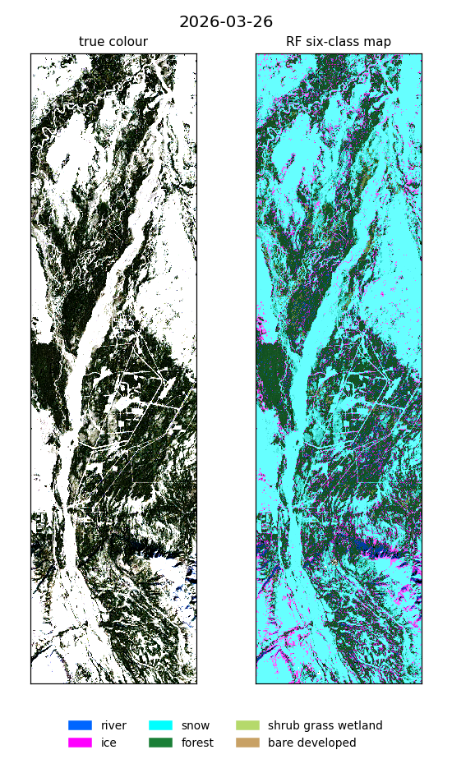
2026-03-26 (midwinter), six classes, run 10.
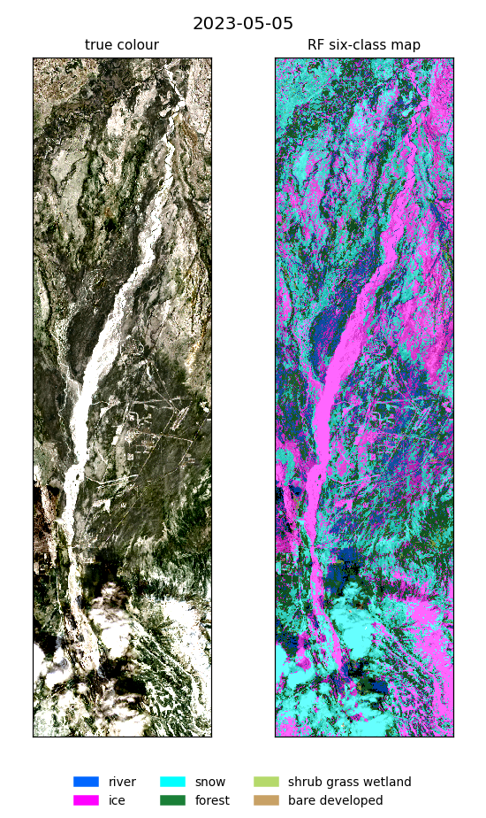
2023-05-05 (breakup), six classes, run 10.

9. River penalty: before and after (run 15)
Same run 15 forest, without and with the 600 m river penalty, whole box, with_daksh model.
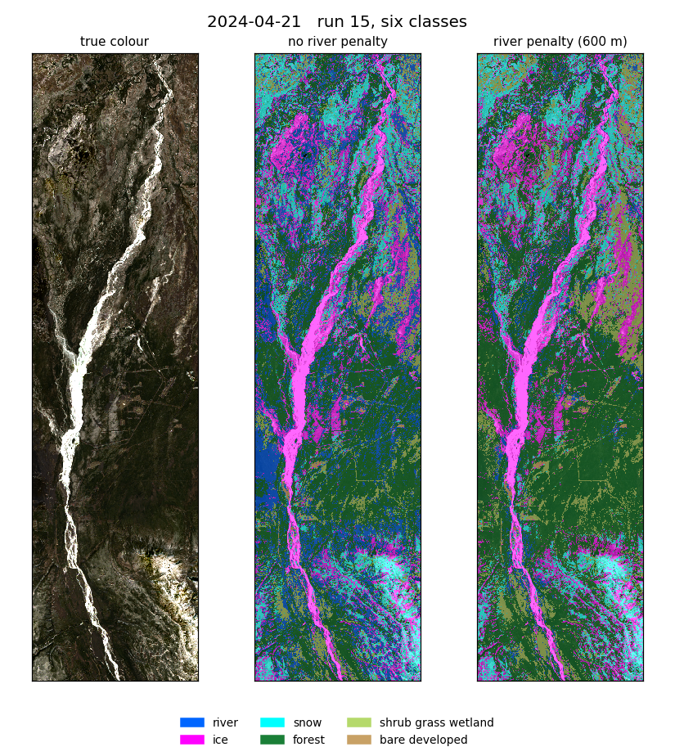
2024-04-21: true colour, no river penalty, river penalty.
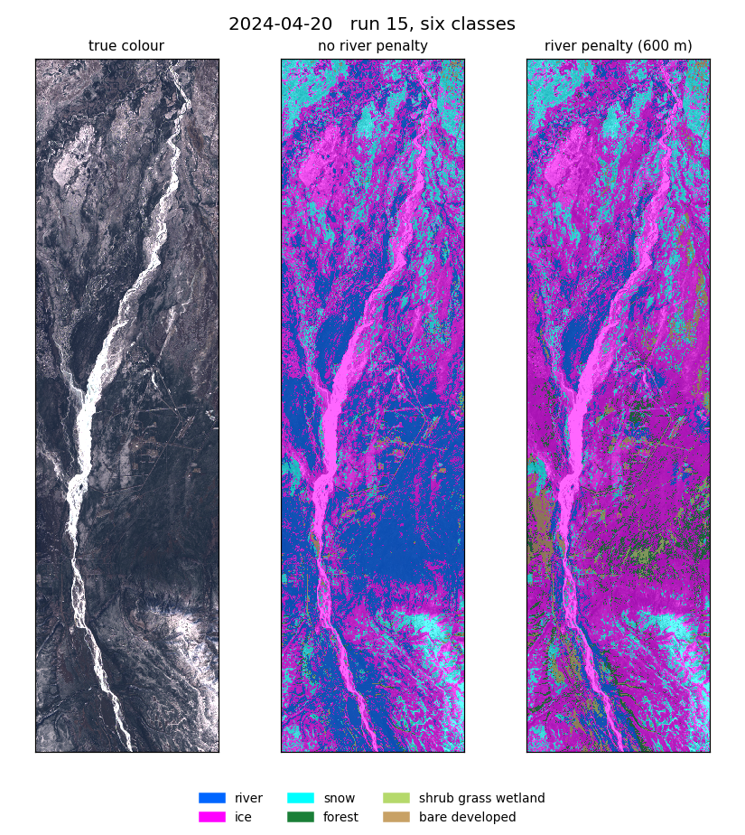
2024-04-20: true colour, no river penalty, river penalty.
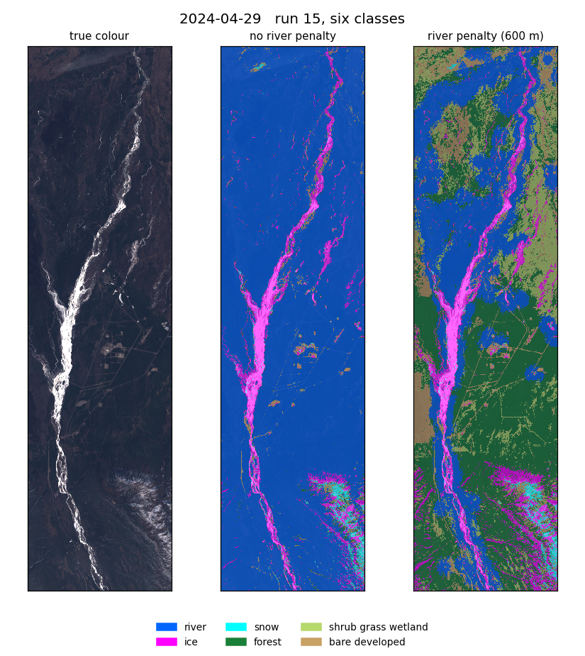
2024-04-29: true colour, no river penalty, river penalty.
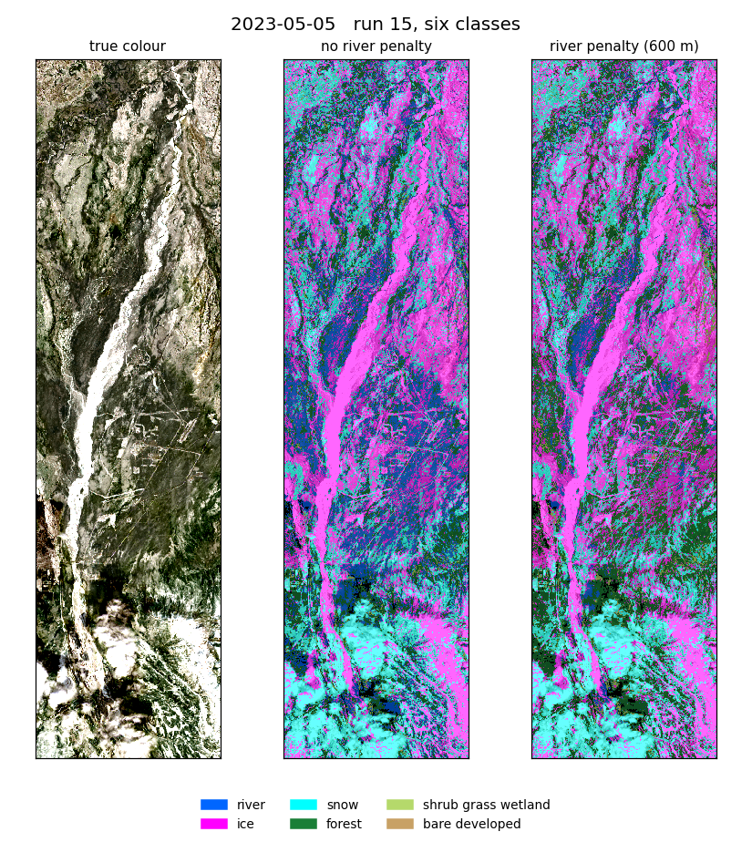
2023-05-05: true colour, no river penalty, river penalty.

10. Files, QGIS and how to rerun
Where | What
~/Desktop/nenana_river_models/ | main folder: runs/, presentation/, reports/, qgis_project/, data_layers/
runs/<NN>_<what>_<dataset> | link to each run's model folder (metrics.txt, oof.npz, pred_<date>.tif, images/)
qgis_project/nenana_all.qgz | self-contained QGIS project; every date group has rf_runs/ with all runs, fix and no-fix maps
presentation/ | full and short decks, figures, make_figures.py
~/Desktop/nenana_crops/daksh/ | all scripts; output/<run folder>/ holds every result

Script | Run
train_rf.py, external_test.py, combine.py, scene_mask.py | 01 (and the binary / one-vs-rest tasks)
run_corridor.sh | 03
rf_all_bands.py | 05
rf_six_classes.py [--nlcd-input] | 06, 07
rf_tune.py [--nlcd-input] | 08, 09
rf_terrain.py | 10
rf_feature_search.py | 11
rf_angles.py | 12
rf_limited.py | 13
rf_river_fix.py | 14
rf_river_forced.py | 15
add_rf_runs.py, make_qgis_package.py | QGIS project
report/word_content_rf.py + build_word.js | this report

Environment ~/venvs/river-ml/bin/python. Each run writes output/<run folder>/<1_exclude_daksh | 2_with_daksh | 3_external_test_daksh>/.

11. Things to know when reading the results
- Ice (1,732 px) and snow (564 px, 714 with daksh) come from only 2023-10-04, 2024-04-21 and 2024-03-12, so their scores move a lot with each polygon.
- 2023-07-24 holds 31,021 of the 39,991 river pixels, so it shapes what the models call river.
- With NLCD as input, the land-type scores partly measure agreement with NLCD; river, ice and snow stay a fair test.
- with_daksh has no temperature and no SWIR2 input (the daksh image lacks them).
- Clouds were never labelled, so models call them snow or ice.
- The external test has 532 pixels and no river.
- Run 12's gain is partly the sun angles acting as a date label; run 13 onward removes them.

