Nenana river ice from VIIRS 375 m: Run 17: VIIRS unmixing with the run 16 Landsat maps (Oleson et al. 1995)
Part of the VIIRS series (runs 17-20); labels from the run 16 Landsat 30 m maps, VIIRS 375 m inputs only.

Contents

1. Summary
date | pixels | I1 R² / cv | I2 R² / cv | I5 R² / cv
2023-04-19 | 9,967 | 0.62 / 0.60 | 0.63 / 0.61 | -0.10 / -0.35
2023-05-05 | 9,616 | 0.59 / 0.54 | 0.50 / 0.43 | 0.08 / -0.11
2023-07-24 | 9,880 | 0.01 / -0.06 | 0.05 / -0.02 | 0.07 / -0.05
2023-10-04 | 9,729 | 0.76 / 0.68 | 0.67 / 0.50 | 0.44 / 0.03
2024-04-21 | 9,988 | 0.77 / 0.74 | 0.62 / 0.57 | 0.59 / 0.53
2024-06-22 | 10,010 | 0.60 / 0.53 | 0.11 / 0.08 | 0.16 / 0.08
2024-09-02 | 9,905 | 0.16 / 0.14 | 0.14 / 0.11 | 0.19 / -0.05
2025-07-04 | 10,010 | 0.23 / -0.14 | 0.12 / 0.06 | 0.12 / 0.01
2026-03-26 | 9,237 | 0.67 / 0.65 | 0.67 / 0.65 | 0.19 / -0.08
2026-08-01 | 9,880 | 0.32 / 0.28 | 0.21 / 0.15 | 0.05 / -0.03

- Class values recovered from VIIRS by least squares on the run 16 class shares (Gaussian PSF, best shift).
- Works on snow / break-up days (I1 R² up to 0.77); fails in summer (R² < 0.1).
- Rare classes (river 0.4 %) come out unstable or negative; thermal bands do not unmix.
- Regression, so no confusion matrix: R², cv R², RMSE and cv RMSE per band are given.

2. Data and design

2.1 Why VIIRS
Run 16 maps six classes from Landsat 30 m, but Landsat passes every 8-16 days and is often cloudy. VIIRS passes daily at 375 m. Runs 17-20 move from 30 m to 375 m: the run 16 maps are summarised per VIIRS pixel and used as labels, and VIIRS bands are the only image inputs.

2.2 Grids
layer | grid
Run 16 Landsat map | EPSG:4326, 995 x 1635 px, 0.00027027° (~30 m); classes 1 river, 2 ice, 3 snow, 4 forest, 5 shrub_grass_wetland, 6 bare_developed
VIIRS (Patches/nenana_<date>/<date>_viirs_375m.tif) | EPSG:4326, 80 x 132 px, 0.00337838° (12.5 Landsat px); 9 bands I1, I2, I3 (TOA reflectance), I4, I5 (brightness temperature K), SZA, SAA, VZA, VAA
Water mask alaska_occ_375m.tif | EPSG:4326, same 0.00337838° grid, aligned exactly (offset col 6412, row 2209); JRC water occurrence 0-1

2.3 Dates
date | season | use | VIIRS-Landsat shift m (S, E) | VZA °
2023-04-19 | spring, snow | VIIRS only (prediction) | 30, 0 | 9
2023-05-05 | spring break-up | labelled (run 16 map) | 60, -26 | 9
2023-07-24 | summer | labelled (run 16 map) | 0, 26 | 12
2023-10-04 | autumn freeze-up | labelled (run 16 map) | 30, -52 | 10
2024-04-21 | spring break-up | labelled (run 16 map) | 0, -26 | 13
2024-06-22 | summer | labelled (run 16 map) | 30, 0 | 1
2024-09-02 | late summer | VIIRS only (prediction) | -90, -78 | 2
2025-07-04 | summer | VIIRS only (prediction) | 30, -26 | 7
2026-03-26 | late winter | labelled (run 16 map) | 0, 0 | 28
2026-08-01 | summer | VIIRS only (prediction) | 0, 26 | 28

Run 16 dates without a VIIRS file (2024-03-12, 2024-04-20, 2024-04-29) are left out. The 4 VIIRS-only dates have no run 16 map and are only predicted (no score).

2.4 From 30 m classes to VIIRS pixels
- Each Landsat pixel is assigned to the VIIRS pixel it falls in, after moving the Landsat map by the run 17 shift (at most ~60 m). Shares of each class per VIIRS pixel = 'box' fractions.
- A VIIRS pixel is used when >= 98 % of it is mapped. A VIIRS pixel holds 12 or 13 Landsat pixels per side (12.5 on average); an early version divided by 12.5² and dropped every 12 x 12 pixel (a dashed grid of holes, ~25 % of pixels). Fixed: the share is now divided by the real count (floor 12 x 12, so edge pixels still count as partial). Runs 17-20 use the fix.
- Four parts per pixel: open_river = river, ice = ice, snow = snow, snow_free_land = forest + shrub + bare.

2.5 The four states and the two rules
state | river | land
1 ice_free_river_snow_free_land | open | no snow
2 ice_free_river_snow_covered_land | open | snow
3 ice_covered_river_snow_free_land | ice | no snow
4 ice_covered_river_snow_covered_land | ice | snow

- rule50 (majority): river open if open / (open + ice) > 0.5; land snow-covered if snow / (snow + no-snow land) > 0.5.
- rule90: river open only if open share > 0.9; land snow-free only if snow share < 0.1 (mixed pixels count as snow-covered).
- A pixel with < 1 % river (or < 1 % land) takes the ratio of the whole date, so every pixel gets a state.

2.6 Inputs
Per VIIRS pixel: I1, I2, I3, I4, I5, NDVI_I = (I2-I1)/(I2+I1), NDSI_I = (I1-I3)/(I1+I3), I4-I5, solar zenith, view zenith, JRC mean occurrence and JRC water-zone share (occurrence >= 5 %). RF also gets 3 x 3 mean / std of I1, I2, I3, I5. Runs 19 and 20 add the water-mask occurrence (21 RF inputs). No Landsat band is ever an input.

3. Run 17: unmixing (Oleson et al. 1995)
Oleson, Sarlin, Bajjouk, Steffen (1995, RSE 54: 98-112) recover the reflectance of each land-cover class from coarse pixels: coarse value = Σ class share x class value, solved by least squares over all pixels of the scene. Here the class shares come from the run 16 Landsat map, weighted by a Gaussian point-spread function (σ = 375 m / 2.8 = 134 m, cut at 2σ), and the best VIIRS-Landsat shift is searched within ±6 rows / ±14 columns of Landsat pixels.
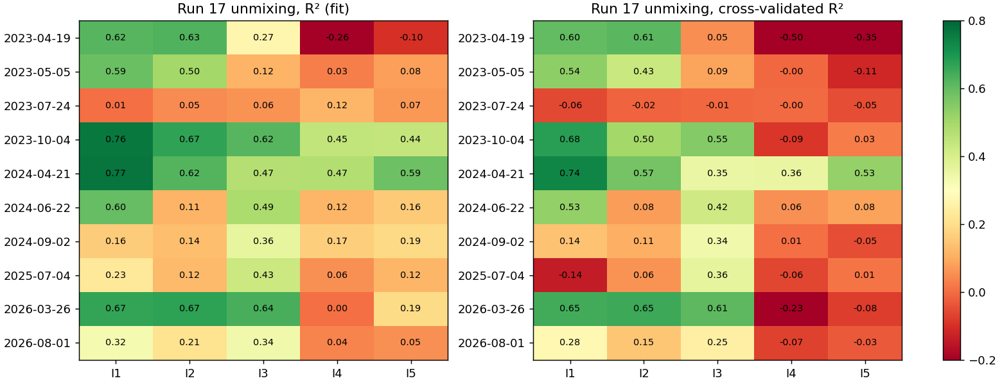
Run 17: R² and cross-validated R² of the unmixing per band and date (Gaussian weights, best shift).
date | pixels | I1 R² / cv | I2 R² / cv | I3 R² / cv | I5 R² / cv | I1 R² box
2023-04-19 | 9,967 | 0.62 / 0.60 | 0.63 / 0.61 | 0.27 / 0.05 | -0.10 / -0.35 | 0.54
2023-05-05 | 9,616 | 0.59 / 0.54 | 0.50 / 0.43 | 0.12 / 0.09 | 0.08 / -0.11 | 0.52
2023-07-24 | 9,880 | 0.01 / -0.06 | 0.05 / -0.02 | 0.06 / -0.01 | 0.07 / -0.05 | 0.01
2023-10-04 | 9,729 | 0.76 / 0.68 | 0.67 / 0.50 | 0.62 / 0.55 | 0.44 / 0.03 | 0.69
2024-04-21 | 9,988 | 0.77 / 0.74 | 0.62 / 0.57 | 0.47 / 0.35 | 0.59 / 0.53 | 0.71
2024-06-22 | 10,010 | 0.60 / 0.53 | 0.11 / 0.08 | 0.49 / 0.42 | 0.16 / 0.08 | 0.55
2024-09-02 | 9,905 | 0.16 / 0.14 | 0.14 / 0.11 | 0.36 / 0.34 | 0.19 / -0.05 | 0.12
2025-07-04 | 10,010 | 0.23 / -0.14 | 0.12 / 0.06 | 0.43 / 0.36 | 0.12 / 0.01 | 0.21
2026-03-26 | 9,237 | 0.67 / 0.65 | 0.67 / 0.65 | 0.64 / 0.61 | 0.19 / -0.08 | 0.59
2026-08-01 | 9,880 | 0.32 / 0.28 | 0.21 / 0.15 | 0.34 / 0.25 | 0.05 / -0.03 | 0.29

All fit metrics per band (Gaussian weights, best shift)
Run 17 is a regression (VIIRS value from class shares), so it has no confusion matrix. Its metrics: R² of the fit, cross-validated R² (5 folds of pixels), RMSE and cross-validated RMSE (reflectance for I1-I3, kelvin for I4-I5).
date | band | R² | cv R² | RMSE | cv RMSE | R² no shift | R² box
2023-04-19 | I1 | 0.618 | 0.603 | 0.097 | 0.099 | 0.619 | 0.542
2023-04-19 | I2 | 0.627 | 0.613 | 0.091 | 0.093 | 0.628 | 0.551
2023-04-19 | I3 | 0.271 | 0.054 | 0.010 | 0.012 | 0.269 | 0.241
2023-04-19 | I4 | -0.263 | -0.500 | 1.055 | 1.150 | -0.251 | -0.365
2023-04-19 | I5 | -0.101 | -0.354 | 1.020 | 1.131 | -0.093 | -0.210
2023-05-05 | I1 | 0.592 | 0.538 | 0.054 | 0.057 | 0.588 | 0.520
2023-05-05 | I2 | 0.502 | 0.431 | 0.046 | 0.049 | 0.499 | 0.439
2023-05-05 | I3 | 0.116 | 0.088 | 0.020 | 0.020 | 0.115 | 0.100
2023-05-05 | I4 | 0.029 | -0.005 | 2.433 | 2.475 | 0.037 | 0.030
2023-05-05 | I5 | 0.081 | -0.114 | 1.955 | 2.153 | 0.088 | 0.067
2023-07-24 | I1 | 0.006 | -0.058 | 0.063 | 0.065 | 0.006 | 0.005
2023-07-24 | I2 | 0.049 | -0.016 | 0.073 | 0.076 | 0.047 | 0.044
2023-07-24 | I3 | 0.060 | -0.007 | 0.063 | 0.066 | 0.057 | 0.052
2023-07-24 | I4 | 0.116 | -0.003 | 2.782 | 2.964 | 0.114 | 0.096
2023-07-24 | I5 | 0.066 | -0.051 | 3.083 | 3.270 | 0.065 | 0.058
2023-10-04 | I1 | 0.762 | 0.682 | 0.020 | 0.023 | 0.759 | 0.694
2023-10-04 | I2 | 0.668 | 0.500 | 0.028 | 0.035 | 0.660 | 0.600
2023-10-04 | I3 | 0.617 | 0.554 | 0.018 | 0.020 | 0.612 | 0.559
2023-10-04 | I4 | 0.445 | -0.087 | 1.324 | 1.853 | 0.439 | 0.388
2023-10-04 | I5 | 0.441 | 0.025 | 0.929 | 1.227 | 0.439 | 0.385
2024-04-21 | I1 | 0.771 | 0.736 | 0.031 | 0.034 | 0.768 | 0.709
2024-04-21 | I2 | 0.620 | 0.574 | 0.028 | 0.029 | 0.621 | 0.563
2024-04-21 | I3 | 0.470 | 0.352 | 0.023 | 0.025 | 0.468 | 0.413
2024-04-21 | I4 | 0.472 | 0.355 | 2.325 | 2.569 | 0.470 | 0.416
2024-04-21 | I5 | 0.586 | 0.526 | 1.943 | 2.079 | 0.585 | 0.524
2024-06-22 | I1 | 0.597 | 0.530 | 0.007 | 0.007 | 0.598 | 0.550
2024-06-22 | I2 | 0.115 | 0.075 | 0.041 | 0.042 | 0.116 | 0.107
2024-06-22 | I3 | 0.487 | 0.419 | 0.020 | 0.021 | 0.483 | 0.450
2024-06-22 | I4 | 0.119 | 0.057 | 3.601 | 3.725 | 0.116 | 0.101
2024-06-22 | I5 | 0.158 | 0.083 | 2.763 | 2.884 | 0.157 | 0.136
2024-09-02 | I1 | 0.163 | 0.143 | 0.018 | 0.018 | 0.144 | 0.120
2024-09-02 | I2 | 0.135 | 0.108 | 0.035 | 0.036 | 0.123 | 0.112
2024-09-02 | I3 | 0.362 | 0.336 | 0.028 | 0.029 | 0.338 | 0.301
2024-09-02 | I4 | 0.166 | 0.006 | 2.154 | 2.353 | 0.170 | 0.145
2024-09-02 | I5 | 0.188 | -0.049 | 1.574 | 1.788 | 0.194 | 0.163
2025-07-04 | I1 | 0.229 | -0.139 | 0.011 | 0.014 | 0.228 | 0.207
2025-07-04 | I2 | 0.124 | 0.061 | 0.041 | 0.042 | 0.124 | 0.116
2025-07-04 | I3 | 0.427 | 0.363 | 0.019 | 0.020 | 0.422 | 0.393
2025-07-04 | I4 | 0.055 | -0.060 | 3.814 | 4.040 | 0.054 | 0.044
2025-07-04 | I5 | 0.117 | 0.011 | 2.405 | 2.546 | 0.116 | 0.097
2026-03-26 | I1 | 0.667 | 0.647 | 0.101 | 0.104 | 0.667 | 0.593
2026-03-26 | I2 | 0.673 | 0.653 | 0.099 | 0.102 | 0.673 | 0.599
2026-03-26 | I3 | 0.636 | 0.612 | 0.010 | 0.010 | 0.636 | 0.564
2026-03-26 | I4 | 0.004 | -0.226 | 1.126 | 1.249 | 0.004 | -0.058
2026-03-26 | I5 | 0.192 | -0.076 | 1.190 | 1.373 | 0.192 | 0.116
2026-08-01 | I1 | 0.324 | 0.279 | 0.012 | 0.012 | 0.325 | 0.292
2026-08-01 | I2 | 0.213 | 0.151 | 0.040 | 0.042 | 0.216 | 0.196
2026-08-01 | I3 | 0.337 | 0.251 | 0.024 | 0.025 | 0.332 | 0.303
2026-08-01 | I4 | 0.037 | -0.068 | 3.493 | 3.679 | 0.035 | 0.030
2026-08-01 | I5 | 0.054 | -0.031 | 2.651 | 2.769 | 0.053 | 0.046

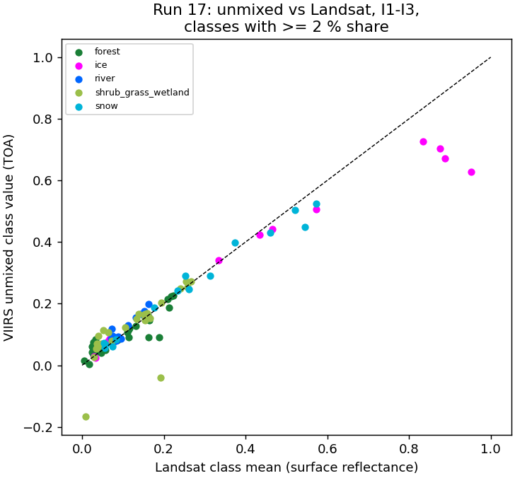
Run 17: unmixed VIIRS class values against the Landsat mean of the same class (red / NIR / SWIR1).
2024-04-21, I1 (red) unmixed: river -0.070, ice 0.422, snow 0.187, forest 0.069, shrub_grass_wetland 0.079, bare_developed 0.094. Ice and snow match Landsat within ~0.01; river (0.4 % of the image) comes out negative.
- Works when the classes differ strongly and each covers enough of the image: snow / ice dates, I1 and I2.
- Fails in summer (R² < 0.1): forest, shrub and river look alike at 375 m, as in the paper's prairie scene.
- Rare classes (river 0.4 %) get unstable or negative values: the paper's 'well represented' condition.
- Gaussian weights beat box weights (higher I1 R²); the shift adds little (<= ~60 m).
- Run 17 is a check of the physics; runs 18-20 learn the inverse (VIIRS -> shares / states) instead.

4. Things to know
- Labels are the run 16 Landsat maps, not hand labels: any run 16 error (gravel as river, cloud as snow/ice) becomes a VIIRS label.
- Only 6 labelled days; each model sees 5 per fold. Ice and break-up states come from 3 days.
- State 2 (open river, snow land) has a few hundred pixels in total; its F1 is not reliable.
- The JRC occurrence behind the water mask ends in 2021; moved channels fall outside the mask.
- VIIRS view angle and clouds vary daily; no cloud mask is applied, so cloudy days give wrong states.
- The 30 m to 375 m shift (run 17) is small (<= ~60 m) and applied before the shares are computed.

5. Files
what | where (~/Desktop/nenana_crops/daksh/)
run 17 unmixing | rf_viirs_unmix.py -> output/17_viirs_unmix/ (results.json, summary.txt, <date>/weights_psf.tif, viirs_fit.tif, viirs_residual.tif)
run 18 whole image | viirs_states.py -> output/18_viirs_states/ (truth|rf|unetpp/pct_<date>.tif, <rule>/class_<date>.tif, images/)
run 18 images | make_run18_images.py -> output/18_viirs_states/images/
run 19 river + buffer | RIVER_BUFFER=1 viirs_river_states.py -> output/19_viirs_river_states/ (mask/, truth|rf|unetpp|cnn2d/<rule>/class_<date>.tif, images/)
run 20 river only | RIVER_BUFFER=0 viirs_river_states.py -> output/20_viirs_river_only/
prediction images | RIVER_BUFFER=1|0 viirs_river_predict.py -> <run>/predict/ (images/pred_<date>.jpg, pred_<date>_rule90.jpg, totals.json, VIIRS-only maps)
water mask | ~/Desktop/nenana_crops/alaska_occ_375m.tif; cropped copies in <run>/mask/
this report | report/word_content_viirs.py + report/build_word.js; deck presentation/build_deck_viirs.js

Every .tif is on the VIIRS grid (EPSG:4326) and opens in QGIS; class maps carry a .qml style (1-4 colours, 0 = not predicted).

