Nenana river ice from VIIRS 375 m: Run 18: open water, ice, snow and land % and the four states over the whole VIIRS image
Part of the VIIRS series (runs 17-20); labels from the run 16 Landsat 30 m maps, VIIRS 375 m inputs only.

Contents

1. Summary
rule | model | accuracy | balanced acc | Cohen κ | macro prec | macro rec | macro F1 | weighted F1
rule50 | RF | 0.759 | 0.585 | 0.643 | 0.615 | 0.585 | 0.574 | 0.757
rule50 | UNet++ | 0.704 | 0.567 | 0.560 | 0.549 | 0.567 | 0.532 | 0.690
rule90 | RF | 0.846 | 0.660 | 0.760 | 0.686 | 0.660 | 0.637 | 0.850
rule90 | UNet++ | 0.744 | 0.584 | 0.604 | 0.609 | 0.584 | 0.570 | 0.739

- Best rule50 model: RF, accuracy 0.759, macro F1 0.574; 60,068 scored VIIRS pixels.
- Leave-one-date-out over the 6 run 16 dates: each date is predicted by models trained on the other 5.
- rule50 accuracy per date (RF): 2023-05-05 0.71, 2023-07-24 0.96, 2023-10-04 0.93, 2024-04-21 0.11, 2024-06-22 1.00, 2026-03-26 0.87.
- The river state of most pixels follows the whole date, so one wrong date flips the image (RF 2024-04-21).

2. Data and design

2.1 Why VIIRS
Run 16 maps six classes from Landsat 30 m, but Landsat passes every 8-16 days and is often cloudy. VIIRS passes daily at 375 m. Runs 17-20 move from 30 m to 375 m: the run 16 maps are summarised per VIIRS pixel and used as labels, and VIIRS bands are the only image inputs.

2.2 Grids
layer | grid
Run 16 Landsat map | EPSG:4326, 995 x 1635 px, 0.00027027° (~30 m); classes 1 river, 2 ice, 3 snow, 4 forest, 5 shrub_grass_wetland, 6 bare_developed
VIIRS (Patches/nenana_<date>/<date>_viirs_375m.tif) | EPSG:4326, 80 x 132 px, 0.00337838° (12.5 Landsat px); 9 bands I1, I2, I3 (TOA reflectance), I4, I5 (brightness temperature K), SZA, SAA, VZA, VAA
Water mask alaska_occ_375m.tif | EPSG:4326, same 0.00337838° grid, aligned exactly (offset col 6412, row 2209); JRC water occurrence 0-1

2.3 Dates
date | season | use | VIIRS-Landsat shift m (S, E) | VZA °
2023-04-19 | spring, snow | VIIRS only (prediction) | 30, 0 | 9
2023-05-05 | spring break-up | labelled (run 16 map) | 60, -26 | 9
2023-07-24 | summer | labelled (run 16 map) | 0, 26 | 12
2023-10-04 | autumn freeze-up | labelled (run 16 map) | 30, -52 | 10
2024-04-21 | spring break-up | labelled (run 16 map) | 0, -26 | 13
2024-06-22 | summer | labelled (run 16 map) | 30, 0 | 1
2024-09-02 | late summer | VIIRS only (prediction) | -90, -78 | 2
2025-07-04 | summer | VIIRS only (prediction) | 30, -26 | 7
2026-03-26 | late winter | labelled (run 16 map) | 0, 0 | 28
2026-08-01 | summer | VIIRS only (prediction) | 0, 26 | 28

Run 16 dates without a VIIRS file (2024-03-12, 2024-04-20, 2024-04-29) are left out. The 4 VIIRS-only dates have no run 16 map and are only predicted (no score).

2.4 From 30 m classes to VIIRS pixels
- Each Landsat pixel is assigned to the VIIRS pixel it falls in, after moving the Landsat map by the run 17 shift (at most ~60 m). Shares of each class per VIIRS pixel = 'box' fractions.
- A VIIRS pixel is used when >= 98 % of it is mapped. A VIIRS pixel holds 12 or 13 Landsat pixels per side (12.5 on average); an early version divided by 12.5² and dropped every 12 x 12 pixel (a dashed grid of holes, ~25 % of pixels). Fixed: the share is now divided by the real count (floor 12 x 12, so edge pixels still count as partial). Runs 17-20 use the fix.
- Four parts per pixel: open_river = river, ice = ice, snow = snow, snow_free_land = forest + shrub + bare.

2.5 The four states and the two rules
state | river | land
1 ice_free_river_snow_free_land | open | no snow
2 ice_free_river_snow_covered_land | open | snow
3 ice_covered_river_snow_free_land | ice | no snow
4 ice_covered_river_snow_covered_land | ice | snow

- rule50 (majority): river open if open / (open + ice) > 0.5; land snow-covered if snow / (snow + no-snow land) > 0.5.
- rule90: river open only if open share > 0.9; land snow-free only if snow share < 0.1 (mixed pixels count as snow-covered).
- A pixel with < 1 % river (or < 1 % land) takes the ratio of the whole date, so every pixel gets a state.

2.6 Inputs
Per VIIRS pixel: I1, I2, I3, I4, I5, NDVI_I = (I2-I1)/(I2+I1), NDSI_I = (I1-I3)/(I1+I3), I4-I5, solar zenith, view zenith, JRC mean occurrence and JRC water-zone share (occurrence >= 5 %). RF also gets 3 x 3 mean / std of I1, I2, I3, I5. Runs 19 and 20 add the water-mask occurrence (21 RF inputs). No Landsat band is ever an input.

3. Run 18: % mix and states over the whole image
RF regressor (4 outputs, depth 12, min leaf 20, sqrt, 300 trees) and UNet++ (resnet18, softmax over the four parts, soft cross-entropy, 1500 steps, flips, flip test-time augmentation) predict the four part shares of every VIIRS pixel. The states come from the predicted shares by rule50 / rule90.
model | open water MAE pp / R² | ice | snow | snow-free land | rule50 acc | rule90 acc
RF | 1.6 / 0.84 | 1.4 / 0.90 | 11.3 / 0.79 | 11.4 / 0.82 | 0.759 | 0.846
UNet++ | 1.1 / 0.76 | 1.3 / 0.77 | 11.8 / 0.71 | 12.1 / 0.73 | 0.704 | 0.744

date | truth % water/ice/snow/land | RF % | RF acc50 | UNet++ % | U++ acc50
2023-05-05 | 0.2 / 3.8 / 70.1 / 26.0 | 1.3 / 5.4 / 59.9 / 33.4 | 0.71 | 0.2 / 2.8 / 63.9 / 33.1 | 0.76
2023-07-24 | 3.9 / 0.0 / 0.4 / 95.7 | 4.1 / 0.3 / 5.9 / 89.6 | 0.96 | 3.7 / 1.0 / 10.0 / 85.2 | 0.86
2023-10-04 | 1.8 / 1.9 / 6.2 / 90.0 | 0.9 / 1.0 / 13.0 / 85.1 | 0.93 | 0.8 / 0.7 / 10.4 / 88.1 | 0.06
2024-04-21 | 0.4 / 3.5 / 34.9 / 61.2 | 3.3 / 3.3 / 27.3 / 66.1 | 0.11 | 0.6 / 2.5 / 30.8 / 66.1 | 0.74
2024-06-22 | 3.9 / 0.0 / 0.3 / 95.8 | 3.6 / 0.1 / 0.9 / 95.3 | 1.00 | 2.9 / 0.1 / 0.2 / 96.7 | 0.99
2026-03-26 | 0.0 / 4.2 / 64.8 / 31.0 | 0.4 / 4.7 / 62.9 / 32.0 | 0.87 | 0.1 / 4.9 / 74.6 / 20.5 | 0.80

RF rule50 per state
state | true px | RF F1 | RF prec | RF rec
1 open river, no-snow land | 20,978 | 0.80 | 0.68 | 0.97
2 open river, snow land | 188 | 0.01 | 0.01 | 0.05
3 ice river, no-snow land | 20,630 | 0.67 | 0.93 | 0.52
4 ice river, snow land | 18,272 | 0.82 | 0.84 | 0.79

UNet++ rule50 per state
state | true px | UNet++ F1 | UNet++ prec | UNet++ rec
1 open river, no-snow land | 20,978 | 0.78 | 0.67 | 0.92
2 open river, snow land | 188 | 0.04 | 0.02 | 0.14
3 ice river, no-snow land | 20,630 | 0.51 | 0.70 | 0.40
4 ice river, snow land | 18,272 | 0.80 | 0.80 | 0.81

RF part % per date: MAE (percentage points) / R²
date | open_river | ice | snow | snow_free_land
2023-05-05 | 1.3 / -0.63 | 3.0 / 0.93 | 21.5 / 0.30 | 20.1 / 0.30
2023-07-24 | 2.2 / 0.90 | 0.3 / -2397913384223.22 | 5.8 / -22.79 | 7.3 / 0.12
2023-10-04 | 1.3 / 0.54 | 1.2 / 0.63 | 8.9 / 0.48 | 9.0 / 0.71
2024-04-21 | 3.3 / -1.18 | 1.4 / 0.93 | 15.9 / 0.58 | 15.6 / 0.68
2024-06-22 | 1.1 / 0.95 | 0.1 / -367573116821.66 | 1.1 / 0.11 | 1.9 / 0.94
2026-03-26 | 0.4 / -1286.60 | 2.2 / 0.94 | 15.4 / 0.70 | 14.8 / 0.70

UNet++ part % per date: MAE (percentage points) / R²
date | open_river | ice | snow | snow_free_land
2023-05-05 | 0.4 / -0.08 | 1.4 / 0.85 | 19.5 / 0.26 | 18.9 / 0.21
2023-07-24 | 2.4 / 0.76 | 1.0 / -17065437849465.22 | 9.8 / -49.81 | 12.0 / -1.03
2023-10-04 | 1.4 / 0.49 | 1.5 / 0.43 | 7.4 / 0.41 | 7.8 / 0.64
2024-04-21 | 0.8 / -0.13 | 1.8 / 0.78 | 17.8 / 0.46 | 17.3 / 0.54
2024-06-22 | 1.5 / 0.85 | 0.1 / -392672718401.64 | 0.4 / 0.25 | 1.7 / 0.85
2026-03-26 | 0.1 / -128.72 | 1.9 / 0.85 | 16.6 / 0.51 | 15.5 / 0.51

Confusion matrices and other metrics
Rows = true state, columns = predicted state; each cell shows the pixel count and the % of that true state (recall). Balanced accuracy = mean recall over the states present; Cohen κ = agreement beyond chance; weighted F1 = F1 weighted by the number of true pixels per state.
rule | model | accuracy | balanced acc | Cohen κ | macro prec | macro rec | macro F1 | weighted F1
rule50 | RF | 0.759 | 0.585 | 0.643 | 0.615 | 0.585 | 0.574 | 0.757
rule50 | UNet++ | 0.704 | 0.567 | 0.560 | 0.549 | 0.567 | 0.532 | 0.690
rule90 | RF | 0.846 | 0.660 | 0.760 | 0.686 | 0.660 | 0.637 | 0.850
rule90 | UNet++ | 0.744 | 0.584 | 0.604 | 0.609 | 0.584 | 0.570 | 0.739

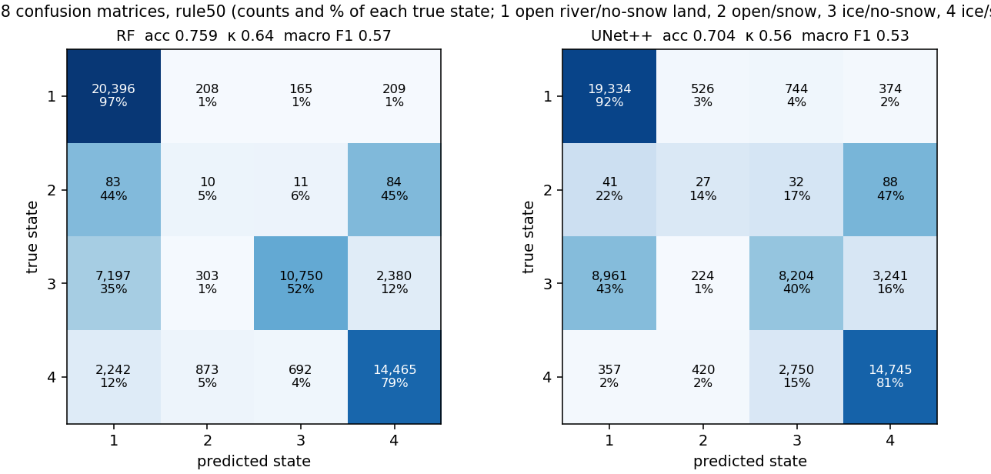
Run 18: confusion matrices, rule50, every model (leave-one-date-out).
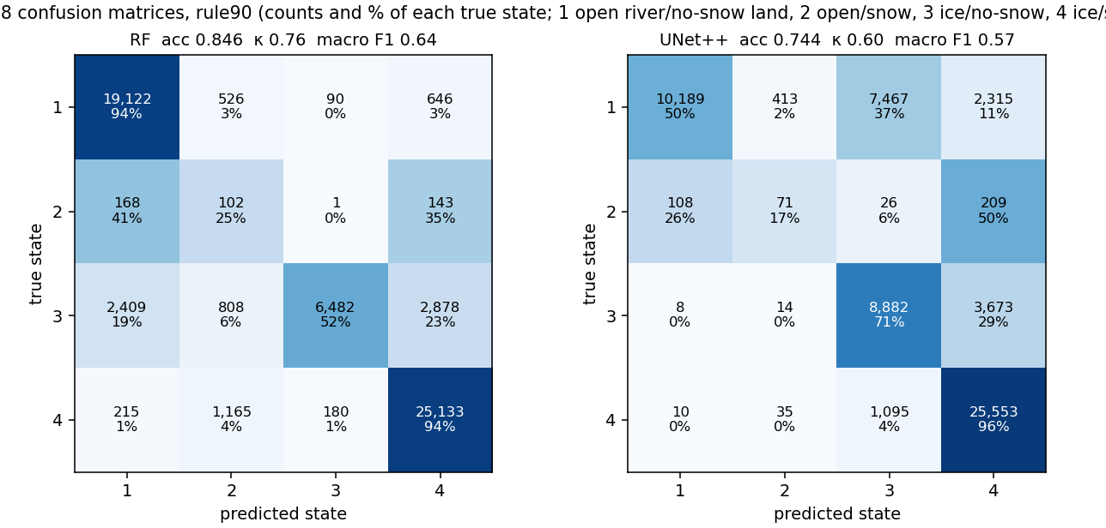
Run 18: confusion matrices, rule90, every model (leave-one-date-out).
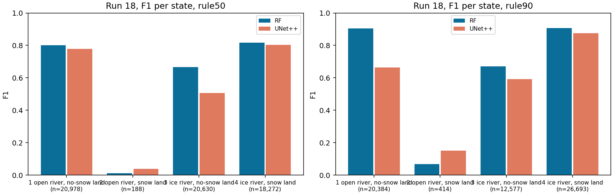
Run 18: F1 per state and model (n = true pixels).
- The snow / land split is learned well; the river state of most pixels comes from the whole-date ratio (< 1 % river), so one wrong day flips the whole image: RF calls 2024-04-21 open.
- UNet++ has only 5 images per fold and is less accurate than RF.
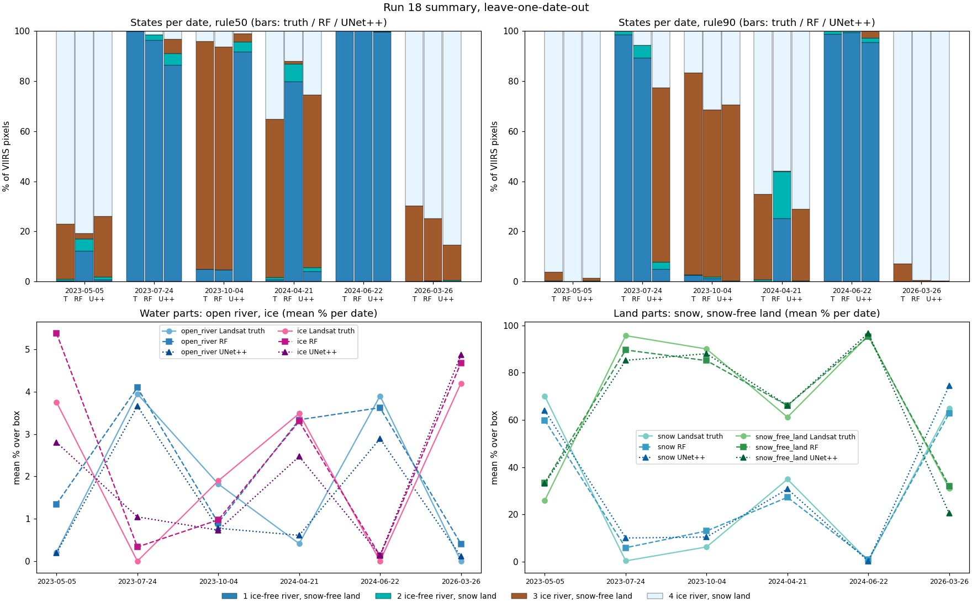
Run 18 summary: states per date (truth / RF / UNet++) and mean % per part.
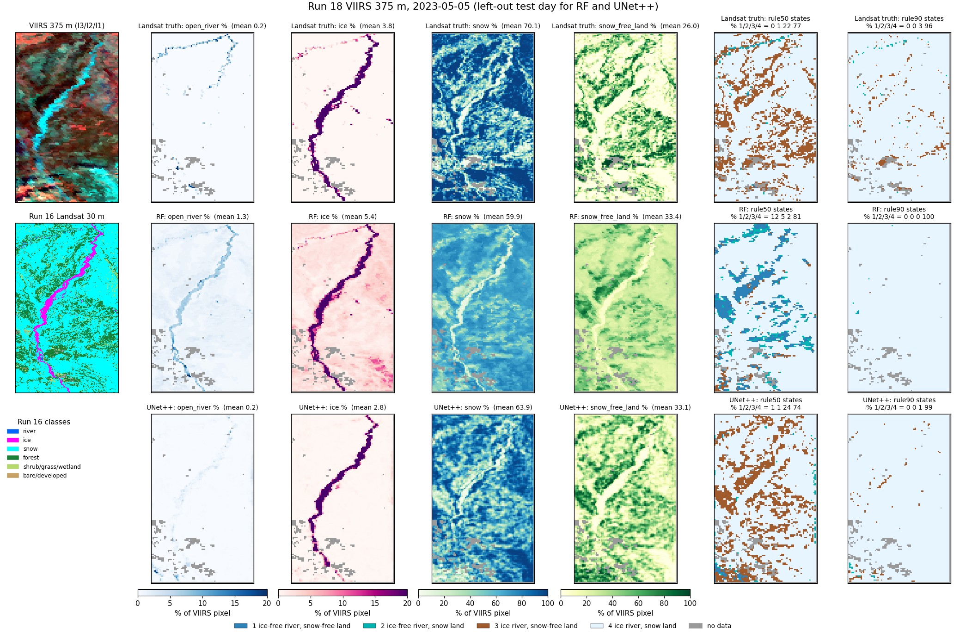
Run 18, 2023-05-05 (spring break-up): % maps and state maps, truth / RF / UNet++.
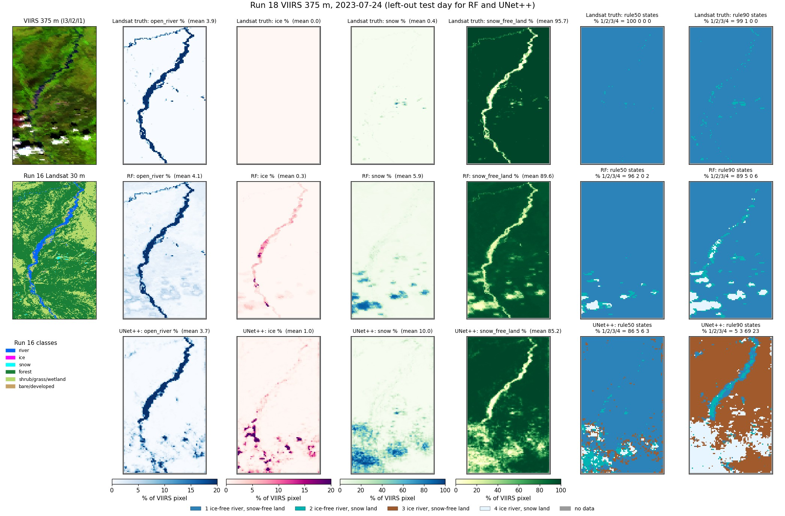
Run 18, 2023-07-24 (summer): % maps and state maps, truth / RF / UNet++.
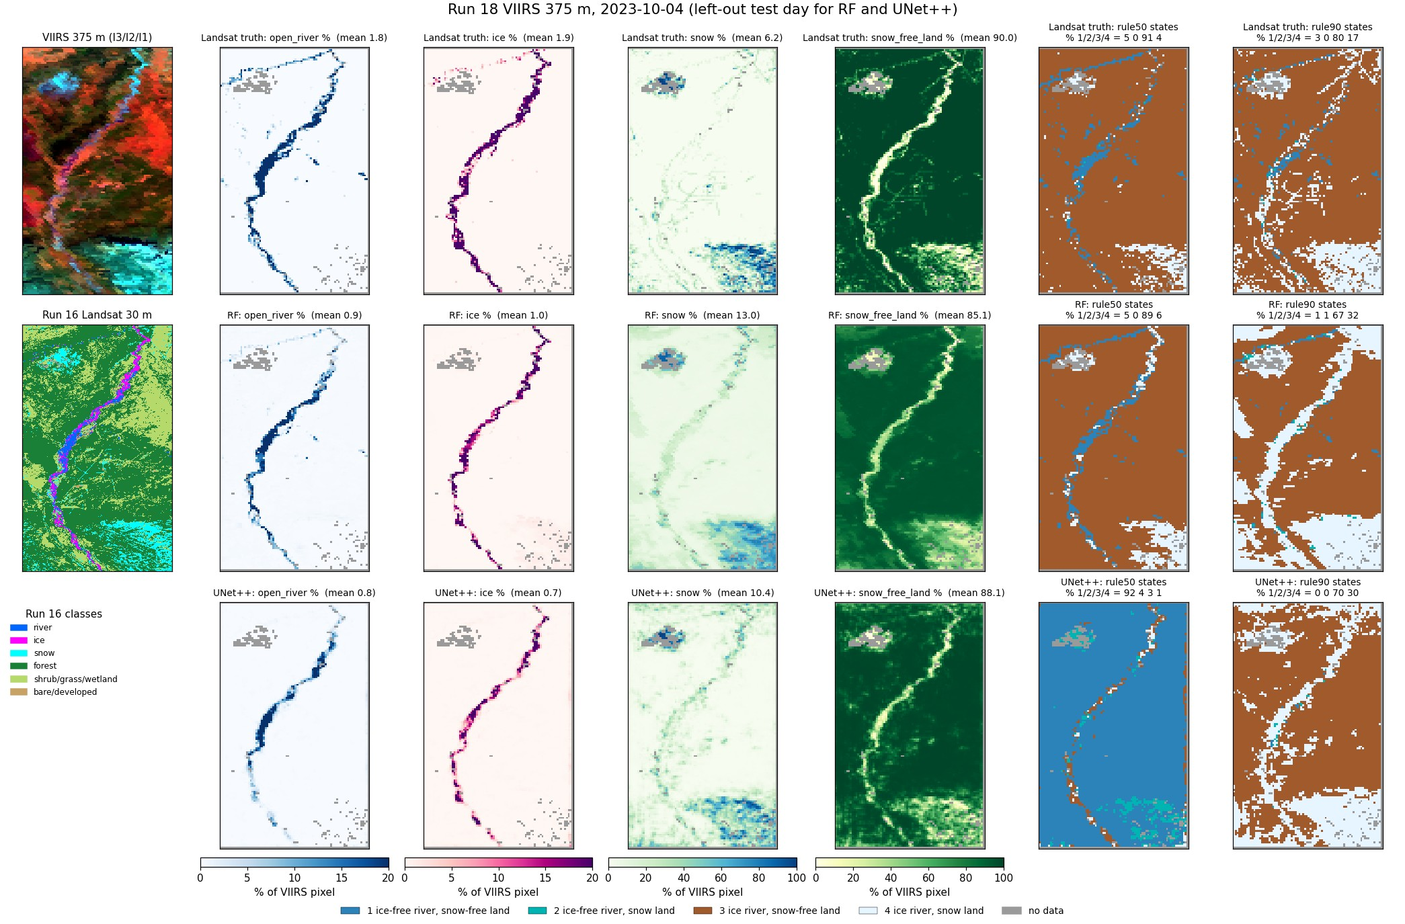
Run 18, 2023-10-04 (autumn freeze-up): % maps and state maps, truth / RF / UNet++.
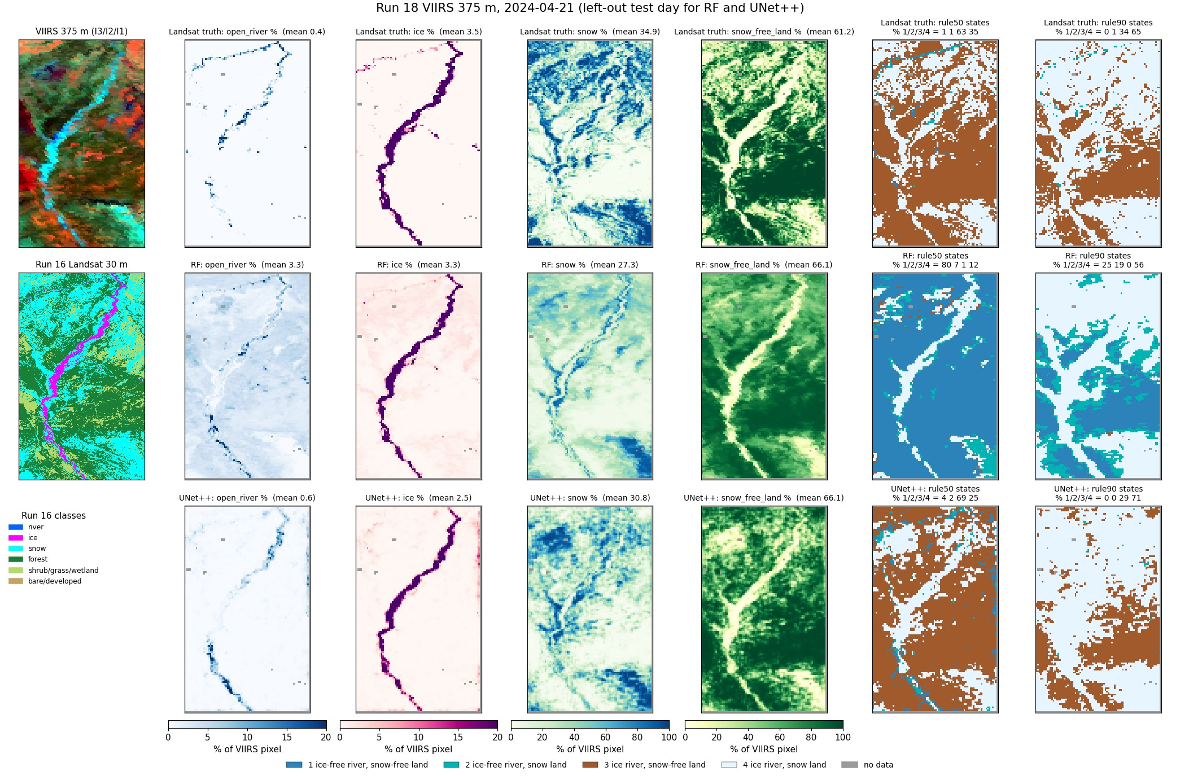
Run 18, 2024-04-21 (spring break-up): % maps and state maps, truth / RF / UNet++.
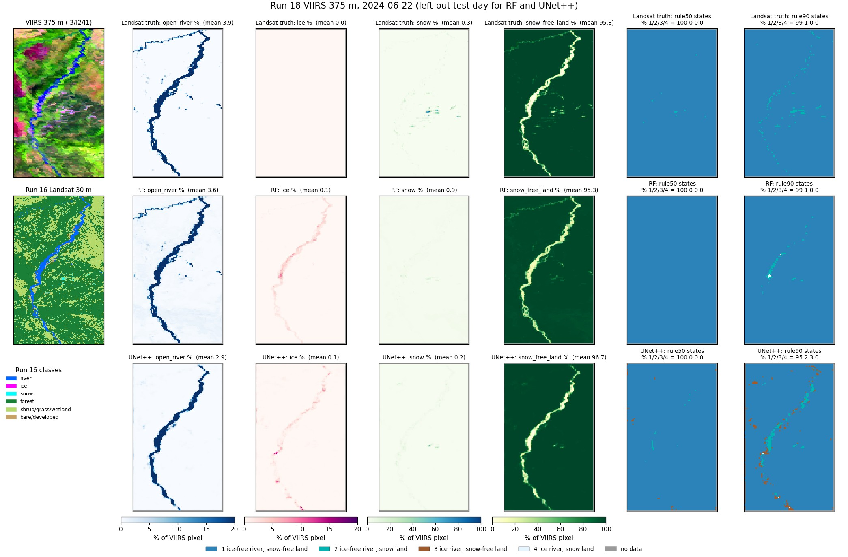
Run 18, 2024-06-22 (summer): % maps and state maps, truth / RF / UNet++.
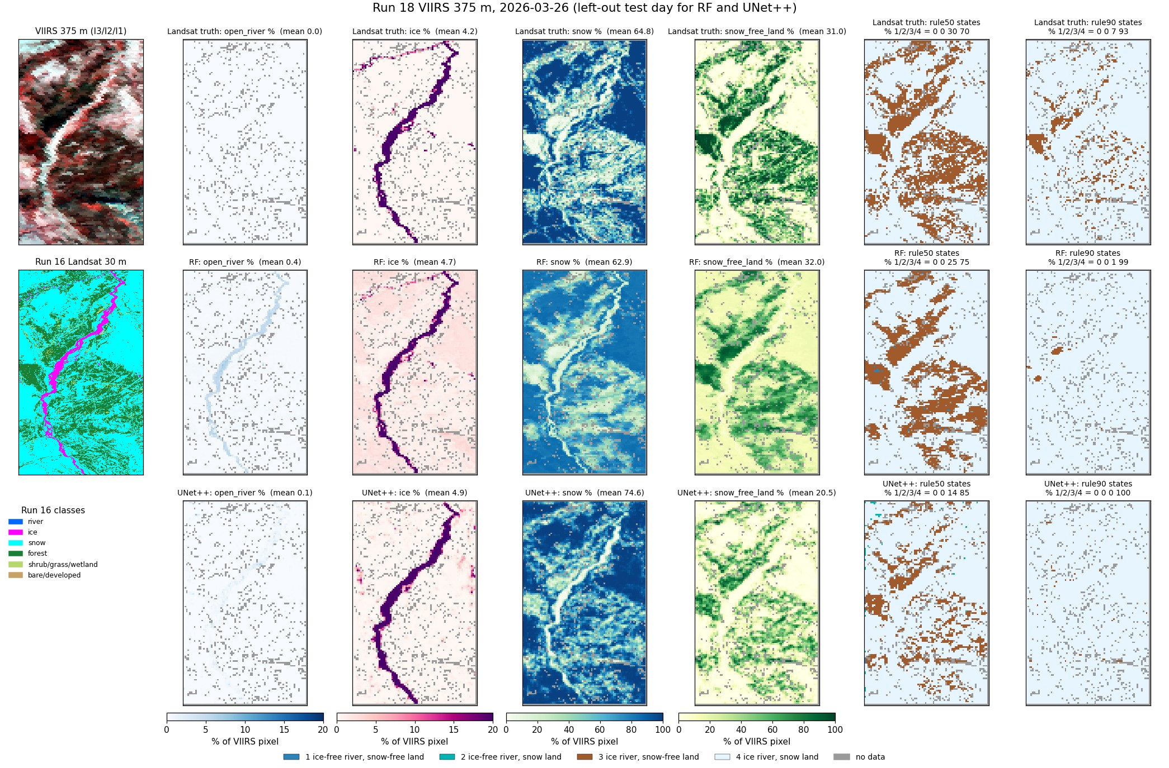
Run 18, 2026-03-26 (late winter): % maps and state maps, truth / RF / UNet++.

4. Things to know
- Labels are the run 16 Landsat maps, not hand labels: any run 16 error (gravel as river, cloud as snow/ice) becomes a VIIRS label.
- Only 6 labelled days; each model sees 5 per fold. Ice and break-up states come from 3 days.
- State 2 (open river, snow land) has a few hundred pixels in total; its F1 is not reliable.
- The JRC occurrence behind the water mask ends in 2021; moved channels fall outside the mask.
- VIIRS view angle and clouds vary daily; no cloud mask is applied, so cloudy days give wrong states.
- The 30 m to 375 m shift (run 17) is small (<= ~60 m) and applied before the shares are computed.

5. Files
what | where (~/Desktop/nenana_crops/daksh/)
run 17 unmixing | rf_viirs_unmix.py -> output/17_viirs_unmix/ (results.json, summary.txt, <date>/weights_psf.tif, viirs_fit.tif, viirs_residual.tif)
run 18 whole image | viirs_states.py -> output/18_viirs_states/ (truth|rf|unetpp/pct_<date>.tif, <rule>/class_<date>.tif, images/)
run 18 images | make_run18_images.py -> output/18_viirs_states/images/
run 19 river + buffer | RIVER_BUFFER=1 viirs_river_states.py -> output/19_viirs_river_states/ (mask/, truth|rf|unetpp|cnn2d/<rule>/class_<date>.tif, images/)
run 20 river only | RIVER_BUFFER=0 viirs_river_states.py -> output/20_viirs_river_only/
prediction images | RIVER_BUFFER=1|0 viirs_river_predict.py -> <run>/predict/ (images/pred_<date>.jpg, pred_<date>_rule90.jpg, totals.json, VIIRS-only maps)
water mask | ~/Desktop/nenana_crops/alaska_occ_375m.tif; cropped copies in <run>/mask/
this report | report/word_content_viirs.py + report/build_word.js; deck presentation/build_deck_viirs.js

Every .tif is on the VIIRS grid (EPSG:4326) and opens in QGIS; class maps carry a .qml style (1-4 colours, 0 = not predicted).

